# Step-by-Step Guide: Enrolling a User in MBE50 Using Reclaim

## Summary

The text provides a step-by-step guide for enrolling a user in MBE50 using Reclaim. It starts with logging into the system and navigating to the "Update Enrollment" section. The user ensures their communication information is correct and can add dependents if needed. The process involves entering the user's and dependents' names, answering questions on medical needs, and selecting preferred medical positions, which help in choosing the best plan. The demonstration concludes with selecting the most suitable plan, confirming the enrollments, and completing the enrollment process.

## Steps

Hello everybody, I'm going to show you how to enroll a user in this thing here in MBE50



using Reclaim.

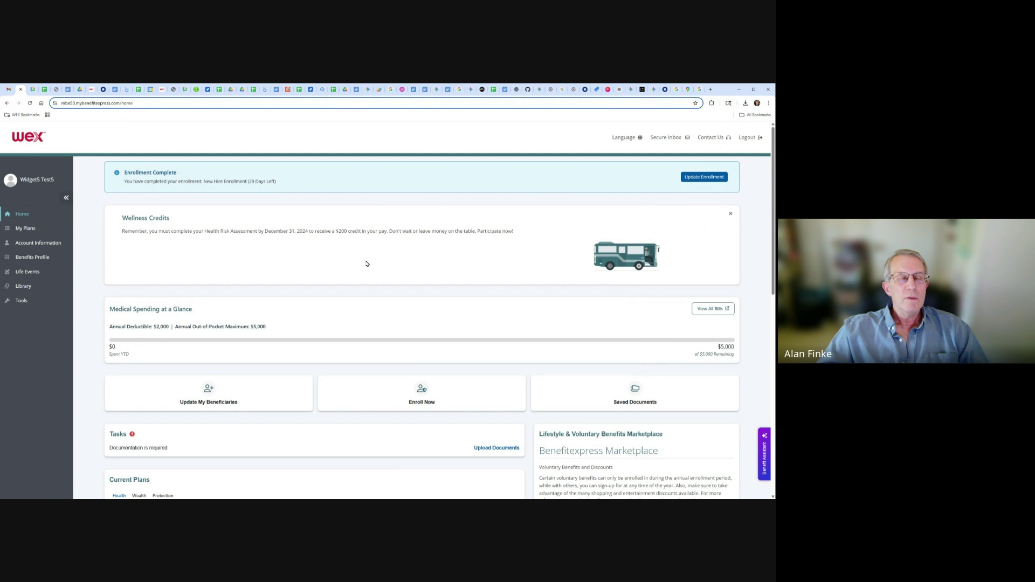

So first log in, go to Update Enrollment, I've enrolled before, so I'm changing my enrollment.

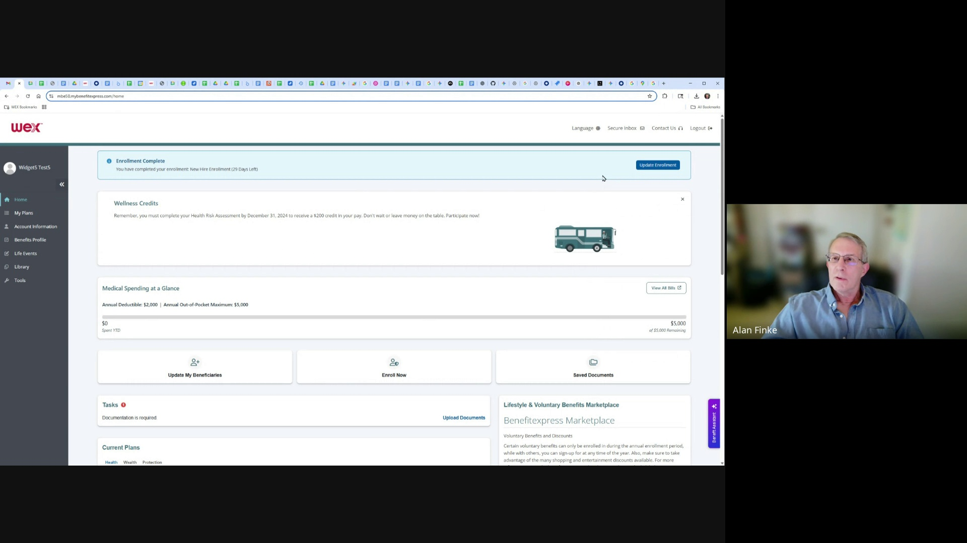

Make sure Communication Information is correct.

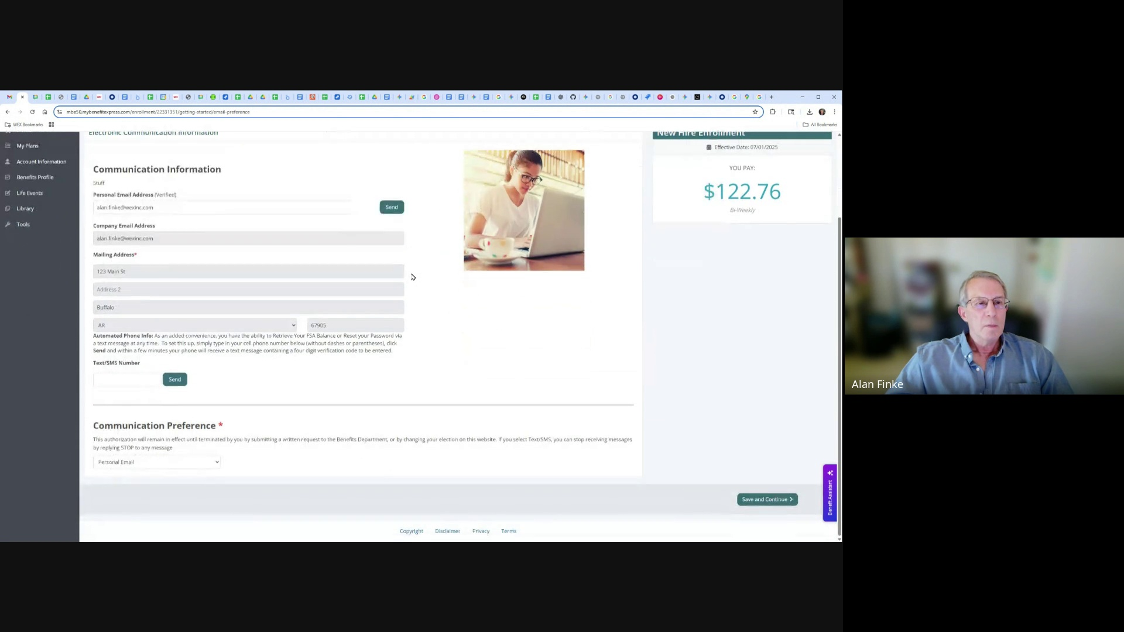

And then if I want to add dependence, I can do this here, but in this case, I'm just going to simply enroll.

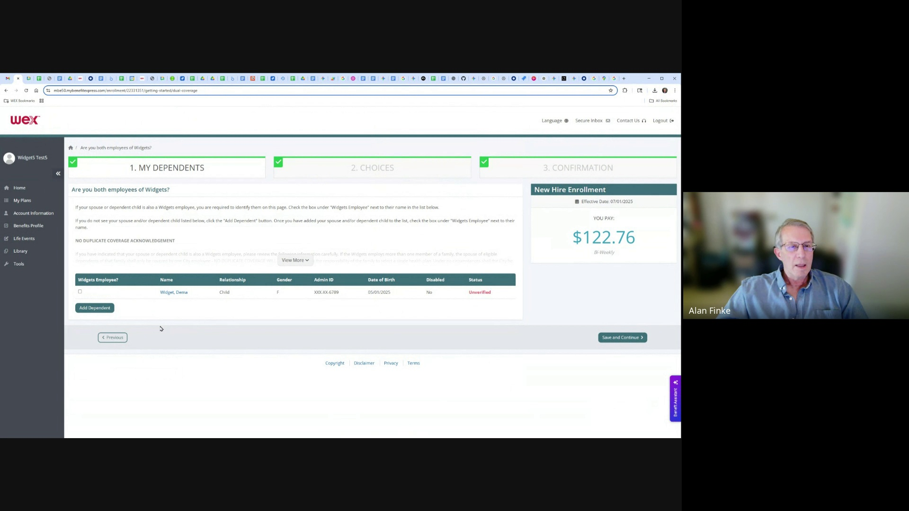

So I'm going to enroll here, get started, I'm going to, my name is demo widget, my

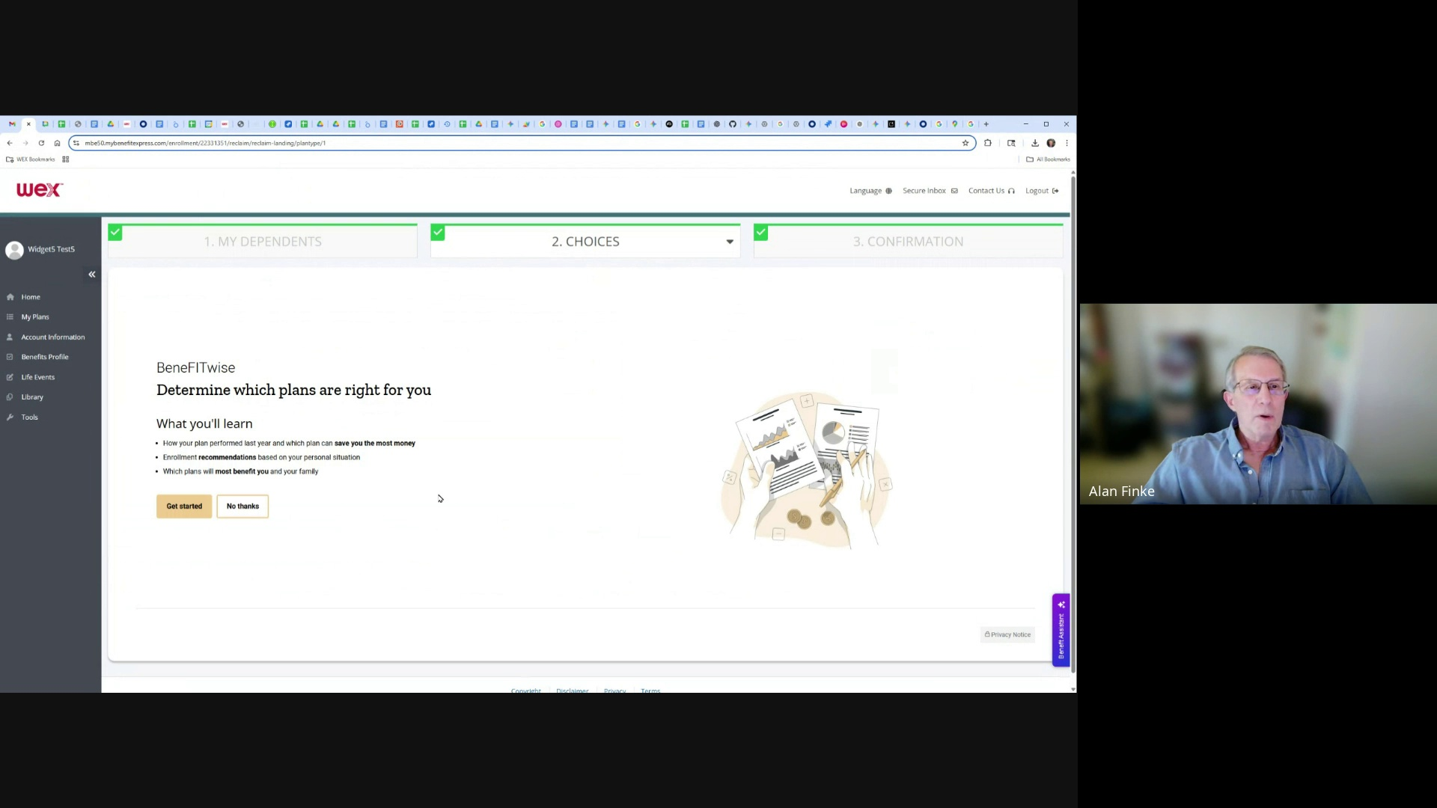

daughter in demo widget, so I'm going to continue to enroll here.

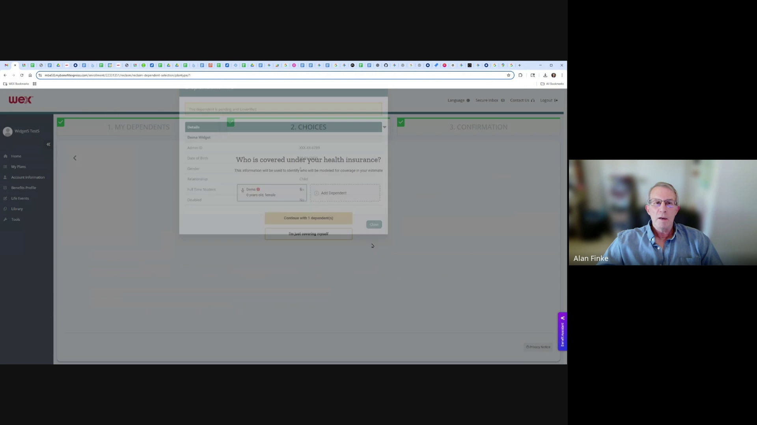

Waiting for this to load.

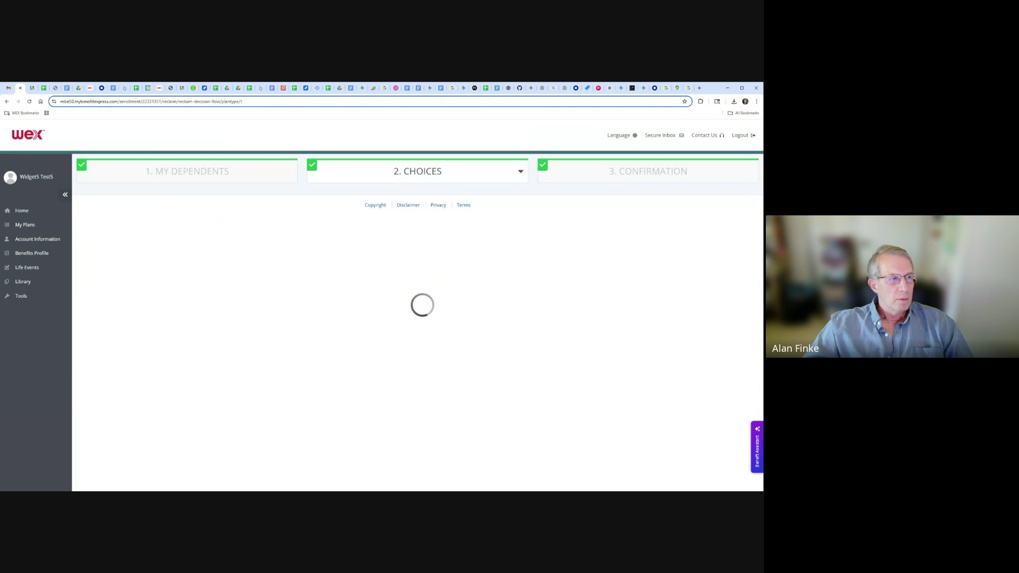

Once it's loaded, it will ask you a series of questions for your those affordable team.

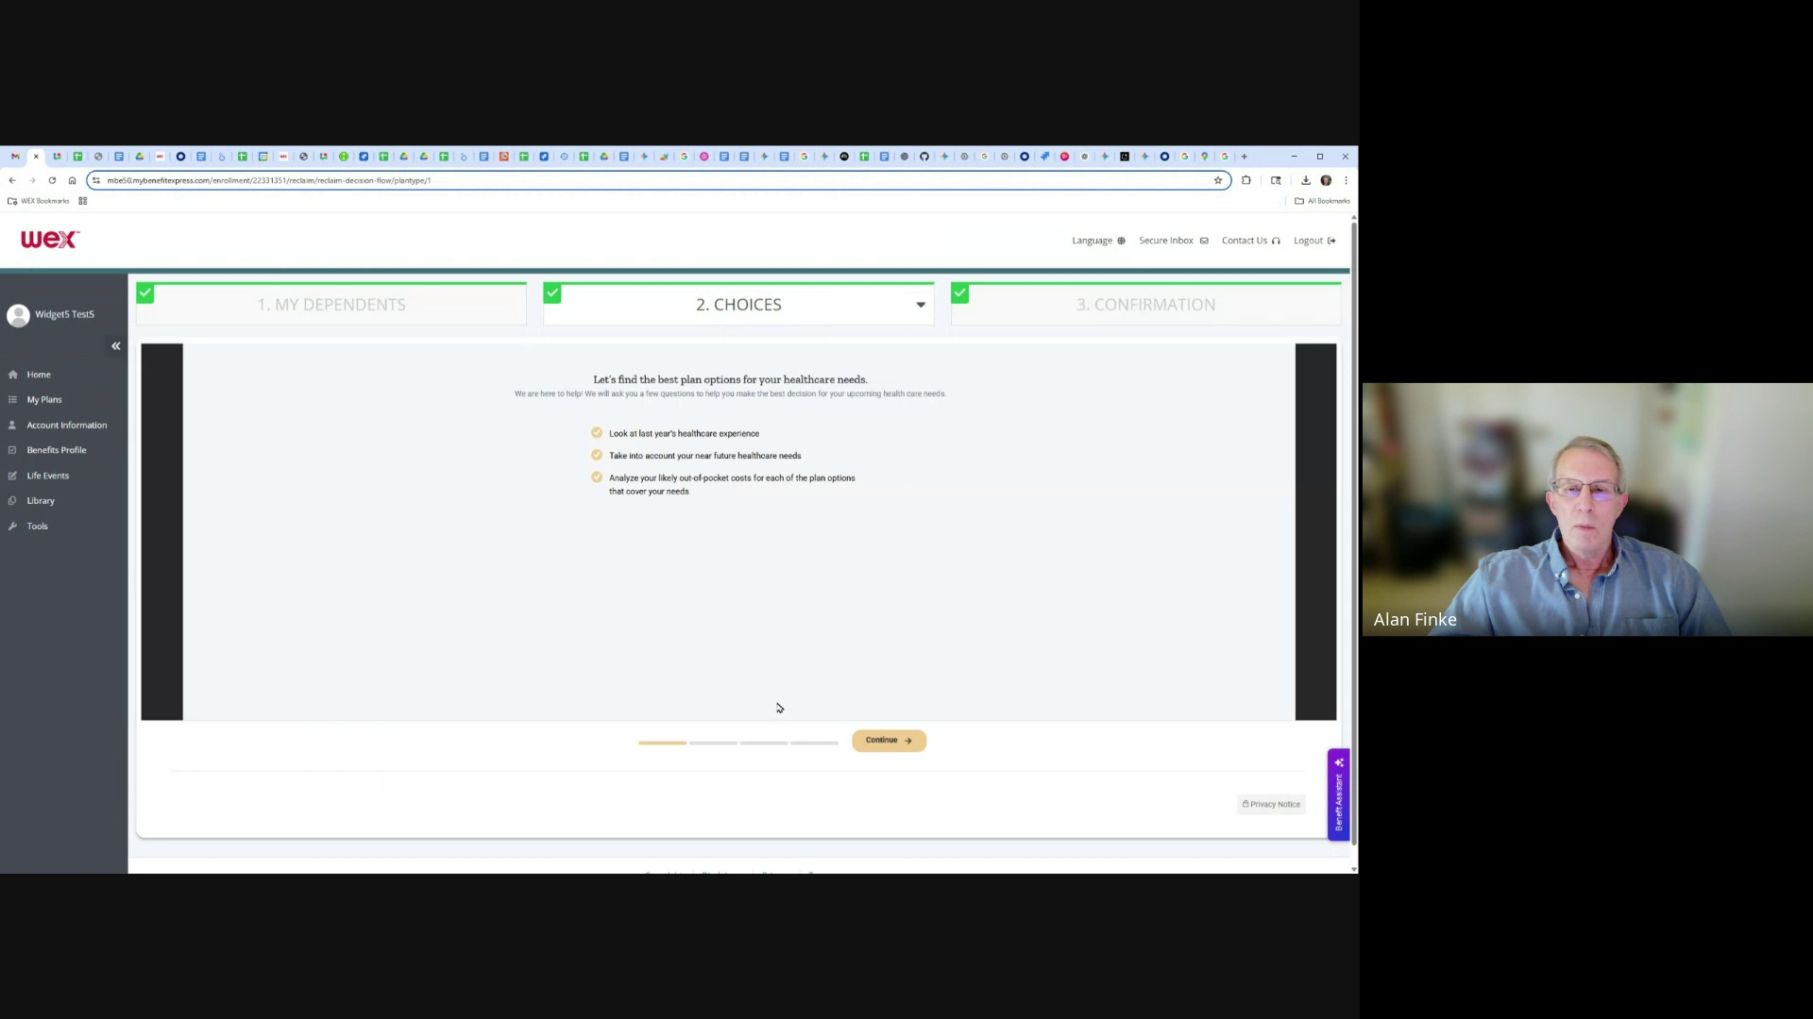

If you have any special medical needs coming up, if you have special, you select them,

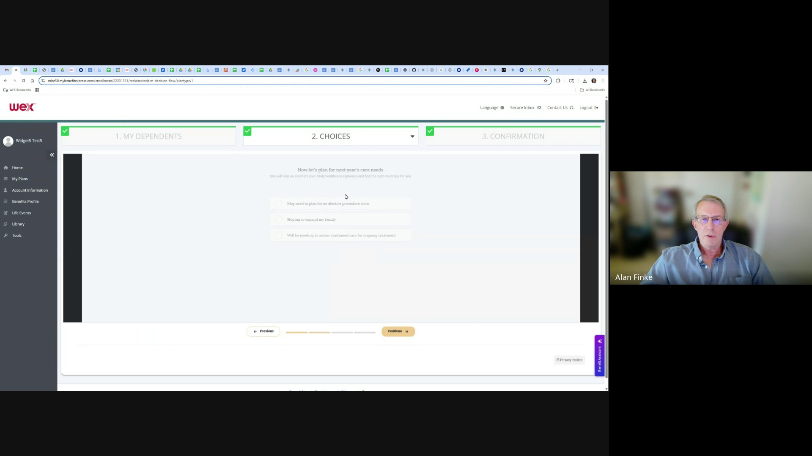

preview screen. If you have a position you prefer, you can enter that here, and it will look for

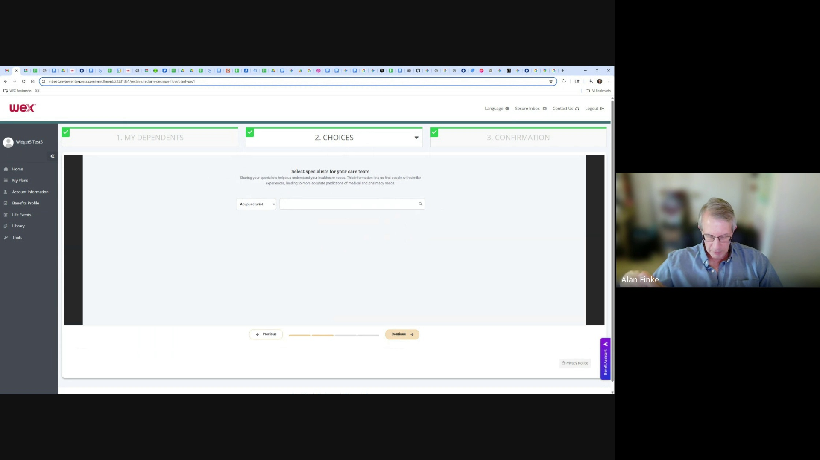

plans that support your position.

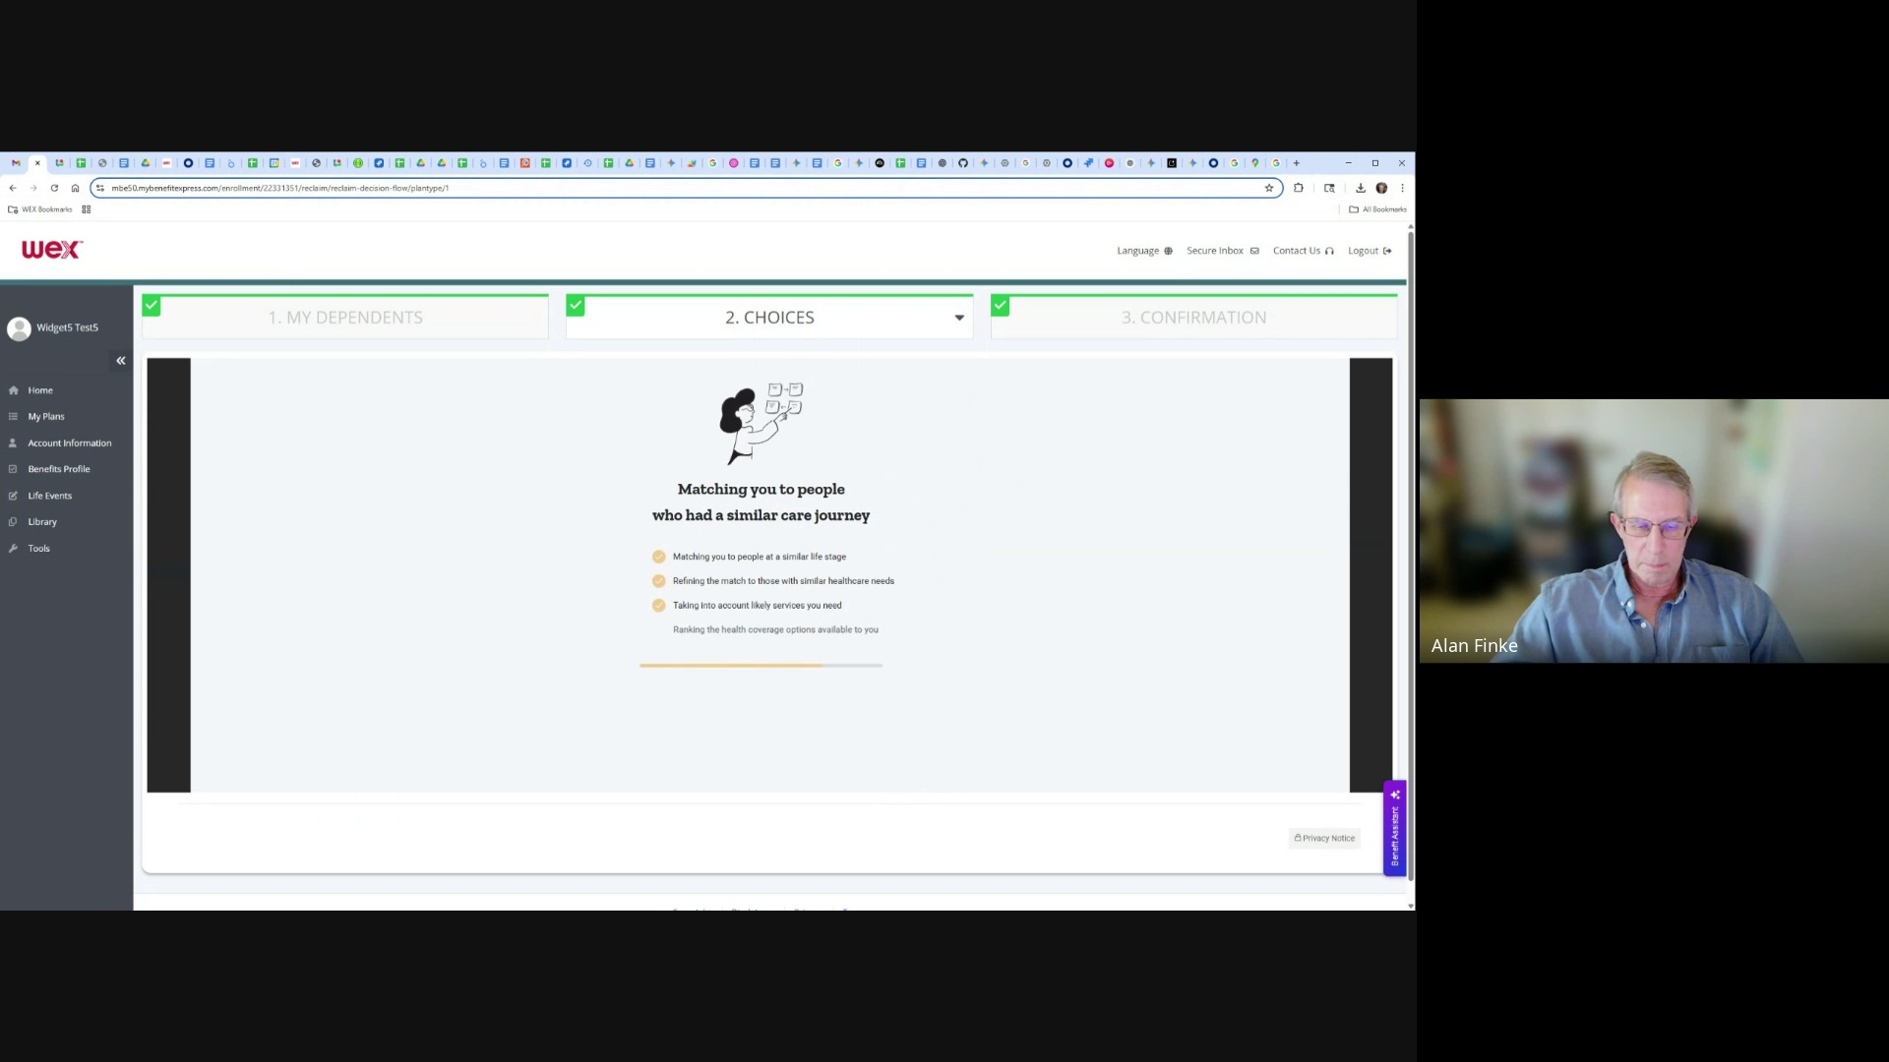

Now finds a match and decides what is the best plan for me.

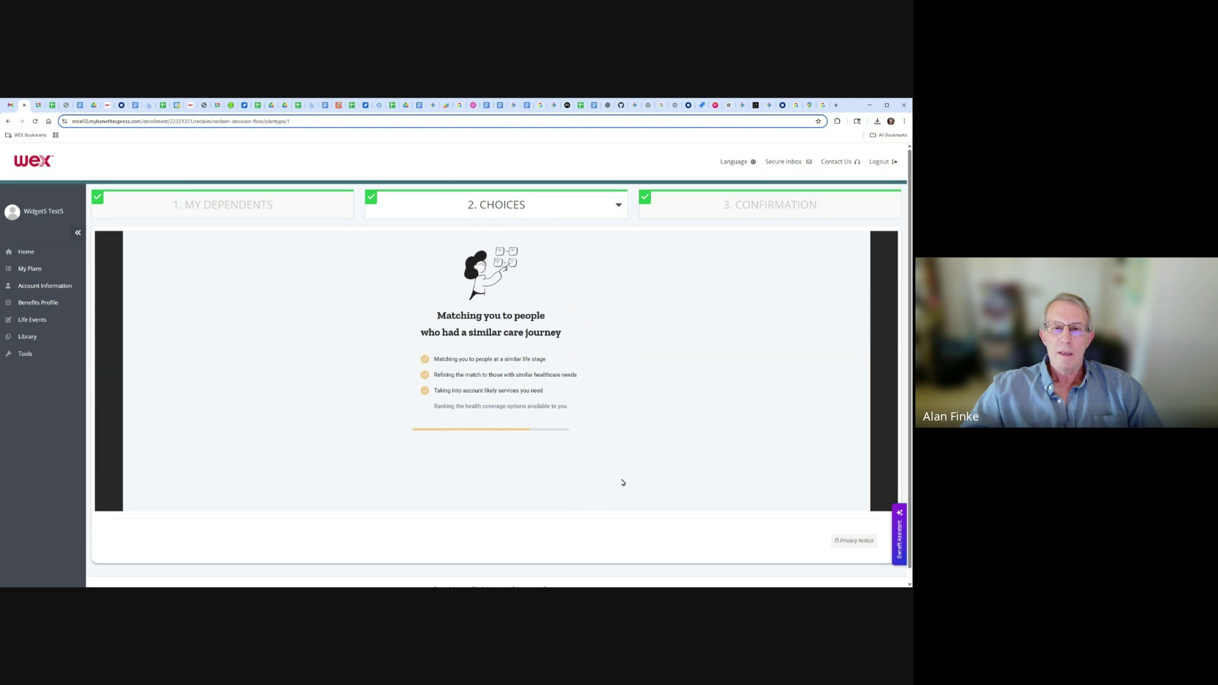

And here, me decide the bronze plan was best.

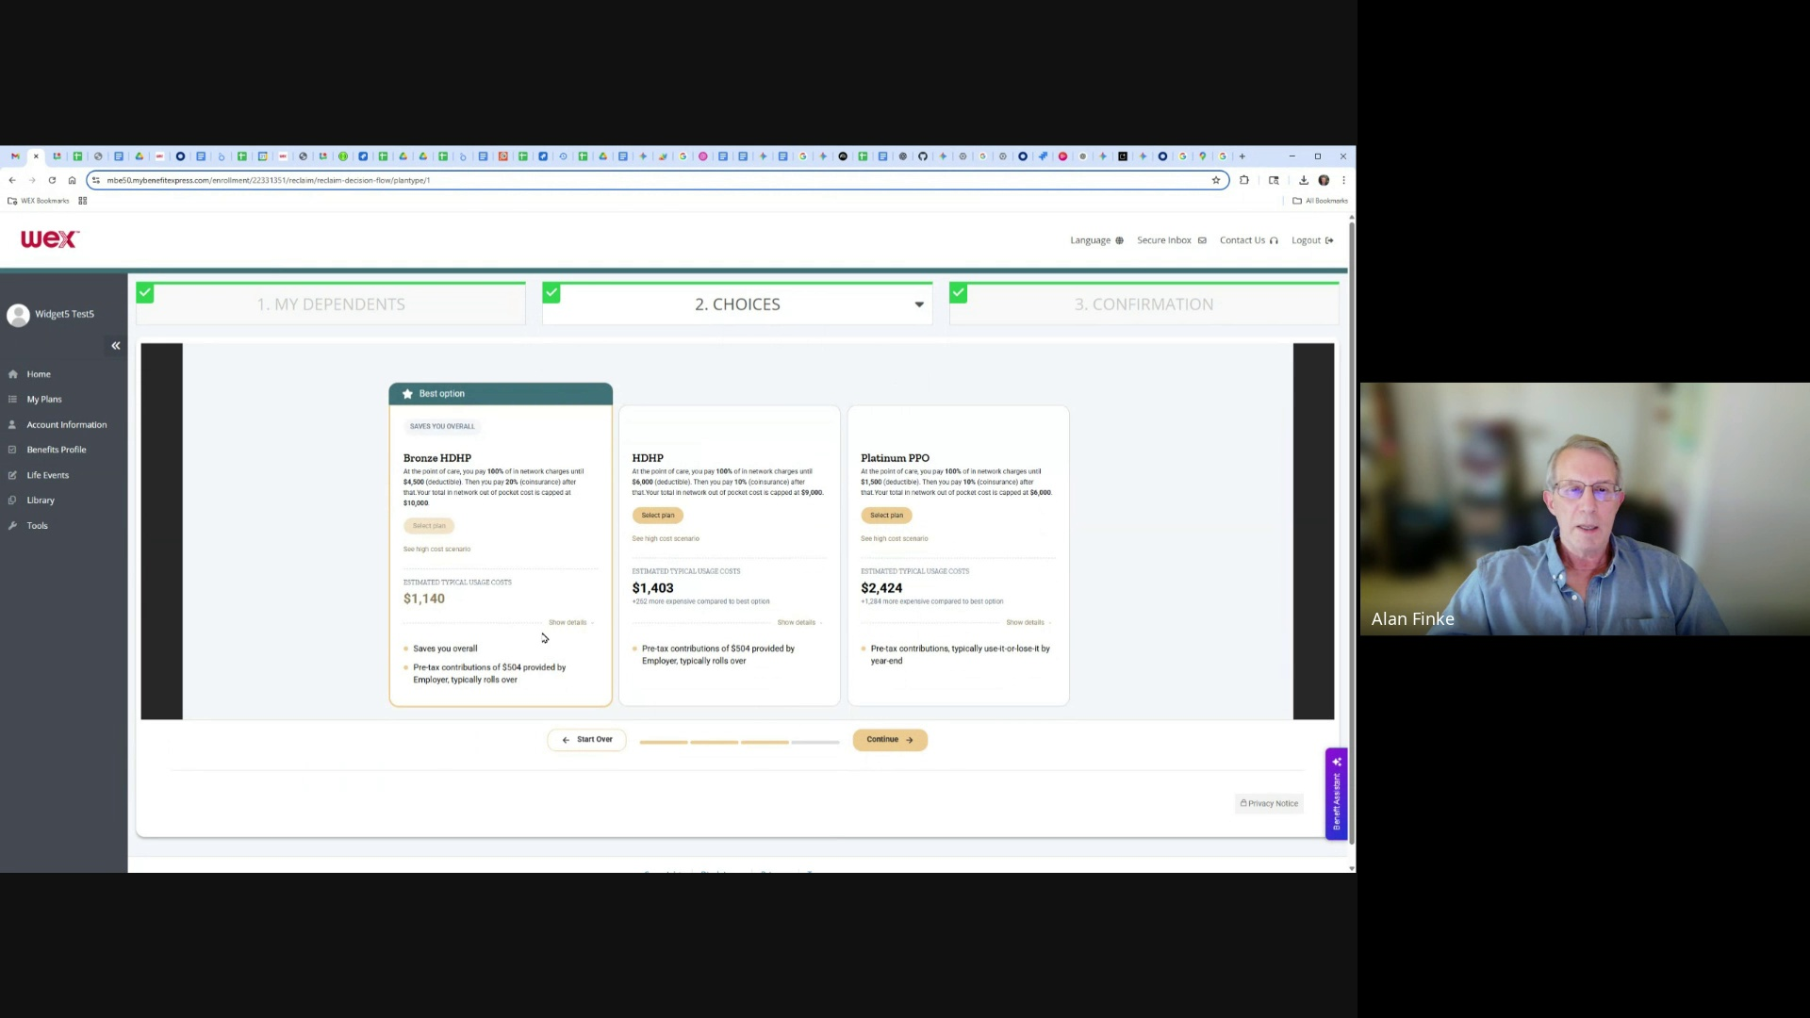

So I'm going to continue with this, I'm all set, and I can confirm my enrollments,

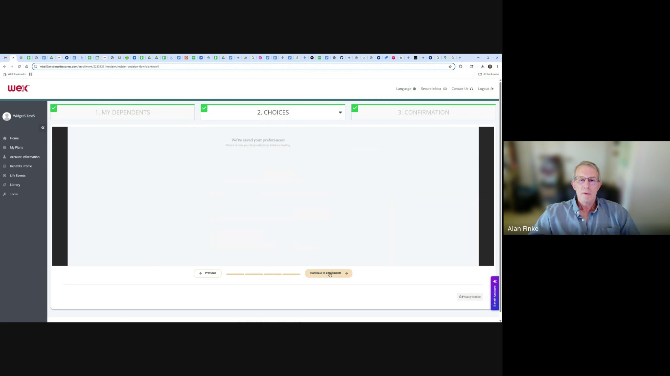

and finish enrollments.

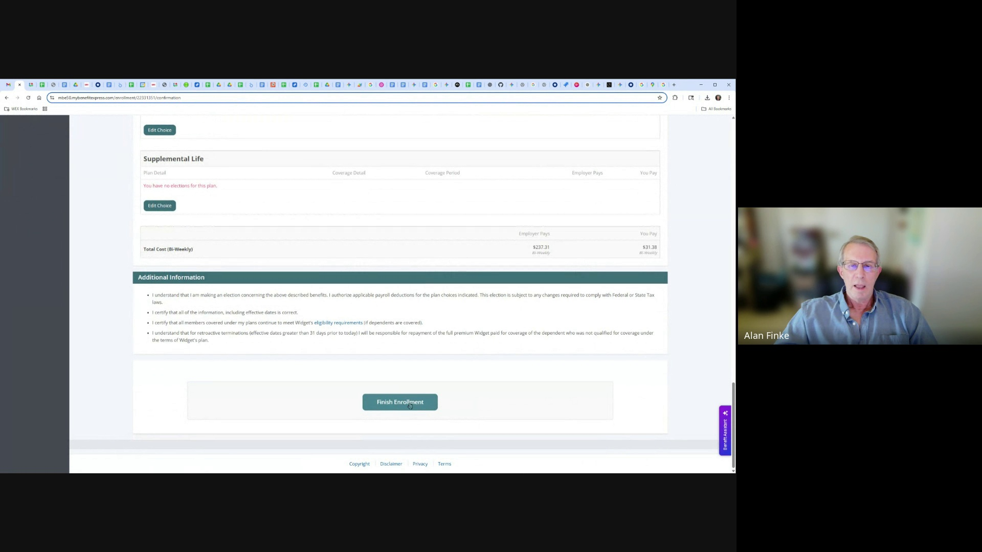

Enrollment is complete.

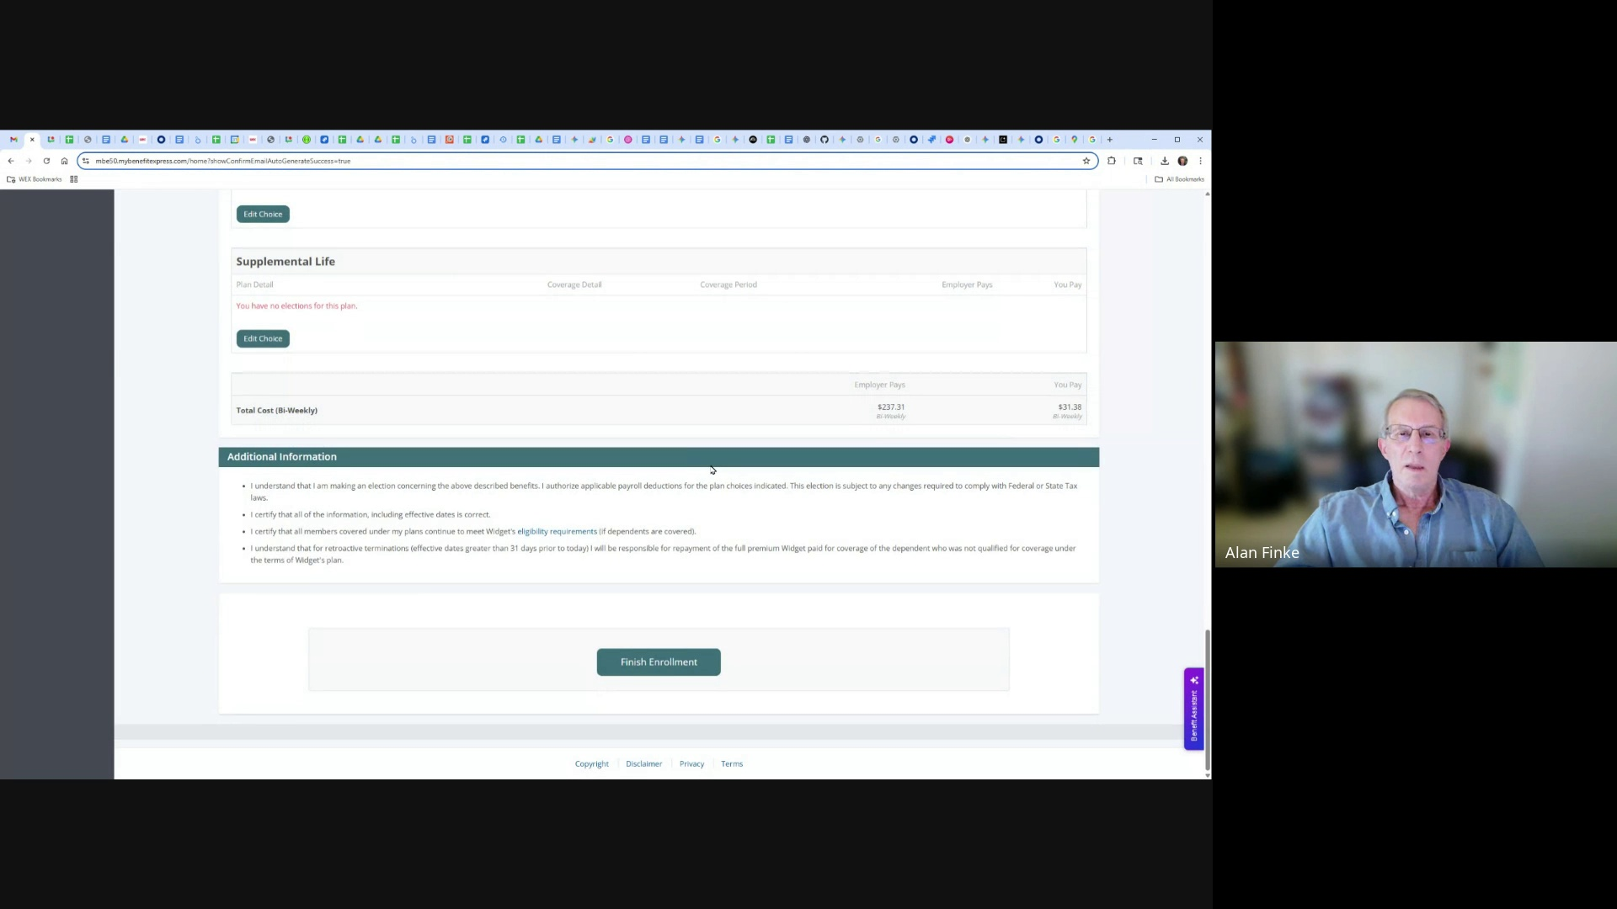

Thank you.

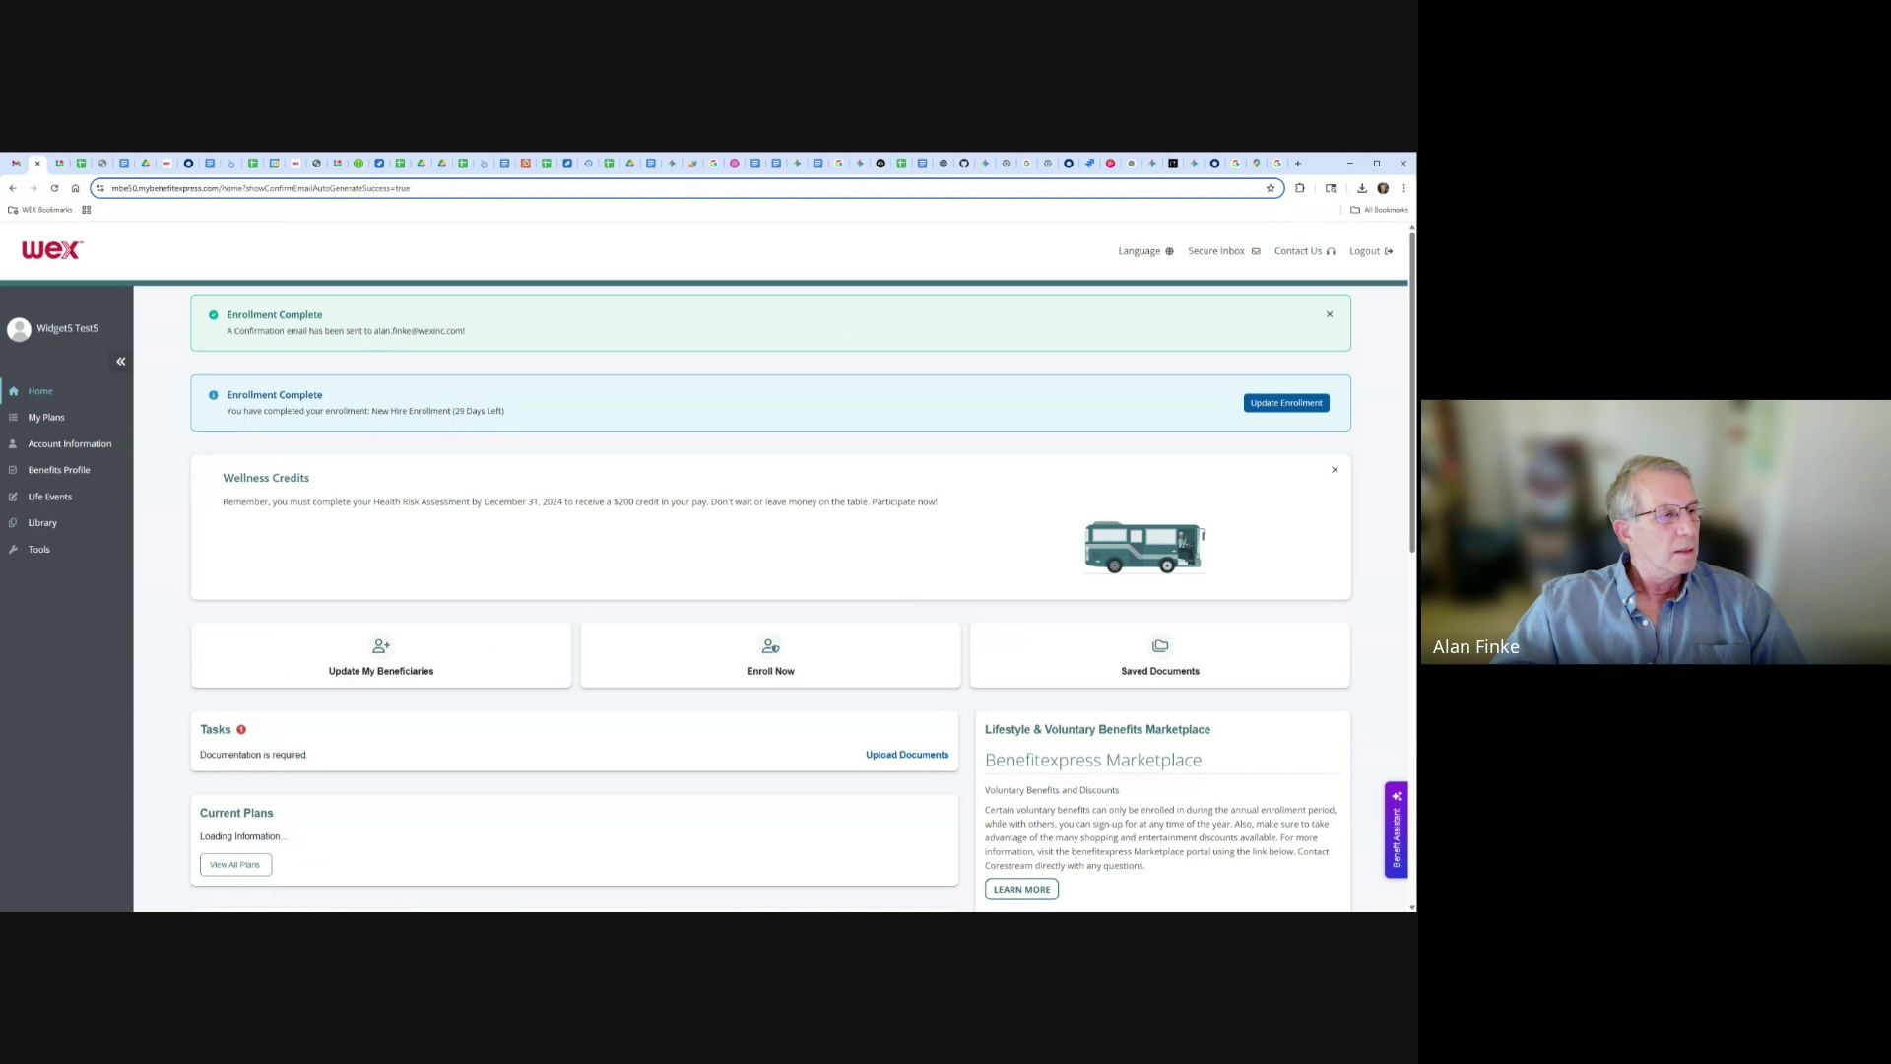

I will stop recording now.

