 |  |  |  | RailCom |  | Arduino Nano Connect
GPIO pin | Pico/PicoW | OLED 0.91 | DRV8874 | Pin | Use | Nano Pin no | Usage
0 | TX |  |  | A | Ch1 RX | TX
1 | RX |  |  | AS | Ch1 Orient. | RX
2 |  |  |  |  |  | Not exposed | radio
3 |  |  |  |  |  | Not exposed | radio
4 | I2C0:sda | (SDA) |  |  |  | 12 | SPI0:miso
5 | I2C0:scl | (SCK) |  |  |  | 10
6 | I2C1:sda |  |  |  |  | 13 | SPI0:sck
7 | I2C1:scl |  |  |  |  | 11 | SPI0:mosi
8 | SPI1:miso |  |  |  |  | Not exposed | radio
9 |  |  |  |  |  | Not exposed | radio
10 | SPI1:mosi |  |  |  |  | Not exposed | radio
11 | SPI1:clk |  |  |  |  | Not exposed | radio
12 |  | SDA |  |  |  | A4/D18 | I2C0:sda
13 |  | SCK |  |  |  | A5/D19 | I2C0:scl
14 |  |  |  |  |  | Not exposed | radio
15 |  |  |  | B | Ch2 RX | 3
16 | SPI0:miso |  |  | BS | Ch2 Orient. | 4
17 |  |  |  |  |  | 5
18 | SPI0:clk |  | EN(ABLE) |  |  | 6
19 | SPI0:mosi |  | nSLEEP |  |  | 7
20 |  |  | PH(ASE) |  |  | 8
21 |  |  | nFault |  |  | 9
22 |  |  |  |  |  | Not exposed | microphone
23 | radio |  |  |  |  | Not exposed | microphone
24 | radio |  |  |  |  | Not exposed | LSM6
25 | radio/LED |  |  |  |  | 2
26 |  |  |  |  |  | A0/D14
27 |  |  |  |  |  | A1/D15
28 |  |  |  |  |  | A2/D16
29 | radio |  |  |  |  | A3/D17
+5V | Vin
3V3 | 3V3 (output) | 3V3 | 3V3
DC Com | Gnd | Gnd | Gnd

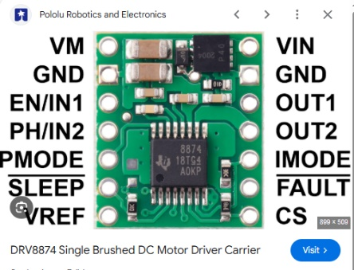

https://www.pololu.com/product/4035

https://botland.store/motor-drivers-modules/21359-drv8874-single-channel-37v21a-motor-driver-pololu-4035.html

Minimal Wiring Arrangement:
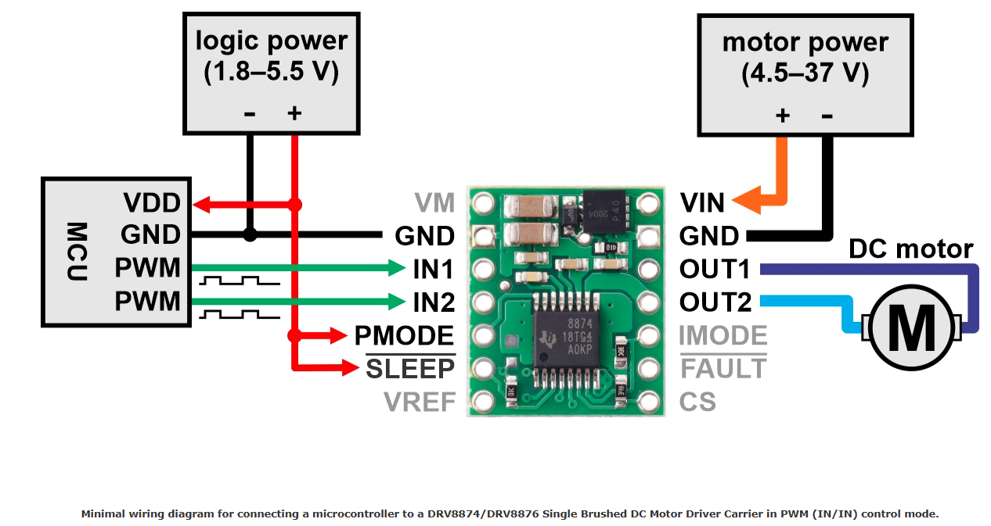

The pins of the DRV8874 driver
Pin | Default state | Description
VIN |  | Input voltage from 4.5 V to 37 V.
GND |  | The mass of the system for the engine and logic.
VM |  | Pin that gives access to the motor's power supply after activation of the MOSFET protection against reverse voltage. It can be used to power other system components with reverse polarity protection.
OUT1 |  | Engine output 1.
OUT2 |  | Motor output 2.
EN / IN1 | LOW | Pin 1 for motor turn ON / OFF PHASE / ENABLE (PH / EH).
PH / IN2 | LOW | Pin 2 to control the direction of rotation of the motor PHASE / ENABLE (PH / EH).
FAULT | FLOATING | Open-drain, fault output activated with low state. The pin goes low after exceeding the permissible current or voltage. Must be pulled up with a resistor, to be high by default.
SLEEP | LOW | The SLEEP input causes the controller to enter the low power state after entering the low state. This pin can also be switched to clear a stuck over current or over temperature fault.
VREF |  | Current limiting threshold reference voltage.

