Lab 6

Team Members:

Alan Tony (191CS207)

Aashish Prateek (191CS225)



Computer Networks Lab (CS302)

**Steps followed:**

1. Mininet was imported from *.ovf* file and installed in VMware Workstation Player.
2. Ubuntu VM was booted from VMware Workstation Player
3. Logged into Mininet

**Pre-question Trials**

Mininet is a *network emulator* which creates a network of virtual hosts, switches, controllers, and links. Mininet hosts run standard Linux network software, and its switches support OpenFlow for highly flexible custom routing and Software-Defined Networking.

To experiment with the network, we need to *ssh* into the Mininet VM. We get the IP address of the VM by entering *ifconfig* on the Mininet terminal. Also pass the -X option to open an *xterm* interface to use terminals of different hosts in the network on our Ubuntu VM.

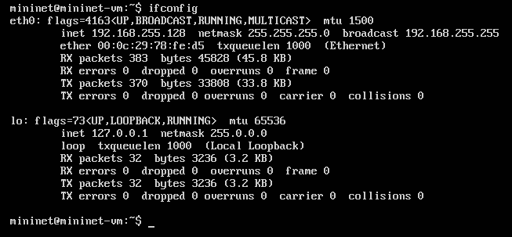

To start interacting with the network we initiate the network using command ‘*sudo mn’.* The network simulated by this command is of Mininet’s default minimal topology which looks like:

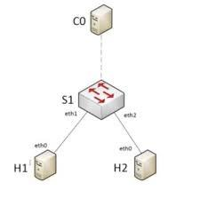

*Mininet’s minimal topology*

* **ping**:

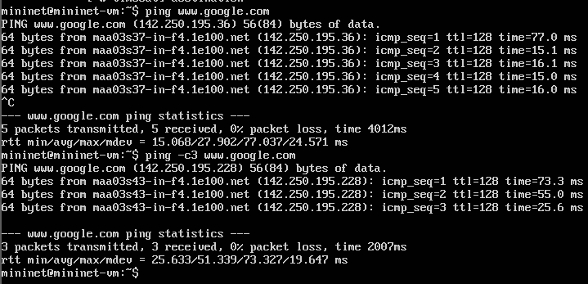

* **arp**: Using the arp command allows **you to display and modify the Address Resolution Protocol (ARP) cache**

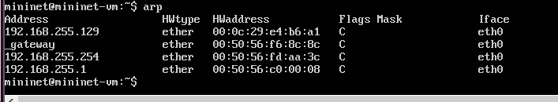

* **nslookup**: Nslookup (stands for “Name Server Lookup”) is a **useful command for getting information from DNS server**.

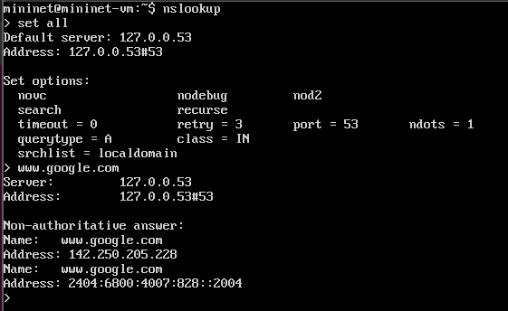

* **whois**: Whois is a **widely used Internet record listing that identifies who owns a domain and how to get in contact with them**.

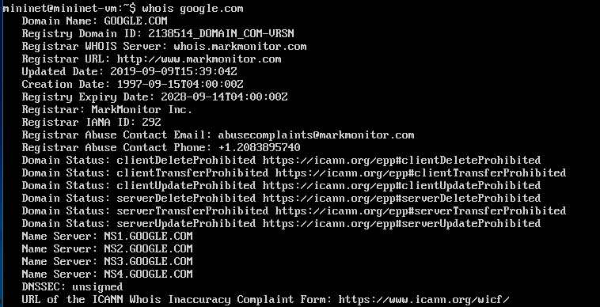

* **traceroute**: Traceroute is **a command that runs tools used for network diagnostics**. These tools trace the paths data packets take from their source to their destinations, allowing administrators to better resolve connectivity issues.

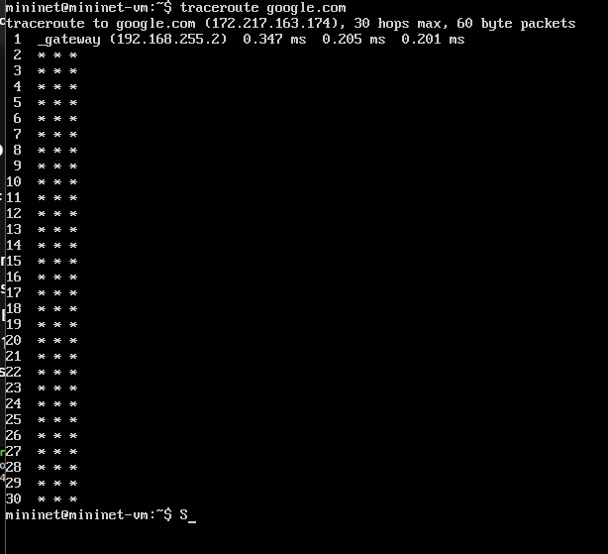

* **hostname**: Get or set hostname or DNS domain name

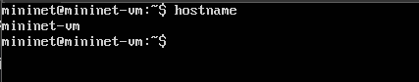

* **route**: In computing, route is a command used to view and manipulate the IP routing table in Unix-like and Microsoft Windows operating systems and also in IBM OS/2 and ReactOS.

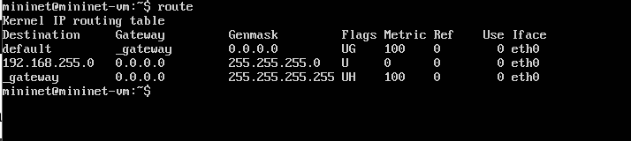

* **netstat**: In computing, netstat is a command-line network utility that displays network connections for Transmission Control Protocol, routing tables, and a number of network interface and network protocol statistics.

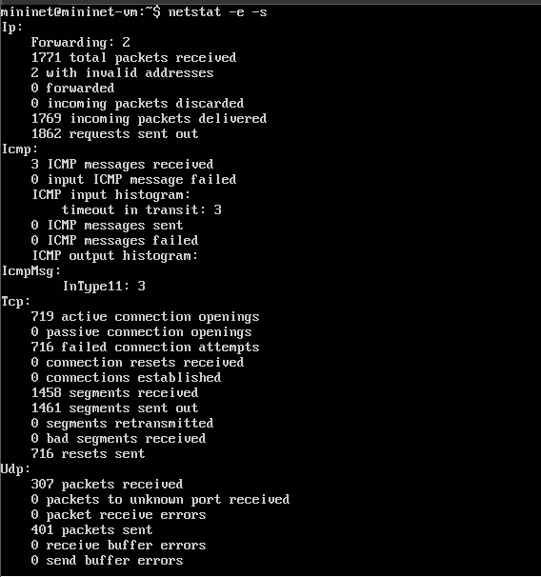

* **tcpdump**: tcpdump is a packet analyzer that is launched from the command line. It can be used **to analyze network traffic by intercepting and displaying packets that are being created or received by the computer it's running on**.

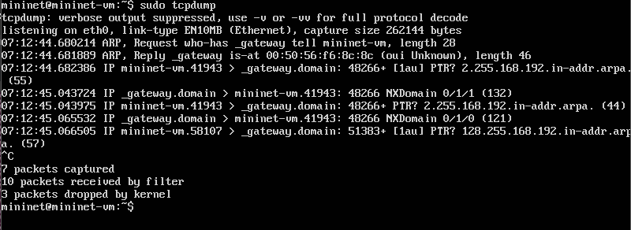

***P.T.O***

**Virtual Network Setup**

Here we are beginning the network using the ‘sudo mn’ command from the host virtual machine which connects to the mininet VM.

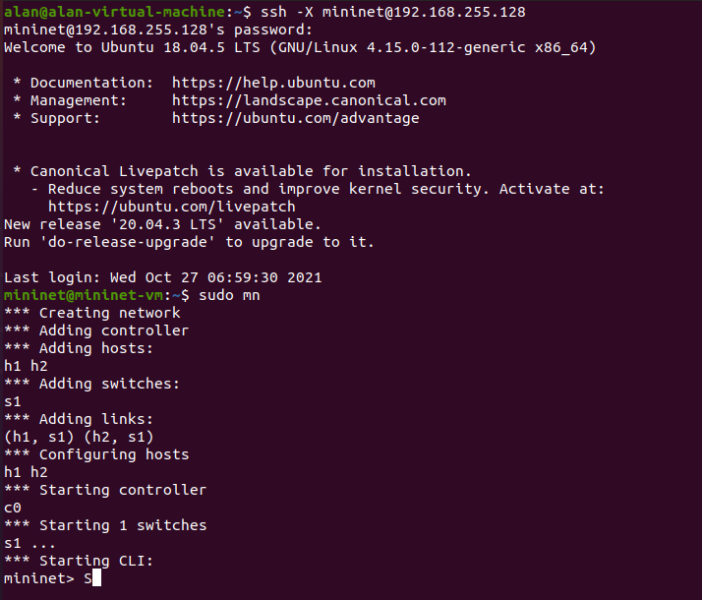

The ‘nodes’ command lets us view the details of all the nodes or components of the network.

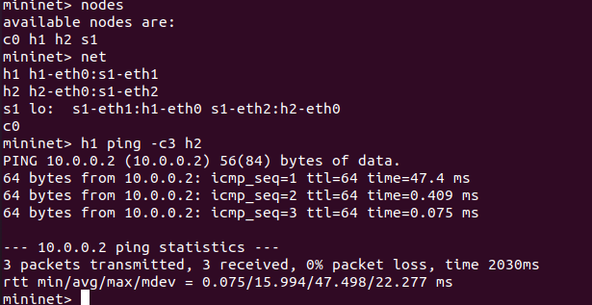

**Answers**

PART A

1. IP addresses: The ‘dump’ command is used within the mininet framework to get a list of all the network elements along with their IP addresses.

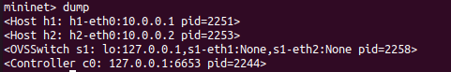

1. MAC addresses and interfaces (obtained with *ifconfig*): ‘ifconfig’ is used to obtain all configuration-related information regarding the virtual network.

* h1

1. Interfaces for ‘h1’ include ‘h1-eth0’ whose MAC address is 00:00:00:00:00:01
2. another interface for h1 is ‘lo’ whose IP address is 127.0.0.1 and is also known as a loopback interface.

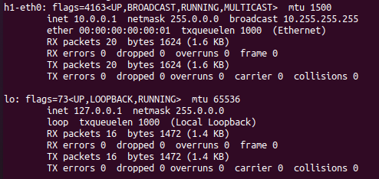

* h2
  1. Interfaces for ‘h2’ includes ‘h2-eth0’ whose MAC address is 00:00:00:00:00:02
  2. another interface for h2 is ‘lo’ whose IP address is 127.0.0.1 and is also known as a loopback interface.

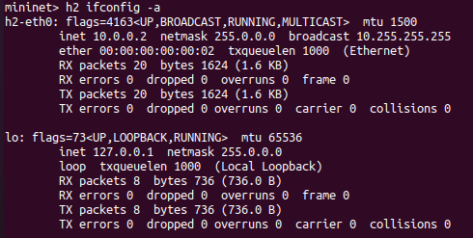

* c0: List of interfaces for ‘c0’ or basically the controller includes:
  1. ‘eth-0’ with MAC address 00:0c:29:78:fe:d5
  2. loopback(lo) with IP 127.0.0.1
  3. ‘ovs-system’ with MAC address 22:0e:25:23:2e:c0
  4. ‘s1’ with MAC address ca:27:d0:76:3a:4c
  5. ‘s1-eth1’ with MAC address 3e:6b:01:7d:9e:bb
  6. ‘s1-eth2’ with MAC address 3a:b2:71:79:96:c9

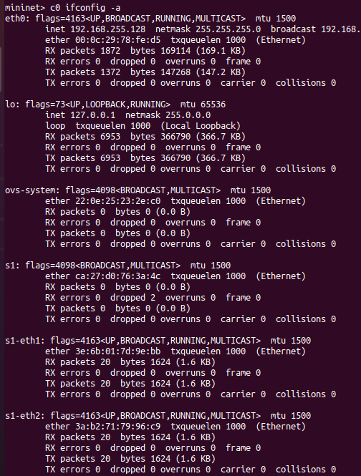

* s1: The list of interfaces for ‘s1’ include:
  1. ‘eth-0’ with MAC address 00:0c:29:78:fe:d5
  2. loopback(lo) with IP 127.0.0.1
  3. ‘ovs-system’ with MAC address 22:0e:25:23:2e:c0
  4. ‘s1’ with MAC address ca:27:d0:76:3a:4c
  5. ‘s1-eth1’ with MAC address 3e:6b:01:7d:9e:bb
  6. ‘s1-eth2’ with MAC address 3a:b2:71:79:96:c9

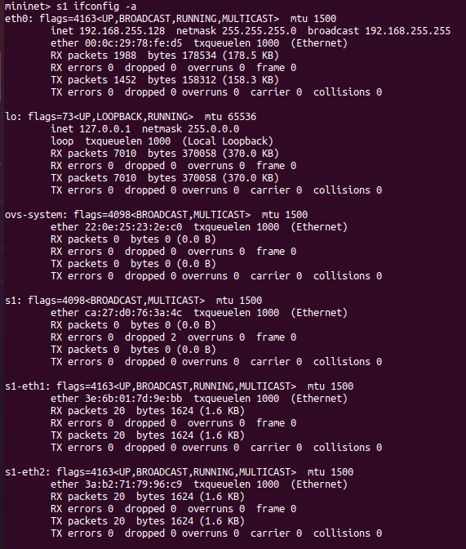

1. The latency between mininet vm and :
   1. [www.rutgers.edu](http://www.rutgers.edu) : Network latency, sometimes called lag, is the term used to describe delays in communication over a network. Latency meaning in networking is best thought of as the amount of time it takes for a packet of data to be captured, transmitted, processed through multiple devices, then received at its destination and decoded. Here we observe that the network latency between ‘www.rutgers.edu’ and mininet VM is around the 250ms range.

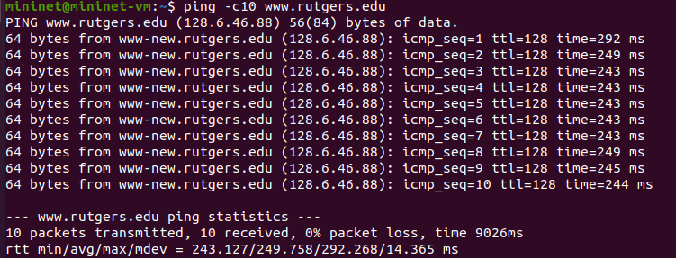

* 1. [www.stanford.edu](http://www.stanford.edu) :

Here we observe that the network latency between ‘www.stanford.com’ and mininet VM is around the 13ms range.

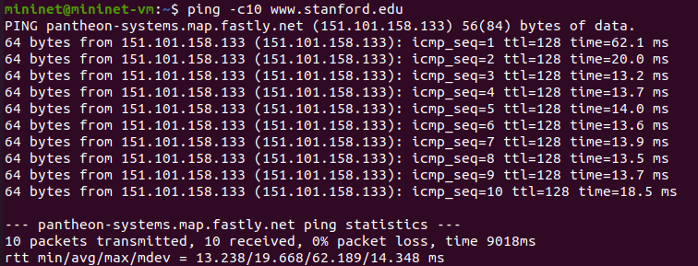

* 1. [www.google.com](http://www.google.com) :

Here we observe that the network latency between ‘www.google.com’ and mininet VM is around the 13ms range.

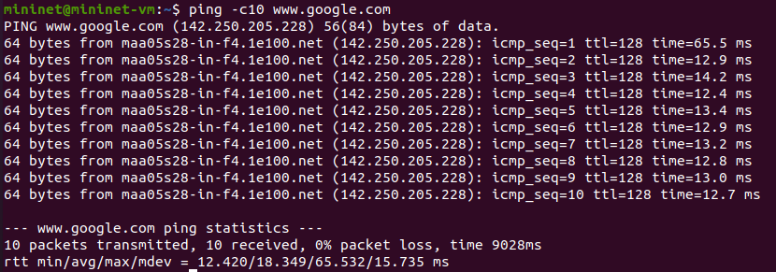

finally we make conclusions that the average latency between mininet and the respective sites is in the order

[www.google.com](http://www.google.com) < [www.stanford.com](http://www.stanford.com) < www.rudgers.edu

here [www.rudgers.edu](http://www.rudgers.edu) has the highest average latency and network delay. hence its lag is the highest and [www.google.com](http://www.google.com) has the least delay or lag. [www.stanford.com](http://www.stanford.com) falls very close to [www.google.com](http://www.google.com) in terms of network latency or lag.

PART B

1. Print the MAC address of host h1. Print the MAC addresses of switch s1. Explain the different interfaces that s1 has
2. MAC address of host h1:

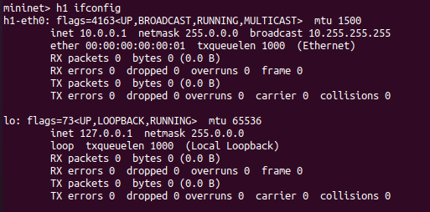

1. MAC address of host s1 (contained in s1 section, in flags) and different interfaces that s1 has (the interfaces are eth0, eth1, and eth2):

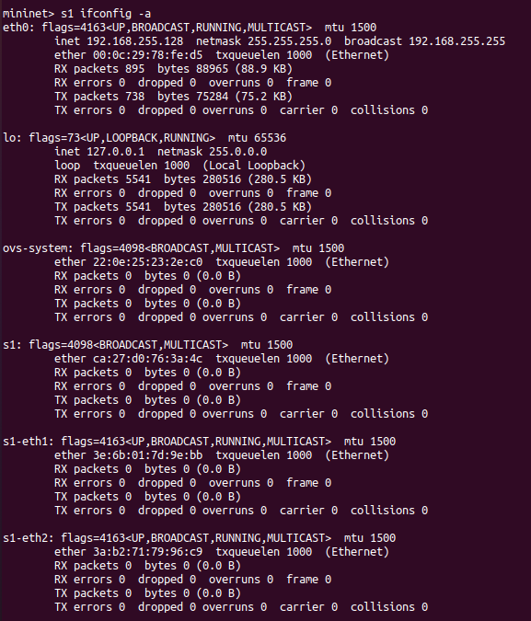

1. The ‘ping’ command lets us ping h1 from h2. to view the ARP entries, we can observe the ping statistics column where we can see that h1’s IP address to MAC address is stored in the ARP entry table of h2. to view this table we use the ‘h1 arp -a’ command. and this same logic works vice-versa too.

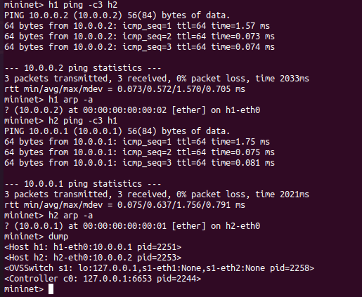

3. The following screenshot shows the TCP throughput from h1 to h2. We observe that the bandwidth between h1 and h2 is 19.8 Gbits/sec



