**Steps followed:**

1. Mininet was imported from *.ovf* file and installed in VMware Workstation Player.
2. Ubuntu VM was booted from VMware Workstation Player
3. Logged into Mininet

**Pre-question Trials**

Mininet is a network emulator which creates a network of virtual hosts, switches, controllers, and links. Mininet hosts run standard Linux network software, and its switches support OpenFlow for highly flexible custom routing and Software-Defined Networking.

To experiment with the network, we need to *ssh* into the Mininet VM. We get the IP address of the VM by entering *ifconfig* on the Mininet terminal. Also pass the -X option to open an *xterm* interface to use terminals of different hosts in the network on our Ubuntu VM.

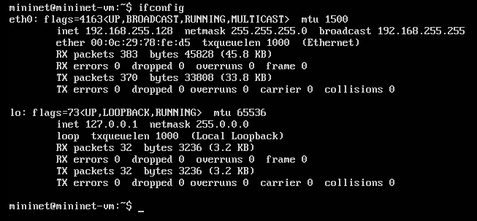

To start interacting with the network we initiate the network using command ‘*sudo mn’.* The network simulated by this command is of Mininet’s default minimal topology which looks like:

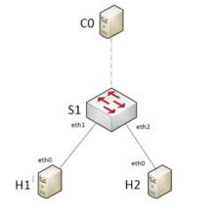

*Mininet’s minimal topology*

ping:

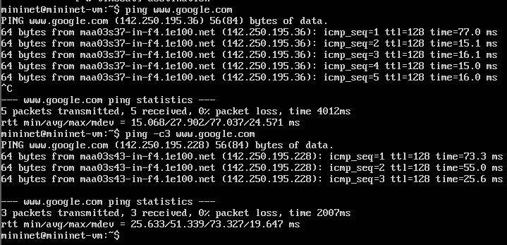

arp: Using the arp command allows **you to display and modify the Address Resolution Protocol (ARP) cache**

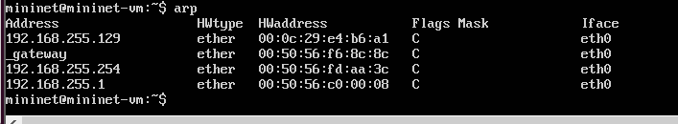

nslookup: Nslookup (stands for “Name Server Lookup”) is a **useful command for getting information from DNS server**.

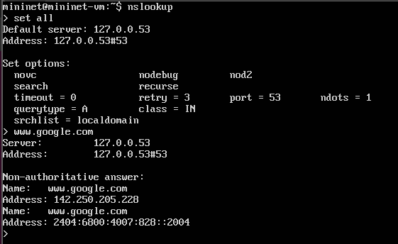

Whois: Whois is a **widely used Internet record listing that identifies who owns a domain and how to get in contact with them**.

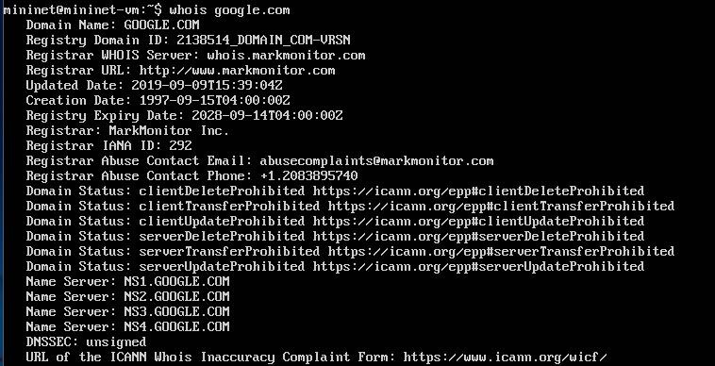

Traceroute: Traceroute is **a command that runs tools used for network diagnostics**. These tools trace the paths data packets take from their source to their destinations, allowing administrators to better resolve connectivity issues.

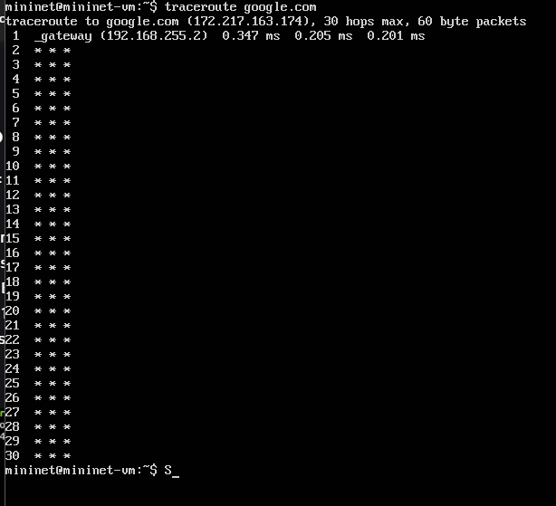

hostname: Get or set hostname or DNS domain name

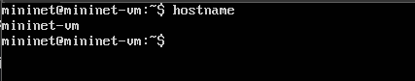

route: In computing, route is a command used to view and manipulate the IP routing table in Unix-like and Microsoft Windows operating systems and also in IBM OS/2 and ReactOS.

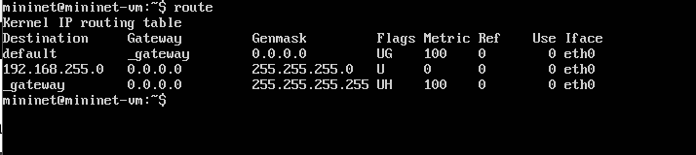

netstat: In computing, netstat is a command-line network utility that displays network connections for Transmission Control Protocol, routing tables, and a number of network interface and network protocol statistics.

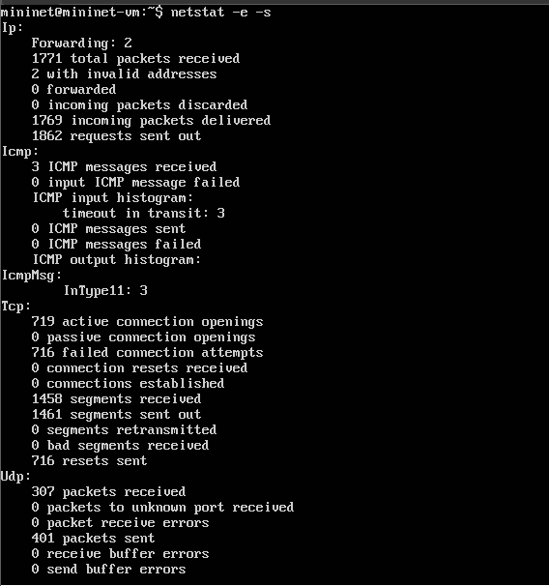

tcpdump: tcpdump is a packet analyzer that is launched from the command line. It can be used **to analyze network traffic by intercepting and displaying packets that are being created or received by the computer it's running on**.

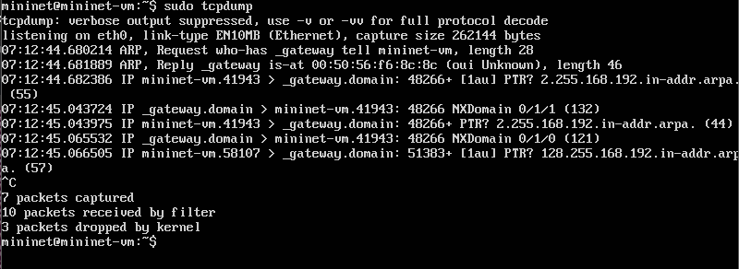

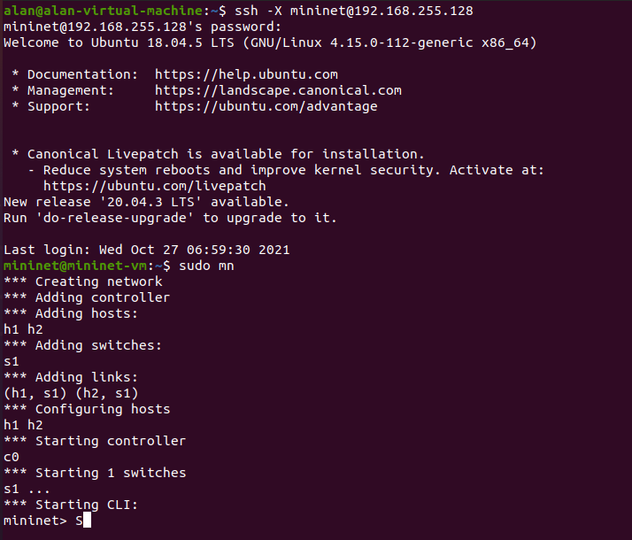

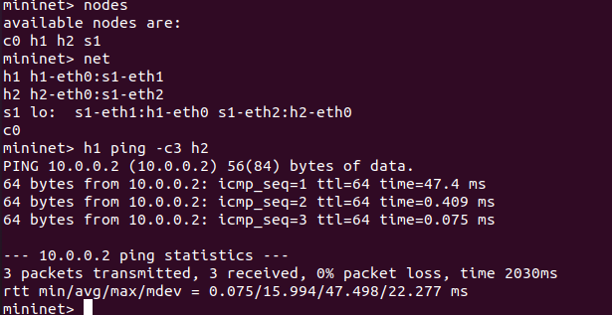

PART A

1. IP addresses:

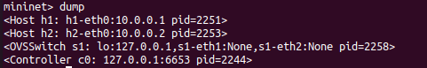

1. MAC addresses and interfaces (obtained with *ifconfig*)
2. h1

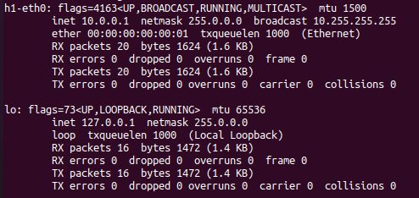

1. h2

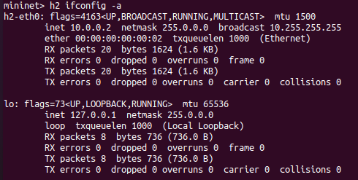

1. c0

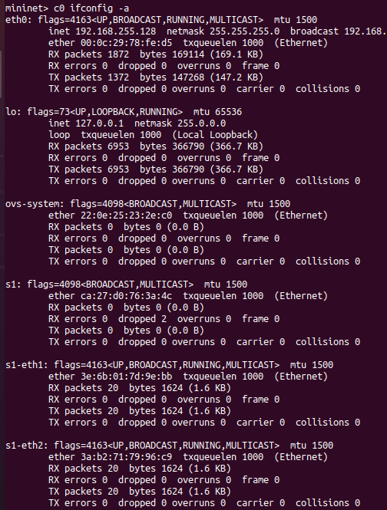

1. s1

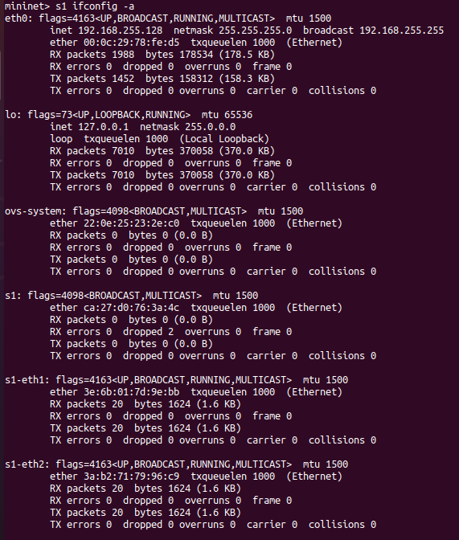

1. Calculate the latency between mininet vm and www.rutgers.edu for 10 packets. Repeat the result for stanford.edu and www.google.co.in and compare the difference in latency

PART B

1. Print the MAC address of host h1. Print the MAC addresses of switch s1. Explain the different interfaces that s1 has
2. MAC address of host h1:

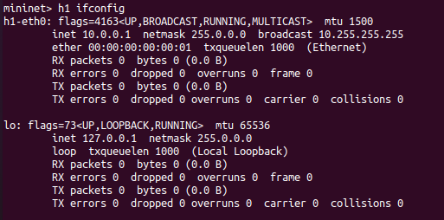

1. MAC address of host s1 (contained in s1 section, in flags) and different interfaces that s1 has (the interfaces are eth0, eth1, and eth2):

