## Planning Website

This website is a daily task planning and project management website, which allow you to plan and manage your daily tasks and to manage team projects. etc.

## Entities and Roles

* Some terms and definitions:
  + **Board:** is where your tasks are.
  + **Task:** is the work or duty you want to do.
  + **Status:** are the states in which the tasks are going through.
  + **Label:** are the tags or the texts that associated with tasks. Example: important, personal, family. etc.
* The picture below shows a board that includes statuses, tasks and labels:

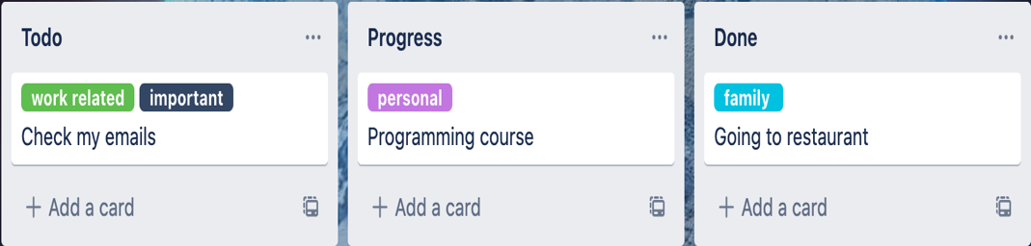

* **Board**:

**Statuses:** Aboard can have, to-do, in-progress, dev-review, testing, done and close statuses.

**User roles:**

1. **Product Owner**
   * + Can do CRUD on boards.
     + Can do CRUD on tasks.
     + Can do CRUD on labels.
     + Can update the status of tasks from any status to another in a team board.
     + Can assign tasks.
     + Can view task logs (task status changes done by users).
2. **Developer**
   * + Can see all the tasks assigned to him/her.
     + Can only move their tasks from to-do to in-progress and in-progress to testing on the board.
3. **Tester**
   * + Can see all the tasks assigned to him/her.
     + Can only move the task from testing to dev-review on the board.

## Program features

* The program should allow users to first create an account.
* The program should allow users to log into his account.
* The program should allow users to create boards, statuses, tasks and labels. each board can have one or more statuses, the tasks will move from one status to another.
* A task will have a title, description, image, and due date and current status.
* Each task can have one or more labels associated with.
* Each task should have one assignee.
* The program should allow user to search through his/her tasks.
* The program should allow user to filter his/her tasks based on labels associated.
* The program should allow user to sort his/her tasks according to one of the below:
* By task name in ascending or descending order.
* By created date (from oldest to newest or vice versa)
* Task status changes should be logged into the database like below:  
  *Example:*

*User Name: Aram.*

*Action: Status Change.*

*Detail: Change status from testing to dev-review.*

* The program should allow user to see the saved logs for a specific task.

## Required

* You are only in charge of implementing the backend of this project. (APIs).
* The project should be implemented using Laravel PHP framework and MySQL as DBMS.
* Using postman: structure all your APIs in postman and export the collection and include it in the root of your project while pushing to GitHub.
* Fork the below GitHub repo and create your project on it:

<https://github.com/jihadadulrazaqjasim/planning-app>

## Nice to have:

* Unit/Feature testing.
* Deploying your code on a free hosting service.
* Dockizing your app.

## What’s important for us?

* Your coding style.
* OOP.
* Good database design.
* API structure.