CONTINUOUS INTERNAL ASSESSMENT — 3 (CIA-3) PROJECT REPORT
DineFlow: Multi-Branch Restaurant Management & Table Reservation System
Course: Advanced JavaScript Backend Frameworks (Node.js & Express JS) • Semester: 5th Semester
Institution: Department of Computer Science, Christ University (in partnership with L&T EduTech)
Project Code & Title: | P07 — Multi-Branch Restaurant Management & Table Reservation System
Batch / Section: | Batch 47 (4)
Submission Date: | September 10, 2026 (Deadline: September 12, 2026)
Technology Stack: | Node.js, Express.js (v4.21), MongoDB (Mongoose v8.6), JWT, bcryptjs, Bootstrap 5

Mandatory Team Details
S.No | Student Name | Roll No. / Reg No. | Department | Section / Batch
1 | ALAN R S (Lead Developer) | 2247101 | Computer Science | Batch 47 (4)
2 | Team Member 2 | 2247102 | Computer Science | Batch 47 (4)
3 | Team Member 3 | 2247103 | Computer Science | Batch 47 (4)
4 | Team Member 4 | 2247104 | Computer Science | Batch 47 (4)

🔗 Mandatory GitHub Repository Link:
https://github.com/Alan-rs-hub/L-T_Project_Restaurant_management
Local Server URL: http://localhost:5001 | REST API Base: http://localhost:5001/api

1. Executive Summary & Problem Overview
Modern multi-branch restaurant establishments face severe operational bottlenecks when relying on disparate, disconnected tools for table bookings, dynamic food order processing, itemized billing, and kitchen routing. Standard standalone software often fails to enforce strict business invariants—such as preventing table overbooking, blocking unauthorized order status jumps, and computing unalterable server-side financial calculations.
DineFlow is an enterprise-grade Restaurant Management and Table Reservation platform engineered strictly adhering to the Model-View-Controller (MVC) architectural pattern. It eliminates human coordination errors by introducing an automated table conflict detection engine, a finite state machine for kitchen queues, and server-controlled itemized billing.
Role-Based Access Control (RBAC) User Personas:
• Customer: Browse branch menus, check real-time table availability, make/cancel reservations, place dine-in/takeaway food orders, view itemized bills, and submit star ratings.
• Kitchen Staff: Real-time Kitchen Display System (KDS) 3-stage board (Placed → Preparing → Ready) with audio chimes and state advancement buttons.
• Branch Manager: Menu management, stock toggling, sales aggregations, popular dishes ranking, and peak hours analysis.
• System Administrator: Multi-branch CRUD, table inventory allocations, system-wide revenue reports, and platform oversight.
2. System Architecture & Technology Stack
Component Layer | Technology / Framework | Purpose & Implementation Specifics
Backend Runtime | Node.js (v16+) & Express (v4.21.0) | REST API service, routing, middleware chaining, static client serving
Database & ODM | MongoDB & Mongoose (v8.6.0) | Normalized document storage, compound indexing, pre-save hooks
Authentication | JWT (jsonwebtoken) & bcryptjs (12 rounds) | Stateless token auth and secure salted password hashing
Request Validation | Joi (v17.13.3) Middleware | Strict schema validation for all incoming request payloads & query params
Logging & CORS | Morgan & CORS | HTTP request logging and cross-origin resource access control
Frontend Client | HTML5, CSS3, JS ES6+, Bootstrap 5 | Dark glassmorphism UI with live cart drawer, booking flow, and KDS board
Zero-Config DB | mongodb-memory-server | Automated embedded MongoDB fallback for instant zero-dependency evaluation

3. Database Design & Mongoose Schemas (All 7 Models)
The database design consists of 7 normalized collections linked via ObjectId references, enforced with compound indexes for performance and business validation:
Model Name | Key Attributes & Types | Indexes, Constraints & Business Rules
User | name (Str), email (Str), passwordHash (Str), role (Enum: customer/kitchen/manager/admin) | Unique email; bcrypt 12-round hashing hook; password stripped on toJSON serialization
Branch | name (Str), address (Str), seatingCapacity (Num), isActive (Bool) | Unique branch naming; active status query index
Table | branchId (Ref: Branch), tableNumber (Num), capacity (Num), isActive (Bool) | Compound unique index { branchId: 1, tableNumber: 1 } prevents duplicate table numbers
MenuItem | branchId (Ref: Branch), name (Str), category (Enum 8 types), price (Num), isAvailable (Bool) | Category enum (appetizer, main_course, dessert, beverage, side, soup, salad, special); compound index
Reservation | customerId (Ref), branchId (Ref), tableId (Ref), dateTime (Date), duration (Num), partySize (Num), status (Enum) | Index on tableId + dateTime + status for real-time overlap conflict queries; status enum
Order | orderNumber (Str), customerId (Ref), branchId (Ref), items [orderItemSchema], billing {}, orderType, status | Unique orderNumber (ORD-<ts>-<rand>); embedded billing subdocument; status workflow state enum
Feedback | orderId (Ref: Order), customerId (Ref: User), rating (Num 1-5), comment (Str) | Compound unique index { orderId: 1 } strictly enforces 1 review per completed order

4. Implemented Functional Modules (All 13 Modules)
# | Module Name | Primary Role | Implementation & Validation Logic
1 | User Authentication & RBAC | All Roles | JWT Bearer token generation, bcrypt 12-round salted hashing, role authorization middleware (customer, kitchen, manager, admin).
2 | Branch Management | Admin | CRUD operations on physical restaurant branches with seating capacity tracking and active status toggling.
3 | Table Inventory Management | Admin | Table allocations per branch with seating capacities; compound unique index prevents duplicate table numbers.
4 | Menu & Category Management | Admin, Manager | Branch-specific dish catalogs across 8 categories; live stock availability toggling and text search.
5 | Real-Time Table Reservation | Customer | Automated table conflict/overlap detection algorithm: (start < existEnd && end > existStart). Party size capacity check.
6 | Food Ordering System | Customer | Dine-in and takeaway food ordering with live stock availability and branch affinity validation.
7 | Order State Machine | Kitchen, Manager | Strictly enforced state transitions: placed → preparing → ready → served / delivered. Cancel only allowed in placed state.
8 | Kitchen Display (KDS) | Kitchen Staff | 3-column live queue board, 10-second auto-refresh, and synthesized Web Audio chime alert on new incoming orders.
9 | Itemized Billing Engine | System Engine | Server-side deterministic calculation: Subtotal + 5% Tax + 10% Service Charge = Grand Total. Zero client trust.
10 | Cancellation Policy | Customer, Admin | 1-hour advance notice policy enforced on customer cancellations; admin retains override authority.
11 | Order History & Tracking | Customer | Chronological itemized invoices, real-time status badges, and receipt downloads.
12 | Feedback & Reviews | Customer | 1-5 star ratings & reviews allowed exclusively on completed orders (served/delivered); duplicate reviews blocked.
13 | Manager Analytics | Manager, Admin | MongoDB aggregation pipelines: Revenue by branch, top 5 dishes ranking, peak activity hours, and KPI overview.

5. Core Business Rules & Validation Logic
1. Table Double-Booking Prevention: Overlap query: (newStart < existingEnd) && (newEnd > existingStart). Rejects conflicting slots with 409 RESERVATION_CONFLICT.
2. Finite Order State Machine: Transitions strictly follow: placed → [preparing, cancelled], preparing → [ready], ready → [served, delivered]. Skips return 409 INVALID_STATUS_TRANSITION.
3. 1-Hour Cancellation Window: Customers cannot cancel reservations less than 60 minutes before scheduled booking time (returns 409 CANCELLATION_POLICY).
4. Server-Side Itemized Billing: Deterministic math computed exclusively on the server in utils/calculations.js: Subtotal + 5% Tax + 10% Service Charge.
6. Key REST API Endpoint Reference Catalog
Endpoint Route | Method | Auth Guard | Description & Response Summary
/api/auth/register | POST | Public | Registers new user; returns JWT token & user profile
/api/auth/login | POST | Public | Authenticates credentials; returns JWT bearer token
/api/branches | GET / POST | Public / Admin | Lists active branches / Creates new restaurant branch
/api/tables/available | GET | Authenticated | Queries available tables matching branch, date, time, party size
/api/menu | GET / POST | Public / Mgr, Admin | Catalog search & category filter / Creates menu dish item
/api/reservations | GET / POST | Authenticated | Lists bookings / Books table with overlap conflict validation
/api/reservations/:id | DELETE | Customer, Admin | Cancels reservation enforcing 1-hour notice policy
/api/orders | POST / GET | Authenticated | Places food order with server billing / Lists order history
/api/orders/:id/status | PUT | Kitchen, Admin | Advances order workflow state (placed → preparing → ready)
/api/kitchen/orders | GET | Kitchen, Admin | Live real-time queue for placed, preparing, and ready orders
/api/feedback | POST / GET | Customer | Submits 1-5 star review for completed (served/delivered) orders
/api/manager/reports/sales | GET | Manager, Admin | Aggregates revenue, order counts, and avg values by branch

7. Verified Application UI Showcase
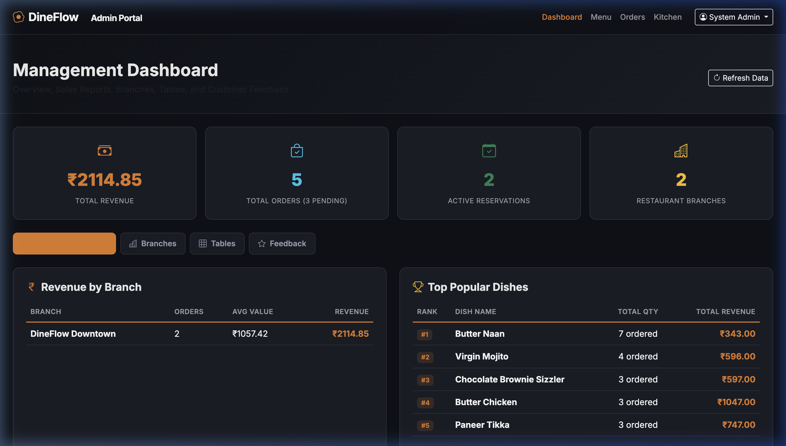
Figure 1: Admin Analytics & Revenue Dashboard (Live KPI Counters, Charts, and Tabbed Views)
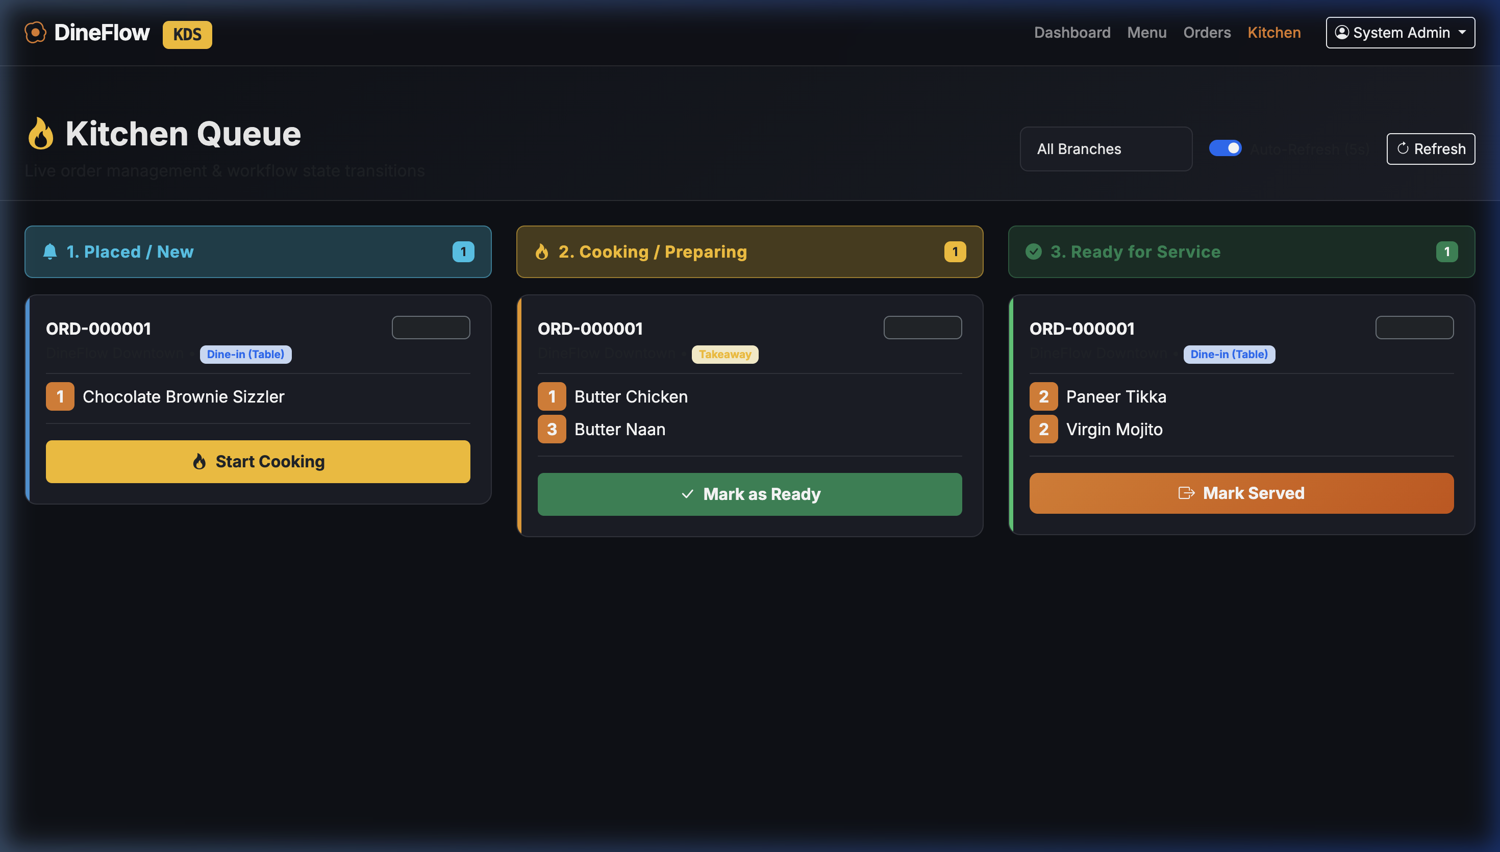
Figure 2: Real-Time 3-Stage Kitchen Display System (KDS) Board with Status Transitions

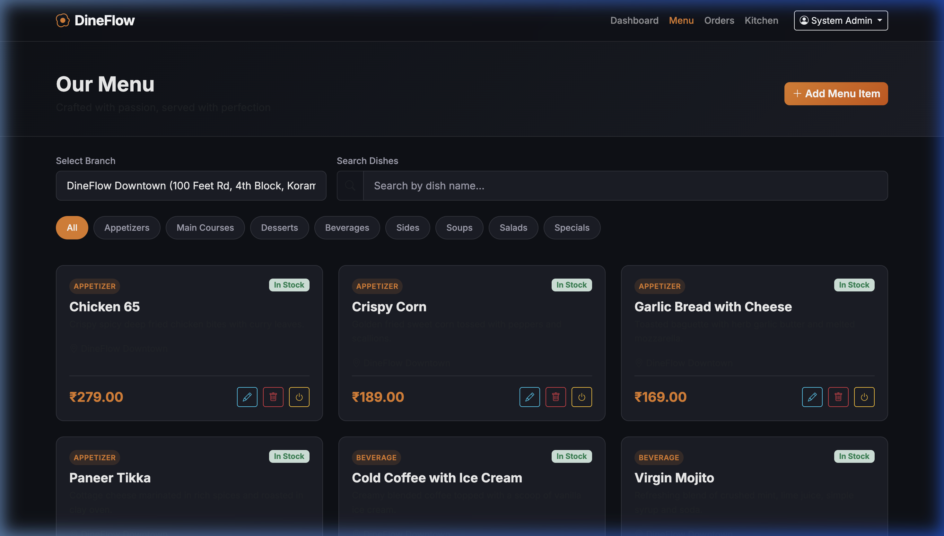
Figure 3: Interactive Food Menu Catalog with Branch Filters, Category Pills, and Live Cart Drawer
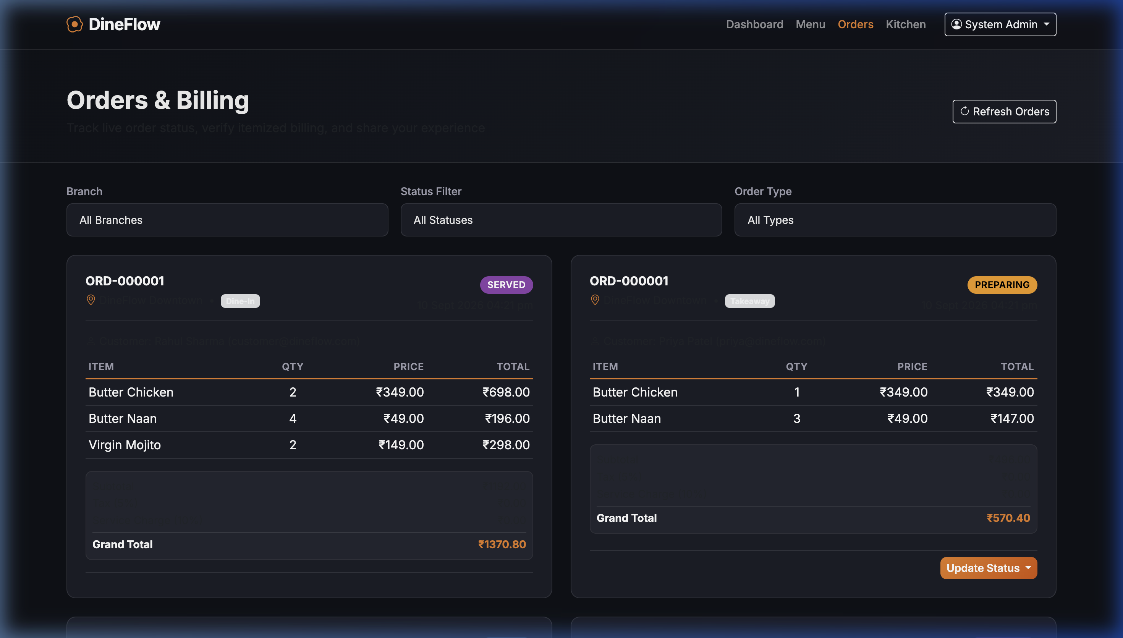
Figure 4: Order History, Itemized Billing Invoices, and Customer Experience Feedback Modal
8. Setup, Execution Guide & Pre-Configured Demo Accounts
Step 1: Install Dependencies: npm install
Step 2: Seed Demo Database: npm run seed (Populates realistic branches, tables, menu, reservations, orders, feedback)
Step 3: Start Application Server: npm start (Live at http://localhost:5001)
Role | Email Address | Password | Accessible Features & Capabilities
Admin | admin@dineflow.com | admin123 | Full dashboard, branch/table CRUD, sales analytics, menu & orders
Manager | manager@dineflow.com | manager123 | Sales reports, popular dishes ranking, peak hours, KDS access
Kitchen Staff | kitchen@dineflow.com | kitchen123 | Live Kitchen Display System (KDS) & order queue advancement
Customer 1 | customer@dineflow.com | customer123 | Table reservation booking, food cart ordering, order history, reviews
Customer 2 | priya@dineflow.com | customer123 | Table reservation booking, food cart ordering, order history, reviews

Submitted for Continuous Internal Assessment - 3 (CIA-3)
Department of Computer Science • Christ University • Academic Year 2026
Official GitHub Repository: https://github.com/Alan-rs-hub/L-T_Project_Restaurant_management

