1. Look at the basic structure of the sketch and Label the different components.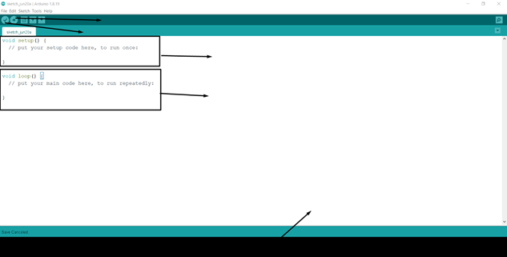

* The program is completed by the first function which is in the arrow.
* The codes are uploaded to the Arduino by the second function which is in the arrow.
* The arrow pointing to the third function is the setup function, which is the Arduino program's starting point and only executes once.
* The fourth arrow represents the second function, which is required for the program to operate and is instantly switched off of Arduino.
* The fifth function in the arrow represents the area that reveals whether or not the code was successfully compiled and executed.

2. Using **void setup()** and **void loop()** function write a program to light up a LED.

**//Program turn on LED**

**//LED Connected to pin 13**

**void setup() {**

**// put your setup code here, to run once:**

**// initialize pin 13 as output**

**pinMode(LED_BUILTIN,OUTPUT);**

**}**

**void loop() {**

**// put your main code here, to run repeatedly:**

**//Turn on LED at Pin 13**

**digitalWrite(LED_BUILTIN,HIGH);**

**}**

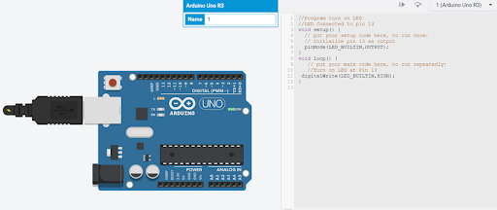

3. Declare and initialize the variable to turn on the LED. Use the code from the previous question to change the program.

**//Program turn on LED**

**//LED Connected to pin 13 declaring a variable**

**int led = LED_BUILTIN;**

**void setup() {**

**// put your setup code here, to run once:**

**// initialize pin 13 as output**

**pinMode(led,OUTPUT);**

**}**

**void loop() {**

**// put your main code here, to run repeatedly:**

**//Turn on LED**

**digitalWrite(led,HIGH);**

**}**

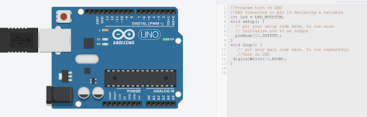

4. Write a program to use delay() function to make a blinking LED.

**//delay(milliseconds)**

**//Program to BLink LED Connected at Pin 6**

**void setup() {**

**pinMode(6,OUTPUT); // initialize pin 6 as output pin**

**}**

**void loop() {**

**digitalWrite(6,HIGH); //turn on lED at pin 6**

**delay(1000); //delay 0f 1 sec**

**digitalWrite(6,LOW); //turn OFF the LED at pin 6**

**delay(1000); //delay of 1 sec**

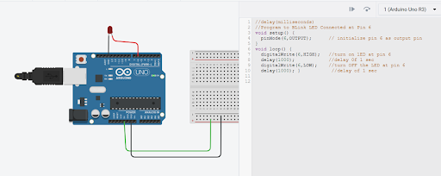

5. Write a program using **“for loop”** to blink LED for a certain number of iterations.

**//Program to blink 2 LEDs**

**//red LED connected to pin 11**

**//initilize variable as output pins**

**int rled = 11;**

**Int gled=12;**

**void setup()**

**{**

**//initialize pins**

**pinMode(rled,OUTPUT);**

**pinMode(gled,OUTPUT);**

**}**

**void loop()**

**{**

**//blink red LED 5 times**

**for(int i=0;i<5;i++)**

**{**

**digitalWrite(rled,HIGH);**

**delay(1000);**

**digitalWrite(rled,LOW);**

**delay(1000);**

**}**

**}**

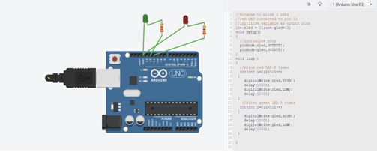

6. Now, change the same program as **number 5** using **“while and do-while loop”**.

//Program to blink 2 LEDs

//red LED connected to pin 11

//initilize variable as output pins

int rled = 11;

int gled=12;

void setup()

{

//initialize pins

pinMode(rled,OUTPUT);

pinMode(gled,OUTPUT);

}

void loop()

{

//blink red LED 5 times

int iCount = 0;

while (iCount <5)

{

digitalWrite(rled,HIGH);

delay(1000);

digitalWrite(rled,LOW);

delay(1000);

iCount = iCount + 1;

}

//blink green LED 5 times

int iCount2 = 0;

while (iCount2 <5)

{

digitalWrite(gled,HIGH);

delay(1000);

digitalWrite(gled,LOW);

delay(1000);

iCount2 = iCount2 +1;

}

}

//Program to blink 2 LEDs

//red LED connected to pin 11

//initilize variable as output pins

int rled = 11;

int gled=12;

void setup()

{

//initialize pins

pinMode(rled,OUTPUT);

pinMode(gled,OUTPUT);

}

void loop()

{

//blink red LED 5 times

int iCount = 0;

do {

digitalWrite(rled,HIGH);

delay(1000);

digitalWrite(rled,LOW);

delay(1000);

iCount = iCount + 1;

}

while (iCount <5);

//blink green LED 5 times

int iCount2 = 0;

do {

digitalWrite(gled,HIGH);

delay(1000);

digitalWrite(gled,LOW);

delay(1000);

iCount2 = iCount2 +1;

}

while (iCount2 <5);

}

