Tutorial -1

1. Find the value of the given resistors.

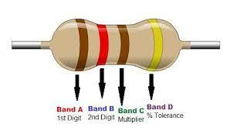

|  |  |  |  |  |
| --- | --- | --- | --- | --- |
| Brown | Red | Brown | Yellow | |
|  | | Multiplier | Tolerance | |
| 1 | 2 | 10 Ω | +/- 0% | |
| Soln,  =12*10 Ω +/- 0%  =12 Ω +/- 0% | | | | |
| =12Ω + 0/100*100  =12Ω | | | | =12Ω - 0/100*100  =12Ω |

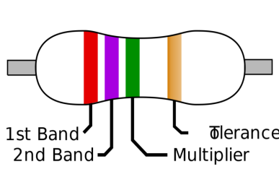

|  |  |  |  |
| --- | --- | --- | --- |
| Red | Purple | Multiplier | Tolerance |
| Green | Orange |
| 2 | 7 | 100kohm | +/-0 |
| Calculation:  =27*100 kohm +/- 0  = 2700 ohm +/-0 | | | |

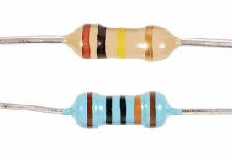

|  |  |  |  |
| --- | --- | --- | --- |
| Brown | Black | Multiplier | Tolerance |
| Yellow | Yellow |
| 1 | 0 | 10 kohm | 5%gold |
| Calculation:  =1*10 kohm +/- 5% gold  = 10 kohm +/- 5% gold | | | |

|  |  |  |  |  |
| --- | --- | --- | --- | --- |
| Brown | Black | Black | Multiplier | Tolerance |
| Orange | Brown |
| 1 | 0 | 0 | 1k ohm | +/- 1% of brown |
| Calculation:  =100*1 kohm +/- 1%  =100 kohm +/- 1% | | | | |

1. Calculate the value of equivalent resistor in the given figures.

R1=20ohm R2=20ohm R3=30Ω R4=30Ω

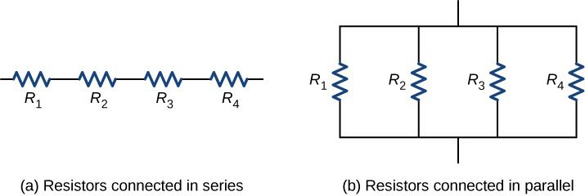

Given,

R1 = 20Ω R3 = 30Ω

R2 = 20Ω R4 = 30Ω

Soln,

1. Rs=R1+R2+R3+R4 = 20+20+30+30=100 Ω
2. R*1/P=1/R1+1/R2+1/R3+1/R4=1/20+1/20+1/30+1/30=6 Ω
3. An electronic circuit has a voltage source of 5v and a resistor of 100 ohm. Calculate the current across the circuit.

Soln,

Voltage(V)= 5V

Resistor(R)=100Ω

Current(I)=?

Now,

I=V/R=5/100=0.05A

1. A battery with a terminal voltage of  9V is connected to a circuit consisting of four 20 ohm and one 10 ohm resistors all in series. (a) Calculate the equivalent resistance of the circuit. (b) Calculate the current through each resistor. (c) Calculate the potential drop across each resistor. (d) Determine the total power dissipated by the resistors and the power supplied by the battery.

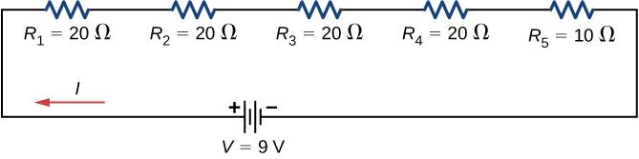

Given,

R1,R2,R3,R4=20 Ω

R5=10 Ω

1. Req = R1+R2+R3+R4+R5=20+20+20+20+10=90 Ω
2. I= v/ Req=9/90=0.1A
3. V1=R1*I=20*0.1=2V

V2=R2*I=20*0.1=2V

V3=V4=2V

V5=R5*I=10*0.1=1V

1. P=V1234*I=2*0.1=0.2

P=V5*I=1*0.1=0.1

Total power= 0.9w

1. Three resistors  R1=1Ω, R2=2Ω, and R3=3Ω are connected in parallel. The parallel connection is attached to a 3V voltage source. (a) What is the equivalent resistance? (b) Find the current supplied by the source to the parallel circuit. (c) Calculate the currents in each resistor and show that these add together to equal the current output of the source. (d) Calculate the power dissipated by each resistor. (e) Find the power output of the source and show that it equals the total power dissipated by the resistors.

Given,

R1=1 Ω v=3V

Soln,

1. R2= 2 Ω

R3= 3 Ω

Req= 1/1+1/2+1/3=6/11

1. I= V/R =3/6/11=5.55A
2. I1= V/R1=3/1=3A

I2= V/R2=3/2=1.5A

I3= V/R3=3/3=1A[I1+I2+I3=5.5A]

1. P=V*I=3*5.5=16.5W

P1=V*I1=3*3=9W

P2=V*I2=3*1.5=4.5W

P3=V*I3=3*1=3W[P=P1+P2+P3=16.5W]

1. P1+P2+P3=16.5W

P=16.5W

1. Find the overall capacitance and the individual rms voltage drops across the following sets of two capacitors in series when connected to a 12V AC supply.
2. two capacitors each with a capacitance of 47nF

1/ct=1/c1+1/c2=23.5nf

V1=ct/c1*12v

23.5/47)*12=6volts

b)  one capacitor of 470nF connected in series to a capacitor of 1μF

soln,

1/ct=1/c1+1/c2+1/470+1/1000=319.72nf

V1=Ct/470*12V=8.1V

V2=Ct/1000*12V=3.8V