

4CS016 - Embedded Systems Programming

8x8x8 LED Cube



# Uni ID: 2329767

# Submitted by: Alan Shah

# Group: L4CG5

Module leader name: Mr. Subas Bista

Lecture name: Mr. Sulove Bhattarai

Word Count: 1829

Date of Submission: 5/17/2023

## Acknowledgement

My sincere appreciation goes out to Mr. Subash Bista, the module leader, for allowing me the chance to learn more about the module by working on this project called the 8x8x8 Led Cube. I would especially want to thank Mr. Raj Pradhan and our mentor Mr. Sulove Bhattrai for their time and effort throughout the year. I found their recommendations and assistance to be helpful for completing the project.

Contents:

1. Introduction to 8x8x8 LED Cube: 1

2. Tools Used: 2

I. 512 LEDs (5mm): 2

II. 220ohm Resistors – 64pc: 2

III. Shift Resistor – 74HC595 – 10pc: 2

IV. Soldering Iron: 2

V. Copper Wire: 2

VI. Prototype Circuit Board: 3

VII. Jumper Wire: 3

VIII. Arduino UNO: 3

IX. 16 Pin IC Base – 9 pc: 3

X. Transistor 2222A - 16 pc: 3

3. Working Principle: 4

4. Circuit Diagram & Fritzing Schematic: 5

5. Programming: 6

6. Testing: 18

7. Conclusion: 20

8. References 21

Figure 1 Fritzing Schematic 5

Figure 2 Circuit Diagram 5

Figure 3 Step 1 18

Figure 4 Step 2 18

Figure 5 Step 3 19

# Introduction to 8x8x8 LED Cube:

Electronic displays have become increasingly popular in recent years, both for business and personal usage. This has resulted in the creation of matrix display systems that make use of LEDs or LCDs. These systems may show messages, pictures, logos and even animations, all of which can fascinate and interest any audience. Consider a cube comprised of 512 LEDs placed in a 3D layout like a Rubik’s cube. The cube is built with a wire structure and soldered LED connections. Each LED is controlled by three wires, one for the anode and two for the cathode, allowing each LED to be controlled independently. A universal serial bus cord or additional energy source supply can be used to power the cube. To program the cube, connect the microcontroller to a computer and write code to control the individual LEDs. The LED cube is a popular DIY electronics project that takes basic electronics and programming experience. It may be utilized for a variety of functions, including decorating, visual presentations, and instructional purposes.

# Tools Used:

## 512 LEDs (5mm):

When current is passed through an LED it produces light. It can be found in red, green, blue, and yellow colors. Mostly they are used in projects as signals or to give visual aspect to the project. A semiconductor light source with two leads is referred to as a light-emitting diode. The p-n junction diode emits light when energized. When the leads get the right voltage, the device's electrons can recombine and discharge energy in the form of photons. (Jain, 20)

## 220ohm Resistors – 64pc:

The movement of electricity encounters resistance as it passes through a resistor, which is a passive electrical component. In all electrical networks and electronic circuits, they can be found. Ohms is a unit of measurement for resistance. When a resistor experiences a voltage drop of one volt (V) between its terminals and a current of one ampere (A), the resistance that results in is measured as an ohm. Current flow is controlled by the voltage at the terminal ends. (eepower, 2023)

## Shift Resistor – 74HC595 – 10pc:

It is an integrated circuit which has sixteen pins and is composed of a D-type latch and a shift resistor. It takes serial data and delivers it through parallel pins. It additionally features parallel and serial outputs, and both the shift resistor and the D latch have clock inputs. It is a part of the HC series of logic devices designed for CMOS applications. It has internal registers, including a shift register and a storage register, into which data is loaded one bit at a time and then it is sent to the storage unit only when the data latch pin is enabled. (Utmel electronics, 2023)

## Soldering Iron:

The use of a soldering iron is an essential component of the soldering process. The soldering iron is made up of an insulated body and a high-temperature tip designed to melt solder. Although there are many diverse types of soldering irons, electrically powered models dominate the market. The primary function of the soldering iron is to deliver the increased temperature required to liquefy the solder. After the soldering process is completed, the solder is allowed to cool and solidify naturally, a process that can be accomplished at room temperature. The resultant solidification creates a long-lasting, conductive link that remains intact until the solder is heated again. (Ligiting Equiptment Sale, 2023)

## Copper Wire:

Copper wire is a basic electrical conductor that has several applications in home, commercial, and industrial settings. It is often made up of one or more strands of pure copper that have been coated with various insulating materials such as PVC, PE, PP, PUR, or PTFE. Such insulation is required to avoid short-circuiting and electrical fires caused by arcing between wires in a circuit. The pervasiveness of copper wire underscores its important function as a basic component in the electrical systems that pervade modern life. (rs-online, 2023)

## Prototype Circuit Board:

PCB prototypes are basic circuit boards that serve as an evaluation tool for circuit designs prior to finalization and large-scale manufacture. These boards are used to assess a design's feasibility, efficacy, and performance. Designers may save time and money by studying and improving their ideas on a PCB prototype board before pursuing costly manufacturing processes. PCB prototype boards are a crucial component of the product development process since they allow for a full examination of the design's efficacy and viability. (ElectronicSolvers, 2023)

## Jumper Wire:

An electrical conductor called a jumper wire is used to link several circuits on printed circuit boards. When connected to a circuit, a jumper wire can create a short circuit with another electrical circuit. This capacity allows for the manipulation of electric current, the halting of circuit activities, and the activation of circuits that may not operate well via standard wiring methods. Thus, jumper wires provide an important avenue for designing and improving electronic circuits, which contributes to the overall efficiency and effectiveness of electronic devices. (showa-seisen, 2023)

## Arduino UNO:

The ATmega328P is the heart of the micro controller board Arduino Uno. Six of the total fourteen digital input/output pins on the Arduino Uno can be used as pulse-width modulation (PWM) outputs. Six analog inputs, a 16 MHz ceramic resonator (CSTCE16M0V53-R0), a USB port for communication, a power connector, an ICSP header for programming, and a reset button are all included on the board. The microcontroller on the board may be powered instantly by connecting it to a computer through USB or by using an AC-to-DC converter or battery. One of the advantages of the Arduino Uno is its ease of use, which allows for experimenting with little concern of creating irrevocable harm. If required, the microcontroller chip may be easily replaced, allowing for a fresh start in the testing process. (Arduino, 2023)

## 16 Pin IC Base – 9 pc:

16 Pin IC A socket base adaptor is a 16-pin IC holder that may be soldered right to the PCB. When necessary, the IC can be removed from this socket. When used, the IC is inserted into the socket. This base serves as a detachable IC holder. When the IC is temperature sensitive and the heat from the soldering iron might harm the IC, the socket is employed. This socket is utilized when working with a microcontroller IC and may be taken out to be programmed. (ROBU.IN, 2023)

## Transistor 2222A - 16 pc:

The 2N2222A transistor is a typical NPN BJT and is mostly utilized in applications that need switching and low-power amplification. The major applications for this transistor are low power, low to medium current, medium voltage, and fast speeds. For applications requiring low to medium current, the 2N2222A transistor, which has a constant DC collector current of 800mA, must be used. It operates at a high transition frequency of 250MHz with delay times of 10ns, 225ms, 60ms, and 25ms during the rise and fall of the transition. In the TO-92 package, it is offered. (elprocus, 2023)

# Working Principle:

Controlling a three-dimensional matrix of LEDs to produce different patterns and animations is the basic idea behind an 8x8x8 LED cube powered by an Arduino Uno. The 512 individual LEDs are grouped in an 8x8x8 matrix to create the LED cube. A single display pixel is represented by each LED in the total display.

The LEDs are effectively controlled via multiplexing. Eight horizontal planes make up each of the cube's layers, which are separated into those layers. Using a quick cycle across each individual plane in a layer, the multiplexing process successively turns on each layer one at a time.

Shift registers are frequently employed to increase the number of output pins that are accessible on the Arduino Uno. Shift registers function as serial-to-parallel converters, allowing numerous LEDs to be controlled with fewer pins. To operate the eight levels of an 8x8x8 LED cube, at least nine shift registers are needed, plus one more pin for plane selection.

Programming: To operate the LED cube, the Arduino Uno is programmed with the appropriate timings, animations, and patterns. The application uses multiplexing to activate the right LEDs at the right moment, creating a variety of visual effects.

The Arduino Uno can produce a variety of visual effects, such as scrolling text, images, and dynamic patterns, by carefully regulating the layer selection and plane activation in a certain order. (instructables, 2023)

# Circuit Diagram & Fritzing Schematic:

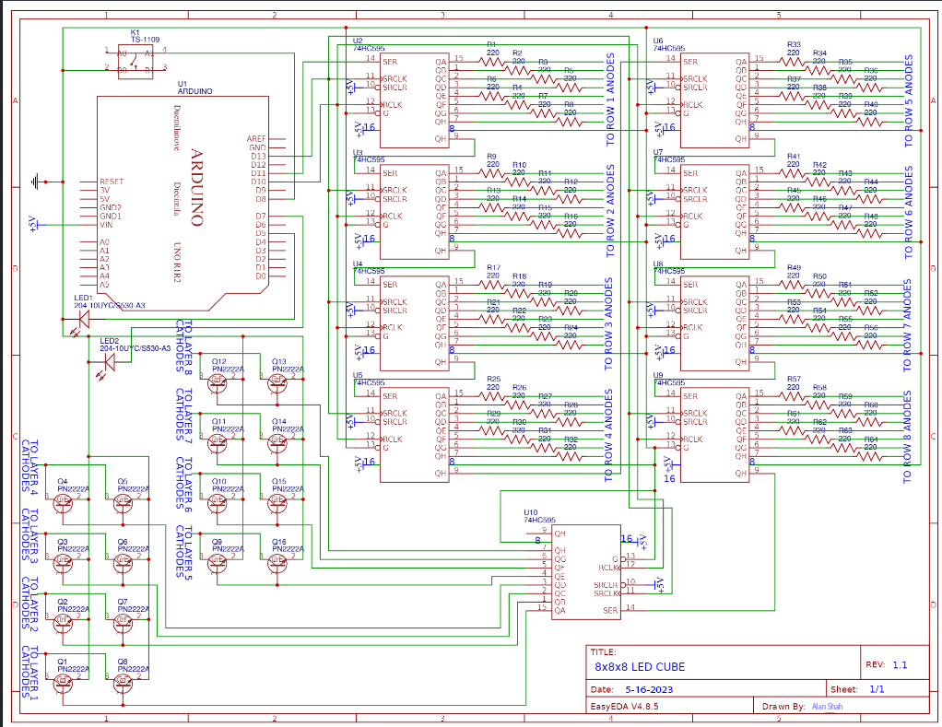

Figure Fritzing Schematic

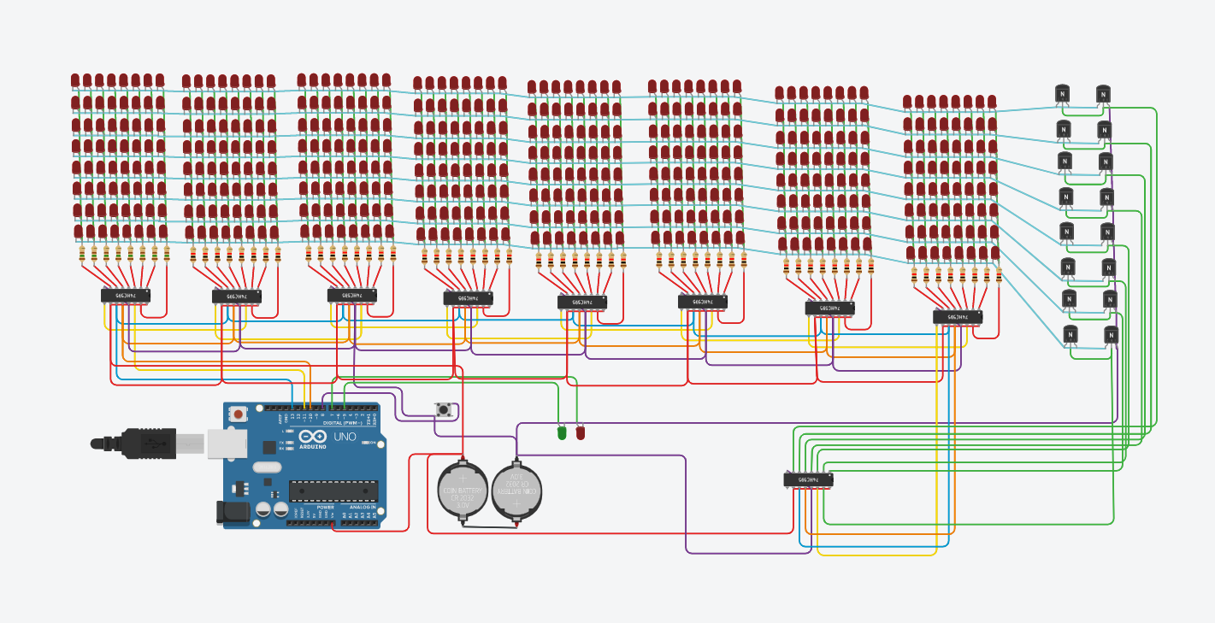

Figure Circuit Diagram

# Programming:

# Testing:

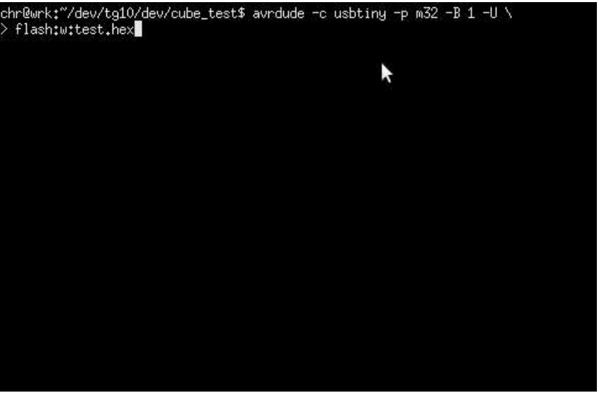

Figure Step 1

Figure Step 2

Figure Step 3

To serve as a point of reference for later operations, the initial test code starts by creating a level surface along a given axis.

The test code then moves the surface through each of the remaining eight places along that specific axis. The algorithm ensures that the system can manage and precisely respond to a variety of spatial orientations by iteratively moving through each position.

The test code moves on to try again with the other two axes after successfully navigating the surface along one axis. The system's functionality is extensively evaluated from several angles thanks to its wide-ranging coverage.

The test code then goes on to layer the LED illumination when the surface traversal is finished for all three axes. The LEDs are turned on one at a time, successively lighting up the layers in an upward motion from the bottom. This gradual illumination provides a methodical assessment of the LEDs' response and verifies their appropriate wiring and operating state.

The test code offers useful insights into the functioning and integrity of the system by doing these actions. It verifies successful LED lighting, proper component wiring, and accuracy of spatial motions. This thorough testing process guarantees that everything is working as planned and enables any required troubleshooting or modifications.

# Conclusion:

For the 8x8x8 LED Cube project, an Arduino Uno microcontroller will be used to build a cube with 512 LEDs placed in an 8x8x8 grid. To cut down on the quantity of output pins required for LED control, shift registers are used. The cube may show a variety of patterns and animations, providing opportunities for both decoration and instruction. While the project gives participants practical expertise in embedded systems programming and fundamental electronics, thorough testing assures optimal operation.

# References

Arduino, 2023. *Arduino.* [Online]   
Available at: https://store.arduino.cc/products/arduino-uno-rev3  
[Accessed 1 5 2023].

ElectronicSolvers, 2023. *ElectronicSolvers.* [Online]   
Available at: https://electronicslovers.com/2020/07/an-introduction-to-prototyping-printed-circuit-boards-pcbs.html#:~:text=PCB%20prototyping%20boards%20are%20simple,and%20feasibility%20of%20your%20design.  
[Accessed 1 5 2023].

elprocus, 2023. *elprocus.* [Online]   
Available at: https://www.elprocus.com/2n2222a-transistor/#:~:text=2N2222A%20transistor%20offers%20constant%20DC,in%20the%20TO-92%20package.  
[Accessed 16 5 2023].

instructables, 2023. *instructables.* [Online]   
Available at: https://www.instructables.com/Led-Cube-8x8x8/  
[Accessed 16 5 2023].

Ligiting Equiptment Sale, 2023. *Ligiting Equiptment Sale.* [Online]   
Available at: https://lightingequipmentsales.com/what-is-a-soldering-iron.html  
[Accessed 1 5 2023].

ROBU.IN, 2023. *ROBU.IN.* [Online]   
Available at: https://robu.in/product/16-pin-dip-ic-socket-base-adaptor-pack-of-5/#:~:text=16%20Pin%20IC%20Socket%20base,as%20a%20removable%20IC%20holder.  
[Accessed 16 5 2023].

rs-online, 2023. *rs-online.* [Online]   
Available at: https://uk.rs-online.com/web/content/discovery/ideas-and-advice/copper-wire-guide  
[Accessed 1 5 2023].

showa-seisen, 2023. *showa-seisen.* [Online]   
Available at: https://www.showa-seisen.co.jp/english/jumper-wire/#:~:text=What%20is%20a%20jumper%20wire,jump)%20to%20the%20electric%20circuit.  
[Accessed 1 5 2023].

Utmel electronics, 2023. *Utmel electronics.* [Online]   
Available at: https://www.utmel.com/components/74hc595-shift-register-ic-pinout-advantage-and-datasheet?id=553  
[Accessed 1 5 2023].