**Instruction:**

Complete all questions in **2 hours.**

1. Construct a 4-bit Serial In parallel Out shift register using D- flip flop. Explain the Working mechanism of the circuit taking Serial input 1010. Also, draw the timing diagram according to the given input.

Ans:

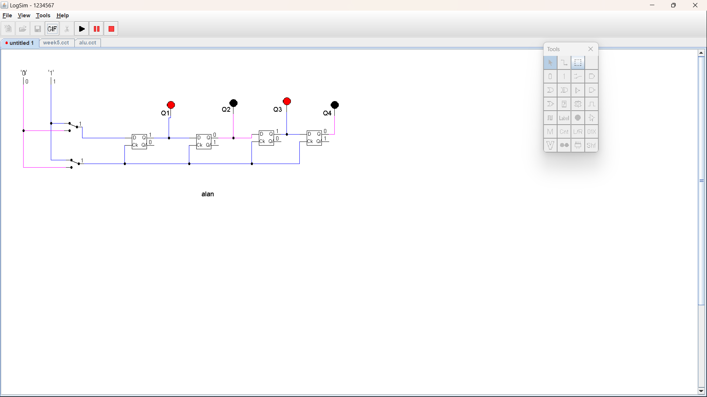

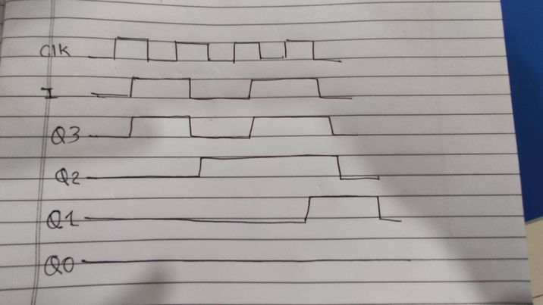

Figure : timing diagram

|  |  |  |  |  |  |
| --- | --- | --- | --- | --- | --- |
| Clock | I | Q3 | Q2 | Q1 | Q0 |
| Initial | | 0 | 0 | 0 | 0 |
| 1 | 0 | 0 | 0 | 0 | 0 |
| 1 | 1 | 1 | 0 | 0 | 0 |
| 1 | 0 | 0 | 1 | 0 | 0 |
| 1 | 1 | 1 | 0 | 1 | 0 |

The clock is rising, indicating that the value of the clock is 1. At the start state all, the values are 0 as there is no previous input to store. When the clock is in the high state, the value of Q3 is moved to Q2, thus the value is 0; similarly, the values of Q2 and Q1 are shifted to Q1 and Q0, respectively. When the input is 1, then Q3's value is also 1 and Q2's value is 0 compared to Q3's previous value. Likewise, Q2, Q2, Q1, and Q0's values are also 0 compared to Q3, Q2, and Q1's prior values. When the input is 0 then the value of Q3 is also 0 and the value of Q2 is 1 from the previous Q3 value and similarly the value of Q2, Q1, Q0 are also 0 from the previous Q2 and Q1 values. When the input is 1, the value of Q3 is also 1, and the value of Q2 is 0 from the previous Q3 value; similarly, the values of Q1, Q0 are 1 and 0 from the prior Q2 and Q1 values**.**

1. Design a 3-bit counter using Toggle D flip flop and draw the timing diagram.

Ans:

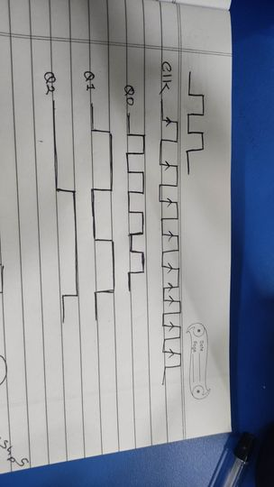

1. Load all. cut file from the logs folder. The circuit should look like this

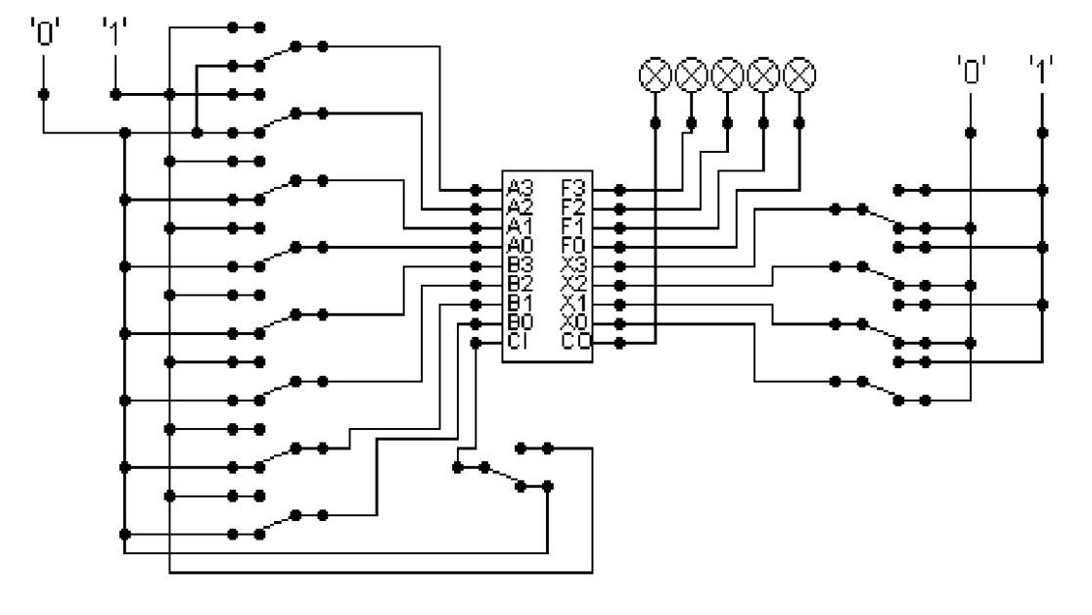

The circuit behaves like a simple arithmetic logic unit. The inputs A0-A3 represent a 4-bit binary number. Inputs B0-B3 represent another binary number. A0 and B0 are the least significant bits respectively. The following table details the functions supported by the chip. All other control lines = 0.

|  |  |  |
| --- | --- | --- |
| Function | Add | Subtract |
| X3-X0 | 1010 | 1011 |

1. Use A= 15 and B = 7

|  |  |  |
| --- | --- | --- |
| Input A=15 B=7, F=X3-X0, add =1010 | Output | |
| Add=1010  Binary Value  A=1111  B=0111 | Result | Screenshot |
| 0110 |  |
|  |

|  |  |  |
| --- | --- | --- |
| Input A=15 B=7, F=X3-X0, add =1010 | Output | |
| subtract=1011  Binary Value  A=1111  B=0111 | Result | Screenshot |
| 111 |  |
|  |

1. Use A = 13 and B = 9

Write the corresponding result of the operations. Manually provide each operation has provided the correct result.

|  |  |  |  |  |
| --- | --- | --- | --- | --- |
| Input A=13 B=9, F=X3-X0, add =1010 | | | Output | |
| Add=1010  Binary Value  A=1101  B=1001 | Result | | | Screenshot |
| 0110 |  | | |
|  |

|  |  |  |
| --- | --- | --- |
| Input A=13 B=9, F=X3-X0, add =1010 | Output | |
| subtract=1010  Binary Value  A=1101  B=1001 | Result | Screenshot |
| 11 |  |
|  |

*Thank you.*