**Attempt all questions**

1. Write a command to check our windows version.

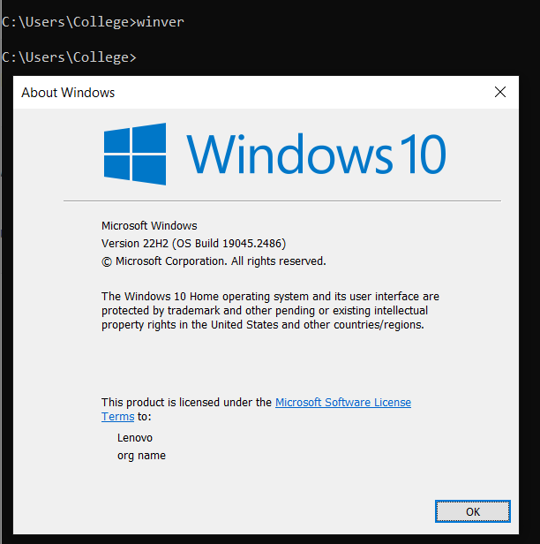

1. Create the directory date. Within that directory create a text file to show the current system date.

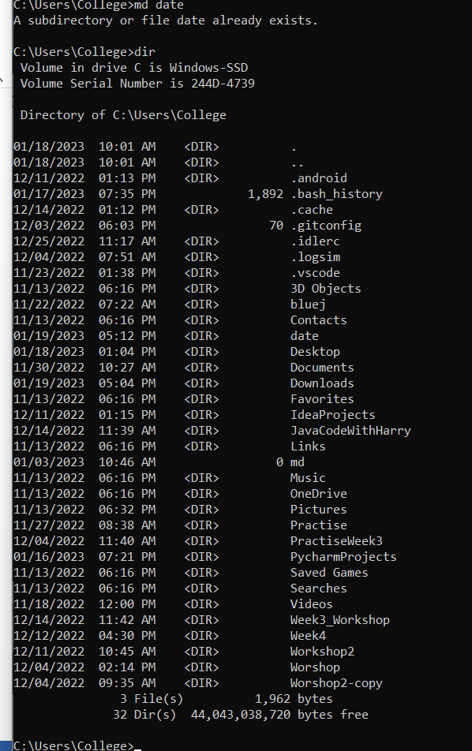

1. Show the system information using the command.

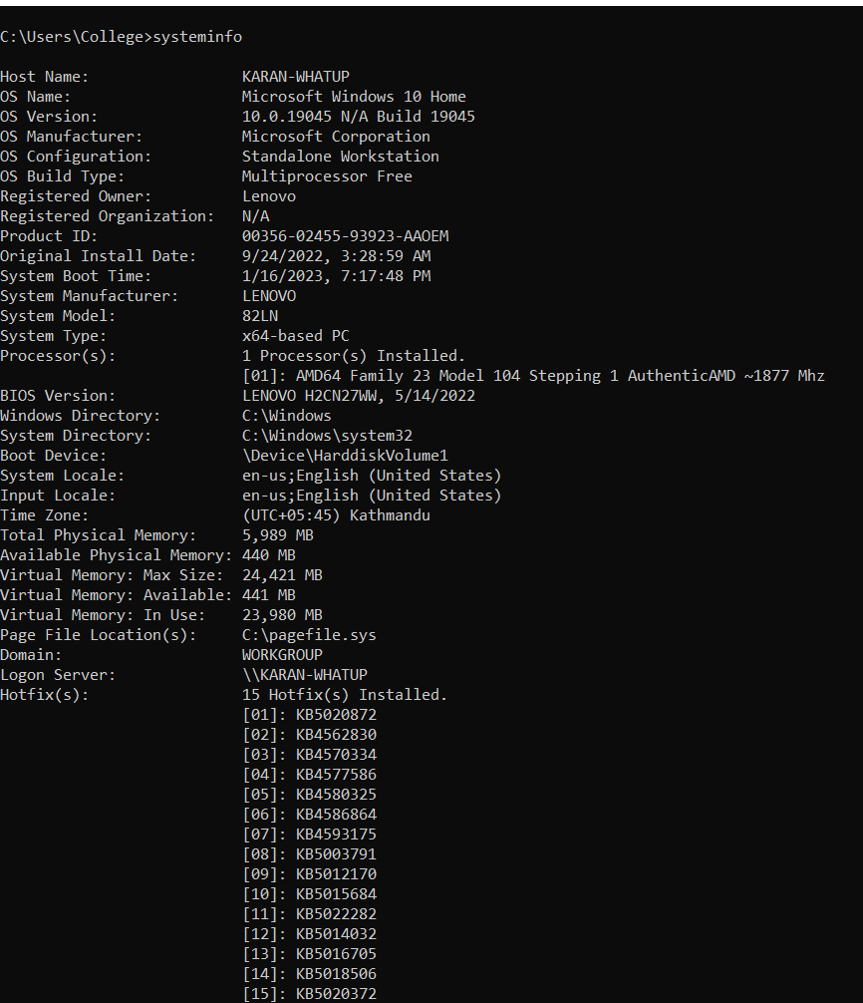

1. Create the directory called **systemInfo** and create the file name **systemInfo.txt**. In that file all your system information should be auto generated using the command.

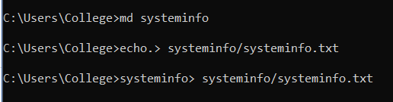

1. Launch the **systeminfo.txt** using notepad using the command.

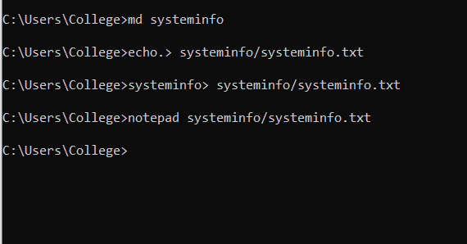

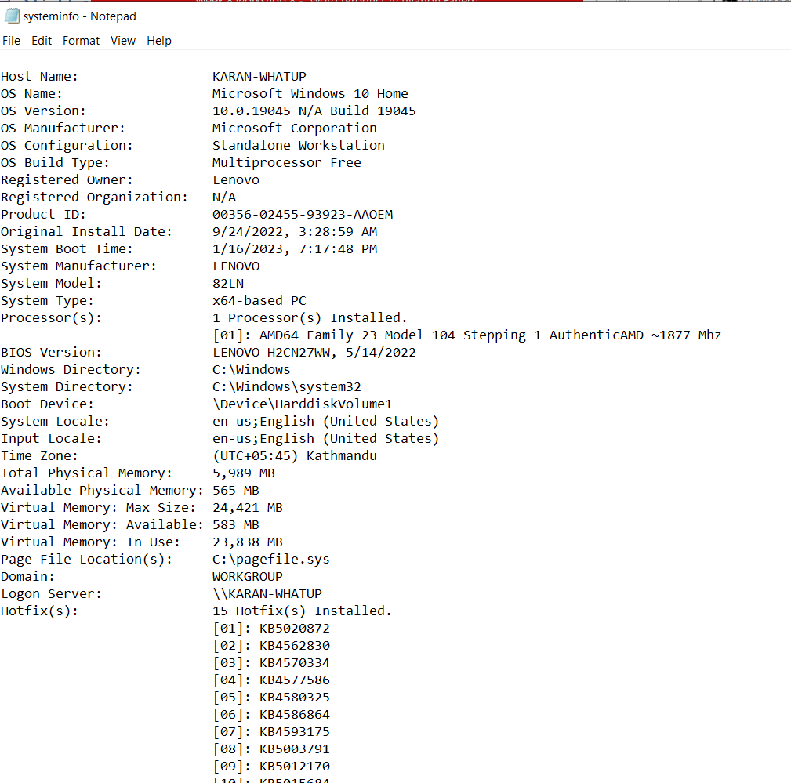

1. Briefly explain about the Ping,getmac,ipconfig command.

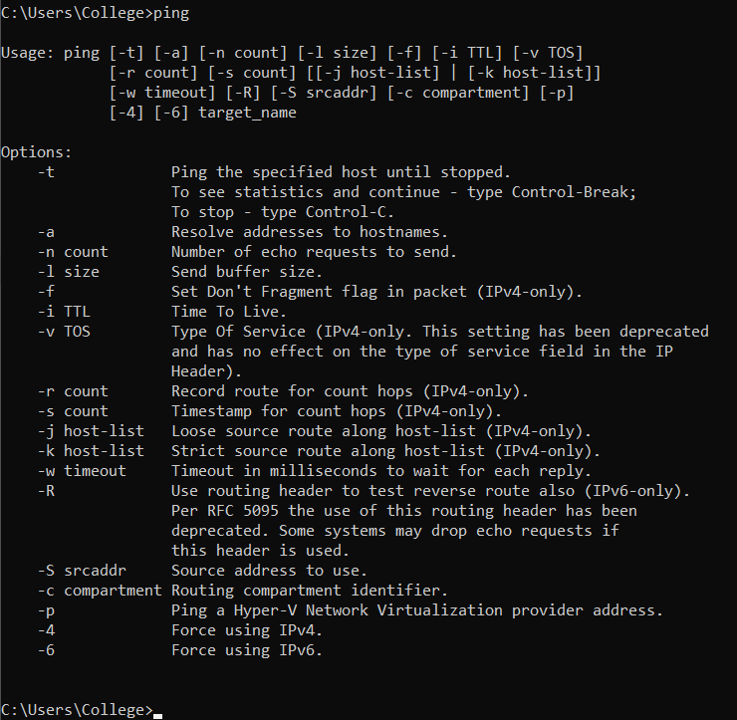

Ping command is for testing the connectivity of two devices on a network which sends ICMP (Control Message Protocol) echo request. This command is used to see whether a device is reachable on a network.



This is used to view Media Access Control (MAC) of windows computer in which it is used to see address of interfaces of network.

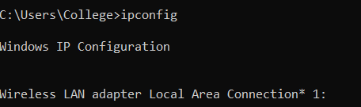

Ipconfig command is used in managing IP address configuration and to view it. It is utilized for viewing current IP address, default gateway of a network, subnet mask.

1. Ping the google domain and paste the screenshot.

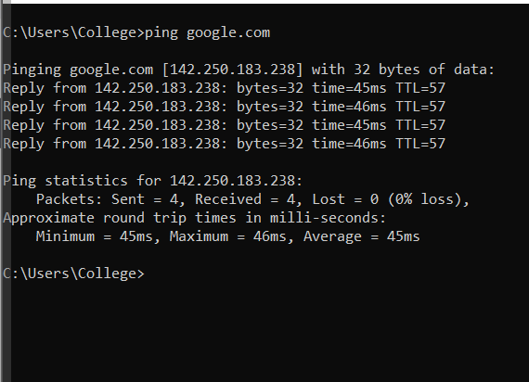

1. Show the ip address of your device.

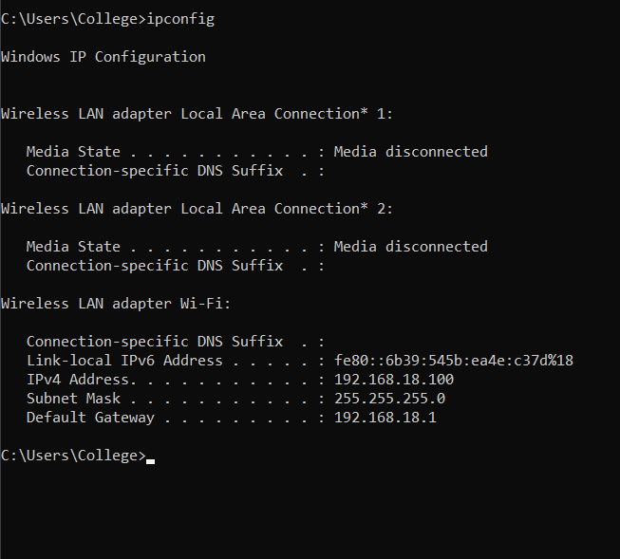

1. What is the use of the FC command?

This command is used for displaying the differences between two files by comparing them. The syntax used in cmd is fc file_1 file_2.

1. Create the directory called difference. In that directory create two files File1.txt and File2.txt. Add contents in 2 files and perform the ascii comparison of these 2 files.

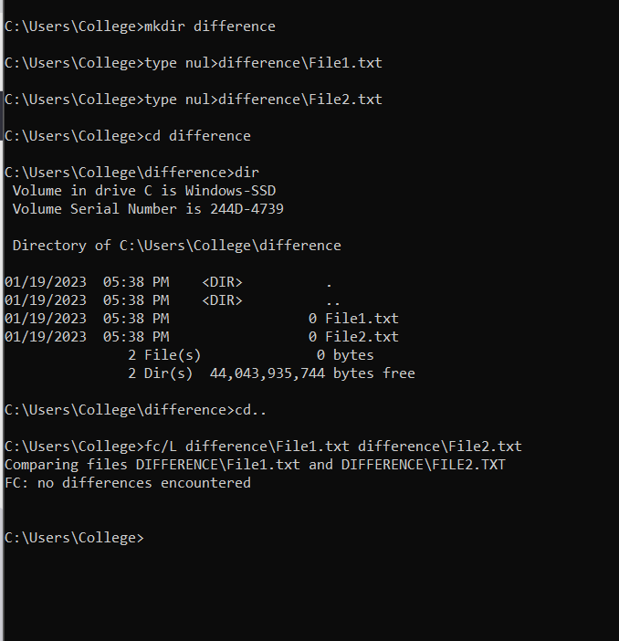

1. Generate the power efficiency diagnostics report using the command.

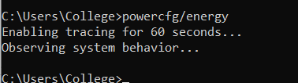

This report gets stored in desktop in the form of energy-report.html

1. What does the CHKDSK do?

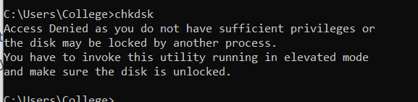

Basically, this command that is chkdsk which means check disk is used to check the file system and its meta data. This can also be used to fix errors.

1. Explain doskey /history command.

doskey: used to manage and create command macros in windows.

History: this command is used with doskey command to see the history of commands in command prompt in cmd.