. Workshop 2

Group A

1. What is the string class in Java? Is string a data type?

- Character strings are represented by the string class. Strings include the entire alphabet ("ABC"). Strings have a fixed value and cannot have it modified. - String is a type of data, yes.

2. How can you make a string upper case or lower case in Java?

* A string is changed to upper case letters using the upper case () technique. A string is changed to lower case letters using the lower case () technique.
* For example: System.out.println(“Str.tr upper case()”);

3. Can you use string in switch case in Java? Explain it in briefly.

- The variable being switched on is examined for each case in a switch statement, which enables equality testing of a variable against a set of values. In Java, using a switch statement with strings is possible. But every case must be String when employing a switch statement

4. Explain difference types of conditional statement in Java. - The if condition

when the block of code to be executed is true.

* The If- else statement

when the code is to be executed is true and false.

* While loop statement

an iterative control statement that repeatedly executed a part/set of statements based on a provided condition.

* For loop

iterates a programs multiple times. Better to declare the loop control variable with in the loop header.

* Do-while loop

executes a part of the programs at least once and the further execution depends upon the given Boolean condition.

5. What is the value of the variable number after the follow is executed?

* Integer x= 5;
* Integer number=0;
* Integer number n= number*k;
* Integer number= number*k*2;
* Number1= 10
* Number=0
* Number2=10
* the value of number 1 and number 2 is same.

6. How do you spilt Strings in Java?

- We can spilt in Java using split() method.

7. How do you check if two string are equal in Java or not?

- The equals () method is used to check if two string are equal in Java or not.

Group B

1. Find the difference between Beth’s age (57) and Tom’s age (34).

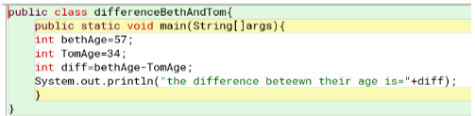

Output:



1. Develop a system to store your name as variable.

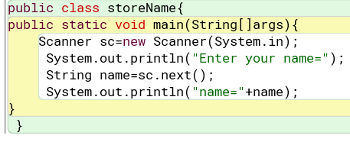

Output:

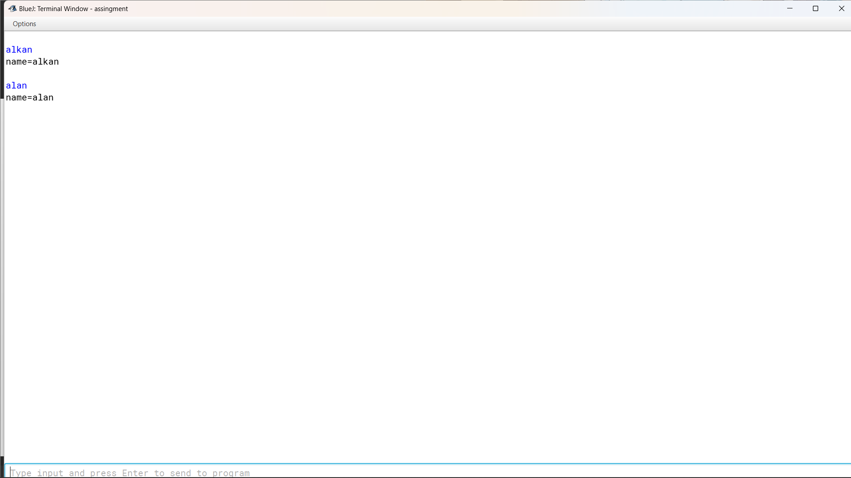

1. Create the above java program in the java environment and then modify the program to use the following statements. Note down the response to each. Do they differ from what you would expect?

* boolean result = true && true;

 = The result is true.

* boolean result = true && false || true;

= The result is true.

* boolean result = false && false || true;

 = The result is true.

* boolean result = false && 0;

=Boolean data type only stores true and false so the calculation of one Boolean type and another integer type shows an error.

* boolean result = !(false) && true;

= The result is true.

* boolean result = !(true && !(false &&false));

= The result is false.

* boolean result = (10 > 14) and (4 == 5);

= We don’t get the desired result because and statement is not a syntax. If && used instead of and, the program will execute.

* boolean result = true && 5;

= Boolean data type only stores true and false so the calculation of one Boolean type and another integer type shows error.

* boolean result = (3 * 4) != (14 - 2) && ('C' >= 'D');

= The result is true.

* boolean result = (12 * 2) == (3 * 8);

= The result is true.

* boolean result = (14 * 2) != (3 * 8);

= The result is true.

1. Find the difference between 7 factorial and 5 factorial.

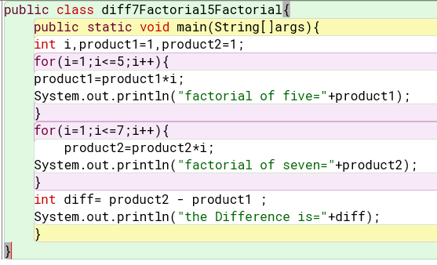

Output:

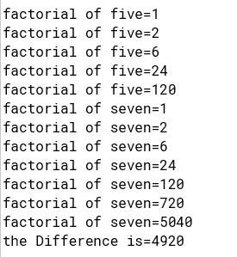

1. Complete the following questions by taking user input.

* Write a Java program that prompts a user for their last name and stores it in a variable named last_name.

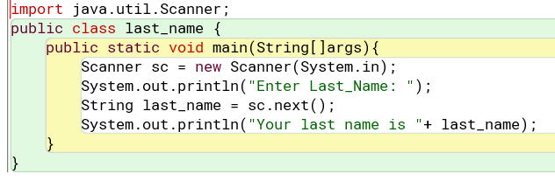

Output:

* Give an instruction that prompts a user for their age and stores it as an integer in a variable named age.

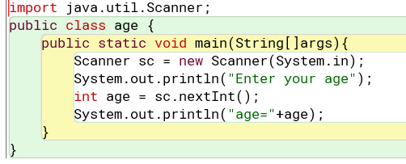

Output:

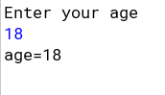

* Give an instruction that prompts a user for their temperature and stores it as a float in a variable named current_temperature.

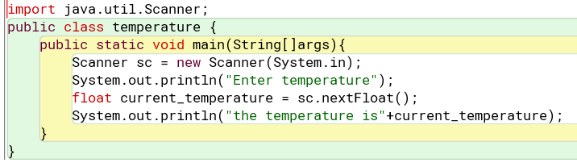

Output:

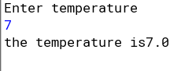

1. Give a call to printf that is provided one string that displays the following address on three separate lines:

* John Doe
* 123 Dudley Street
* 123 Dudley Street

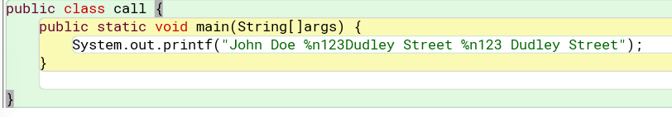

Output:

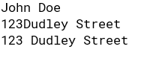

1. Write a java program in which:

* The user enters either 'A', 'B', or 'C'. If 'A' is entered, the program should display the word 'Apple'; if 'B' is entered, it displays 'Banana'; and if 'C' is entered, it displays 'Coconut'. Use nested if statements for this.

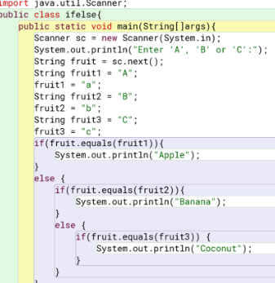

Output

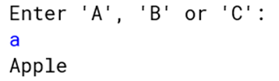

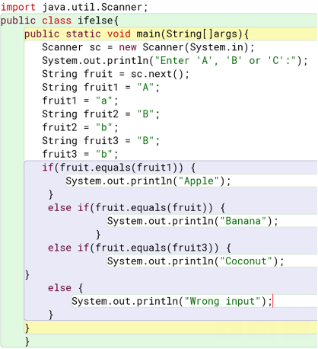

* Repeat question (a) using an (if statement with "else if" pairs) instead.
* A student enters the number of college credits earned. If the number of credits is greater than or equal to 90, 'Senior Status' is displayed; if greater than or equal to 60, 'Junior Status' is displayed; if greater than or equal to 30, 'Sophomore Status' is displayed; else, 'Freshman Status' is displayed.

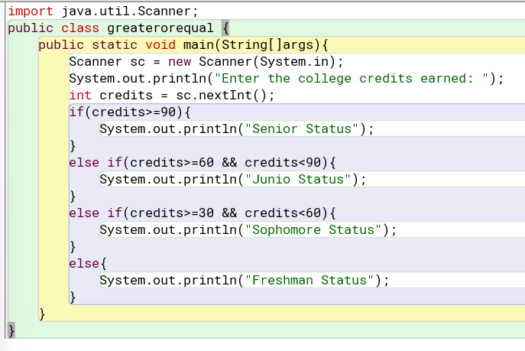

Output:

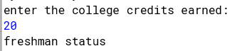

Group C

1. Create a Java software that will ask the user for a number and then display whether it is positive or negative.

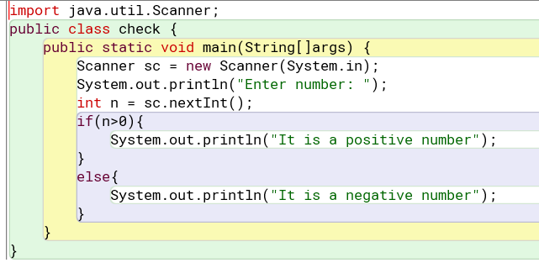

Output:

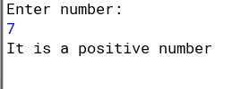

1. Your name left justified 15 spaces. [Formatted Output]

Output:

1. Your name right justified 15 spaces. [Formatted Output]

Output:

1. There were a bunch of students who were curious about their total marks, percentage and grade using the marks from five subjects as input. Develop a system to help them find their grades.

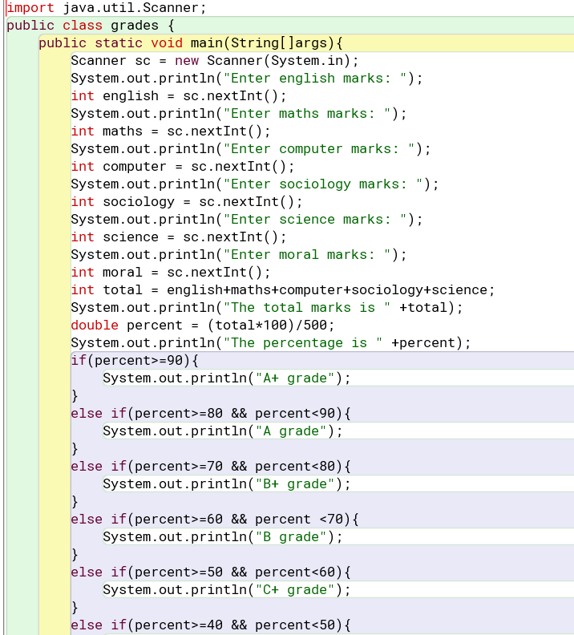

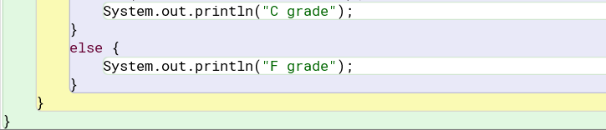

Output:

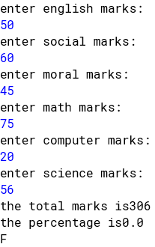

1. Write a Java program that allows the user to enter two integer values and displays the results with the following arithmetic operators applied to them. For example, if the user enters the values 7 and 5, the output would be:

* Addition: 7 + 5 = 12Subtraction: 7 – 5 = 2
* Multiplication: 7 * 5 = 35
* Division: 7 / 5 = 1.40
* Modulus: 7 % 5 = 2
* Exponentiation: 7 ** 5 = 16,807

[All floating-point results should be displayed with two decimal places of accuracy and with commas where appropriate.]

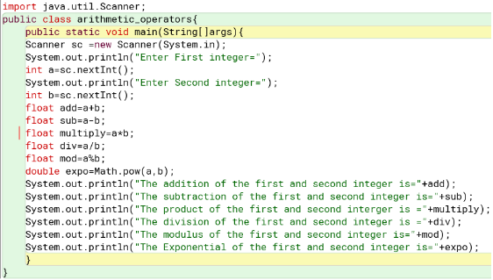

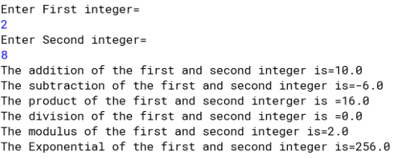

1. Let’s create a java program to input a number and check whether it is a Buzz number or not. A number is said to be a buzz number when it ends with 7 or is divisible by 7.

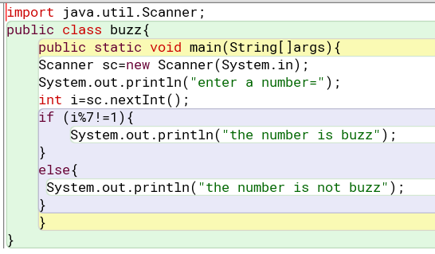

Output:

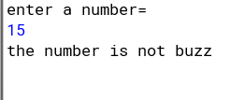

1. Let’s take an example program where we will take the age of user as input and find whether he is a child, adult, or senior on the basis of age. Using Java if-else-if ladder statements.

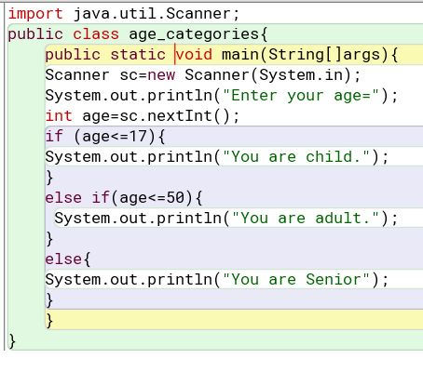

Output:

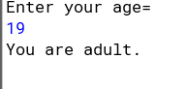

1. Bruno Mars just appeared his examination and got 75%. He goes to his tutor and asks his grade. Now being a tutor you need to develop a program which tells his grade.

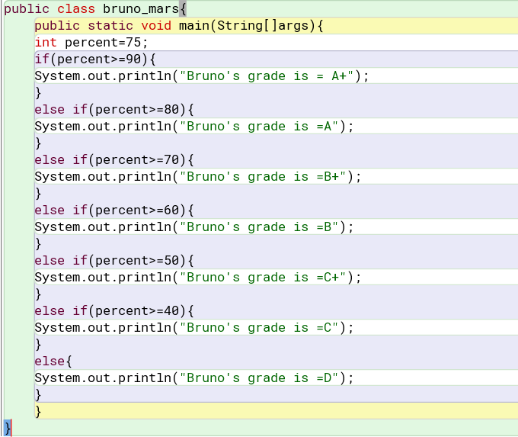

Output:



9. If a customer wants to take a t-shirt from your shop and he wants to buy a t-shirt and feeds in his/her size. Then print the availability as per their preference. [Using Switch Case Statement].

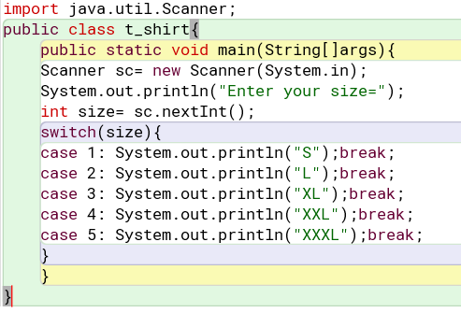

Output:

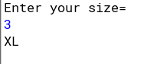

Group D

1. Let’s create a printing application program where we will take the number of copies to be printed as input from the user and then prints the price per copy and the total price for the printing copies. The chart price to print the number of copies is given below:

0 – 99 : $0.30 per copy

100 – 499 : $0.28 per copy

500 – 799 : $0.27 per copy

800 – 1000 : $0.26 per copy

over 1000 : $0.25 per copy

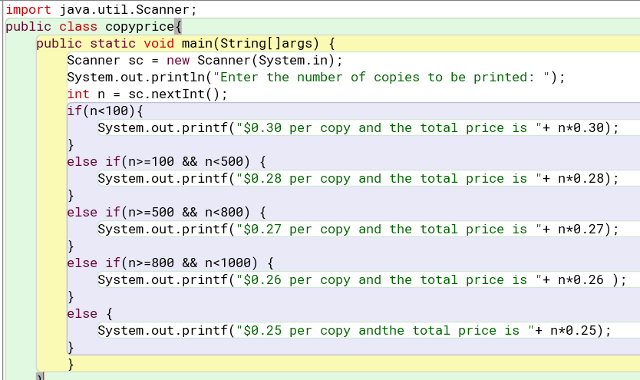

Output:



2. Follow the simulation of Floor example from lecture slide and develop a system where you need to ask user the floor number. Also determine whether the floor is actual floor or not.

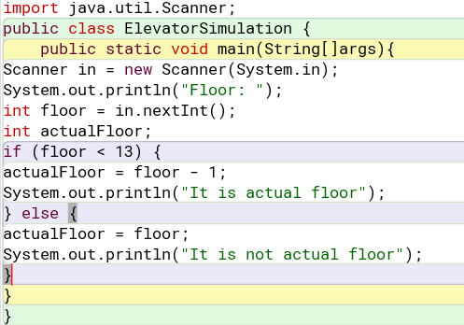

Output

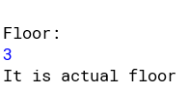

3. [Scenario] You’re waiting at a station and the announcer has just broadcast that your train is going to be 13445 seconds late. You need to work out in understandable terms what that means. You assume this is going to be quite a long time so you whip out your laptop to write a program to convert the seconds into hours, minutes and seconds, aiming to maximize readability by giving priority to the largest units, i.e. the resulting seconds and minute’s values must not be greater than 60. You will need four variables to hold: the total number of seconds; the number of hours; the number of minutes; and the number of remaining seconds. The example output should look something like this:

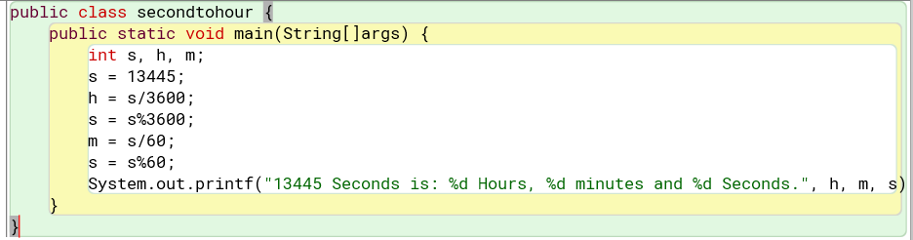

Output:

