* **Bike.xml**

<?xml version="1.0" encoding="UTF-8"?>

<?xml-stylesheet type="text/xsl" href="transform.xsl"?>

<Rents>

<Bikes>

<id>1</id>

<name>CBR 120</name>

<description>Advaced engine</description>

<rent>32</rent>

<stock>2</stock>

</Bikes>

<Bikes>

<id>2</id>

<name>SPLENDOR</name>

<description>city based use</description>

<rent>22</rent>

<stock>3</stock>

</Bikes>

<Bikes>

<id>3</id>

<name>GSX 320</name>

<description>sports bike.</description>

<rent>65</rent>

<stock>1</stock>

</Bikes>

</Rents>

* **Bike.xsd**

<?xml version="1.0" encoding="UTF-8"?>

<xs:schema xmlns:xs="http://www.w3.org/2001/XMLSchema">

<xs:element name="Rents">

<xs:complexType>

<xs:sequence>

<xs:element name="Bikes" maxOccurs="unbounded">

<xs:complexType>

<xs:sequence>

<xs:element name="id" type="xs:integer"/>

<xs:element name="name" type="xs:string"/>

<xs:element name="description" type="xs:string"/>

<xs:element name="rent" type="xs:decimal"/>

<xs:element name="stock" type="xs:integer"/>

</xs:sequence>

</xs:complexType>

</xs:element>

</xs:sequence>

</xs:complexType>

</xs:element>

</xs:schema>

* **Bike.xsl**

<?xml version="1.0" encoding="UTF-8"?>

<xsl:stylesheet version="1.0" xmlns:xsl="http://www.w3.org/1999/XSL/Transform">

<xsl:output method="html" indent="yes"/>

<!-- Template for the root element -->

<xsl:template match="/Rents">

<html>

<head>

<title>Bike rental </title>

<style>

table { width: 100%; border-collapse: collapse; }

th, td { border: 1px solid black; padding: 8px; text-align: left; }

th { background-color: #f2f2f2; }

</style>

</head>

<body>

<h1>Bike Rental List</h1>

<table>

<tr>

<th>ID</th>

<th>Name</th>

<th>Description</th>

<th>Rent</th>

<th>Stock</th>

</tr>

<xsl:for-each select="Bikes">

<tr>

<td><xsl:value-of select="id"/></td>

<td><xsl:value-of select="name"/></td>

<td><xsl:value-of select="description"/></td>

<td><xsl:value-of select="Rent"/></td>

<td><xsl:value-of select="stock"/></td>

</tr>

</xsl:for-each>

</table>

</body>

</html>

</xsl:template>

</xsl:stylesheet>

* **Validation process**

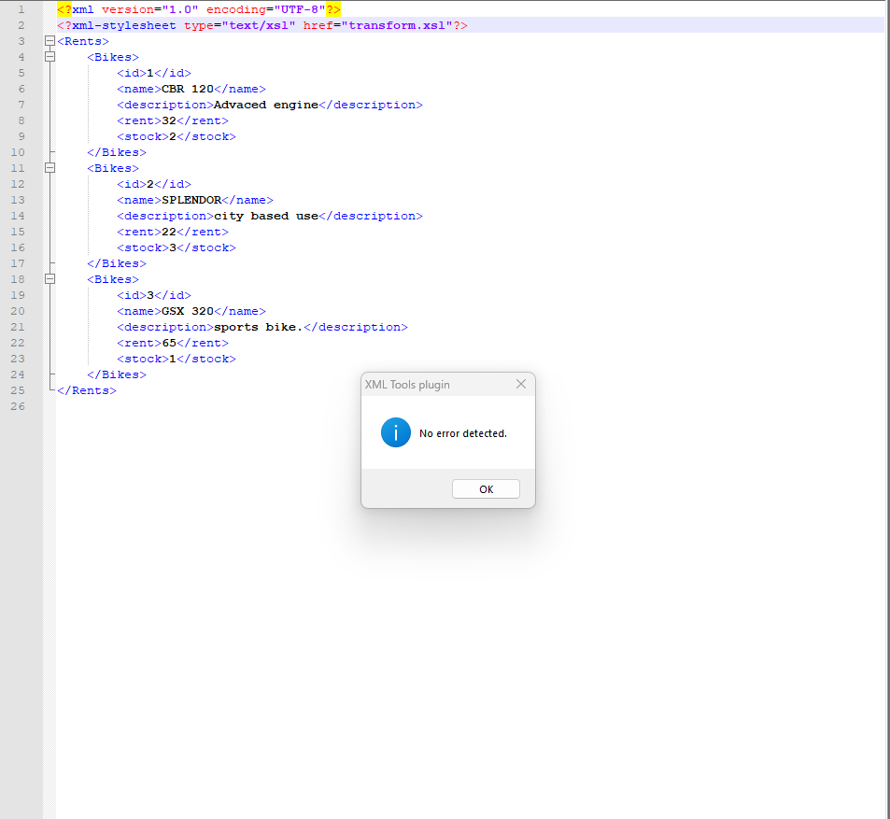

* **Table format output**

