New York University
Computer Science Department
Courant Institute of Mathematical Sciences

Database Systems Project Part I – Modeling

Student: Alan Mo NetID: bm3883
Date: 07/09/26

Course Title: Database Systems Course Number: CSCI-GA.2433-001
Instructor: Jean-Claude Franchitti Session:6
- Introduction
This report presents a logical entity-relationship model for the Enterprise Data Architecture project. The model is based on the Project Support Material and focuses on four subject areas, which is Account, Customer, Associate and Contract.

The purpose is to support some business cases. The model does not try to build a full insurance system. It focuses on entities, attributes, keys, relationships, and constraints needed for the project cases.

The model uses a relational database design approach. Many-to-many relationships are resolved with associative entities. Role and relationship fields are used to keep the design simple.

- Modeling Approach
The rules are as following.

Surrogate primary keys.
Main entities use readable single-column primary keys, like AccountID, CustomerID, AssociateID, and ContractID. Natural business rules are kept with alternate keys or unique constraints.

Associative entities for many-to-many relationships.
The support material includes many n..n cases. These are modeled with associative entities. For example, ACCOUNT and BILLING_ACCOUNT are connected through ACCOUNT_BILLING_ACCOUNT.

Role and relationship type fields.
Different business roles are stored with fields, such as RoleType and RelationshipType. This avoids creating many small role tables.

History fields.
Entities that represent changing relationships include StartDate, EndDate, and Status, which supports employment history, contract changes, and relationship changes.

Source-system records.
ACCOUNT stores the consolidated account record. ACCOUNT_ALIAS stores the original source records from systems as GroupMaster Columbus, GroupMaster New York, and Flex.

- Entity-Relationship Diagram
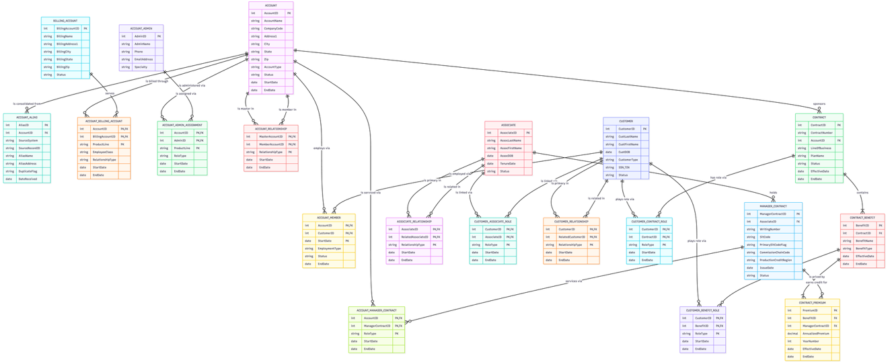
Figure 1. Enterprise Data Architecture ER Diagram
The ER diagram uses Crow’s Foot notation. The model contains 20 entities. Most many-to-many relationships are resolved by associative entities.
- Entity Documentation
Entity | Primary Key | Foreign Keys | Purpose
ACCOUNT | AccountID | — | Stores the consolidated employer or group account.
ACCOUNT_ALIAS | AliasID | AccountID | Stores original source-system records before consolidation.
BILLING_ACCOUNT | BillingAccountID | — | Stores billing address or PO box information.
ACCOUNT_BILLING_ACCOUNT | AccountID + BillingAccountID + ProductLine | AccountID, BillingAccountID | Resolves Account and BillingAccount many-to-many relationship.
ACCOUNT_ADMIN | AdminID | — | Stores account administrator information.
ACCOUNT_ADMIN_ASSIGNMENT | AccountID + AdminID + ProductLine | AccountID, AdminID | Assigns administrators to accounts.
ACCOUNT_RELATIONSHIP | MasterAccountID + MemberAccountID + RelationshipType | Both reference ACCOUNT | Stores account-to-account relationships.
CUSTOMER | CustomerID | — | Stores person or legal entity information, such as a trust.
ACCOUNT_MEMBER | AccountID + CustomerID + StartDate | AccountID, CustomerID | Links customers to accounts and supports employment history.
ASSOCIATE | AssociateID | — | Stores company sales associate information.
MANAGER_CONTRACT | ManagerContractID | AssociateID | Stores writing number and SitCode information.
ACCOUNT_MANAGER_CONTRACT | AccountID + ManagerContractID + RoleType | AccountID, ManagerContractID | Links accounts to servicing manager contracts.
ASSOCIATE_RELATIONSHIP | AssociateID + RelatedAssociateID + RelationshipType | Both reference ASSOCIATE | Stores associate broker or recruiter relationships.
CONTRACT | ContractID | AccountID | Stores policy or contract information. Each contract is linked to one account. For an individual policy, the account can be stored as an Individual or Direct account.
CONTRACT_BENEFIT | BenefitID | ContractID | Stores benefits or riders under a contract.
CONTRACT_PREMIUM | PremiumID | BenefitID, ManagerContractID | Stores premium records for benefits.
CUSTOMER_RELATIONSHIP | CustomerID + RelatedCustomerID + RelationshipType | Both reference CUSTOMER | Stores customer-to-customer relationships.
CUSTOMER_CONTRACT_ROLE | CustomerID + ContractID + RoleType | CustomerID, ContractID | Stores customer roles on contracts.
CUSTOMER_BENEFIT_ROLE | CustomerID + BenefitID + RoleType | CustomerID, BenefitID | Stores customer roles on benefits.
CUSTOMER_ASSOCIATE_ROLE | CustomerID + AssociateID + RoleType | CustomerID, AssociateID | Stores customer roles related to associates.

- Relationship Documentation
Relationship | Cardinality | Explanation
ACCOUNT to ACCOUNT_ALIAS | 1:N | One account can have many original source records.
ACCOUNT to BILLING_ACCOUNT | M:N | Resolved by ACCOUNT_BILLING_ACCOUNT.
ACCOUNT to ACCOUNT_ADMIN | M:N | Resolved by ACCOUNT_ADMIN_ASSIGNMENT.
ACCOUNT to ACCOUNT | M:N | Resolved by ACCOUNT_RELATIONSHIP.
ACCOUNT to CUSTOMER | M:N | Resolved by ACCOUNT_MEMBER.
ASSOCIATE to MANAGER_CONTRACT | 1:N | One associate can hold many SitCodes or writing numbers.
ACCOUNT to MANAGER_CONTRACT | M:N | Resolved by ACCOUNT_MANAGER_CONTRACT.
ASSOCIATE to ASSOCIATE | M:N | Resolved by ASSOCIATE_RELATIONSHIP.
ACCOUNT to CONTRACT | 1:N | One account can sponsor zero or more contracts. Each contract belongs to one account in this simplified model.
CONTRACT to CONTRACT_BENEFIT | 1:N | One contract has one or more benefits.
CONTRACT_BENEFIT to CONTRACT_PREMIUM | 1:N | One benefit has one or more premium records.
MANAGER_CONTRACT to CONTRACT_PREMIUM | 1:N | One manager contract can be linked to many premiums.
CUSTOMER to CUSTOMER | M:N | Resolved by CUSTOMER_RELATIONSHIP.
CUSTOMER to CONTRACT | M:N | Resolved by CUSTOMER_CONTRACT_ROLE.
CUSTOMER to CONTRACT_BENEFIT | M:N | Resolved by CUSTOMER_BENEFIT_ROLE.
CUSTOMER to ASSOCIATE | M:N | Resolved by CUSTOMER_ASSOCIATE_ROLE.

- Case Verification
  - Account Design Cases
Case | Supported By | Explanation
Account n..n BillingAccount | ACCOUNT_BILLING_ACCOUNT | Supports multiple PO boxes for FSA, Life, and A&H invoices. ProductLine and EmployeeClass explain billing use.
Account n..n Account | ACCOUNT_RELATIONSHIP | Supports master/member relationships, such as GroupMaster and FlexMaster.
Account n..n AccountAdmin | ACCOUNT_ADMIN_ASSIGNMENT | Supports multiple administrators for one account and one administrator serving many accounts.
Account 1..n AccountMember | ACCOUNT_MEMBER | Supports multiple employees, previous employment, moonlighting, and employment history.
AccountAlias | ACCOUNT_ALIAS | Stores original source records after account consolidation.
CompanyCode as logical key | Unique constraint on account natural key | Allows same account name and address when CompanyCode is different. Prevents duplicates when CompanyCode is the same.

  - Associate Design Cases
Case | Supported By | Explanation
Account n..n ManagerContract | ACCOUNT_MANAGER_CONTRACT | Supports one SitCode servicing many accounts and one account having several associate roles.
Associate 1..n ManagerContract | MANAGER_CONTRACT | Supports many writing numbers and SitCodes for one associate.
SitCode0 and side deals | PrimarySitCodeFlag | Marks the formal reporting chain. Other SitCodes represent side deals.
Commissions vs. Production Credit | CommissionChainCode, ProductionCreditRegion | Separates commission chain from production credit region.
Associate n..n Associate | ASSOCIATE_RELATIONSHIP | Supports broker and recruiter relationships.

  - Contract Design Cases
Case | Supported By | Explanation
Contract has multiple benefits | CONTRACT_BENEFIT | One contract can contain many benefits or riders.
Each benefit has multiple premiums | CONTRACT_PREMIUM | One benefit can have premium records for different years or periods.
Policy changes over years | EffectiveDate, EndDate, YearNumber | Supports new spouse and child benefits added to an existing contract.
Different associates write different premiums | ManagerContractID in CONTRACT_PREMIUM | Credit is attached to the premium, not only to the contract.

  - Customer Design Cases
Case | Supported By | Explanation
Customer n..n Customer | CUSTOMER_RELATIONSHIP | Supports family and trust relationships.
Customer n..n Contract | CUSTOMER_CONTRACT_ROLE | Supports roles such as Owner, Payer, and Insured.
Customer n..n ContractBenefit | CUSTOMER_BENEFIT_ROLE | Supports Beneficiary and CoveredPerson roles.
Customer n..n Account | ACCOUNT_MEMBER | Supports employment at more than one account.
Customer n..n Associate | CUSTOMER_ASSOCIATE_ROLE | Supports commission beneficiaries.

- Verification Summary
Case | Supported By | Status
A1 Account n..n BillingAccount | ACCOUNT_BILLING_ACCOUNT | Supported
A2 Account n..n Account | ACCOUNT_RELATIONSHIP | Supported
A3 Account n..n AccountAdmin | ACCOUNT_ADMIN_ASSIGNMENT | Supported
A4 AccountMember and history | ACCOUNT_MEMBER | Supported
A5 AccountAlias consolidation | ACCOUNT_ALIAS | Supported
A6 CompanyCode logical key | Unique constraint | Supported
B1 Account n..n ManagerContract | ACCOUNT_MANAGER_CONTRACT | Supported
B2 Associate 1..n ManagerContract | MANAGER_CONTRACT | Supported
B3 Commissions vs. Production Credit | MANAGER_CONTRACT attributes | Supported
B4 Associate n..n Associate | ASSOCIATE_RELATIONSHIP | Supported
C1 Contract, Benefit, Premium | CONTRACT_BENEFIT, CONTRACT_PREMIUM | Supported
D1 Customer n..n Customer | CUSTOMER_RELATIONSHIP | Supported
D2 Customer n..n Contract | CUSTOMER_CONTRACT_ROLE | Supported
D3 Customer n..n ContractBenefit | CUSTOMER_BENEFIT_ROLE | Supported
D4 Customer n..n Account | ACCOUNT_MEMBER | Supported
D5 Customer n..n Associate | CUSTOMER_ASSOCIATE_ROLE | Supported

- Assumptions and Simplifications
Those assumptions are used in this design:
- CustomerID identifies both people and legal entities, such as trusts.
- CustomerType distinguishes Individual, Trust, and Estate.
- A NULL EndDate means the relationship is active.
- Every CONTRACT is linked to one ACCOUNT in this model. ACCOUNT can represent an employer/group account or an individual/direct account.
- The 13-month history requirement is treated as a retention policy. The schema supports history with StartDate and EndDate.
- ProductLine is stored as a coded attribute, such as FSA, Life, or A&H.
- Full commission calculation is out of scope.
- Full geographic hierarchy is out of scope.
- Full product catalog is out of scope.
- Full ETL logic is out of scope. ACCOUNT_ALIAS only stores source records and duplicate flags.

- Conclusion
The proposed ER model supports the Account, Associate, Contract, and Customer cases in the Project Support Material. The model uses associative entities for many-to-many relationships. It uses a role field to represent business roles and a date field to support historical records. The design provides a clear logical model for Project Part I. It can be used as the basis for later relational database design.

