New York University
Computer Science Department
Courant Institute of Mathematical Sciences

Database Systems Project Part III
Logical Schema Optimization and Machine Learning Model Creation

Student: Alan Mo
NetID: bm3883
Course: CSCI-GA.2433-001
Instructor: Jean-Claude Franchitti
Due Date: 08/06/26
1. Introduction
Project Part III extends the logical and hybrid data model in Parts I and II. It implements a PostgreSQL 16 physical database, a quote-to-policy workflow, a machine learning pipeline for the DS010 unstructured report, and a cloud analytics layer.

The database contains 36 tables, including the 26 tables from Part II, six workflow tables, and four machine learning tables. Physical design decisions include indexing, partitioning evaluation, clustering evaluation, and a materialized view. The machine learning pipeline uses TF-IDF and K-means to group the DS010 report into six themes. Google BigQuery Sandbox was used to load seven tables and run four analytical queries.

Part III covers five areas:
- Physical database design and performance testing
- Quote-to-policy workflow design
- Machine learning over the DS010 document
- Extension of the data lake and Enterprise Data Architecture
- Cloud analytics through BigQuery

2. Physical Database Design
2.1 Database Extension
The Part II schema was retained. No existing table was renamed or removed.
Part III adds six workflow tables:
- QUOTE
- QUOTE_COVERAGE
- QUOTE_RISK_FACTOR
- QUOTE_STATUS_HISTORY
- PAYMENT_AUTHORIZATION
- QUOTE_CONVERSION
And four machine learning tables:
- ML_RUN
- DOCUMENT_CHUNK
- ML_CLUSTER_RESULT
- ML_CLUSTER_SUMMARY
The complete physical design consists of the 26-table Part II schema and the 10-table Part III extension.

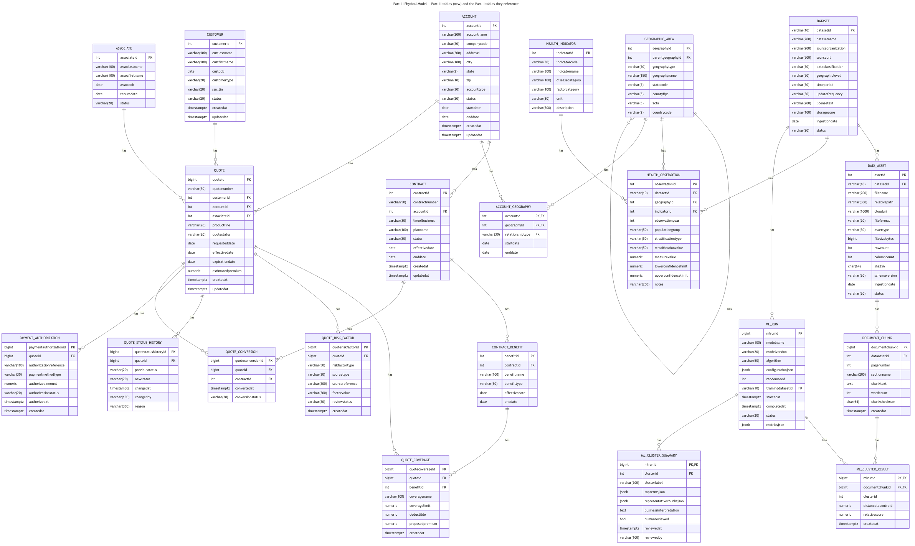
Figure 1. Part III physical extension and its relationships with the Part II schema.
2.2 Indexing
Sixteen indexes were added for the documented workload. They support:
- account and contract lookup;
- open quote queues;
- active contract lookup;
- county FIPS lookup;
- regional health joins;
- indicator aggregation;
- dataset lineage;
- machine learning result retrieval.
Partial indexes are used for active contracts and open quotes. Composite indexes follow the order used by query filters and joins. Covering indexes include columns required by repeated analytical queries.
The database contains 87 indexes in total:
- 52 indexes from Part II;
- 16 Part III workload indexes;
- 15 primary-key and unique indexes for the new tables;
- 4 materialized-view indexes.

2.3 Partition and Clustering
Partition was tested with 500,000-row synthetic tables. One table used range partitions by year. The other used a standard composite index.
Test | Partitioned | Non-partitioned
Point lookup | 0.158ms | 0.070ms
Full-year scan | 417buffers | 4167buffers

Partitioning reduced I/O for annual scans. The composite index was faster for selective lookups. The live HEALTH_OBSERVATION table contains 320 sample rows, so partitioning was not applied to it.
PostgreSQL CLUSTER was tested on the synthetic observation table. It was not applied to ACCOUNT, CUSTOMER, CONTRACT, or QUOTE because these tables receive updates and would not retain the physical order.
2.4 Materialized View
The project creates:
MV_ACCOUNT_REGIONAL_HEALTH_PROFILE
The view materializes the following path:
ACCOUNT
→ ACCOUNT_GEOGRAPHY
→ GEOGRAPHIC_AREA
→ HEALTH_OBSERVATION
→ HEALTH_INDICATOR
The view is refreshed after a curated data load. A unique index supports concurrent refreshes.
Query | Execution time
Live five-table join | 0.072ms
Materialized view | 0.027ms

The view contains county-level context. It does not represent individual medical risk.

2.5 Performance Results
Test | Result
Composite index, 500,000 rows | 7.121 ms to 0.032 ms
Materialized view | 0.072 ms to 0.027 ms
Annual partition scan | 4,167 to 417 buffers
Active contract query | Partial index selected
County FIPS query | Partial index selected

3. Quote-to-Policy Workflow
The workflow allows a customer to request a quote and receive an issued policy.
The existing CONTRACT table represents the final policy. It contains:
- policy number;
- account;
- line of business;
- plan;
- status;
- effective date;
- end date;
- benefits;
- premiums.
The QUOTE_CONVERSION table links an accepted quote to the resulting CONTRACT row. A separate POLICY table was not added because it would duplicate the existing contract structure.

The workflow contains 16 use cases:
- Identify or register the customer
- Identify the account
- Select the product line
- Create the quote
- Add coverage
- Validate required data
- Retrieve permitted regional context
- Review risk factors
- Calculate the estimated premium
- Present the quote
- Accept, reject, revise, or expire the quote
- Record payment authorization
- Convert the quote into a contract
- Create benefit and premium records
- Record status history
- Store policy-document metadata

The six workflow tables contain the following test data:
Table | Rows
QUOTE | 121
QUOTE_COVERAGE | 180
QUOTE_RISK_FACTOR | 40
QUOTE_STATUS_HISTORY | 240
PAYMENT_AUTHORIZATION | 20
QUOTE_CONVERSION | 20

Database constraints reject:
- invalid quote statuses;
- invalid date ranges;
- duplicate quote conversions;
- status records without a change;
- patient-level risk-factor sources.
PAYMENT_AUTHORIZATION stores only a payment gateway reference. No payment credential is stored in the database.
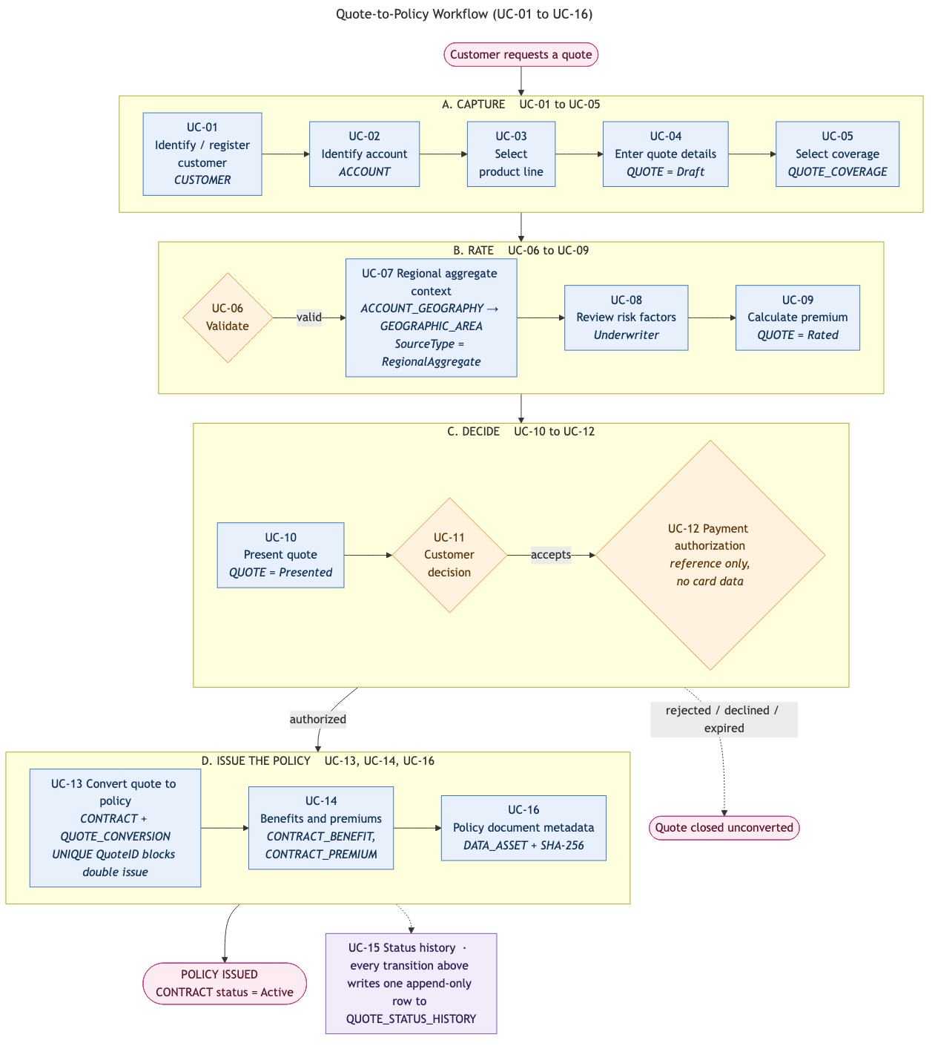
Figure 2. Quote-to-policy workflow from quote request to policy issuance.
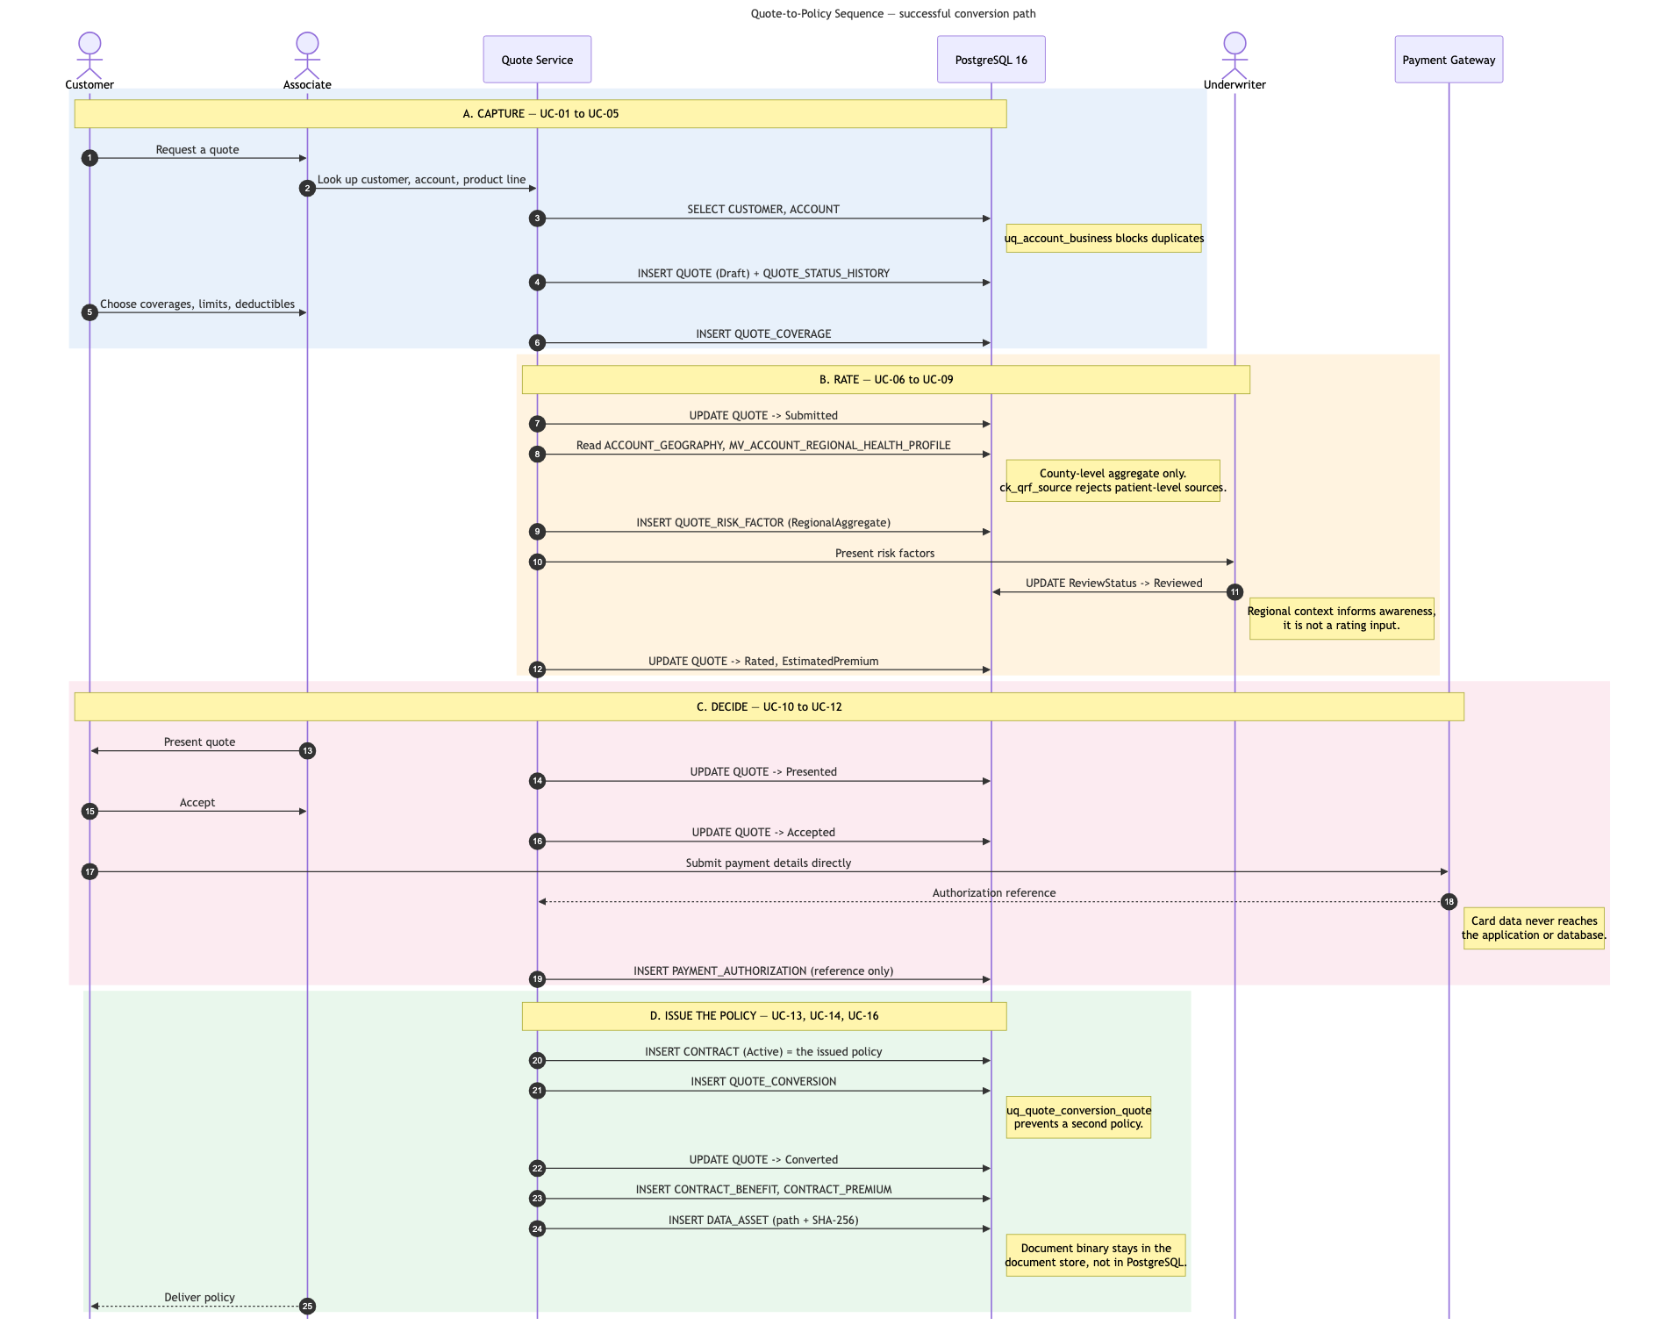
Figure 3. Main interactions among the customer, quote service, PostgreSQL database, regional data service, rating process, and payment gateway.

4. Machine Learning Model
4.1 Dataset and Objective
The machine learning source is DS010, the 2025 County Health Rankings & Roadmaps report.
The model identifies recurring public-health and community themes. Its purpose is to support document navigation, public-data research, and regional portfolio review.
DS010 does not contain target labels. An unsupervised model was therefore selected. The project does not create disease forecasts, customer risk scores, premium estimates, or medical classifications.
The data lake holds ten public datasets from three organizations. The files were downloaded from official sources and were not changed.

4.2 Text Processing
The pipeline:
- locates DS010 through DATASET and DATA_ASSET;
- verifies the recorded checksum;
- extracts text by page;
- removes repeated headers;
- splits text at paragraph boundaries;
- preserves page numbers;
- removes empty and duplicate chunks.
Page-level processing would produce only 18 records. Paragraph-aware chunking produced 32 records while preserving source lineage.

4.3 Features and Model Selection
TF-IDF was used with:
Setting | Value
N-gram range | 1-2
Minimum document frequency | 2
Maximum document frequency | 0.8
Vocabulary size | 520
Random seed | 42
K-means models were tested for K values from 2 through 8. Cluster solutions containing fewer than four chunks were excluded to limit fragmentation. K=6 was selected.
Metric | value
Silhouette score | 0.1212
Davies–Bouldin score | 2.2855
Inertia | 20.2833
Cluster sizes | 4, 4, 7, 4, 4, 9
The silhouette score indicates overlap among the themes. The result is suitable for document review but not classification.

4.4 Results
Cluster | Interpreted theme | Use
0 | Narratives and structural determinants | Background research
1 | School funding and educational disparity | Fairness review
2 | Publisher and citation language | Cleaning diagnostic
3 | Housing cost burden and income | Regional data research
4 | Public health and community organizing | Source context
5 | Social rules and community conditions | Indicator research
Cluster 2 consists mainly of publisher and citation terms. This identifies a text-cleaning improvement for a future model.
Cluster 3 connects to American Community Survey housing and income data already stored in the data lake.
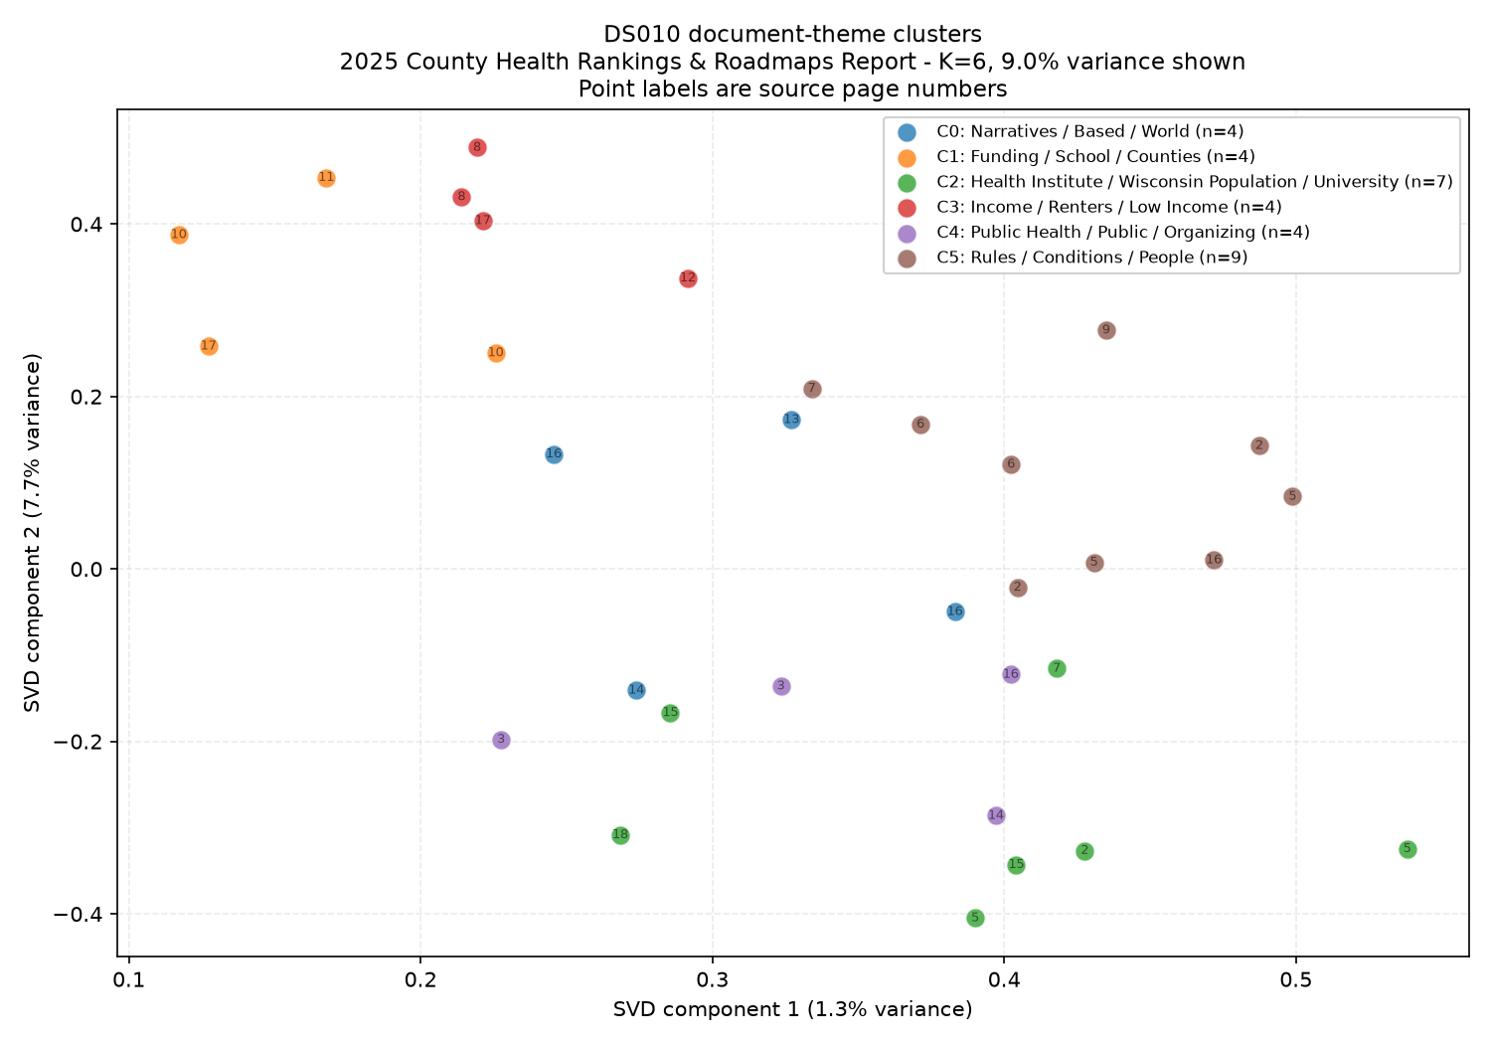
Figure 4. DS010 chunks projected into two dimensions with TruncatedSVD.
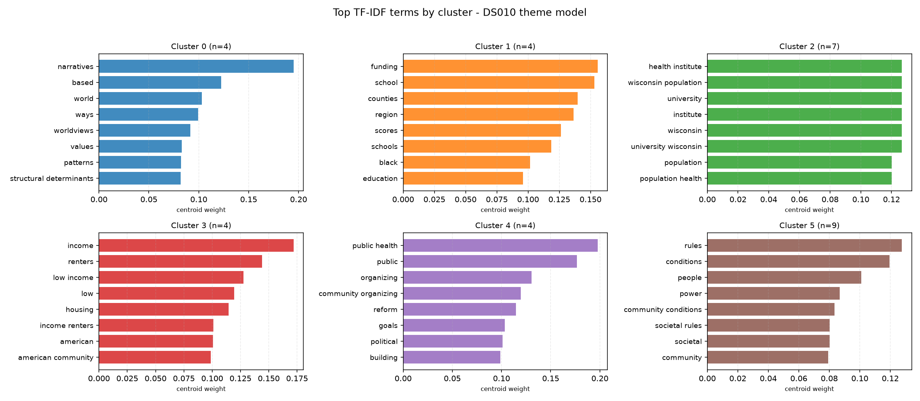
Figure 5. Highest-weighted TF-IDF terms for each cluster.

4.5 EDA Integration
Model outputs are stored in:
- ML_RUN;
- DOCUMENT_CHUNK;
- ML_CLUSTER_RESULT;
- ML_CLUSTER_SUMMARY.
The PDF remains in the data lake. PostgreSQL stores metadata, extracted text, model results, and lineage.

A model theme can suggest a candidate indicator. A person must review the theme before a related county measure is added to HEALTH_INDICATOR or HEALTH_OBSERVATION. Model output does not update CUSTOMER, QUOTE, CONTRACT, or premium tables.

5. Big Data Platform and Cloud Analytics
5.1 Data Lake Extension
The Part II data-lake zones remain in place. Part III adds:
- ML chunks;
- cluster assignments;
- cluster summaries;
- model metrics;
- fitted models;
- lineage records;
- database performance results.
No raw file was changed. The existing curated tables were used for PostgreSQL and BigQuery.

5.2 BigQuery Implementation
Google BigQuery Sandbox was used and seven tables were loaded.
Table | Rows
geographic_area | 3,196
health_indicator | 148
health_observation | 320
dataset_catalog | 10
data_asset | 10
ml_cluster_assignments | 32
ml_cluster_summary | 6

All BigQuery row counts matched the local sources. Four queries were executed:
- Geographic coverage by level
- Health indicators summarized by state
- Machine learning cluster summary
- Dataset lineage and license inventory
The first query returned 3,144 counties, 320 observations, and 40 distinct indicators. State and national rows contained no observations because the curated sample is county based.
The second query summarized aggregate indicators by state. The third query combined ML results with source-page and review information. The fourth query returned metadata for all ten datasets.

6. Reference Architecture
The implemented architecture contains:
Business Domain
- Account
- Customer
- Associate
- Quote
- Policy represented by CONTRACT
- Product and benefit
- Regional research
- Business review
Application Domain
- Data ingestion
- Data-quality validation
- PostgreSQL workload
- Quote-to-policy workflow
- ML pipeline
- BigQuery analytics
Data and Infrastructure Domain
- Local data lake
- PostgreSQL 16 in Docker
- Python ML pipeline
- BigQuery Sandbox
- Model outputs
- Logs and evidence
DIKW Domain
- Data: raw files and insurance transactions
- Information: curated regional observations and contract summaries
- Knowledge: reviewed ML themes
- Decision: product and portfolio review with human approval
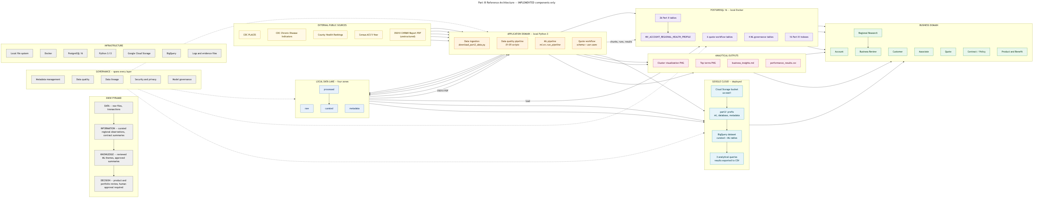
Figure 6. Implemented architecture connecting public sources, the local data lake, PostgreSQL, the ML pipeline, BigQuery, and business review.

7. Data Quality, Security, and Governance
7.1 Data Quality
Check | Result
Raw-file checksums | 10 of 10 matched
Duplicate curated keys | 0
Invalid county FIPS values | 0 of 3,144
Broken foreign keys | 0
Failed PDF pages | 0 of 18
Empty or duplicate chunks | 0

7.2 Security and Privacy
The implementation includes:
- no credentials in the repository;
- least-privilege database roles;
- restricted access to CUSTOMER.SSN_TIN;
- no patient-level health records;
- no stored payment credentials;
- append-only quote status history;
- source references for risk factors;
- audit timestamps.

The ml_writer role cannot update insurance tables.
7.3 Fairness and Decision Limits
The source document contains demographic and economic disparity terms. Regional health and socioeconomic measures may act as proxies if used in individual insurance decisions.
The following controls limit this risk:
- health observations are linked to geographic areas, not customers;
- public-health data is aggregate;
- patient-level sources are prohibited;
- each risk factor records its source;
- ML output cannot update insurance tables;
- cluster interpretations require a named reviewer;
- regional indicators are restricted to research and portfolio review.
The model organizes document passages. It does not approve policies, calculate premiums, or assess individuals.

8. Validation
Validation area | Result
Database tests | 78 passed
ML tests | 44 passed
SQL negative tests | 23 passed
Data-lake checks | 14 passed
Deliverable checks | 18 passed
Referential-integrity checks | 0 orphan records
Reproducibility | Identical results across two model runs
Cloud analytics | 7 tables and 4 queries verified

9. Conclusion
Project Part III converts the Part II logical schema into a PostgreSQL physical implementation. It adds a quote-to-policy workflow, a machine learning model, and cloud analytics.
The physical design applies indexing, partitioning evaluation, clustering evaluation, and materialization. Tests show that composite indexes support selective lookups, partitioning reduces I/O for annual scans, and the materialized view improves a repeated regional-health query.
The machine learning model identifies six themes in the DS010 report. The results support document review and data research. They do not support automated insurance decisions.
BigQuery extends the local data lake into a cloud analytics layer. Seven tables were loaded and four queries were executed. Data quality, lineage, security, and model governance controls connect the implementation to the Enterprise Data Architecture.
The logical schema has 26 tables. There are 20 Part I tables and 6 hybrid tables. The schema is written for PostgreSQL 16.

References
Centers for Disease Control and Prevention. CDC PLACES: Local Data for Better Health, County Data.
Centers for Disease Control and Prevention. U.S. Chronic Disease Indicators.
County Health Rankings & Roadmaps. 2025 Annual Data Release.
University of Wisconsin Population Health Institute. Building Power for Health and Equity: 2025 County Health Rankings & Roadmaps Report. March 2025.
U.S. Census Bureau. American Community Survey 5-Year Estimates, 2024 Subject Tables.
PostgreSQL Global Development Group. PostgreSQL 16 Documentation.
Pedregosa, F., et al. “Scikit-learn: Machine Learning in Python.” Journal of Machine Learning Research, vol. 12, 2011.
Rousseeuw, P. J. “Silhouettes: A Graphical Aid to the Interpretation and Validation of Cluster Analysis.” Journal of Computational and Applied Mathematics, vol. 20, 1987.
Google Cloud. BigQuery Sandbox Documentation.

