|  |  |  |  |
| --- | --- | --- | --- |
|  |  | **CONTENTS** |  |
| Abstract | |  | i |
| Nomenclature | |  | ii |
| List of Figures | |  | iii |
| List of Tables | |  | iv |
| **Chapter 1: Introduction** | | | 1 |
| 1.0 | Types of prosthetic limbs | | 1 |
| **Chapter 2: Literature Review & Problem Identification** | | | 4 |
| 2.0 | Literature Review | | 4 |
| 2.1 | The Human Hand | | 5 |
| 2.2 | Capabilities of prosthetic hands | | 7 |
| 2.3 | Connection to the Body | | 19 |
| 2.4 | User Control | | 20 |
| 2.5 | Sensory Feedback | | 21 |
| **Chapter 3: Component design & manufacturing** | | | 23 |
| 3.0 | Mechanical designs | | 23 |
|  | 3.0.1 | Early ideas and concept Drawings | 23 |
|  | 3.0.2 | Ergonomics | 23 |
|  | 3.0.3 | Computer Assisted Design | 24 |
|  | 3.0.4 | Manufacturing and Assembly | 31 |
| 3.1 | Electrical Design | | 32 |
|  | 3.1.0 | Actuation | 33 |
|  | 3.1.1 | Microcontroller | 34 |
|  | 3.1.2 | Voltage regulator | 36 |
|  | 3.1.3 | Electromyography Sensor | 37 |
|  | 3.1.4 | Power Supply | 38 |
| 3.2 | Firmware Implementation | | 39 |
|  | 3.2.0 | Servo Signals | 39 |
|  | 3.2.1 | Emg Control | 40 |
|  | 3.2.2 | Sensor feedback | 40 |
|  | 3.2.3 | Program Flow | 41 |
| **Chapter 4: Testing and Results** | | | 42 |
| 4.0 | System Specifications | | 42 |
| 4.1 | Component Strength | | 43 |

|  |  |  |  |
| --- | --- | --- | --- |
| 4.2 | Actuation | | 44 |
|  | 4.2.0 | Fluidity | 44 |
|  | 4.2.1 | Strength | 44 |
| 4.3 | Control |  | 44 |
| 4.4 | Battery Life | | 46 |
| **Chapter 5 Conclusion** | | | 47 |
| 5.0 | Overall System Performance | | 47 |
| 5.1 | Benefits to an Amputee | | 47 |
| 5.2 | Implications & Contribution to the Field | | 47 |
| **Appendix** | |  | 49 |
| **Reference** | |  | 52 |
| **Bio data** | |  | 54 |

**ABSTRACT**

Physical impairment can limit the physical function. Such individual then can be called as a handicap. In cases of individuals with loss of limbs and next to nothing residual capacity, it is very difficult for them to associate with daily activities as well as employment, education, independent living, etc. This project will depict the information relating the substitution of the upper limb of an amputee by Myoelectric Prosthetic Arm. The objective of this project was to redesign a prosthetic arm that would be affordable for common people and be best fit for ages from eighteen to fifty. The advances in science and technology have led to development of externally powered prosthesis that interface directly with the neuromuscular system and recreate some of a normal hand’s sophisticated proprioceptive control. This device known as Myoelectric

Arm is based on biological electronic sensors, is battery operated, controlled by microprocessor and driven by motors. It then translates this muscle activity as triggered by the user into information via microcontroller, which control the artificial limbs movements via electric motors. The end result is that the artificial limb moves much like a natural limb, according the mental stimulus of the user. The Myoelectric artificial limb does not require any unwieldy straps or harnesses to function. Instead, it is custom made to fit and attach to the remaining limb. Myoelectric hand/arm component perform better than conventional prosthesis in terms of function, weight, comfort and cosmetics. The final design includes a robust and strong design, which can easily be manipulated by the user. It contains cheap, light, but also strong materials.

Page | i

|  |  |  |
| --- | --- | --- |
|  |  | **NOMENCLATURE** |
| **S No** | **Acronym** | **Abbreviations** |
| 1 | EMG | Electro Myography |
| 2 | PLA | Polyactic Acid |
| 3 | ADC | Analogue to Digital Converter |
| 4 | USB | Universal Serial Bus |
| 5 | DOF | Degree of Freedom |

Page | ii

**LIST OF FIGURES**

**Figure No** **Figure Name**

1. Prosthetic toe made from leather and wood
2. Body powered hook
3. Advanced DARPA myoelectric prosthetic arm
4. Paraplegic woman uses her thoughts to guide a robotic arm
5. Major Bones in the human hand
6. Degrees of freedom at a single point
7. Depiction of the degrees of freedom in a human finger
8. Commercial finger images (top) kinematic models of finger joint coupling mechanism(bottom)
9. Various flexion arrangements of human fingers-not possible with modern prosthetic arm
10. Various grip patterns of the Bebionic 3
11. Opposed and non opposed thumb positions of the Bebionic 3
12. Survey results of myoelectric prostheses users
13. Examples of amputation suitable for the iLimb digits
14. ILimb digits attached to an amputee four fingers and the thumb but palm still intact
15. Artificial tendon driven anthromorphic hand
16. Integrated springs
17. Close wound linear spring
18. 3D printed integrated spring design
19. Twisted tendon actuation method
20. Dextrous shadow hand
21. UB hand tendon network
22. Depiction of joint conformity
23. High DOF finger module.
24. APL intrinsic hand being used by an amputee
25. SMA’s used to pull tendons which close/open ring and pinky finger
26. 3D printed humanoid

**Page**

**No**

2

2

3

3

5

6

6

7

8

9

10

10

11

12

12

13

13

13

13

14

15

15

16

16

17

18

Page | iii

|  |  |  |
| --- | --- | --- |
| 2.23 | Design of 3d printed hand and forearm | 19 |
| 2.24 | Results of a survey on myoelectric prosthetic arm users | 22 |
| 3.1 | Index finger design | 24 |
| 3.2 | Thumb section | 25 |
| 3.3 | Palm section | 26 |
| 3.4 | Latest wrist rotation model | 27 |
| 3.5 | Tendon actuation system | 27 |
| 3.6 | Depiction of tendon drive for the index finger | 28 |
| 3.7 | Assembly of hand and modular forearm | 28 |
| 3.8 | Exploded view of forearm assembly | 29 |
| 3.9 | Section view elbow assembly | 30 |
| 3.10 | Transparent view of elbow assembly | 31 |
| 3.11 | 3D printer | 32 |
| 3.12 | Signal flow diagram | 33 |
| 3.13 | Tower Pro MG996r servo motor | 33 |
| 3.14 | Arduino | 34 |
| 3.15 | Arduino UNO pin diagram | 36 |
| 3.16 | IC 7805 Regulator | 36 |
| 3.17 | EMG Sensors kit and signal output | 37 |
| 3.18 | Lithium polymer battery powering the device | 38 |
| 3.19 | PWM signals | 39 |
| 3.20 | Program flow | 41 |
| 4.1 | Final 3D printed model | 42 |

Page | iv

**List of Tables**

|  |  |  |
| --- | --- | --- |
| **Table No** | **Table Name** | **Page No** |
| 4.1 | System specifications | 43 |

Page | v

**CHAPTER - 1**

**INTRODUCTION**

It could be argued that the most valuable possession to any human being is their body. Replacing a missing human limb, especially a hand, is a challenging task which makes one truly appreciate the complexity of the human body. For centuries innovators have been trying to replace lost limbs with manmade devices. Several prosthetic devices have been discovered from ancient civilizations around the world demonstrating the ongoing progress of prosthetic technology.

Until recent times the design of prosthetic limbs has progressed relatively slowly. Early innovations such as the wooden leg can be thought of as simple prosthetic devices. History shows that for a long time prostheses have remained passive devices that offer little in terms of control and movement.

Over time materials improved and designs started incorporating hinges and pulley systems. This led to simple mechanical body powered devices such as metal hooks which can open and close as a user bends their elbow for example.

Recent times however have given way to enormous advancements in prosthetic devices. Focus is not only on the physical aspects of a device but also the control and biofeedback systems. Slowly we are approaching an advanced trans-human integration between machine and body. Perhaps sometime in the future prosthetic devices will be faster, stronger and maybe even healthier than our biological limbs.

Throughout the course of this thesis we will explore myoelectric prosthetic arms. It is aimed to design a device which mimics the function of the human arm as best as possible and can be controlled to some extent by muscular contractions.

**1.0 Types of Prosthetic Limbs**

There are several different categories of prosthetic devices. They are generally grouped by the way in which the device is controlled, including:

Page | 1

**Passive Prostheses**

Passive prosthetics are simple, non-moving devices that aim to restore cosmetic appearance and basic functionality to an amputee. A simple wooden ‘pirate’ peg leg is an example of a simple passive prosthetic. Prosthetic toes have even been found attached to ancient Egyptian mummy’s as show in the figure 1.1 to the below.

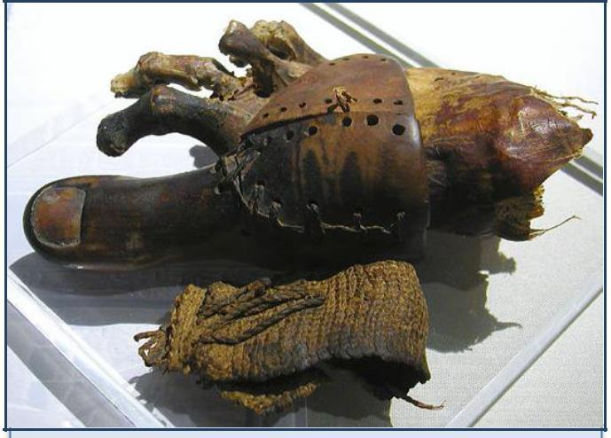

Figure 1.1 – Prosthetic toe made from leather and wood.

**Mechanical Body Control Prostheses**

Body powered prosthetics are controlled via a harness connected to the user. They are generally a simple device such as a mechanical hook which is linked to elbow/shoulder movement figure 1.2. Although these devices are relatively simple they remain the most popular type of prosthesis today.

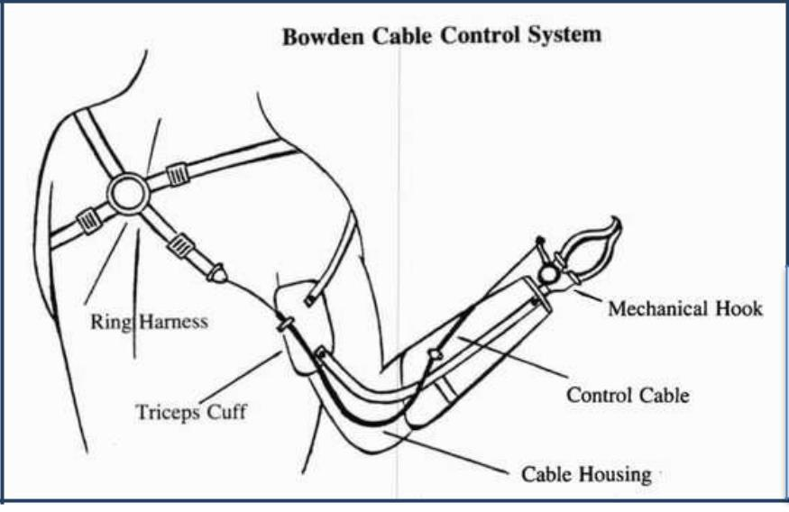

Figure 1.2 – Body powered hook .

Page | 2

**Myoelectric controlled prosthesis**

Myoelectric prostheses measure electromyography (EMG) signals generated from the contraction of muscles near an amputee’s residual limb as shown in fig: 1.3. These signals are measured through electrodes placed on the surface of the skin or embedded directly into muscles. These signals are then amplified and sent to a microcontroller which analyses this information and controls the internal actuators. Myoelectric devices allow for far greater amounts of control than mechanical devices.

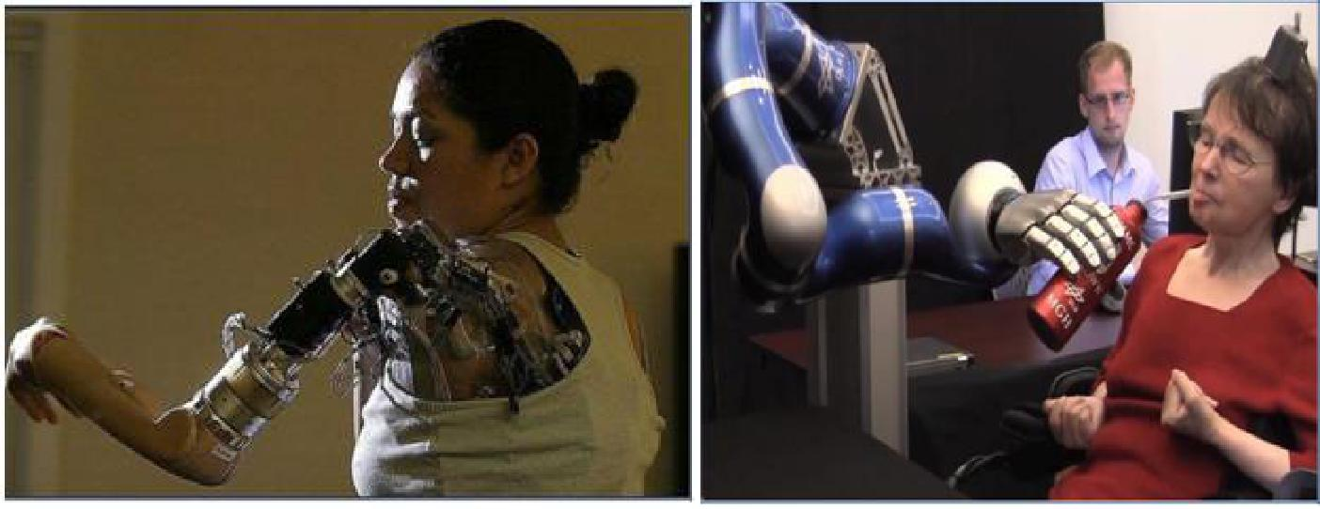

Figure 1.3 – Advanced DARPA myoelectric Figure 1.4 – Paraplegic woman uses her

|  |  |  |
| --- | --- | --- |
| prosthetic arm | thoughts to guide a robotic arm |  |
|  |  |

**Direct brain interface**

The most cutting edge type of control is a direct brain neural interface as shown in fig: 1.4. A surgical procedure places electrode arrays on the surface of the brain which are attached to pedestals implanted into the patient’s skull. As the patient thinks of motion signals detected on the pedestals are used to control the movement of a robotic arm. This type of technology is still in its infancy but has already demonstrated disabled people controlling bionic devices with their thoughts alone**.**

Page | 3

**CHAPTER- 2**

**PROBLEM IDENTIFICATION & LITERATURE REVIEW**

The overall goal of prosthesis is to return as much functionality as possible to a person missing a limb. An ultimate goal would to one day be able to perfectly replace missing limbs. The aim of this work is to design and build a 3D printed prosthetic arm. A user of this device will be able to control the arm via muscular flexing detected using surface electrodes placed on the skin.

Modern 3D printers allow for detailed mechanical components to be created and assembled relatively fast. Fabricating complex designs using other methods would be far more expensive and would not be possible in such a short period of time. To actuate the device the first approach is to implement an artificial tendon network. This method is used to actuate various robotic hands which will be discussed in the literature review section. The benefits of this system are that it is a low cost and relatively simple way of controlling fingers.

Another option would be to design a rigid joint linked system to control finger movement. Such a solution is in fact more popular among commercial prosthetic arms; however trying to design a small intricate gear linkage system from weak 3D printed components would not be possible with the available 3D printers. Details of the systems inner workings shall be discussed appropriately throughout this thesis. There is always more than one solution to any problem and many compromises have been made in design of this device.

It is extremely difficult to produce an exceptional design from scratch. Many solutions may seem plausible at first but later lead to unforeseen problems. Trying to perfect the first design over several months is not only wasteful of precious time, but also leads to a narrow minded approach. A far better method of attack is to produce the first prototype as quickly as possible, analyze the system and make improvements. 3D printing allows us to easily manufacture new and improved designs.

**2.0 Literature Review:**

Several arms such as the Be-bionic 3 and iLimb are myoelectric controlled robotic arms commercially available to the public. Numerous more prosthetic arms exist in research around the world which are

Page | 4

usually developed as prototypes to test advanced designs and concepts. Research prosthetics are generally more complex in terms of mechanical design and control and monitoring systems but are inferior to commercial devices in terms of practicality, cost and robustness.

**2.1 The Human hand:**

The human hand comprises of at least 27 bones (depending on the individual) , more than 30 individual muscles and over 100 named ligaments, nerves and arteries. As shown in fig: 2.1. Prostheses aim to replicate the functions of the human body and return functionality to persons with missing extremities. No current prosthetics can match the dexterity, flexibility and fluidity of the human hand. Before any further discussion, let us briefly explain the meaning of a “degree of freedom” (DOF) for a reader with a non-engineering background.

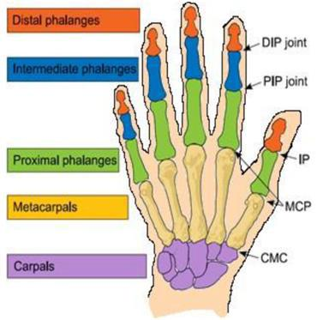

Figure 2.1 – Major Bones in the human hand.

Page | 5

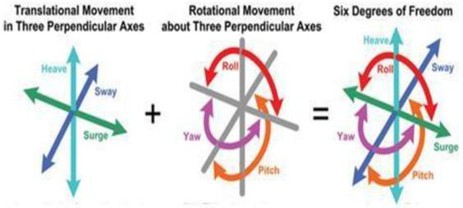

Figure 2.2 – Degrees of freedom at a single point.

Looking at the fig 2.2, imagine a point in space. From this point we can translate (move) along 3 different axes, i.e. we can move forward/backward, up/down and left and right. At the same point we can also rotate around 3 different axes. The human neck for example has 3 degrees of rotational freedom – we can look left/right, up/down and tilt our head sideways. So in total a single point can have a maximum of 6 degrees of freedom (3 translational, 3 rotational).

The human finger in total has 4 degrees of freedom as shown in fig 2.3. Three of these are the rotations of each joint (DIP, PIP, MCP) which combine to control flexion and extension of the finger. The knuckle (MCP joint) also allows for abduction/adduction (wiggling the finger from side to side).

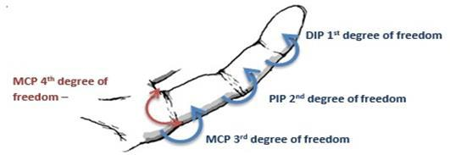

Figure 2.3 – Depiction of the degrees of freedom in a human finger

In the thumb the lower CMC joint also allows for abduction/adduction – which gives 5 DOFs in the thumb. Finger and all joints in the human body are actuated (moved) via contraction of muscles and tendons.

Page | 6

**2.2 Capabilities of Prosthetic hands**

The vast majority of commercial prosthetic fingers are actuated through a joint linkage as shown in fig: 2.4 systems powered by DC electric motors. Kinematic models for various prosthetic fingers are show below. Each finger incorporates its own mechanism to mechanically couple joints together. Rotating the metacarpal joint (knuckle) simultaneously rotates the higher phalange joint.

The problem with this type of design is that there is no control over individual finger joints. All joints in the finger are controlled through a single actuator which means the entire finger has only a single degree of freedom – these fingers can only open/close in a single way. In reality a human finger has control over individual joints so is capable of flexing in a variety of ways, shown in fig 2.4.

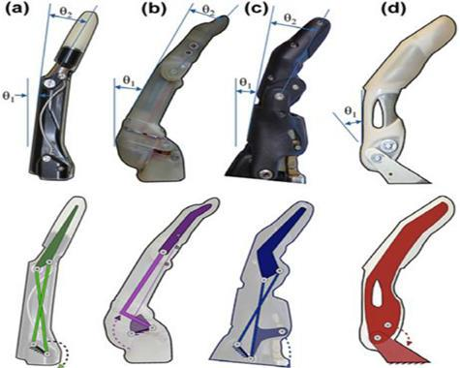

Figure 2.4 – Commercial finger images (top) kinematic models of finger joint coupling mechanism (bottom)

Although commercial prosthetic fingers may have the same number of joints as a human finger, they have fewer degrees of freedom. Usually 1 or 2 compared to 4.

Page | 7

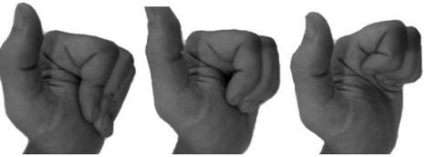

Figure 2.5 – Various flexion arrangements of the human fingers – not possible with modern prosthetic hands

Dexterity arises from the numerous degrees of freedom of the human hand. The fine motor control a person has over their individual finger joints allows for a vast array of intricate tasks to be achieved. In contrast, commercial prostheses are limited to simple tasks partially due to the lack of fine control in the fingers. For example, trying to knit, sew or play a musical instrument like a guitar with a modern commercial prosthetic device would be extremely difficult if not impossible.

Another critical design point in commercial prosthesis is durability. The average user will wear a myoelectric prosthetic hand in excess of 8 hours per day. Therefore, prosthetic arms for commercial use must be robust, lightweight and packaged into a closed system that can be attached to an amputee. Mechanical complexity determines the degrees of freedom in the system; however, there is usually a trade-off because increasing complexity can lead to an increase of the size of the device and also reduce robustness and durability.

**The Bebionic 3**

The Bebionic 3 is a world leading commercial myoelectric arm. Like others of its kind, the Bebionic 3 uses a predefined grip system. A user can select from 14 different grip patterns using muscle activity around their upper forearm. The user does not essentially have control of individual finger movements, rather they can select a grip pattern and then use muscle activity to activate the movements of that specific grip. Four of the fourteen grips of the Bebionic 3 are shown in below figure 2.6.

Page | 8

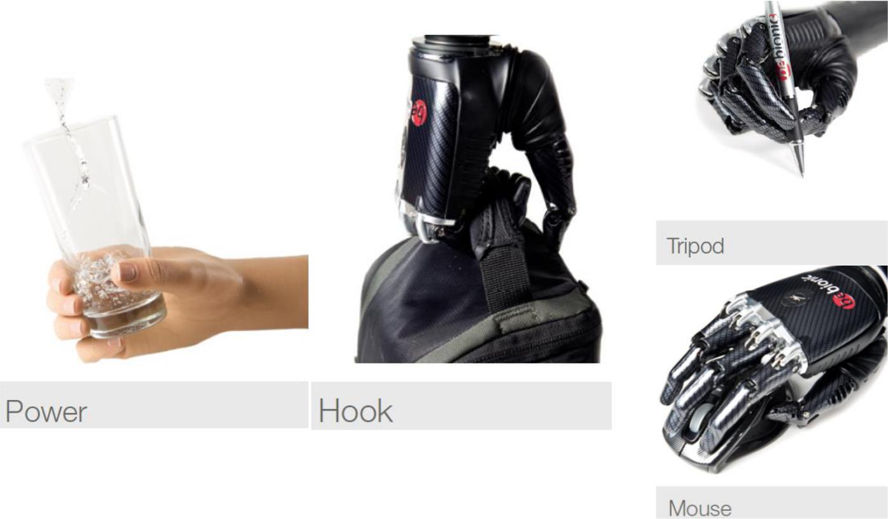

Figure 2.6 – Various grip patterns of the Bebionic 3

The problem with a predefined grip system is that the user cannot finely control finger positions in order to grip a specific object or complete a task. Rather, a user must choose a grip pattern that best suits the job at hand and then actuator that grip pattern.

Furthermore, the user must cycle through a number of grip patterns before they get to their desired choice. For example, unzipping a bag, picking up a heavy object, placing it in that bag and then zipping the bag up could require a number of grip changes. As a result certain simple tasks like this could actually take quite some time to complete and can become tedious and frustrating.

The thumb accounts for arguably 40 percent of human hand use [1]. Thumb design is critical in all prosthetic hands and is more complex than the other fingers.

The Bebionic 3 has an adjustable thumb which can be placed in an opposed or non-opposed position, the difference between these positions can be seen in the images below. This prosthesis cannot directly change the thumbs position. In order to switch between opposed and non-opposed positions the user must apply an external force to “click” the thumb into position, e.g. use the other hand to change the prosthetic thumb position.

Page | 9

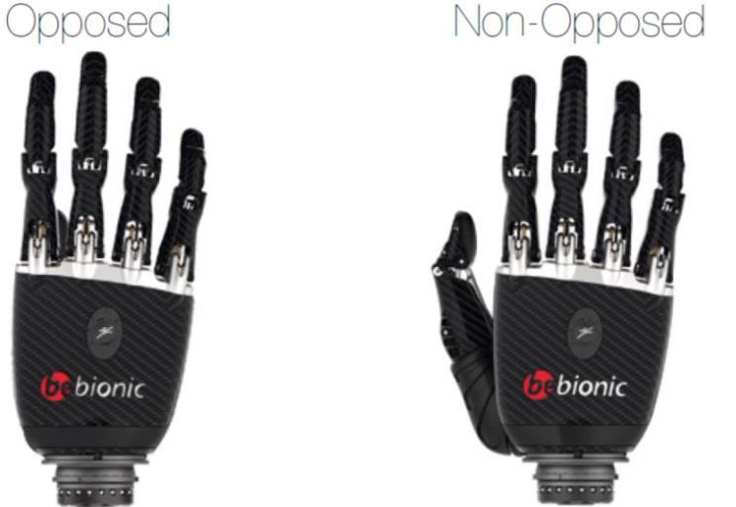

Figure 2.7 – Opposed and Non-opposed thumb positions of the Bebionic 3

Suppose a user of the Bebionic 3 is using a computer mouse. If that user reaches to pick up a bottle of water not only would they have to change the thumb position using their other hand, they would also need to cycle to a new grip state. The user would be better off using their other biological hand to fetch the water bottle in the first place. In such a situation this prosthesis provides no practical benefit.

With all that being said, prosthetic devices are intended to provide more than functional practicality. For many amputees, the loss of an extremity is also accompanied by a significant decrease in confidence and self esteem. A prosthetic arm can help alleviate these issues.

Physical appearance is an important aspect of prosthetic arms. A survey of myoelectric prosthetic hand users found that the majority of adult users were dissatisfied with their devices cosmetic appearance.

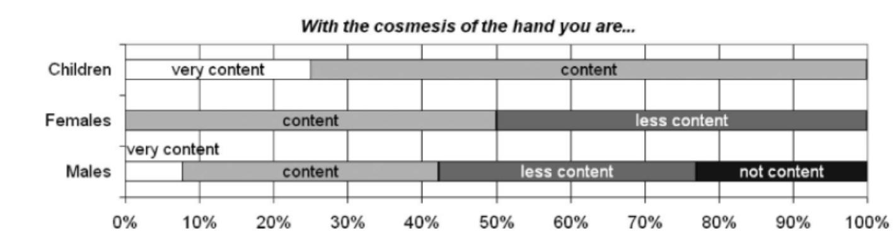

Figure 2.8 – Survey results of myoelectric prostheses users

Page | 10

The Bebionic 3 is controlled through electro myography (EMG) electrodes placed on the surface of the user’s skin. The placement of these electrodes depends on the level of amputation but is usually around the upper forearm. Bebalance computer software can be used to adjust a number of settings to enhance the user’s control of the device and tune the system to the user’s myoelectric signals.

The level of EMG control is dependent on the specific amputation but is generally limited to only a few different commands which cannot be executed simultaneously.

In fact, it is due to this limitation in control that a predefined grip system and a manually adjustable thumb were designed. If a more complex system was designed the user would simply have no way of controlling it.

**iLimb digits**

One major difficulty with developing prosthetic arms is that amputation can occur at any point along the arm and is unique in every case. The Bebionic 3 arm previously discussed incorporates electric motors into the palm to actuate the fingers. As a result the Bebionic would be of no use to an amputee who has lost several fingers but still has their palm intact.

The iLimb digits developed by touch bionics incorporate electric motors directly into the prosthetic fingers. This allows for the palm area to fit into a socket connection attaching the prosthetic fingers to the hand. The image below shows possible amputations which would be suitable for use of the iLimb digits.

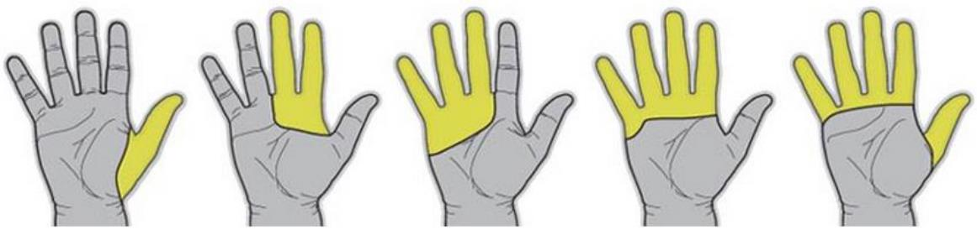

Figure 2.9 – Examples of amputations suitable for the iLimb Digits

A custom socket is designed to fit around the remaining area of the users palm and as many digits as necessary can be added to the system. Like the Bebionic 3, the iLimb digits are controlled through EMG electrodes, which are placed over muscle regions in the palm. A small package must be worn around the user’s wrist which contains the battery and controller for the system. A disadvantage of this

Page | 11

system is that relatively small motors have to be used to be able to fit inside the fingers. This leads to digits which move slower and are weaker than those in other commercial prostheses.

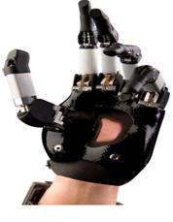

Figure 2.10 – iLimb Digits attached to an amputee four fingers and the thumb but palm still intact

**Vanderbilt Hand**

Research prosthetic devices are designed to test advanced mechanical designs and sophisticated control methods. Most research hands require an external power system, making them non-suitable as an attachment to an amputee. Many research arms like the Vanderbilt and Bologna Universities anthropomorphic arms experiment with artificial tendon designs to drive finger movements– as opposed to a mechanical linkage system in commercial devices.

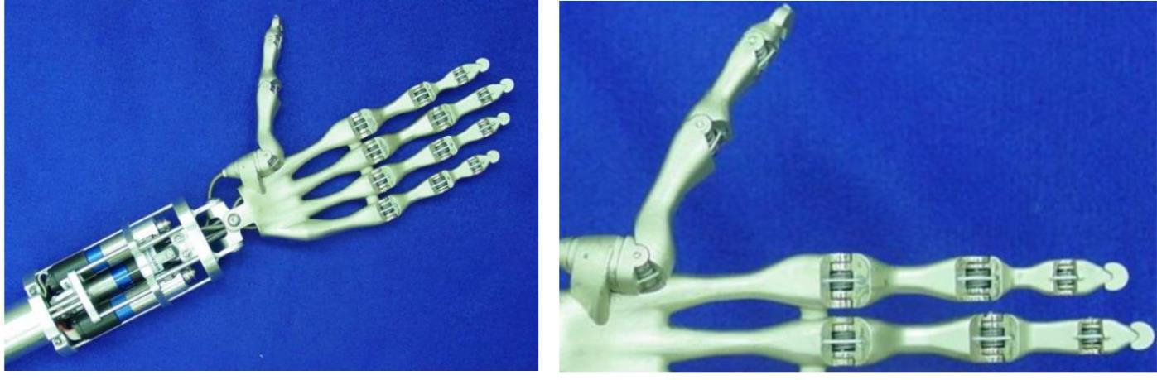

Figure 2.11 – Artificial tendon driven anthropomorphic hand

The above images show the tendons (white wire) running through the fingers and thumb. Brushed DC motors drive a pulley system which tensions the tendons. This tension results in all three finger joints closing simultaneously. In order to open the fingers, springs have been implemented into each joint.

Page | 12

When tension is released in the tendons these springs return the finger to its initial open position. The image 2.12 shows the coiled steel springs incorporated into each joint.

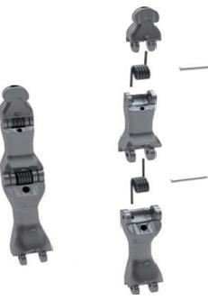

Figure 2.12 – Integrated springs

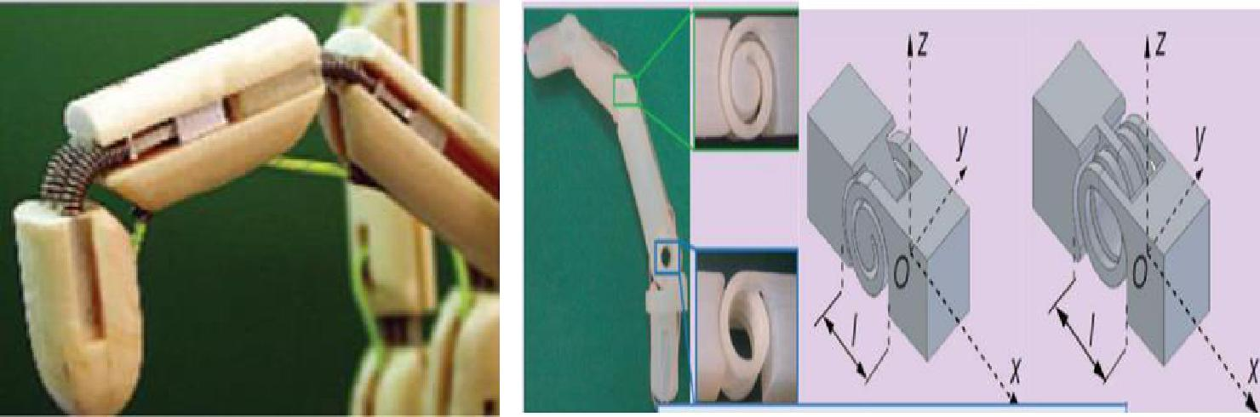

Figure 2.13 – Close wound linear spring Figure 2.14 – 3D printed integrated spring design

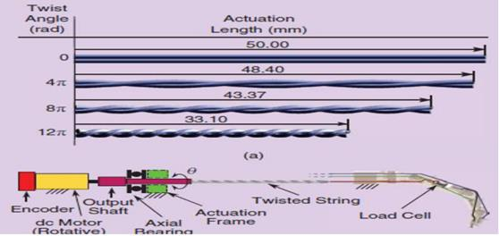

Figure 2.15 – Twisted tendon actuation method

Page | 13

We can see above that linear springs can be used to return fingers to an open position or the spring mechanism can be directly incorporated into the structure.

The UB hand IV has also experimented with a twisted string actuation system. Essentially, a DC motor is used to twist two tendons together. This shortens the length of the tendons which generates tension and closes the fingers.

The big advantage of this method lies in the fact that there is a direct transformation of rotational motion in the motors to linear motion in the tendons – no intermediate pulley system is required to move the fingers. Another advantage is that large forces can be exerted by the fingers. Essentially, the tendon pair can continue to be twisted, increasing the force exerted by the finger – until of course there is a mechanical failure somewhere.

However, this can be a slow way of actuating fingers since many rotations are required in order to fully close a finger. In their most recent public video it seems the UB hand researchers have switched to using Servo motors to control fingers for improved speed.

The UB hand IV as shown in fig: 2.17 achieve a high number of DOF by using a large tendon network. The commercially available Shadow Hand also utilizes a large tendon network and achieves

20 DOF’s The Shadow Hand however uses pneumatic air muscles to tension its artificial tendons. In both cases a large area is required to drive all the tendons which make the systems too bulky to be attachable to an amputee.

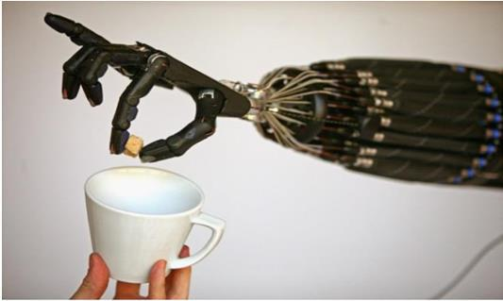

Figure 2.16 – Dextrous Shadow hand

Page | 14

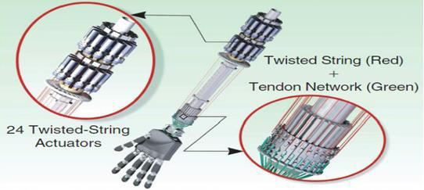

Figure 2.17 – UB hand IV tendon network

One major advantage that artificial tendon driven prosthetic hands have over earlier discussed mechanically joint linked system is what is known as joint conformity. Joint conformity allows fingers to adapt to the shape of the object they are grasping. Joint linked fingers, like the Bebionic, are stiff and rigid when they close; tendon systems however have some flexibility at the joints, illustrated below as shown in fig: 2.18.

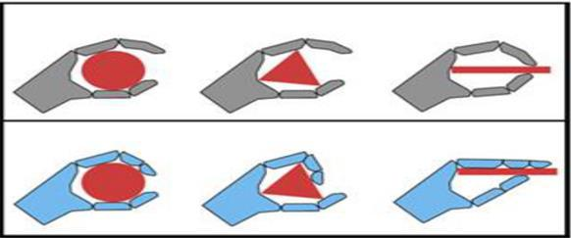

Figure 2.18 – Depiction of joint conformity

**22 Degree of Freedom APL Hand**

One of the most advanced modern prosthetic arms is the 22 degree of freedom Intrinsic Hand developed at the John Hopkins Applied Physics Laboratory as shown in fig: 2.19. This hand has been developed through DARPA initiative and funding and has unmatched mechanical dexterity.

Page | 15

To achieve such fine control designers incorporated a total of 15 miniature DC motors directly in the fingers, palm and wrist.

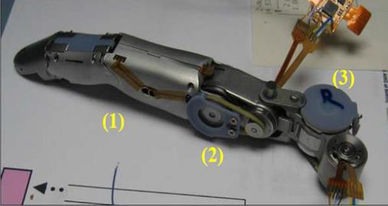

Figure 2.19 – High DOF finger module

Furthermore, this device is designed to fit to a 50th percentile female arm making it truly exceptional in terms of its complexity and size. The Intrinsic Hand is able to replicate almost every movement of the biological human hand.

Using standard EMG sensing techniques as shown in fig: 2.20 there is no way of obtaining enough control for a user to practically use all the degrees of freedom of this device. However, DARPA is further funding the development of a prosthesis/brain neural interface to connect the user’s nervous system directly to inputs in the arm.

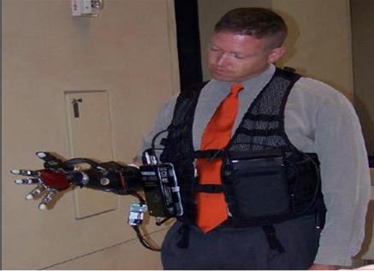

Figure 2.20 – APL intrinsic hand being used by an amputee

Page | 16

**Shape Memory Alloy Actuation**

Another interesting method of actuating prosthetic hands is by using shape memory alloys

(SMA’s). SMA’s return to a predefined shape or size when subject to the appropriate thermal procedure (heating or cooling). The design below from Vanderbilt University uses SMA springs which contract when heated, therefore tensioning tendons which close the fingers.

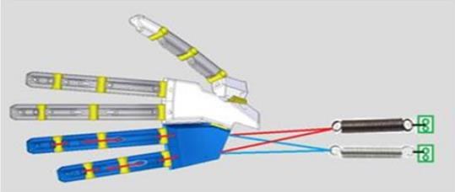

Figure 2.21 – SMA’s used to pull tendons which close/open ring and pinky fingers

In this design an electrical current is passed through the SMA’s to heat them up and initiate contraction. There are two major problems with this method though

* Designing a precise control system for SMA actuators is very complex. Contraction rate of the SMA, spring response and varying weights of objects grasped all contribute to this problem.
* Heating the SMA and then waiting for it to cool can take quite some which makes closing and opening a finger a relatively slow process.

At the University of Utah researchers have used hot and cold water reservoirs to speed up the SMA actuation process. Fingers in this system flex and extend in a reasonable amount of time but there is a very large area required for heating and cooling apparatus to drive this system and reservoirs of water must be present. As this technology is developed further SMA’s may become a viable actuation option for prosthetic hands. A great benefit it that they are noise free and low weight.

Page | 17

One final note about research prosthetic hands is that there is a vast number of actuation methods not discussed, pneumatic, hydraulic and so on . In almost every situation the apparatus required to drive the systems are bulky and take up far too make space to be able to be fitted to an amputee.

**3D Printed Bionic Arms**

Over the past couple of years developing 3D printed bionic limbs has become quite popular. InMoov is an independently run project developing a life like humanoid robot from 3D printing technology. The entire project is open source and provides great mechanical design insight into producing 3D printed robotic body parts.

The open source nature of this project allows the public to access computer aided designs and follow step by step guides on how to 3D print and assemble this system. The InMoov fingers are controlled by tendons actuated through servo motors placed in the forearm.

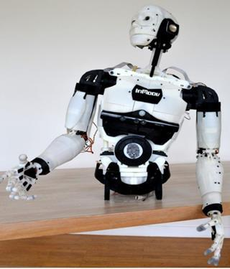

Figure 2.22 – 3D printed humanoid

Page | 18

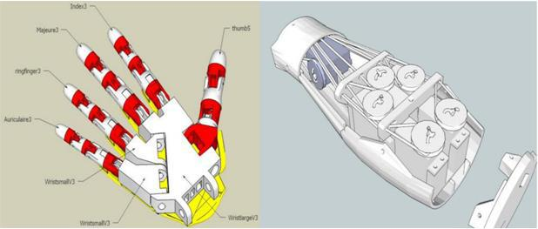

Figure 2.23 – Design of 3D printed hand and forearm

The InMoov fingers (including the thumb) only have a single degree of freedom which limits the dexterity of the hand. However, this is a simple solution which has a great advantage over other anthropomorphic hands which is that this design is low cost and easily manufactured through 3D printing.

The problem with the InMoov hand is that the Servos take up the entire forearm leaving no room for it to be attached to a stump between the elbow and wrist.

**2.3 Connection to the Body**

**Socket Design**

The first goal of prosthetic management is protection of the residual limb since 90% of upper limb amputations arise from physical trauma. Prolonged pressure exerted on damaged soft tissue areas can lead to a significant compromise of the remaining appendage. Problems an amputee may experience include pain, swelling, blisters, skin irritations, edema, and a restriction of blood flow.

Sockets must be designed in a manner that is safe for the user, comfortable, hygienic and distributes the weight of the prosthesis in an optimal manner.

The most common way of fitting a prosthetic is by creating a custom socket that fits around the amputees stump. This socket can either be self-suspending, suction fitted or secured by harnesses

Page | 19

to the user. Comfort and load distribution can be increased by providing some form of padding such as a prosthetic sock, inflatable air pockets or by reducing the density and stiffness at a sensitive region.

Several lost cost prosthetic arms use some form of thermo softening plastic to create a custom socket. A plastic sheet is heated and formed around an amputees stump. A prosthetic sock can be worn to create a snug fit between the user and the device.

**Ossiointegration**

Ossiointegration is the process of permanently integrating a non-biological component with a human bone. In prosthetic devices a titanium stud is screwed into a long bone in the arm or leg at the amputation site. Over time the titanium and bone fuse together to create a firm anchor point for the prosthetic to be attached. Ossiointegration is not an overly common practice, however it does offer several benefits including.

* + A strong, sturdy anchor point
  + No need for soft tissue to bear the weight of the prosthesis No skin/blood flow issues induced by a socket
  + No fitting problems due to a gain or loss in weight

1. **User Control**

**Electromyography sensing**

Myoelectric signals are electrical pulses within the body produced by contracting muscles.

Surface electrodes on the user’s skin can detect these small signals and in the case of prosthetics be used to control the device.

The problem with surface EMG techniques is that there is a lot of cross talk between muscle signals. Because muscles groups, especially in the arm, are physically close together, it is difficult to distinguish exactly which muscle is generating the measured signal via the surface electrodes. One way of alleviating this problem is through target muscle reinnervation (TMR). TMR is a surgical procedure which takes residual nerve endings from an amputation site and spreads them

Page | 20

across an alternative intact muscle group. Because the nerves and corresponding muscle contractions are now spread over a larger area it is easier to decipher individual signals. Surface

EMG electrodes require a clean and secure connection to the user’s skin which makes measurements susceptible to sweating and electrode displacement.

**Implanted myoelectric sensors**

Implanted myoelectric sensors (IMES) are inserted directly into targeted muscles through a surgical procedure. Using IMES for EMG control allows for relatively cross-talk free signals. This means muscle signals are more distinguishable and deeper muscles can also be used for control. As a result this method allows a user to have more control over their prosthetic device. Users of IMES systems have been able to independently control their prosthesis’ thumb, fingers and wrist rotation simultaneously.

**Brain Controlled Interface**

The most cutting edge form of control is a direct brain interface be researched and developed by DARPA. Two sensor arrays placed on the surface of the brain through a surgical procedure are wired to two pedestals embedded in the skull. A patient using this technology has been able to control a robotic arm in 3 dimensional space as well as open and close the hand – all through the power of her thoughts alone.

**2.5 Sensory Feedback**

One major problem of many prosthetic devices is that they lack feedback to the user. The sense of touch is a natural feedback mechanism which allows a person to make physical adjustments both consciously and subconsciously. With no form of feedback a user must rely entirely on vision to determine the position and force of their prostheses. Survey results show almost all users of myoelectric prostheses want some form of modern sensory feedback [9]. Modern prostheses can provide feedback by stimulating senses in some area of the body. Vibration motors and temperature pads placed on the surface of the skin provide rudimentary sensory substitution. The majority of myoelectric prosthesis users found these forms of feedback to be useful. Another emerging form of feedback is through electro-tactile arrays. By electrically stimulating arrays of

Page | 21

electrodes a false sense of touch can be created. For example, an electro-tactile array on a smart phone screen can create artificial surface textures of wood and stone.

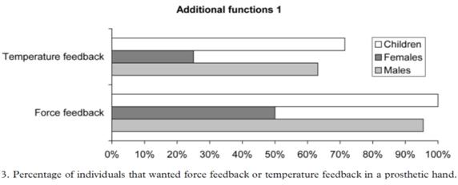

Figure 2.24 – Results of a survey on myoelectric prosthetic arm users

Another emerging form of feedback is through electro-tactile arrays. By electrically stimulating arrays of electrodes a false sense of touch can be created [26]. For example, an electro-tactile array on a smart phone screen can create artificial surface textures of wood and stone. Electro-tactile pads could be fitted around the stump of an amputee generating artificial senses of touch. The stimulating signals could be controlled via pressure sensors connected to fingers tips. Essentially this would shift the sense of fingertip touches to the stump.

Page | 22

**CHAPTER-3**

**COMPONENT DESIGN & MANUFACTURING**

**3.0 Mechanical Design**

To create a useful myoelectric prosthesis it is necessary to have a well-designed mechanical system which mimics the functionality of the human arm as best as possible. Among many other things mechanical design involves how joints are actuated and the types of forces present in the system. The bionic arm design presented in this section can be entirely manufactured with a 3D printer and basic tools.

**3.0.1 Early Ideas:**

After researching several actuation methods for prosthetic arms an artificial tendon design was chosen. As seen in the literature reviews of the Shadow Hand, UB Hand and InMoov artificial tendons are a viable way of actuating bionic hands. The tendons can be any high strength line which does not stretch when tensioned. These lines connect to the fingers and are tensioned by motors in the forearm. Pulling on the tendons cause the fingers to open and close in order to make it portable and attachable to an amputee. Ideally we would like these motors placed as closely to the fingers as possible, however due to their relatively large size we cannot house the motors used inside the palm section. Instead the motors housed within the forearm.

**3.0.2 Ergonomics**

Ergonomics is the interaction between humans and machines. The field of prosthetics is interesting as it deals with ergonomics between prosthetics and amputees such – physical attachment to the body and sensory feedback. Ergonomics must also be considered for the interaction between a person’s prosthesis and other people. An ideal prosthesis is physically comfortable for the amputee to wear, easy and natural to control, provides useful sensory feedback and interacts well with its environment.

Page | 23

The dimensions of a large male hand have been used for design proportions. A universal goal in prosthetic design is to achieve shapes and sizes that match an average female physique. It is much easier to scale a design up in size rather than shrink it down to fit a smaller person.

Scalability has been kept in mind throughout the design process. Components can be easily rescaled in computer modeling software and printed relatively fast. This allows for various size prototypes to be developed with ease.

**3.0.3 Computer Assisted Design**

Solid works is a computer design software package made for modeling solid mechanical components and assemblies. Solid works is a popular tool in the engineering industry and has been used extensively in designing and analyzing mechanical components.

**Fingers**

Each finger consists of three individual printed components linked together with polypropylene pins. The artificial tendon loops around the inside tip of the finger to create a tendon locking point. This tendon runs through channels inside the finger to form an enclosed loop. When the tendon is pulled rotational forces are applied to all the joints and the finger curls up as shown in fig 3.1.

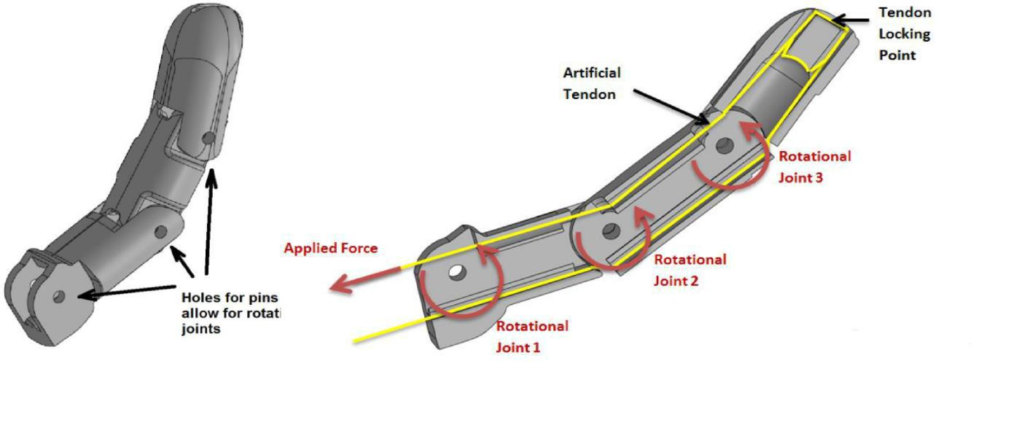

Figure 3.1- Index Finger Design

The tendon locking point is essential so that when the tendon is tensioned it pulls the tip of the finger and causes all joints to rotate. If the tendon did not lock it would just slip when tensioned

Page | 24

and the finger would not move. To open the finger from a closed position tension is applied to the other end of the tendon.

High quality braided fishing line has been used as it offers minimal stretch when tensioned. Nylon fishing line would stretch over time leading to a loss of tension which would negatively affect finger movements. Tendons in the biological human hand work in a similar way, however there are far more biological tendons attached to different bones – allowing for more precise control of the fingers.

**Thumb**

The thumb has also been designed in a similar fashion as shown in fig 3.2. Most commercial and research prosthetic hands aim to provide at least two degrees of freedom in the thumb. This thumb however only provides a single degree of freedom – it can only open/close in a single way. Guide holes have been incorporated into the design of the fingers and thumb to optimize tendon orientation and prevent the tendon lines from getting caught on a sharp edge.

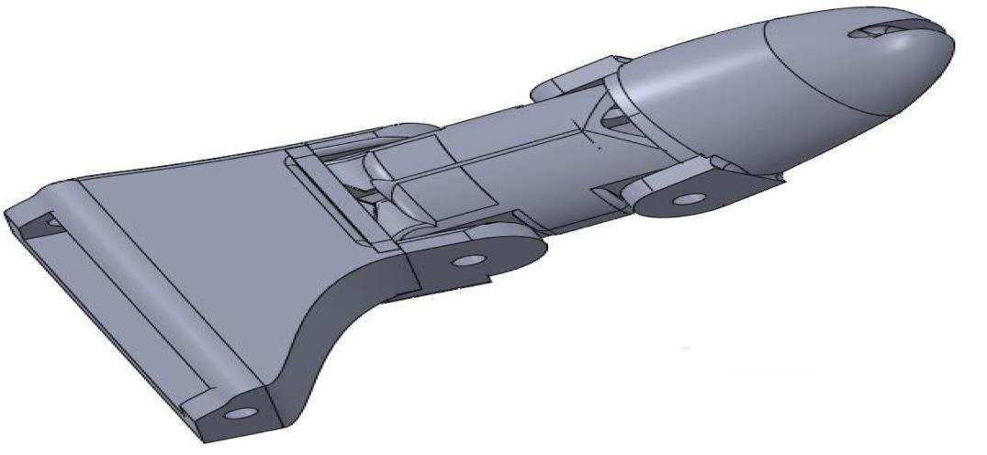

Figure 3.2 – Thumb Section

**Palm**

Each finger connects to the palm by polypropylene pins. The bottom of the palm incorporates part of the wrist rotation mechanism discussed on the following page.

Page | 25

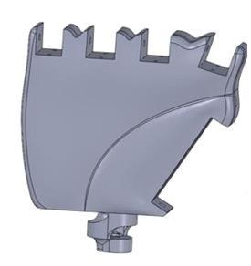

Figure 3.3 – Palm Section

**Wrist**

The continuous rotation servos have no angular position feedback. In order to rotate the hand to a specific position a mechanical block would have to be designed or less accurate open loop control methods would have needed to be used.

To avoid these problems it was decided to drop the gear system and instead press fit the palm section directly onto the shaft of the servo in the forearm as shown below. A passage through the pivot point of this joint allows the tendons to pass from the fingers through to the forearm. This allows for ± 90 degrees of rotation about the wrist and eliminates the problem of angular position control. The challenge with this design is providing enough strength. A large opening around the base cylinder had to be left for the tendons to pass through as the wrist rotates through 180O. This big opening concentrates stress around the small cross sectional area near the base of the palm. The images on the previous page show a wrist model which snapped during testing as it was too weak. The latest model operates on the exact same principle but includes far more material around the base to increase the component strength and prevent fractures occurring at this point.

Page | 26

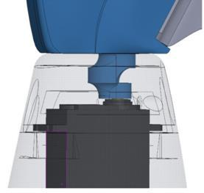

.

Figure 3.4 – Latest wrist rotation model

A small horizontal ridge around the outside of the small cylinder helps transfer lateral loads to the outer forearm shell. The tendons bottle neck as they pass through the small wrist opening to the motors in the forearm. Wrist rotation of 180O causes the tendons to twist and overlap which in undesirable but cannot be avoided. This type of design would not allow for the wrist to continuously rotate around as is would cause the tendons to twist around and become entangled.

**Drive system**

The tendons wrap around custom 3D printed servo horns creating a closed loop shown below fig 3.5. As the servo motor rotates one way it pulls on the tendon and closes the finger. To open the finger the motor is rotated in the opposite direction.

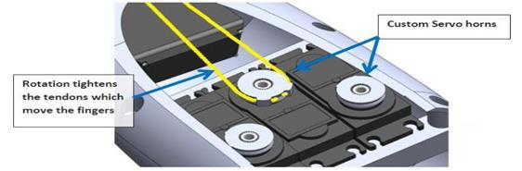

Figure 3.5 – Tendon actuation system

Page | 27

The fig 3.6 shows the artificial tendon drive for the index finger. All other tendons have been omitted for clarity. The thumb, index and middle fingers are connected to individual servo motors. Because the interior space of the arm is limited the ring and pinky fingers have both been tied to the same servo, meaning they open and close in tandem.

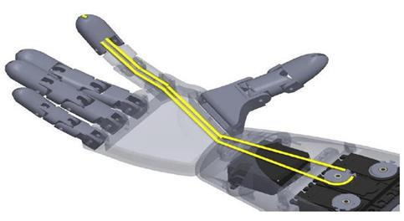

Figure 3.6 – Depiction of the tendon drive for the index finger

**Modularity**

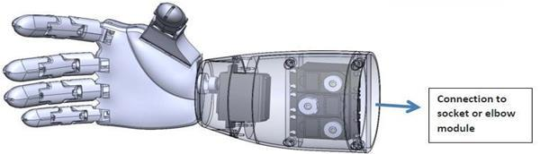

Figure 3.7 – Assembly of hand and modular forearm

Amputation can occur anywhere along the arm and is unique in every case. An ideal design facilitates connection to a stump located anywhere along the arm. The hand and wrist section could now be fitted to a person amputated along their forearm. This hand/wrist module can now also be connected to an elbow section which provides a solution for an above elbow amputation. Methods of mechanically fitting this prosthetic hand to an amputee have only briefly been touched on in this thesis and will be discussed further in the future work section. In order to design a socket connection a mould or

Page | 28

CAD rendering of an amputee’s stump would be required. Thermoforming plastic could be used to mould around the stump and some form of a harness or straps would most likely be required to produce a stable connection.

**Forearm**

Although the forearm section contains no moving components its design is still somewhat challenging as this section needs to house five servo motors, lithium polymer (LiPo) battery and allow for assembly. After the complete forearm section was designed it had to be split into separate components which could then be assembled with screws. If the forearm was 3D printed as a single large component then there would be no way of assembling the motors and tendons inside the arm. 3D printed PLA plastic is relatively weak and can easily be split by the turning a screw. To minimize the chance of a crack occurring guides holes for the screws have been incorporated into the design and care has been taken to ensure there is enough material to firmly support the screw.

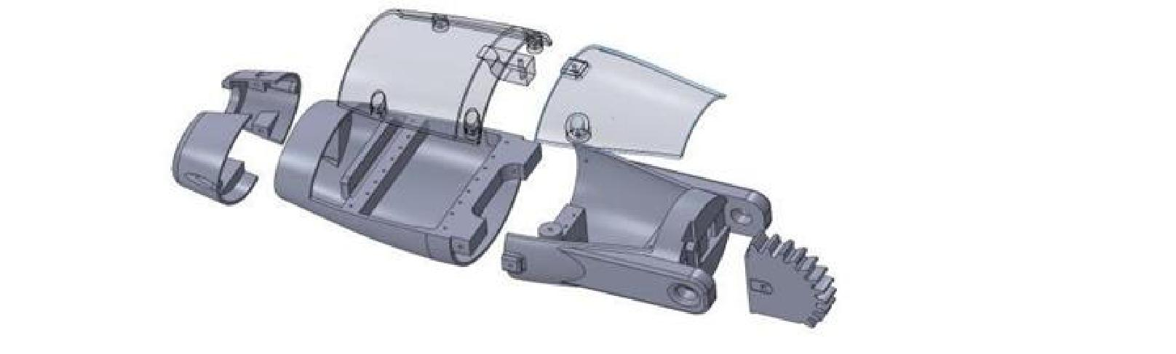

Figure 3.8 – Exploded view of forearm assembly

The two large sections of the forearm could be 3D printed as a single piece without affecting the assembly of the device. However, the UP 2 is simply not large enough to print an object of this size. The two pieces were printed separately and then secured together with super glue.

The Gear section seen in the image above is part of the elbow rotation mechanism. It is crucial that the quality of this gear be as dimensionally accurate as possible.

Printing the gear separately produces a printed gear of higher quality. This gear was then pressed into a groove in the forearm and glued into position.

Page | 29

**Elbow**

The elbow actuator must always move the weight of the forearm on top of any additional load. The minimum required torque to lift the forearm with no load is roughly 13.5kg-cm (see calculations). The TowerPro servo being used provides 10kg-cm of torque as shown in fig 3.9. In order to lift the arm using a single servo a gear system had to be implemented. Gears allow us to generate more torque (turning force) at the cost of speed. A small gear pressed onto the bicep servo drives a larger gear section connected to the forearm. The designed gear system increases the torque from the servo by a factor of 2.10.

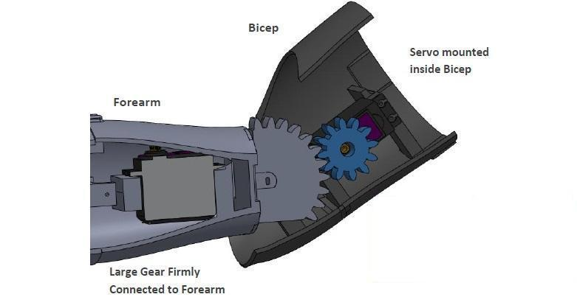

Figure 3.9 – Section view of the Elbow assembly.

This Elbow has been designed to provide 110 degrees of rotation. This allows for a straight orientation and a right angle bend. With the addition of the gears the servo now has to rotate the small gear by 290O to completely bend the elbow. As previously mentioned a standard servo can only rotate through 180O so modifications had to be made to increase the servos rotational range.

The elbow servo was opened up and the mechanical stop inside was removed. Inside servo motors there is also a small potentiometer which provides feedback to an internal chip controlling the rotation of the motor. This was removed from inside the servo and slotted into a groove in the large forearm gear.



Page | 30

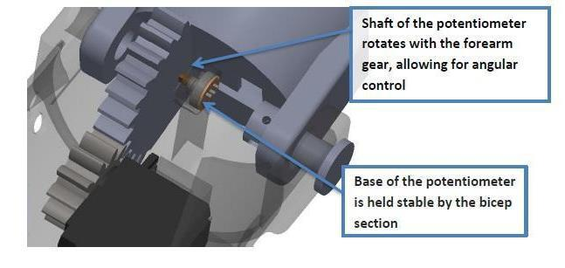

Figure 3.10 – Transparent view of elbow assembly

By mounting the potentiometer in the forearm we have altered the servos angular feedback. The potentiometer now rotates 2.1 times slower than before, resulting in an increased servo range of 380O – more than enough to move the elbow. However, by increasing the rotation range we have decreased the angular resolution of the servo as shown in fig 3.10.

The lower left image shows the elbow servo motor with its custom gear meshing with the gear on the forearm (left). The image on the right shows the shaft of the potentiometer slotting into the forearm gear. The motor and the potentiometer are fixed to the bicep section which is not shown below.

**3.0.4 Manufacturing & Assembly**

All mechanical components have been produced using an Ultimaker 2+ a fused deposition modeling 3D printer as shown in fig 3.11. This type of 3D printer produces what is known as support material which provides support to horizontal planes during printing. Care has to be taken when removing this support material as to not damage the component.

All the pins used within the device, such as at the finger joints, have been 3mm diameter polypropylene filament. After printing these pin holes were drilled with a 3mm bit to improve dimensional accuracy.

Page | 31

The UP 2 provides its own development environment which allows for fine tuning of the printer options. Several features have been experimented with such as print speed, layer resolution and extrusion temperature to produces high quality printed components.

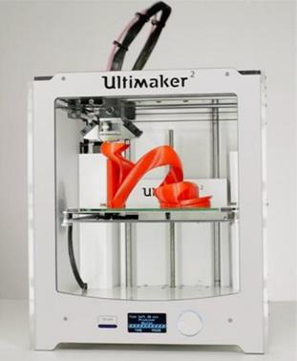

Figure 3.11 – UP 2 printing a component

1. **Electrical Design**

**Signal Flow Overview**

A user flexing generates an analogue signal which is amplified, rectified and smoothed by the EMG sensor board. The microcontroller uses this analogue signal to generate a pulse width modulated signal. This drives servo motors which tension the tendons causing the fingers to curl up.

Page | 32

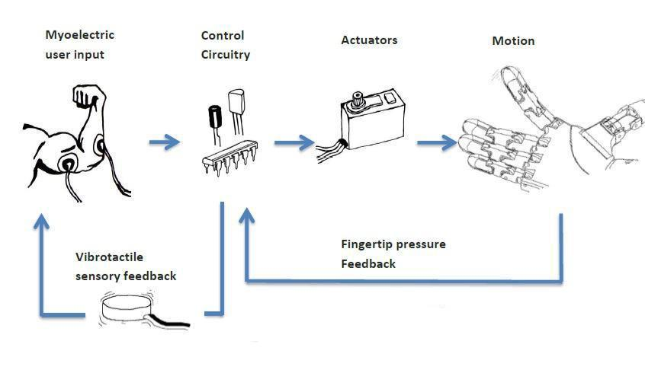

Figure 3.12 – Signal flow diagram

**3.1.0 Actuation**

As previously discussed the actuators used in this system are standard servo motors. These motors can be controlled to rotate to angular positions up to ± 90 degrees from rest.

Since the artificial tendons move fairly little in order to open and close each finger, the angular precision of each servo somewhat affects how precisely the fingers can be controlled. Relatively inexpensive servo motors have been used in this system to maintain a low cost. The use of higher quality servos would of course increase finger strength and precision but would cost significantly more.

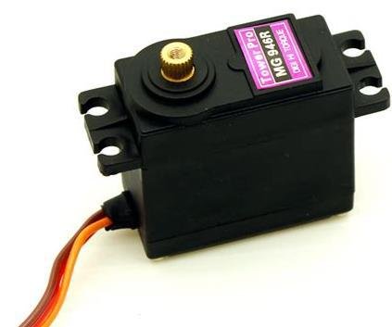

Figure 3.13 – TowerPro MG996r Servo motor

**3.1.1 Microcontroller**

Page | 33

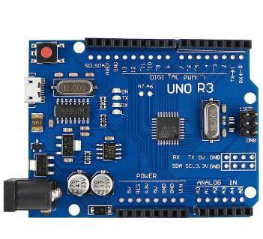

Fig 3.14- Arduino

The Arduino UNO is an open-source microcontroller board based on the Microchip ATmega328P microcontroller and developed by Arduino.cc. The board is equipped with sets of digital and analog input/output (I/O) pins that may be interfaced to various expansion boards (shields) and other circuits. The board has 14 Digital pins, 6 Analog pins, and programmable with the Arduino IDE (Integrated Development Environment) via a type B USB cable. It can be powered by a USB cable or by an external 9 volt battery, though it accepts voltages between 7 and 20 volts. It is also similar to the Arduino Nano and Leonardo. The hardware reference design is distributed under a Creative Commons Attribution Share-Alike 2.5 license and is available on the Arduino website. Layout and production files for some versions of the hardware are also available. "Uno" means one in Italian and was chosen to mark the release of Arduino Software (IDE) 1.0. The Uno board and version 1.0 of Arduino Software (IDE) were the reference versions of Arduino, now evolved to newer releases. The Uno board is the first in a series of USB Arduino boards, and the reference model for the Arduino platform. The ATmega328 on the Arduino Uno comes preprogrammed with a boot loader that allows uploading new code to it without the use of an external hardware programmer. It communicates using the original STK500 protocol. The Uno also differs from all preceding boards in that it does not use the FTDI USB-to-serial driver chip. Instead, it uses the Atmega16U2 (Atmega8U2 up to version R2) programmed as a USB-to-serial converter.

Page | 34

The Arduino/Genuino Uno has a number of facilities for communicating with a computer, another Arduino/Genuino board, or other microcontrollers. The ATmega328 provides UART TTL (5V) serial communication, which is available on digital pins 0 (RX) and 1 (TX). An ATmega16U2 on the board channels this serial communication over USB and appears as a virtual com port to software on the computer. The 16U2 firmware uses the standard USB COM drivers, and no external driver is needed. However, on Windows, a .inf file is required. The Arduino Software (IDE) includes a serial monitor which allows simple textual data to be sent to and from the board. The RX and TX LEDs on the board will flash when data is being transmitted via the USB-to-serial chip and USB connection to the computer (but not for serial communication on pins 0 and 1). A Software Serial library allows serial communication on any of the Uno's digital pins.

Rather than requiring a physical press of the reset button before an upload, the Arduino Uno is designed in a way that allows it to be reset by software running on a connected computer. One of the hardware flow control lines (DTR) of the ATmega8U2/16U2 is connected to the reset line of the ATmega328 via a 100 nano farad capacitor. When this line is asserted (taken low), the reset line drops long enough to reset the chip. The Arduino software uses this capability to allow you to upload code by simply pressing the upload button in the Arduino environment. This means that the boot loader can have a shorter timeout, as the lowering of DTR can be well-coordinated with the start of the upload. This setup has other implications. When the Uno is connected to either a computer running Mac OS X or Linux, it resets each time a connection is made to it from software (via USB). For the following half second or so, the boot loader is running on the Uno. While it is programmed to ignore malformed data (i.e. anything besides an upload of new code), it will intercept the first few bytes of data sent to the board after a connection is opened. If a sketch running on the board receives one-time configuration or other data when it first starts, make sure that the software with which it communicates waits a second after opening the connection and before sending this data. The Uno contains a trace that can be cut to disable the auto-reset. The pads on either side of the trace can be soldered together to re-enable it. It's labeled "RESET-EN". You may also be able to disable the auto-reset by connecting a 110 ohm resistor from 5V to the reset line; see this forum thread for details.

Page | 35

**Arduino pin diagram**:

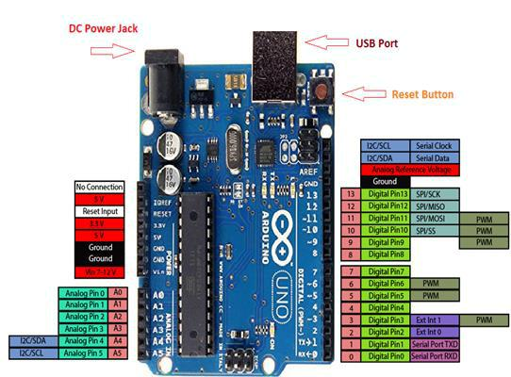

Figure 3.15- Arduino Uno Pin diagram

**3.1.2 Voltage regulators**

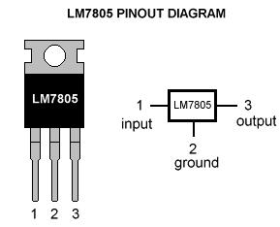

Figure 3.16- IC7805 Regulator

Power regulators have been used in order to control the voltage and power supplied to the servos and the microcontroller. These regulators prevent a situation in which a servo could be stalling

Page | 36

and drawing a large amount of current from the battery. If such a case happened to all six servos simultaneously it could easily damage the electronics or even cause a fire in a worst case scenario.

Out of availability 5V surface mount regulators have been used to supply the servos and a 3.3V regulator used to power the microcontroller. The specific regulators used output a maximum current of 1A.

A fair assumption is that each servo will need access to at least 500mA of current to operate. Therefore each 1A power regulator supplies two servos. These specific regulators hold the output stable at 5V. This results in slightly slower and weaker servo performance as ideal servo power is about 6.5V.

**3.1.3 Electromyography Sensor**

Easy to use single channel EMG sensor boards have been used to sense and measure muscle activity. This kit contains a small PCB and three surface electrodes. Two of these electrodes measure the voltage potential across a muscle and the third is a ground reference point placed on a boney feature.

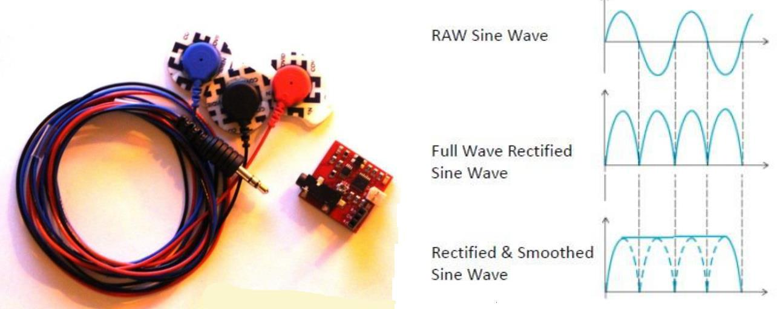

Figure 3.17 – EMG sensor kit & signal output

The muscle sensor kit is designed to be used directly with a microcontroller. As a user flexes, an internal amplification system converts minute electrical pulses into a rectified and smoothed signal that can be used as an input to a microcontroller’s analogue to digital converter.

Page | 37

**3.1.4 Power Supply**

It is important that this system is portable and completely powered by internal sources. Using a wall power supply is fine for testing and debugging but a prosthetic arm needs to be powered by a source an amputee can easily carry around.

Servo motors use a significant amount of current during operation. Disposable batteries would not be a good solution since the servos would drain power too fast meaning they would have to be replaced quite frequently. Lithium Polymer (LiPo) batteries offer a high energy density and are rechargeable.

There is a trade-off between battery life and battery size. Ideally we would like the arm to be able to run for several hours without needing to be recharged. However, to achieve this, the size of the battery may become too large to be housed within the device.

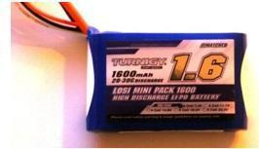

Figure 3.18– Lithium Polymer battery powering the device

The muscle sensor kits require very little power whereas the Servos and microcontroller require a significant amount. The muscle sensor kits require two power sources to create a positive and negative voltage reference. These sensors are sensitive to input voltage spikes and require a stable power supply to generate high quality signals.

For these reasons the EMG sensing boards are supplied power by two separate 9V batteries. Two disposable batteries should provide power for a substantially long time. When they do run out they can be easily and cheaply replaced.

A more sophisticated electrical system could link all components to a single power source using techniques to generate a negative voltage for the EMG sensors. This would reduce the size, weight and clutter of the current power supply system.

Page | 38

**3.2 Firmware Implementation**

**3.2.0 Servo Signals**

A pulse width modulated signal is used to control the servo motors. Every 20ms a pulse between 1ms and 2ms long is sent from the PIC microcontroller to the internal control circuitry of the servo as shown in fig: 3.19.

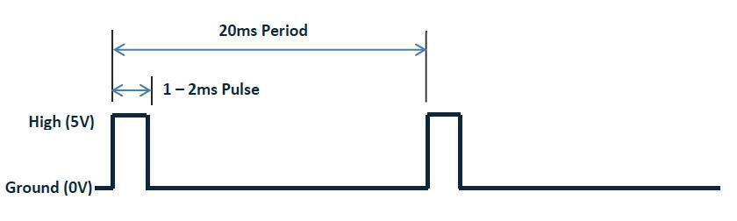

Figure 3.19 – PWM signals

A 1.5ms pulse rotates the servo shaft to its central position. Different pulse widths correspond to different motor shaft positions.

To create a PWM we could use a software timer to accurately control the timing and duration of a pulse. Another option would be to use the inbuilt PWM generator feature of the microcontroller. The problem with both these options is that there are not enough software timers to control each servo. Six servos need to be controlled and only four timers are available

For this bionic arm two 16-bit software timers have been used to accurately control six servosSix PWM signals need to be generated on individual output pins.

Every 3.3ms the beginning of a new pulse is started on a new output line. After six cycles 20ms have passed a new pulse begins on the first signal line and the cycle repeats. A software timer is used to control the 3.3ms period time. If for example only five servos were used then we would start a new signal every 4ms.

The image below outlines how two timers have been used to generate all six of the PWM signals.

Page | 39

A maximum of eight individual servos can be controlled using this method. Anymore and the time between the start of each pulse becomes less than the pulse width of each signal .Meaning another timer or method would have to be used.

**3.2.1 EMG Control**

As discussed in the electronics design section, each muscle sensor board outputs an analogue signal (0–3V) into an analogue pin on the microcontroller. The microcontroller performs and analogue to digital conversion on this signal storing the result as a 10-bit binary value which is used to control the positioning of the servo motors..

The basic EMG control is as follows.

* One electrode set measures myoelectric signals from a muscle region such as the bicep. As a user flexes the EMG signal is used to switch between different grip pattern states of the Arm. A state could be a precision grip, power grip or wrist/elbow rotation configuration.
* The other EMG sensor monitors another muscle region such as the forearm. Flexing the this muscle region actuates the specific state the device is in – fingers close or joints rotate to pre-set positions.

Using this method it is possible to control the opening and closing of different grips as well as allowing for wrist and elbow rotation states. However, only a single command can be executed at a time and it naturally takes a user some time to cycle between states. This means it is not possible to close individual fingers and rotate the wrist at the same time using this basic control.

Ideally we would like a system which allows the user to control the exact positions and force applied by each digit and also allow for control of several movements simultaneously.

A basic form of proportional control was implemented and tested on this device. This allows the user to close the fingers more by flexing harder. The magnitudes of the EMG signals were used to linearly increase the pulse widths of the PWM servo signals.

**3.2.2 Sensor Feedback**

Ideally we would like to include pressure sensors on each finger to provide some feedback. These sensors provide information to the microcontroller about how much force is being applied

Page | 40

at each fingertip. This information can be used to control vibration motors housed in a flexible band than can be worn around the upper arm. This provides some basic sensory feedback to the user letting them know if they are grasping an object and how much force they are applying.

**3.2.3 Program Flow**

The basic structure of the current program is outlined below.

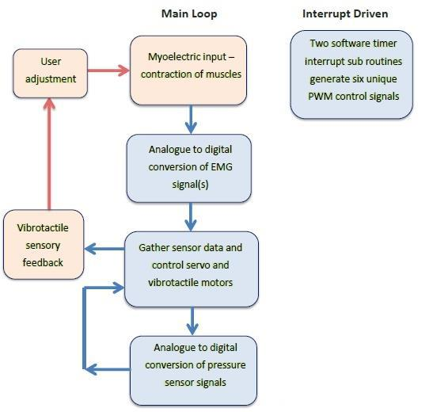

Figure 3.20 – Program flow. The light red sections indicate the human integration modules

Page | 41

**CHAPTER – 4**

**TESTING AND RESULTS**

The final system is a bionic arm offering six degrees of freedom and the ability to be controlled through myoelectric signals. The total design consists of thirty six individual 3D printed components

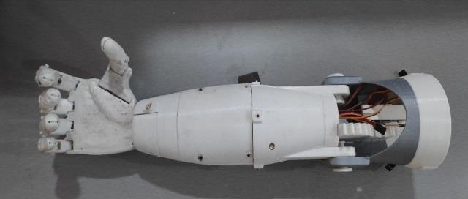

Figure 4.1 – Final 3D printed prosthetic arm

Several features of the prosthetic arm have been tested and measured to improve the performance and characteristics of the system.

**4.0 System Specifications**

The thumb, index and middle fingers each move independently and the ring finger and small finger move in tandem. The wrist allows for 180 degrees of rotation and the elbow allows for 110 degrees of bending. A user can control the motion of the arm through a set of EMG electrodes placed on their forearm and/or bicep. At this stage two electrodes sets allow for rudimentary control of the arms range of motions. The device is completely portable and has a battery life of more than 3 hours.

Page | 42

|  |  |
| --- | --- |
| **System Properties** | **Description** |
|  |  |
| System Weight | 950g |
|  |  |
| Material | PLA plastic |
|  |  |
| Tendons | Braided Fishing Line |
|  |  |
| Power Source | 2-Cell 7.4V Lithium polymer rechargeable |
|  | battery |
| Microcontroller | NODEMCU |
|  |  |
| EMG Sensors | Muscle Sensor Kit V3 |
|  |  |
| Servo Voltage | AP1117 – 5V output, maximum current 1A |
| Regulators |  |
|  | Table 4.1 – System specifications table |

**4.1 Component Strength**

Unfortunately, 3D printed components are naturally quite weak due to the way they are made. A 3D printed object is slowly built up by a nozzle extruding molten material in cross sectional layers. The boundary between two 3D printed layers is essentially an imperfection in the grain structure of the material. The ultimate tensile strength of 3D printed PLA is significantly lower than PLA formed by injection moulding. For example, LEGO blocks are made from PLA but are injection molded rather than 3D printed. Injection moulding results in much stronger components and improved surface finishes. 3D printed components offer poor mechanical properties which are dependent on the specific 3D printer being used and the quality of the print.

Several components broke when being handled and assembled. Many components had to be given an acetone coating after they had been printed. Acetone dissolves PLA so by allowing it the flow through cracks and seams the layers bond together better and component strength is improved.

Another method is to suspend components in an evaporating stream of acetone gas. This bonds layers together much better and increases the strength of components. It also creates a good durable surface finish. However, much care has to be taken to not overly dissolve component surfaces which could lead to significant warping of the part.

Page | 43

**4.2 Actuation**

**4.2.0 Fluidity**

The fingers move in a relatively smooth and natural manner. The fluidity of finger movements is dependent on several factors including friction between moving plastic components, servo control and also how well the tendons are tensioned.

The middle finger opens and closes exceptionally well. The ring and small finger do not move as smoothly and do not completely close. This is because both ring and small finger tendons are tied to the same servo which has to work to move both fingers in tandem. Since the small finger is a 0.8 scale of the ring finger it means its tendons do not have to move as far to open and close the finger. Neither tendon is actuated in an optimal manner which reduces the fluidity of the ring and small fingers.

**4.2.1 Strength**

Testing using small kitchen scales indicates the fingers can provide at least 300g of force each. Indeed the servo motors could be rotated more to further increase the tension on the tendons. This would effectively increase the closing force of each finger. The limiting factor in finger force is not the torque of the servo motors but rather the strength of the printed PLA components. If we kept increasing the tension applied by the servos either a finger component would break or a fracture would occur at the wrist.

The only sure way of determining the absolute maximum finger force would be to test to destruction. Unfortunately tests to destruction could not be carried out – otherwise there would be no working system to present.

Unfortunately the servo actuating the elbow joint is simply not strong enough to move the entire forearm reliably and smoothly. The servo used in the elbow is rated at 10kg-cm. A high quality top of the line servo could offer 25kg-cm, coupled with the torque increase from the gear system this would be more than enough to safely rotate the arm about the elbow. These super high torque servos would significantly raise the cost of the system.

Page | 44

**4.3 Control**

The basic Boolean EMG control allowed for different states to be cycled through and actuated. One state allowed for wrist rotation and another state allowed for finger actuation. It was possible to instruct the hand to close, rotate to a certain position, rotate back and then reopen. Such a movement could be used to grasp and pour a liquid from a bottle. However having to switch between the two states made the task slow and tedious using this basic EMG control.

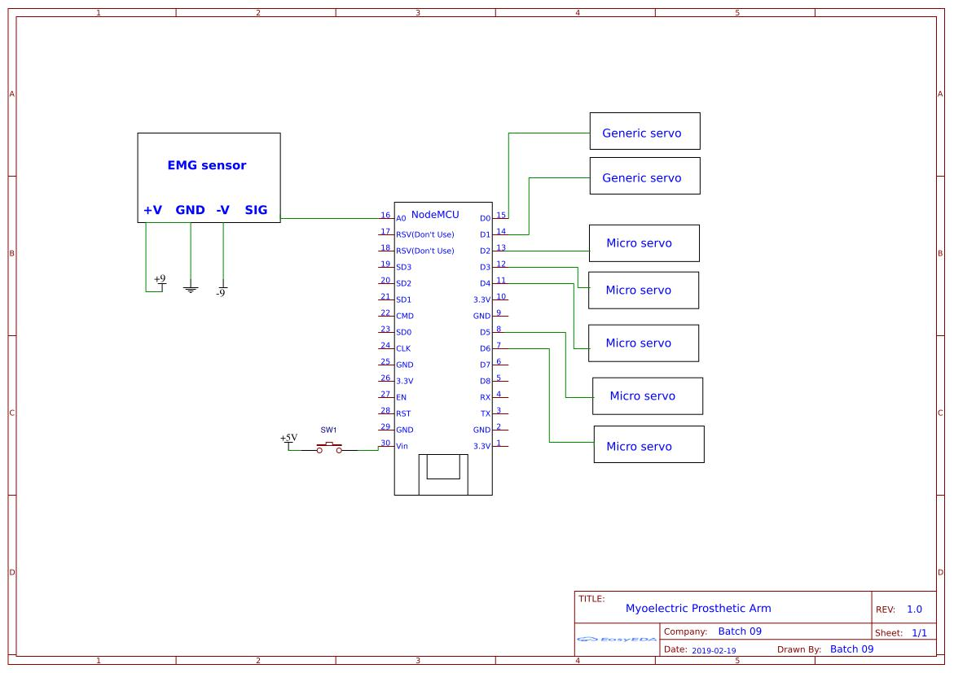

Figure 4.2 – Electrical design

Proportional control of the fingers worked fairly well – the harder the user flexed the more the fingers would close. However, this proportional control caused the fingers to start shaking when trying to close – which was due to noisy signals being used to control servo positions.

Page | 45

Initially the EMG signals were sampled every 100ms converting the magnitude of the signal to a decimal value. The servos were also updated every 100ms.

As seen in the oscilloscope images on the next page the EMG signals are quite noisy. This means the signal voltage level can significantly jump or drop in 100ms which results in the servos being instructed to constantly move around to different positions. This is especially bad with high level signals.

**4.4 Battery Life**

The LiPo battery being used is rated at 1600mAh. The maximum current the system can pull in any circumstance is around 3.1A. This corresponds to an extreme worst case battery life of roughly 30 minutes (1600mAh/3.1A). However, such a scenario would only happen if all the servo motors were continuously pulling at their maximum capacity – which would never happen for an extended amount of time.

A much more realistic estimate is an average current consumption of 75mA by each servo. Incorporating power requirements of the microcontroller and other electronics a reasonable estimate of 550mA required system power gives an estimate of just under 3 hours of battery life. In practice the battery life is significantly longer lasting up to 6 hours. This is because majority of the time the joints are at a rest position minimizing the power usage of the motors.

Page | 46

**CHAPTER – 5**

**CONCLUSION**

The academic goals of this thesis were initially uncertain and certainly change throughout the course of the year. The initial aim was to develop a low cost 3D printed myoelectric prosthetic arm. The goals and expectations for this thesis have been achieved and it is hoped that the presented body of work allows for several new thesis topics to be researched in the future.

**5.0 Overall System Performance**

The final system provides relatively good performance and characteristics for a prototype 3D printed model. The device is fast and responsive to electro-myography user input but offers limited strength. Over the course of testing the system has proven to be reliable and has required minimal maintenance since being assembled.

The biggest downfall of this design is its lack of toughness. Certain regions such as the wrist are at a high risk of breaking if the device is subject to moderate forces. In the real world a practical prosthetic arm must be able to absorb sudden shocks and support heavy loads without failing. Ways to improve the strength and toughness have been discussed in the previous results section.

**5.1 Benefits to an Amputee**

At this stage the presented prosthetic arm is not at a state where it can be used by an amputee

– it is more so a low cost bionic arm.

With the design of a proper socket connection the possibility exists for the University to arrange collaboration with a medical institute to allow the device to be tested and used by amputees. Such testing would be invaluable in analyzing and improving the devices performance.

**5.2 Implications & Contribution to the Field**

The presented device provides a platform for future research by final year engineering students to develop and test advanced prosthetic designs such as sophisticated EMG control algorithms, integrated pressure feedback and other advanced bio-mechatronic concepts and designs.

Page | 47

With future growth of the 3D printing industry advanced printers and materials will allow students to develop more ‘commercial-like’ prosthetic devices – robust and durable systems that could benefit a wide range of peoples with a missing limb.

With ongoing research improvements will hopefully lead to a system that is more durable and offers improved dexterity and control. Perhaps a future design will someday benefit amputees and improve the quality of people’s lives.

Page | 48

**APPENDIX**

include <Servo.h>

Servo servo1 ;

Servo servo2 ;

Servo servo3 ;

Servo servo4 ;

Servo servo5 ;

Servo servo6 ;

Servo servo7 ;

int angle = 0;

void setup() {

// put your setup code here, to run once: Serial.begin(115200);

|  |  |  |  |
| --- | --- | --- | --- |
| servo1.attach(16); //D0 | | // INDEX FINGER | "MICRO SERVO" |
| servo2.attach(5); | //D1 | // MIDDLE FINGER "MICRO SERVO" | |
| servo3.attach(4); | //D2 | // RING FINGER | "MICRO SERVO" |
| servo4.attach(0); | //D3 | // LITTLE FINGER "MICRO SERVO" | |
| servo5.attach(2); | //D4 | // THUMB FINGER "MICRO SERVO" | |
| servo6.attach(13); //D7 | | // WRIST JOINT | "GENERIC SERVO" |
| servo7.attach(15); //D8 | | // ANKLE JOINT | "GENERIC SERVO" |

}

void loop() {

// put your main code here, to run repeatedly:

int sv = analogRead(emg);

Page | 49

if(sv < 10){

servo1.write(180);

servo2.write(180);

servo3.write(180);

servo4.write(180);

servo5.write(180);

}

else if(sv < 20){ servo1.write(180); servo2.write(180);

}

else if(sv < 40){ servo2.write(180); servo3.write(180);

}

else if(sv < 50){ servo4.write(180); servo5.write(180);

}

else if(distance < 60){ servo6.write(180);

}

else if(sv < 70){

Page | 50

servo7.write(180);

}

else { servo1.write(0); servo2.write(0); servo3.write(0); servo4.write(0); servo5.write(0); servo6.write(0); servo7.write(0);

}

}

Page | 51

**REFERNCES**

1. Belter, Joseph T,M.S., B.S., J. L. Segil, Dollar, Aaron M, PhD,S.M., B.S. and R. F. Weir PhD. Mechanical design and performance specifications of anthropomorphic prosthetic hands: A review. Journal of Rehabilitation Research and Development 50(5), pp. 599-618. 2013.
2. Europen Commission community research, Cognitive Robotic Systems. DEXMART. DEXterous and autonomous dual-arm/hand robotic manipulation with sMART sensory-motor skills: A bridge from natural to artificial cognition. February 2, 2009.
3. Tim Taylor. Muscles of the Hand and Wrist. Inner Body org. http://www.innerbody.com/image_skel13/ligm27.html#full-description.
4. Hands Facts and Tivia. The electronic textbook of hand surgery. http://www.eatonhand.com/hw/facts.htm.
5. RSL Steeper. Bebionic 3 Technical Information. 2014. http://bebionic.com/.
6. Touch Bionics. i-limb Digits Clinician User Manual. 2014, http://www.touchbionics. com/
7. George ElKoura, Karan Singh. Handrix: Animating the Human Hand. Department of Computer Science, University of Toronto, Toronto, Canada Side Effects Software, Inc., Toronto, Canada. Eurographics/SIGGRAPH Symposium on Computer Animation (2003).
8. Lillian Y. Chang and Yoky Matsuoka. A Kinematic Thumb Model for the ACT Hand. The Robotics Institute, Carnegie Mellon University. Proceedings of the 2006 IEEE International Conference on Robotics and Automation.
9. Christian Pylatiuk, Stefan Schulz and Leonhard Döderlein. Results of an Internet survey of myoelectric prosthetic hand users. Prosthetics and Orthotics International, Sage Publications Dec1, 2007.
10. Myoelectric Bebionic 3 bionic hand. CNET, November 2012. https://www.youtube.com/watch?v=KCIpbRSMfGM.
11. Tuomas E. Wiste, Skyler A. Dalley, Thomas J. Withrow Member, IEEE and Michael Goldfarb, Member, IEEE. Design of a Multifunctional Anthropomorphic.

Page | 52

1. Prosthetic Hand with Extrinsic Actuation. 2009 IEEE 11th International Conference on Rehabilitation Robotics, Kyoto International Conference Center, Japan, June 23-26, 2009.
2. Claudio Melchiorri, Gianluca Palli, Giovanni Berselli, and Gabriele Vassura. Development of the UB hand.
3. IV. Bologna University, Overview of Design Solutions and Enabling Technologies, September 2013.
4. Frank R¨othling, Robert Haschke, Jochen J. Steil, and Helge Ritter Neuroinformatics Group, Faculty of Technology, Bielefeld University. Platform Portable Anthropomorphic Grasping with the Bielefeld 20-DOF Shadow and 9-DOF TUM Hand. Proceedings of the 2007 IEEE/RSJ International
5. Conference on Intelligent Robots and Systems San Diego, CA, USA, Oct 29 - Nov 2, 2007.
6. Shadow Robot Company. Shadow Dextrous Hand, 2014. http://www.shadowrobot.com/products/dexterous-hand/
7. Weir, R., Mitchell, M., Clark, S., Puchhammer, G., Haslinger, M., Grausenburger, R., Kumar, N.,
8. Hofbauer, R., Kushnigg, P., Cornelius, V., Eder, M., Eaton, H3 Wenstrand, D.THE INTRINSIC HAND – A 22 Degree-of-Freedom Artificial Hand-Wrist Replacement. Measuring Success in Upper Limb
9. Prosthetics,” Proceedings of the 2008 MyoElectric Controls/Powered Prosthetics Symposium, held in Fredericton, New Brunswick, Canada, August 13–15, 2008.
10. Erkan Kaplanoglu. Design of Shape Memory Alloy-Based and Tendon-Driven Actuated Fingers Towards a Hybrid Anthropomorphic Prosthetic Hand. International Journal of Advanced Robotic Systems, July 2012.
11. Patrick Maudsley. Shape Memory Alloy (SMA) Robotic Hand - University of Utah Mechanical Engineering. May, 2009. https://www.youtube.com/watch?v=zQih9tLbEzo
12. Chris Lake. Chapter 14: Partial Hand Amputation: Prosthetic Management. American Academy of Orthopaedic Surgeons.
13. Brooker, Graham. Introduction to Biomechatronics. Scitech publishing, 2012.

Page | 53

**BIODATA**

Page | 54