"EMTP Primer.pdf" Section 5

Case 5: Capacitor Switching

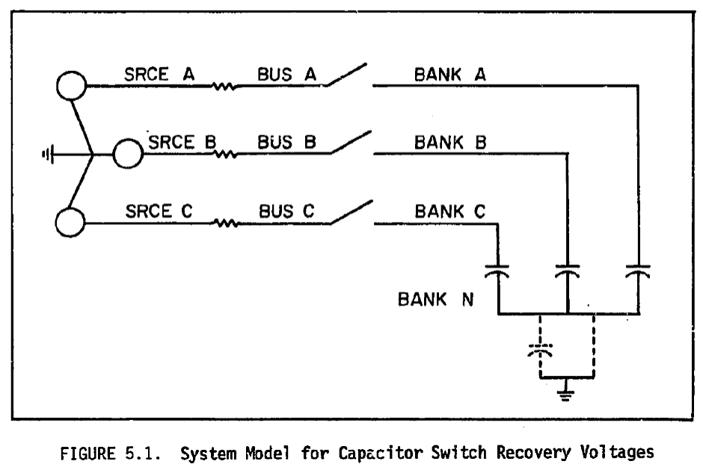

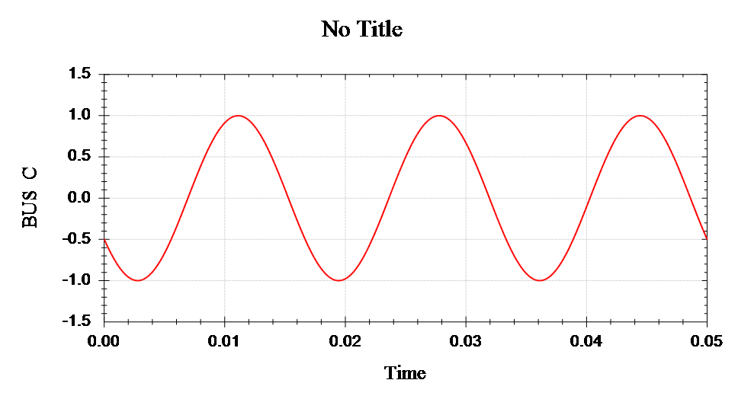

Fig 5.4 Phase C Voltage, Ungrounded Bank

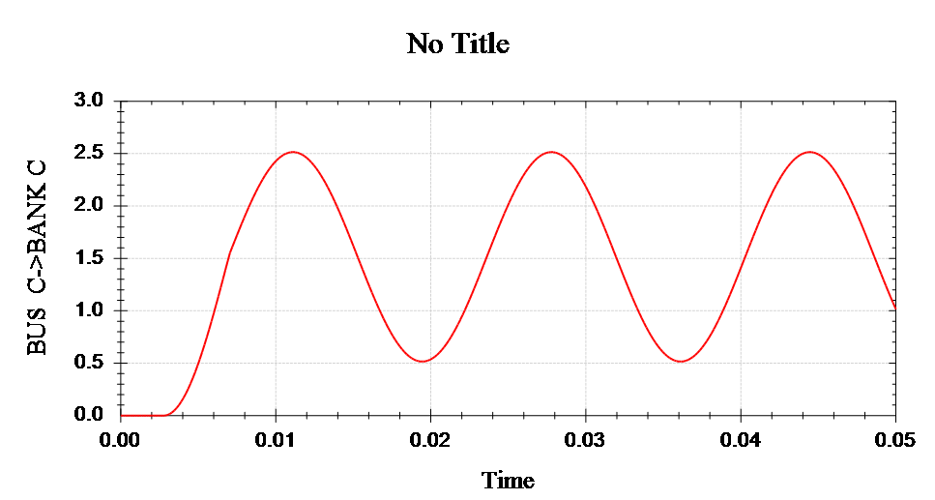

Fig 5.4 Phase C Recovery Voltage, Ungrounded Bank