"EMTP Primer.pdf" Section 5

Case 5: Capacitor Switching

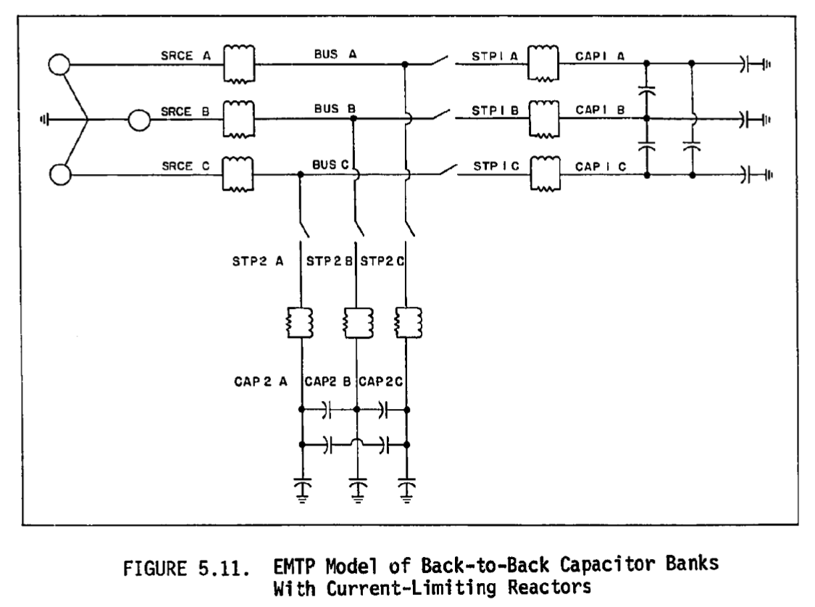

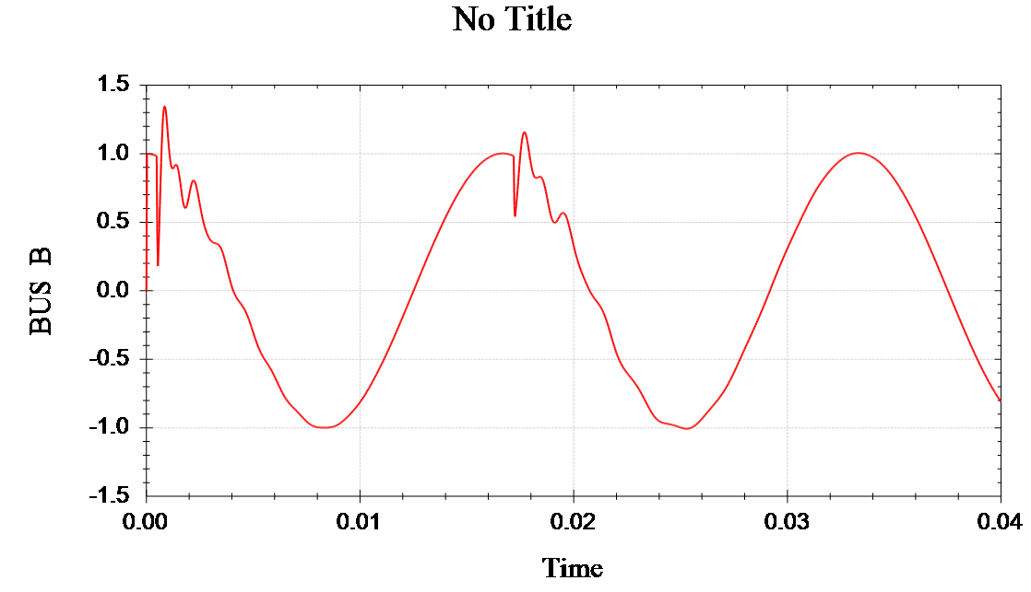

Fig 5.14 Phase B Bus Voltage During back-to-back energization

~~Fig 5.4 Phase C Recovery Voltage, Ungrounded Bank~~