"EMTP Primer.pdf" Section 5

Case 5: Capacitor Switching

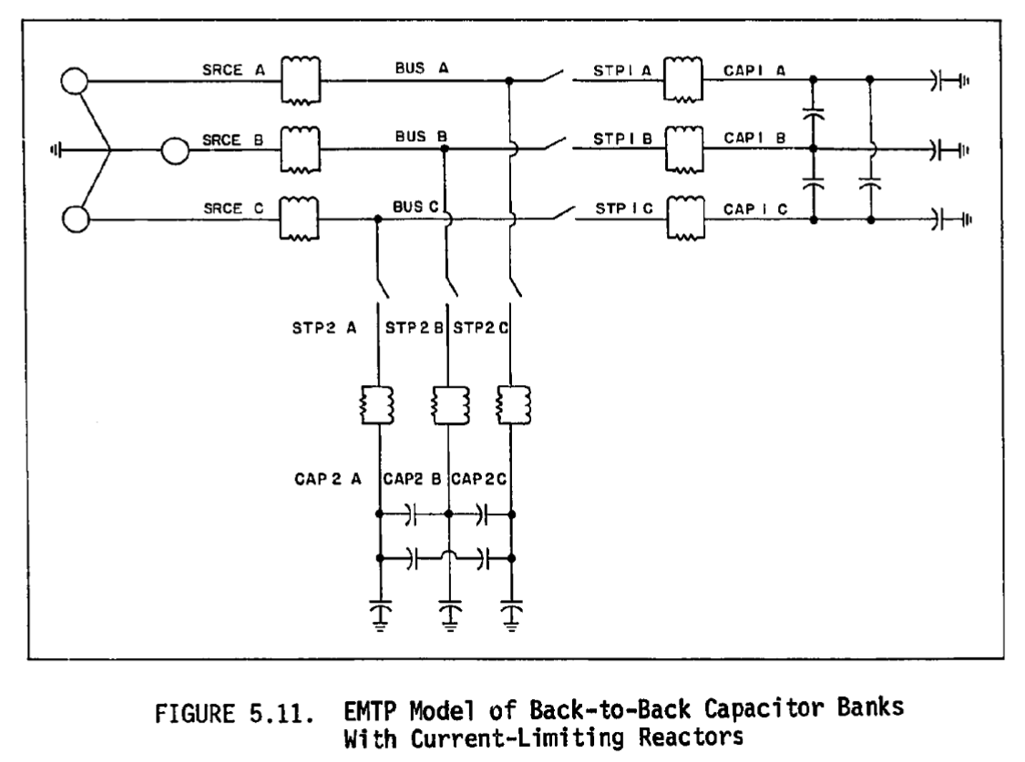

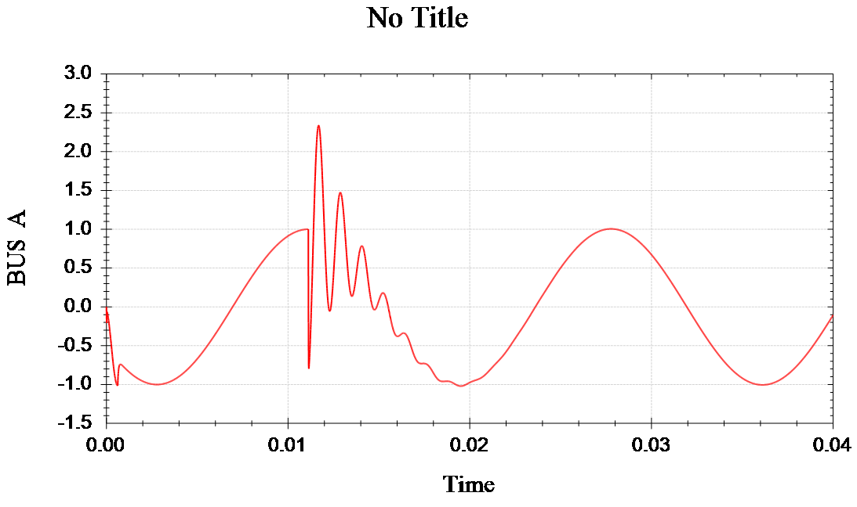

Fig 5.19 Phase A Bus Voltage During Restrike of Step 1

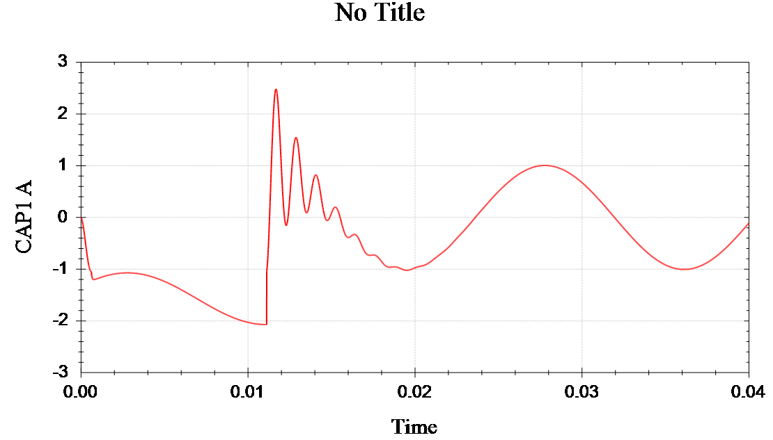

Fig 5.20 Phase A Step 1 Voltage During Restrike of Step 1