"EMTP Primer.pdf" Section 7

Case 7: Reclosing of Transmission Lines

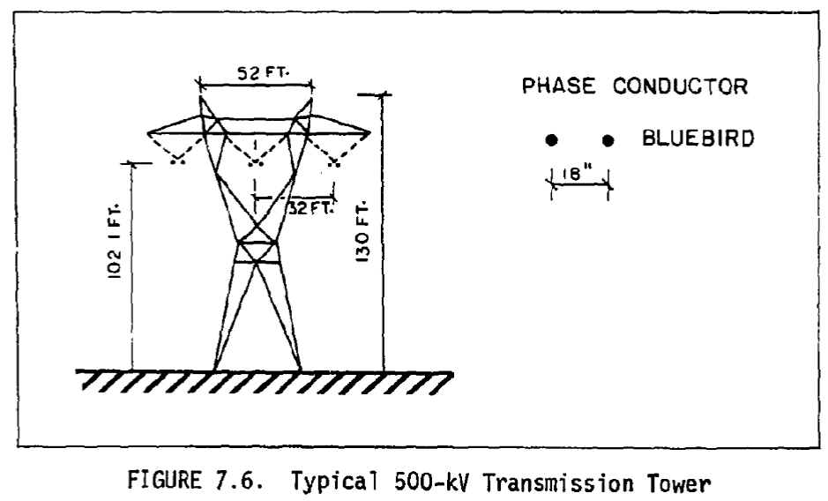

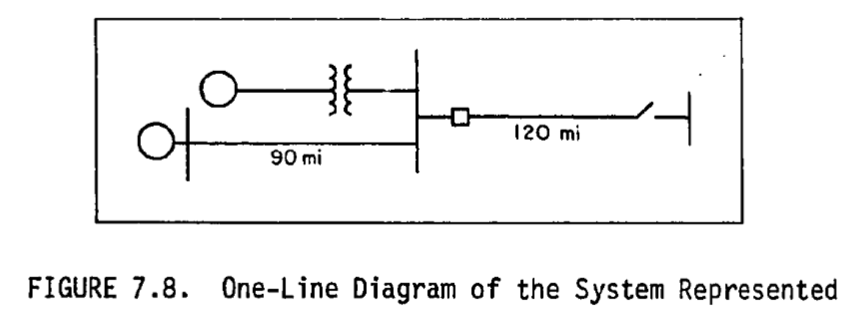

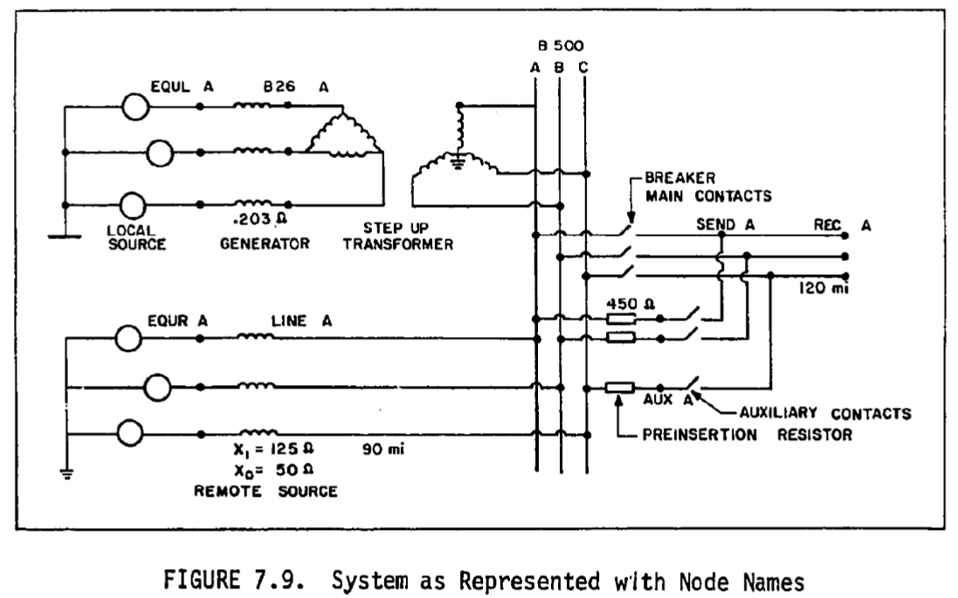

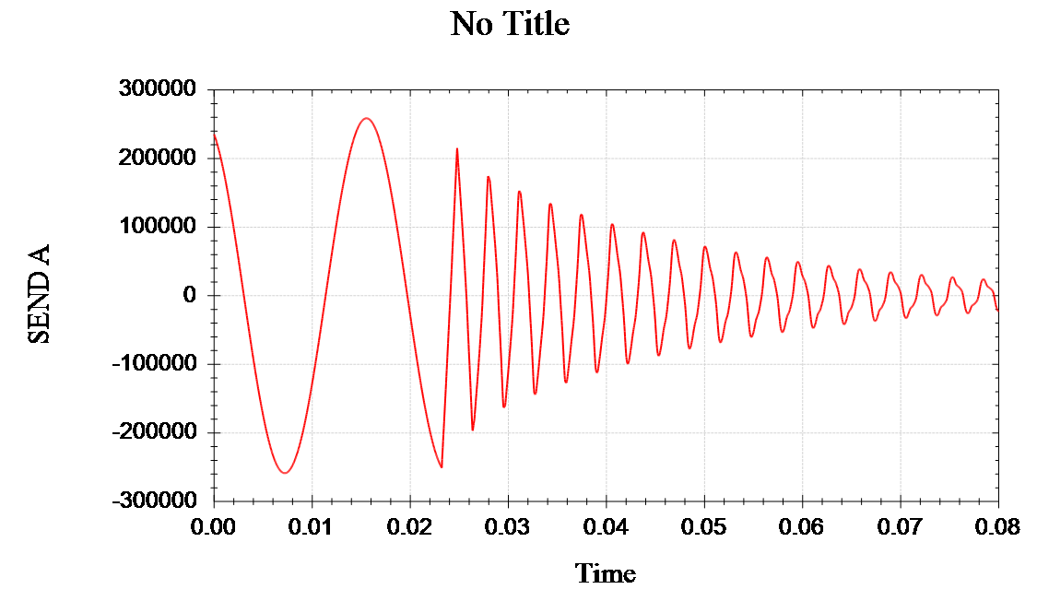

Fig 7.10 Fault Clearing, Phase A Sending end voltage

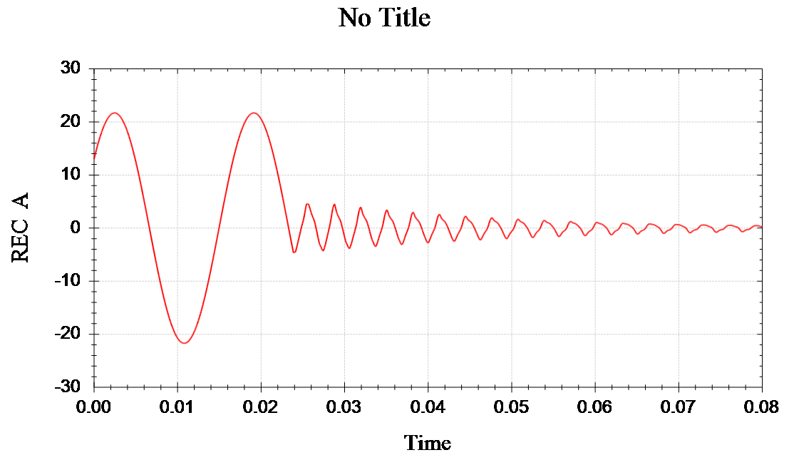

Fig 7.10 Fault Clearing, Phase A Receiving end voltage