在excel中使用VB进行一致性核对

添加VB代码步骤
- 先用录制宏，然后“停止录制”


- 打开VB，在personal中，新建模块
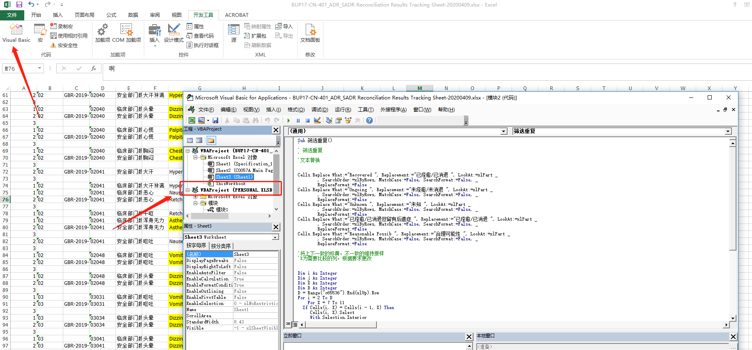

- 插入模块 ，将代码复制进去并保存
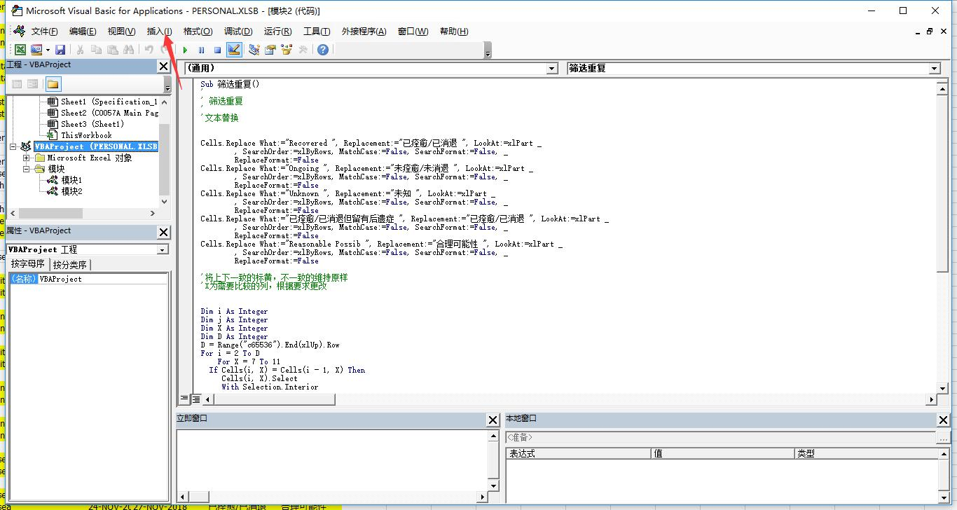
- 使用的时候，直接点击宏，然后执行
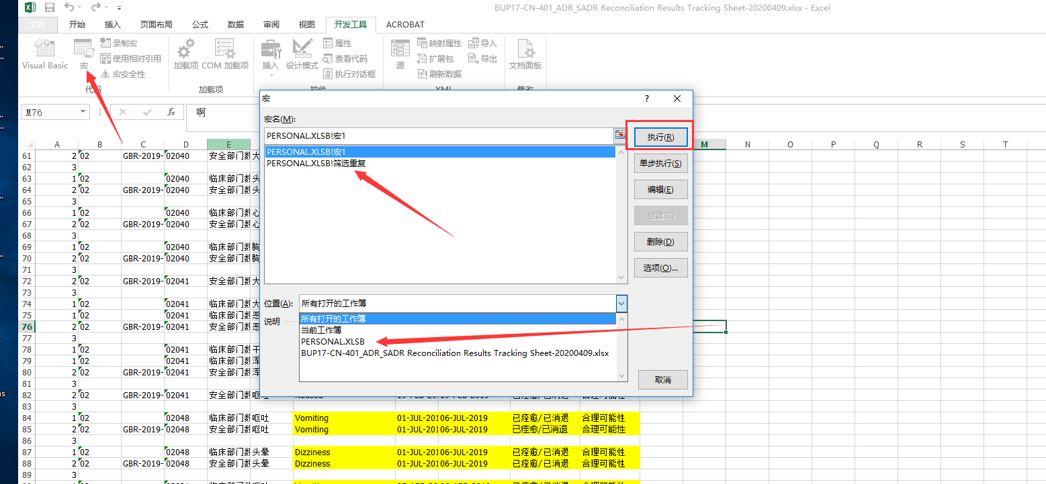

绿色的参数根据具体项目更改

上下列一致时（上下列重复）标黄代码
Sub 筛选重复()
'
' 筛选重复
'
'文本替换

Cells.Replace What:="Recovered ", Replacement:="已痊愈/已消退 ", LookAt:=xlPart _
, SearchOrder:=xlByRows, MatchCase:=False, SearchFormat:=False, _
ReplaceFormat:=False
Cells.Replace What:="Ongoing ", Replacement:="未痊愈/未消退 ", LookAt:=xlPart _
, SearchOrder:=xlByRows, MatchCase:=False, SearchFormat:=False, _
ReplaceFormat:=False
Cells.Replace What:="Unknown ", Replacement:="未知 ", LookAt:=xlPart _
, SearchOrder:=xlByRows, MatchCase:=False, SearchFormat:=False, _
ReplaceFormat:=False
Cells.Replace What:="已痊愈/已消退但留有后遗症 ", Replacement:="已痊愈/已消退 ", LookAt:=xlPart _
, SearchOrder:=xlByRows, MatchCase:=False, SearchFormat:=False, _
ReplaceFormat:=False
Cells.Replace What:="Reasonable Possib ", Replacement:="合理可能性 ", LookAt:=xlPart _
, SearchOrder:=xlByRows, MatchCase:=False, SearchFormat:=False, _
ReplaceFormat:=False

'将上下一致的标黄，不一致的维持原样
'X为需要比较的列，根据要求更改

Dim i As Integer
Dim j As Integer
Dim X As Integer
Dim D As Integer
D = Range("c65536").End(xlUp).Row
For i = 2 To D
For X = 7 To 11
If Cells(i, X) = Cells(i - 1, X) Then
Cells(i, X).Select
With Selection.Interior
.Pattern = xlSolid
.PatternColorIndex = xlatomatic
.Color = 65535
.TintAndShade = 0
.PatternTintAndShade = 0
End With
Cells(i - 1, X).Select
With Selection.Interior
.Pattern = xlSolid
.PatternColorIndex = xlatomatic
.Color = 65535
.TintAndShade = 0
.PatternTintAndShade = 0
End With
End If
Next X
Next i

End Sub

插入空行代码
**********************excel插入空白行1（每5行插入一行空白，可用）
Sub Insert5()
lastRow = Cells(Rows.Count, "A").End(3).Row

For i = lastRow To 1 Step -1
If i Mod 5 = 0 Then
Rows(i + 1).Insert
End If
Next
End Sub
**********************excel插入空白行2（A列，上下行不等时，插入空白行）
Sub Insertb()
lastRow = Cells(Rows.Count, "A").End(3).Row

For i = lastRow To 1 Step -1
If Cells(i, "A") <> Cells(i + 1, "A") And Cells(i, "A") <> "" And Cells(i + 1, "A") <> "" Then
Rows(i + 1).insert
End If
Next
End Sub

excel增加sheet 超链接代码
*******************************excel增加sheet 超链接代码，同时各个sheet增加返回链接

Function WorkSheetExists(oWB As Workbook, ByVal sWkName As String) As Boolean
'判断指定名称的工作表是否存在
'oWB为具体的工作簿,sWkName为工作表的名称,结果返回True表示存在
On Error Resume Next
Dim oWK As Worksheet
Set oWK = oWB.Worksheets(sWkName)
'如果出错表示不存在指定名称的工作表
If Err.Number <> 0 Then
WorkSheetExists = False
Else
WorkSheetExists = True
End If
Err.Clear
End Function
Sub TOC()
Excel.Application.DisplayAlerts = False
On Error Resume Next
Dim oWK As Worksheet
Dim oWB As Workbook
Dim oSp As Shape
Set oWB = Excel.ActiveWorkbook
If WorkSheetExists(oWB, "导航目录") = False Then
Set oWK = oWB.Worksheets.Add(Excel.Worksheets(1))
oWK.Name = "导航目录"
oWK.Range("a1") = "目录"
Else
Set oWK = oWB.Worksheets("导航目录")
oWK.Delete
Set oWK = oWB.Worksheets.Add(Excel.Worksheets(1))
oWK.Name = "导航目录"
oWK.Range("a1") = "目录"
End If
Dim oWK1 As Worksheet
i = 2
For Each oWK1 In oWB.Worksheets
Dim oRng As Range
If oWK1.Name <> oWK.Name Then
oWK1.Shapes("超链接").Delete
Set oRng = oWK.Range("a" & i)
sAddress = "'" & oWK1.Name & "'!A1"
oWK.Hyperlinks.Add oRng, "", sAddress, , oWK1.Name
Set oSp = oWK1.Shapes.AddShape(msoShapeLeftArrow, 0, 0, 20, 10)
oWK1.Hyperlinks.Add oSp, "", "'" & oWK.Name & "'!A1", , ""
oSp.Name = "超链接"
oSp.TextFrame2.TextRange.Text = "《"
i = i + 1
End If
Next
Excel.Application.DisplayAlerts = True
End Sub

SAS Derive增加链接
********************************************SAS Derive增加链接，并且更新描述为form名称
Function WorkSheetExists(oWB As Workbook, ByVal sWkName As String) As Boolean
'判断指定名称的工作表是否存在
'oWB为具体的工作簿,sWkName为工作表的名称,结果返回True表示存在
On Error Resume Next
Dim oWK As Worksheet
Set oWK = oWB.Worksheets(sWkName)
'如果出错表示不存在指定名称的工作表
If Err.Number <> 0 Then
WorkSheetExists = False
Else
WorkSheetExists = True
End If
Err.Clear
End Function
Sub DeriveLink()
Excel.Application.DisplayAlerts = False
On Error Resume Next
Dim oWK As Worksheet
Dim oWB As Workbook
Dim oSp As Shape
Set oWB = Excel.ActiveWorkbook
If WorkSheetExists(oWB, "TOC") = False Then
Set oWK = oWB.Worksheets.Add(Excel.Worksheets(1))
oWK.Name = "TOC"
oWK.Range("a1") = "目录"
Else
Set oWK = oWB.Worksheets("TOC")
oWK.Delete
Set oWK = oWB.Worksheets.Add(Excel.Worksheets(1))
oWK.Name = "TOC"
oWK.Range("a1") = "目录"
End If
Dim oWK1 As Worksheet
i = 2
For Each oWK1 In oWB.Worksheets
Dim oRng As Range
If oWK1.Name <> oWK.Name And oWK1.Visible = True Then
oWK1.Shapes("超链接").Delete
Set oRng = oWK.Range("a" & i)
sAddress = "'" & oWK1.Name & "'!A1"
oWK.Hyperlinks.Add oRng, "", sAddress, , oWK1.Name
Set oSp = oWK1.Shapes.AddShape(msoShapeLeftArrow, 0, 0, 20, 10)
oWK1.Hyperlinks.Add oSp, "", "'" & oWK.Name & "'!A1", , ""
oSp.Name = "超链接"
oSp.TextFrame2.TextRange.Text = "《"
i = i + 1
End If
Next
Excel.Application.DisplayAlerts = True

Columns(2).ClearContents '清空B列数据,这样就可以随着工作表的变化，生成不同的工作表目录

Dim sh As Worksheet
For Each sh In Sheets
If sh.Name <> "TOC" Then
sh.Range("V2").Copy Sheets("TOC").Range("B" & 1 + n) 'V2为需要统一提取的值所在单元格位置
n = n + 1
End If
Next
Range("B1") = "Description" '第一个单元格写入字符串

End Sub

表格拆分
********************************************根据某一列数据，拆分表格数据，并重命名表格名称为该列数据名

Sub 工作表拆分2() '通过筛选方法完成需求，速度快，但当有合并单元格时就不能用。读者可以根据实际情况选用
Dim SplitCol As String, ColNum As Integer, HeadRows As Byte, arr, lastrow, i, ShtIndex, only As New Collection, Rng As Range
SplitCol = "a" '指定拆分条件所在列
HeadRows = 1 '指定标题行数，该区域不参与拆分
If HeadRows >= ActiveSheet.UsedRange.Rows.Count Then Exit Sub '如果指定的标题行大于已用区域行数则退出程序
ColNum = Cells(1, SplitCol).Column '将列标转换成数字
lastrow = ActiveSheet.UsedRange.Rows.Count '获取当前表已用区域的行数
arr = Range(Cells(HeadRows + 1, SplitCol), Cells(lastrow, SplitCol)).Value '将拆分列的数据赋与变量arr
On Error Resume Next
If ActiveSheet.FilterMode Then Cells.AutoFilter '如果处于筛选模式，那么去除筛选模式
For i = 1 To lastrow - HeadRows '遍历arr所有数据
'提取其中的不重复值
If Len(arr(i, 1)) > 0 Then only.Add CStr(arr(i, 1)), CStr(arr(i, 1))
Next i
ShtIndex = ActiveSheet.Index '获取当前表位置
On Error Resume Next
For i = 1 To only.Count
Debug.Print Sheets(only(i)).Name '获取与only对象中每个元素同名的工作表名（用意为判断是否存在该工作表）
If Err = 0 Then MsgBox "当前工作簿已存在与待拆分项目同名的工作表“" & only(i) & "”，暂无法拆分", 64, "友情提示": Exit Sub
Err.Clear
Next i
Application.ScreenUpdating = False '关闭屏幕更新，加快执行速度
Application.Calculation = xlCalculationManual '调为手动计算，加快执行速度
For i = 1 To only.Count '创建工作表，表的数量与表名由only对象中不重复值而定
Sheets.Add After:=Sheets(Sheets.Count) '创建
Sheets(Sheets.Count).Name = only(i) '命名
Sheets(ShtIndex).Rows("1:" & HeadRows).Copy Sheets(Sheets.Count).Cells(1, 1) '复制标题
Next i
Sheets(ShtIndex).Select '返回待拆分工作表
For i = 1 To only.Count '遍历Collection对象所有成员。Collection对象包括了所有拆分条件，即工作表名
'对拆分条件所在列进行筛选，筛选条件是Collection对象中的成员，本例中是部门名称
Range(Cells(HeadRows, SplitCol), Cells(lastrow, SplitCol)).AutoFilter Field:=1, Criteria1:=only(i)
Set Rng = Range(Cells(HeadRows + 1, SplitCol), Cells(Rows.Count, SplitCol).End(xlUp)).SpecialCells(xlCellTypeVisible).EntireRow '引用筛选后的数据（整行）
With Sheets(only(i)).UsedRange.Rows(Sheets(only(i)).UsedRange.Rows.Count + 1) '引用拆分后的工作表的已用区域下一行
Rng.Copy .Cells(1) '第一次复制，复制所有数据，仅取其格式
.Cells = Rng.Value '第二次复制，仅复制数值
End With
Next
Cells.AutoFilter '去除筛选模式
Application.ScreenUpdating = True '恢复屏幕更新
Application.Calculation = xlCalculationAutomatic '恢复自动计算
MsgBox "拆分完毕！", 64, "友情提示"
End Sub

合并多个workbook的多个sheet
********************************************将多个excel的workbook合并到一个excel中

Function WorkSheetExists(oWB As Workbook, ByVal sWkName As String) As Boolean
'判断指定名称的工作表是否存在
'QQ1722187970
'oWB为具体的工作簿,sWkName为工作表的名称,结果返回True表示存在
On Error Resume Next
Dim oWK As Worksheet
Set oWK = oWB.Worksheets(sWkName)
'如果出错表示不存在指定名称的工作表
If Err.Number <> 0 Then
WorkSheetExists = False
Else
WorkSheetExists = True
End If
Err.Clear
End Function

Sub Books2Sheets0xls()
'定义对话框变量
Dim fd As FileDialog

Set fd = Application.FileDialog(msoFileDialogFilePicker)

'新建一个工作簿
Dim newwb As Workbook
Set newwb = Workbooks.Add
Dim ActivePath As String

With fd
If .Show = -1 Then
'定义单个文件变量
Dim vrtSelectedItem As Variant

'定义循环变量
Dim i As Integer
i = 1

'开始文件检索
For Each vrtSelectedItem In .SelectedItems
'打开被合并工作簿
Dim tempwb As Workbook
Set tempwb = Workbooks.Open(vrtSelectedItem)

For X = 1 To tempwb.Sheets.count

'复制工作表
tempwb.Worksheets(X).Copy Before:=newwb.Worksheets(i)

'把新工作簿的工作表名字改成被复制工作簿文件名，这儿应用于xls文件，即Excel97-2003的文件，如果是Excel2007，需要改成xlsx
newwb.Worksheets(i).Name = Left$(Split(VBA.Replace(tempwb.Name, ".xls", ""), "_")(0), 29) & X

i = i + 1

Next X

'关闭被合并工作簿
tempwb.Close savechanges:=False

'i = i + 1
Next vrtSelectedItem
End If
End With

Set fd = Nothing
Sheets("Sheet1").Delete

' 设置目录超链接

Excel.Application.DisplayAlerts = False
On Error Resume Next
Dim oWK As Worksheet
Dim oWB As Workbook
Dim oSp As Shape
Set oWB = Excel.ActiveWorkbook
If WorkSheetExists(oWB, "导航目录") = False Then
Set oWK = oWB.Worksheets.Add(Excel.Worksheets(1))
oWK.Name = "导航目录"
oWK.Range("a1") = "目录"
Else
Set oWK = oWB.Worksheets("导航目录")
oWK.Delete
Set oWK = oWB.Worksheets.Add(Excel.Worksheets(1))
oWK.Name = "导航目录"
oWK.Range("a1") = "目录"
End If
Dim oWK1 As Worksheet
i = 2
For Each oWK1 In oWB.Worksheets
Dim oRng As Range
If oWK1.Name <> oWK.Name Then
oWK1.Shapes("超链接").Delete
Set oRng = oWK.Range("a" & i)
sAddress = "'" & oWK1.Name & "'!A1"
oWK.Hyperlinks.Add oRng, "", sAddress, , oWK1.Name
Set oSp = oWK1.Shapes.AddShape(msoShapeLeftArrow, 0, 0, 20, 10)
oWK1.Hyperlinks.Add oSp, "", "'" & oWK.Name & "'!A1", , ""
oSp.Name = "超链接"
oSp.TextFrame2.TextRange.Text = "《"
i = i + 1
End If
Next
Excel.Application.DisplayAlerts = True

End Sub

Sub Books2Sheets2()
Dim newwb As Workbook
Set newwb = Workbooks.Add
Dim MyFile As String
Dim Arr(100) As String
Dim count As Integer
Dim ActivePath As String
ActivePath = Application.ActiveWorkbook.Path
MyFile = Dir(ActivePath & "*.xlsx")
count = count + 1
Arr(count) = MyFile

Do While MyFile <> ""
MyFile = Dir
If MyFile = "" Then
Exit Do
End If
count = count + 1
Arr(count) = MyFile '将文件的名字存在数组中
Loop

For i = 1 To count

Dim tempwb As Workbook
Set tempwb = Workbooks.Open(ActivePath & Arr(i))
'复制工作表
tempwb.Worksheets(1).Copy Before:=newwb.Worksheets(i)

'把新工作簿的工作表名字改成被复制工作簿文件名，这儿应用于xls文件，即Excel97-2003的文件，如果是Excel2007，需要改成xlsx
newwb.Worksheets(i).Name = Split(VBA.Replace(tempwb.Name, ".xlsx", ""), "_")(1)

'关闭被合并工作簿
tempwb.Close savechanges:=False
Next
Sheets("Sheet1").Delete
End Sub

Sub Books2Sheets1xlsx()
'定义对话框变量
Dim fd As FileDialog

Set fd = Application.FileDialog(msoFileDialogFilePicker)

'新建一个工作簿
Dim newwb As Workbook
Set newwb = Workbooks.Add
Dim ActivePath As String

With fd
If .Show = -1 Then
'定义单个文件变量
Dim vrtSelectedItem As Variant

'定义循环变量
Dim i As Integer
i = 1

'开始文件检索
For Each vrtSelectedItem In .SelectedItems
'打开被合并工作簿
Dim tempwb As Workbook
Set tempwb = Workbooks.Open(vrtSelectedItem)

For X = 1 To tempwb.Sheets.count

'复制工作表
tempwb.Worksheets(1).Copy Before:=newwb.Worksheets(i)

'把新工作簿的工作表名字改成被复制工作簿文件名，这儿应用于xls文件，即Excel97-2003的文件，如果是Excel2007，需要改成xlsx
newwb.Worksheets(i).Name = Left$(Split(VBA.Replace(tempwb.Name, ".xlsx", ""), "_")(1), 29) & X

i = i + 1
Next X

'关闭被合并工作簿
tempwb.Close savechanges:=False

Next vrtSelectedItem
End If
End With

Set fd = Nothing
Sheets("Sheet1").Delete

' 设置目录超链接

Excel.Application.DisplayAlerts = False
On Error Resume Next
Dim oWK As Worksheet
Dim oWB As Workbook
Dim oSp As Shape
Set oWB = Excel.ActiveWorkbook
If WorkSheetExists(oWB, "导航目录") = False Then
Set oWK = oWB.Worksheets.Add(Excel.Worksheets(1))
oWK.Name = "导航目录"
oWK.Range("a1") = "目录"
Else
Set oWK = oWB.Worksheets("导航目录")
oWK.Delete
Set oWK = oWB.Worksheets.Add(Excel.Worksheets(1))
oWK.Name = "导航目录"
oWK.Range("a1") = "目录"
End If
Dim oWK1 As Worksheet
i = 2
For Each oWK1 In oWB.Worksheets
Dim oRng As Range
If oWK1.Name <> oWK.Name Then
oWK1.Shapes("超链接").Delete
Set oRng = oWK.Range("a" & i)
sAddress = "'" & oWK1.Name & "'!A1"
oWK.Hyperlinks.Add oRng, "", sAddress, , oWK1.Name
Set oSp = oWK1.Shapes.AddShape(msoShapeLeftArrow, 0, 0, 20, 10)
oWK1.Hyperlinks.Add oSp, "", "'" & oWK.Name & "'!A1", , ""
oSp.Name = "超链接"
oSp.TextFrame2.TextRange.Text = "《"
i = i + 1
End If
Next
Excel.Application.DisplayAlerts = True

End Sub

创建文件夹目录
********************************************获取该文件夹下所有文件名称以及超链接
Sub autogetFld()

Dim strfldpath As String

With Application.FileDialog(msoFileDialogFolderPicker)

.Title = "请选择指定文件夹"

If .Show Then strfldpath = .SelectedItems(1) Else Exit Sub

End With

Application.ScreenUpdating = False

Range("a:b").ClearContents

Range("a1:b1") = Array("文件夹", "文件名")

Call Searchfiletohyperlinks(strfldpath)

Range("a:b").EntireColumn.AutoFit

Application.ScreenUpdating = True

End Sub

Function Searchfiletohyperlinks(ByVal strfldpath As String) As String

Dim objfld As Object

Dim objfile As Object

Dim objsubfld As Object

Dim strfilepath As String

Dim lnglastrow As Long

Dim intnum As Integer

Set objfld = CreateObject("scripting.filesystemobject").GetFolder(strfldpath)

For Each objfile In objfld.Files

lnglastrow = Cells(Rows.count, 1).End(xlUp).Row + 1

strfilepath = objfile.Path

intnum = InStrRev(strfilepath, "\")

Cells(lnglastrow, 1) = Left(strfilepath, intnum - 1)

Cells(lnglastrow, 2) = Mid(strfilepath, intnum)

ActiveSheet.Hyperlinks.Add anchor:=Cells(lnglastrow, 2), Address:=strfilepath, ScreenTip:=strfilepath

Next objfile

For Each objsubfld In objfld.SubFolders

Call Searchfiletohyperlinks(objsubfld.Path)

Next objsubfld

Set objfld = Nothing

Set objfile = Nothing

Set objsubfld = Nothing

End Function

Sub ListFilesTest()

With Application.FileDialog(msoFileDialogFolderPicker)

If .Show Then myPath$ = .SelectedItems(1) Else Exit Sub

End With

If Right(myPath, 1) <> "" Then myPath = myPath & ""

[a:a] = "" '清空A列

Call ListAllFso(myPath) '调用FSO遍历子文件夹的递归过程

End Sub

Function ListAllFso(myPath$) '用FSO方法遍历并列出所有文件和文件夹名的【递归过程】

Set fld = CreateObject("Scripting.FileSystemObject").GetFolder(myPath)

'用FSO方法得到当前路径的文件夹对象实例 注意这里的【当前路径myPath是个递归变量】

'MsgBox fldcount

For Each F In fld.Files '遍历当前文件夹内所有【文件.Files】

count = UBound(Split(F, "\"))

[a65536].End(3).Offset(1) = " |" & Space(2 * count) & " |" & Space(count) & F.Name & "" '在A列逐个列出文件名

Next

Dim mplen As Integer
Dim plen As Integer

mplen = Len(myPath)

For Each fd In fld.SubFolders '遍历当前文件夹内所有【子文件夹.SubFolders】

plen = Len(fd.Path)

subcount = UBound(Split(fd, "\"))

[a65536].End(3).Offset(1) = " |-" & String(subcount, "-") & Right(fd.Path, plen - mplen - 1) & "" '在A列逐个列出子文件夹名

[a65536].End(3).Interior.ColorIndex = 6

Call ListAllFso(fd.Path) '注意此时的路径变量已经改变为【子文件夹的路径fd.Path】

'注意重点在这里： 继续向下调用递归过程【遍历子文件夹内所有文件文件夹对象】

Next

End Function

