Overview
This is a living document. It will change.
Jmeter (http://jmeter.apache.org/) is an Open Source stress testing tool used by many organizations around the world. It allows you to graphically build plans and later run them. It can work as stand alone or in a master/child configuration. This configuration enables one Jmeter instance to control many other Jmeter instances. This allows for scalable load. If necessary commercial services allow you to-do this through the cloud (http://blazemeter.com/).
This document describes the design and configuration of a modular Jmeter test plan that can easily grow and cover a wide set of web service services within Sakai OAE. The test plan calls other test plan fragments, it is also data driven pulling information out of text files.
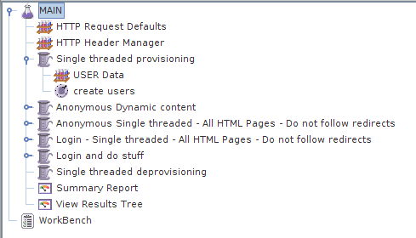

Mentoring
It is important that there is enough knowledge to maintain the stress test infrastructure. This requires knowledge diffusion. The most effective approach is through mentoring.

Quality Assurance Practices
You can re-use test plans for a multitude of purposes. Here are some examples:
Functional Testing Under Load: By placing load on the system while functionally testing you will get an approximate idea of the scalability issues. For example, for a commercial LMS (names not to be mentioned) if you hit searches for courses then the system administration page becomes unusable.

Fail over tests: Place load across the cluster and then turn off a system. If the cluster does not recover properly then you will get to see a domino effect, uneven sharing of load knocking one system out after the next. This happens when load balancers have the wrong type of sharing algorithm.

Smoke or Burn tests: Hit the system either hard or very hard for a sustained period. This gives you confidence in new hardware or topologies.

Performance tripwire: Jenkins is a Continuous Integration server. You can get it to run and then consume the results of Jmeter tests. From this you can see the response trends across builds. After understanding the personality of the product you can set levels to warnings or build failure based on largest acceptable response time.

Capacity Planning: If you know your usage patterns then you can generate realistic load, incrementing load until you reach an unstable region. From this information you can estimate the number of server needed in a cluster. With Java applications, it is difficult to correctly plan as issues such as resource leaks or JVM memory tuning tend to non deterministically rate limit.

Functional Testing through Assertions: Jmeter has a wide range of assertions including the ability to look into the body of responses for particular patterns. This is another way to connect Jmeter up to Jenkins. Failing builds if assertions fail.

Other terms: Be warned terminology varies depending to whom you talk, examples: Stability testing, volumn testing.

Design Principles
Here are a number of design principles to consider:
Data Driven: Jmeter has the ability to read in data from CSV files or a database and then use that information in sending requests. This allows for a simple structure where Jmeter loops through the data file and fires off requests. This deskills part of the maintenance of the test plan and defers the creation of more detailed provisioning.

Open Source: By using an Open Source product you are lowering the entry barrier for potential users. Commercial products cost money and have a smaller audience.

One MAIN plan: Simple reconfiguration for a multitude of scenarios becomes possible by placing many different tests under one Main test plan.

Reuse of Material: Material that already exists takes precedence over writing new material. For example of existing material look at Ian Boston's or my work found under the /nakamura/testscripts directory.

Modularity: [Technical Information]: You can split Jmeter into parts using Fragments and include controllers.

Thread Groups: By splitting test plans into thread groups you can go through each thread group sequentially or in parallel. You can also turn thread groups off by setting their thread count to 0. This allows you to reconfigure which parts of Sakai OAE are tested on the fly.

Labels: Complexity can hide meaning. Having too much information is just as bas as having not enough. Meaning is obscured and the results give you a false feeling of scientific method. In Jmeter the results are collected per name. If you have a number of samples with the same label then the results are collected into the same bucket simplifying reporting.

Variable expansion: By adding variables at the top of the MAIN test plan and allowing their values to propagate into the jmeter fragments allows a maintainer to change the variables in one central location rather than changing constants in multiple places.

Weaknesses
Here are some weak points of Jmeter:

Usage patterns: Generating realistic usage patterns is difficult and prone to error. Jmeter is at best an approximation.

Code Coverage: Jmeter pounds away at the same request types lowering the degree of code coverage. You can mitigate this issue by being data driven and adding randomness through internal Jmeter functions.

JavaScript: Jmeter does not run the JavaScript in HTML pages. AJAX requests sent have to be hard coded.

Monitoring of Java Applications
To gain insight into what is actually happening inside a Java application during stress testing, not only do you need to monitor the general health of the machine that the application sits on, but also the JVM's health and the log files.
For reviewing log files live on a *NIX system consider using tail -f
For the JVM, consider running JMX from the JVM live on localhost and tunneling through SSH. The following command will enable JMX on port 1099 for the demo version of Sakai OAE.
java -Xms512m -Xmx1024m -XX:MaxPermSize=256m -Dcom.sun.management.jmxremote.port=1099 -Dcom.sun.management.jmxremote.authenticate=false -Dcom.sun.management.jmxremote.ssl=false -jar org.sakaiproject.nakamura.app-1.2.0.jar 1> run.log 2>&1 &
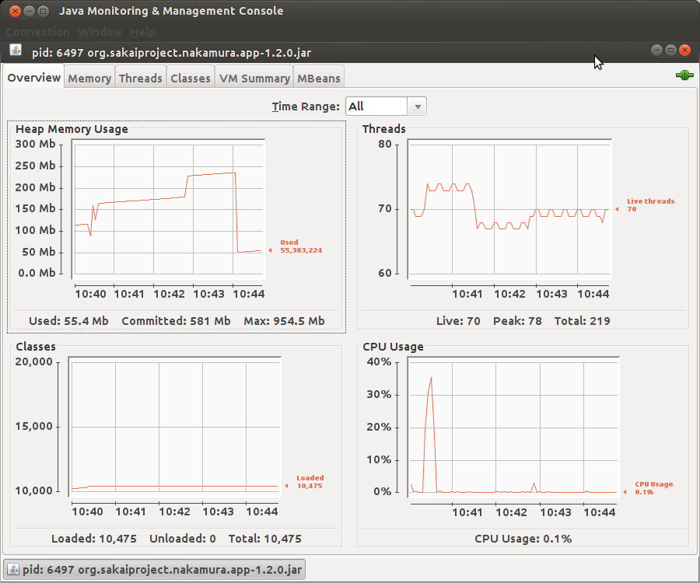

Configuration
Here are the files used:
- Main.jmx: Main test plan
- *_fragment.jmx: - Files that are partial Jmeter test plans called from MAIN.jmx
- html.csv: CSV file mentioning all the HTML pages found in 3akai.
- user_for_Main.csv: 2000 user accounts
- get_html.pl: Generates html.csv
- addfirstandlast.pl: Used to generate user_for_Main.csv from firstnames.csv and lastnames.csv/.
Here are the meanings of the variables used. Note, that as the test plan grows so will the list of variables.
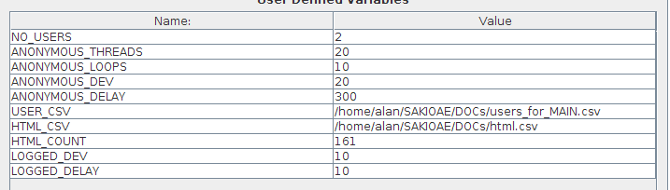
- NO_USERS: Number of users to create
- ANONYMOUS_THREADS: Number of threads to use in parallel for anonymous test
- ANONYMOUS_LOOPS: Number of loops to use for anonymous test
- ANONYMOUS_DEV: Todo with time delays in MS.
- ANONYMOUS_DELAY: Average delay between clicks for the anonymous user
- USER_CSV: Location of user csv file
- HTML_CSV: Location of HTML csv file.
- HTML_COUNT: Number of HTML documents to hit
- LOGGED_DEV: Todo with time delays in MS.
- LOGGED_DELAY: Average delay between clicks for a logged in user

Limitations: Currently we cant use variable expansion inside the include controller. This implies that when you move the location of files you will need to edit each one individually. I am hoping this is a known bug and that the limitation will be removed in a future update.

To turn off part of the plan set 0 for the number of threads in a particular thread group.
