PRACTICA 3

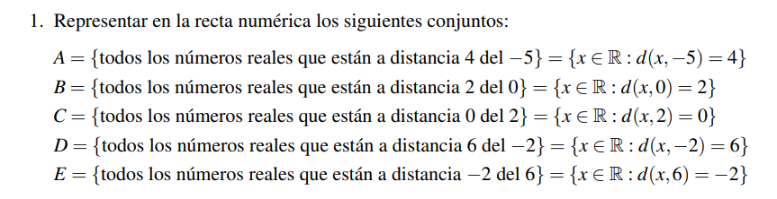



1. |x+5|=4 SOL={1,9}
2. |x+2|=0 SOL={-2,2}
3. |x+0|=2 SOL={2} 🡪 Si distancia es = 0, no se mueve en la recta
4. |x+2|=6 SOL={-4,8}
5. |x+6|=-2 ABSURDO 🡪 No tiene solución porque no es posible moverse de forma **negativa**

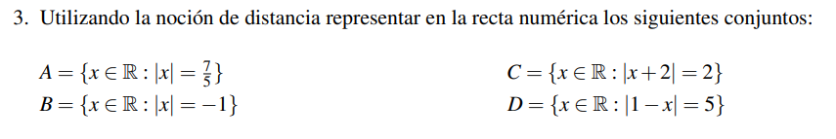

B. Absurdo

D. |1-x|=5 es igual a |x+1|=5

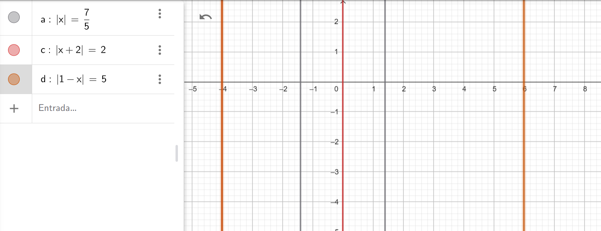

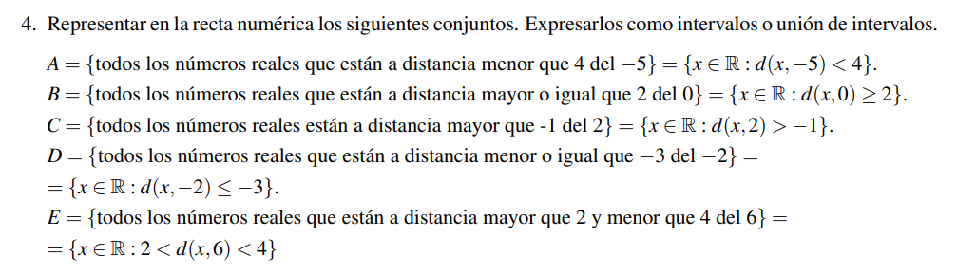

1. |x-5|<4 🡺 SOL= (-9,-1)
2. |x+0|>=2 🡺 SOL= (-00, -2] U [2,+00)
3. |x+2|>-1 🡺 SOL= ABS 🡪 Dado que el modulo ya a ser >= 0, la distancia tiene que ser positivo
4. |x+2|<=-3 🡺 SOL= ABS
5. |x+6|>2 🡺 SOL= (-00,4) U (8,+00) |x+6|<4 🡺 SOL=(2,10)

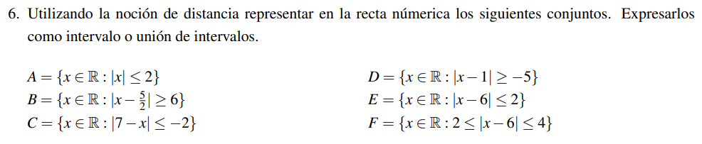

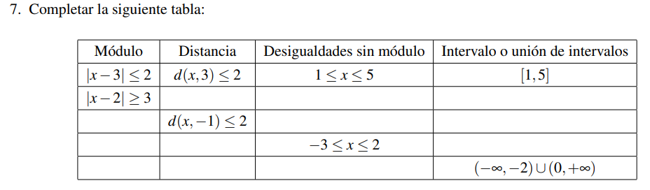

|  |  |  |  |
| --- | --- | --- | --- |
| Módulo | Distancia | Desigualdades sin módulo | Intervalo o unión de intervalos |
| |x-3| <= 2 | D(x,3) <= 2 | 1<=x<=5 | [1,5] |
| |x-2| >= 3 | D(x,2) >= 3 | X<=-1 ó x>=5 | (-00,-1] U [5,+00) |
| |x+1|<=2 | D(x,-1) <= 2 | -3<=x<=1 | [-3,1] |
|  |  | -3<=x<=2 |  |
| |x+1|>=1 | D(x,-1)>=1 | X<=-2 ó x>=0 | (-00,-2) U (0,+00) |



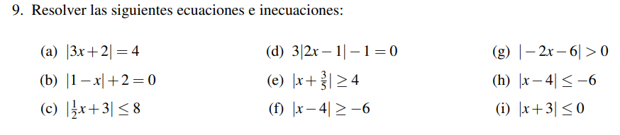

1. |3x+2|=4

|  |  |
| --- | --- |
| 3x+2=4 | 3x+2=-4 |
| 3x=2 | 3x=-6 |
| X=2/3 | X=-2 |
| **SOL={-2,2/3}** | |

1. |1+x|+2=0

|1+x|=-2 **ABSURDO**

1. |1/2X+3|<=8

|  |  |
| --- | --- |
| 1/2x+3<=-8 | 1/2x+3>=8 |
| 1/2x<=-11 | 1/2x>=8-3 |
| X<=-22 | 1/2x>=5 |
|  | x>=5/(1/2) |
|  | x>=10 |
| **SOL=(-00,-22] U [10,+00)** | |

1. 3|2x-1|-1=0

3|2x-1|=1

|2x-1|=1/3

|  |  |
| --- | --- |
| 2x-1=-1/3 | 2x-1=1/3 |
| 2x=-1/3+1 | 2x=1/3+1 |
| X=-2/3:2 | X=4/3:2 |
| X=-2/6 | x=4/6 |
| X=-1/3 | x=2/3 |
| **SOL={-1/3,2/3}** | |

1. |x+3/5|>=4

|  |  |
| --- | --- |
| X+3/5<=-4 | X+3/5>=4 |
| X<=-4-3/5 | x>=17/5 |
| X<=-23/5 |  |
| **SOL=(-00,-23/5] U [17/5,+00)** | |

1. |x-4|>=-6

**SOL=R**, dado que el modulo va a ser siempre > o 0 va a ser mayor a -6

1. |-2x-6|>0

**SOL=R-{-3}**, cumple para todos los reales excepto -3

1. |x-4|<=-6

**ABSURDO**, el valor absoluto no puedo ser negativo -6

1. |x+3|<=0

|  |  |
| --- | --- |
| No es posible - 0 | X+3<=0 |
|  | X<=-3 |
| **SOL={-3}** | |

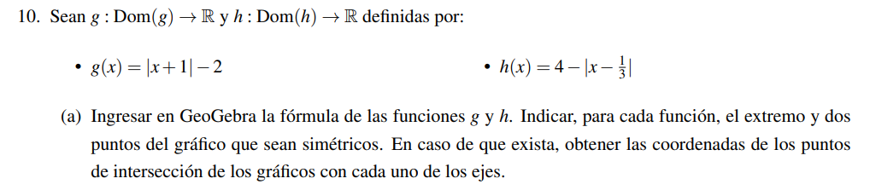

Vertice g(x)

**Yv=-2**

Obtener Xv de g(x) = 0

x+1=0 **Xv=-1**

**V= (-1,-2)**

Vertica h(x)

**Yv=4**

**Xv=1/3**

**Punto de intersección**

Intersección eje Y

G(0)=(0+1)-2=-1 (0,-1)

Intersección eje X

(x+1)-2=0 x+1-2=0 x=1 (1,0)

|x+1|-2=0

|x+1|=2

|  |  |
| --- | --- |
| X+1=-2 | X+1=2 |
| X=-3 | X=1 |
| Los puntos de simetría con el eje x cuando y=0 son (-3,0) y (1,0) | |

Intersección eje Y

H(0)=4-(0-1/3) 4-(-1/3) 4-1/3 11/3 (0,11/3)

Intersección eje X

4-|x-1/3|=0

|x-1/3|=4

|  |  |
| --- | --- |
| x-1/3=-4 | x-1/3=4 |
| X=-4+1/3 | X=4+1/3 |
| X=-11/3 | X=13/3 |
| Los puntos de simetría con el eje x cuando y=0 son (-11/3,0) y (13/3,0) | |

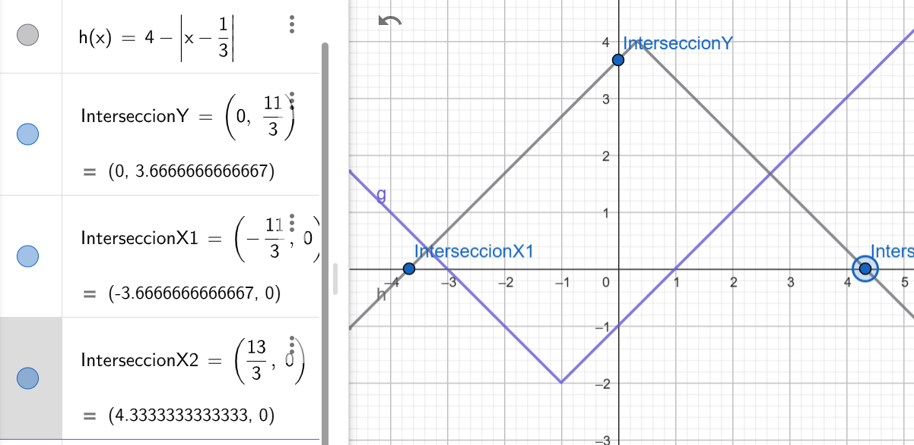

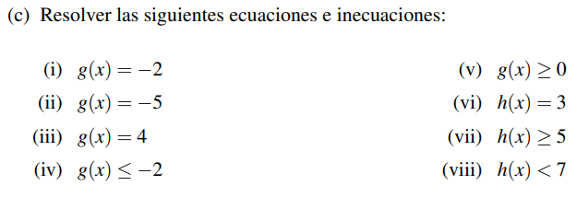

1. G(-2)=-2+1

Pertenece (-1,-2)

1. G(-5)=-5+1

No pertenece(-4,-2)

1. G(4)=5

Pertenece (5,4)

1. |x+1|-2<=-2

|x+1|<=0

|  |  |
| --- | --- |
| No es posible <=0 | X+1<=0 |
|  | X<=-1 |
| **SOL=(-00,-1]** | |

1. |x+1|-2>=0

|x+1|>=2

|  |  |
| --- | --- |
| X+1<=-2 | X+1>=2 |
| X<=-3 | x>=1 |
| **SOL=(-00,-3] U [1,+00)** | |

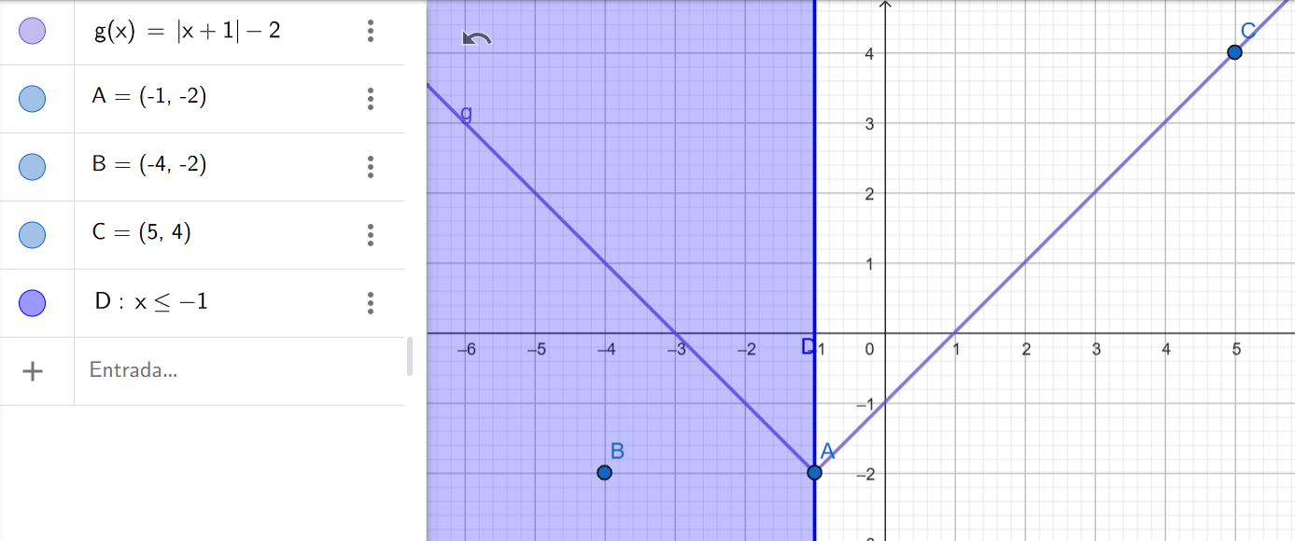

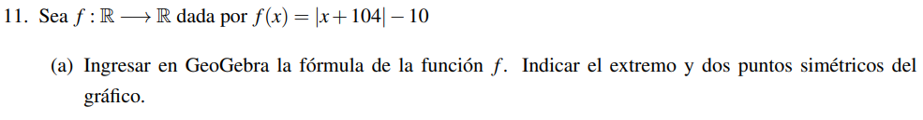

Vertice= (-104,-10)

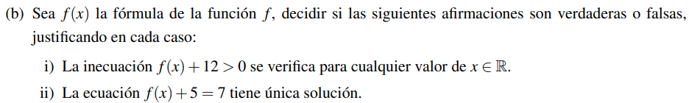

1. |x+104|-10+12>0

|x+104|>-2

Falso, dado que es absurda la inecuación ya que el modulo debe ser >=0

1. |x+104|-10+5>7

|x+104|>9

Falso, dado que la inecuación 9 tiene dos soluciones



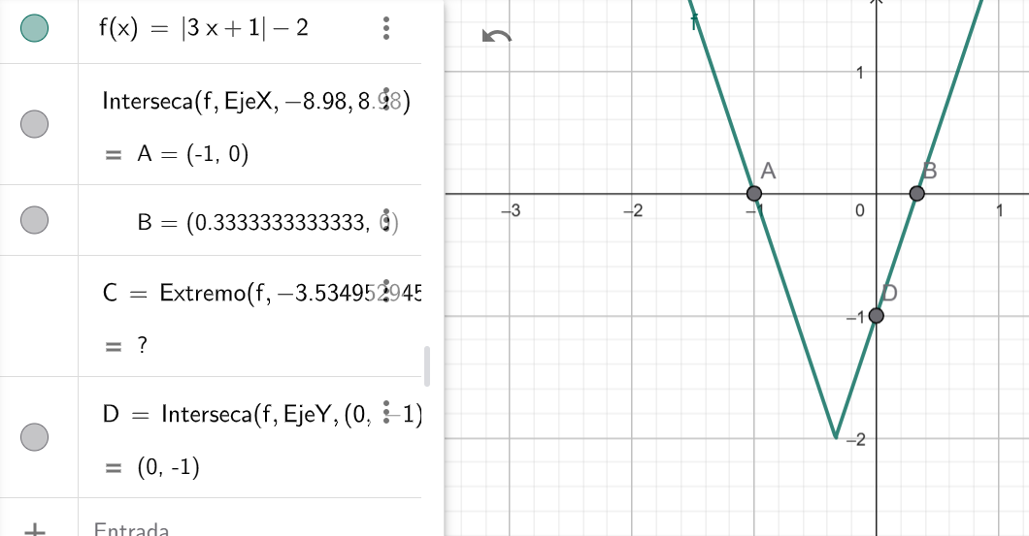

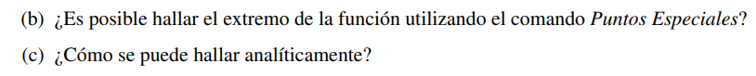

Yv=-2

**Xv=** 3x+1 = 0 x=-1/3

Extremos de la función (-1/3,-2)

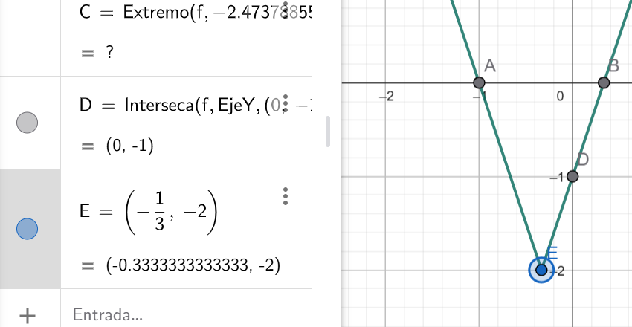



F(x)=|3x+2|-2 =0

C0=|3X+2|=2

|  |  |
| --- | --- |
| 3x+2=-2 | 3x+2=2 |
| 3x=-4 | 3x=0 |
| X=-4/3 | X=0 |
| C0={-4/3,0} | |

F(x)=|3x+2|-2 >0

C+=|3x+2|>2

|  |  |
| --- | --- |
| 3x+2<-2 | 3x+2>2 |
| 3x<-4 | 3x>0 |
| X<-4/3 | X>0 |
| C+=(-00,-4/3) U (0,+00) | |

F(x)=|3x+2|-2 <0

C+=|3x+2|<2

|  |  |
| --- | --- |
| 3x+2<-2 | 3x+2>2 |
| 3x<-4 | 3x>0 |
| X<-4/3 | X>0 |
| C+=(-00,-4/3) U (0,+00) | |