PRACTICA 4

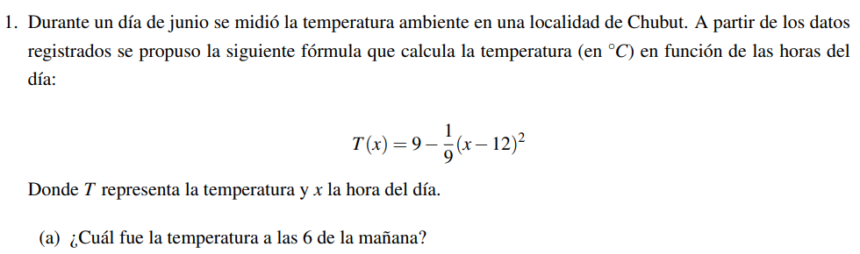

T(6)=9-1/9(6-12)^2

9-1/9(-6)^2

9-1/9(-36)

9-36/9

9-4= 5

Entonces el punto (6,5)

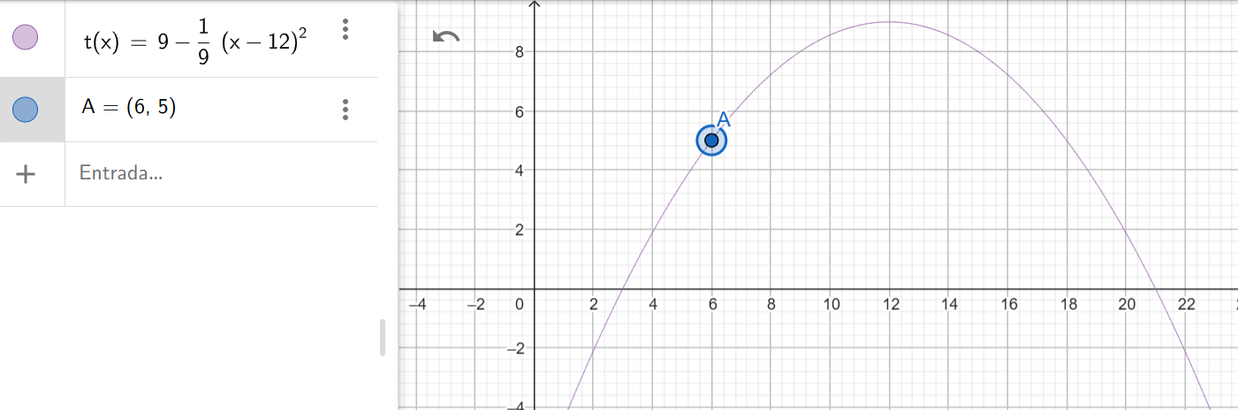



Para obtener **puntos simétricos** igualamos a **T(x)=Y**

9-1/9(x-12)^2=8

-1/9(x-12)^2=-1

(x-12)^2=9

/(x-12)^2=/9

x-12=3 🡪 -3 ; +3

|  |  |
| --- | --- |
| x-12=-3 | x-12=3 |
| X=9 OK | X=15 |

Entonces verificamos puntos simétrico (15 ; 8)

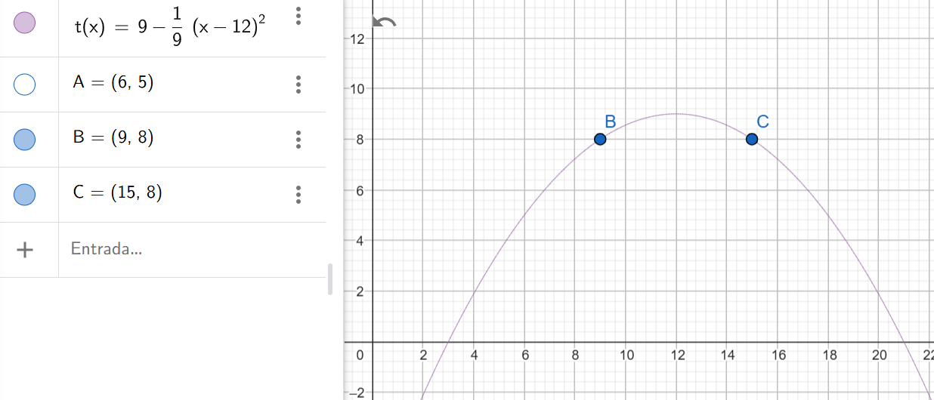



Para obtener **puntos simétricos** de la **raíz** igualamos a **T(x)=0**

9-1/9(x-12)^2=0

-1/9(x-12)^2=-9 : (-1/9)

(x-12)^2=81

/(x-12)^2=/81

x-12=9 🡪 -9 ; +9

|  |  |
| --- | --- |
| x-12=-9 | x-12=9 |
| X=3 OK | X=21 |

