

Modelling drill performance in a spreadsheet
Alan Cooper, Senior Principal Consultant, Snowden Mining Industry Consultants

87 Colin Street West Perth WA 6005
PO Box 77 West Perth WA 6872
Tel + 61 8 9213 9213
Fax + 61 8 9322 2576

Modelling drill performance in a spreadsheet

 |  | Snowden  87 Colin St West Perth WA 6005 Australia  PO Box 77 West Perth WA 6872 Australia  Telephone: +61 8 9213 9213  Facsimile: +61 8 9322 2576  Website: http://www.snowdengroup.com
Alan Cooper
Senior Principal Consultant
acooper@snowdengroup.com

Introduction
Snowden Mining Industry Consultants (Snowden) is in the business of mining studies. One component of a mining study is mining equipment selection and equipment numbers. Equipment numbers are calculated based on equipment productivities. The productivities of loader and trucks are generally well understood. Surprisingly drill productivity is not so well understood. At least in the studies that Snowden reviews from time to time.
Figure 1 presents a typical (small) drill rig used for drill and blast.
Figure 1 SCH5000CL drill rig
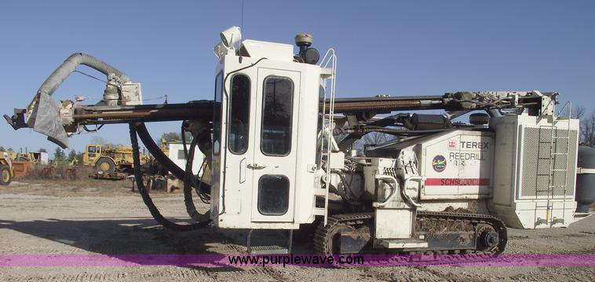

Why calculate equipment productivity? Equipment productivity is an intermediate calculation for equipment numbers and activity costs (usually calculated in $/t):
- Equipment number = work / utilisation / productivity
- Activity cost = cost (per hour) / productivity (per hour)

Is drill productivity important? Snowden thinks so. Table 1 presents the range in activity cost estimates from a Snowden study. Drill and blast had the greatest range. Snowden is clearly too low but even the contractors had difficulty estimating the drill and blast costs. Not surprising as everyone was guessing the drill penetration rate (among other guesses)!
Table 1 Range in drill and blast estimates
Source | Mining less drill and blast | Drill and blast | Contract cost | Mining administration | Total mining
Snowden estimate | $2.98/t | $0.53/t | $3.51/t | $0.27/t | $3.78/t
Budget quotation A | $3.04/t | $0.76/t | $3.80/t | $0.27/t | $4.07/t
Budget quotation B | $2.73/t | $1.33/t | $4.06/t | $0.27/t | $4.33/t
Range | $0.31/t | $0.80/t | $0.55/t | $0.00/t | $0.55/t

The scope of this paper is to present a Snowden’s method for estimating drill penetration rate and drill productivity.

Basis of work
This work was based on a paper by S. Kahraman, N. Bilgin, C. Feridunoglu, "Dominate rock properties affecting the penetration rate of percussive drills", published by the International Journal of Rock Mechanics & Mining Sciences 40 (2003).
This paper was very useful for three reasons:
- it presented a model for estimating penetration rates
- it provided the test data in a form that allowed the model to be tested
- the test data covered a wide rate of rock types.
Table 2 and Table 3 present the test data and the test drill specifications from Kahraman’s (et. al.) paper.
Table 2 Rate of penetration (ROP) versus rock type and rock properties
Rock | UCS (MPa) | E (MPa) | ROP (m/min)
Limestone | 123.8 | 10,682 | 0.77
Altered sandstone | 20.1 | 1,566 | 1.64
sandstone | 149.2 | 8,746 | 0.4
Dolomite | 68 | 6,830 | 1.15
Limestone | 51.3 | 7,193 | 1.16
Diabase | 110.9 | 10,901 | 0.85
Marl | 39.5 | 4,060 | 1.27
Metasandstone | 25.7 | 10,562 | 1.42

Table 3 Test drill spefications
Drill | Tamrock DHA 600 S | Unit
Power | 125 | kW
Blow per Minute | 3200 | bpm
Pulldown Pressure | 60 | bar
Blow Pressure | 90 | bar
Rotational Pressure | 60 | bar
Air Pressure | 6 | bar
Bit Diameter | 89 | mm
Bit type | button

Modelling penetration rate
Kahraman (et. al.) presented the following concepts:
Hustrulid and Fairhust penetration model PR =Ei*f*Tr/A/SE
Where:
PR is the penetration rate
Ei is the energy per blow (N m)
f is the blow frequency (blow/min)
Tr is the energy transfer rate
A is the drill hole area (m²)
SE is the specific energy (N m/m³).
and
- SE = σc²/2/E (Hughes and Mellor specific energy model)
Where:
SE is the specific energy
E is the secant modulus
σc is the rock compressive strength.

Kahraman’s (et. al.) penetration rate model results
Figure 2 presents the results of Kahraham’s (et. al.) paper. Note the apparent outlier (i.e. the meta-sandstone). What is important here is that the power regression suggests that the Hustrulid and Fairhust penetration rate model presented by Kahraham’s (et. al.) is non-linear. This suggests that the parameters are not constant for the Hughes and Mellor specific energy model is not a good fit.
Figure 2 Kahraman (et. al.) results
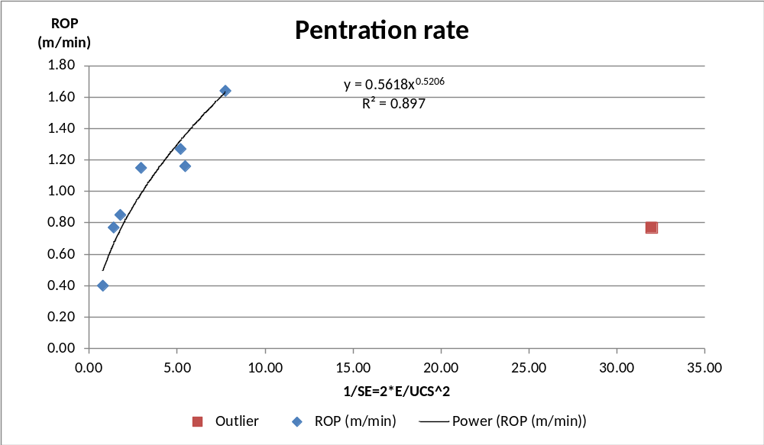

Snowden linearised this data by taking square root of SE (refer to Figure 3).
Figure 3 Linearised version Kahraman (et. al.) results
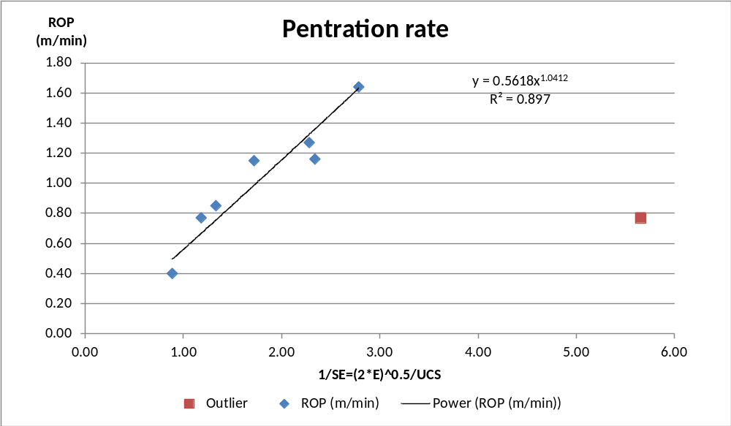
Snowden linearised this data by taking square root of SE (refer to Figure 3). Note that the regression passes through the origin.
Figure 4 Linearised version Kahraman (et. al.) results
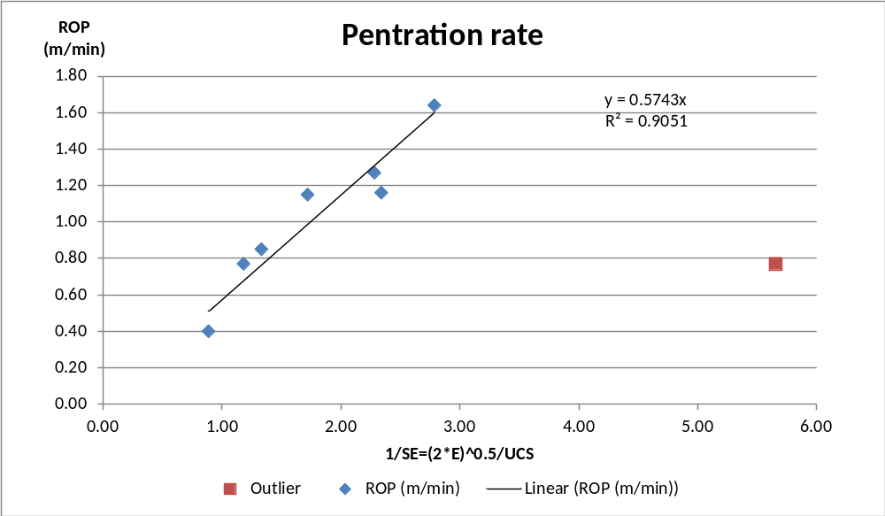

Figure 5 presents another model for specific energy based on work by Bauer and Calder:
SE =k* ln(UCS)
Where
SE is the specific energy
k is a proportionality constant
UCS is the rock compressive strength.

The advantage of the Bauer and Calder model is that it does not require an estimate of secant modulus (E).
Figure 5 Bauer and Calder model
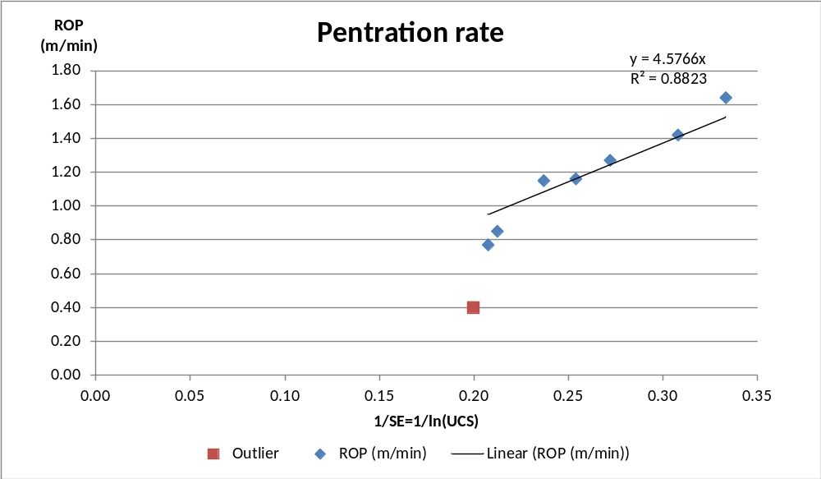

Developing a drill rig penetration rate model

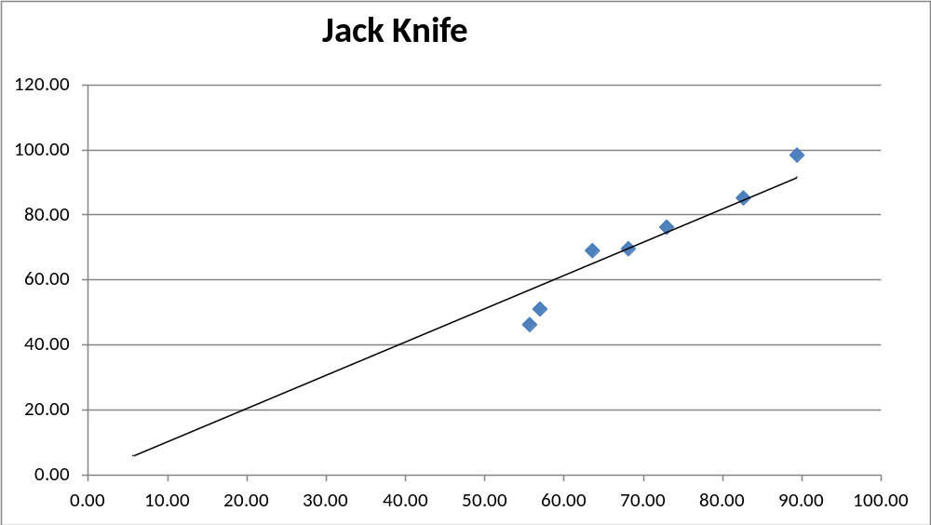
Modelling Truck Performance in a Spreadsheet
The physics or mathematics behind the truck performance is not difficult and the results match well with truck manufacturers’ performance graphs. The calculation of fuel burns is also presented here. Fuels burns are of interest because of the impact of increasing fuel prices and because they are often based on historical usage rather than calculated as part of the truck performance.

The physics of a truck
The up ramp truck speed is dependant on the energy available from the engine to lift the truck weight, including its payload, against gravity and to overcome rolling resistance and transmission losses (refer Figure 6 and Equation 1).
Figure 6 Rolling resistance model
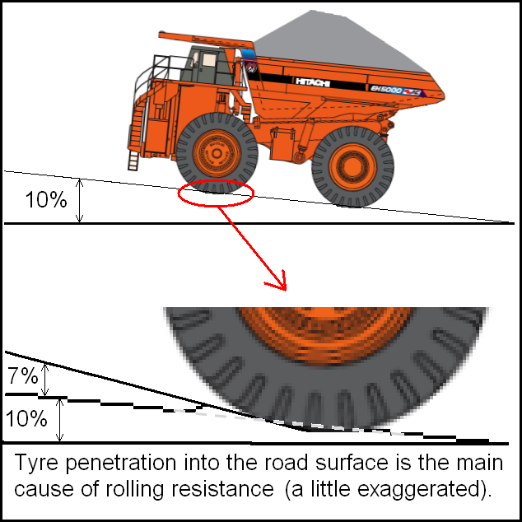
Equation 1: Up ramp truck speed

UpRampTruckSpeed=3.6*GrossEnginePower*TransmissionEfficiency*(1+RampGrade*RampGrade)^0.5
TotalTruckWeight*9.81*(RampGrade+RollingResistance)

The down ramp truck speed is dependant on the energy that engine can absorb generated by the truck running down hill from gravity but less rolling resistance and transmission losses (refer Equation 2).
Equation 2: Down ramp truck speed

DownRampTruckSpeed=-3.6*GrossEnginePower*RetarderFactor*(1+RampGrade*RampGrade)^0.5
TotalTruckWeight*9.81*(RampGrade+RollingResistance)

In both cases the maximum truck speed needs to be limited to the manufacturer’s recommendation. Further speed restrictions may be applied for site specific (i.e. safety) reasons. The gross engine power (in kilowatts), trucks weights [maximum and unloaded (in tonnes)] are published in the truck manufactures manuals.
The transmission efficiency factor and the retarder factor are used to calibrate the model to the manufacturer’s performance graph. An 80% transmission efficiency and a 115% retarder factor seems to work universally.
Figure 7 shows the model plotted against the Caterpillar 777D truck (using the performance graph and assuming 3% rolling resistance, refer Figure 8). The up ramp performance calibration is very good. The down ramp performance approximates the “gear” speeds. This is considered sufficient for most applications.
Figure 7 Truck Model Calibration
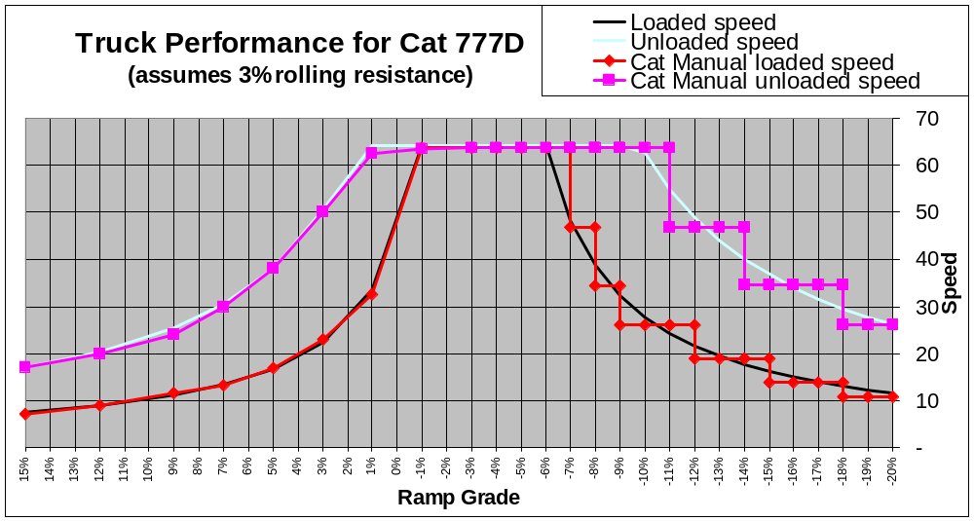

Figure 8 Caterpillar 777D truck performance graphs
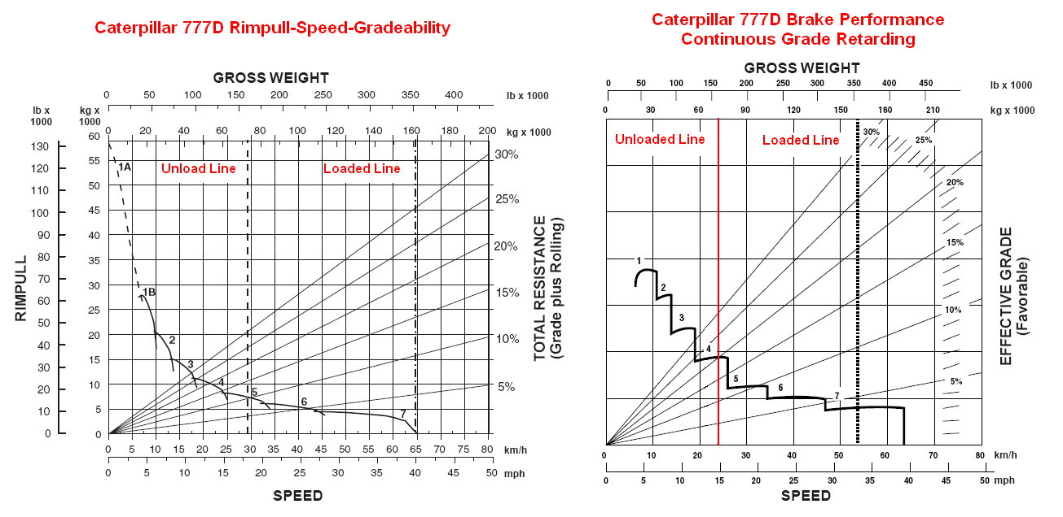

Electric trucks and trolley assist
The model will work for electric trucks and trolley assist applications but calibration of the transmission efficiency and retarder factors may be required.

Retarder options
Some trucks have additional retarder capacity options. In these cases the retarder factor would have to be increased.

Engine Load
The engine loading (up ramp) is calculated in Equation 3.
Equation 3: Engine loading

EngineLoading=UpRampTruckSpeed*TotalTruckWeight*9.81*(RampGrade+RollingResistance)
3.6*GrossEnginePower*TransmissionEfficiency*(1+RampGrade*RampGrade)^0.5

Fuel consumption
Fuel burn estimates are approximate (+/-10%) (refer Equation 4).

Equation 4: Fuel burns
FuelBurn=23.3%*GrossEnginePower*(EngineLoading*96%+4%)

The 23.3% factor seems to be a reasonable average estimate. If the maximum fuel burn is known for the truck type then the factor can be re-calculated (refer Equation 5).
Equation 5: Fuel burn factor

FuelBurnFactor=MaximumFuelBurn
GrossEnginePower

Practical Application
Table 4 contains the formulas previously discussed in a simple model for the Hitachi EH4500 truck. The key assumption is that the haulage profile segments can be re-calculated into an equivalent profile using level, up 10% or 10% down, segments. Real haulage profiles never meet this constraint but the error resulting from the assumption is not considered significant.
Table 4 The EH4500 truck performance model
EH4500 | Level | Up Ramp | Down Ramp
Case
Grade | 0.0% | 10.0% | -10.0%
Engine power (kw) | 2,014 | 2,014 | 2,014
Transmission efficiency | 80% | 80% | 80%
Retarder Efficiency | 115% | 115% | 115%
Rolling resistance | 2.5% | 2.5% | 2.5%
Loaded Performance
Loaded weight | 479 | 479 | 479
Loaded Speed Limit | 45.0 | 30.0 | 30.0
Speed | 45.0 | 9.9 | 23.8
Engine Power | 91% | 100% | 0%
Fuel Consumption (ltr/hr) | 429 | 469 | 14
Unloaded Performance
Unloaded weight | 211 | 211 | 211
Unloaded Speed Limit | 45.0 | 30.0 | 30.0
Speed | 45.0 | 22.5 | 30.0
Engine Power | 40% | 100% | 0%
Fuel Consumption (ltr/hr) | 197 | 469 | 14*

- Some truck manufacturers shut the injectors off when the truck is running down ramp
- The blue text are input values while the black text are calculated values

The unloaded weight is from the manufacturer’s handbook but could be increased if necessary to allow for “carry-back” (that is material stuck to the truck tray).
Table 5 illustrates the extraction of the key data for truck modelling.
Table 5 Rationalised EH4500 truck performance
Truck Speeds (km/hr)
 | Loaded | Unloaded
Level | 45 | 45
Up Ramp | 9.9 | 22
Down Ramp | 24 | 30
Truck Fuel Burns (l/hr)
 | Loaded | Unloaded
Level | 429 | 197
Up Ramp | 469 | 469
Down Ramp | 14 | 14
Idle | 14 | 14

Table 6 Schedule truck capacity, effective operating time and cycle delays
Truck Schedule Data
Unloaded Truck Weight | 198
Maximum Truck Weight | 480
Carry Back | 5%
Nominal Capacity | 100%
Moisture (%) | 4%
Capacity (dmt) | 257
Productive Hours per Year | 6,600
Effective Minutes per Hour | 50.0
Queue & Spot | 1.0
Load | 2.5
Dump | 1.0

Table 7 presents an example haulage profile.

Table 7 Haul profile
Haul Distances
Forward Trip (Loaded):
Level | 800
Up Ramp | 1,800
Down Ramp | 300
Return Trip (Unloaded):
Dump
Up Ramp | 300
Down Ramp | 1,800
Level | 800
Total Metres | 5,800

Using the truck speeds from Table 5 and haul distances from Table 7, the cycle time can be calculated (refer Table 8).
Table 8 Cycle times
Cycle Time
Forward Trip (Loaded):
Queue & Spot | 1.00
Load | 2.50
Level | 1.07
Up Ramp | 10.90
Down Ramp | 0.76
Return Trip (Unloaded):
Dump | 1.00
Up Ramp | 0.75
Down Ramp | 3.60
Level | 1.07
Cycle Time | 21.68

Using the truck fuel burns from Table 5 and cycle time components from Table 8 the fuel burns can be calculated (refer Table 9). The fuel burn per effective hour (50 minute hour) is the fuel burn per cycle multiplied by the cycle time.

Table 9 Fuel burns
Truck Cycle Time and Fuel Burn Calculations
Fuel Burn
Forward Trip (Loaded):
Queue & Spot | 0.23
Load | 0.59
Level | 7.63
Up Ramp | 85.15
Down Ramp | 0.18
Return Trip (Unloaded):
Dump | 7.82
Up Ramp | 6.26
Down Ramp | 0.84
Level | 3.51
Litres/Cycle | 104.4
Litres/Effective Hour | 288.9

Table 10 presents the final truck productivity and fuel burn per productive hour.
Table 10 Final Truck productivity and fuel burns
Truck Cycle Time and Fuel Burn Calculations
Truck productivity (tonnes) per Productive Hour | 626
Truck Fuel Burn (kilolitres) per Productive Hour | 229
Truck productivity (tonnes) per Year | 4,131,293

Sensitivities
For the practical example above, a 2.5% rolling resistance was applied. This value is suitable for good road conditions. What would happen if the rolling resistance was 3% and the maximum level speed reduced to 30km/hr (from 45km/hr)? The model (refer Table 11) suggests that productivity would fall about 7% (or haulage costs would rise about 7%).
Table 11 Truck productivity for 3% rolling resistance and a 30km/hr speed limit
Truck Cycle Time and Fuel Burn Calculations
Truck productivity (tonnes) per Productive Hour | 593
Truck Fuel Burn (kilolitres) per Productive Hour | 243
Truck productivity (tonnes) per Year | 3,912,381

Conclusion
The modelling of truck performance directly in a spreadsheet is not particularly difficult and allows tighter integration of the schedule and cost model. Useful for “what if” scenarios as demonstrated above.
If you would like a copy of the spreadsheet used above, please email: acooper@snowdengroup.com.

http://www.purplewave.com/cgi-bin/mnlist.cgi?111117/A6518
Hustrulid WA, Fairhurst C., “A theoretical and experimental study of the percussive drilling of rock”, International Journal of Rock Mechanics and Mineral Science, 1971 and 1972
Hughes H., “Some aspects of rock machining”, International Journal of Rock Mechanics and Mineral Science, 1972
Mellor M. “Normalization of specific energy values”, International Journal of Rock Mechanics and Mineral Science, 1972
Bauer, A. and Calder, P.N., “Drilling in Open Pit Iron Mines”, American Mining Congress (1966)
Truck image downloaded from www.hitachimining.com

