

Modelling Truck Performance in a Spreadsheet
Alan Cooper, Principal Mining Consultant, Snowden Mining Consultants
29 August 2008

87 Colin Street West Perth WA 6005
PO Box 77 West Perth WA 6872
Tel + 61 8 9213 9213
Fax + 61 8 9322 2576

Modelling Truck Performance in a Spreadsheet

 |  | Snowden  87 Colin St West Perth WA 6005 Australia  PO Box 77 West Perth WA 6872 Australia  Telephone: +61 8 9213 9213  Facsimile: +61 8 9322 2576  Website: http://www.snowdengroup.com
Alan Cooper
Principal Consultant Mining Engineer
acooper@snowdengroup.com

Introduction
Most open pits today are mined using the truck and shovel mining system (refer Figure 1). These operations usually model their mining schedules and cost models using a spreadsheet. However, truck performance and ultimately haulage requirements (that is truck numbers) are usually modelled in a specialised truck haulage program such as TALPAC. As discussed here, truck performance and haulage requirements can be modelled in a spreadsheet, there are some simple formulas which can be applied with significant benefits.

Figure 1 Truck and shovel in operation
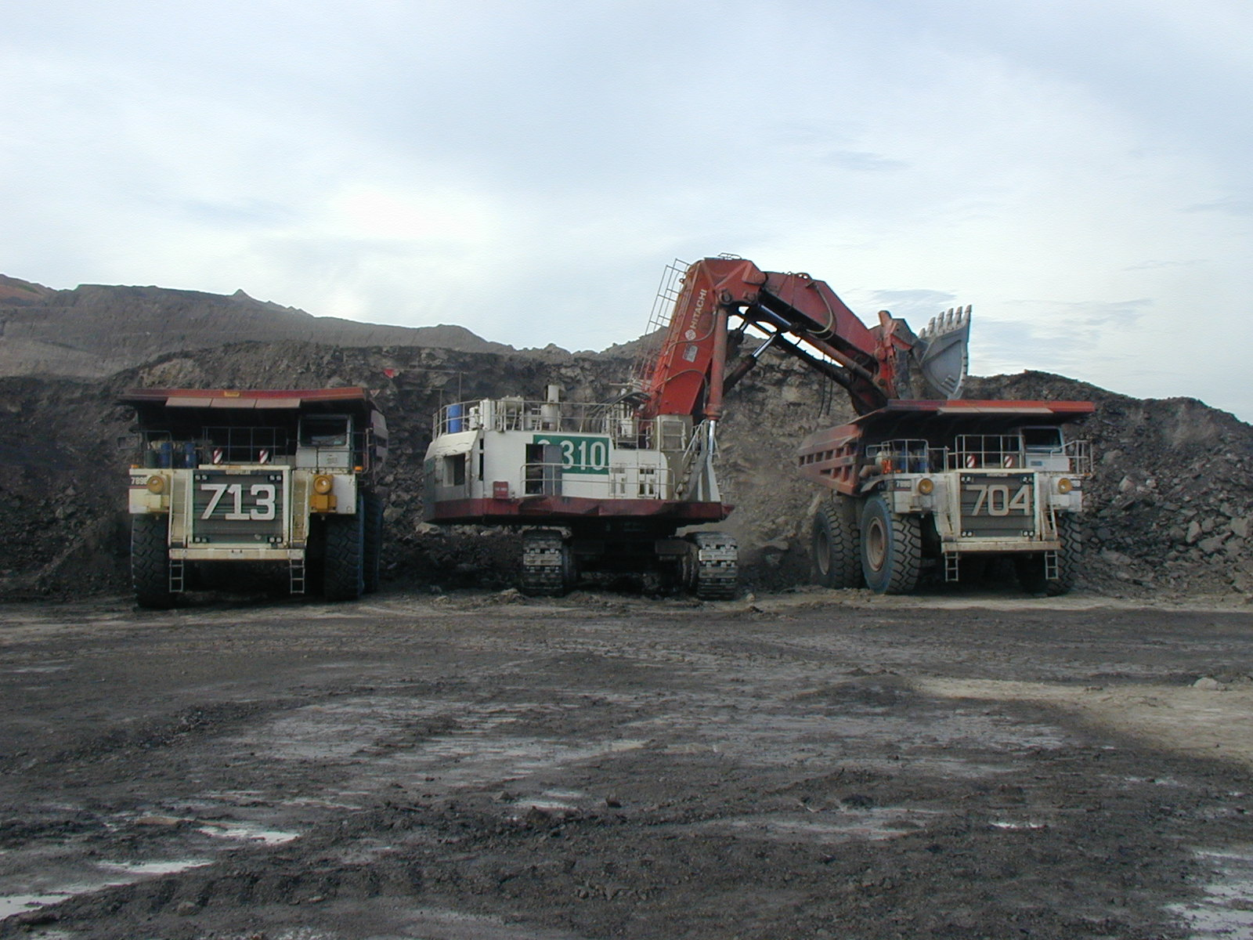

Modelling Truck Performance in a Spreadsheet
The physics or mathematics behind the truck performance is not difficult and the results match well with truck manufacturers’ performance graphs. The calculation of fuel burns is also presented here. Fuels burns are of interest because of the impact of increasing fuel prices and because they are often based on historical usage rather than calculated as part of the truck performance.

The physics of a truck
The up ramp truck speed is dependant on the energy available from the engine to lift the truck weight, including its payload, against gravity and to overcome rolling resistance and transmission losses (refer Figure 2 and Equation 1).
Figure 2 Rolling resistance model
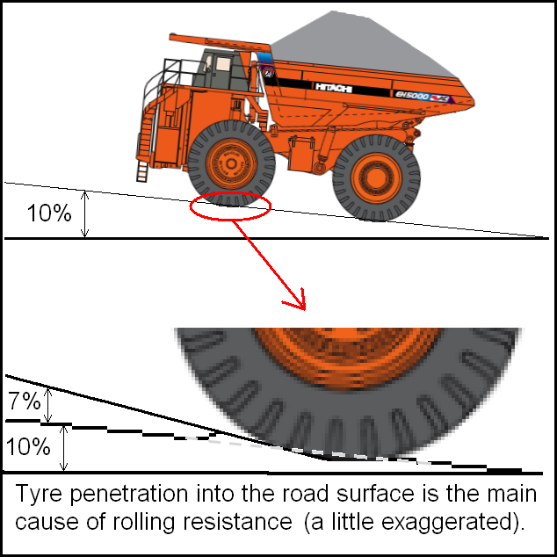
Equation 1: Up ramp truck speed

UpRampTruckSpeed=3.6*GrossEnginePower*TransmissionEfficiency*(1+RampGrade*RampGrade)^0.5
TotalTruckWeight*9.81*(RampGrade+RollingResistance)

The down ramp truck speed is dependant on the energy that engine can absorb generated by the truck running down hill from gravity but less rolling resistance and transmission losses (refer Equation 2).
Equation 2: Down ramp truck speed

DownRampTruckSpeed=-3.6*GrossEnginePower*RetarderFactor*(1+RampGrade*RampGrade)^0.5
TotalTruckWeight*9.81*(RampGrade+RollingResistance)

In both cases the maximum truck speed needs to be limited to the manufacturer’s recommendation. Further speed restrictions may be applied for site specific (i.e. safety) reasons. The gross engine power (in kilowatts), trucks weights [maximum and unloaded (in tonnes)] are published in the truck manufactures manuals.
The transmission efficiency factor and the retarder factor are used to calibrate the model to the manufacturer’s performance graph. An 80% transmission efficiency and a 115% retarder factor seems to work universally.
Figure 3 shows the model plotted against the Caterpillar 777D truck (using the performance graph and assuming 3% rolling resistance, refer Figure 4). The up ramp performance calibration is very good. The down ramp performance approximates the “gear” speeds. This is considered sufficient for most applications.
Figure 3 Truck Model Calibration
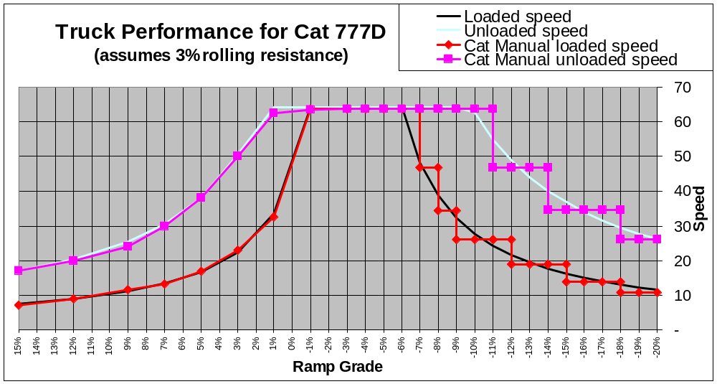

Figure 4 Caterpillar 777D truck performance graphs
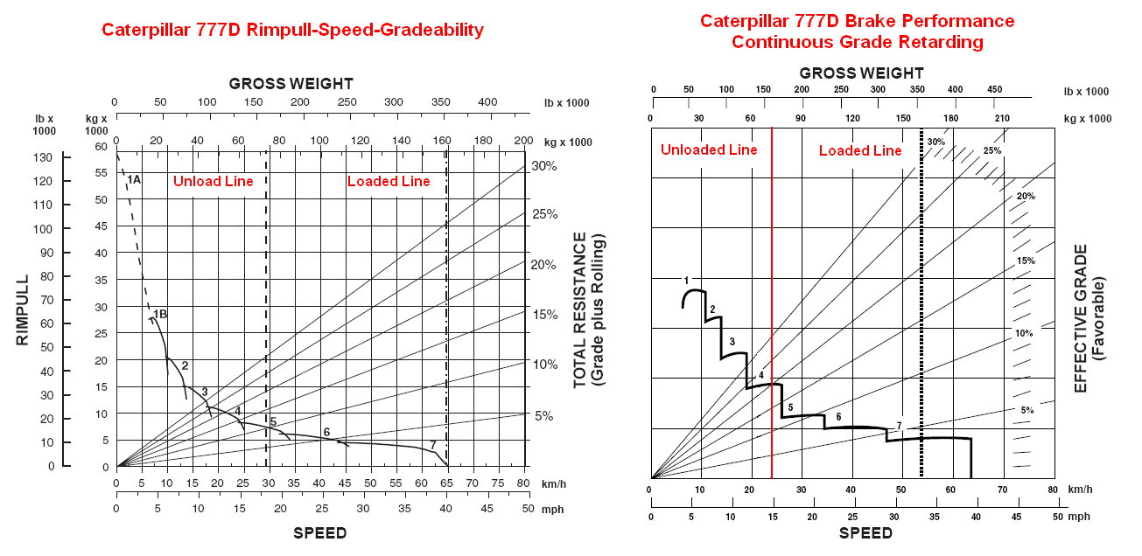

Electric trucks and trolley assist
The model will work for electric trucks and trolley assist applications but calibration of the transmission efficiency and retarder factors may be required.

Retarder options
Some trucks have additional retarder capacity options. In these cases the retarder factor would have to be increased.

Engine Load
The engine loading (up ramp) is calculated in Equation 3.
Equation 3: Engine loading

EngineLoading=UpRampTruckSpeed*TotalTruckWeight*9.81*(RampGrade+RollingResistance)
3.6*GrossEnginePower*TransmissionEfficiency*(1+RampGrade*RampGrade)^0.5

Fuel consumption
Fuel burn estimates are approximate (+/-10%) (refer Equation 4).

Equation 4: Fuel burns
FuelBurn=23.3%*GrossEnginePower*(EngineLoading*96%+4%)

The 23.3% factor seems to be a reasonable average estimate. If the maximum fuel burn is known for the truck type then the factor can be re-calculated (refer Equation 5).
Equation 5: Fuel burn factor

FuelBurnFactor=MaximumFuelBurn
GrossEnginePower

Practical Application
Table 1 contains the formulas previously discussed in a simple model for the Hitachi EH4500 truck. The key assumption is that the haulage profile segments can be re-calculated into an equivalent profile using level, up 10% or 10% down, segments. Real haulage profiles never meet this constraint but the error resulting from the assumption is not considered significant.
Table 1 The EH4500 truck performance model
EH4500 | Level | Up Ramp | Down Ramp
Case
Grade | 0.0% | 10.0% | -10.0%
Engine power (kw) | 2,014 | 2,014 | 2,014
Transmission efficiency | 80% | 80% | 80%
Retarder Efficiency | 115% | 115% | 115%
Rolling resistance | 2.5% | 2.5% | 2.5%
Loaded Performance
Loaded weight | 479 | 479 | 479
Loaded Speed Limit | 45.0 | 30.0 | 30.0
Speed | 45.0 | 9.9 | 23.8
Engine Power | 91% | 100% | 0%
Fuel Consumption (ltr/hr) | 429 | 469 | 14
Unloaded Performance
Unloaded weight | 211 | 211 | 211
Unloaded Speed Limit | 45.0 | 30.0 | 30.0
Speed | 45.0 | 22.5 | 30.0
Engine Power | 40% | 100% | 0%
Fuel Consumption (ltr/hr) | 197 | 469 | 14*

- Some truck manufacturers shut the injectors off when the truck is running down ramp
- The blue text are input values while the black text are calculated values

The unloaded weight is from the manufacturer’s handbook but could be increased if necessary to allow for “carry-back” (that is material stuck to the truck tray).
Table 2 illustrates the extraction of the key data for truck modelling.
Table 2 Rationalised EH4500 truck performance
Truck Speeds (km/hr)
 | Loaded | Unloaded
Level | 45 | 45
Up Ramp | 9.9 | 22
Down Ramp | 24 | 30
Truck Fuel Burns (l/hr)
 | Loaded | Unloaded
Level | 429 | 197
Up Ramp | 469 | 469
Down Ramp | 14 | 14
Idle | 14 | 14

Table 3 Schedule truck capacity, effective operating time and cycle delays
Truck Schedule Data
Unloaded Truck Weight | 198
Maximum Truck Weight | 480
Carry Back | 5%
Nominal Capacity | 100%
Moisture (%) | 4%
Capacity (dmt) | 257
Productive Hours per Year | 6,600
Effective Minutes per Hour | 50.0
Queue & Spot | 1.0
Load | 2.5
Dump | 1.0

Table 4 presents an example haulage profile.

Table 4 Haul profile
Haul Distances
Forward Trip (Loaded):
Level | 800
Up Ramp | 1,800
Down Ramp | 300
Return Trip (Unloaded):
Dump
Up Ramp | 300
Down Ramp | 1,800
Level | 800
Total Metres | 5,800

Using the truck speeds from Table 2 and haul distances from Table 4, the cycle time can be calculated (refer Table 5).
Table 5 Cycle times
Cycle Time
Forward Trip (Loaded):
Queue & Spot | 1.00
Load | 2.50
Level | 1.07
Up Ramp | 10.90
Down Ramp | 0.76
Return Trip (Unloaded):
Dump | 1.00
Up Ramp | 0.75
Down Ramp | 3.60
Level | 1.07
Cycle Time | 21.68

Using the truck fuel burns from Table 2 and cycle time components from Table 5 the fuel burns can be calculated (refer Table 6). The fuel burn per effective hour (50 minute hour) is the fuel burn per cycle multiplied by the cycle time.

Table 6 Fuel burns
Truck Cycle Time and Fuel Burn Calculations
Fuel Burn
Forward Trip (Loaded):
Queue & Spot | 0.23
Load | 0.59
Level | 7.63
Up Ramp | 85.15
Down Ramp | 0.18
Return Trip (Unloaded):
Dump | 7.82
Up Ramp | 6.26
Down Ramp | 0.84
Level | 3.51
Litres/Cycle | 104.4
Litres/Effective Hour | 288.9

Table 7 presents the final truck productivity and fuel burn per productive hour.
Table 7 Final Truck productivity and fuel burns
Truck Cycle Time and Fuel Burn Calculations
Truck productivity (tonnes) per Productive Hour | 626
Truck Fuel Burn (kilolitres) per Productive Hour | 229
Truck productivity (tonnes) per Year | 4,131,293

Sensitivities
For the practical example above, a 2.5% rolling resistance was applied. This value is suitable for good road conditions. What would happen if the rolling resistance was 3% and the maximum level speed reduced to 30km/hr (from 45km/hr)? The model (refer Table 8) suggests that productivity would fall about 7% (or haulage costs would rise about 7%).
Table 8 Truck productivity for 3% rolling resistance and a 30km/hr speed limit
Truck Cycle Time and Fuel Burn Calculations
Truck productivity (tonnes) per Productive Hour | 593
Truck Fuel Burn (kilolitres) per Productive Hour | 243
Truck productivity (tonnes) per Year | 3,912,381

Conclusion
The modelling of truck performance directly in a spreadsheet is not particularly difficult and allows tighter integration of the schedule and cost model. Useful for “what if” scenarios as demonstrated above.
If you would like a copy of the spreadsheet used above, please email: acooper@snowdengroup.com.

A Runge Limited software package
Truck image downloaded from www.hitachimining.com

