ARCON96 for Windows 10

# Objective:

The objective of this work is to develop a replacement for the ARCON96 module ARCONVB.EXE. ARCONVB.EXE is a 16-bit executable not compatible with Windows 10. The replacement should be compatible with Windows 10 and should provide the same user experience as ARCONVB.EXE. The user experience should be similar enough that the ARCON96 user manual can continue to be used for the replacement software.

# ARCON96 User Interface Description

## Splash Screen

ARCON96 opens with a splash screen, permitting the user to continue or cancel. Only two buttons are active on this screen, titled “Intro”, and there is no menu available. The “Cancel” button terminates the program. The “Continue” button leaves the “Intro” screen and displays a disclaimer dialog. The dialog contains “Ok” and “Cancel” buttons. The “Cancel” button terminates the application while the “Ok” button presents the user with the “Scenario Input” screen.

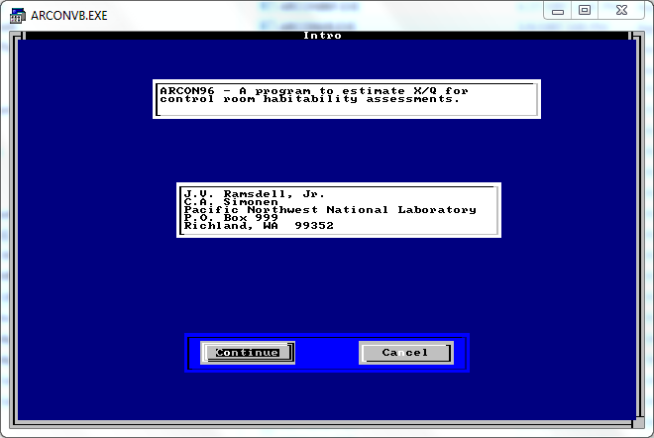

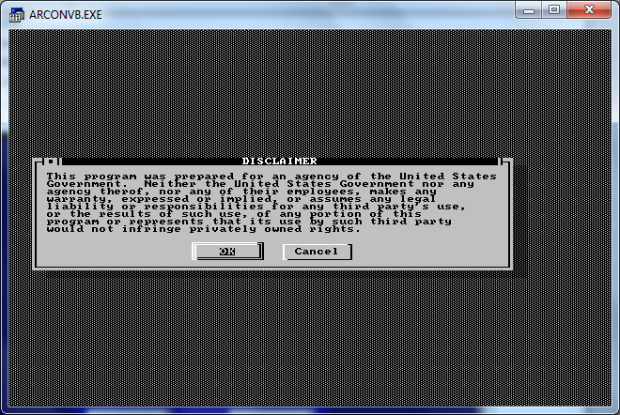

## Scenario Input Screen

The “Scenario Input” screen permits the user to select an existing ARCON96 input file or to create a new file.

Selecting “Input New File” will present the user with a dialog to create a new file name or select an existing file name. Either choice will present the user with the more detailed Scenario Input Screen, referred to here as “Scenario Input Screen, Advanced”.

Selecting “Open an Existing Input File” presents the user with a dialog box identical to the one displayed by the “Input New File” option. Only the underlying action changes, where opening an existing input file will read the file and populate the “Scenario Input Screen, Advanced” screen. Once the user has selected an existing input file to open, the application presents a dialog box permitting the user to save any modifications to either a new file name or the existing file name.

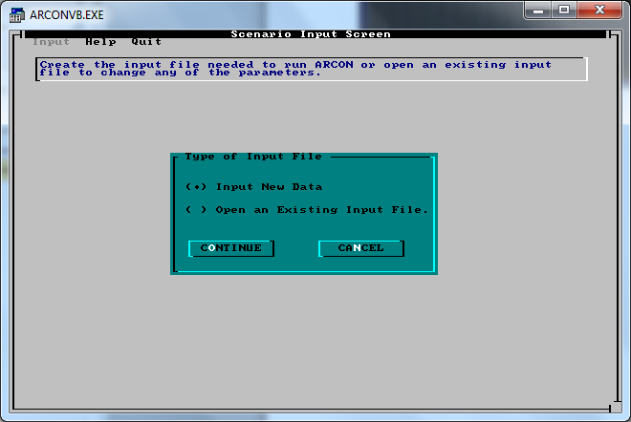

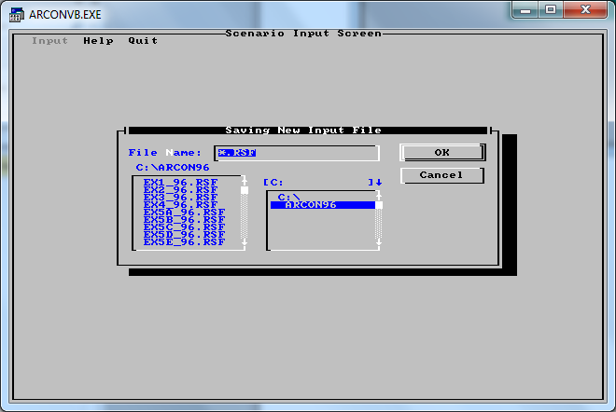

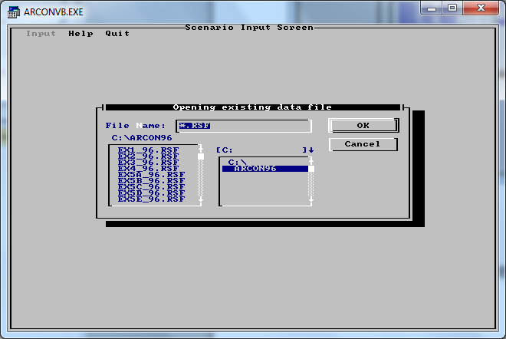

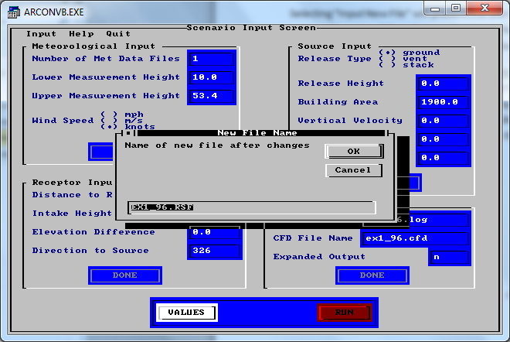

## Scenario Input Screen, Advanced

### General Layout

Following the selection of an input file name, the Scenario Input Screen changes to permit input of most, if not all, of the scenario description. Of the six possible input panels, four are displayed on the Scenario Input Screen. Values in these four input panels can be edited directly on the Scenario Input Screen. As each input panel is completed, the “Done” button for that panel should be pressed. This blanks the associated input panel, making it simple to determine which input panels have been completed. “Done” cannot be selected (the button is not active) until values are input for all fields in a given panel. Selecting “Done” will hide the associated input panel. The “Run” button for the screen is not active until all four input panels have been completed. Completed panels may be revealed again by selecting the panel in the “Input” menu. Validation of the input data on the various panels is primarily accomplished when the focus is moved from a given input field. However, overall checking can be accomplished by selecting the “Values” button on the Scenario Input Screen.

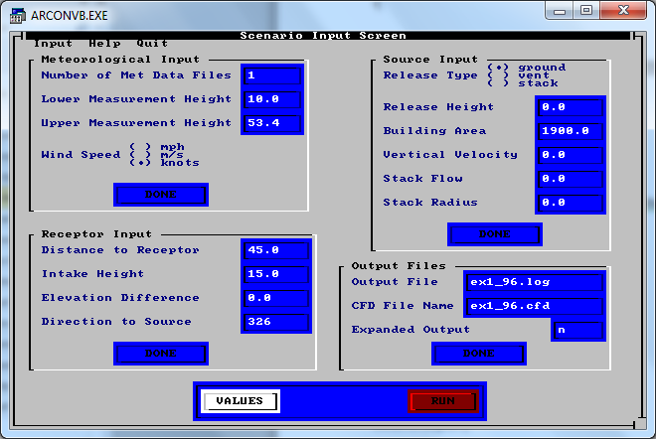

### Meteorological Input

The input data format is numerical for most fields along with a radio button input for the wind speed units. Entering a value for the Number of Met Data Files (and leaving the field) will invoke an immediate dialog box with the fifth panel, the “Metfile” panel. This panel is used to enter the names of the met data files that will be used. When initially displayed the panel has only a single data field used to enter the name of the first met data file. If more than one met data file is being used, hitting the tab key will make second and subsequent data entry fields appear in sequence. Once sufficient file names have been entered, the tab key will make the focus move from the data entry fields to the “File Search” and “Done” buttons. Entering a value greater than 10, less than 1, or any non-numeric value will generate an error message and the user will be returned to the Scenario Input screen rather than being presented with the Metfile input panel.

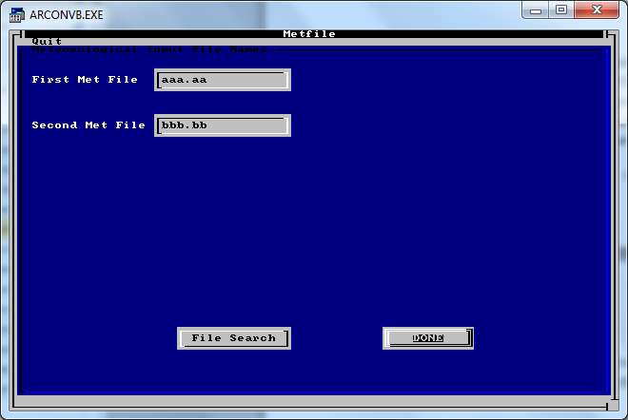

### Source Input

The input data format is primarily numerical with a radio button input for the release type. Otherwise, this panel follows a generic format. Input values outside of pre-defined ranges will generate an error dialog box when the focus leaves a field.

### Receptor Input

The input data format is numerical. Otherwise, this panel follows a generic format. Input values outside of pre-defined ranges will generate an error dialog box when the focus leaves a field.

### Output Files

The input data format for both output file names is alphanumeric. No error messages are generated by the file name input fields, but a blank field loosing focus will generate a default file name (Arcon96.log) for the “Output File” file name. The “Expanded Output” input is an alpha field requiring either a “y” or “n” entry and lowercase is required.

### Buttons

The Scenario Input screen has two buttons labeled “Values” and “Run”. Selecting the “Values” button will perform data validation. Presumably the data validation has already been accomplished during data entry, but there may be instances where a hand-built input file has been read and not all of the input data is valid.

The “Run” button is intended to be selected after the “Values” button. The run button first generates a dialog box stating that an Arcon96 RSF input file has been written.

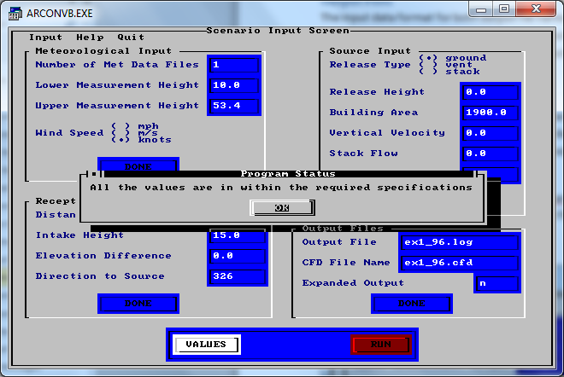

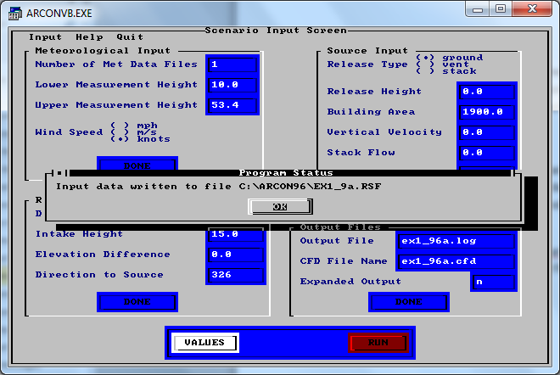

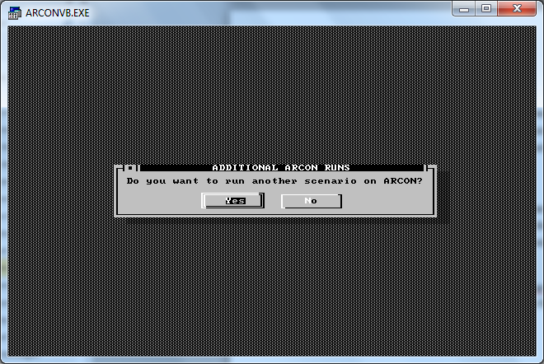

### Scenario Input Screen Menu

#### Input

This menu item allows the user to edit the various data entry panels, but the interaction form differs for the various panels. Selecting Meteorological, Receptor, Source, or Output will just toggle the visibility of these panels on the Scenario Input Screen. However, this behavior is valuable if a panel has been completed and then dismissed using associated “Done” button.

Selecting Met File Name(s) allows direct access to the Met File input panel, used to input meteorological file names .

Selecting Default permits user-entry of a collection of default values not entered in other input panels.

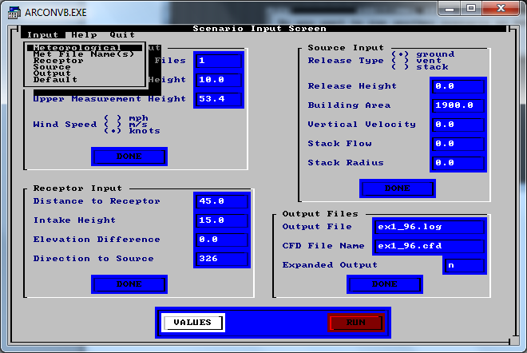

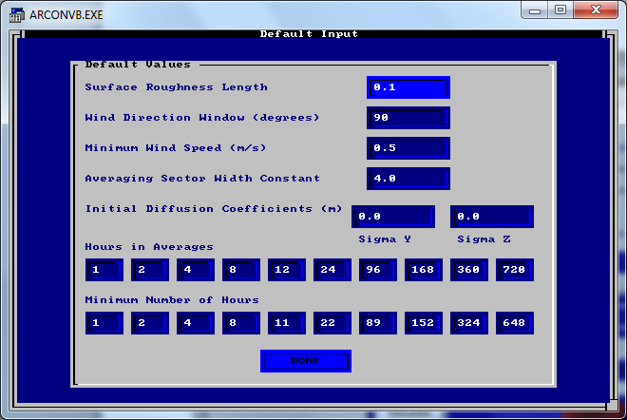

#### Help

Selecting the “Help” menu item displays a selection of help menu topics. This display and the resulting help information is taken from the ASCII text file ARCHELP.TXT.

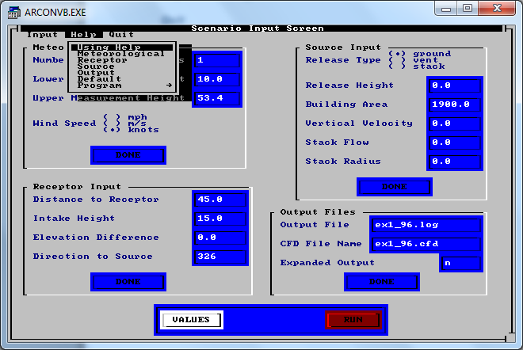

#### Quit

Selecting the “Quit” menu item immediately quits the application. No warning is given.

### Error Messages

Error messages are associated with each of the input fields. Note that in many cases the error message can be generated by non-numeric data in a numeric field, even though the resulting error message does not directly address this issue.

|  |  |
| --- | --- |
| **Field** | **Message** |
| Number of Met Data Files | Values less than 1 or greater than 10 are not allowed. Please enter an integer between 1 and 10. |
| Lower Measurement Height | Values less than zero are not allowed NOR values greater than 100. Nor are values greater than the upper measurement height. Please enter an appropriate value. |
| Upper Measurement Height | Values less than the lower measurement height are not allowed. Nor are values greater than 300 meters. Please enter an appropriate value. |
| Release Height | Values less than zero are not allowed NOR values greater than 300. Please enter an appropriate value. |
| Building Area | Values less than zero are not allowed. Nor are values greater than 10000 meters. Please enter an appropriate value. |
| Vertical Velocity | Allowable values are between 0 and 50. Please enter an appropriate value. |
| Stack Flow | Allowable values are between 0 and 100. Please enter an appropriate value. |
| Stack Radius | Allowable values are between 0 and 10. Please enter an appropriate value. |
| Distance to Receptor | Values less than 0 are not allowed NOR values greater than 10000. Please enter an appropriate value. |
| Intake Height | Values less than zero are not allowed NOR are values greater than 100. Nor are values greater than the upper measurement height. Please enter an appropriate value. |
| Elevation Difference | Values less than -1000 meters are not allowed. Nor are values greater than 1000 meters. Please enter an appropriate value. |
| Direction to Source | Allowable values are between 0 and 360 (degrees). Please enter an appropriate value. |
| Expanded Output | Allowable characters are n (no) and y (yes). However, only the first letter of each option is input. Please enter an appropriate character. |
| Surface Roughness Length | Values less than 0 are not allowed. Default values set to program standard. |
| Wind Direction Window (degrees) | Values less than 0 are not allowed. Default values set to program standard. |
| Minimum Wind Speed (m/s) | Values less than 0 are not allowed. Default values set to program standard. |
| Averaging Sector Width Constant | Values less than 0 are not allowed. Default values set to program standard. |

## File Format

The graphical front end of ARCON96 communicates with the console-based backend by way of an ARCON96 input file. The file input format is dictated by the FORTRAN source code file SCENREAD.FOR. However, it appears that the example input files shipped with ARCON96 may use a more conservative format, possibly dictated by the ARCONVB.EXE program. This alternate format is provided in brackets following the FORTRAN format.

|  |  |  |  |
| --- | --- | --- | --- |
| **Fortran Format Code** | **Fortran Variable Name** | **Description** | **Associated ARCON96VB.EXE Input Screen** |
| I5 [I2] | NMETFILE | Number of met data files | Scenario Input Screen, met input panel |
| A40 [8.3 format] | MET_FILE(*) | Names of met data files | Metfile Input Screen |
| F10.0 [F9.0] | MHT1 | Height of lower level met data | Scenario Input Screen, met input panel |
| F10.0 [F9.0] | MHT2 | Height of upper level met data | Scenario Input Screen, met input panel |
| I5 [I4] | SPD_TYPE | Wind speed data type | Scenario Input Screen, met input panel |
| I5 [I4] | RTYPE | Release type | Scenario Input Screen, source input panel |
| F10.0 [F9.0] | RHT | Release height | Scenario Input Screen, source input panel |
| F10.0 [F9.0] | BAREA | Building area | Scenario Input Screen, source input panel |
| F10.0 [F9.0] | W0 | Vertical velocity of vent exhaust | Scenario Input Screen, source input panel |
| F10.0 [F9.0] | F0 | Stack or vent flow rate | Scenario Input Screen, source input panel |
| F10.0 [F9.0] | SRAD | Stack radius | Scenario Input Screen, source input panel |
| 2I5 [2I4] | WIND_DIR, WINDOW | Wind direction and window | Scenario Input Screen, receptor input panel (direction)  Default Input Screen (window) |
| F10.0 [F9.0] | DIST | Distance from release point to intake | Scenario Input Screen, receptor input panel |
| F10.0 [F9.0] | RECHT | Receptor height | Scenario Input Screen, receptor input panel |
| F10.0 [F9.0] | T_DIFF | Difference in plant grade between stack and intake grade at release point | Scenario Input Screen, receptor input panel |
| A40 [8.3 format] | LOG_FILE | Results summary log file name | Scenario Input Screen, output file panel |
| A40 [8.3 format] | CFD_FILE | Results CFD file name | Scenario Input Screen, output file panel |
| F10.0 [F3.0] | Z0 | Surface roughness length | Default Input Screen |
| F10.0 [F9.0] | UMIN | Minimum wind speed | Default Input Screen |
| F10.0 [F9.0] | SW_CNST | Sector width constant | Default Input Screen |
| 10I4 | NA(*) | X/Q averaging intervals | Default Input Screen |
| 10I4 | NAVMIN(*) | Min number of hours for each averaging interval | Default Input Screen |
| 2F10.0 [2F9.0] | Sigy0, sigz0 | Sigma y0 and sigma z0 for area source | Default Input Screen |

# Development Environment

The original release of ARCON96 was developed using Microsoft’s Visual Basic language for the GUI routines and a FORTRAN compiler for the calculation module. The visual basic executables, ARCONVB.EXE and ARCONVB2.EXE, appear to be 16-bit applications not suitable for execution under Windows 10. The FORTRAN executable, ARCON96F.EXE, appears to be a 32-bit application that continues to execute under Windows 10.

The update to the GUI routines will be developed in C# using Visual Studio 2017. The GUI will be a Windows Presentation Foundation client application and will use the .NET Framework 4.6.1.

# Deployment Strategy

Deployment within the Dominion network must be compatible with the “Bit9” security product as well as the “Win 10 My Software Installs” software distribution system. Historically, both of these requirements have been challenging for software deployment.

This application will meet both requirements by using the Visual Studio Publish Wizard. The goal is to produce a ClickOnce installation package. The installation package will permit installation from a CDROM (or equivalent) and will not require administrator privileges to execute. The resulting application will not check for updates from the network. A shortcut will be added to the Start Menu and the application will be capable of being uninstalled via Add/Remove Programs.