A Genetic Algorithm for Pascal

Prof. Alan D. Freed
Department of Mechanical Engineering, Texas A&M University, College Station, TX

General Information
Contact
All feedback is welcome. Please email it to: afreed @ tamu.edu.
Software Version
1.3.3, November 2015
Programming Language and Required Packages
Library 'GenAlg' is written in Pascal, compiled in Free Pascal, and was developed using Lazarus.
Library 'GenAlg' requires the 'Arrays' and 'rng' libraries written by the same author.
Copyright
© 2014-2015, Alan D. Freed
All rights reserved.
Licensing
This software is licensed under the GNU Lesser General Public License, vs. 3 or later. The license reads:

GENALG is a free software: you can redistribute it and/or modify it under the terms of the GNU Lesser General Public License as published by the Free Software Foundation, either version 3 of the License, or (at your option) any later version.

GENALG is distributed in the hope that it will be useful, but WITHOUT ANY WARRANTY; without even the implied warranty of MERCHANTABILITY or FITNESS FOR A PARTICULAR PURPOSE. See the GNU Lesser General Public License for more details.
You should have received a copy of the GUN Lesser General Public License along with RNG. If not, see <http://www.gnu.org/licenses/>.
References
- Goldberg, D.E., Genetic Algorithms in Search, Optimization, and Machine Learning, Addison-Wesley, Boston, 1989.
- Goldberg, D.E., The Design of Innovation: Lessons learned from and for competent genetic algorithms. In: Genetic algorithms and evolutionary computation, Vol. 7, Klewer, Boston, 2002.

Discussion of the Library Interface
A template comprised of four programming units that utilizes the interface of library 'GenAlg' is listed in the Appendix. One is for defining basic type and functions used throughout the suite. One is for entering the data. Another is for creating a model. And the third is a solver that calls them. You will need to write a driver that calls the solver, e.g., in the three demos supplied with the software the driver is a Lazarus program that creates figures to display output from the genetic algorithm. These template files are supplied with the software.
Genetic Algorithm
Details of the genetic algorithm are buried within the library. They do not permeate up to the interface. The author drew heavily on the books of Goldberg cited above in his construction of this genetic algorithm.

At the core of this genetic algorithm are haploid genes that can admit two states, passive and recessive, represented by a binary value. At a very low probability of occurrence, a gene may mutate from passive to active or vice versa.

A chromosome is an array of genes assembled as a Grey binary number. Grey numbers are selected over regular binary numbers so that mutation events have a more refined effect. Each chromosome represents a model parameter whose optimal value is being sought. A decoder/encoder pair maps a floating point real into a Grey binary array and back again. These are one-to-one mappings.

A genome is a collection of chromosomes, one for each parameter being sought. It contains the genetic information.

A creature is comprised of a genome and a fitness that associates with it. Fitness is taken to be a range-weighted harmonic sum of the root mean squared errors between model predictions acquired over a collection of experiments.

A colony is a population of creatures, usually numbering in the hundreds. To evolve a colony from one generation into the next, creatures from the existing generation are picked at random for mate selection via tournament play. From two tournaments, a pair of parent creatures get selected for mating with the outcome being a child creature that will move onto the next generation. Only the elite creature from an existing population moves onto the next generation. All other creatures perish at the moment when a new population of children from the current generation become the adults of the next generation. Mating involves a crossover event with a high probability of occurrence between like pairs of chromosomes from two parents. Where a pair of chromosomes are to be split and their genetic information swapped (i.e., crossover) is a probabilistic outcome. The end result is that a child's chromosome strands are comprised of gene segments from both parents.
The original generation is procreated. Every gene is assigned randomly with 50-50 odds in that generation. This provides a dispersed population over the window of admissible parametric values, a Monte Carlo sampling. To aid in maintaining a diverse population, a procreated immigrant or two may get introduced into a population at each generation at a low probability of occurrence. Mutation also aids in maintaining diversity. No clones are allowed in this implementation of a genetic algorithm. Instead of evolving a population of creatures to an existence where all creatures are clones of one another, this implementation of a genetic algorithm determines its convergence criteria and population size according to algorithms derived by Goldberg (2002) from probability theory.
Constants and Types
Constants and types are not exported by library 'GenAlg'. You must declare those that you use within your application.

The vector and matrix types used by 'GenAlg' come from the 'Arrays' library. The functions used to manage them can be found in their separate documentation and are imported in unit gaCore.

Library 'GenAlg' has five constants that dimension the problem which the programmer must size. From this, there are three additional variables used for dimensioning that are created at run time.

Library 'GenAlg' uses a procedure type to interface a model with the optimizer.
Functions and Procedures
These can be broken down into different classifications.
System Functions and Procedures
Library 'GenAlg' utilizes the following array types:
type
TBVector = array of Boolean;
TIVector = array of Integer;
TRVector = array of Real;
TSVector = array of String;
TRMatrix = array of TRVector;
TRData = array of TRMatrix;
where functions to manage them can be found in the library 'Arrays'. All arrays are considered to index from 1.

'GenAlg' uses instances of a function type to assign model parameters that are to be held fixed during the optimization process. They are actually created after the varied parameters have been assigned. Sometimes it becomes useful to define a 'fixed' parameter as a function of 'varied' parameters, e.g., one may be able to provide more reliable max/min boundaries to the varied parameters when using a fixed parameter that is defined as a constraint in terms of the varied parameters.
type
TVectorFn = function (var v : TRVector) : TRVector;
In the case of how a TVectorFn is used within 'GenAlg', the argument sent through the function contains the varied parameters for a creature, while the returned vector contains the fixed parameters for that creature.

'GenAlg' requires that the model you use to interface with it be a procedure of type
type
TModel = procedure (
experiment : Integer; // INPUT exp is in range 1..dimE
var modelParameters : TRVector; // INPUT [1..dimP]
var controlData : TRMatrix; // INPUT [1..dimNC[exp]][1..dimNS[exp]]
var responseData : TRMatrix); // OUTPUT [1..dimNR[exp]][1..dimNS[exp]]
where there are dimE experiments that can be handled (different formulæ describing the same model may apply to different boundary conditions, for example) with the model being comprised of dimP parameters, some may be fixed. A set of control data are provided for the selected experiment to which the model returns a compatible set of response data. For experiment exp, say, there are dimNC[exp] control variables and dimNR[exp] response variables collected at dimNS[exp] sampling points. The objective of the genetic algorithm is to determine an optimal set of model parameters that describe these response data.

Running the Genetic Algorithm
This interface is simple and intuitive. It is comprised of three procedures.

Procedure StartGeneticAlgorithm creates a genetic algorithm and populates it with its first generation. It requires eleven arguments to achieve this objective.
- Argument numericalModel is a procedure that is an instance of the model type TModel which the programmer creates. It is the model whose parameters are being sought by this optimization technique.
- Argument expControlData is an instance of type TRData. It specifies the independent data controlled in the various experiments to be considered.
- Argument expResponseData is also an instance of type TRData. It specifies the dependent data whose responses were measured in the various experiments to be considered.
- Argument varyParameters is an instance of type TBVector. It specifies whether or not a given parameter is to be allowed to be varied by the optimizer, or whose value is to be held fixed throughout the process.
- Argument fixedParameters is an instance of type TVectorFn. This function assigns values to the fixed parameters which may depend on the varied parameters. If all parameters are to vary, then assign fixedParameters to nil.
- Argument alienParameters is an instance of type TRVector. It is the user's best guess as to what the varied parametric values likely are.
- Argument minParameters is an instance of type TRVector. It is a reasonable guess by the user as to what the lower bounds are for the varied parametric values.
- Argument maxParameters is an instance of type TRVector. It is a reasonable guess by the user as to what the upper bounds are for the varied parametric values.
- Argument significantFigs in an Integer that specifies how many significant figures one hopes to be able to secure in the solution provided. It is restricted to lie within the range of 1…7. This effects both the population size and the number of generations required to attain convergence.
- Argument parameterNames is an instance of type TSVector. It provides the name for each parameter, varied and fixed, and is used when writing out the report.
- The final argument reportFileName is a String that contains the name of the file (less any extension, it will be given a .txt extension) that the report is to be written into. This report will appear in the directory that you execute your program in.

Procedure AdvanceToNextGeneration creates a new population of children and advances them to the next generation of adults. It outputs a single argument that specifies whether or not the algorithm has reached 'theoretical' convergence. Even if the algorithm has reached convergence, users can continue to call AdvanceToNextGeneration as many times as they like before stopping the program. The genetic algorithm itself is very fast. What effectively controls the performance of a particular application run is the efficiency of the solver used by the model whose parameter are being fit.

Procedure StopGeneticAlgorithm is a command that terminates the runtime of the genetic algorithm and writes out a report of its findings to a file specified in StartGeneticAlgorithm.

Procedure DeleteGeneticAlgorithm removes the dynamically allocated memory created by a genetic algorithm. Do no call this unless you no longer need to access the data from a running of the genetic algorithm.
Algorithmic Data
Procedure GeneticAlgorithmData outputs the number of creatures per generation (it is the same from one generation to the next in this implementation of a genetic algorithm), the number of generations that were created over the lifetime of the colony, the total number of immigrants that were introduced into the colony over all of the generations, the total number of crossovers that took place during mating over all of the generations, and the total number of gene mutations that took place over all of the generations.
Elite Creature Data
There are two procedures belonging to this category.
- Procedure EliteCreatureData provides the fitness of the elite creature. The model parameters that associate with this fitness are returned as an instance of type TRVector whose associated Grey encodings are supplied as an instance of type TSVector. Fitness is defined by

where E is the number of experiments, and y represents the response, either model or experiment, as specified, with RMSE being the root mean squared error between model and experiment. Each term in this harmonic sum is normalized by the range in its response, thereby rendering the overall fitness a dimensionless measure.
- Procedure EliteCreatureFits provides data from which curves can be constructed to contrast model verses experiment for a selected experiment. All arrays are of type TRMatrix. Matrices expControl and expResponse are both returned values. Matrix modelControl is the only input matrix. It specifies the points where matrix modelResponse matrix is to be populated. It is not necessary that expControl and modelControl be of the same dimension, although that is the likely scenario. Typically, one wants a modelControl that is sufficiently dense so as to provide a smooth curve when plotted.
Population Fitness Data
There are two procedures belonging to this category.
- Procedure FitnessMoments provides the first four sampling statistics, here created using the fitness data of the current population. These are the sample mean, the sample standard deviation, the sample skewness and the sample excess kurtosis. Skewness and kurtosis are both zero in a normally distributed sampling. If skewness is negative, the distribution has a heavy tail on the left side of the mean. And if it is positive, it has a heavy tail on the right side of the mean. If the excess kurtosis is negative, the distribution is flatter than a normal distribution. And if it is positive, the distribution is more peaked than a normal distribution.

- Procedure FitnessStatistics provides the type of Johnson distribution (SB, bounded; SL, log-normal; SN, normal; SU, unbounded; and ST which is an SB distribution with γ = 0) that best describes the fitness data of the current population along with its four statistics: γ, δ, ξ and λ. Johnson distributions, as a collective set {SB, SL, SU} (SN and ST are special cases within this set), have the capability of describing the first, four, sample moments in any data set. A normal distribution, on the other hand, has the capability of describing the first, two, sample moments in any data set.

Johnson distributions obey transformations that map them into normal distributions. Juxtapositions ÷ between type designations and their mappings are as follows:

where

where

where

where

where X is a random variate and Z is a standard, normal, random variate (with zero mean and a standard deviation of one) wherein μ denotes the sample mean and σ the sample standard deviation.
Example
A trivial example is to determine the parameters of a linear model used to fit noisy data. This is overkill in the sense that we are using a hammer to swat a fly, but the method is illustrative and the model is intuitive for the reader, so it makes a good case study. The linear model considered is distributed as demo 1.
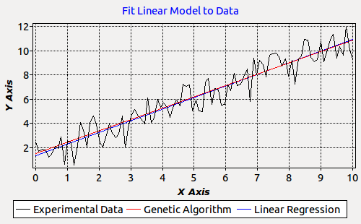Illustration 1: Genetic algorithm vs. linear regression after two generations.

Illustration 1 presents typical output from demo 1. Here results from the genetic algorithm are presented after the 2nd generation (theoretical convergence is after the 27th generation, actual convergence was by the 5th generation). We see there is but a small difference between the fittings of these data from linear regression and from the genetic algorithm. This quickly disappears with increasing generations in that the lines become indistinguishable. This provides a measure of confidence in the overall implementation of the genetic algorithm.

A Random Process
The genetic algorithm is truly a random process. I say this because the parameters held by the creatures of a population do not appear to have any common distribution. In the illustrations put forward below, distributions for the slope and the y-intercept in four successive runs are plotted looking at the fittest 50% of creatures. Each run is described by different sets of noisy data whose mean tendency is a straight line with a slope of 2 and a y-intercept of 1 generated with a standard deviation of 1 in white noise. The outcomes are all different.

The following figures are from four successive runs where we record distributions of the slope amongst the top half of all creatures in the final population of the colony.

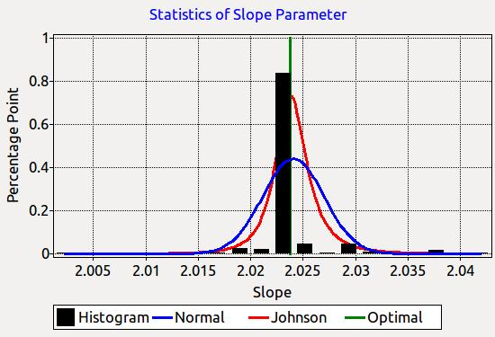
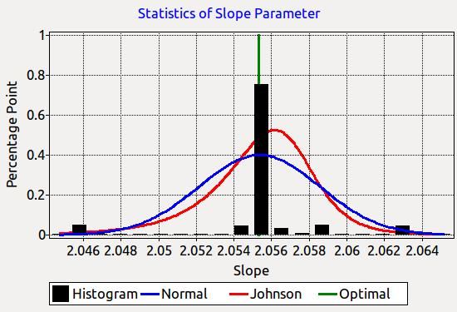

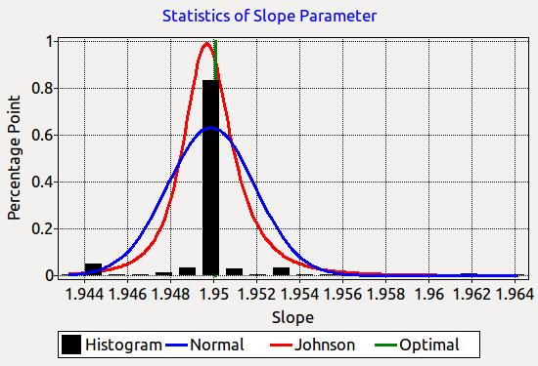
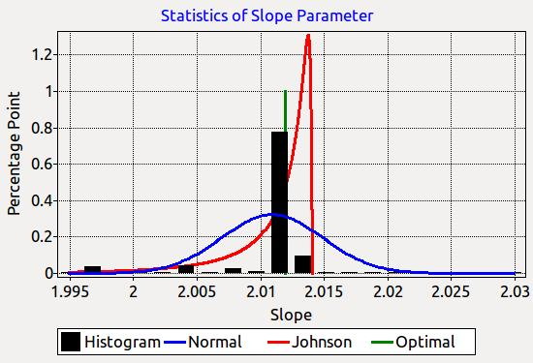

The next set of figures are from four additional successive runs where we record distributions of the y-intercept amongst the top half of all creatures in the final population of the colony.
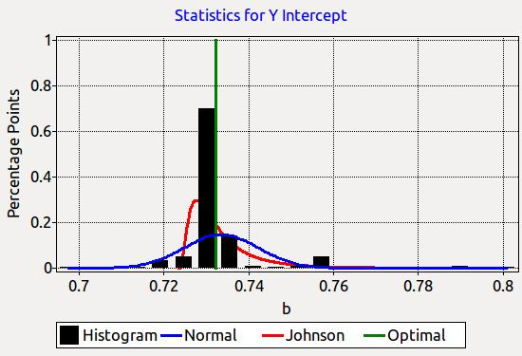
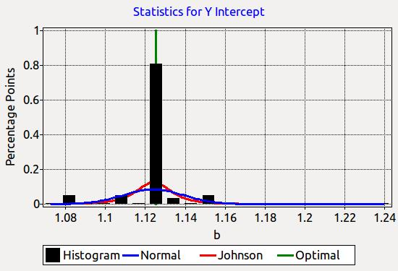

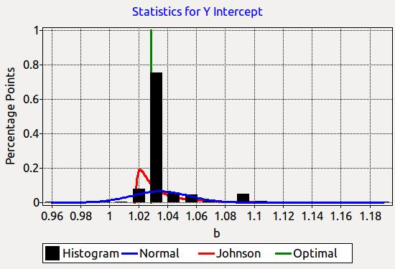
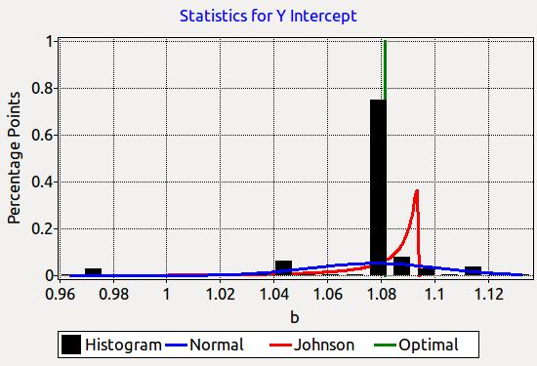

What is apparent in all eight images is the efficiency of the genetic algorithm to lock onto an optimal solution whenever a single optimum is present.
Report
Each run of the optimizer generates a report. An example of such a report is listed below.

----------------------------------------------------------------------------
An optimization of 1 random variable extracted from 1 experiment
comprising of 100 total data points fit with a model in 2 parameters
using a genetic algorithm with a population of size 626.
----------------------------------------------------------------------------
| elite | ------------------ population fitness ------------------
# | fitness | --- mean --- | - std dev - | - skewness - | - kurtosis -
1 2.142252E+1 2.65E+0 3.52E+0 2.54E+0 7.13E+0
2 2.143342E+1 8.86E+0 5.44E+0 4.85E-1 -5.23E-1
3 2.145444E+1 1.57E+1 7.29E+0 -9.47E-1 -6.86E-1
4 2.145445E+1 1.66E+1 7.31E+0 -1.24E+0 -1.31E-1
5 2.145446E+1 1.67E+1 7.32E+0 -1.21E+0 -2.14E-1
6 2.145446E+1 1.66E+1 7.45E+0 -1.19E+0 -2.85E-1
7 2.145446E+1 1.71E+1 7.14E+0 -1.37E+0 2.02E-1
8 2.145446E+1 1.64E+1 7.57E+0 -1.12E+0 -4.58E-1
9 2.145446E+1 1.72E+1 6.89E+0 -1.40E+0 3.34E-1
10 2.145446E+1 1.70E+1 7.11E+0 -1.28E+0 -1.98E-2
11 2.145446E+1 1.77E+1 6.55E+0 -1.61E+0 1.04E+0
12 2.145446E+1 1.67E+1 7.42E+0 -1.26E+0 -1.17E-1
13 2.145446E+1 1.66E+1 7.30E+0 -1.16E+0 -3.26E-1
14 2.145446E+1 1.66E+1 7.31E+0 -1.14E+0 -4.07E-1
15 2.145446E+1 1.66E+1 7.32E+0 -1.13E+0 -4.26E-1
16 2.145446E+1 1.73E+1 6.81E+0 -1.38E+0 2.82E-1
17 2.145446E+1 1.67E+1 7.16E+0 -1.21E+0 -1.74E-1
18 2.145446E+1 1.67E+1 7.27E+0 -1.20E+0 -2.52E-1
19 2.145446E+1 1.70E+1 7.01E+0 -1.33E+0 1.48E-1
20 2.145446E+1 1.73E+1 6.72E+0 -1.41E+0 4.31E-1
21 2.145446E+1 1.65E+1 7.39E+0 -1.17E+0 -3.09E-1
22 2.145446E+1 1.65E+1 7.42E+0 -1.17E+0 -3.18E-1
23 2.145446E+1 1.69E+1 7.18E+0 -1.32E+0 9.13E-2
24 2.145446E+1 1.70E+1 7.14E+0 -1.31E+0 4.81E-2
25 2.145446E+1 1.67E+1 7.11E+0 -1.21E+0 -1.77E-1
26 2.145446E+1 1.65E+1 7.33E+0 -1.20E+0 -2.19E-1
27 2.145446E+1 1.68E+1 7.17E+0 -1.27E+0 -2.29E-2
- - - - - - - - - - - - - - - - - - - - - - - - - -
Statistics from this optimization run include:
number of generations = 27
number of creatures = 626
number of immigrants = 52
number of crossovers = 26192
number of mutations = 77877
- - - - - - - - - - - - - - - - - - - - - - - - - -
Fitness statistics from the last generation are:
| Normal Distribution || ------------- Johnson Distribution ----------
| mean | std dev || S? | gamma | delta | xi | lambda
1.68E+01 7.17E+00 SB -7.77E-01 1.97E-01 1.04E+00 2.06E+01
- - - - - - - - - - - - - - - - - - - - - - - - - -
Parameters from the elite creature are:
# lower optimum upper name of parameter
1 4.000E-01 1.968E+00 1.000E+01 slope m
2 2.000E-01 1.199E+00 5.000E+00 intercept b
----------------------------------------------------------------------------

Appendix: A Template
There are five parts to the template provided with 'GenAlg'. The first provides basic types and functions used throughout the suite. It is gaCore. The second is used to create your model in a format that is accessible to the optimizer, i.e., gaModel. A third is used to enter a data set in a format that can be utilized by the optimizer, i.e., gaData. The fourth is a solver that calls the genetic algorithm, i.e., gaSolver. And the fifth is a driver that runs the optimizer, i.e., gaDriver. Units gaModel and gaData will require a fair amount of coding for your specific application. See the demos to get an idea of how this is done. Unit gaSolver and program gaDriver will not likely require any modification, at least to start with. You may want to alter them to better suit your needs as you gain experience using this optimizer.

What is typeset in red requires your attention.
GaCore
// global directives
{$MODE OBJFPC} // allows objects, classes, interfaces, exception handling
{$H+} // use ANSI strings
{$IFDEF UNIX}
{$CALLING CDECL} // uses the GCC calling convention - for Unix libraries
{$PIC ON} // create Position Independent Code - for Unix libraries
{$ENDIF}
unit gaCore; // you may want to rename this to better suit your needs

interface

uses
{$IFDEF UNIX}{$IFDEF UseCThreads}
cthreads,
{$ENDIF}{$ENDIF}
Classes, SysUtils;

// Array types defined in 'Arrays' and used by the 'GenAlg' library

type
TBVector = array of Boolean;
TIVector = array of Integer;
TRVector = array of Real;
TSVector = array of String;
TRMatrix = array of TRVector;
TRData = array of TRMatrix;

// Functions used to create and manage the array types of 'Arrays'.

function NewBVector (len : Integer) : TBVector;
// Creates a boolean vector indexing from 1 to len with elements of FALSE.

function NewIVector (len : Integer) : TIVector;
// Creates an integer vector indexing from 1 to len whose elements are all 0.

function NewRVector (len : Integer) : TRVector;
// Creates a real vector indexing from 1 to len whose elements are all 0.0.

function NewSVector (len : Integer) : TSVector;
// Creates a string vector indexing from 1 to len whose elements are all ''.

function LenBVector (var v : TBVector) : Integer;
// Returns the length of boolean vector v.

function LenIVector (var v : TIVector) : Integer;
// Returns the length of integer vector v.

function LenRVector (var v : TRVector) : Integer;
// Returns the length of real vector v.

function LenSVector (var v : TSVector) : Integer;
// Returns the length of string vector v.

function NewRMatrix (rows, columns : Integer) : TRMatrix;
// Creates a real matrix indexing as [1..rows][1..columns]
// whose elements are assigned values of 0.0.

function NewRData (experiments : Integer;
var variablesPerExp : TIVector;
var samplesPerExp : TIVector) : TRData;
// Creates a new real-valued data structure indexing as
// [1..experiments][1..variablesPerExp[experiment]][1..samplesPerExp[experiment]
// whose elements are all assigned values of 0.0.

// You may need other functions exported by 'Arrays'. These are most common.

implementation

function NewBVector (len : Integer) : TBVector; external 'Arrays';

function NewIVector (len : Integer) : TIVector; external 'Arrays';

function NewRVector (len : Integer) : TRVector; external 'Arrays';

function NewSVector (len : Integer) : TSVector; external 'Arrays';

function LenBVector (var v : TBVector) : Integer; external 'Arrays';

function LenIVector (var v : TIVector) : Integer; external 'Arrays';

function LenRVector (var v : TRVector) : Integer; external 'Arrays';

function LenSVector (var v : TSVector) : Integer; external 'Arrays';

function NewRMatrix (rows, columns : Integer) : TRMatrix; external 'Arrays';

function NewRData (experiments : Integer; var variablesPerExp : TIVector;
var samplesPerExp : TIVector) : TRData; external 'Arrays';

begin
end.

gaData
// global directives
{$MODE OBJFPC} // allows objects, classes, interfaces, exception handling
{$H+} // use ANSI strings
{$IFDEF UNIX}
{$CALLING CDECL} // uses the GCC calling convention - for Unix libraries
{$PIC ON} // create Position Independent Code - for Unix libraries
{$ENDIF}

unit gaData; // you may want to rename this to something more suitable

interface

uses
{$IFDEF UNIX}{$IFDEF UseCThreads}
cthreads,
{$ENDIF}{$ENDIF}
Classes, SysUtils;

// Exported constants/variables for the genetic algorithm for this application

const
dimE = ?; // number of experiments
dimR = ?; // number of response variables over all experiments
dimS = ?; // number of fitted sample points over all experiments

var
dimNC : TIVector; // number of control variables per experiment
dimNR : TIVector; // number of response variables per experiment
dimNS : TIVector; // number of sampling points taken per experiment

// ---------------------------------------------------------------------------

// Exported procedures used by the solver

// Data are staggered arrays of real matrices which index from
// [1..experiments][1..variables[experiment]][1..samples[experiment]]
// where experiment lies within the interval of 1..experiments,
// variables index from 1..experiments and
// samples index from 1..experiments.

function ExperimentalControlData : TRData;

function ExperimentalResponseData : TRData;

implementation

function ExperimentalControlData : TRData;
var
c, e, s : Integer;
data : TRData;
begin
// dimensioning the controls
dimNC := NewIVector(dimE);
// assign the number of control variables used in each experiment
dimNC[1] := ?;
...
// dimensioning the samplings
if dimNS = nil then begin // may be assigned in ExperimentalResponseData
dimNS := NewIVector(dimE);
// assign the number of samplings taken in each experiment
dimNS[1] := ?;
...
end;
// dimensioning the return array of control variables
data := NewRData(dimE, dimNC, dimNS);
// assigning the data to be returned
for e := 1 to dimE do
for c := 1 to dimNC[e] do
for s := 1 to dimNS[e] do begin
// assign the control data to its data structure
data[e][c][s] := ?;
...
end;
// returning the data
ExperimentalControlData := data
end;

function ExperimentalResponseData : TRData;
var
e, r, s : Integer;
data : TRData;
begin
// dimensioning the responses
dimNR := NewIVector(dimE);
// assign the number of response variables used in each experiment
dimNR[1] := ?;
...
// dimensioning the samplings
if dimNS = nil then begin // may be assigned in ExperimentalControlData
dimNS := NewIVector(dimE);
// assign the number of samplings taken in each experiment
dimNS[1] := ?;
...
end;
// dimensioning the return array of response variables
data := NewRData(dimE, dimNR, dimNS);
// assigning the data to be returned
for e := 1 to dimE do
for r := 1 to dimNR[e] do
for s := 1 to dimNS[e] do begin
// assign the response data to its data structure
data[e][r][s] := ?;
...
end;
// returning the data
ExperimentalResponseData := data
end;

begin

dimNC := nil;
dimNR := nil;
dimNS := nil;

// initialize any additional global variables used in this unit

end.

gaModel
// global directives
{$MODE OBJFPC} // allows objects, classes, interfaces, exception handling
{$H+} // use ANSI strings
{$IFDEF UNIX}
{$CALLING CDECL} // uses the GCC calling convention - for Unix libraries
{$PIC ON} // create Position Independent Code - for Unix libraries
{$ENDIF}

unit gaModel; // you may rename this to suit your needs

interface

uses
{$IFDEF UNIX}{$IFDEF UseCThreads}
cthreads,
{$ENDIF}{$ENDIF}
Classes, SysUtils, gaData;

// Exported constants for the genetic algorithm pertinent to this application

const
dimP = ?; // number of parameters, both fixed and varied
dimPV = ?; // number of parameters that are allowed to vary

// A model is implemented for parameter estimation via an instance of type

type
TModel = procedure (experiment : Integer; // input
var modelParameters : TRVector; // input
var controlData : TRMatrix; // input
var responseData : TRMatrix); // output
{ where
experiment : used to determine which experiment to get response data
an interger between 1 and dimE
modelParameters : all model parameters (both fixed and adjustable)
indices range over [1..dimP]
controlData : a sequence of experimentally controlled values
[controlVariable][valueAtASamplingInstant]
indices range over [1..dimNC[e]][1..dimNS[e]]
responseData : predicted responses for these controls & parameters
[responseVariable][valueAtASamplingInstant]
indices range over [1..dimNR[e]][1..dimNS[e]] }

// Instances are used to assign values to the fixed paramters of a model

type
TVectorFn = function (var v : TRVector) : TRVector;

// Exported procedures and functions used by the driver

procedure MyModel (experiment : Integer; // input
var modelParameters : TRVector; // input
var controlData : TRMatrix; // input
var responseData : TRMatrix); // output
{ an instance of type TModel }

function MyFixedParameters (var variedParameters : TRVector) : TRVector;
{ an instance of type TVectorFn }

// Associated functions that are sent to the genetic algorithm

function VaryParameters : TBVector;
{ specify which parameters are to be varied (TRUE) and which are not (FALSE) }

function NameParameters : TSVector;
{ assign names to all of the parameters, varied and fixed, for the report }

// The remaining procedure provide information for the varied parameters only

function AlienParameters : TRVector;
{ best guess at what the varied parameters might be }

function MaximumParameters : TRVector;
{ upper boundary of the search domain for all of the varied parameters }

function MinimumParameters : TRVector;
{ lower boundary of the search domain for all of the varied parameters }

implementation

// Create the model to be used to fit the data against

procedure MyModel (experiment : Integer; // input
var modelParameters : TRVector; // input
var controlData : TRMatrix; // input
var responseData : TRMatrix); // output
begin
...
end;

// Assign the fixed parameters, which may be functions of the ones varied

function MyFixedParameters (var variedParameters : TRVector) : TRVector;
var
fixed : TRVector;
begin
if dimP = dimPV then
fixed := nil
else begin
// these sequence according to VaryParameters, i.e., the first occurance
// where VaryParameters[i] is FALSE gets assigned to FixedParameters[1]
fixed := NewRVector(dimP-dimPV);
fixed[1] := ?;
...
end;
FixedParameters := fixed
end;

// user-defined procedures required in every GenAlg application

// the lengths of VaryParameters and NameParameters are for all parameters
// both varied and fixed

function VaryParameters : TBVector;
var
vary : TBVector;
begin
vary := NewBVector(dimP);
vary[1] := ?;
...
VaryParameters := vary
end;

function NameParameters : TSVector;
var
names : TSVector;
begin
names := NewSVector(dimP);
// assign names to both the fixed and varied parameters
names[1] := ?;
...
NameParameters := names
end;

// all remaining functions return vectors of the varied parameter length

function AlienParameters : TRVector;
var
alien : TRVector;
begin
// this is a guess at what one expects the varied parameters should be
alien := NewRVector(dimPV);
alien[1] := ?;
...
AlienParameters := alien
end;

function MaximumParameters : TRVector;
var
maxP : TRVector;
begin
// the greatest (or most positive) parameter values to be considered
maxP := NewRVector(dimPV);
maxP[1] := ?;
...
MaximumParameters := maxP
end;

function MinimumParameters : TRVector;
var
minP : TRVector;
begin
// the smallest (or most negative) parameter values to be considered
minP := NewRVector(dimPV);
minP[1] := ?;
...
MinimumParameters := minP
end;

begin
end.

gaSolver
// global directives
{$MODE OBJFPC} // allows objects, classes, interfaces, exception handling
{$H+} // use ANSI strings
{$IFDEF UNIX}
{$CALLING CDECL} // uses the GCC calling convention - for Unix libraries
{$PIC ON} // create Position Independent Code - for Unix libraries
{$ENDIF}

unit gaSolver; // you may want to rename this to better suit your needs

interface

uses
{$IFDEF UNIX}{$IFDEF UseCThreads}
cthreads,
{$ENDIF}{$ENDIF}
Classes, SysUtils, gaData, gaModel;

// Exported procedures

procedure RunGeneticAlgorithm (reportName : String);
// execute the genetic algorithm to fit a model to experimental data

procedure GetEliteData (out fitness : Real;
var parameters : TRVector;
var genome : TSVector);
// model parameters that fit the data with the minimum RMSE to the data

procedure GetModelData (selectExperiment : Integer; // 1..dimE
var xExperiment : TRMatrix; // output
var yExperiment : TRMatrix; // output
var xModel : TRMatrix; // input
var yModel : TRMatrix); // output
// get data pairs for the experimental data and the model fits to these data
// the experimental matrices are indexed as [variable][sample]
// the model matrices index as [variable][node] where the node may differ
// from the sampling points

implementation

// Procedures used to manage the genetic algorithm genAlg.

procedure StartGeneticAlgorithm (numericalModel : TModel;
var expControlData : TRData;
var expResponseData : TRData;
var varyParameters : TBVector;
fixedParameters : TVectorFn;
var alienParameters : TRVector;
var minParameters : TRVector;
var maxParameters : TRVector;
significantFigs : Integer;
var parameterNames : TSVector;
reportFileName : String);
external 'GenAlg';
{ Create a new optimization project and run it through the first generation.
where
numericalModel : the model whose parameters are sought
expControlData : the control values in the experimental data set
expResponseData : the response values in the experimental data set
varyParameters : those parameters that the optimizer will vary
fixedParameters : values for the fixed parameters - nil if all will vary
alienParameters : best guess at the values of the varied parameters
minParameters : minimum allowed values for the varied parameters
maxParameters : maximum allowed values for the varied parameters
significantFigs : significant figures sought in parameters - 2 to 7
parameterNames : array of strings that provide names for the parameters
reportFileName : name of the file for writing the report to, less .txt }

procedure AdvanceToNextGeneration (out converged : Boolean); external 'GenAlg';
{ Advance the genetic algorithm to its next generation.
where
converged : indicates if algorithm has 'theoretically' converged or not }

procedure StopGeneticAlgorithm; external 'GenAlg';
{ Terminate the genetic algorithm and close the associated GA report file. }

procedure EliteCreatureData (out fitness : Real;
var parameters : TRVector;
var genome : TSVector); external 'GenAlg';
{ Retreive data about the elite creature from the current generation.
where
fitness : value of the elite creature's fitness or quality parameter
1 E RANGE(expY_e)
fitness = - SUM --------------------
E e=1 RSME(expY_e, modY_e)
E is the number of experiments being fit against
expY are the response data measured in experiments
modY are the response data preducted by the model
parameters : the model parameters that associate with with this creature
genome : an array of chromosomes (represent parameters) whose genes
are bits, dominant=1 and recessive=0, written in a string }

procedure EliteCreatureFits (selectExperiment : Integer; // 1..dimE
var expControl : TRMatrix; // output
var expResponse : TRMatrix; // output
var modelControl : TRMatrix; // input
var modelResponse : TRMatrix); // output
external 'GenAlg';
{ Retreive XY data that can be used to create graphs of model vs. experiment
where
selectExperiment : choose an experiment for which the model is to be run
expControl : x data from the experiments for use in creating graphs
expResponse : y data from the experiments for use in creating graphs
modelControl : x data from model using the elite creature's parameters
modelResponse : y data from model using the elite creature's parameters }

// ---------------------------------------------------------------------------
// ---------------------------------------------------------------------------

// code specific to this application follows below

// ---------------------------------------------------------------------------
// ---------------------------------------------------------------------------

// Exported procedures

procedure RunGeneticAlgorithm (reportName : String);
var
alienParam : TRVector;
converged : Boolean;
expCtrl : TRData;
expResp : TRData;
fixedParam : TVectorFn;
generation : Integer;
model : TModel;
maxParam : TRVector;
minParam : TRVector;
names : TSVector;
sigFigs : Integer;
varyParam : TBVector;
begin
// initialize fields
sigFigs := 6; // choose a fairly large number to get a larger population
// assign field that are imported from gaData and gaModel
alienParam := AlienParameters;
expCtrl := ExperimentalControlData;
expResp := ExperimentalResponseData;
fixedParam := @MyFixedParameters;
maxParam := MaximumParameters;
minParam := MinimumParameters;
model := @MyModel;
names := NameParameters;
varyParam := VaryParameters;
WriteLn;
StartGeneticAlgorithm(model, expCtrl, expResp,
varyParam, fixedParam, alienParam, minParam, maxParam,
sigFigs, names, reportName);
Write('Working on generation 1');
WriteLn(' done');
generation := 1;
converged := False;
repeat
Inc(generation);
if generation < 10 then
Write('Working on generation ', generation)
else
Write('Working on generation ', generation);
AdvanceToNextGeneration(converged);
WriteLn(' done')
until converged;
// this final step writes out a report describing the findings from the GA
StopGeneticAlgorithm
end;

procedure GetEliteData (out fitness : Real;
var parameters : TRVector;
var genome : TSVector);
begin
EliteCreatureData(fitness, parameters, genome)
end;

procedure GetModelData (selectExperiment : Integer;
var xExperiment : TRMatrix;
var yExperiment : TRMatrix;
var xModel : TRMatrix;
var yModel : TRMatrix);
begin
EliteCreatureFits(selectExperiment, xExperiment, yExperiment, xModel, yModel)
end;

begin
end.

gaDriver
// global directives
{$MODE OBJFPC} // allows objects, classes, interfaces, exception handling
{$H+} // use ANSI strings
{$IFDEF UNIX}
{$CALLING CDECL} // uses the GCC calling convention - for Unix libraries
{$PIC ON} // create Position Independent Code - for Unix libraries
{$ENDIF}

program gaDriver;

uses
{$IFDEF UNIX}{$IFDEF UseCThreads}
cthreads,
{$ENDIF}{$ENDIF}
Classes, SysUtils, gaSolver;

procedure Run;
var
reportName : String;
begin
// enter the name of the text file that the report is to be written to
reportName := '...';
// run the genetic algorithm
RunGeneticAlgorithm(reportName)

(* the following functions are also available to be called

GetEliteData (var parameters : TRVector; var genome : TSVector);

GetModelData (selectExperiment : Integer; // 1..dimE
var xExperiment : TRMatrix; // output
var yExperiment : TRMatrix; // output
var xModel : TRMatrix; // input
var yModel : TRMatrix); // output *)
end;

begin
Run
end.

