**UML Class Diagram for Order Processing**

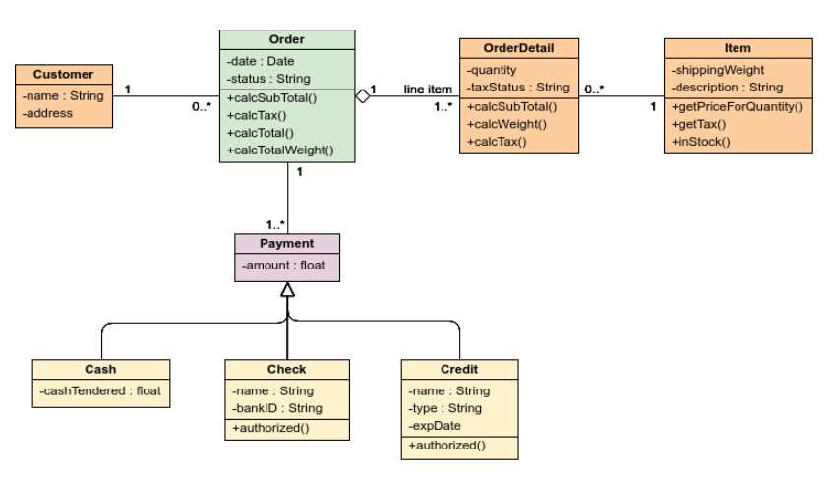

Each Item may be composed of one or more OrderDetails and each OrderDetail must be part of exactly one item.

Each Order may be composed of one or more customers and each customer must be part of exactly one Order.

Each order must be composed of one or more Payment and each Payment must be part of exactly one Order.

A Payment is of three types: Cash, Check and Credit. Cash, Check and Credit inherit the generalized property; amount from a Payment and can also have their specialized properties like name, type, expDate, bankID and cashTendered.

OrderDetail is part of Order. Each OrderDetail is composed of exactly one Order and each Order must be composed of one or more OrderDetails.

**UML Class Diagram for a Document Filling System**

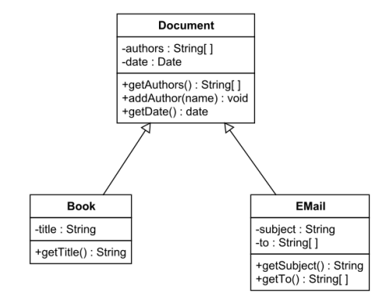

**Document**

Comprises two private attributes:

1. author – Stores an array of strings
2. date - Stores a Date

In addition, it has three public operations:

1. getAuthors – Takes no input and returns an array of strings
2. addAuthor – Takes a name as parameter t and returns void
3. getDate – Takes no input and returns a date

**Book**

Comprises one private attribute: title which stores a string and one public operation: getTitle which takes no argument and returns a string.

**Email**

Made up of two private attributes:

1. subject – Stores a string
2. to – Stores an array of strings

It also has two public operations:

1. getSubject – Takes no argument and returns a string
2. getTo – Takes no parameter and returns an array of strings.

**Updated UML**

