1. Language Goals and Non-Goals

1.1 Purpose and Vision
SynQ is an authority-expression and state-transition language rather than a general-purpose programming language. Its design prioritizes long-term correctness over unrestricted expressiveness. A SynQ program declares who may act, what facts may be consumed, which state domains may change, what failures are possible, and what invariants must remain true.
AIVM extends this design to AI workloads. It provides typed model references, bounded inference, proof or attestation verification, deterministic policy gates, AI job state machines, and receipts. It does not convert probabilistic model behavior into implicit authority.

1.2 Design Goals

1.2.1 Determinism
Given identical admitted artifacts, state root, inputs, authority context, verified facts, host profile, model profile, and execution schedule, every conforming implementation MUST produce identical success/failure status, return data, events, resource charges, state writes, inference receipts, and candidate state root.

1.2.2 Authority correctness
Every mutating entry point MUST declare an authority requirement. Authority is evaluated against UMA identity state, Aegis verification results, wallet or governance policy, recovery state, delegation scope, and invocation context. There is no implicit privilege derived from a raw public key, calldata suffix, transaction-origin field, operator identity, or AI recommendation.

1.2.3 Post-quantum resilience and cryptographic agility
SynQ uses Aegis-governed cryptographic profiles. Contracts declare the verification property they require, not a private-key operation or hard-coded algorithm implementation. Profiles can evolve without changing persistent UMA identity or the semantic meaning of existing authorization conditions.

1.2.4 Formal verifiability
The language restricts control flow, effects, aliasing, authority, resource ownership, and external inputs so that safety properties can be expressed and checked. Security-sensitive optimization passes require translation validation or equivalent semantic-equivalence evidence.

1.2.5 Resource predictability
All execution consumes versioned execution units. The schedule covers CPU, memory, storage, hashing, cryptography, proof verification, AI operations, model loading, event emission, state growth, and nested calls. Counters use checked arithmetic and fail before overflow.

1.2.6 Cross-domain composition
SynQ consumes SCETP and SXCP artifacts as typed verified facts. Contracts cannot reinterpret their proof semantics, query arbitrary remote state during execution, or trust a relayer merely because the relayer delivered a message.

1.2.7 AI workload integrity
AI execution is bound to an immutable model identity, runtime profile, preprocessing graph, input commitment, policy profile, resource limit, and verification mode. A result affecting state MUST produce an InferenceReceipt and satisfy a deterministic contract policy gate.

1.3 Non-Goals
SynQ and AIVM do not provide:
- unrestricted system programming, dynamic linking, reflection, or runtime code generation;
- ambient filesystem, network, process, wall-clock, or environment-variable access;
- floating-point consensus arithmetic;
- unrestricted recursion, unbounded loops, or hidden dynamic dispatch;
- raw private-key signing, key generation, key export, or arbitrary cryptographic primitive selection from contract code;
- raw delegatecall, storage-layout aliasing, or code-slot delegation;
- direct remote-chain execution or pooled-custody bridge semantics;
- implicit trust in AI output, operator reputation, model branding, or service availability;
- on-chain training of large models in the consensus path; or
- AI control of validator voting, finality, governance voting, key lifecycle, treasury authority, or identity recovery.

1.4 Canonical Security Guarantees
The following eighteen guarantees are canonical for version 7.0. Each guarantee is implemented by one or more compiler, proof-checker, AIVM, SynQ-VM, consensus, wallet, or operational controls; no guarantee should be described as universal outside its stated enforcement boundary.
- explicit authority declaration;
- capability attenuation and non-amplification;
- linear asset ownership and conservation;
- scoped, expiring approvals;
- bounded control flow and analyzable termination;
- checked arithmetic and canonical numeric behavior;
- declared effects and module-scoped resource access;
- explicit typed failures and atomic rollback;
- deterministic encoding, event ordering, and state-key derivation;
- no raw delegatecall or hidden storage aliasing;
- no synchronous transfer callbacks;
- canonical artifact and dependency binding;
- independent proof checking and fail-closed verification;
- typed UMA, SCETP, and SXCP context binding;
- deterministic simulation bound to state and code;
- controlled upgrades with semantic diffs and migration proofs;
- AI model/runtime/input/policy/receipt provenance; and
- AI output non-authority unless admitted through an approved deterministic, proof-verified, or typed-attested path.

1.5 Relationship to the Synergy Stack
SynQ occupies the execution-language layer. AIVM occupies the execution-host and AI-workload layer. PoSy remains the finality layer. Aegis remains the cryptographic authority layer. UMA remains the identity substrate. SCETP governs same-chain external intent. SXCP governs cross-chain verified facts. The Synergy Wallet performs local policy and user authorization. AI nodes provide compute and receipts but do not become consensus, governance, or identity authorities.
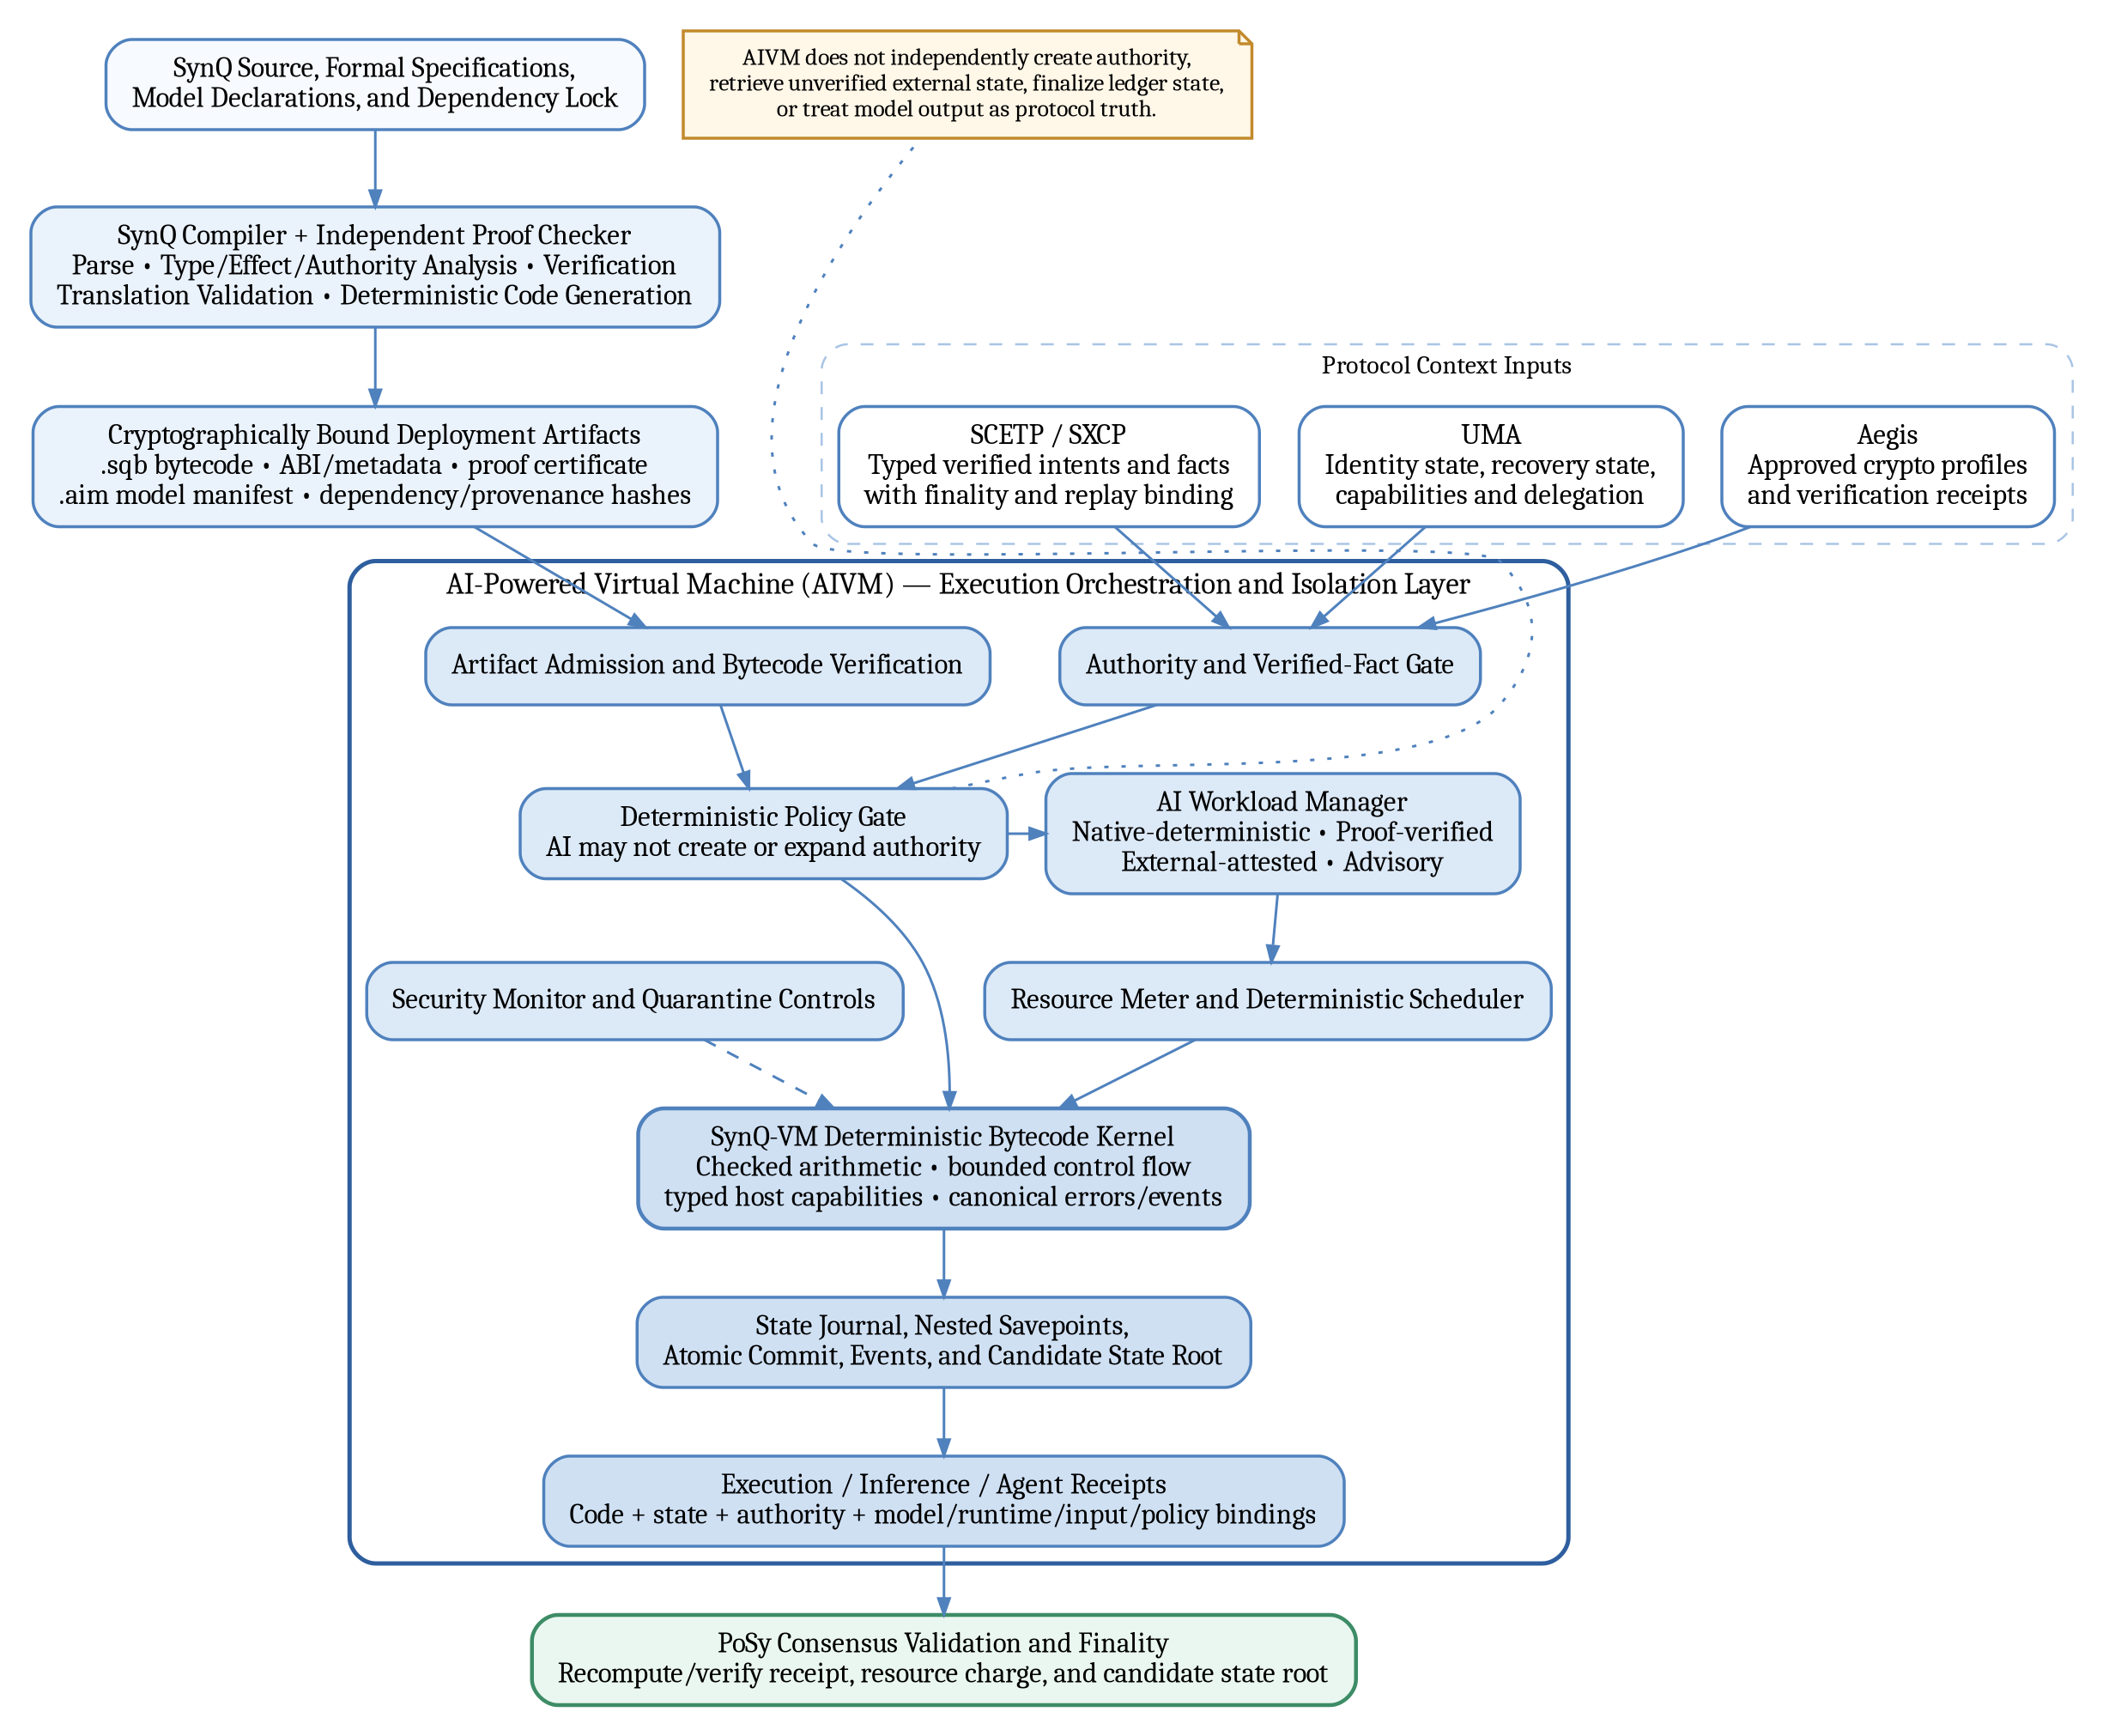
Figure 1. AIVM and SynQ-VM architecture within the Synergy execution stack.

1.6 Future Extensions
Future versions may add new deterministic tensor operators, proof systems, model formats, privacy-preserving inference, secure aggregation, federated-learning publication, or hardware backends. Such additions require:
- a versioned profile and activation height;
- canonical test vectors;
- resource calibration;
- security review and model-risk assessment;
- cross-client parity; and
- a migration path that does not silently change existing contract meaning.

