6. Compilation Targets, AIVM, and Runtime

6.1 Compilation and Admission Pipeline
The build pipeline separates source correctness, proof correctness, artifact integrity, and runtime admission. No single compiler or solver is the sole trust anchor.
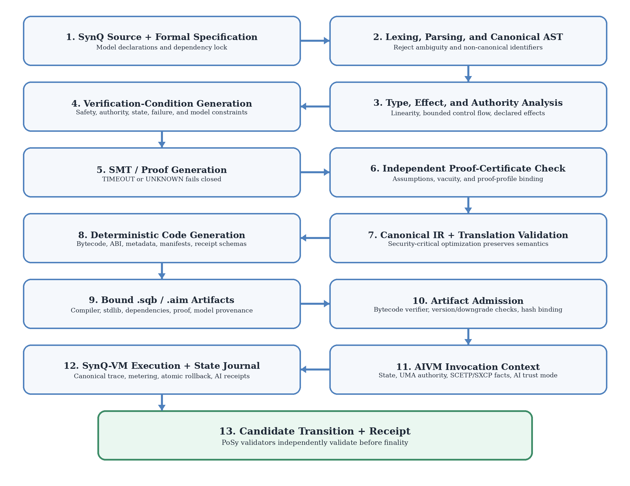
Figure 2. SynQ compilation, admission, and AIVM execution pipeline.
The canonical stages are:
- source decoding and lexical analysis;
- parsing into a canonical abstract syntax tree;
- name resolution and dependency closure;
- type, linearity, authority, effect, boundedness, and manifest checks;
- verification-condition generation;
- external solver execution and proof-certificate production;
- independent proof checking and vacuity/coverage analysis;
- canonical SSA intermediate representation;
- optimization with translation validation;
- bytecode, ABI, metadata, and artifact-envelope generation;
- reproducible-build attestation; and
- artifact admission and bytecode verification before AIVM execution.

6.2 Canonical Abstract Syntax Tree
The AST preserves source locations, normalized identifiers, declarations, types, attributes, specifications, effect sets, model references, and dependency identities. Comments are not consensus-semantic, but manifest text and specified user-facing descriptions are included in metadata and hash binding.
Two conforming parsers must produce the same canonical AST hash for the same valid source.

6.3 Intermediate Representation
SynQ IR is typed SSA with explicit control-flow blocks, authority checks, effect tokens, linear-resource moves, journal operations, fact consumption, and AI operations.
block entry(auth, intent):
v0 = auth.verify TreasurySpend
v1 = state.load reserve
v2 = ai.infer.native risk_model, intent
v3 = policy.require_monotonic_safety v2
br v3.requires_delay, delayed, immediate
IR cannot contain implicit host calls. Every state, cryptographic, fact, or AI operation carries a profile and resource annotation.

6.4 Deployment Artifact (.sqb)
A .sqb deployment artifact is a canonical envelope rather than raw bytecode.
Section | Required contents
Header | Magic, format version, network compatibility, VM target, flags
Code | Canonical SynQ-VM bytecode
Constants | Canonically encoded immutable constants
ABI | Functions, types, errors, events, authority and fact requirements
Effects | Declared/inferred effect summaries
Verification | Proof profile, proof certificate hash, assumptions, coverage summary
Models | Immutable model IDs, allowed modes, input/output schemas, resource bounds
Dependencies | Content-addressed package and standard-library closure
Manifests | Human-readable action and risk descriptions
Provenance | Source hash, AST/IR hash, compiler identity, build flags, reproducible-build attestation
Upgrade metadata | Storage, ABI, authority, effect, model, dependency, and migration versions
All section hashes are bound into the artifact root. Component substitution invalidates the artifact.

6.5 Bytecode Verification
Before deployment, invocation, or upgrade, the bytecode verifier checks:
- format and version compatibility;
- canonical encoding and section lengths;
- known opcodes and operand forms;
- valid control-flow targets;
- stack-height consistency and bounded depth;
- initialized local and memory access;
- linear-resource consumption;
- authority and effect instruction placement;
- host-function profile validity;
- model and proof profile validity;
- absence of code/data overlap;
- resource upper bounds; and
- agreement among code, ABI, effects, models, and proof metadata.
Verification is deterministic and bounded. Malformed artifacts are rejected before state mutation.

6.6 AIVM Definition
AIVM is the Synergy node-side execution orchestration, isolation, and AI-workload platform. It performs the following ordered responsibilities:
- artifact and profile admission;
- invocation-context construction;
- UMA, Aegis, SCETP, SXCP, approval, delegation, and recovery-state checks;
- model and AI trust-mode validation;
- execution-unit reservation;
- SynQ-VM and approved AI-kernel invocation;
- host-capability mediation;
- state journaling and event staging;
- receipt, trace commitment, and candidate state-root production; and
- output to the consensus validation path.
AIVM does not independently finalize state, invent external facts, sign on behalf of users, modify governance policy, or treat an AI result as sovereign truth.

6.7 AIVM Component Model
Component | Responsibility
Artifact Admission Gateway | Validates .sqb, .aim, proof, dependency, and profile binding
Authority and Fact Gate | Verifies UMA authority, recovery state, capabilities, SCETP intents, SXCP facts, nullifiers, and expiry
SynQ-VM Kernel | Executes canonical bytecode
AI Inference Subsystem | Executes native deterministic models or manages proof/attestation receipt admission
Deterministic Policy Gate | Applies range, confidence, monotonic-safety, authority, and capability constraints to AI outputs
Host Capability Gateway | Exposes versioned deterministic state, Aegis, fact, model, logging, and randomness interfaces
Resource Meter and Scheduler | Reserves and charges execution, proof, storage, and AI units
State Journal and Commit Engine | Maintains savepoints, writes, events, nullifiers, receipts, and atomic commit
Security Monitor | Detects invalid artifacts, divergence, sandbox violations, abnormal resources, and repeated failures

6.8 AIVM AI Trust Modes
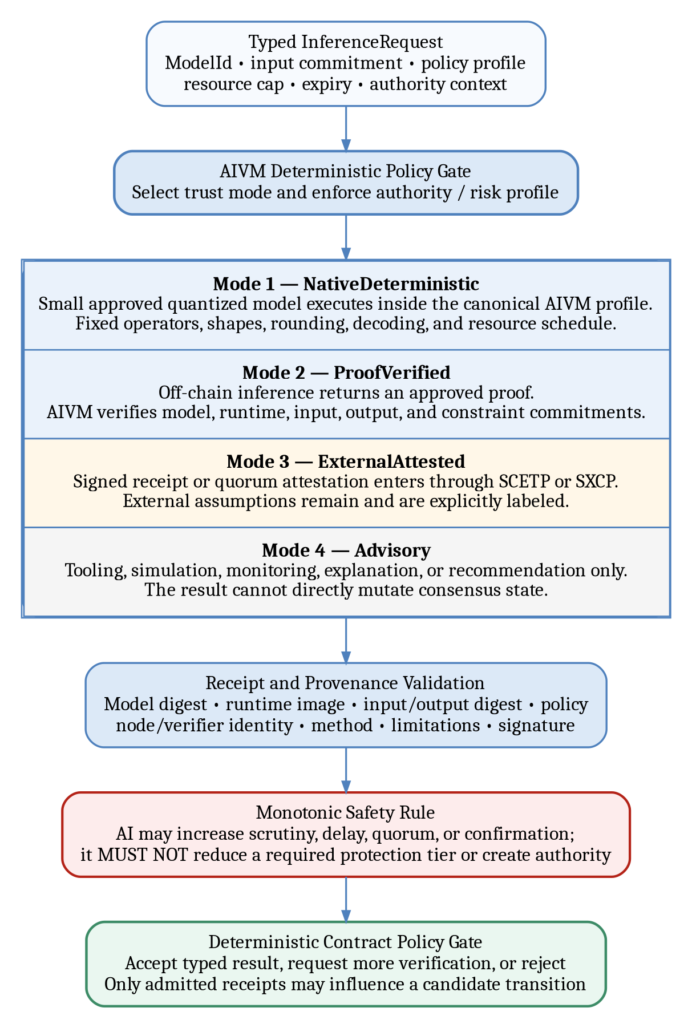
Figure 3. AIVM inference trust modes and deterministic policy gate.

6.8.1 NativeDeterministic
A small, bounded, quantized model executes within the canonical AIVM profile. Every validator or authoritative execution client can reproduce the output exactly.
Requirements:
- fixed operator graph;
- approved deterministic operators only;
- integer or fixed-point arithmetic;
- canonical quantization, saturation, rounding, and decoding;
- bounded input and output shapes;
- bounded token count and generation length;
- no nondeterministic GPU kernels;
- no online model fetch;
- immutable model ID; and
- cross-platform conformance vectors.
This mode is suitable for compact classifiers, bounded scoring functions, embeddings with fixed operators, anomaly rules, and monotonic risk escalation.

6.8.2 ProofVerified
An AI Inference Node executes a larger model off-chain and returns the output with an approved proof. AIVM verifies the proof and model/runtime/input binding. Only the proof verifier runs in the consensus path.
The proof statement binds:
- model and runtime digests;
- preprocessing and decoding profile;
- input commitment;
- output digest;
- inference constraints;
- execution trace or circuit commitment; and
- request and policy identifiers.
Proof verification is fail-closed. UNKNOWN, unsupported profile, malformed proof, or limit exceedance rejects the result.

6.8.3 ExternalAttested
An external AI provider or quorum produces a signed receipt admitted through SCETP or SXCP. External assumptions remain. This mode is appropriate when deterministic replay or a proof is unavailable and policy explicitly permits attestation.
Authoritative use is restricted. High-value custody, identity recovery, consensus, governance, key lifecycle, and irreversible system actions MUST NOT rely solely on a single attested AI output. Policies may require independent verifiers, quorum comparison, delay, human or guardian confirmation, and conservative fallback.

6.8.4 Advisory
AI output is used for developer tooling, simulation explanations, anomaly detection, monitoring, UI assistance, contract review, or operator recommendations. It is never consensus-authoritative and cannot directly write state.
An advisory result may be attached to a transaction manifest, but the transaction remains governed by deterministic code and explicit authorization.

6.9 Deterministic AI Operators
The initial native operator set may include:
- integer/fixed-point matrix multiplication;
- convolution with fixed padding and stride;
- elementwise add, multiply, min, max, clamp, and comparison;
- deterministic activation approximations defined by lookup table or fixed polynomial;
- pooling and normalization with exact rounding;
- embedding lookup;
- top-k with canonical tie-breaking;
- deterministic argmax;
- fixed-vocabulary tokenization and decoding; and
- bounded tree, linear, or rule-ensemble evaluation.
Operators not listed in the active profile are invalid. GPU acceleration is permitted only when it reproduces canonical reference vectors bit-for-bit; otherwise execution falls back to the reference CPU or proof-verified path.

6.10 Model Artifact (.aim)
The AIVM model container is a content-addressed artifact:
AIMHeader {
magic = "AIVM"
format_version
model_id
operator_profile
element_profile
input_schema_hash
output_schema_hash
graph_digest
weights_digest
tokenizer_digest?
preprocessing_digest
quantization_digest
runtime_profile
safety_profile
publisher_identity
publication_receipt_hash
signature
}
Weights may be embedded, chunked, or referenced through a content-addressed repository. The complete digest closure is part of ModelId. Mutable URLs are not authoritative references.

6.11 Inference Request and Receipt
An inference request is immutable after creation. It includes model, mode, schema, input commitment, resource cap, policy profile, expiry, requester identity/capability, privacy classification, and callback or continuation information.
A receipt contains the minimum provenance fields required by the Intelligence Layer:
- request ID;
- model ID and model digest;
- runtime image or kernel profile digest;
- input commitment;
- output digest and typed output;
- node or provider identity where applicable;
- trust mode;
- policy profile;
- execution or AI units;
- proof, verification receipt, or attestation set;
- limitation and confidence labels;
- verifier identity and version where applicable; and
- receipt signature or Aegis verification artifact.

6.12 Deterministic Policy Gate
No AI result is consumed directly. The policy gate checks:
- model and mode eligibility;
- output type and range;
- proof/attestation validity;
- confidence and limitation labels;
- stale or revoked model/runtime status;
- requester capability;
- maximum value or action scope;
- monotonic safety constraints;
- human, guardian, quorum, or delay requirements; and
- replay/nullifier status.
The gate’s decision is deterministic. A model may recommend a safety tier, but the gate computes the final permitted action under protocol and contract rules.

6.13 AI Agent Execution
An AI agent does not receive a wallet key or unrestricted contract capability. The model proposes actions; each tool call is separately authorized and executed.
An AgentActionReceipt binds:
- agent ID, model ID, and policy;
- request and planning-step number;
- tool identifier and arguments commitment;
- authority envelope used for the tool;
- memory and data access receipts;
- spending, value, and action caps;
- sandbox profile;
- tool result digest;
- final action digest; and
- verifier or policy outcome.
Agents have a maximum step count, tool allowlist, per-tool capability, cumulative spend cap, time/height expiry, and explicit cancellation path. They cannot self-modify, load unsigned models, add tools, expand memory scope, or delegate authority beyond the envelope.

6.14 Host Capability Gateway
Contract code has no direct system access. Host functions are identified by a versioned capability ID and declare:
- deterministic class;
- input/output schemas;
- authority boundary;
- effect category;
- maximum input/output size;
- execution-unit formula;
- failure types;
- activation and deprecation heights; and
- conformance vectors.
Host functions include state access, Aegis receipt verification, UMA resolution, fact admission, model registry lookup, native inference, proof verification, event staging, and governed randomness.

6.15 SynQ-VM Instruction Classes
The exact opcode map is versioned in Appendix C. Instruction classes include:
- constants, stack, locals, and typed memory;
- checked arithmetic and comparison;
- canonical branching and calls;
- state load/store through declared domains;
- asset move, split, merge, lock, mint, burn, and release;
- authority and capability checks;
- verified-fact load and consume;
- event staging;
- journal savepoint, commit, and rollback;
- Aegis verification;
- AI model binding, native inference, proof verification, receipt admission, and job emission; and
- return and typed failure.
Unknown opcodes fail bytecode verification.

6.16 Hardware Acceleration
Hardware acceleration is an implementation detail, not a semantic change. Accelerated cryptography, proof verification, hashing, and AI kernels must match canonical outputs and resource accounting. Runtime profiles bind the backend implementation identifier and conformance status.
A backend with a parity failure is quarantined. AIVM falls back to an approved reference backend when policy permits; it does not accept an approximate result.

6.17 Execution Receipts
Every execution produces a receipt containing:
- transaction and artifact IDs;
- VM, host, resource, and model profile versions;
- base and candidate state roots;
- input, authority, and verified-fact commitments;
- return or failure code;
- events root;
- read/write set commitment;
- consumed nullifiers;
- execution-unit totals;
- inference receipt roots;
- trace commitment; and
- implementation and verifier identifiers required for audit.
Receipts are candidate artifacts until consensus accepts the state transition.

6.18 AIVM Operational Profiles
Production profiles prohibit public admin/debug RPC, dynamic plugins, unsigned model loading, unrestricted tracing, production core dumps containing sensitive memory, and direct container or GPU control from public interfaces. Administrative surfaces require private routing, mTLS, RBAC, audit logging, and signed changes.
State-root mismatch, verifier disagreement, model-digest mismatch, sandbox violation, or deterministic replay failure automatically removes the affected client from authoritative execution duties pending review.

6.19 Meaning of “AI-Powered”
AIVM is AI-powered in three deliberately separated senses. The separation is normative because collapsing these roles would allow a probabilistic service to acquire execution or protocol authority merely by being useful.
- AI-native workload execution. SynQ contracts can request bounded inference, embedding, classification, ranking, evaluation, or agent planning through typed AIVM capabilities. The result is admitted only under one of the four trust modes in §6.8.
- AI verification and provenance. AIVM validates model, runtime, input, output, policy, proof, attestation, and node receipts. Verification determines whether a result is eligible for a contract policy gate; it does not turn the model into an identity or authority source.
- AI-assisted operations. Models may assist simulation explanation, vulnerability triage, routing, capacity planning, anomaly detection, code review, or operator support. These outputs are advisory unless a separate deterministic or cryptographically verified admission path is satisfied.
AIVM is not a self-modifying virtual machine, a model-governed consensus engine, or an autonomous signer. It MUST NOT let a model rewrite bytecode, alter the active operator profile, load an unsigned artifact, change an execution-unit schedule, bypass the authority gate, select a weaker trust mode after failure, or replace consensus validation.
Training and fine-tuning do not occur inside the authoritative transaction stack. They produce candidate model artifacts and lineage records. A candidate becomes eligible for AIVM use only after content addressing, provenance checks, evaluation, publication authorization, registry activation, and any governance or security review required by its profile.

6.20 Intelligence-Layer Node Integration
AIVM composes with the Synergy Intelligence Layer through receipt-bound service roles. These roles provide workload, storage, routing, verification, or evaluation services without inheriting consensus, identity, governance, treasury, or key-lifecycle authority.
Intelligence-layer role | AIVM use | Required artifact or receipt | Authority boundary
AI Routing Node | Selects an eligible provider using model, privacy, price, latency, health, and verification policy | Route-selection receipt containing candidate set, policy, selected provider, expiry, and signature | Selection is advisory to AIVM policy; it does not prove output correctness
AI Inference Node | Executes approved off-chain or service-hosted inference | Inference receipt binding model, runtime, input, output, resource use, policy, node, and signature | Produces workload output only
AI Verification Node | Replays, verifies proofs, compares quorum outputs, or checks policy/provenance | Verification receipt identifying method, evidence, result, limitations, evaluator version, and signature | May attest verification result; does not create invocation authority
AI Training and Fine-Tuning Node | Produces candidate adapters, checkpoints, or models | Training/checkpoint package with base-model digest, dataset root, hyperparameters, runtime image, evaluation, and signature | Cannot activate or replace an AIVM model directly
Federated Learning Coordinator Node | Coordinates signed rounds and secure aggregation | Round manifest, participant commitments, aggregation receipt, candidate checkpoint, and fault record | Coordinates participants; cannot make a candidate authoritative
Model Repository Node | Serves content-addressed model and tokenizer artifacts | Repository inclusion/provenance receipt and artifact digest closure | Availability is not correctness or activation authority
Dataset Provenance Node | Records dataset lineage, rights, redaction, retention, and workload eligibility | Dataset manifest and revocation status | Provides provenance facts under policy; not model-output authority
Vector Memory Node | Performs scoped embedding storage and retrieval | Memory access and retrieval receipt bound to tenant/UMA scope, index root, query commitment, and returned-item commitments | Memory cannot be accessed without explicit capability and privacy policy
AI Agent Execution Node | Executes bounded planning and tool-use workflows | Per-step plan/tool receipt and final AgentActionReceipt | Each state-changing tool action requires an independent authority envelope
GPU Scheduler Node | Allocates approved capacity and records utilization | Capacity-placement and utilization receipt binding device/runtime profile | Scheduling does not validate model output
AI Reputation and Evaluation Node | Produces benchmarks, safety tests, provider scores, and model evaluations | Evaluation receipt with dataset/benchmark, method, version, limitations, and signature | Reputation may filter or escalate policy but MUST NOT be the sole basis for irreversible authority
The route, capacity, inference, verification, policy-decision, and execution receipts form a cryptographically linked receipt chain. Missing or inconsistent links cause refusal or quarantine; AIVM MUST NOT silently substitute a different provider, model, runtime, input, policy, or trust mode.
AIVM MAY operate an embedded provider for small native-deterministic models. For larger workloads, the service roles above are external execution dependencies. Their public endpoints are reached only through authenticated routing/gateway surfaces, while model administration, dataset administration, container control, GPU control, signing, KMS, and operator functions remain private.

6.21 End-to-End AI Workload Lifecycle
A contract-visible AI workload follows this canonical lifecycle:
- Request construction. SynQ creates an immutable InferenceRequest or AgentRequest containing model identity, trust mode, schemas, input commitment, policy, resource cap, privacy class, expiry, authority context, and continuation target.
- Admission. AIVM checks the calling contract, capability, model registry status, runtime profile, allowed trust mode, privacy requirements, value/action limits, and reserved execution/AI units.
- Routing and capacity. When an external node is required, AIVM admits a route-selection receipt and capacity receipt. Provider substitution after request acceptance requires a new route receipt and policy re-evaluation.
- Execution. The native kernel or eligible AI Inference/Agent Execution Node performs the bounded workload against the exact committed model, runtime, preprocessing, decoding, and input.
- Receipt production. The provider emits an inference or agent receipt. The output is not yet contract-authoritative.
- Verification. AIVM executes the native-deterministic comparison, verifies an approved proof, validates a quorum/external attestation, or labels the result advisory. AI Verification Nodes may supply independently signed verification receipts.
- Deterministic policy decision. The policy gate applies output type/range, limitation, confidence, monotonic-safety, authority, value, quorum, human/guardian, delay, and replay rules.
- Continuation. An accepted result is consumed by a new transaction or explicit continuation message. AIVM does not preserve a suspended live VM stack across an unbounded external wait.
- Atomic execution. SynQ-VM revalidates state, authority, facts, model/receipt status, and preconditions, then commits or rolls back atomically.
- Finality and audit. PoSy validators verify the candidate execution receipt and state root. Model, route, capacity, inference, verification, policy, and action receipt roots remain available for audit under their retention profiles.
Timeout, cancellation, model revocation, provider equivocation, proof failure, receipt conflict, route expiry, privacy-policy failure, or resource-limit exhaustion produces a typed terminal or retryable state. A retry MUST preserve the original semantic request or create a new request ID; it MUST NOT silently weaken the trust mode, safety profile, authority requirement, or provenance closure.
For high-value custody, governance, identity recovery, validator operation, treasury execution, key lifecycle, or irreversible system-module actions, AI may propose, classify, or escalate. Final permission is computed by deterministic SynQ and protocol policy, with the required human, guardian, quorum, governance, or cryptographic authorization.

