EECE5644 Fall 2019 – Homework 3

Alan Luke Jacob

NU ID: 001056590

# Question 2:

Plots and Results:

1. 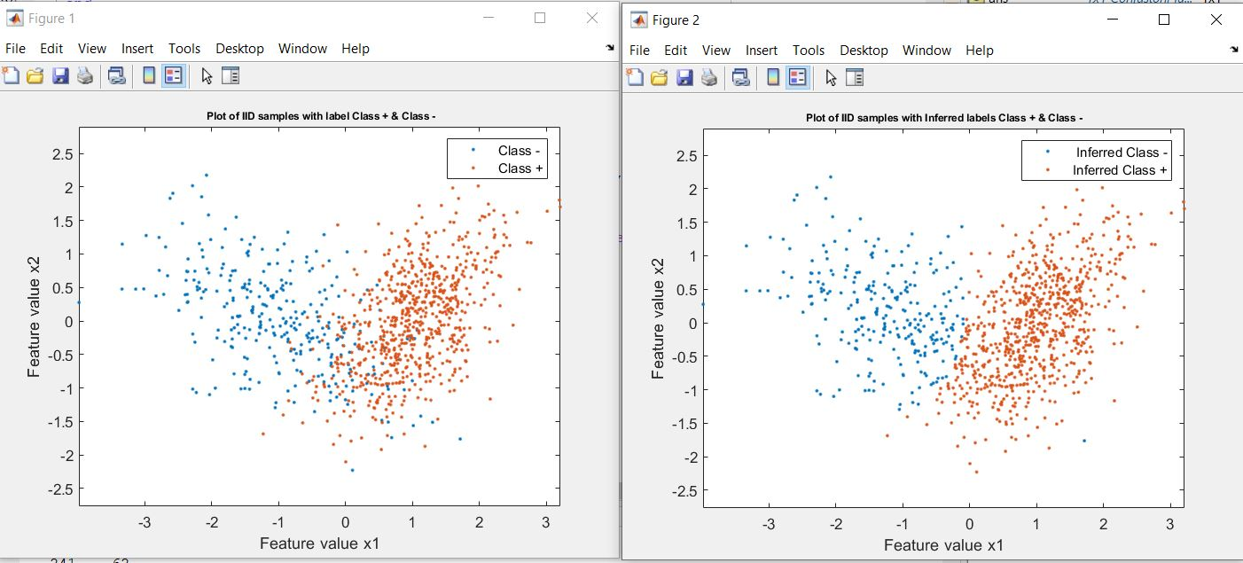MAP- Classifier

Number of samples generated for Class –

303

Number of samples generated for Class +

696

The number of Misclassification errors: 79

Probability of error: 0.0791

Number of samples inferred as Class –

258

Number of samples inferred as Class +

741

1. LDA Classifier

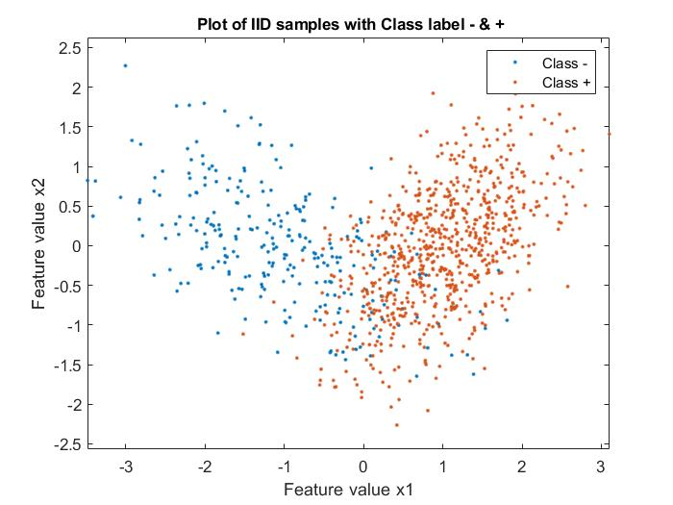

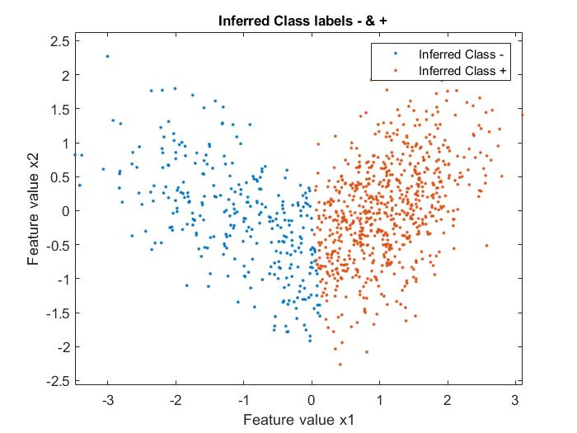

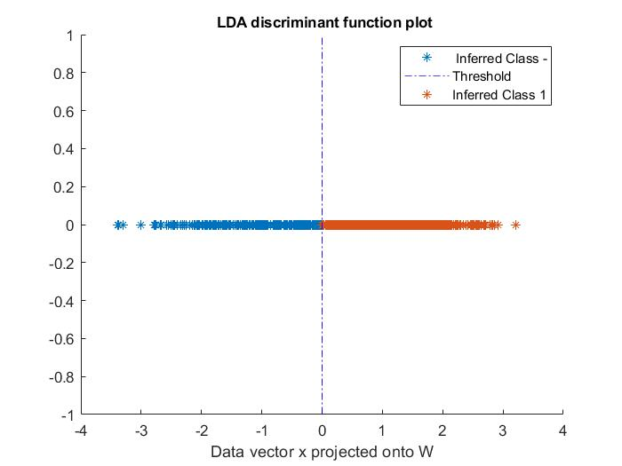

Number of samples generated for Class –

266

Number of samples generated for Class +

733

The number of Misclassification errors: 109

Probability of error: 0.1091

Number of samples inferred as Class –

299

Number of samples inferred as Class +

700

1. Logistic Linear Classifier:

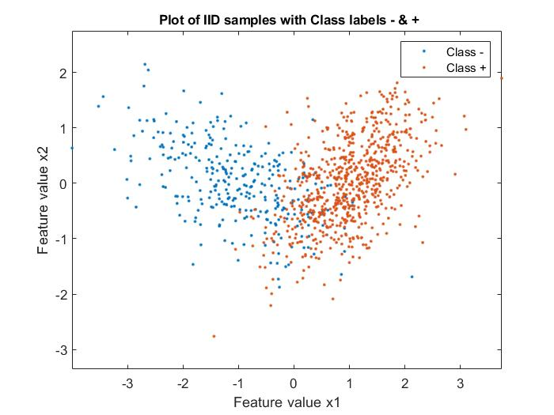

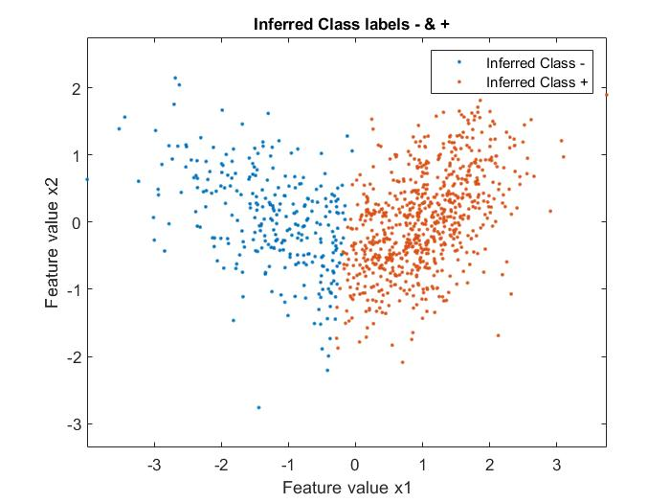

Number of samples generated for Class –

301

Number of samples generated for Class +

698

The number of Misclassification errors: 92

Probability of error: 0.0921

Number of samples inferred as Class –

279

Number of samples inferred as Class +

720

theta =

0.4581

3.2039

-0.3343

|  |  |  |
| --- | --- | --- |
| Classifiers | Number of Misclassifications | Probability of Error |
| 1.MAP Classifier | 79 | 0.0791 |
| 2. LDA Classifier | 109 | 0.1091 |
| 3.Logistic Linear Classifier | 92 | 0.0921 |

# Question 1:

Plots and Results:

1.Data Set N=10 Samples

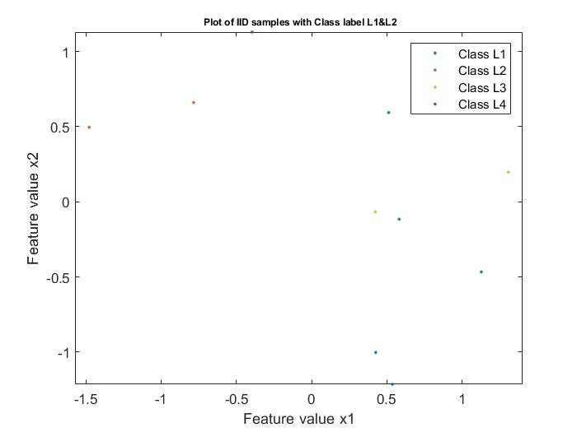

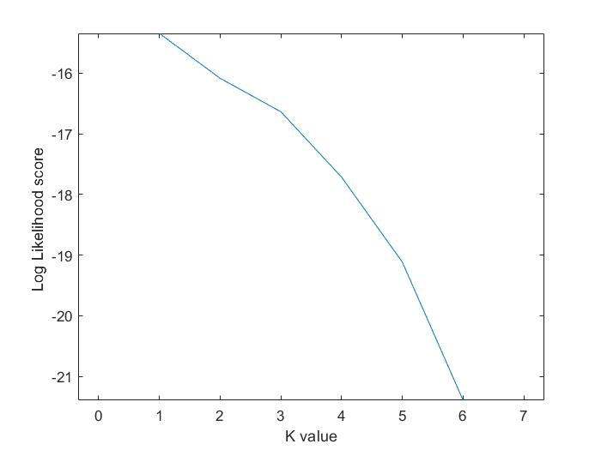

2. Data Set N=100 Samples

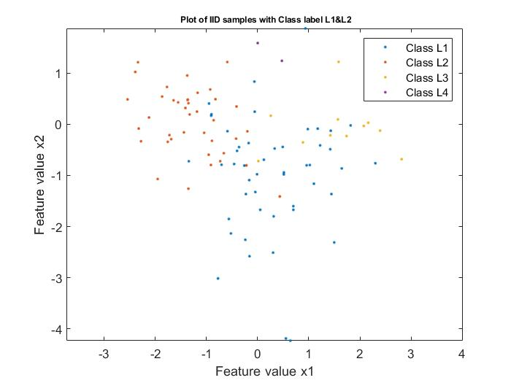

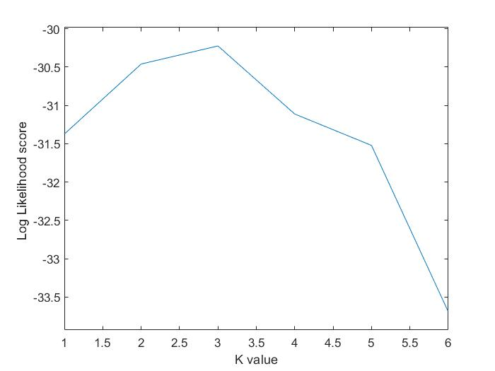

1. Data Set N=1000 Samples

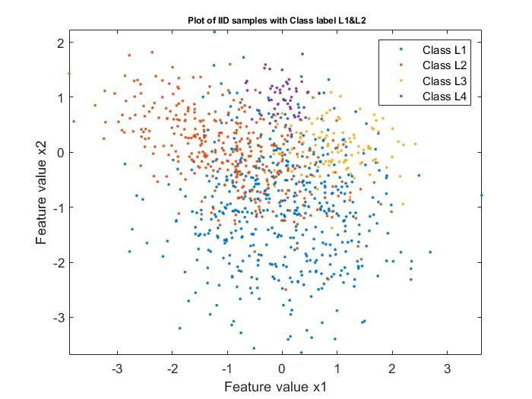

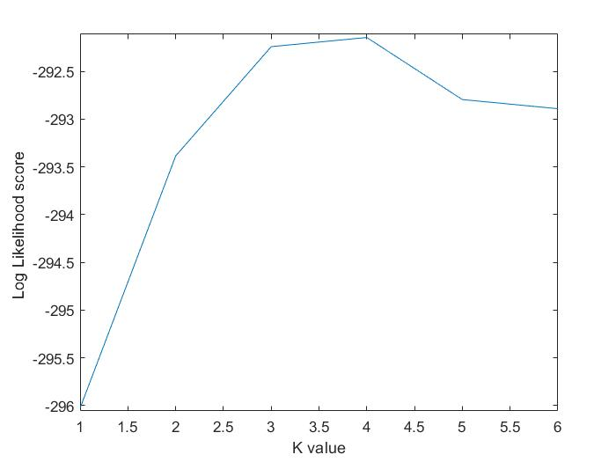

1. Data Set N=10000 samples

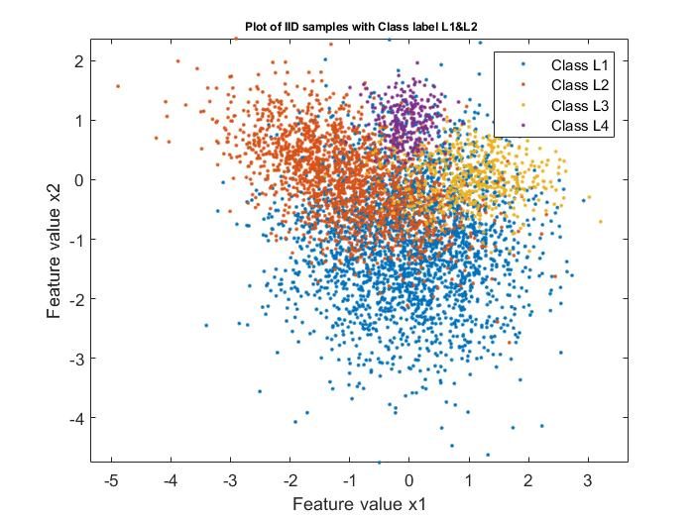

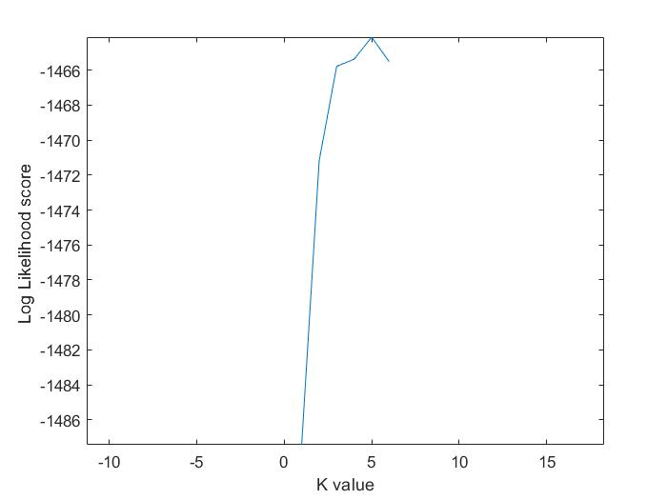

|  |  |
| --- | --- |
| Sample Size | GMM Order Selected |
| N = 10 | 1 |
| N= 100 | 3 |
| N= 1000 | 4 |
| N= 10000 | 5 |

References

1. MATLAB Documentation
2. <https://www.coursera.org/learn/machine-learning/lecture/licwf/advanced-optimization>
3. <https://www.visiondummy.com/2014/04/geometric-interpretation-covariance-matrix/>
4. <https://www.python-course.eu/expectation_maximization_and_gaussian_mixture_models.php>