Migration Tool — Leadership Overview
Nov 5, 2026 · @Alan

Summary
The Migration repo is an AI toolkit that drafts the documentation each application needs before it moves from on-premises to the cloud. Running inside GitLab Duo Chat, it reads an app's source code and its Confluence pages, then produces a Functional Document (Word + Excel) and a traceable Migration Requirements register (Excel).
One command builds the functional document; a second builds the requirements once a subject-matter expert (SME) has reviewed it. Everything it produces is an AI draft with sources cited, so people stay in control of the final content.

Why it matters
Before an app can join a migration wave, someone has to work out what it actually does and what the cloud version must keep doing. Today that knowledge is spread across code, Confluence pages, diagrams and people's heads, and documenting it by hand is slow.
- Faster onboarding per app: an engineer or BA gets a full first draft from one command instead of writing it from scratch.
- Consistent output across apps: every app gets the same document structure and the same eight requirement categories (functional, data, integration, non-functional, security and compliance, operational, infrastructure, transition).
- Traceability: every requirement links back to the business function, data item or integration it came from, and each of those cites a code file and line or a document section.
- Lower risk of gaps: it flags disagreements between code and documents, and raises open questions instead of guessing.
- Fits existing tooling: it runs in GitLab Duo Chat inside VS Code, needs no separate AI catalog or platform, and keeps outputs in each app's own repo.

How it works
For each application, an engineer runs two commands in GitLab Duo Chat, with a human review between them.
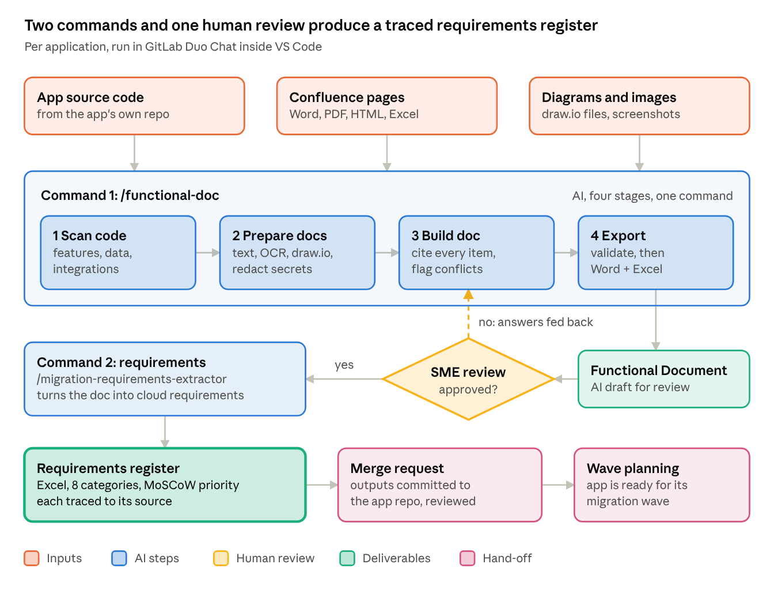
per-app workflow · 2 commands, 1 human review
The SME's answers go back into the same chat and the document is updated before requirements are built. All outputs are committed to the app's own repo and approved through a normal merge request.

Status, limitations and risks
The toolkit is at Draft v0.1: the Python tools are tested on sample files, but the AI skills have not yet been run on 2–3 real applications.
Component | Status
/functional-doc one-command workflow | Draft v0.1
Code scan, doc builder, requirements skills | Draft v0.1
Document prep (text extraction, OCR, secret redaction) | Tested on samples
Word / Excel export with validation | Tested on samples
Install script for app repos | Tested
Prerequisites: GitLab 18.10+ (Duo Agent Platform), GitLab for VS Code 6.71.4+, Python 3.10+, Windows 10/11.
Limitations and risks
- AI drafts need human review. An SME must review every functional document before requirements are built; this is a required step.
- Diagrams from images are less reliable. Flows read by OCR are marked Low confidence; draw.io files are read exactly.
- Requirements depend on source quality. Missing SLAs, volumes or recovery targets are left as "TBD" with an open question, never invented.
- Sensitive data. Common secret patterns are redacted before Duo sees documents and the export blocks any that remain, but teams should still remove passwords and customer data before export.
- Large apps may need the command re-run in a new conversation; finished stages are reused.

Next steps
The next milestone is a pilot on 2–3 real applications to prove output quality before rolling out to the wider migration team.
- ☐ Pick 2–3 pilot applications and their SMEs
- ☐ Confirm every pilot user has GitLab Duo Agent Platform access and the required VS Code extension version
- ☐ Run the workflow end to end and measure time saved versus manual documentation
- ☐ Review pilot results and decide on rollout to the next migration wave
- ☐ Name an owner for the toolkit (skills, prompts and tools)

