Engineering Excellence Expo 2026
Two-page case study submission form
Instructions: Keep the completed entry to exactly two pages. Replace all prompts with final content, observe every word limit, use sanitised and approved information, and attach only assets available for internal publication.
1. Project snapshot (Complete all fields)
Project title | S7 Delivery Control Centre — governed AI-assisted delivery from business requirement to production release
Team member names | Alan Lands [add remaining team members]
Unit/ISU | [Enter unit/ISU]

Engineering theme  (Select all that apply) | ☒ GenAI | ☐ Cloud | ☐ Data engineering
☒ Automation | ☒ Platform engineering | ☒ DevSecOps | ☐ Performance engineering
☐ Accessibility | ☐ Sustainability | ☐ IoT | ☐ High-performance systems
☐ Modernization | ☐ Scalability
2. Executive summary
Challenge, solution, business outcome, and engineering excellence | Maximum 150 words
MapleSure Insurance (our synthetic stand-in for the client) needed a business-driven enhancement, online disability claim submission for plan sponsors, delivered end to end with an AI-assisted SDLC, and wanted to see exactly what the AI covered and how it was governed. We built the S7 Delivery Control Centre: a governed control plane that takes an epic through analysis, design, human sign-off, story breakdown, architecture packs, developer workspaces, independent AI review, quality and release. Every model output is gated by a named human role, recorded in an append-only provenance ledger and badged by provenance. A fully autonomous overnight run took a new requirement to a merged, released application with 98.5% test coverage; the independent reviewer blocked one story until a genuine accessibility defect was fixed. The excellence is the discipline: no phase approves its own work, nothing simulated presents as real, and the journey runs offline from a fresh clone.
3. Business challenges
Problem statement/opportunity, constraints, and importance | Maximum 150 words
The client asked suppliers to demonstrate a multi-sprint, business-driven change delivered from requirement through design, build, test and production release using an AI-assisted SDLC, assessed on delivery KPIs: velocity, cycle time, estimation accuracy, first-time-right rate and defect leakage. Three constraints shaped the work. A one-week build clock against a full-lifecycle claim meant anything not genuinely built had to be staged and visibly labelled as staged. A locked-down target environment with unresolved model access meant plain Python, no API key required, and no dependency on any single AI vendor's tooling. And real enterprise delivery fans out across frontend, API, database, document intake and mainframe streams that are not all AI-addressable, so the answer had to articulate honest coverage rather than claim 100%. It mattered because governance, not feature breadth, is what earns the right to put AI into the delivery path of a regulated insurer.

4. Solution (Engineering differentiators are mandatory)
Architecture, decisions, tools, platforms, technologies, and differentiators | Maximum 250 words
Architecture. A FastAPI server does HTTP translation only; every rule lives in a Python engine where each action runs role check, gate check, write, provenance append, activity append. State is on-disk atomic JSON plus append-only JSONL ledgers. A React/TypeScript Control Centre (committed build, no CDN, loopback-only) renders one state payload; a separate admin app manages prompts, models, roles and users. Four environments share one code path: simulation and demo are offline, live makes real model calls, replay pins them to committed recordings keyed on the prompt hash.
Decisions and technology. Provider-agnostic LLM module (Anthropic, OpenAI, Bedrock, OpenAI-compatible gateways); pytest, ruff, real git and GitHub Actions for evidence; grounding is an architecture.md in each target repository, not a fine-tune.
DIFFERENTIATOR 1: No phase self-approves. Five gates from intake to release; a second model independently reviews generated code against design and acceptance criteria; a rejection stops the pipeline; humans sign release.
DIFFERENTIATOR 2: Provenance-honest output. Every artifact is badged LIVE_AI, REPLAYED_AI, SIMULATED or RULE_BASED, and staleness is derived from the ledger, so a design change flags everything downstream.
DIFFERENTIATOR 3: Prompts as versioned configuration. Rules, skills, playbooks and task text are files with append-only history; the suite fails if a recording drifts from them; human corrections feed model-drafted prompt proposals that only an operator can accept.
DIFFERENTIATOR 4: Reusable and future-ready. Offline-first with 780+ tests green without a key, an enhancement lane converging on the same downstream, and git publication writing only governed context on disposable branches, so any repository onboards.
5. Impact (Report percentage change; use N/A if not measurable)
Impact area | % change
Business value | N/A — pre-production demonstration; no baseline
Productivity | N/A — no baseline; measured: 4 stories built, reviewed and released autonomously in one overnight run
Cycle time | N/A — no baseline; measured: requirement to merged release in a single overnight run
Other metrics | First-time-right 75% (3 of 4 stories passed independent review first time); 98.5% test coverage on the released application
6. Key assets (Include whatever is available)
☒ Diagrams | ☒ Dashboard | ☒ Accelerator | ☒ Images
Key asset description | Maximum 100 words
Diagrams: end-to-end flow poster, architecture and delivery flow, and the DFD and relationship diagrams the app renders per run (docs/slide-decks/). Dashboard: the Control Centre governance pages, including KPI scorecard, provenance ledger, traceability matrix, activity log and delivery-system view. Accelerator: the repository itself, which runs the full governed journey offline from a fresh clone, plus the admin panel for prompt sets, models and roles. Images: the recorded overnight end-to-end run with step log and screenshots (docs/run-evidence/), rendered demo videos (docs/demo-videos/), and the solution overview and leadership decks.

Asset/Image 1  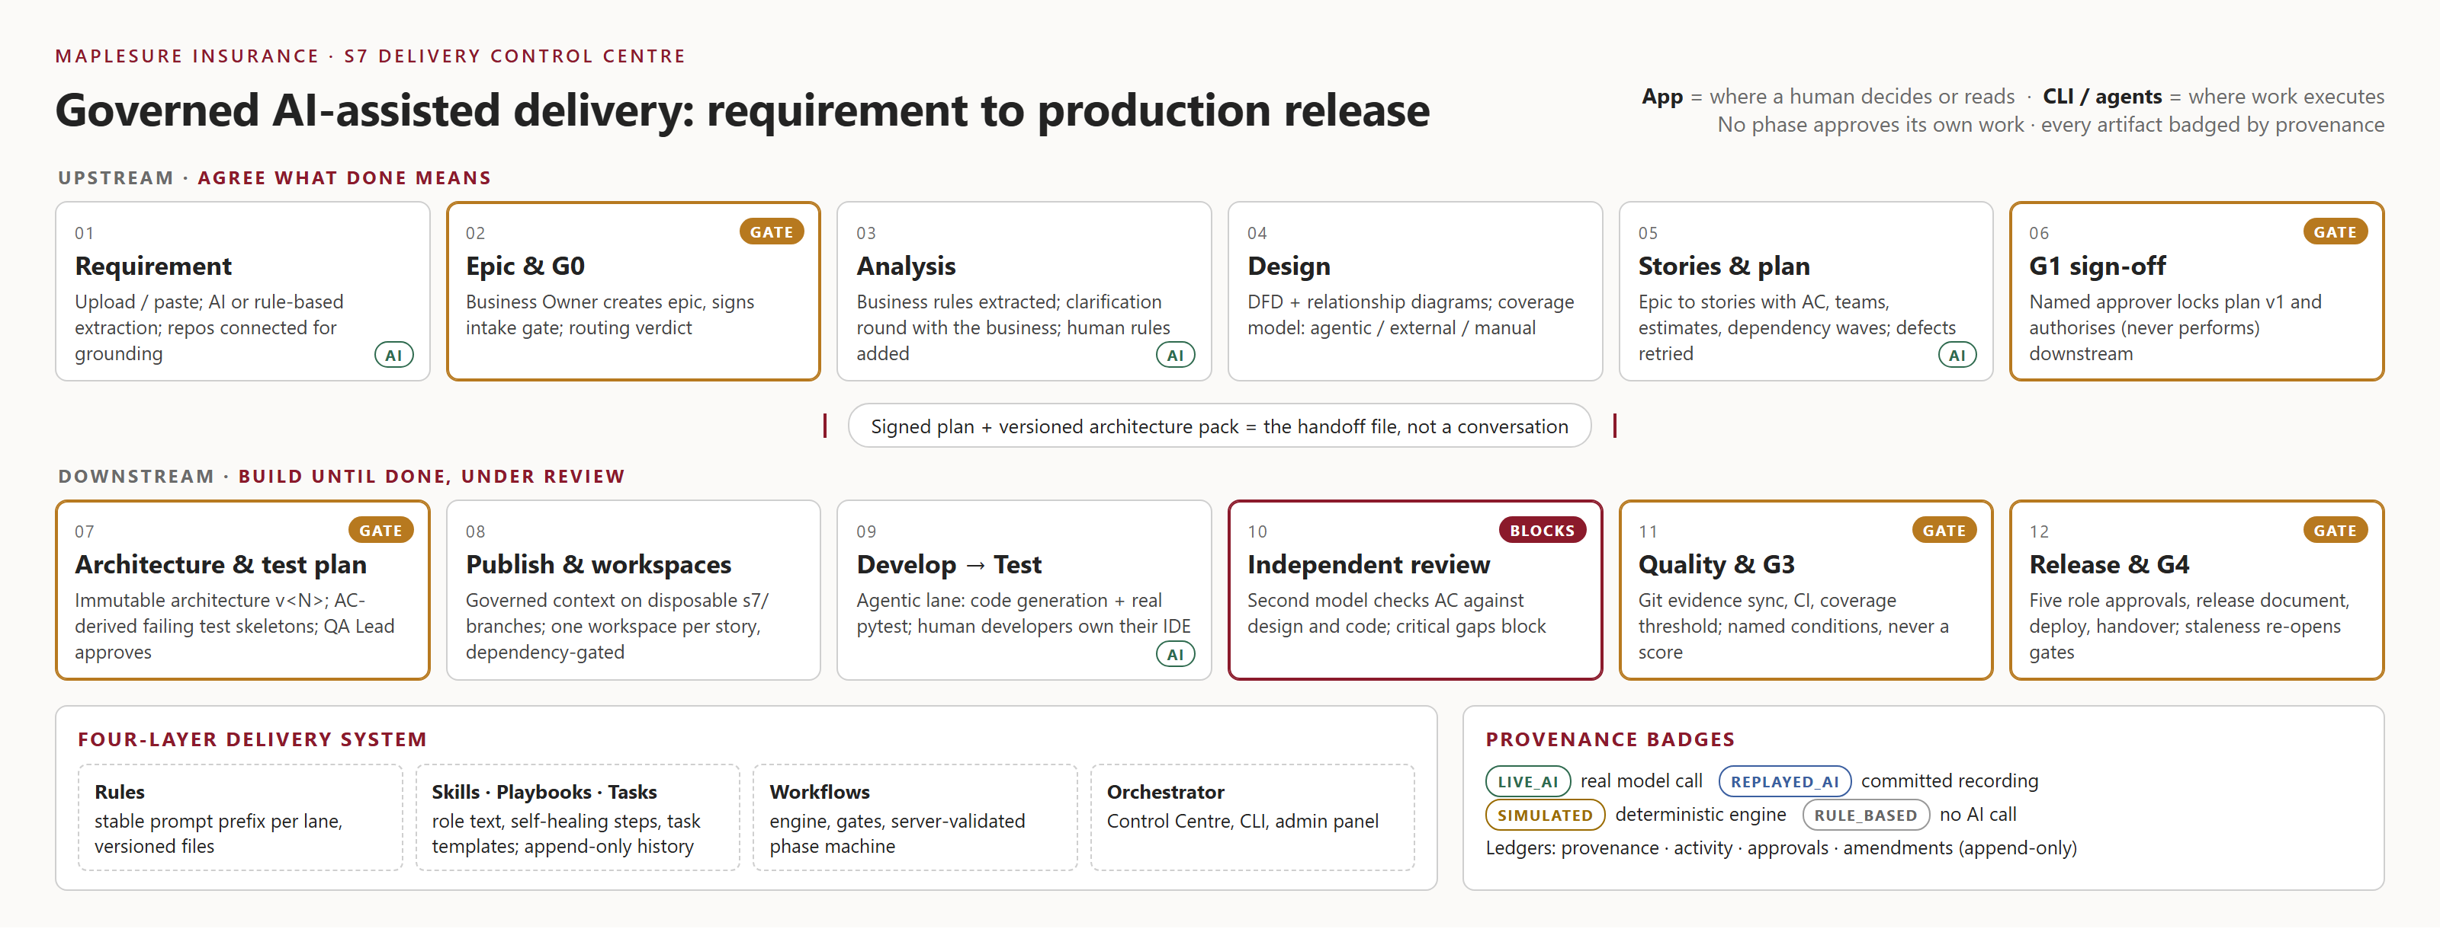  Caption: Governed delivery flow: intake, design, sign-off, architecture packs, workspaces, independent review, quality, release. | Asset/Image 2  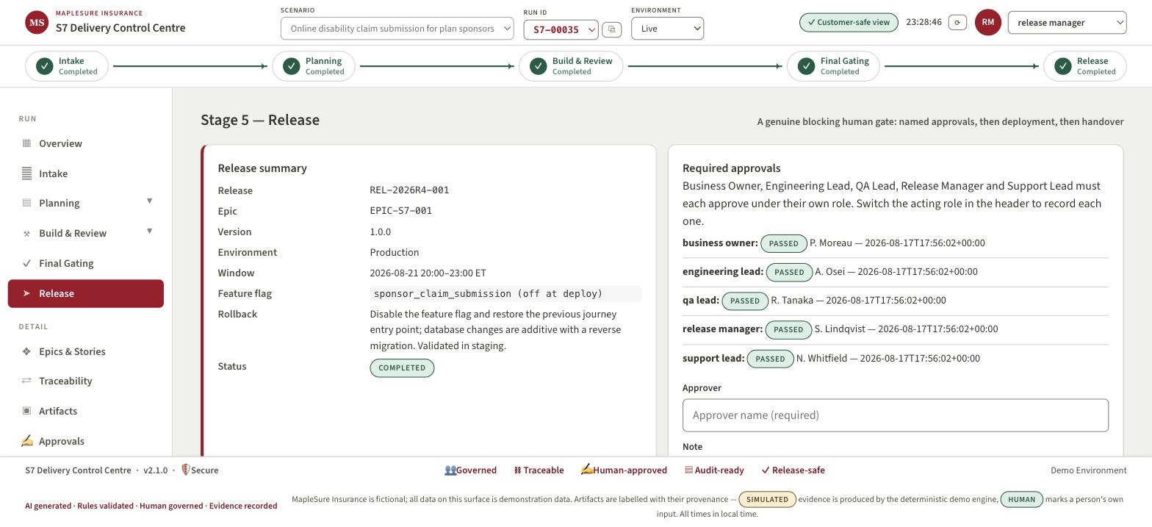  Caption: Overnight autonomous live run: release REL-2026R4-001 completed with five named human approvals, deploy and handover.

