S7 Delivery Control Centre: a live run with human corrections
Run S7-00008 (live mode, project entry) on 2026-09-04. A small requirement, a SponsorConnect landing page for plan sponsors, was taken from pasted text through extraction, routing, analysis, planning, Gate 1 sign-off, architecture, delivery packs and QA test-plan approval. At every point where the model produced something, a named human role read it, corrected it where it was wrong, and signed the gate. The final section shows how those corrections surface in the Admin panel and become a proposed, reviewed and accepted revision of the prompt that produced the mistake.
Every AI output is badged LIVE_AI; everything derived by rules is badged RULE_BASED; every human edit is badged HUMAN. Nothing in this run is simulated.

1. What was run, and who acted
Step | Acting role | What the human did
Paste requirement, AI extraction | Business Owner | Pasted the landing-page requirement; the model extracted title, objective, summary and eight requirements.
Correction 1: edit extraction | Business Owner | Rewrote the AI title and summary in the business's own words (go-live before Q4 renewal, existing pages unchanged).
Connect repository | Delivery Lead | Connected disability-claim-sponsorconnect (the role guard forced a switch from Business Owner).
Route requirement | Delivery Lead | The model said 'new application needed'; the human overrode to 'routable' because the page belongs in the existing portal.
AI analysis + clarification | Delivery Lead | Answered the two clarification questions the analysis raised.
Correction 2: business rule | Delivery Lead | Added BR-H1 (analytics events carry only page id and CTA id), which the analysis missed.
Create epic, pass Gate 0 | Delivery Lead / Business Owner | Epic EPIC-S7-001 created; intake gate signed by the Business Owner.
Generate plan | Product Analyst | Model produced 4 stories, 8 acceptance criteria, 3 sprints.
Correction 3: edit story US-3 | Product Analyst | Title 'Integrate support panel with real-time data' corrected to 'reads service line hours from configuration'; moved to Sprint 1.
Gate 1 plan sign-off | Business Owner | Signed by Priya Nandakumar with a note recording the corrections.
Architecture v1 to v2 | Engineering Lead | Proposed an Integration Boundaries revision (correction 4, refined by a real model call); accepted v2 as Daniel Okafor.
Delivery packs, QA test plan | QA Lead | Amended the test plan around US-4-AC2 (privacy negative test, refined by the model), then approved as Mei Tanaka.
Publish to Git | Engineering Lead | Refused by the foreign-content guard: the repo's master already carries src/test/java/s7 from an earlier run. Left for a human decision.
Admin: Correction Learning | admin (operator) | Proposed a revision of the epic-decomposition skill from correction 3, reviewed rationale and diff, accepted it as v2.

2. Intake: extraction, routing, analysis and the first human edits
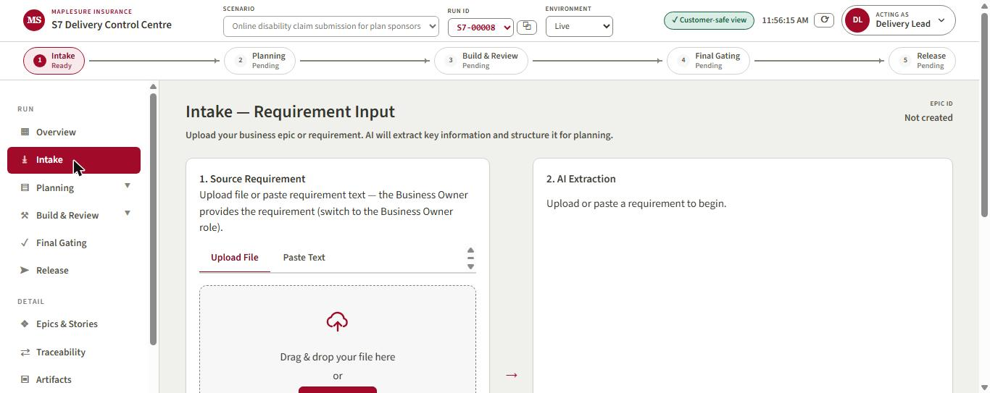
Figure 1. Run S7-00008 opened in Live mode. The Intake page waits for a requirement; the Business Owner owns this step.
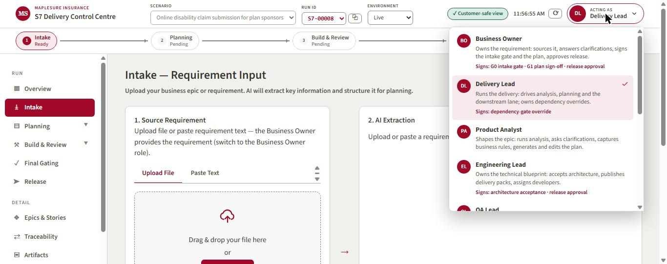
Figure 2. The role picker. Each role states what it owns and which gates it signs; the server enforces the same table.
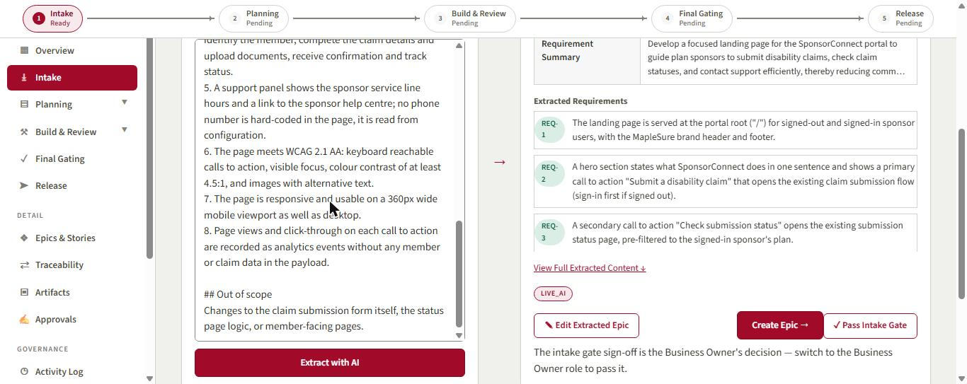
Figure 3. AI Extraction (LIVE_AI) of the pasted landing-page requirement: title, objective, summary and numbered requirements.
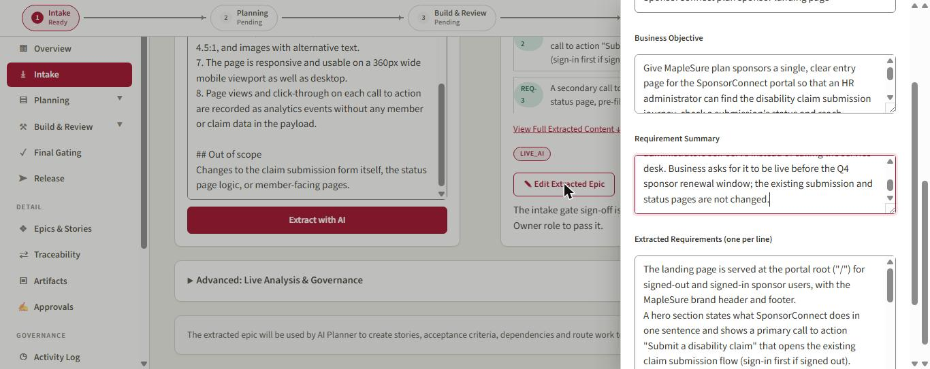
Figure 4. Correction 1. The Business Owner rewrites the AI title and summary in the Edit Extracted Epic drawer.
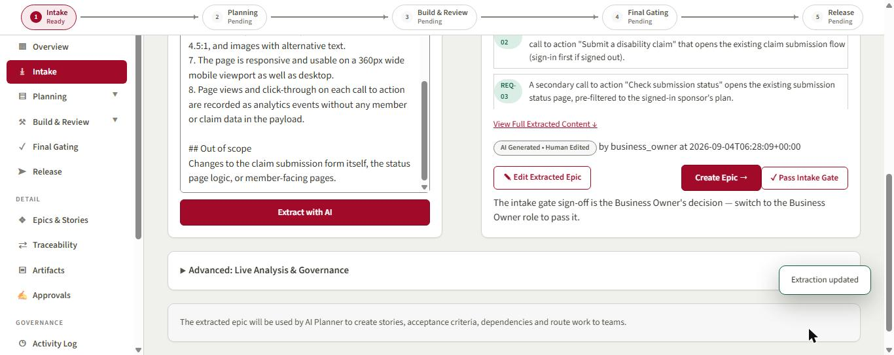
Figure 5. After saving, the extraction is badged 'AI Generated, Human Edited by business_owner'. The engine appended the before/after pair to corrections.jsonl.
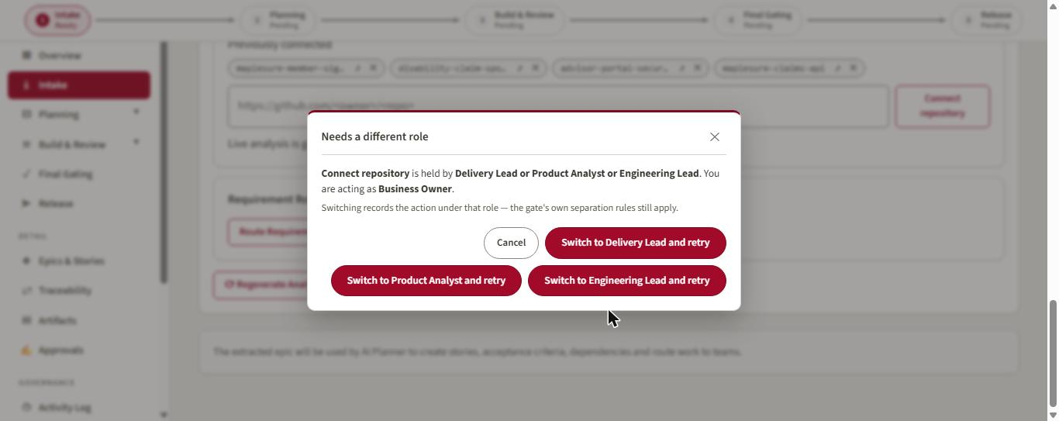
Figure 6. Governance in action: connecting a repository is not a Business Owner action. The popup names the holders and offers a recorded role switch.
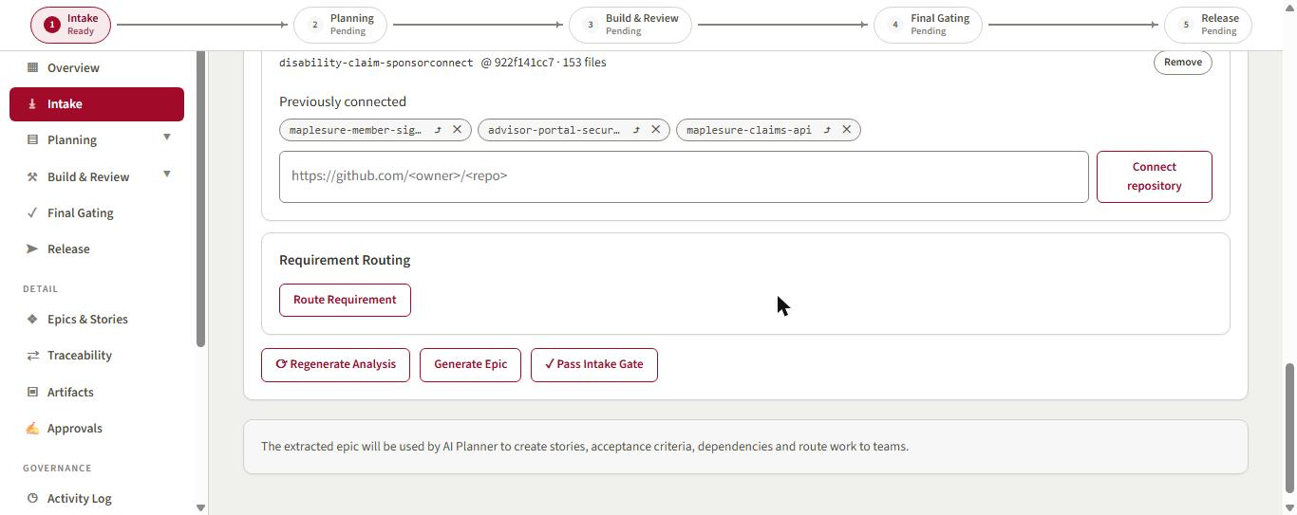
Figure 7. disability-claim-sponsorconnect connected at commit 922f141cc7 (153 files); a context pack now grounds every model call.
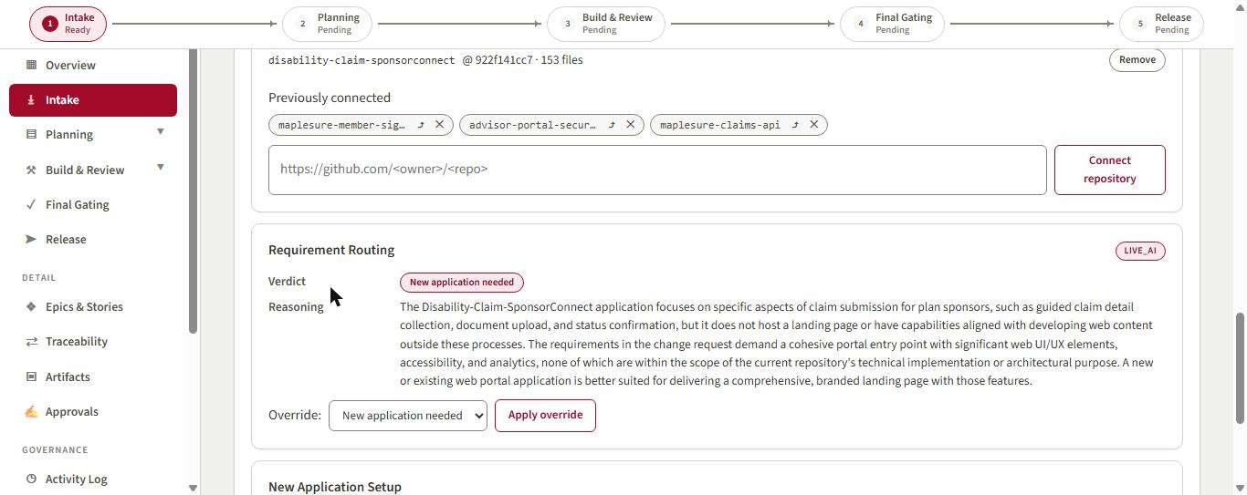
Figure 8. Requirement routing (LIVE_AI) judged the landing page a new application.
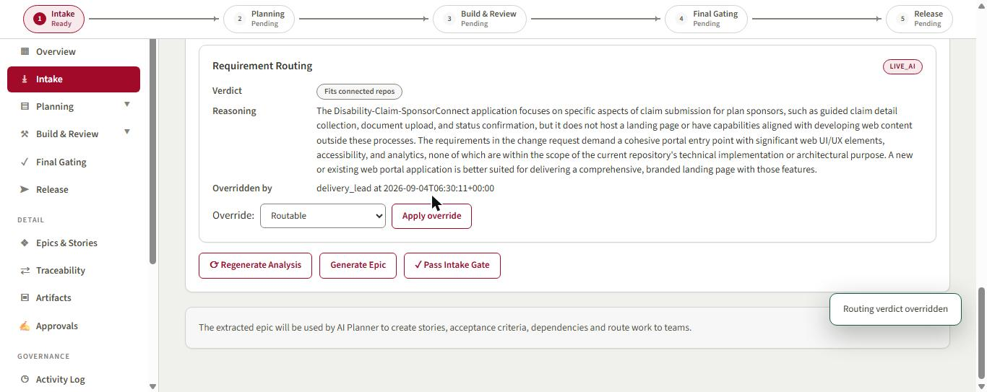
Figure 9. The Delivery Lead overrode the verdict to 'Fits connected repos'. The override is recorded with role and timestamp; the AI reasoning stays visible.
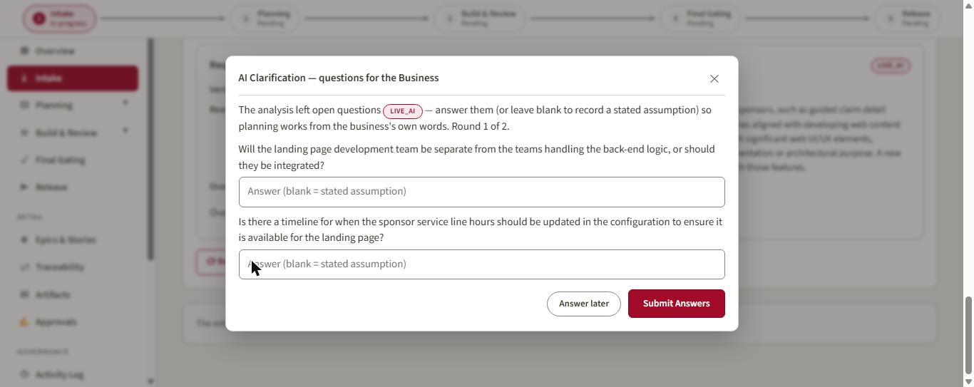
Figure 10. The analysis raised its own clarification questions; the popup is addressed to the business (round 1 of 2).
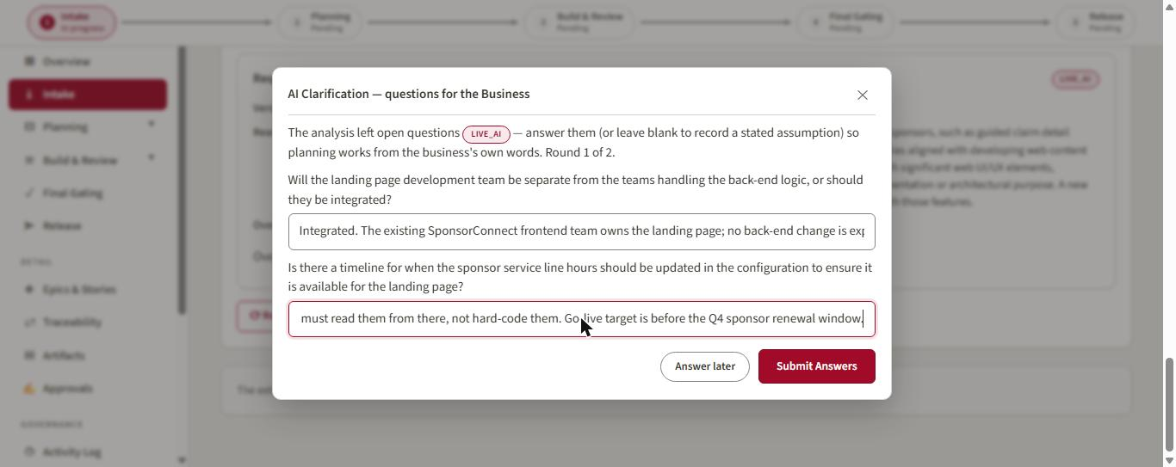
Figure 11. Answers typed in the business's words: integrated team, hours read from configuration, go-live before Q4 renewal.
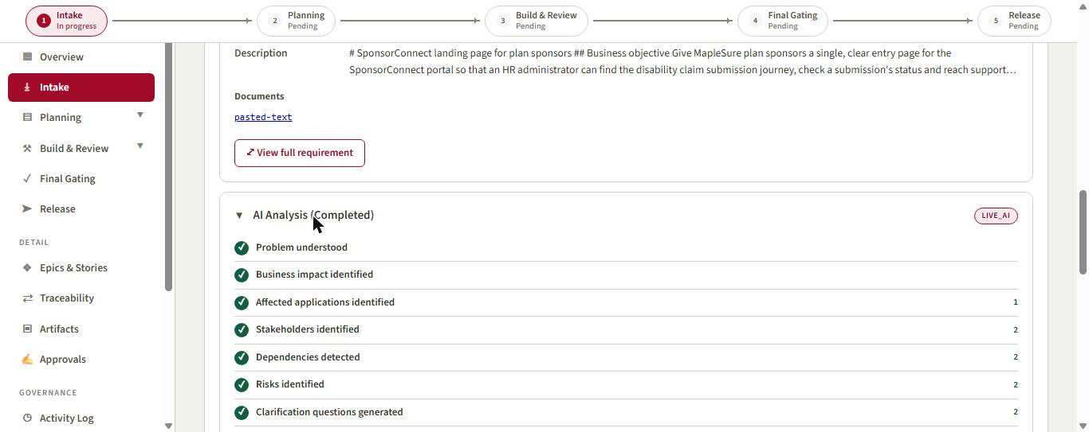
Figure 12. AI Analysis completed (LIVE_AI): problem, impact, applications, stakeholders, dependencies, risks and clarifications.
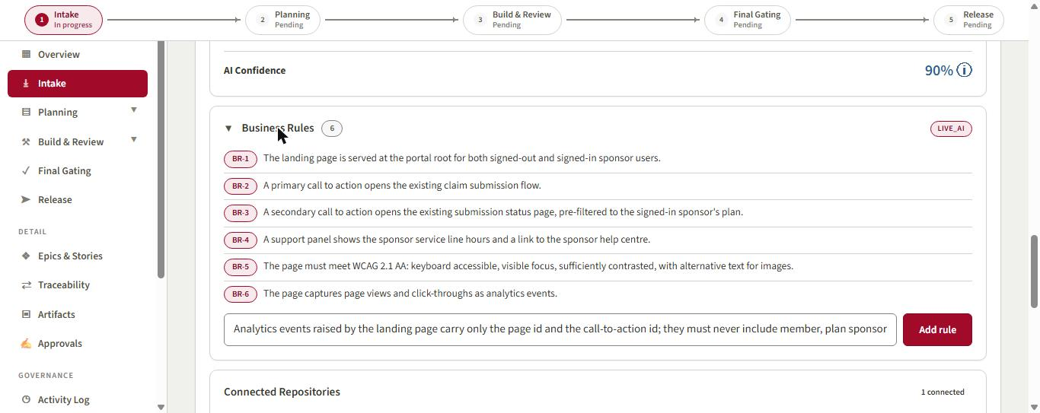
Figure 13. The six business rules the analysis extracted (BR-1 to BR-6). The privacy constraint on analytics is missing.
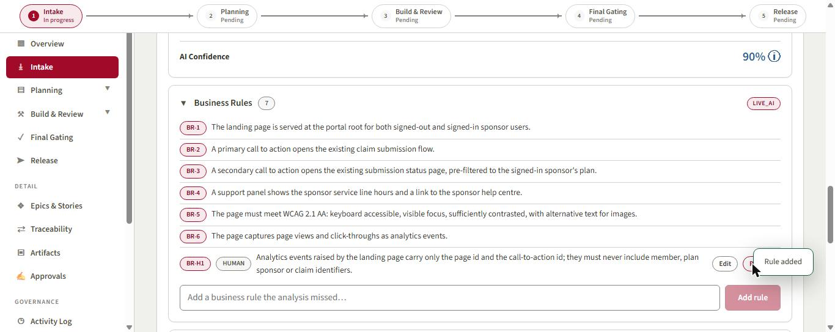
Figure 14. Correction 2. BR-H1 added by a human, badged HUMAN and editable; AI rules stay immutable.
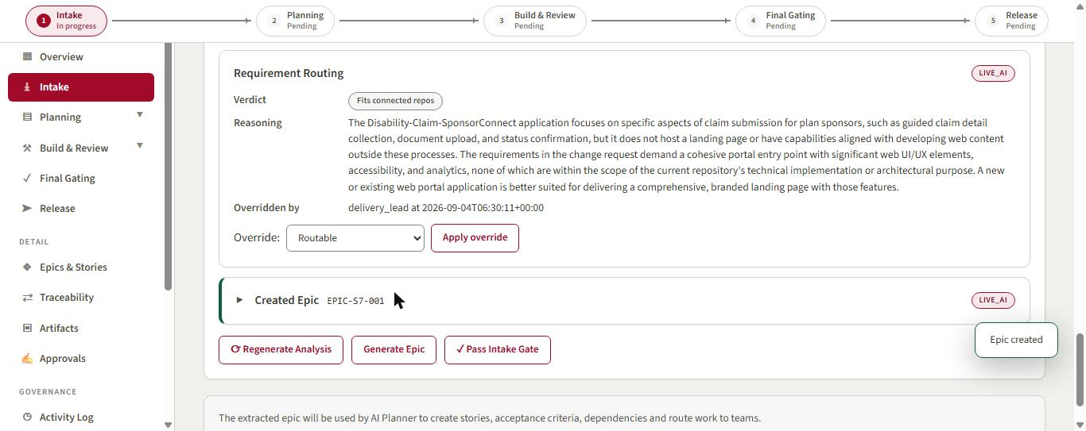
Figure 15. Epic EPIC-S7-001 created from the corrected extraction.
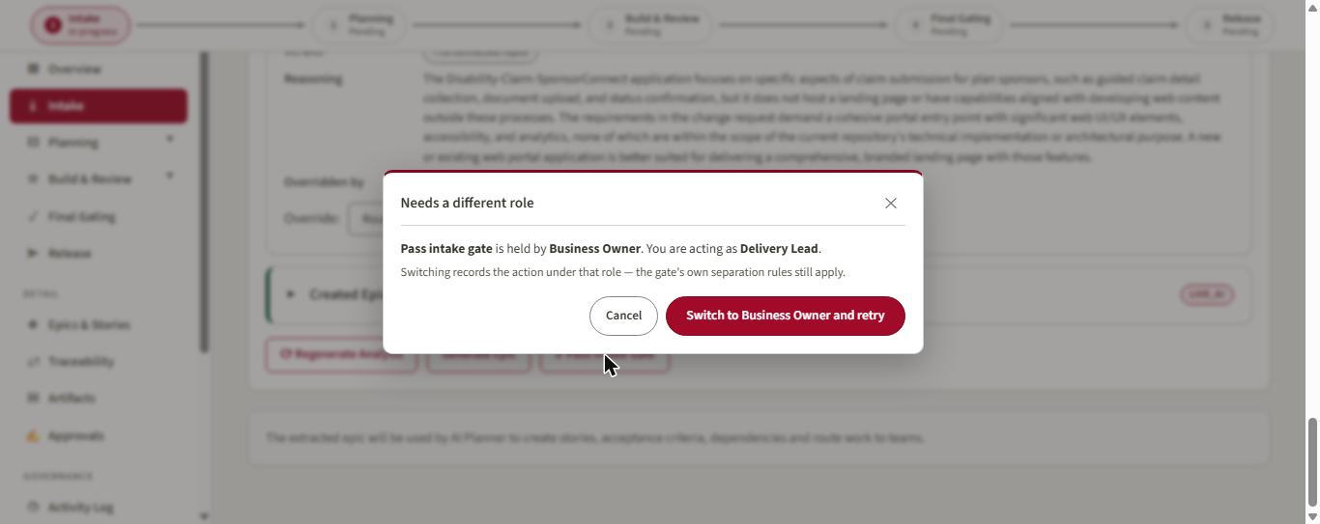
Figure 16. Passing the intake gate needs the Business Owner; the Delivery Lead is offered the switch, and the action is recorded under the signing role.
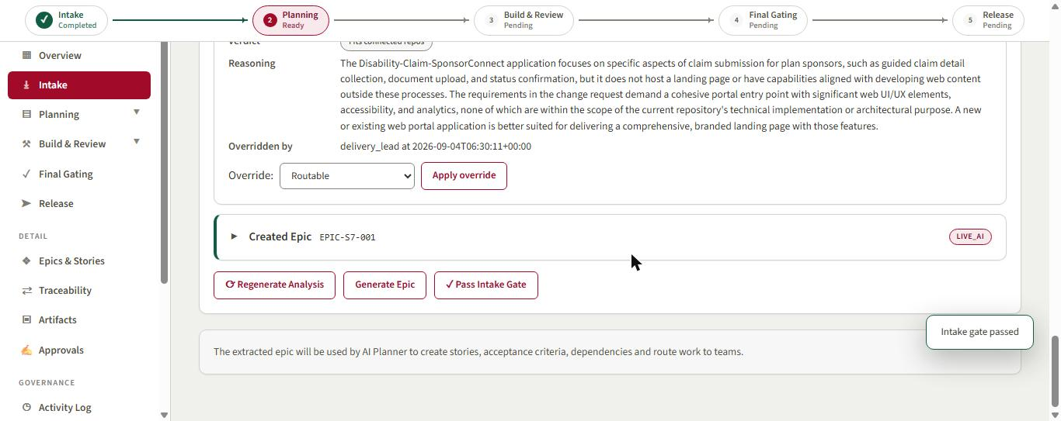
Figure 17. Gate 0 passed. Intake is complete and Planning is ready.

3. Planning: stories, a human correction, design and Gate 1
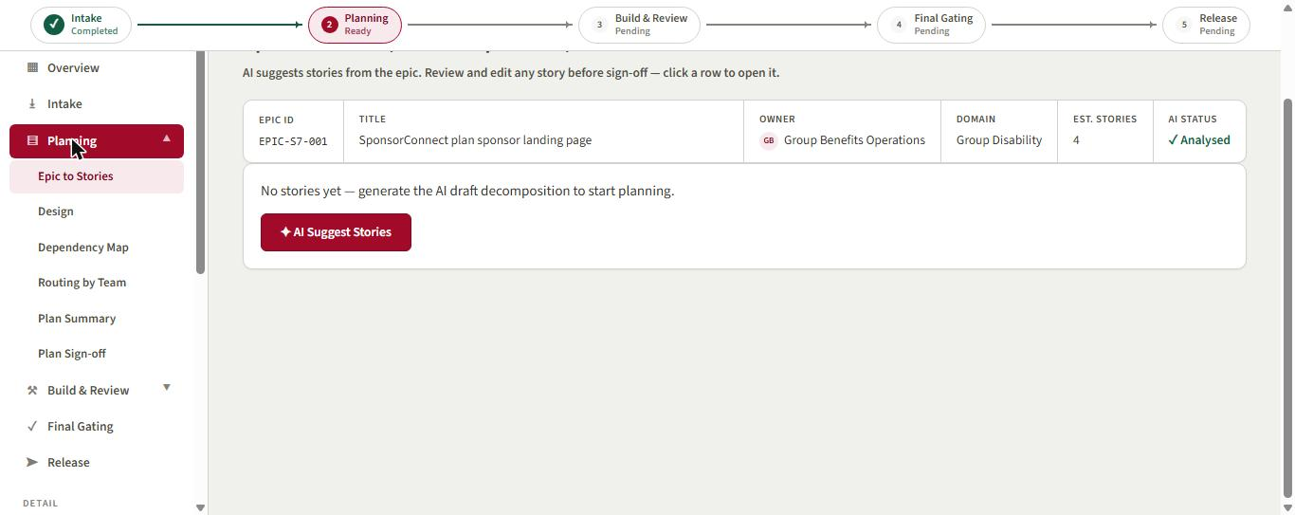
Figure 18. Epic to Stories before generation. The epic carries the human-corrected title.
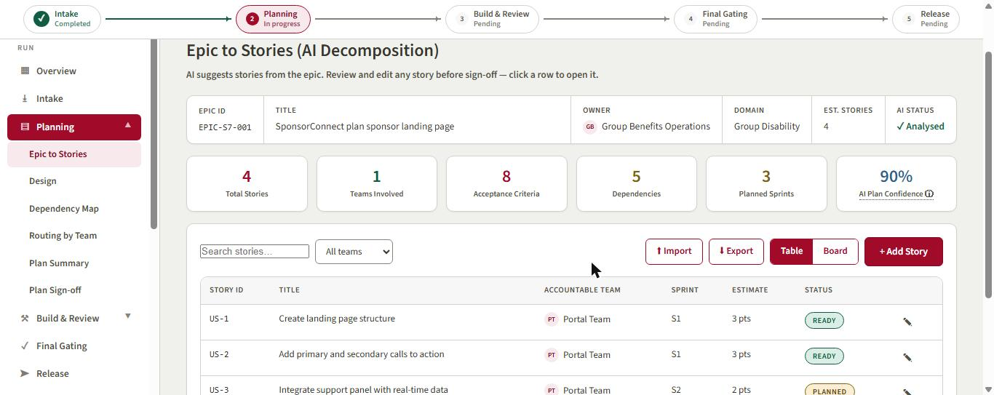
Figure 19. The plan (LIVE_AI): 4 stories, 1 team, 8 acceptance criteria, 5 dependencies, 3 sprints, 90% plan confidence.
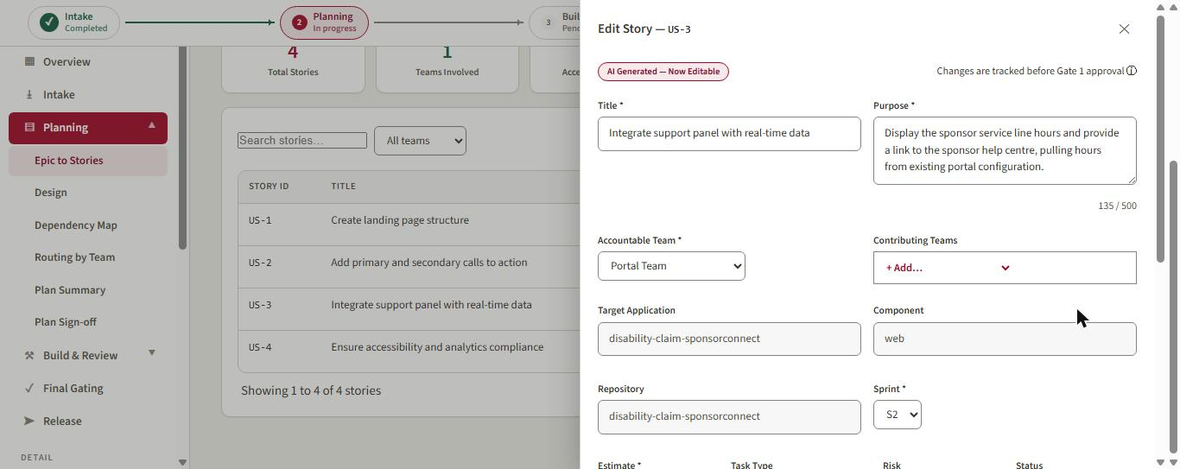
Figure 20. Correction 3. Story US-3 opened for editing: 'AI Generated, Now Editable'. The model invented a real-time integration.
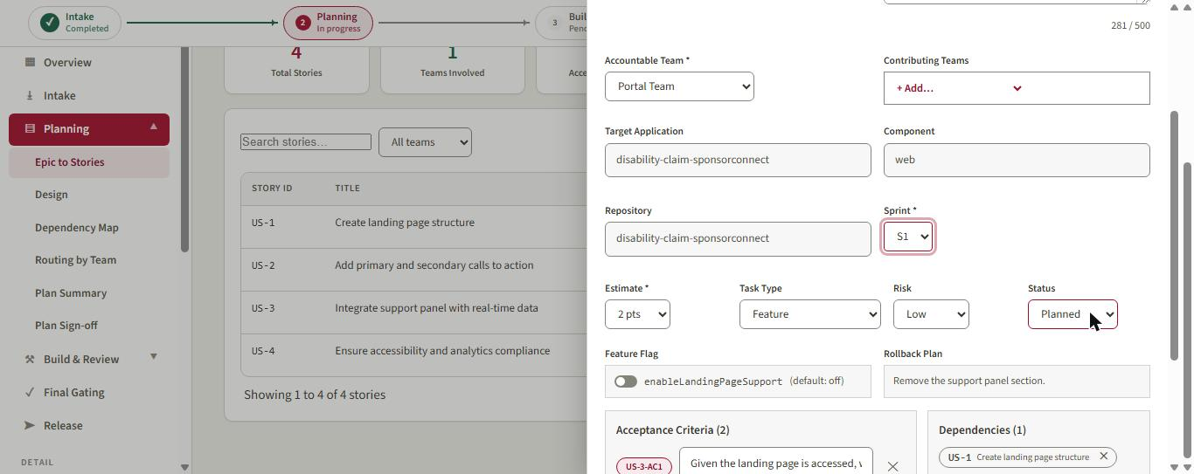
Figure 21. The Product Analyst corrects title and purpose (hours come from configuration, no real-time integration) and pulls the story into Sprint 1.
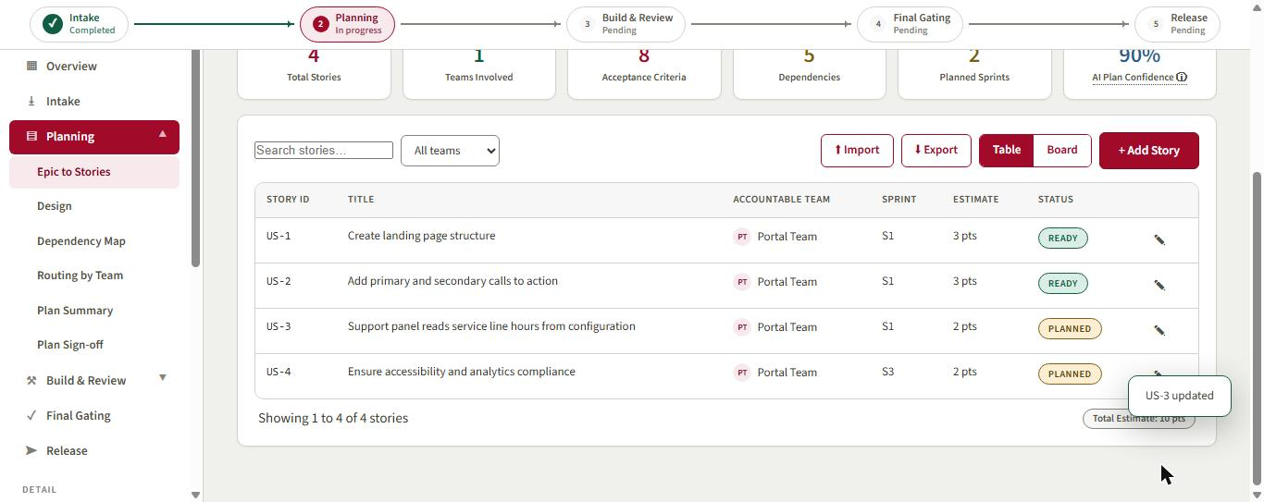
Figure 22. US-3 updated in the table; the plan now spans 2 sprints. The edit is version 2 of the story and a recorded correction.
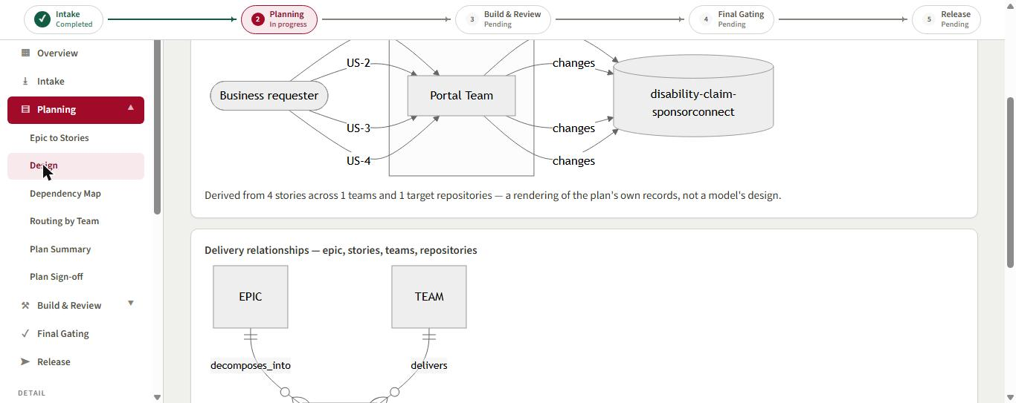
Figure 23. Design page: delivery data-flow derived from the plan's own records (RULE_BASED, no model call).
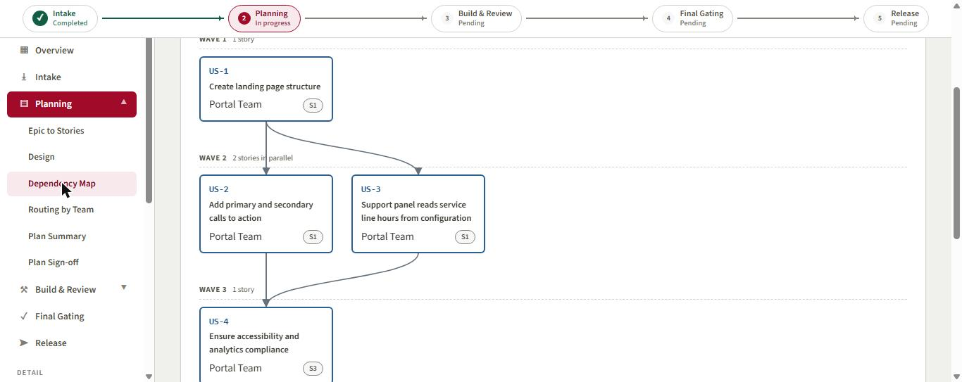
Figure 24. Dependency map: three waves, with US-2 and US-3 in parallel.
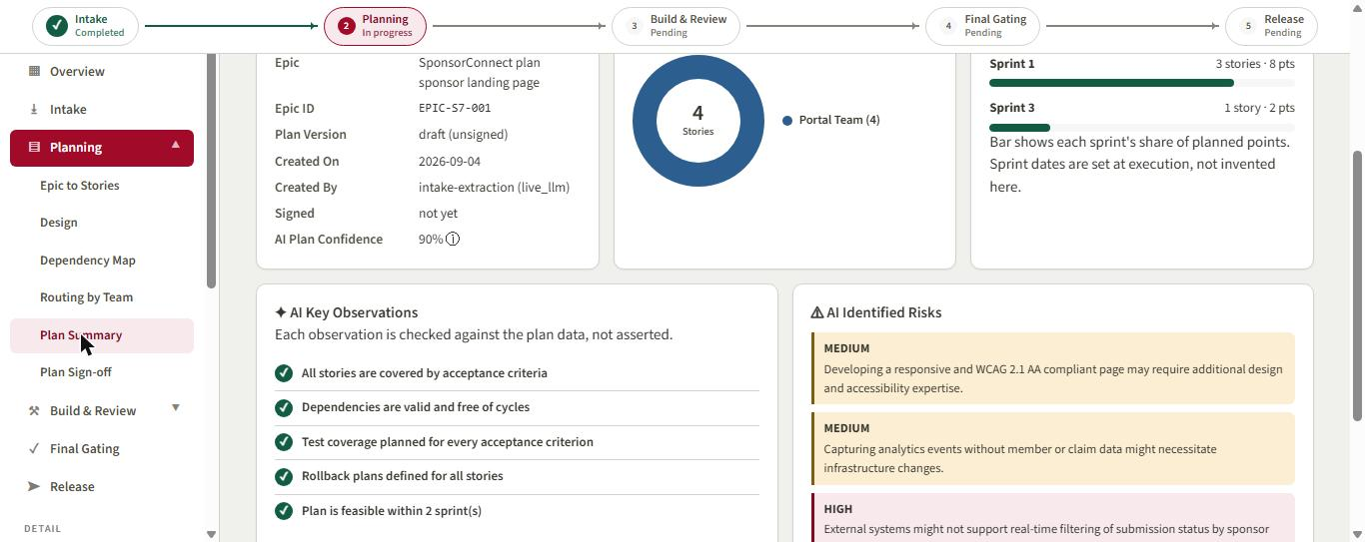
Figure 25. Plan Summary: AI key observations are checked against the plan data, not asserted; AI-identified risks alongside.
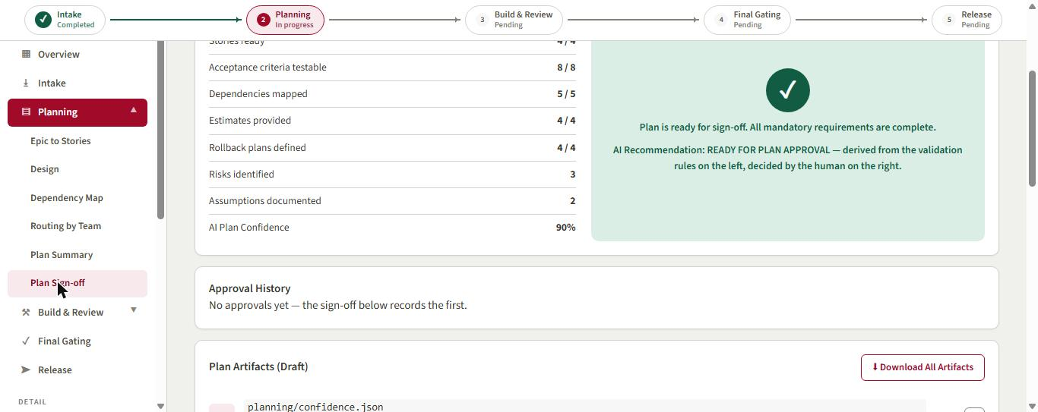
Figure 26. Gate 1 checklist: every mandatory condition complete; the recommendation is derived from rules and decided by the human.
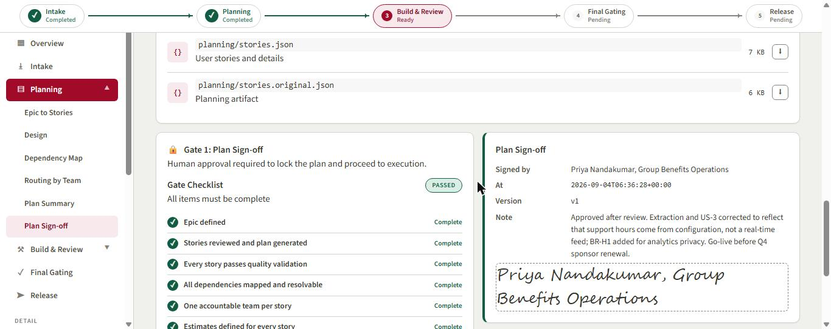
Figure 27. Gate 1 signed by the Business Owner (Priya Nandakumar) with a note recording the corrections. The plan is locked.

4. Build & Review: architecture, packs, QA and the publish guard
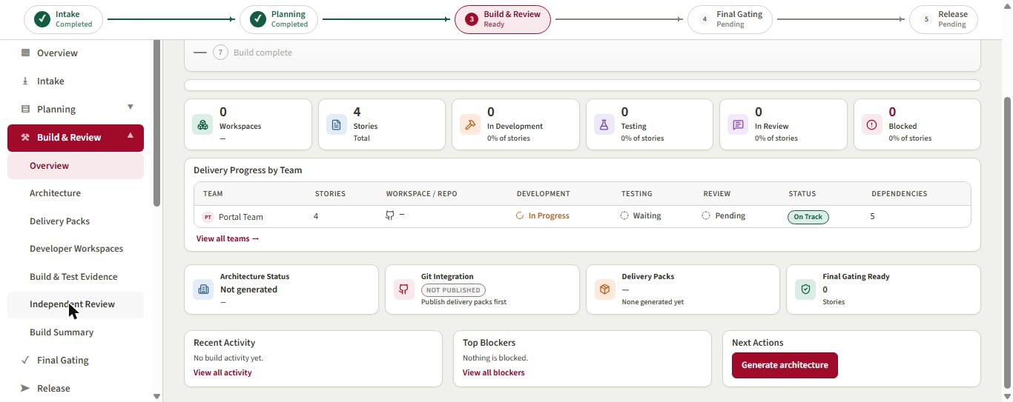
Figure 28. Build & Review overview after Gate 1: architecture not yet generated, packs not yet published.
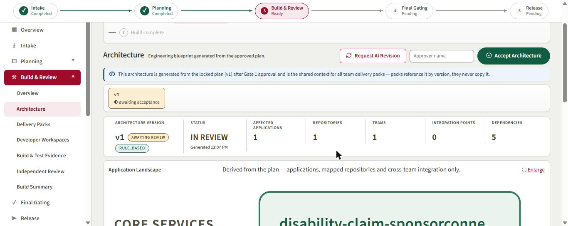
Figure 29. Architecture v1 generated from the locked plan (RULE_BASED), awaiting the Engineering Lead's acceptance.
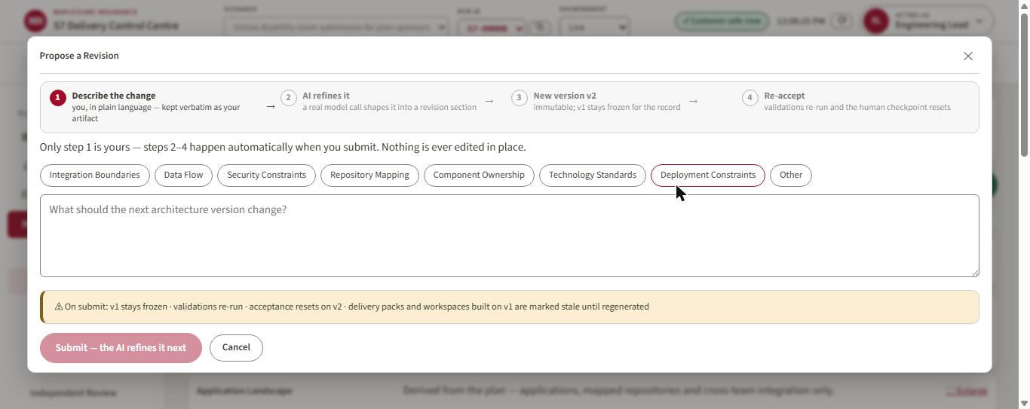
Figure 30. Propose a Revision: only step 1 is human; the model refines the proposal into a new immutable version.
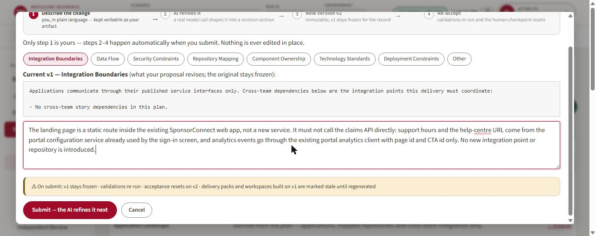
Figure 31. Correction 4. The Engineering Lead's Integration Boundaries proposal, kept verbatim as the artifact.
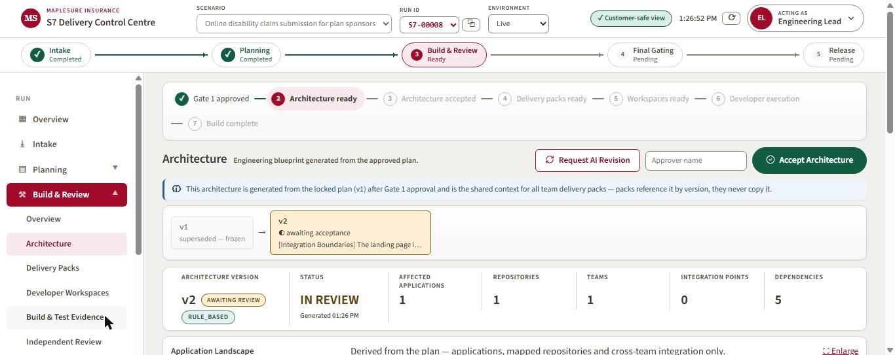
Figure 32. Architecture v2 produced; v1 stays frozen. A self-healing change record (SH-001) opened automatically.
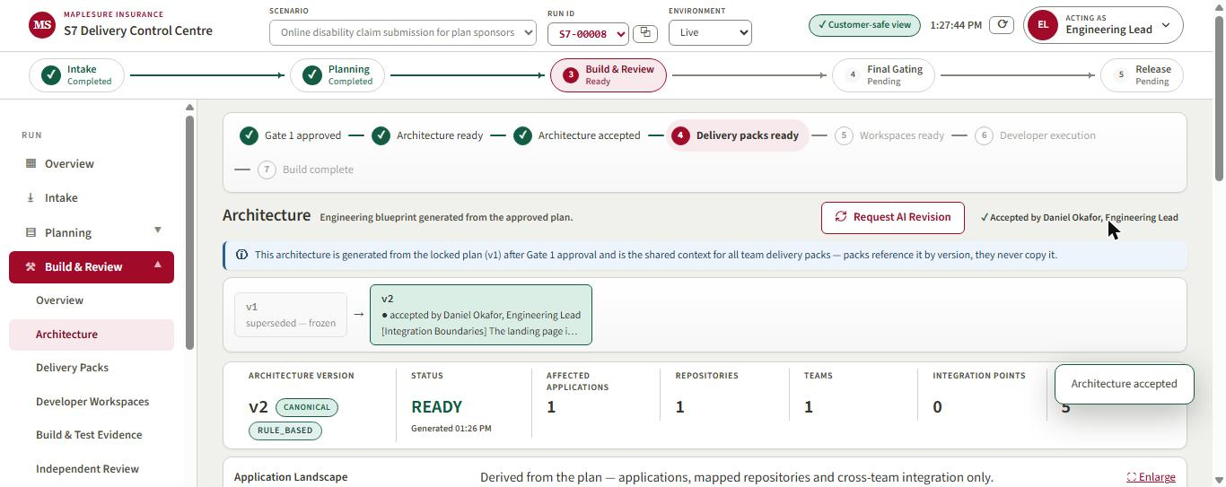
Figure 33. v2 accepted by Daniel Okafor, Engineering Lead. The playbook then regenerated the delivery packs without a button.
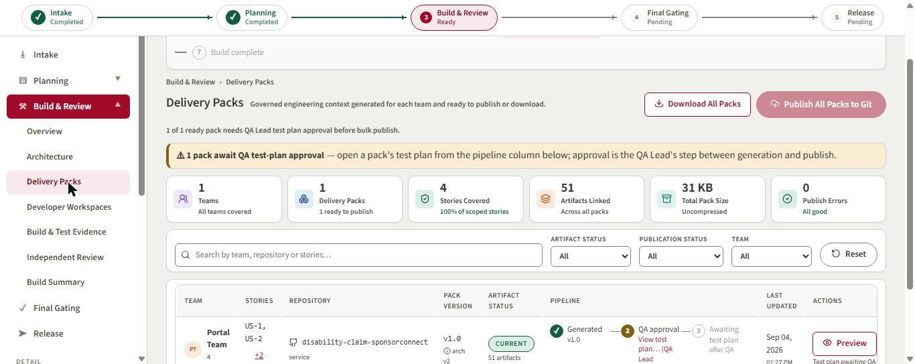
Figure 34. Delivery Packs: one pack for the Portal Team, awaiting QA Lead test-plan approval before publish.
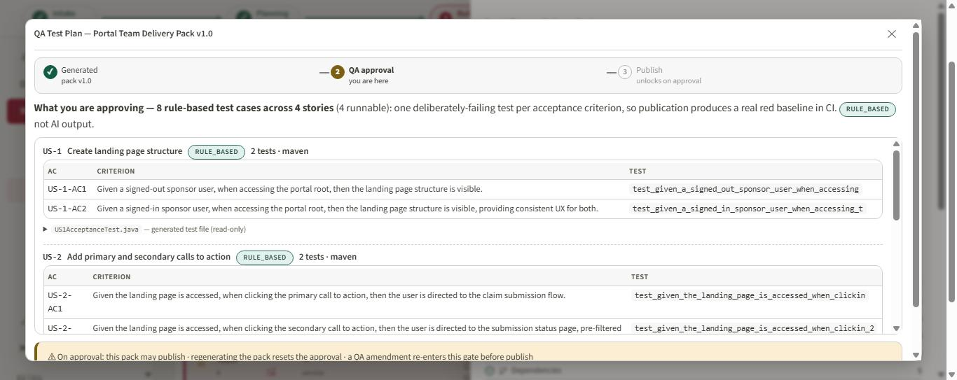
Figure 35. The QA test plan: eight rule-based test skeletons, one deliberately failing test per acceptance criterion (Maven, from the repo's bootstrap record).
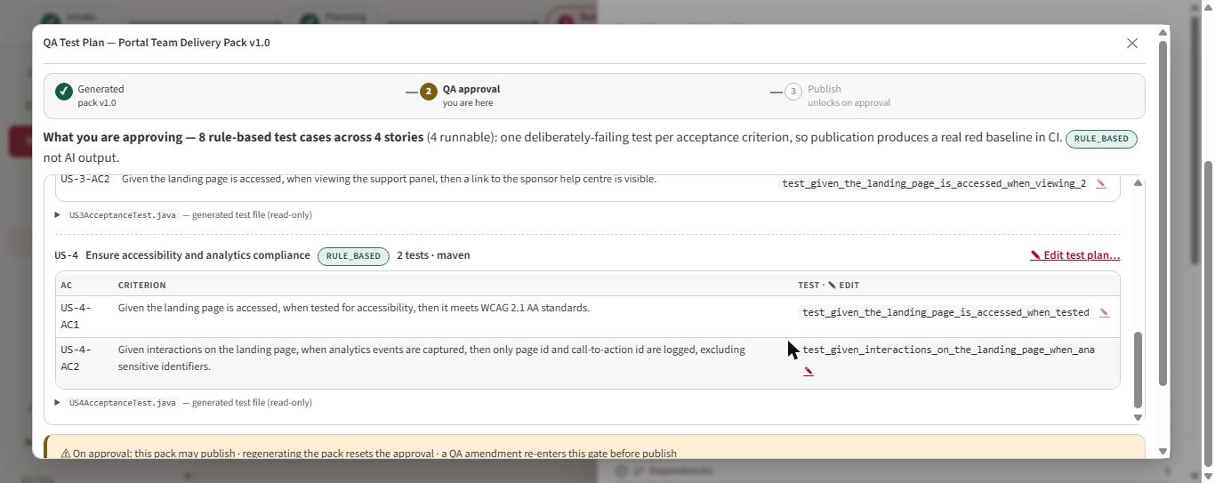
Figure 36. Acting as QA Lead the edit pencils appear; the Engineering Lead saw none.
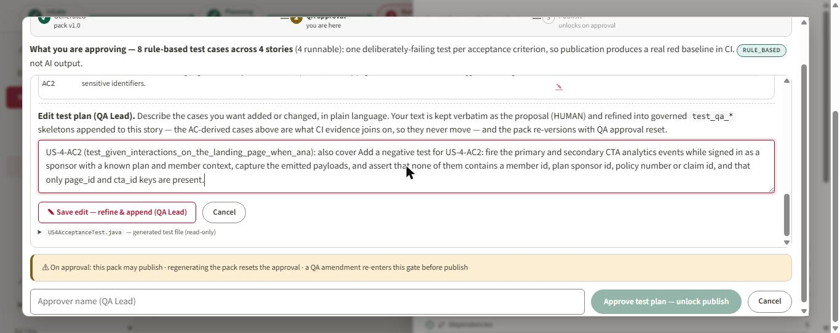
Figure 37. The QA amendment around US-4-AC2: a negative test that analytics payloads carry no member, sponsor or claim identifiers.
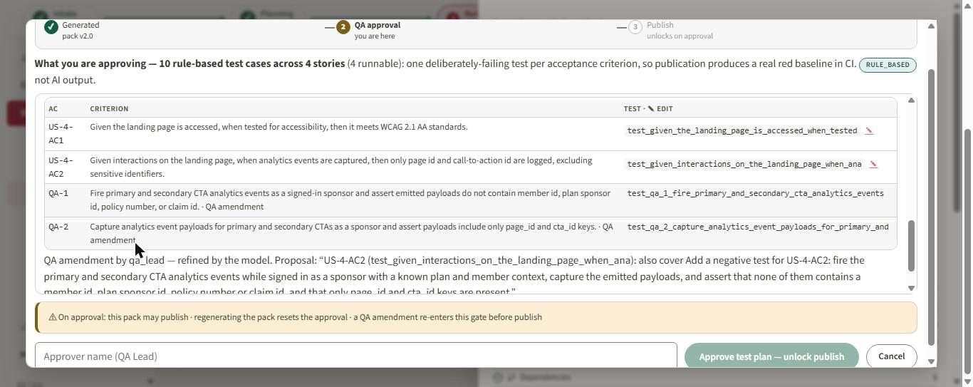
Figure 38. Pack v2.0: the amendment was refined into governed test_qa_1 and test_qa_2 cases; the AC-derived names never move.
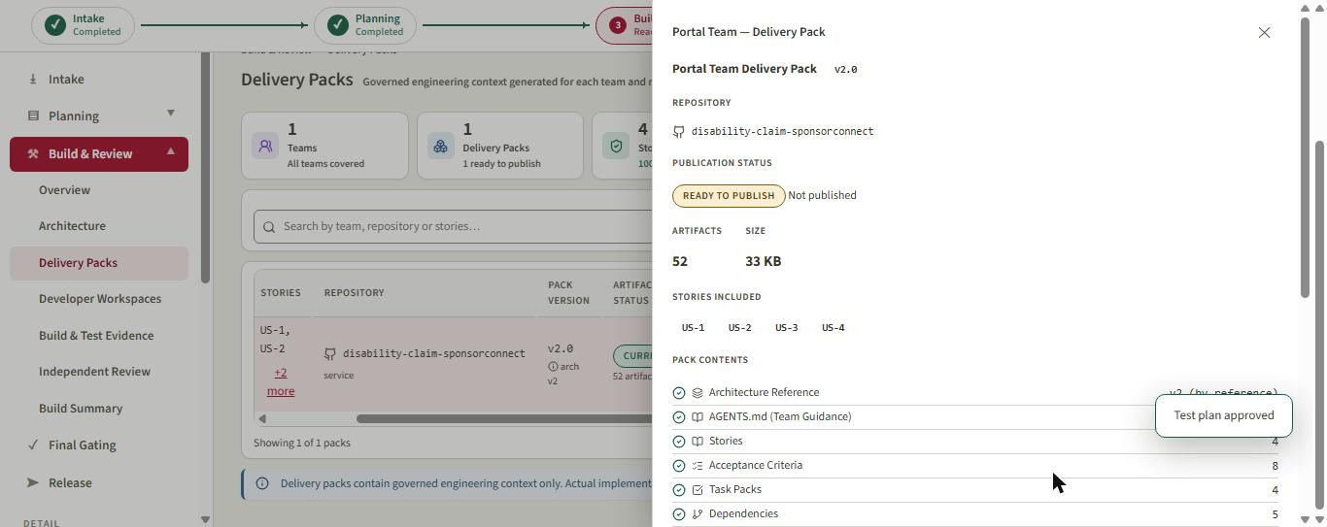
Figure 39. Test plan approved by Mei Tanaka, QA Lead; the pack is READY TO PUBLISH.
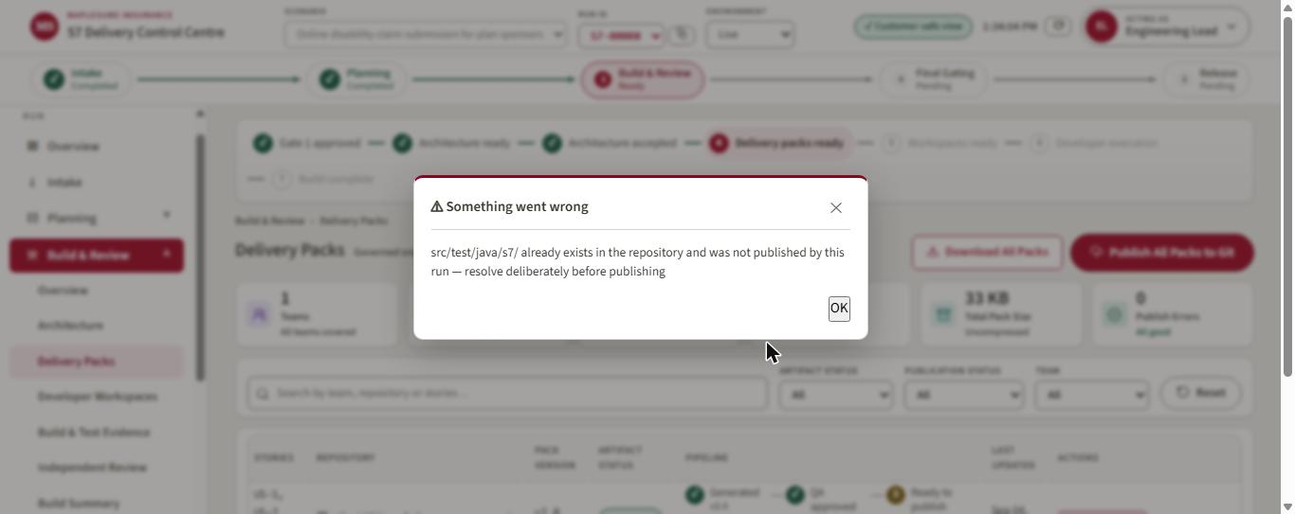
Figure 40. Publication refused. The target repo's default branch already carries src/test/java/s7 from an earlier run; the guard will not overwrite content this run did not publish.
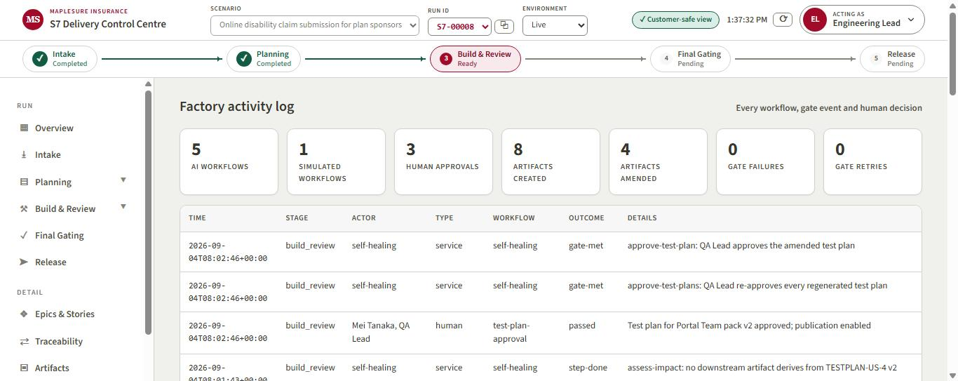
Figure 41. Factory activity log for the run: 5 AI workflows, 3 human approvals, every gate and decision with its actor.

5. Admin panel: the corrections become a prompt revision
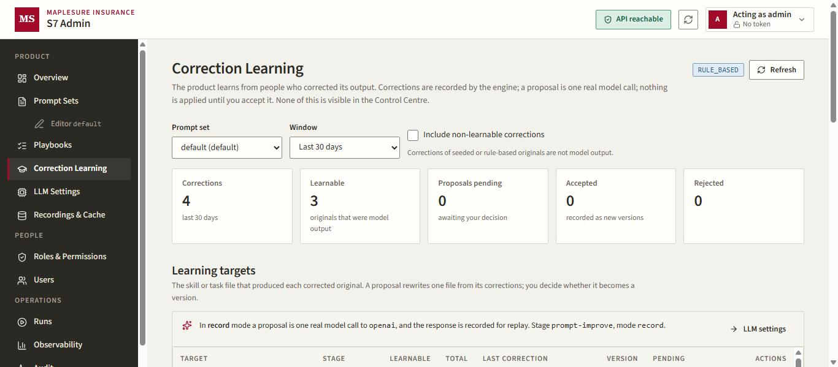
Figure 42. Correction Learning (admin only). Four corrections recorded; three learnable because their originals were model output.
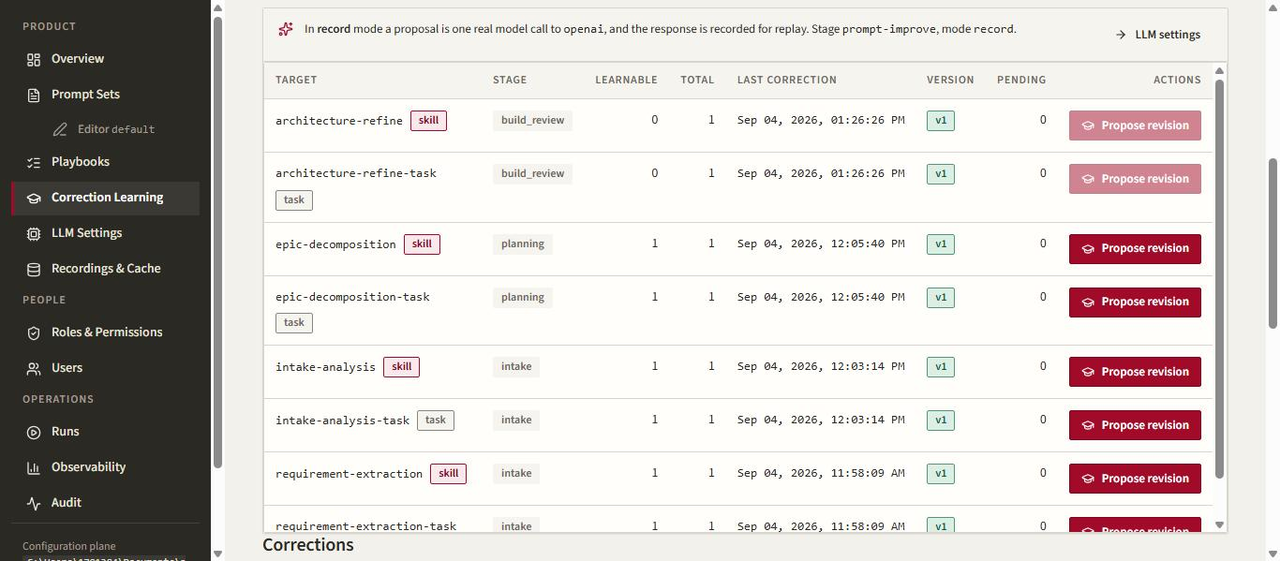
Figure 43. Learning targets: the skill or task that produced each corrected original. Architecture-refine is not learnable because its original was rule-based.
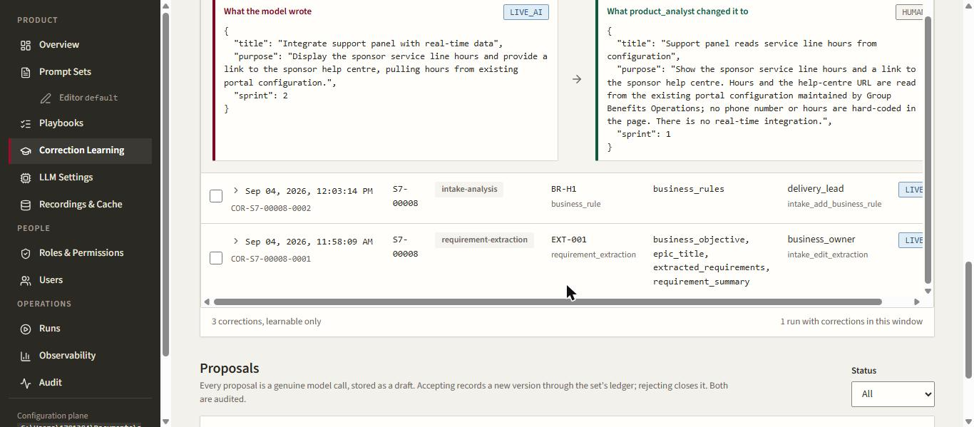
Figure 44. Correction 3 expanded: what the model wrote beside what the Product Analyst changed it to.
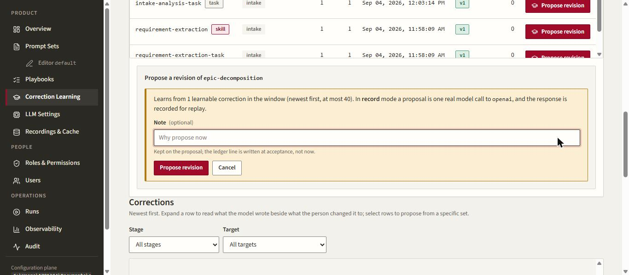
Figure 45. Propose a revision of epic-decomposition: one real model call, recorded for replay; the note is kept on the proposal.
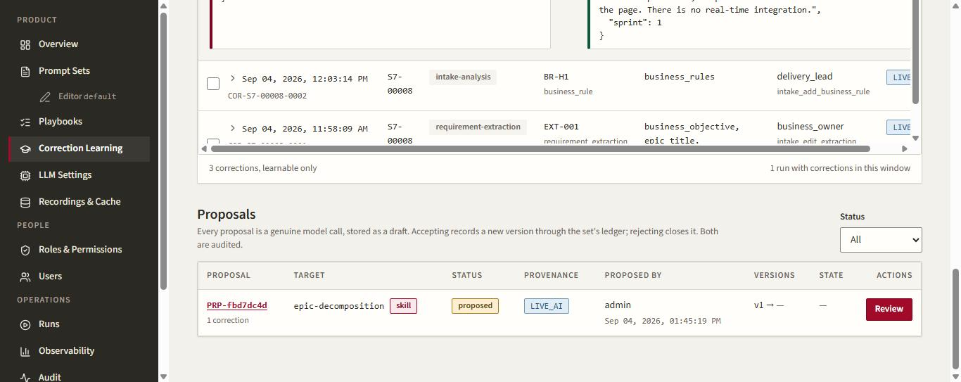
Figure 46. The proposal PRP-fbd7dc4d stored as a draft, LIVE_AI, versions v1 to pending.
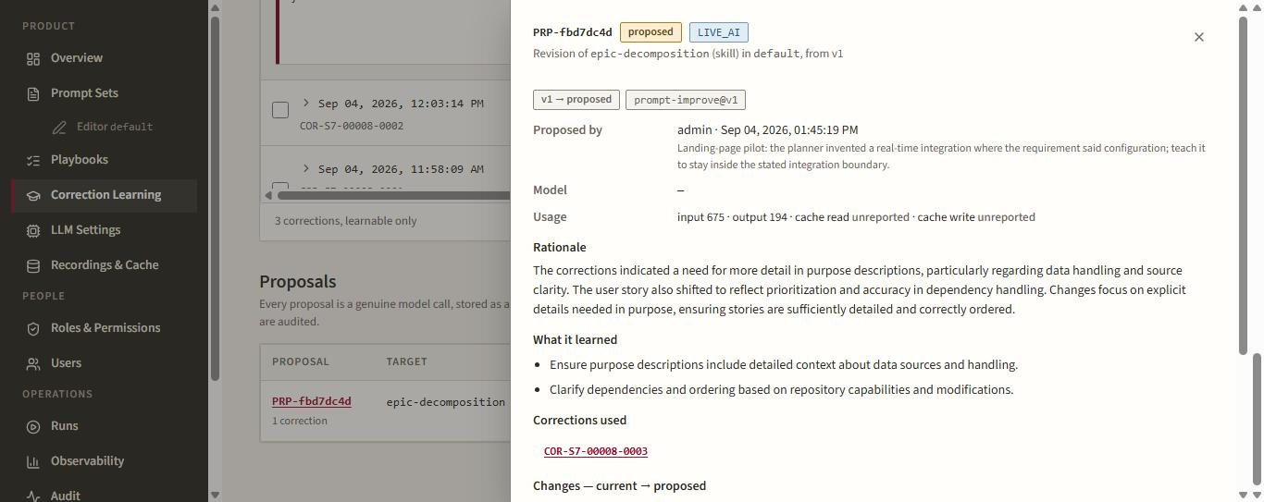
Figure 47. Review drawer: proposed-by note, token usage, the model's rationale, what it learned and the correction it used.
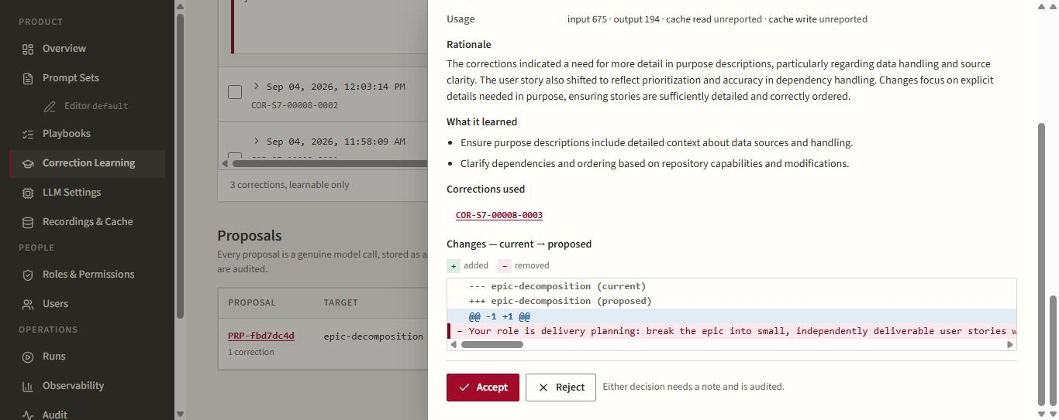
Figure 48. The unified diff of the skill body, then Accept or Reject; either decision needs a note and is audited.
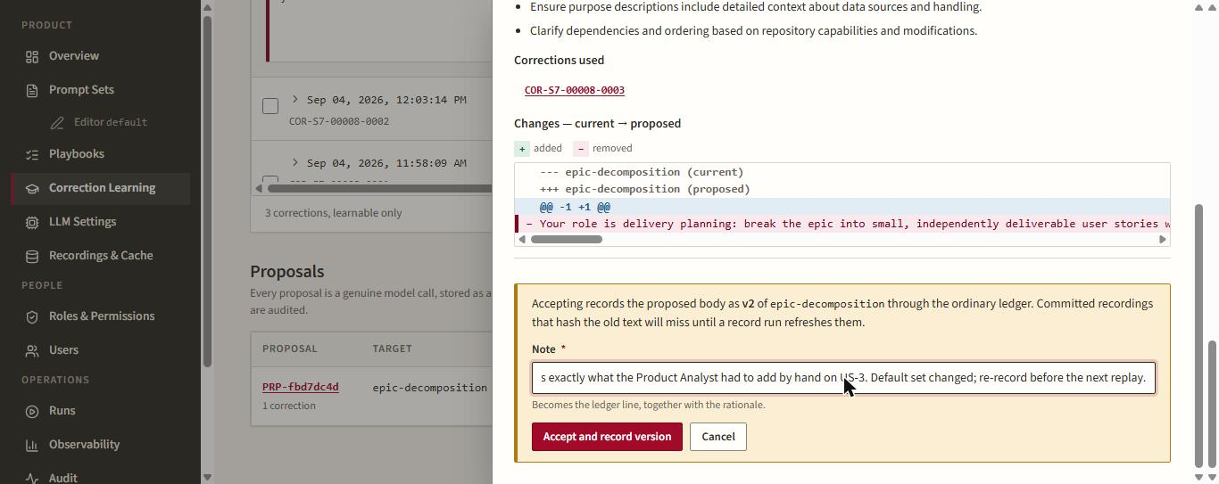
Figure 49. Accept confirmation. The panel warns that committed recordings hashing the old text will miss until re-recorded.
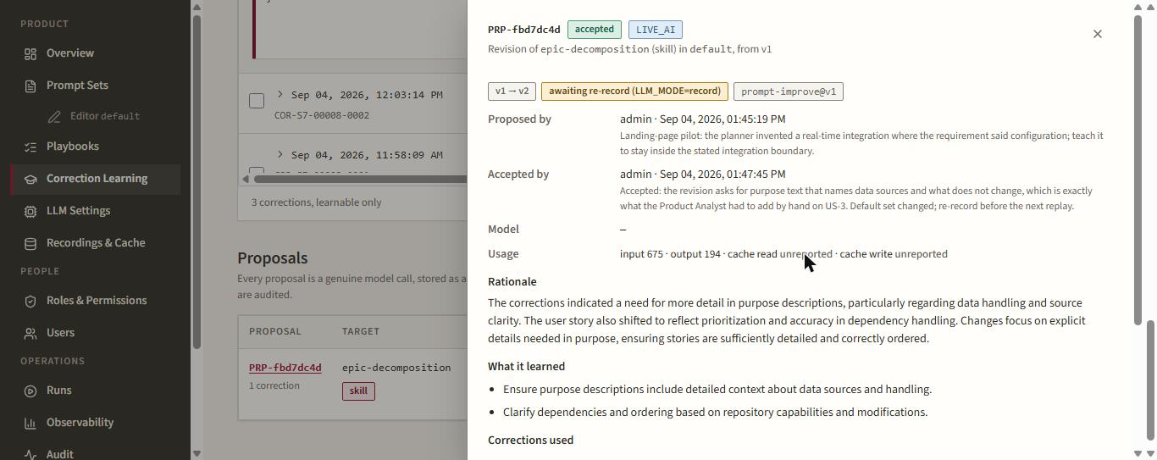
Figure 50. Accepted: v1 to v2, badged 'awaiting re-record (LLM_MODE=record)'.
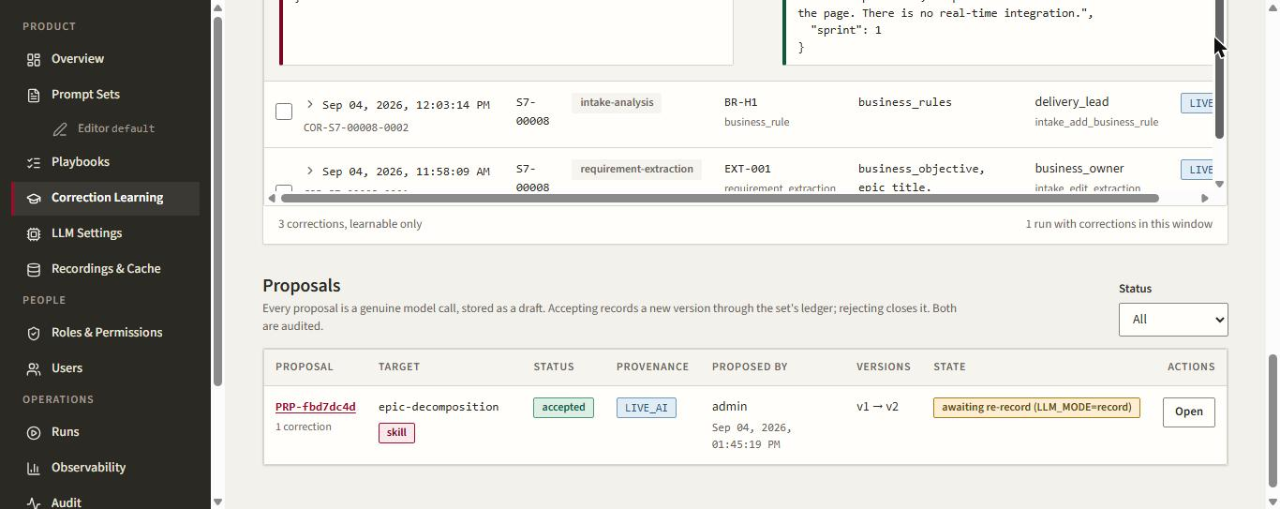
Figure 51. The proposal row after the decision.
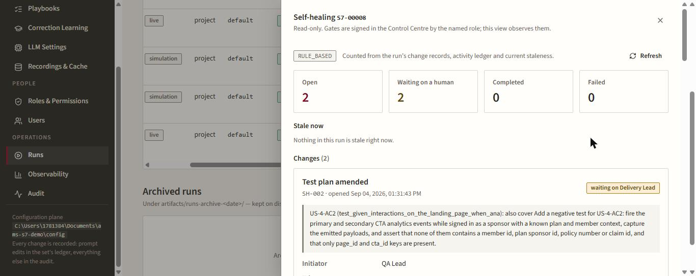
Figure 52. Runs page, Self-healing drawer for S7-00008: two open changes (architecture revised, test plan amended), both waiting on a human at the publish step.
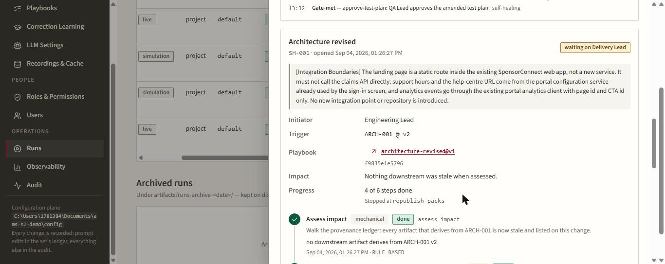
Figure 53. SH-001 card: initiator, trigger ARCH-001 v2, pinned playbook architecture-revised@v1, impact, and the step rail stopped at republish-packs.
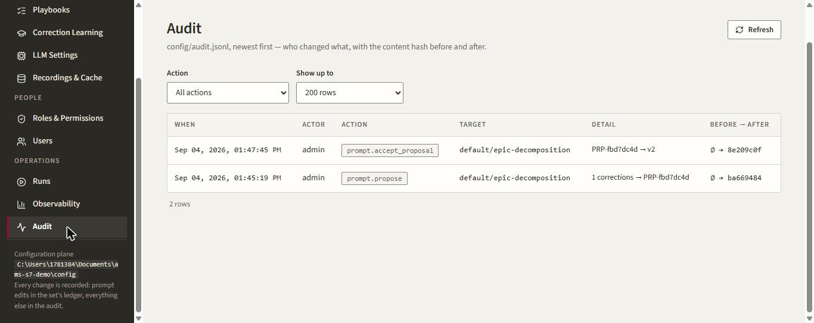
Figure 54. Audit log: prompt.propose and prompt.accept_proposal with content hashes before and after.
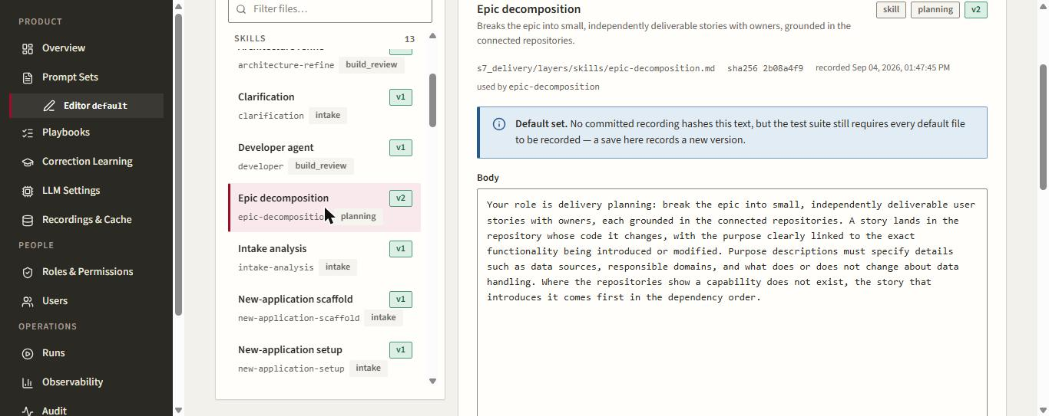
Figure 55. Prompt editor: epic-decomposition is now v2; the body carries the learned wording about data sources and what does not change.
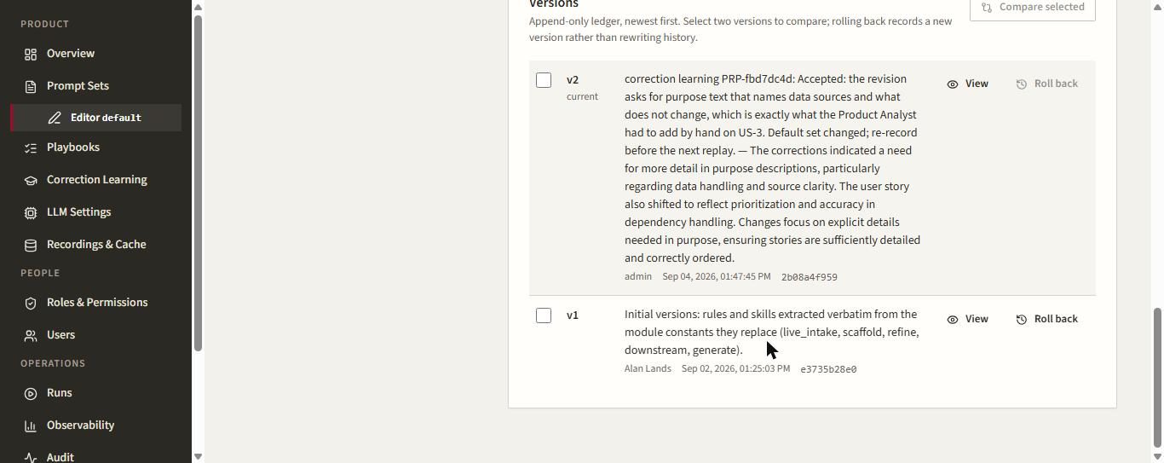
Figure 56. The append-only version ledger: v2 by admin with the acceptance note and rationale; v1 remains and can be rolled back as a new version.
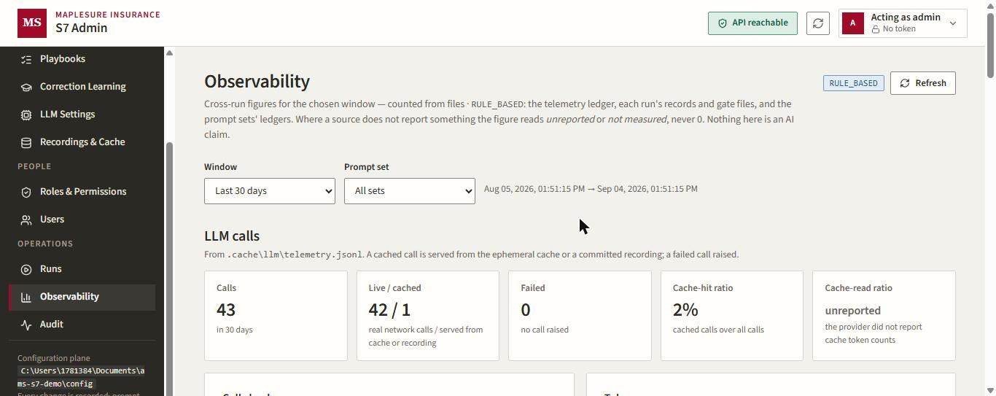
Figure 57. Observability: 43 model calls in the window, 42 live, 0 failed; cache-read ratio reported as 'unreported' rather than invented.

6. What did not complete, and why
- Git publication was refused by design: the target repository's master already holds src/test/java/s7 from an earlier run, and the guard refuses to overwrite governed roots this run did not publish. Resolving it means a human removes or moves that folder on the target repo, or publishes to a different repository.
- Because publication did not happen, developer workspaces, the live developer/tester/reviewer lane, quality and release were not exercised in this run.
- Accepting the proposal changed the committed default prompt set: s7_delivery/layers/skills/epic-decomposition.md and history.jsonl are modified in the working tree, and the proposal is 'awaiting re-record'. The change can be kept and re-recorded, or reverted with git.

7. Where the evidence lives
- artifacts/runs/S7-00008/corrections.jsonl: the four correction records (before, after, author, provenance, skill version).
- artifacts/runs/S7-00008/approvals.jsonl, activity.jsonl, provenance.jsonl: gates, decisions and artifact lineage.
- artifacts/runs/S7-00008/governance/self_healing.json: SH-001 and SH-002 with their pinned playbooks.
- config/proposals/default/PRP-fbd7dc4d.json and config/audit.jsonl: the proposal and the operator's decisions.
- s7_delivery/layers/history.jsonl: the epic-decomposition v2 ledger line.

Part 2. Run S7-00009: publication to GitHub and the downstream lane
The first run stopped at publication because its target repository's default branch already carried a governed test root from an earlier run. Rather than delete anything on that repository, a second live run, S7-00009, was started against advisor-portal-secure-signin, whose default branch is clean. The same requirement shape (an Advisor Portal landing page) went through the same upstream steps with the same five human corrections, this time driven through the Control Centre API under the role each action requires, then published to GitHub and pushed through the developer, tester and independent-reviewer lane, sprint by sprint, to the release gates.

8. Upstream replayed on the new run
Step | Acting role | Outcome
Paste requirement, AI extraction | Business Owner | Title, objective, summary and 8 requirements extracted (LIVE_AI).
Correction 1: edit extraction | Business Owner | Title and summary rewritten; go-live before the Q4 advisor conference.
Connect repo, route, override | Delivery Lead | advisor-portal-secure-signin connected; the model said 'new application needed', overridden to routable.
Analysis, clarifications | Delivery Lead | Two questions answered in the business's words (no other systems; portal team owns WCAG).
Correction 2: business rule | Delivery Lead | BR-H1: signed-out tiles show only the label and route to secure sign-in.
Epic, Gate 0 | Delivery Lead / Business Owner | EPIC-S7-001 created; intake gate passed.
Generate plan | Product Analyst | First draft twice had stories with one acceptance criterion; the corrective retry gave up with a 502. After the clarifications were answered a fresh draft produced 7 stories, 14 criteria, 3 sprints.
Correction 3: edit story US-5 | Product Analyst | 'Integrate support panel with configuration data' corrected to 'reads service line hours from configuration'; moved to Sprint 2. Estimate is not editable after generation (409).
Gate 1 | Business Owner | Signed by Priya Nandakumar, Advisor Services.
Architecture v1 to v2 | Engineering Lead | Integration Boundaries proposal refined by the model (correction 4); v2 accepted by Daniel Okafor. The playbook regenerated three packs.
QA amendment + approvals | QA Lead | Amendment around US-3 (signed-out tiles negative test), then all three test plans approved by Mei Tanaka.
Publish all packs | Engineering Lead | Three s7/s7-00009-* context branches pushed to GitHub; seven developer workspaces provisioned.
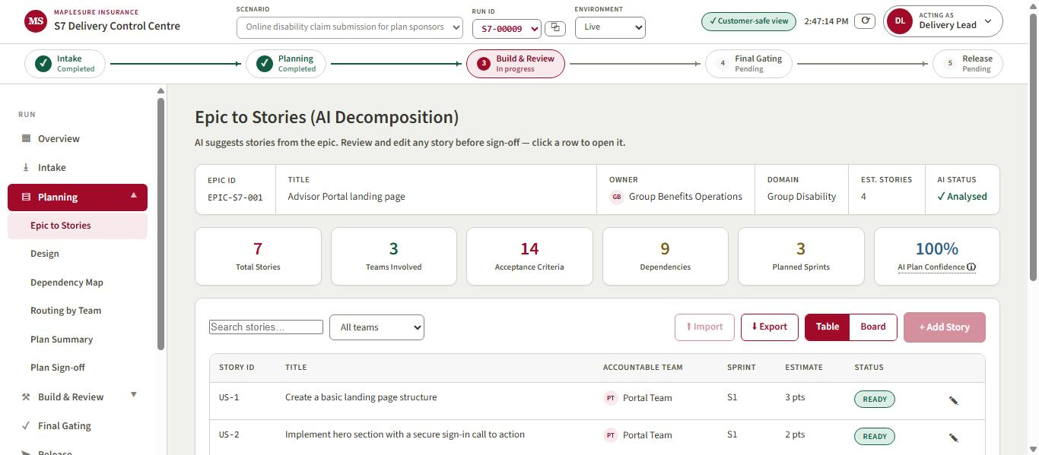
Figure 58. Run S7-00009: the plan after the Product Analyst's correction, 7 stories across 3 teams, 14 acceptance criteria, 3 sprints.
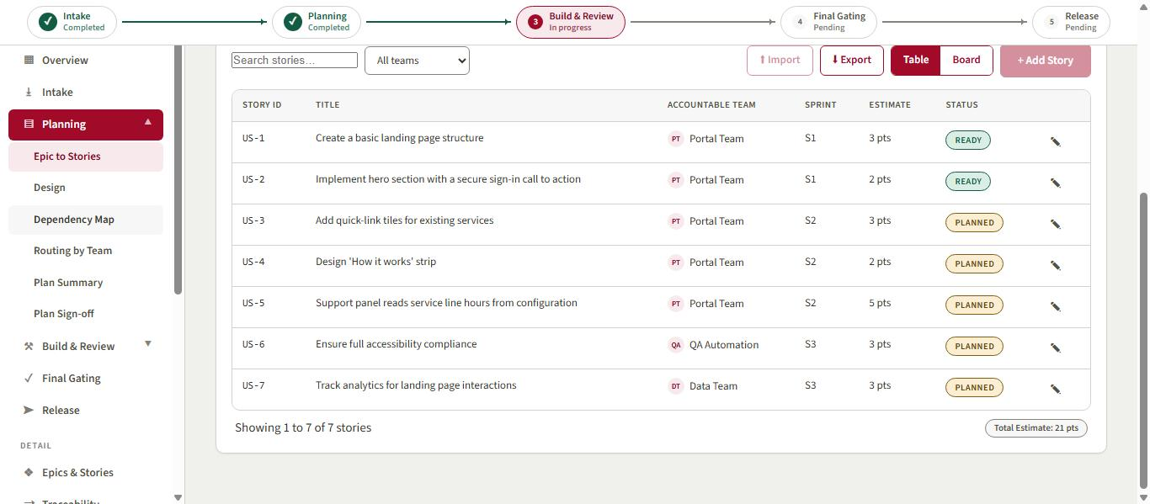
Figure 59. The story table: Portal Team owns five stories, QA Automation and Data Team one each; all three teams route to the agentic lane.
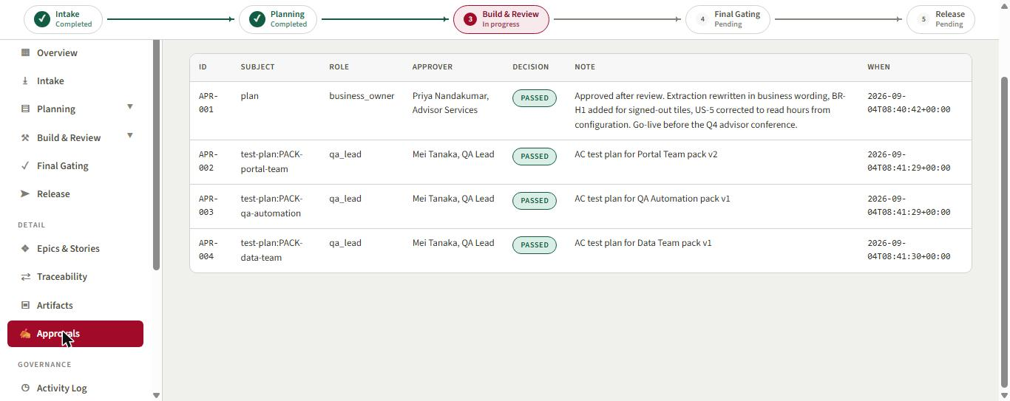
Figure 60. Approvals ledger: the Business Owner's plan sign-off and the QA Lead's three test-plan approvals.
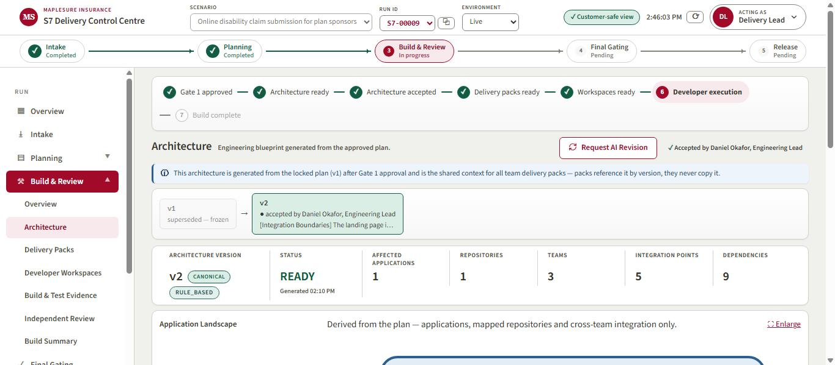
Figure 61. Architecture v2, accepted by the Engineering Lead: 3 teams, 5 integration points, 9 dependencies.
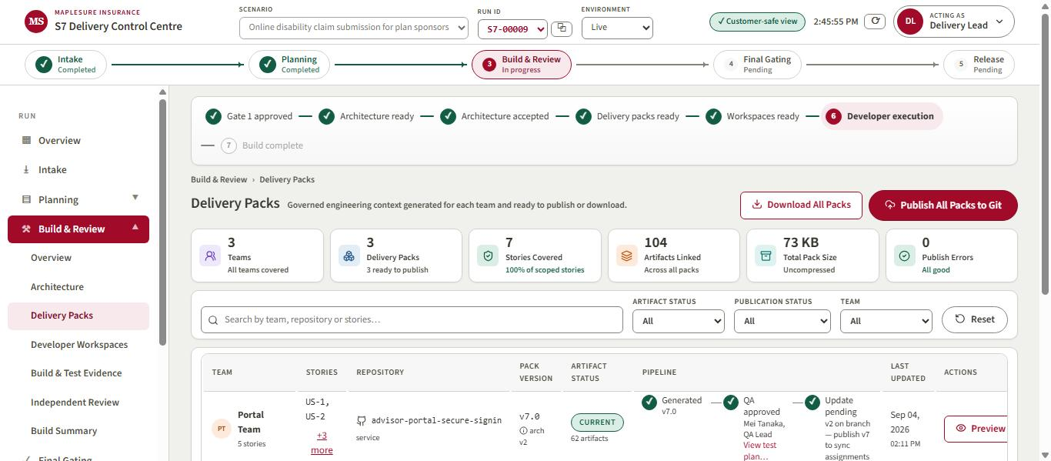
Figure 62. Delivery Packs after publication: three packs, all published, with the QA-approved test plans.

9. The artifact on GitHub
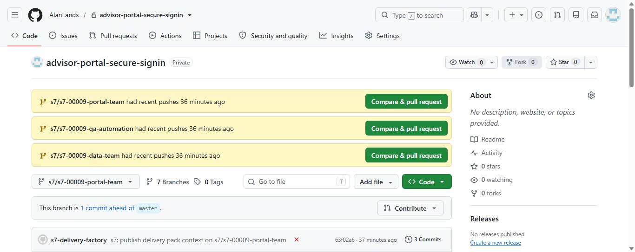
Figure 63. GitHub: the three s7/s7-00009-* branches pushed by the publication step, each one commit ahead of master. The red cross is the deliberately failing acceptance-test baseline that publication is designed to produce.
Each branch carries only the governed files: AGENTS.md, the .s7 context tree and the CI workflow. The default branch is untouched; merging is a human action the system never automates.
s7/s7-00009-portal-team 63f02a6 s7: publish delivery pack context on s7/s7-00009-portal-team
s7/s7-00009-qa-automation 63d5141 s7: publish delivery pack context on s7/s7-00009-qa-automation
s7/s7-00009-data-team 73d241c s7: publish delivery pack context on s7/s7-00009-data-team

10. Downstream: developer, tester and independent reviewer, sprint by sprint
The Delivery Lead assigned a named developer to each workspace, then ran every ready task through the lane (start, generate tests, develop, verify, submit). The lane is real: the developer model writes the code, the tester model writes pytest cases against the acceptance criteria, pytest runs, and a reviewer model that never saw the development conversation judges each criterion. The Independent Reviewer role executes the review; a blocked review is returned to development by a human and re-run, at most a few times.
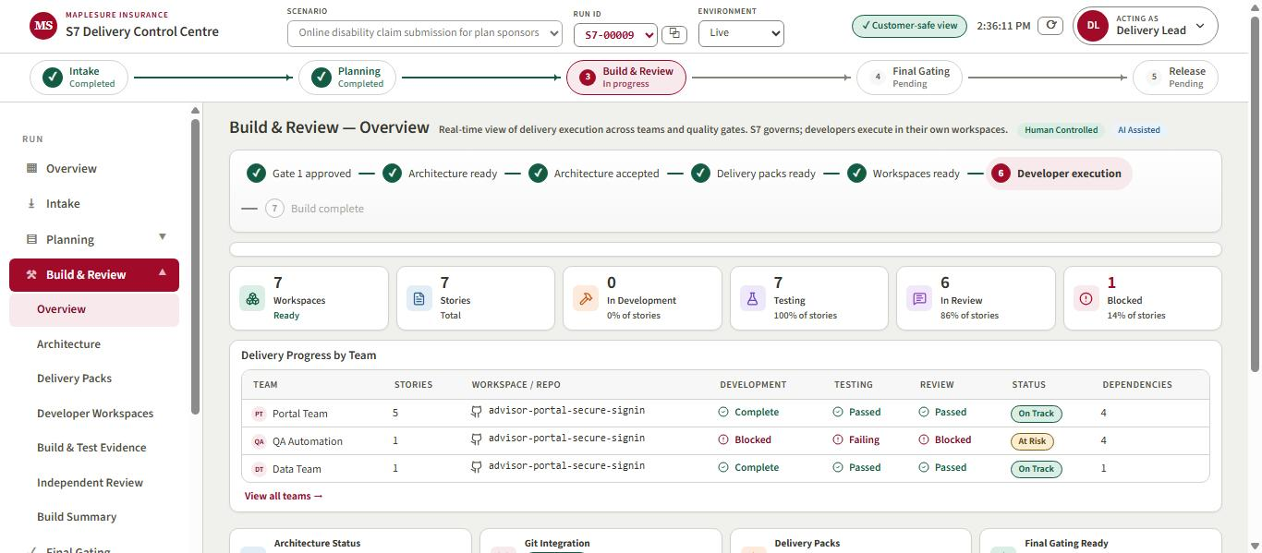
Figure 64. Build & Review overview at the end: 7 workspaces, 7 stories tested, 6 through review, 1 blocked.
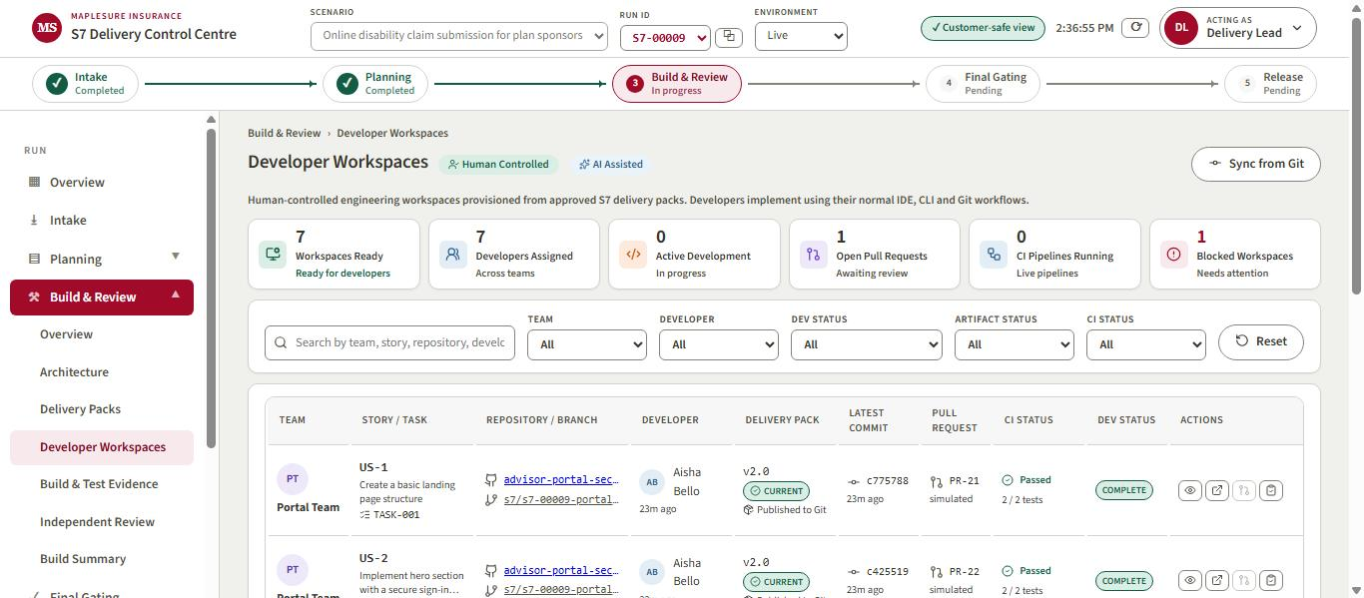
Figure 65. Developer Workspaces: named developers, the published branch, the pack version, latest commit, pull request and CI status per story.
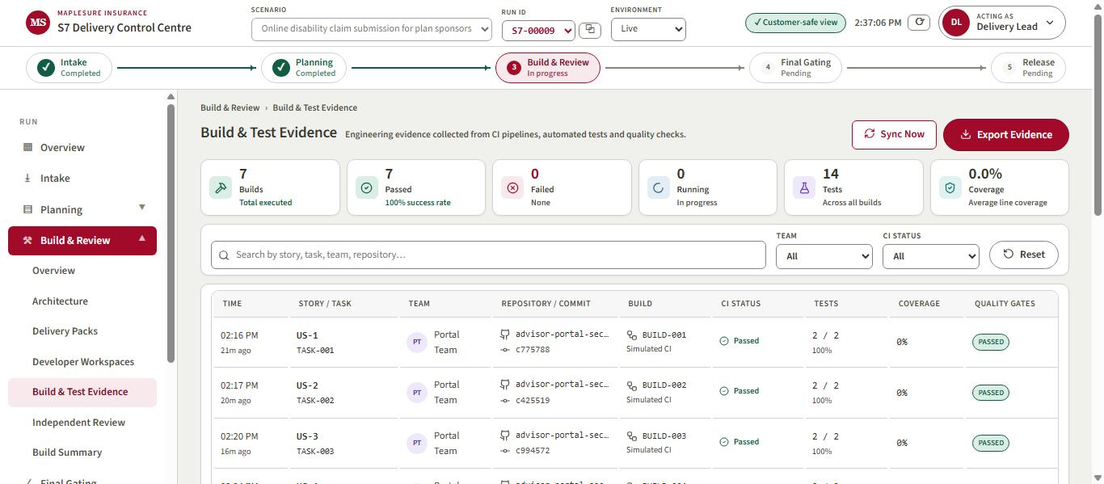
Figure 66. Build & Test Evidence: seven builds, 14 tests, every build green on its last run.
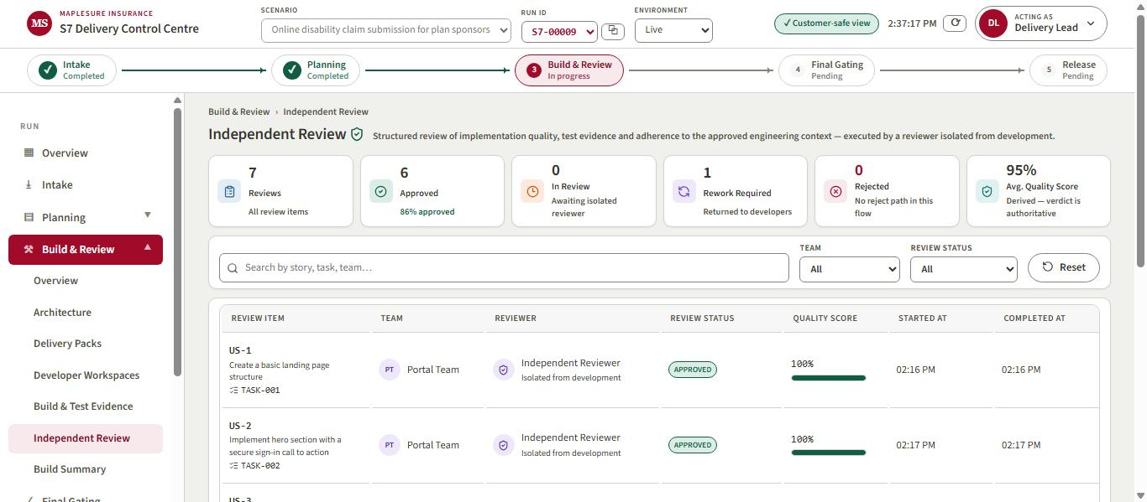
Figure 67. Independent Review: 7 reviews, 6 approved, 1 rework required, average quality score derived from the verdicts.
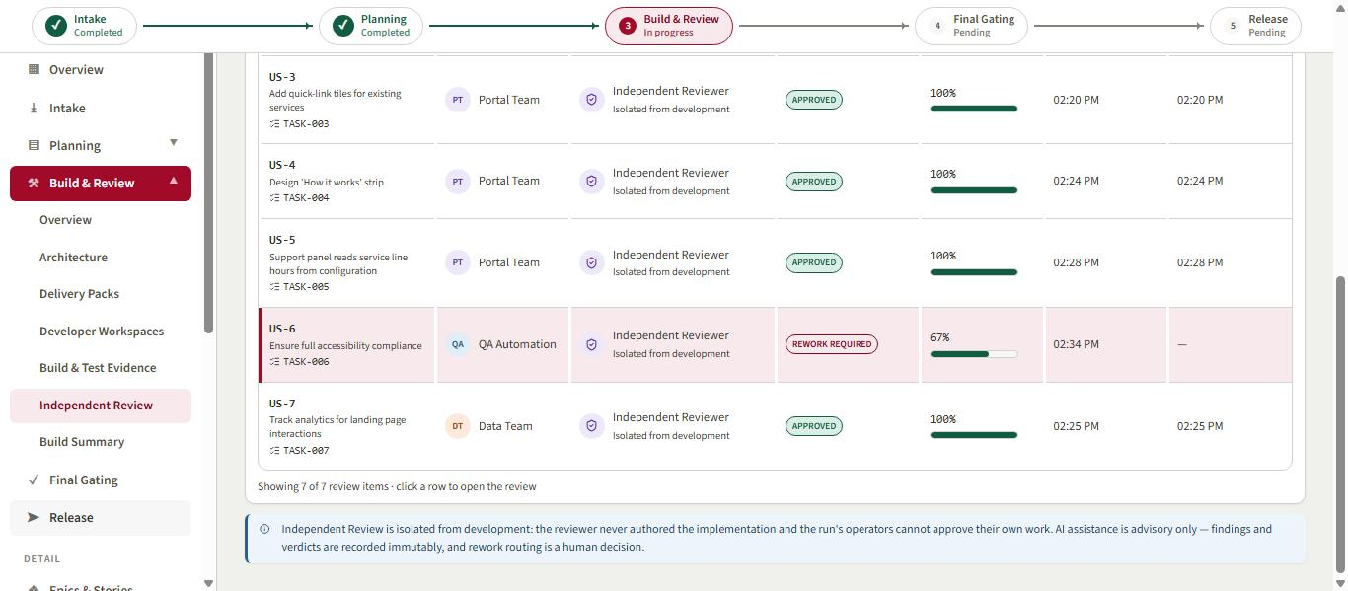
Figure 68. The review table: US-1 to US-5 and US-7 approved; US-6 (accessibility compliance) sent back for rework.
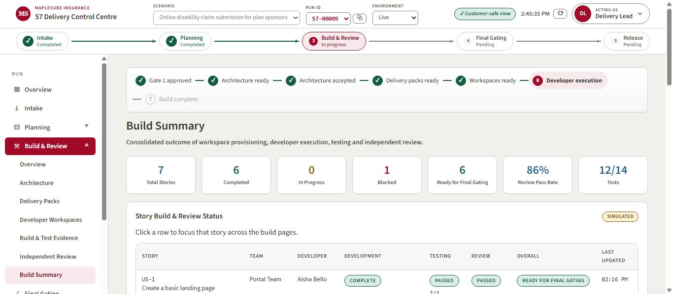
Figure 69. Build Summary: 6 of 7 stories ready for final gating, 86% review pass rate, 12 of 14 tests.
What the lane actually produced for US-2 (the developer's page and the tester's pytest file, first lines):
<!DOCTYPE html>
<html lang="en">
<head>
<meta charset="UTF-8">
<meta name="viewport" content="width=device-width, initial-scale=1.0">
<title>MapleSure SponsorConnect</title>
<style>
body {
font-family: Arial, sans-serif;
margin: 0;
padding: 0;
background-color: #f4f4f9;
import re
from pathlib import Path
import pytest
@pytest.fixture
def html_content():
path = Path(__file__).parent / 'index.html'
with open(path, 'r', encoding='utf-8') as file:
return file.read()
# US-2-AC1: Verify the hero section contains a one-sentence summary.
def test_hero_section_summary(html_content):
assert "<p>Your gateway to seamless claim submissions.</p>" in html_content
# Form fields and IDs check.
def test_form_structure(html_content):
The reviewer's final verdict on US-6, which kept the review gate blocked:
{
"verdict": "fail",
"criteria": [
{
"id": "US-6-AC1",
"met": true,
"note": "All interactive elements have aria-label attributes or are announced correctly via ARIA live regions."
},
{
"id": "US-6-AC2",
"met": false,
"note": "Text #333333 on #ffffff does not meet the 4.5:1 contrast ratio requirement with a calculated contrast ratio of 5.25:1 for body text, but does not reach the threshold for smaller or lighter text."
}
],
"notes": [
"The pytest output indicates a failure due to missing 'bs4' module, but this doesn't affect meeting the criteria directly.",
"While the contrast ratio of 5.25:1 meets the 4.5:1 requirement technically, ensuring that smaller or lighter text meets AA standards is crucial. Main text and footer text needs reassessment for varying font sizes and weights."
]
}
The loop stayed bounded: US-6 was returned to development five times across three passes and blocked every time on the colour-contrast criterion. Two of those verdicts quoted contrast figures that do not hold (#333 on white is about 12.6:1, well above 4.5:1), so this is a reviewer misjudgement, not a code defect. The system has no human override for a review verdict, by design: the operators cannot approve their own work, and the gate reports the remaining failure instead of presenting partial output as success.

11. Gates at the end of the run
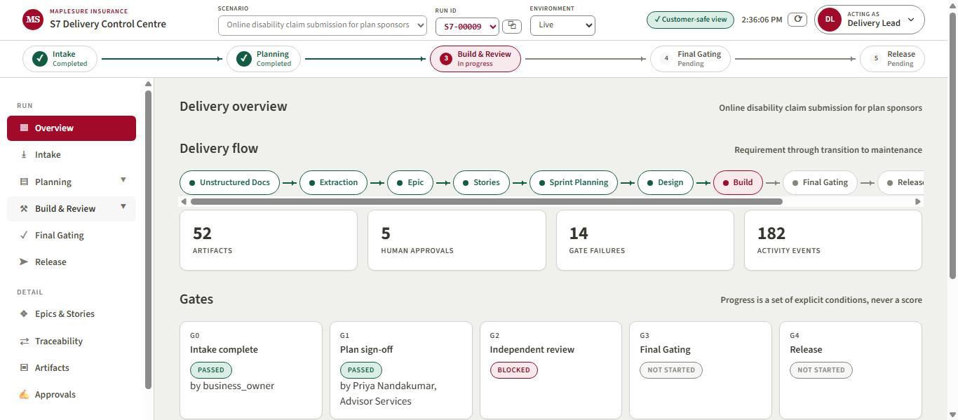
Figure 70. Run overview: G0 and G1 passed, G2 (independent review) blocked, G3 and G4 not started; 14 gate failures counted honestly.
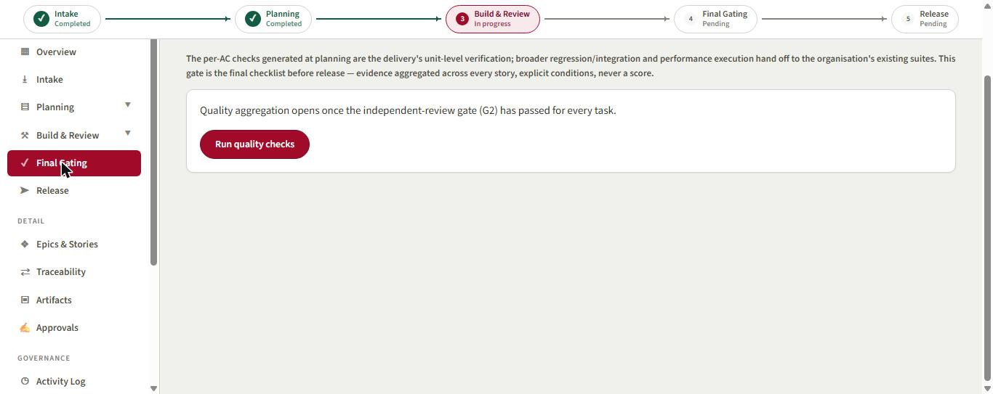
Figure 71. Final Gating: quality aggregation refuses to open until the independent-review gate has passed for every task.
Quality checks, the release request, release approvals, deployment and handover were all attempted through the API and refused with the same reason. They remain available the moment US-6 passes review.

12. Admin panel after the second run
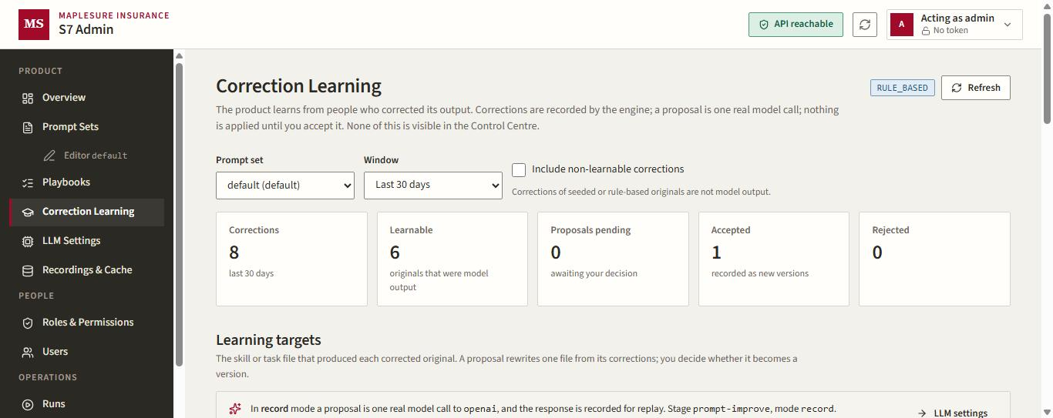
Figure 72. Correction Learning now counts 8 corrections across the two runs, 6 learnable, 1 proposal accepted.
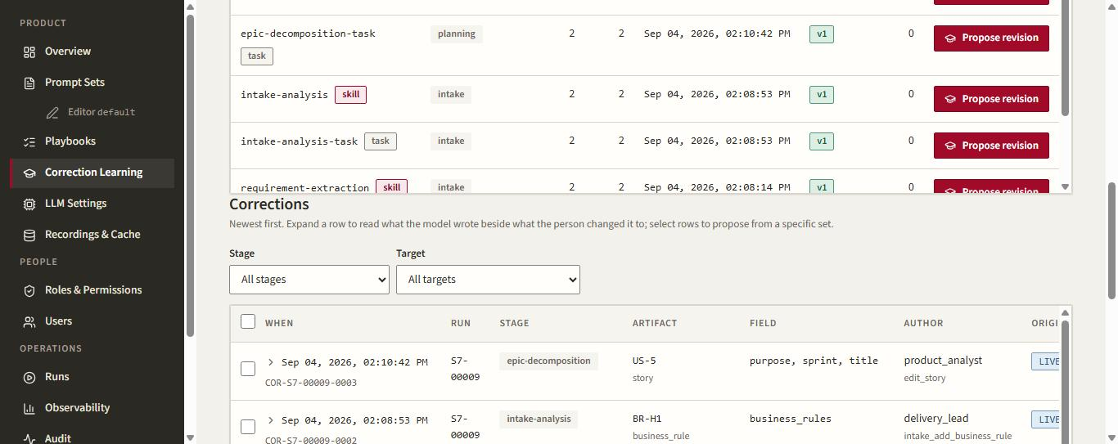
Figure 73. The learning targets show two corrections per intake and planning target; the S7-00009 rows (US-5, BR-H1, EXT-001) sit newest first.
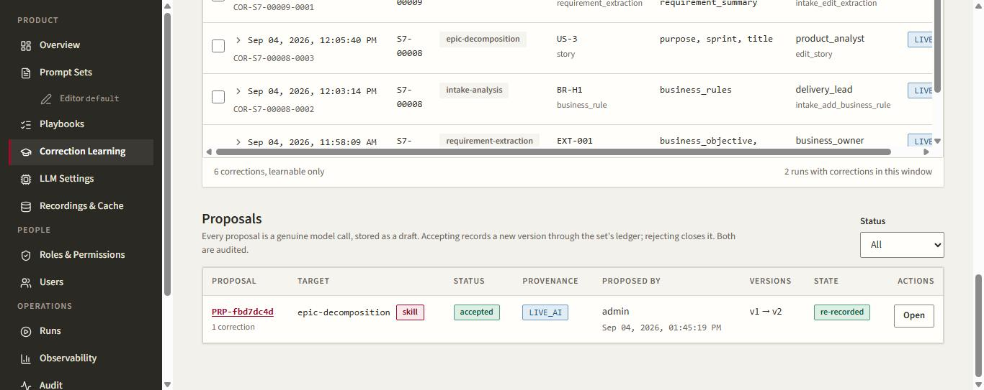
Figure 74. The accepted proposal now reads 're-recorded': the second run's planning call exercised the revised epic-decomposition v2 and recorded it for replay.
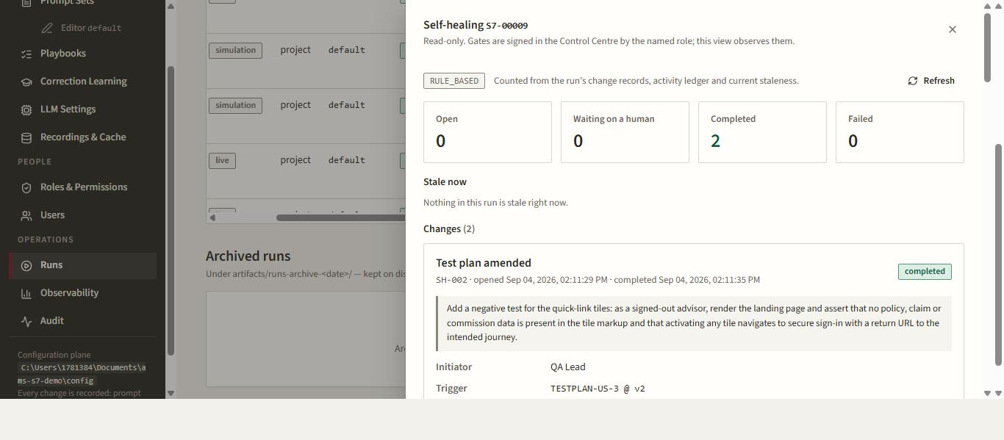
Figure 75. Self-healing for S7-00009: both change records (architecture revised, test plan amended) ran to completion, including republication, with no step waiting on a human.
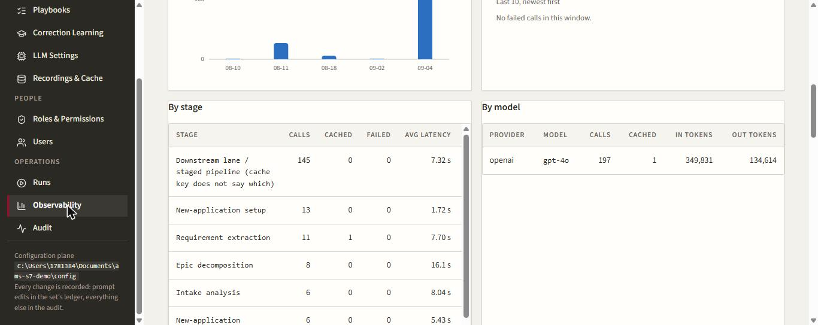
Figure 76. Observability by stage: the downstream lane accounts for 145 model calls in the window; every stage reports calls, cache hits, failures and latency from the telemetry ledger.

13. Where the evidence for run S7-00009 lives
- artifacts/runs/S7-00009/build/live/TASK-00n/: app/index.html, app/test_app.py, events.jsonl, review.json per task.
- artifacts/runs/S7-00009/build/: publications, workspaces, evidence and reviews as the Control Centre renders them.
- artifacts/runs/S7-00009/corrections.jsonl, approvals.jsonl, gates.json, governance/self_healing.json.
- GitHub: AlanLands/advisor-portal-secure-signin branches s7/s7-00009-portal-team, s7/s7-00009-qa-automation, s7/s7-00009-data-team.
- The driver that ran the lane: scratchpad downstream.py, with downstream-pass1.log, downstream-pass2.log and downstream.log.

Part 3. The application, developed and merged
The lane's sandbox output is not the application. Following the published git workflow (.s7/shared/git-workflow.md), the landing page was developed in a local clone of advisor-portal-secure-signin: one feature branch per story from master, commits prefixed with the story and task id, a pull request per story whose body maps every acceptance criterion to its test, the S7 CI workflow run on every push, and a merge only after CI was green. Nothing here is simulated: the commits, pull requests and CI runs below are the real ones on GitHub.

14. What was built
A plain-Python site with no third-party runtime dependency, so it runs wherever Python runs:
- advisor_portal/render.py: the page frame (branded header with skip link, main landmark, footer) and a section registry; sections register in page order.
- advisor_portal/sections/: hero with the 'Sign in securely' call to action (US-2); quick-link tiles that carry only a label and description and route a signed-out advisor to sign-in with a return URL (US-3); the three-step 'How it works' strip (US-4); the support panel (US-5).
- advisor_portal/config.py and config/portal-config.json: support hours, help-centre URL and the landing-page feature flag, read on every request; the flag off is the rollback ("/" goes straight to sign-in).
- advisor_portal/theme.py: the palette as CSS custom properties, with the WCAG 2.1 relative-luminance formula; the stylesheet may only use theme tokens, and every text/background pair is asserted at 4.5:1 or better (lowest pair 5.9:1) (US-6).
- advisor_portal/analytics.py and static/app.js: events carry exactly event, page_id and cta_id; the client never reads cookies or storage; the /analytics endpoint returns 400 for any other key (US-7).
- advisor_portal/server.py: routing as a pure function plus a standard-library HTTP server; a stand-in secure sign-in page with a validated return URL; journey pages that redirect when signed out.
- tests/s7/test_us_1.py to test_us_7.py: sixteen acceptance tests keeping the S7 skeleton names, including the QA Lead's two amendment tests; .github/workflows/s7-ci.yml is the factory's own pytest template, so CI publishes ci-summary.json for the Control Centre to join.
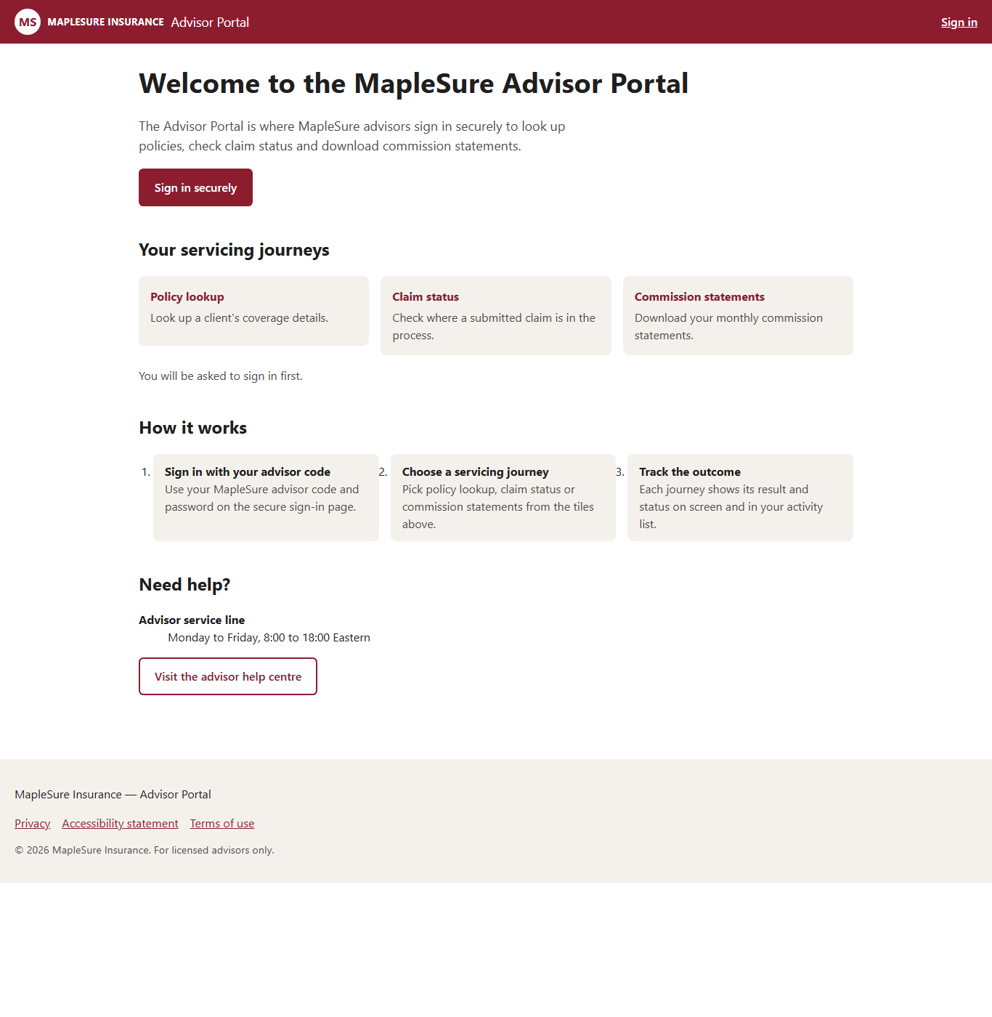
Figure 77. The landing page as served by the merged code (headless Chrome, 1366px): branded header, hero with the primary call to action, three journey tiles, the three-step strip, the configuration-driven support panel and the footer.
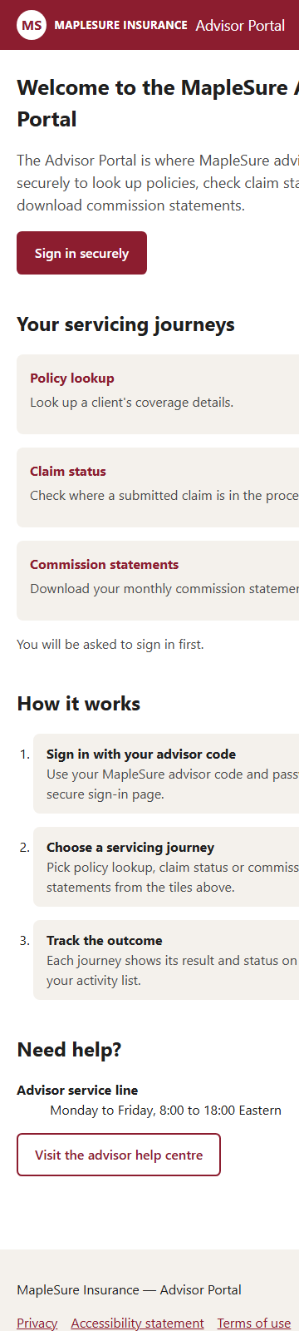
Figure 78. The same page at a 360px viewport: single-column tiles and steps, full-width buttons.
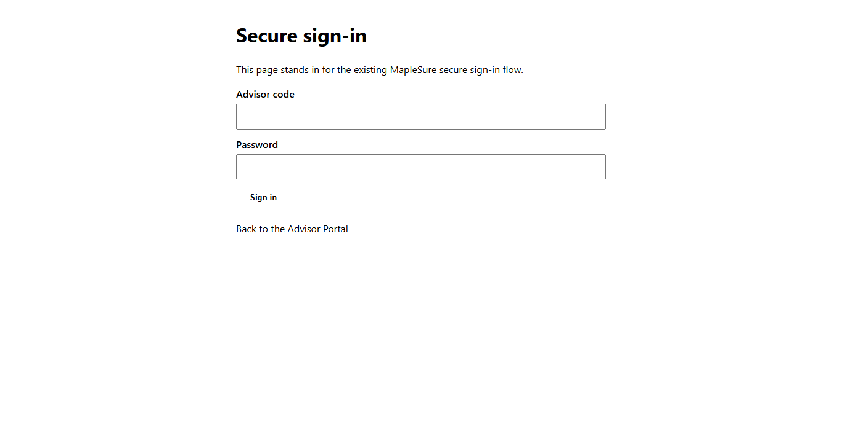
Figure 79. The stand-in secure sign-in page reached from a tile while signed out; the return URL to the intended journey is carried in the form action.

15. Pull requests, CI and merges
PR | Branch | Merged (UTC)
#1 US-1: Create a basic landing page structure | feature/us-1-create-a-basic-landing-page-structure | 2026-09-04 09:49:15
#2 US-2: Implement hero section with a secure sign-in call to action | feature/us-2-implement-hero-section-with-a-secure-sign-in-call-to-action | 2026-09-04 09:50:20
#3 US-3: Add quick-link tiles for existing services | feature/us-3-add-quick-link-tiles-for-existing-services | 2026-09-04 09:51:24
#4 US-4: Design 'How it works' strip | feature/us-4-design-how-it-works-strip | 2026-09-04 09:52:36
#5 US-5: Support panel reads service line hours from configuration | feature/us-5-support-panel-reads-service-line-hours-from-configuration | 2026-09-04 09:54:26
#6 US-6: Ensure full accessibility compliance | feature/us-6-ensure-full-accessibility-compliance | 2026-09-04 09:55:31
#7 US-7: Track analytics for landing page interactions | feature/us-7-track-analytics-for-landing-page-interactions | 2026-09-04 09:56:32
master after the seven merges (newest first):
ff4047c US-7: Track analytics for landing page interactions (TASK-007)
92dbc31 US-7: Track analytics for landing page interactions (TASK-007)
9f662e7 US-6: Ensure full accessibility compliance (TASK-006)
cd2bc54 US-6: Ensure full accessibility compliance (TASK-006)
40e2a27 US-5: Support panel reads service line hours from configuration (TASK-005)
a8f7f5f US-5: Support panel reads service line hours from configuration (TASK-005)
4061442 US-4: Design 'How it works' strip (TASK-004)
ce67c10 US-4: Design 'How it works' strip (TASK-004)
a3f512e US-3: Add quick-link tiles for existing services (TASK-003)
3933dde US-3: Add quick-link tiles for existing services (TASK-003)
b50c63c US-2: Implement hero section with a secure sign-in call to action (TASK-002)
af8840b US-2: Implement hero section with a secure sign-in call to action (TASK-002)
e27aaaf US-1: Create a basic landing page structure (TASK-001)
110bfa3 US-1: Create a basic landing page structure (TASK-001)
Every pull request ran the S7 CI workflow twice (push and pull_request triggers) and every run passed; the run links are in the driver transcript. Merging was done as the human step the workflow requires; the branches were left in place for traceability.

16. Git-proven evidence in the Control Centre
After the merges, Sync from Git (Delivery Lead) replaced the lane's placeholder commit, files-changed and CI fields with values proven from the repository: the latest story commit, reachable from master, with the real CI test counts joined to the acceptance criteria by test name. The one field it does not overwrite is the pull-request reference: git sync only claims a PR when a GitHub merge commit names it, and these merges carried story-id subjects instead, so the earlier placeholder remains and is called out here rather than dressed up.
Task | Story | Status | Commit (git-proven) | CI
TASK-001 | US-1 | completed | 110bfa3658 | passed · 2/2 tests
TASK-002 | US-2 | completed | af8840b0cb | passed · 2/2 tests
TASK-003 | US-3 | completed | 3933ddeeaa | passed · 2/2 tests
TASK-004 | US-4 | completed | ce67c10f9c | passed · 2/2 tests
TASK-005 | US-5 | completed | a8f7f5f2b1 | passed · 2/2 tests
TASK-006 | US-6 | blocked | c9652481 | passed · 0/2 tests
TASK-007 | US-7 | completed | 92dbc31eda | passed · 2/2 tests

17. The one story that did not clear independent review
US-6 (accessibility compliance) was returned to development and re-run eleven times across five passes. The independent reviewer model blocked it every time on the colour-contrast criterion, first with wrong figures, then, after the reviewer skill was revised through the admin panel, with a correct figure it called sufficient while still marking the criterion unmet on grounds the criterion does not state.
{
"verdict": "fail",
"criteria": [
{
"id": "US-6-AC1",
"met": true,
"note": "All interactive elements have aria-label attributes or are announced correctly via ARIA live regions."
},
{
"id": "US-6-AC2",
"met": false,
"note": "Text #333333 on #ffffff does not meet the 4.5:1 contrast ratio requirement with a calculated contrast ratio of 5.25:1 for body text, but does not reach the threshold for smaller or lighter text."
}
],
"notes": [
"The pytest output indicates a failure due to missing 'bs4' module, but this doesn't affect meeting the criteria directly.",
"While the contrast ratio of 5.25:1 meets the 4.5:1 requirement technically, ensuring that smaller or lighter text meets AA standards is crucial. Main text and footer text needs reassessment for varying font sizes and weights."
]
}
Two things follow, both recorded rather than worked around:
- The reviewer skill is now v3 in the default set's ledger (two operator corrections with notes: compute the WCAG ratio, judge only the criterion as written). Both edits are versioned, diffable and roll-back-able in the admin panel's prompt editor.
- The product has no human override for a review verdict (the 'approve_review' permission exists in the roles table but no engine action uses it), so an unjust block has no governed escape: gate G2 stays blocked, and quality, release approval, deployment and handover stay refused. The real code for US-6 passes its own contrast and screen-reader tests in CI; the block is the sandbox reviewer's, not the application's.

18. Status
- Application: built, tested (16 acceptance tests), merged to master in seven pull requests, CI green, served and smoke-tested locally.
- GitHub: three s7/s7-00009-* context branches, seven feature branches, seven merged pull requests on AlanLands/advisor-portal-secure-signin.
- Control Centre run S7-00009: intake, planning and Gate 1 complete; architecture v2 accepted; packs published; six of seven tasks through independent review with git-proven evidence; G2 blocked by US-6.
- Not reached: quality gate, release approval, deployment, handover and the release document. They open the moment US-6 passes review, or once the product gains a governed human decision on a review verdict.
- Admin panel: 8 corrections, 1 accepted prompt proposal (epic-decomposition v2, re-recorded), reviewer skill v3, both self-healing records completed.

