If any part is not clearly visible, indicate Not (clearly) visible
For shape concepts, add very or slightly based on your judgement.
When two or more colors are correct (reddish brown / orange), just combined them: reddish-brown and orange, yellowish brown, olive green, blue-ish gray.
- Body shape: {small/medium/large} and {compact/stocky/plump/robust}
Judge the body size based on surrounding objects, perching birds (sparrow/woodpecker) are typically Small, water birds (gull) are usually Large
Indicate if the overall outline of the body, typically Compact (thin) or Plumb (slightly fat), or Stocky (very fat)
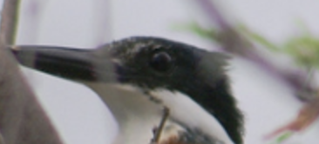
This one is slightly crested (even a small crest)
- Crest shape: {prominent/subtle} and {upright/swept-back}.
Describe the crest as Prominent or Subtle, then its overall structure.
Prominent is typically followed by Upright or Swept-back. Subtle is typically followed by Fluffy. Streaky goes with Prominent if the streaks are long, and Subtle if the streaks are short.
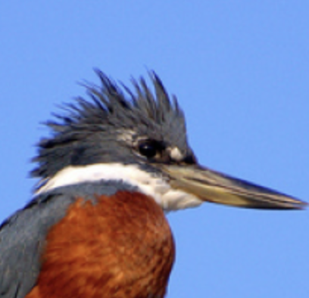 shaggy
- Beak shape: {short/medium/long/pointed}, {thick/slender/flat}, and {straight/curved/conical} {with dip netting}
Short – very short, tiny compared to the head width (left picture), typically followed by Flat and Straight.
Medium – similar length compared to the width of the head (right picture).
Long – extending beyond the width of the head.
Slender is for thin but not Flat beak, usually follows Medium or Long.
Straight – not curved at all. Hooked – extremely curved like a hook.
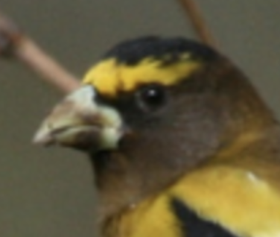 This is conical
- Neck shape: {long/short} and {blending into body/straight/contoured}
Short is typically followed by blending into body.
- Wing shape: {long/short} and {broad/narrow}
Judge the wing shape relative to the body:
Long – extended to or beyond the tail, or Short – appearing much shorter to where the tail starts
Broad – covering a lot of the back and belly, or Narrow – not covering much of the body
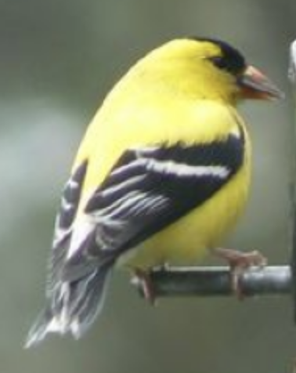
- Tail shape: {short/long} and {rounded/squared/forked/wedged-shape/graduated}
Short – very short and close to the body and should be followed by narrow, Long – extended from the belly. Typically followed by Rounded.
Rounded – appearing like a fan, but gradually shorter towards the edge,
Squared – appearing like a fan, but even length
Forked – divided into 2 equal parts.
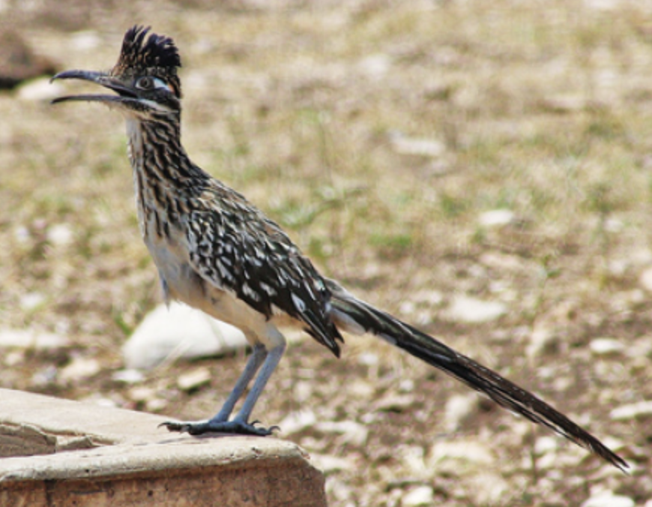 graduated
- Flight feather shape: {coarse/fine} and {overlapping/smooth/fluffy}
Flight feathers are on wings and tail.
Coarse – individual feathers can be seen clearly, should be followed by Overlapping
Fine – thin and dense feathers, no clear separation, should be followed by Smooth.
- Feet type: {clawed/webbed}
For all color concepts, if the main color appears to be changing depending on the viewing angle, add iridescent before color. For example, “iridescent green” belly for the bird in the picture.

Add dark or pale shade of colors based on your judgement.
- Crown color and marking: {<color(s)>} {with <color(s)> stripes/spots/tip or Leave Empty}
Crown color also includes the crest color.
- Beak color: {<color>} {with <color> tip} or {<color> upper and <color> lower}
- Eye color and marking: {<color(s)>} with {<color> eye line/eye ring}
Typically black but indicate other colors if clearly recognized.
Only indicate the eye ring and eye line color if clearly visible. Eye line typically appears across the eyes. Eyebrow stripe typically appears above the eyes.
- Face color and marking:
- If no markings: <color(s)>
- If there are distinct markings: {<color> (mask)} with {<color> cheek} (and) {with <color> whisker mark or Leave Empty}
Mask is the marking that go over a bird’s face, covering the face and eye (like wearing a mask).
Only describe the cheek if it is a different color. Whisker mark appears as stripe(s) on the cheek.
- Throat color and marking: {<color> <throat/chest> patch/bar} or None
- Upper/Lower belly color and marking: {<color>}
Belly is below the chest patch (if visible) towards the start of the tail.
- Wing color and marking: <color(s)> {with <color{s}> stripes/spots/patches/bars or Leave Empty}
First indicate the main color of the wing feathers, including feathers on the back. Next describe the patterns such as stripes, spots, wing bars and wing patches here. Stripes and Spots should be multiple and relatively uniform.
Wing patches are relatively large solid-colored patches.
Wing bars only appears as on the edges of the wing feather layers.
Be as detailed as possible, if multiple patterns appear list them in the order stripes/spots, then patches, and then bars.
- Tail color and marking: <color(s)> {with <color{s}> stripes/spots/patches/tips or Leave Empty}
Follow the same instructions for wing color, substitute bars for tips.
- Feet color: {<color(s)>}

