Scoring
Binary concepts for all attributes not related to markings.
Attributes with markings (see the last rule)
- Concepts are relative; which means, if they are reasonably correct (e.g., olive brown vs gray, orange vs reddish)
  - White bars vs white patches can used interchangeably.
  - White spots and white bars are very different, marked incorrect.
- In general, if not visible clearly, reasonable assumptions can be marked correct.
- Upside tail/wings colors and markings:
  - Sometimes, the model gives specific concepts even though the parts are not clearly visible (e.g., just see the downside of wings/tails), still mark them as correct if the concepts are reasonably inferred.
- Birds living near water can have “webbed feet” (expectedly) even though the feet are not clearly visible.

- {part} color and markings:
  - Marking is optional (not distinguishable for a specific bird/image)
    - Color only is fine Give 0/1 for incorrect/correct
  - Marking is required (e.g., this reference Northern Flicker has a unique marking for “crown color and marking”: gray crown with red nape)
    - Color correct 0.7
    - Marking correct 0.3
    - Both correct 1
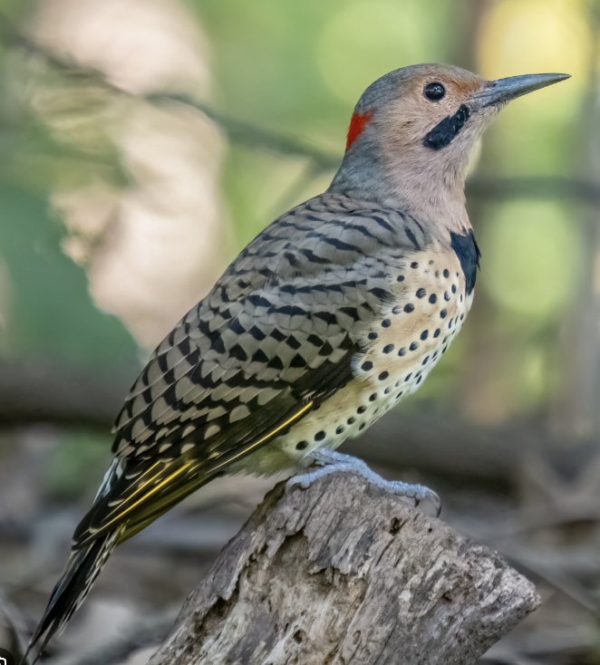

Easy-to-make-Mistake Concept definitions:
- Tail shape:
  - Forked: the tail is distinctly divided into two clear branches.
  - Notched: the tail tip is slightly divided, forming a shallow split between the two sides.
  - Graduated: the tail feathers end at different lengths, creating an uneven or layered outline.
- Wings shape:
  - Length: the wings may be described as short or long relative to the bird’s body length; it also depends on how long it covers the body.
  - Width: the wings may be described as broad or narrow depending on their thickness and how far they extend along the sides of the body.
- Flight feathers:
  - Fine and smooth: the flight feathers appear neatly arranged, slender, and streamlined.
  - Coarse and overlapping: the flight feathers appear thicker, less uniform, and may project outward in different directions.

