# Age grading running races

### Alan Jones, [alan@runscore.com](mailto:alan@runscore.com)

**(Updated 2020-04-13)**

**All Masters standards/factors are as approved by the** [**World Masters Athletics**](http://www.world-masters-athletics.org/) **(WMA) Vice President - Non Stadia, WMA President, and** [**USA Track and Field**](http://usatf.org/) **Masters Long Distance Running Committee.**

### Obtaining the 2015 tables

The tables for male and female runners are provided in Excel spread sheets. They contain age-standards in seconds, age-standards in H:MM:SS, age-factors, and performance factors.

For road races: [Male Road](https://github.com/AlanLyttonJones/Age-Grade-Tables/blob/master/MaleRoadStd2015.xlsx) , [Female Road](https://github.com/AlanLyttonJones/Age-Grade-Tables/blob/master/FemaleRoadStd2015.xlsx)

In September, working with

See below for the analysis that led to these adjustments to the road tables.

Running Age-Grade Tables by [Alan Jones](http://www.runscore.com/Alan/AgeGrade.html) is licensed under a [Creative Commons Attribution 4.0 International License](http://creativecommons.org/licenses/by/4.0/).

### Obtaining the 2010 tables

The tables for male and female runners are provided in Excel spread sheets. They contain age-standards in seconds, age-standards in H:MM:SS, age-factors, and performance factors.

For road races: [Male Road](https://github.com/AlanLyttonJones/Age-Grade-Tables/blob/master/MaleRoadStd2010.xls) , [Female Road](https://github.com/AlanLyttonJones/Age-Grade-Tables/blob/master/FemaleRoadStd2010.xls)

and for track races: Male Track, Female Track.

For those that wish to compare the female road tables from 2006 with the new 2010 ones, they can be obtained here: FemaleRoadStdWMA2006.04.10.XLS

## Executive Summary

Rex Harvey, World Masters Athletics (WMA), and I, in 2006, created updated replacements for the running events of 1500 m and longer for track races and 5 km and longer for road races. These tables replaced the 1994 tables.

* The track and road races are handled separately. There are tables for:
  + Track: 1500 m, 1 mile, 2000 m, 3000 m, 2 miles, 4000 m, 3 miles, 5000 m, 6000 m, 8000 m, 5 miles, and 10,000 m
  + Road: 5 km, 6 km, 4 miles, 8 km, 5 miles, 10 km, 12 km, 15 km, 10 miles, 20 km, half-marathon, 25 km, 30 km, marathon, 50 km, 50 miles, 100 km, 150 km, 100 miles, 200 km.
* Ray Fair has developed standards that use the same tables for all distances from 400 m through the marathon. We found that we can use the same factors from 1500 m (we did not work on distances less than 1500 m) through 10,000 m for males and from 1500 m through 10 miles for the females. Above those distances different factors are used for each distance.
* For both male and female runners, we developed factors through the marathon and then used these marathon factors for ultra-distances through 200 km.
* Open class times were developed by plotting pace (minutes/km) on a semi-log plot and creating a smooth curve that passed through the best times.
* The youth age-factors are greatly affected by Chinese and African runners, both male and female. We discarded young runners from Africa and used primarily USATF/RRIC data for American runners.
* There are performances by one Ukrainian female athlete which are so good that they had to be ignored. By ignoring her performances, it can be shown that females slow, with age, at a rate slightly higher than males. However, if her times are included, the reverse would be the case.
* We have received a lot of help from Rex Harvey, Linda Honikman, Ryan Lamppa, Ken Young, Ray Fair, and Norm Green and have built on the earlier work of Chuck Phillips.
* We thank John Scherf for pointing out that we were still using some of the Chinese records after we had thought we had stopped using them.

## 2004/2006 (2002) Tables

* The first tables done by Rex Harvey and myself were called the WMA 2002 tables. However, work on the male tables was completed in 2004 and the female in 2006 so I refer to them as the male 2004 and female 2006 tables.
* These tables include both the in-stadium events and road events.

## 2010 Long Distance Running Tables

* In 2009, information was provided that indicated that the female tables for older runners at the longer distances were too soft. Several runners were obtaining percentage performances of over 100%. The female tables were then adjusted based on recent data provided by Marian and Don Lein. Don is the USATF Masters Long Distance Running Chair. Go to 2010 Adjustments to see the changes.
* The 2010 tables were created in early 2010, and were approved by both WMA and by United States USA Track & Field (USATF). They are available above.
* These tables are called the WMA/USATF 2010 tables.
* The male tables were not changed since their completion in 2004.
* The track tables have not changed since the 2004/2006 tables.

## 2015 Long Distance Running Tables

* When a new world record, 2:02:57 (as yet not ratified), for the men's Marathon was set on September 28, 2014 at the Berlin Marathon by 30-year-old Denis Kimetto of Kenya, it generated a blog by Robert James Reese from Runner's World magazine. He suggested that it may be time to update the age-grade tables. This inspired me to check on how many times had changed in the almost ten years since the men's tables were established and the almost five years since the women's tables were updated.
* Below is an analysis of how the 2015 tables were generated.
* Ken Young was helpful in evaluating the 2015 tables.
* The 2015 tables were approved in January 2015 by both the USATF Masters Long Distance Running committee chaired by Don Lein and by the WMA.

### Evaluate the 2005 male standards

To evaluate the current male standards I used the 2005 tables to produce a "Performance table." A Performance table shows how close each single-age best comes to the Age Standard for the age of the runner. A value of 100% means the time exactly equals the standard. Any figure above 100% indicates that the performance is better than the standard or, in other words, the standard is "soft." Because of outliers, tables often have a few performances over 100% but if there are more than a few, it means the tables are too soft. Here is the table for the male 2005 standards measured against the 2014 single-age bests. I only included the 5 km, 10 km, Half Marathon, and Marathon since those races are most contested and, therefore have the best data.

**Notice how many performances are over 100%. I count 65. If the single-age best as of 2005 had been used, there should not be any. This tells me that new tables are certainly needed.**

### ****Developing 2015 standards for road races****

The earlier tables used single-age bests from the Road Race Information Center, World Masters Athletes, and the Association of Road Racing Statisticians. However, now the only data that we can find are those from the ARRS. Ken Young, who manages the ARRS data, does an excellent job keeping the data up-to-date.

I went to the ARRS web site, [www.arrs.run](http://www.arrs.run), to update the single-age bests and using methods developed in 2004, and described below, I created a plot of records versus age for each distance. The age standards were determined and plotted on the same graph as the record adjusting so that the curve was always below or right on each record. I have also added the world record for each distance. Here are the plots for 5 km, 10 km, half marathon, and marathon. The plots also contain the time standards from 2005 so you can see where changes were made.

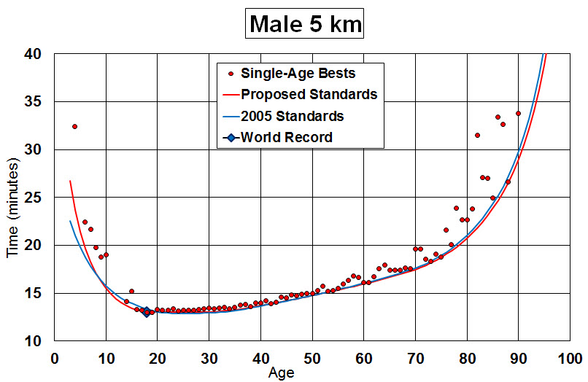

There are very small differences between the 2005 Standards and the Proposed Standards. The very young youth standards have been softened because some earlier times for young runners have not survived scrutiny. On the other hand, upper teen year standards have been toughened because of fast times run by young Africans. This carries through for all distances as you can see below.

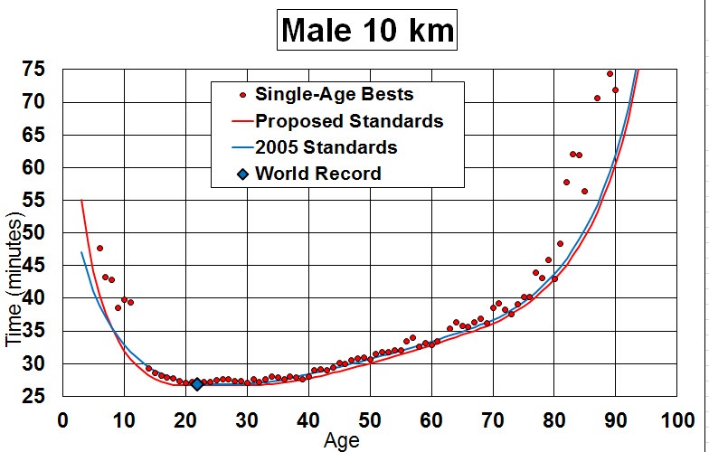

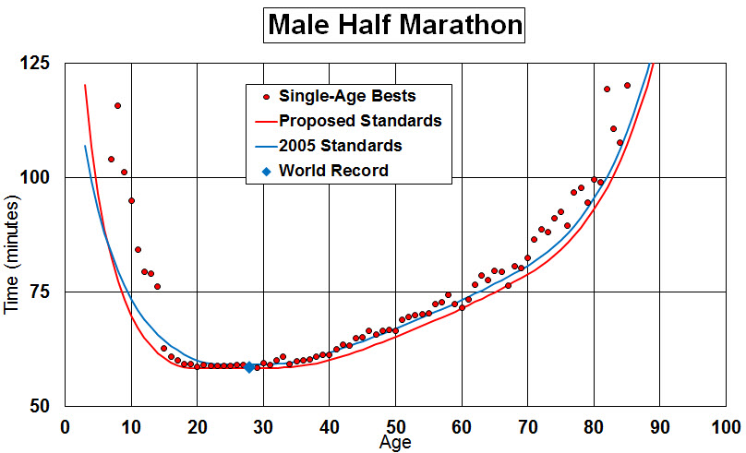

The biggest differences between the proposed standards and the 2005 standards show up in the half marathon.

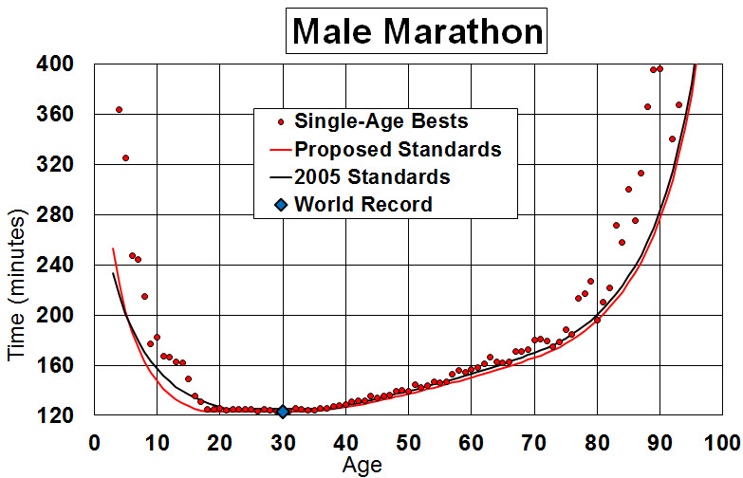

Notice that all times are on or above the Proposed Standards lines.

To get the factors in the intermediate distances, the parameters were interpolated between the values obtained for those four distances. Let me make clear that the age-standards are not interpolated; it is the parameters that generate the standards which are interpolated. See below for definitions of these parameters. To make sure there is a smooth transition as one moves to different distances, a plot of age factors was made against distance as shown below.

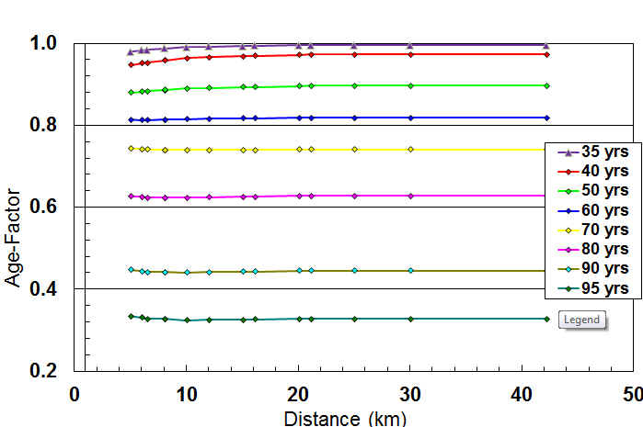

These plots show that the factors are quite constant as one moves through the ages. The fact that they are larger for longer distances (for ages 35 through 60) means that older runners are closer to the open class times than the younger runners. Keep this in mind as we consider female runners below because this trend is reversed for women.

Now that we have the new proposed standards, let's see how they do with the current single-age bests. Here is the table for the 2014 single-age bests evaluated using the proposed age-standards.

Notice that there are no performances greater than 100%. Also note that there are nine which are exactly 100%.

It is interesting to compare the age time standards from 2005 with the 2015 standards. This is done below for the half marathon. The first column contains the 2005 standards and the second column the proposed standards.

It is easy to see the marked improvement over almost all ages which is not surprising as the Half Marathon has become a very popular race with several records and lots of single-age bests being set over the last ten years.

### 2015 Female Standards

Let's look first at how the female standards of 2010 would do when applied to the 2015 records.

**As with the men, there are quite a few performances better than 100% -- 53 of them. It is obvious that the female tables need updating as well.**

I went through the same procedures as above except using the female single-age bests. Here are the plots for the 5 km, 10 km, Half Marathon, and Marathon.

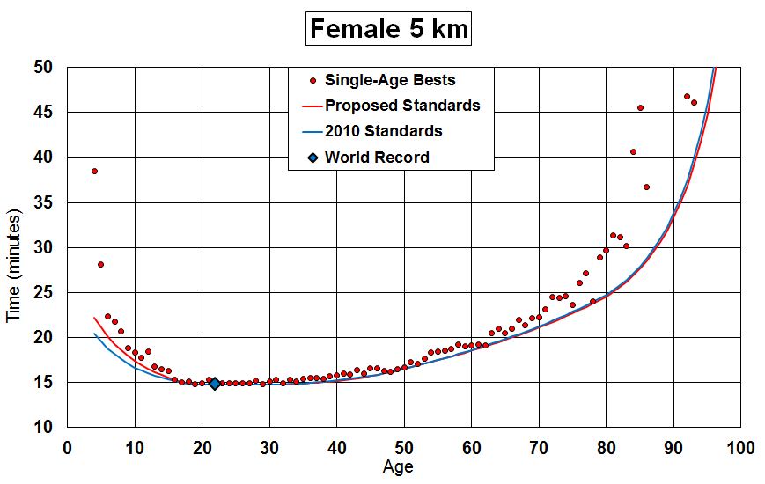

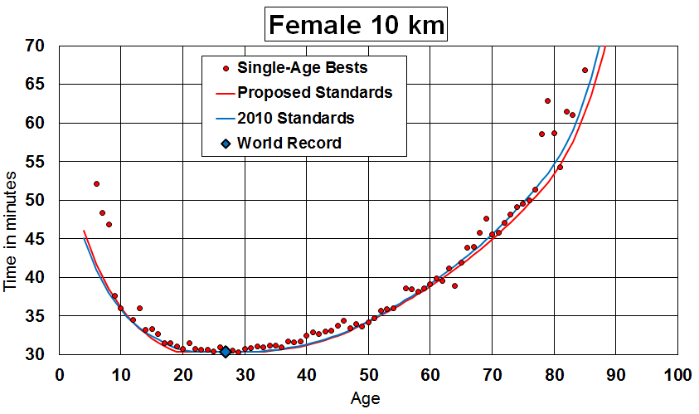

Notice the outlier at age 64. This is performance was 0:38:57 by Angela Copson (ENG), 20 Apr 1947, 04 May 2011, Silverstone, ENG. I ignored it because it was so out of line with the clustering of other performances just above the 2015Standards line. A good case could also be made for ignoring the 81-year performance of 0:54:17 by Deidre Larkin (GBR), 24 Sep 1931, 19 May 2013, Durban RSA. But it is not just a simple case of redrawing this one line because it is necessary to have a smooth transition as one goes from one distance to the next.

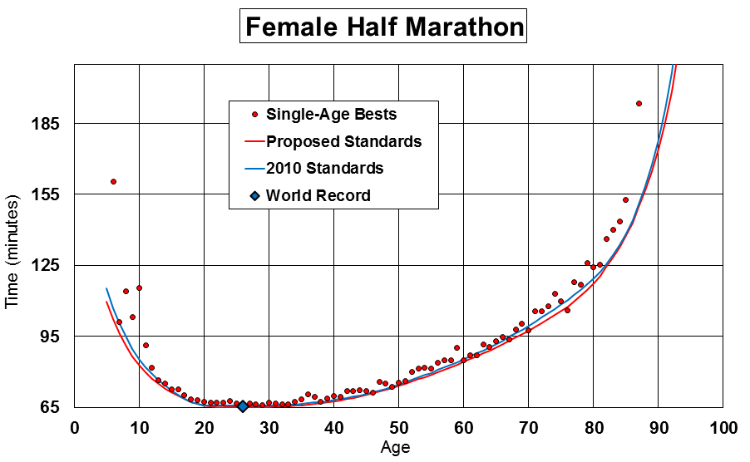

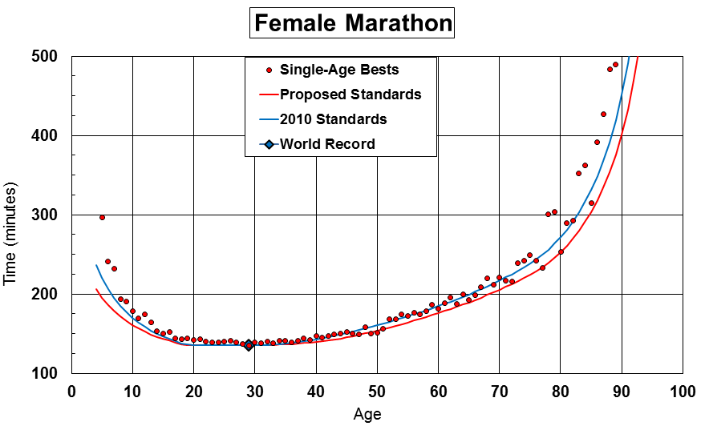

In the marathon you can see two outliers at ages 49 and 50:

49 yr, Marathon, 2:30:17, Tatyana Pozdniakova, (UKR), 04 Mar 1955, 07 Mar 2004, Los Angeles, CA, USA  
50 yr, Marathon, 2:31:05, Tatyana Pozdniakova (UKR), 04 Mar 1955, 06 Mar 2005, Los Angeles, CA USA

These times are under the line but not as obviously so as the previous example. In 2004 I ignored some performances by Tatyana Pozdniakova because they were apparently outliers but I have to admit with the addition of new records in nearby ages, her times do not seem as far out of line as they did previously.

Below is the graph of age-factors versus distance for female runners:

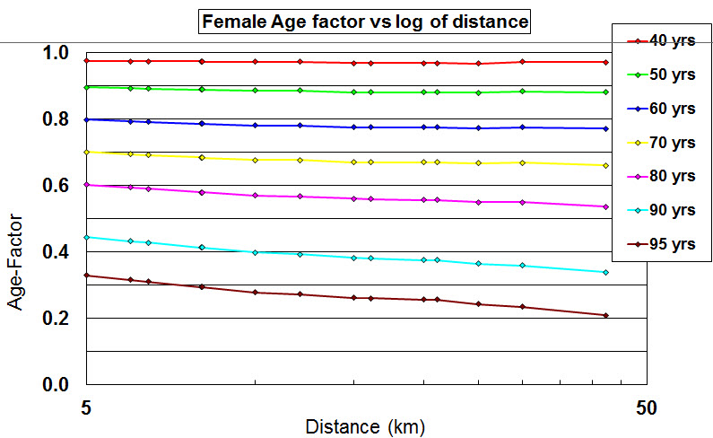

As mentioned above, notice that the female runners are closer to the open class times at the shorter distances whereas the male runners are better at the longer distance

#### Performance Table for Females at various distances

In the above table, you can see these same outliers at age 64 in the 10 km and at ages 49 and 50 in the marathon.

### Background

In 1989 the ***National Masters News*** and the **World Association of Veteran Athletes (WAVA)** compiled a booklet, ***Masters Age-Graded Tables***, of tables for grading athletic performances based on sex and age. These tables covered all standard track and field events plus standard long distance running events and race-walking events. They only covered ages 30 and above. These tables were compiled by a committee composed of Rodney Charnock, Peter Mundle, Charles Phillips, Gary Miller, Bob Fine, Rex Harvey, Phil Mulkey, Bob Stone, Mike Tymn, Christel Miller, Phil Raschker, and Al Sheahen.

In 1994 the tables were updated and were extended to ages 8 through 19 in ***Age-Graded Tables***, National Masters News, P.O. Box 2372, Van Nuys, CA 91404.

In 2002 I did a race in which it seemed to me the younger runners were not being treated fairly. I began, at that time, to create new tables. After some months I began to work with Rex Harvey and Chuck Phillips. See below. In early 2003 I endorsed Chuck's work and stopped working on my own. Then in late 2003 Rex Harvey took a close look at Chuck's tables and found some errors due to some fast performances that Chuck did not know about.

Working closely with Rex Harvey through the spring of 2004, we have developed new tables for track distance running and road races up to 200 km.

### Rex Harvey and Chuck Phillips

Rex Harvey prepared the 1994 WAVA tables for the over-30 ages and Chuck Phillips the youth tables. Since then, each of them has been working on improving the tables. I have Chuck's proposed age standards and have included them on the graphs below. Chuck's approach is described in his book Track & Field Standards & Age Factors and the Effect of Aging. He does curve fitting in both distance and in age to develop a three-dimensional grid and then applies this to each distance. It is a very impressive approach and shows the work of many, many hours.

### Definitions of Open-Class-Standards, Age-standards (time-standards), and Age-factors

* **Open-Class-Standards** represent the fastest time possible, at present, for a given distance. Some of the less popular distances, such as 12 km, have softer records. Therefore, the records for the more popular distances (5 km, 10 km, half-marathon, and marathon) are used to establish the open class standards. These times are plotted on a graph of pace vs distance and the open class standards for the less popular distances are interpolated to fall on the line.
* **Age-Standards**, sometimes called **Time-Standards** are established for each age for each distance. They represent what is believed to be the fastest possible time someone of that age can run for that distance.
* **Age-Factors** are numbers equal to or less than one. The **Age-standard** is determined by dividing the **Age-Factor** for a given age into the **Open-Class Standard** for that distance.

### Jones Method

In 2002 I set out to see if I could create tables that would treat youth runners' times more fairly. To be fair to the WAVA tables, when the youth tables were added in 1994, it was stated that they did not have as much data as they had for the masters and veteran age-groups and that the factors were to be considered only a first attempt.

After looking at the single-age records and the 1994 WAVA tables, I created a formula that consists of a flat section equal to one for open runners. This flat section is followed by a parabola and then a linear section for most of the masters range. This is followed by a parabola for the oldest runners. For the youth runners, the same approach is followed: a parabola, then a linear section, and finally a parabola as one goes to the younger ages. The equations are constructed so that the slope is continuous between the linear and quadratic sections. The following is the formula used to generate the factor where x is the age:

f = 1 - C(c - b)^2 - B(b - x) - A(a - x)^2 for x < a

f = 1 - C(c - b)^2 - B(b - x) for x >= a and x < b

f = 1 - C(c - x)^2 for x >= b and x < c

f = 1 for x >= c and x < d

f = 1 - D(x - d)^2 for x >= d and x < e

f = 1 - D(e - d)^2 - E(x - e) for x >= e and x < f

f = 1 - D(e - d)^2 - E(x - e) - F(x - f)^2 for x >= f

See figure below. Notice that there are 12 parameters: a, b, c, d, e, f, A, B, C, D, E, and F. However, we want to require that the slope is continuous from the quadratic sections to the linear sections. With this requirement, we can determine the value of two of these parameters in terms of the others reducing the number of independent variables to ten. These two additional equations are:

D = E/(2*(e - d))

C = B/(2*(c - b))

These ten parameters can be adjusted to fit the single age records. The factor (f) in the age-graded tables is always a number equal to or less than one. When doing age-grading, a person's time is multiplied by the factor f to obtain a time that this person should be able to run as an open athlete.

Below is a graph of the above expression along with its inverse. Note that the linear sections are linear only in the age-factor. When the inverse is plotted and what is proportional to time, the curve is always concave upwards as shown in the figure.

### Data Used

For open-class-standards, both track and road, I used records from the USATF web site: <http://www.usatf.org/statistics/>.

For single-age records USA records, I used data provided by Linda Honikman of the USAT Road Race Information Center (RRIC). These data were slight updates of what is on the RRIC web page: <http://www.runningusa.org/index_us-records.html>. These records are based solely on USA runners' performances.

For world-wide single-age records, I used data from the web site for the [Association of Road Racing Statisticians](http://www.arrs.net/) (ARRS) compiled by Ken Young. He has single-age records for male and female distances of 10 km, half-marathon, and marathon although he doesn't cover very young and very old runners except for the marathon. I also used the ARRS **All-Time Rankings** and **Veteran's All-Time Rankings** to pull out records in ranges where single-age bests did not exist.

I also used track age-group performances from the WMA web site: <http://www.world-masters-athletics.org/>

Single-age records for some ages for some of the distances were provided to me by Rex Harvey. These are identified in the graphs as "WMA records."

The records identified as "Phillips Records" in the plots below were supplied by Chuck Phillips and were collected from a variety of sources.

### Ray Fair

Ray Fair, Yale University, (<http://fairmodel.econ.yale.edu> ) (Click on the young boy.) has done some fine work on the slow-down athletes experience with age for running events and swimming events. I have added his data to the plots below. His work is just for male athletes and for ages 35 and up. He has come to the conclusion that, for running, one can use the same factors for all distances other than 100 meter and 200 meter runs.

### Track Factors and Road Factors for 5 km and 10 km

Records produced on the track are usually faster than those on road courses. There are several reasons for this, some of which are:

1. Road courses have a 0.1% "Short Course Prevention Factor" added to courses. Often courses are as much as 0.2% over length.
2. The course is measured on the "Shortest Possible Route" but in a race, runners often do not follow this shortest possible route.
3. Often track races, such as World Championships or the Olympics, bring together the best runners in the world creating better competition.
4. Road courses can be hilly. Even small hills can have a significant effect on times.

For males, the track and road records are (Thanks to Graham Coleman, UK, who pointed out that there were some more recent records. These have been added and are reflected in the graph.):

**5000 meters (track) 12:37.35** Kenenisa Bekele (ETH) 31 May 2004 Hengelo

**5 km (road) 12:59.5** Sammy Kipketer (KEN) 29 Sep 1981 26 Mar 2000 Carlsbad CA USA

**10000 meters (track) 26:17.53** Kenenisa Bekeli (ETH) 26 Aug 2005 Brussels

**10 km (road) 27:02** Haile Gebrselassie (ETH) 11 Dec 2002 Doha

Below is a graph of pace in track and road records at distances from 100 meters through 200 km.

The red markers are the actual records. The green line represents a smooth line drawn through the best of the road records and the blue line is drawn through the best track records. The track records considered from here on go through 10,000 m but the line is carried through to the marathon in order to compare with the road pace.

### Performance Factors

The **performance factor** for a given age at a given distance is computed by dividing the best peformance for the distance by the generated age-standard and displaying it as a percent. If the performance factor is ever greater than 100%, then it means that age-standard for that age is too slow and an adjustment should be made.

## World Wide Standards

When starting on this project, I considered the 5000 m track and 5 km road races the same as well as the 10,000 m track and 10 km road races. However, as I proceeded, I realized that the track and road events were really different. If I used the track records and then drew a smooth curve through them to the marathon to establish the open-class standards, I would be creating times for the road distances that would be unachievable and ultimately unfair to runners. For example, the marathon would be based on the road marathon distance whereas, say, the half-marathon would be based on a derived time. This derived time would be much faster than the actual half-marathon records. An effort at the half-marathon would not be rewarded with as good a performance as a similar effort at the marathon distance.

Due to this problem and others when trying to include road times in a track event, we have decided to create separate tables for the track events and the road events. The events for which age-factors have been developed are:

#### Track:

1500 m, 1 mile, 2000 m, 3000 m, 2 miles, 4000 m, 3 miles, 5000 m, 6000 m, 8000 m, 5 miles, and 10,000 m

#### Road

5 km, 6 km, 4 miles, 8 km, 5 miles, 10 km, 12 km, 15 km, 10 miles, 20 km, half-marathon, 25 km, 30 km, marathon, 50 km, 50 miles, 100 km, 150 km, 100 miles, 200 km.

## Male Age Factors

The plots have been generated at the distances mentioned above. Only those for 5000 m, 10,000 m, 5 km, 10 km, half-marathon, and marathon are shown since these are ones with the most supporting data.

In the graphs, the red lines marked as "Proposed WMA" are based on the current work.

The magenta line shows Chuck Phillips' 2004 (Feb. 20) standards and the black line Ray Fair's standards. The Jones and Fair curves are very close. The proposed WMA line runs slightly under Fair's curve.

The 10 km distance is the only one for which we have Rex Harvey's proposed standards for the World Masters Athletics association ("Harvey Proposed" line). His factors are quite close to all of the others. Again Jones and Fair are quite close. Note the 1994 WAVA standards are also plotted and are too optimistic for ages above 75 but are quite close to the others for the rest of the range.

At the marathon distance, the WAVA 94 line is more optimistic than the others over the range from age 40 and up.

### Age-Factor vs Distance

The plot below shows how the age-factor changes for various ages and various distances. The horizontal black lines are Fair's factors. Again we see that our proposal is more optimistic than Fair's for ages 40 through 70 and slightly more pesimistic for ages above 80.

For the youths, we also use the same factors for all distances. However, I wish I could be more sure of the youth records. There are a number of African runners and Chinese runners for whom there might be question about their ages.

### Conclusions

The age-factors of Jones and Fair are very close over the age ranges of 35 to 60 and 85 and above. Jones and Fair used very different methods, but similar models, to generate the factors. This gives confidence that they are reasonable factors. It appears that Fair's conclusion that we can use the same factors for all road distances is valid for all distances.

## Female Age-Standards

For females, the track and road records are:

**5000 meters (track) 14:24.68** Elvan Abeylegesse (TUK) 11 June 2004 Bergen, NOR

**5 km (road) 14:50.4**  Paula Radcliffe (ENG) 17 Dec 1973 14 Sep 2003 London ENG

**10000 meters (track) 30:01.09 Paula Radcliffe (ENG)** 17 Dec 1973 6 Aug 2002

**10 km (road) 30:20.7**  Paula Radcliffe (ENG) 17 Dec 1973 23 Feb 2003

Below is a graph of pace for females at track distances of 5000 meters and 10,000 meters (lower two dots) and road distances from 5 km to the marathon.

As with the men, there is a sizeable gap at 5000 and 10,000 between track and road records. In this case it doesn't even look like they are converging but this is because of the terrific track race at 10,000 meters of 29:31.78 by China's Wang Junxia in 1993. I have adjusted the open-class times to fall on a smooth curve from 5 km road to the marathon. The only two records that it passes through are the 10 km and marathon. All the others were adjusted to fall on the line.

It was found that the same age-factors could be used for distances from 5 km through 15 km. However, above that, they changed quite a bit.

**NOTE**: The curves marked "Fair" are Ray Fair's age-factors derived for males. They are included here for comparison. Fair makes no claim that they represent female performances.

There is a sizeable difference between Jones and Phillips until about age 85. Fair and Jones start out on approximately the same line but depart at about age 60.

We are showing the 8 km plot since it shows the problem when one runner is much faster than her cohorts. The two AARS triangles at ages 48 and 49 represent races run by Tatyana Pozdniakova (b. 04 Mar 1955). If I force the line lower to include these performances, then the age-grade factor for a 49-year-old female becomes 0.9239. For comparison, the age-grade factor for a 49-year-old male is 0.9044. That is, this would imply that women slow down considerably less than men with age. However, all of our other data show that the slowdown is greater for women than for men. We are therefore forced to ignore her performances at 8 km. The USATF/RRIC and the ARRS have both confirmed her age and the courses have been verified. So, this has to remain a mystery.

As the distance goes up, the Proposed WMA line deviates farther from Fair although Jones and Phillips are very close for ages 50 and up.

Phillips and the Proposed WMA lines are quite close although the Proposed is lower in the 40-80 range. This section of the curve is controlled again by some good performances in the upper 40s.

Below is the same plot as above but it uses the same age-factors as are used for the distances of 15 km and lower.

When we use the common curve, we miss some performances in the upper-40s that seem too fast. Those performances are again by Tatyana Pozdniakova.

46y364d 2:30:26 Tatyana Pozdniakova (UKR) 04 Mar 1955 03 Mar 2002 Los Angeles CA USA

47y223d 2:28:59.5 Tatyana Pozdniakova (UKR) 04 Mar 1955 13 Oct 2002 Providence RI USA

49y003d 2:30:17 Tatyana Pozdniakova (UKR) 04 Mar 1955 07 Mar 2004 Los Angeles CA USA

When we use the factors that are specific for the marathon, they capture those performances.

### Age-Factor vs Distance

The age factors are the same for distances up to 15 km and then change to the marathon distance. It is hard to determine those for 30 km and 35 km since there is so little quality data. An attempt was made to have the age-factors change in a continous fashion from 15 km to the marathon.

Note that the age-40 runners receive less adjustment as the distance goes up while runners over 60 get more adjustment.

The youth age-factors change even more, particularly for the youngest runners.

It is interesting to see how the pace (minutes/km) changes with age and distance. This is shown in the next plot:

It doesn't seem to make sense that the female pace for older women would get slightly slower with each distance and then get much slower at distances above the half-marathon.

### 2010 adjustments

After it was brought to our attention that a number of women, particularly at higher ages and longer distances, were performing above 100%, an adjustment was made based on newer data from Marian and Don Lein. Don is chair of the USATF Masters Long Distance Running Committee. Below is a graph for the marathon showing the curve for both the 2006 and the 2010 factors.

The times for the 80 years and plus that fall between the 2004 and 2010 lines, are the data provided by the Leins. Notice that the new curve includes those times and only very slightly adjusts the times for those in the 40-65 age range. While the 2010 adjustment now includes those new times making the tables tougher, in the younger ages from 40 through 70, the tables are very slightly softer. This is because, in extending the line farther to the right, this allowed the middle section to more closely match the actual performances. This results in better age-factors for all master ages. No attempt was made to adjust the youth tables.

It is interesting to contrast the Marathon with the Half-Marathon. Here is that graph:

Notice that the for all ages above 35, the new tables are quite a bit harder. This was required to fit in the new data and preserve a smooth transition as one moves from one distance to the next as well as one age-group to the next.

### Conclusions for female age-standards (written in 2006)

The female age-factors present a problem. It might be that identical factors can be used across the distances from 5 km through the marathon but the current data do not support this conclusion. We could use the same factors and wait for better performances to arrive in coming years. However, in the meantime it would penalize older women in the longer races.

### Comments on the conclusions (written in 2010)

The new tables reflect improvements as was expected in 2006. It implied that better performances would come providing evidence that new tables would be needed.

### Overall Conclusions

* It is believed that the age-standards developed fairly reflect the slow-down for older and younger runners and can be used with confidence for age-grading road races from 5 km through the marathon and track races at 5000 m and 10000 m. As Fair has concluded, we can use the same age-factors for all distances. Different open-class times have been created for track races and road races at the same distances.
* For female runners, the age-factors seem to fall into one group up to about 15 km and then changes continuously up the marathon. It does not seem to be warranted, at this time, to use identical age-factors for women at all ages.
* For both males and females, the youth age-factors are dominated by African and Chinese runners.