RECIPE OPEN DASHBOARD
LAK16

Introduction
We have a democratic hackathon. We are not going to tell you how to build your dashboard. However, we will present you with opportunities and an example set of data, infrastructure and recipes.
This is an example local installation for a Mac computer where both the Sakai LMS and open dashboard are running on your local machine. The security is weak due to the lack of TLS and running the database as root. However, the environment allows you to develop locally.
Please gather any evidence from the hackathon by updating this Google doc.

Environment
Java 8+ (JDK)
Feel free to use either the Oracle JDK or OpenJDK. Oracle JDK Download and Installation
OpenJDK Download and Installation

Git
Feel free to use any git client that you are comfortable with. We'll provide details on the repository, which branch to use, etc. at the hackathon.
Git Download and Installation

Maven 3
We'll be using Maven 3 as our build and dependency management tool. Maven 3 Download and Installation

MongoDB
We'll be using MongoDB as our default backend data store. MongoDB Download and Installation

IDE
Use any source code editor that you are comfortable with. If you don't already have a source code editor or IDE here are some options:
Spring Tool Suite (based on Eclipse) IntelliJ IDEA

OpenDashboard
is a web application that provides a framework for displaying analytics visualizations and data views called “cards”. Cards represent a single discrete visualization or data view but share an API and data model. OpenDashboard was built to fill the need for a highly flexible and pluggable dashboard framework for an open learning analytics environment. The OpenDashboard web application provides access via IMS Learning Tool Interoperability, direct login and single sign-on with SAML.

Implementation
AngularJS
Spring-Boot
Pluggable Datastores (redis + mongodb defaults)

Roadmap
Card configuration and management
Security and session management
Javascript and REST API

Mailing Lists
opendashboard-user@apereo.org
opendashboard-dev@apereo.org

To subscribe or unsubscribe
Send an email to the relevant email address by adding "+subscribe" or "+unsubscribe" to the email address.

Google App Institutions
If you are part of an institution that uses Google Apps, and your institutional settings do not allow you to post via the web forum, you should be able to send email to the list, just not post via the web.

In some cases, your institutional settings may not allow you to subscribe using the email method nor using the web. In this case, please email the list owner to subscribe using the formula (list)+owner@apereo.org. For example, email apereoTL+owner@apereo.org and ask to subscribe.

Once you have all of the required software and tools listed above installed you can clone the OpenDashboard project from github. View project on github

Create a new directory that will contain the OpenDashboard project source code
- Navigate to your newly created directory
- Issue the following git commands (or perform the equivalent commands from your git client)
  - git init
  - git clone https://github.com/Apereo-Learning-Analytics-Initiative/ OpenDashboard.git
The one shop stop for documentation is: http://apereo-learning-analytics-initiative.github.io/OpenDashboard/

Run Monodb locally (MAC or *NIX)

Make sure /data/db exists and has the right permissions:
drwxr-xr-x 9 root wheel 306 Apr 13 16:11 db

E.G.:
sudo touch /data/db
sudo chmod 755 /data/db

From a terminal run monody as root: sudo mongod

You should see output similar to:
2015-04-13T16:11:13.703+0200 I NETWORK [initandlisten] waiting for connections on port 27017

Review installation documentation at: https://docs.mongodb.org/manual/installation/

Download and install the Sakai demo

Warning: The first startup time for Sakai is rather long. Please be prepaid to wait 5 minutes (e.g.: Coffee break or setting up the opendashboard). The size of the Sakai download is also rather large. Alan or one of his colleges will have a USB stick to quickly transfer the download.
Note: visit: https://sakaiproject.org/download-sakai to read the most up to date instructions.

Review the installation documentation: http://source.sakaiproject.org/release/10.6/

Download the relevant demo version such as for the Mac or NIX 10.6

Unpack in a directory of convenience which we shall call <SAKIA_HOME>. Start Sakai up. <SAKAI_HOME>/start-sakai.sh
Note: the first time startup is much longer than the next as sample data is placed in an in memory database (and then preserved) and the war files are expanded for the first time.

Visit the home page of the server (http://http://localhost:8080/portal) when the logging writes something similar to:

Apr 13, 2016 12:52:38 PM org.apache.catalina.startup.Catalina start
INFO: Server startup in 529902 ms

Note: If you see a blank screen then there is a problem with installation

Creating a Sakai user account
Create a user account at: http://localhost:8080/portal/site/!gateway/page/!gateway-700

User Id: lti_student First name: Mock Last name: User
Email: mock.user@dev.nl
Create New Password: tsetse1X#@
Verify New Password: tsetse1X#@

Notes: Do not fill in the type. Change the email address and password to suite your local conditions.

Press the ‘Create Account’ button

Creating a site including the external tool

You will be automatically logged in. Now we are going to create a course site and then add the LTI consumer tool.

Close the Welcome tutorial (click on the red cross).

On the Lefthand side press ‘Worksite Setup’
At the top of the screen press the ‘New’ button You will now find yourself on the Site Type page. Select ‘course site’.
Accept the default value for the ‘Academic term’.
Press the ‘Continue’ button.

You will find yourself on the Course/Section Information page.
Subject: Sample Department
Course: SMPL101
Section: Discussion: 1 SMPL 101 Authoriser’s username: admin Press the ‘Continue’ button.

You will find yourself on the ‘Course Site Information’ page.
Description: Test Course Short Description: Test Course Press the ‘Continue’ button.

You will now find yourself on the ‘Course Site Tools’. Check ‘External Tool’.
Press the ‘Continue’ button.

Notice the wide range of tools available in Sakai. Feel free to enable a few more for your viewing pleasure.

You will find yourself on the ‘Customise tool Instances’ page. Press the ‘Continue’ button.

You will find yourself on the ‘Course Site Access’ page.
Global Access, Check ‘Allow anyone to join the site with valid login id’.

Role for people that join site: Student Press the ‘Continue’ button.

You will find yourself on the ‘Confirm Your Course Site Setup’ page. Press the ‘Request Site’.

You will find yourself on the ‘My Workspace: Worksite Setup’ page. Under ‘Worksite Title’ click the ‘Discussion 1 SMPL101’ link.

Configuring the OpenDashBoard
Note: You will need to have set up your working environment first as mentioned in a previous section.

Keep Sakai running, we are now going to run the OpenDashBoard and then configure the

‘External Tool’.

By default the OpenDashboard sits on localhost port 8081.Lets verify the configuration.

Review the file: <OpenDashboard_HOME>src/main/resources/application.yml

Notice the oauth settings

# Security settings
auth:
oauth:
key: opendash

secret: opendash

From within the top level directory of the OpenDashBoard from the command line run (in one line):

mvn clean package spring-boot:run

Wait a few seconds until the application has started. You will see terminal output similar to:

dServletContainer : Tomcat started on port(s): 8081/http
2015-04-13 15:45:47.157 INFO 2175 --- [ main] od.Application
: Started Application in 4.089 seconds (JVM running for 4.404)

Visit http://localhost:8081/lti. You will get a non infromative error page.

Whitelabel Error Page
This application has no explicit mapping for /error, so you are seeing this as a fallback.
${timestamp}
There was an unexpected error (type=${error}, status=${status}).
${message}

This is OK, but not clean. This just means that you have not authenticated through the LTI protocol. In the terminal your application is running you will see console output similar to:

2015-04-13 15:47:00.999 ERROR 2175 --- [nio-9080-exec-1]
lti.oauth.OAuthFilter : Signature algorithm of null is unsupported.

Or

2016-04-16 15:20:35.302 ERROR 4848 --- [nio-8081-exec-7] od.utils.AppControllerAdvice : Request method 'GET' not supported

org.springframework.web.HttpRequestMethodNotSupportedException: Request method 'GET' not supported
at org.springframework.web.servlet.mvc.method.RequestMappingInfoHandlerMapping.handleNoMatch(RequestMappingInfoHandlerMapping.java:203)

Welcome to the wonderful world of Java Stacktraces.
Not for the faint hearted.

Configuring the ‘External Tool’
You are now in the site you have just created or you will need to click on the Discussion_1_SMPL101 link.

You will find yourself in the ‘Home’ of the ‘Discussion 1 SMPL101’ site. On the lefthand side click ‘External Tool’


Click on the configure icon on the top righthand side of the page.

Add the following details, remembering that the Remote Tool Secret is opendash

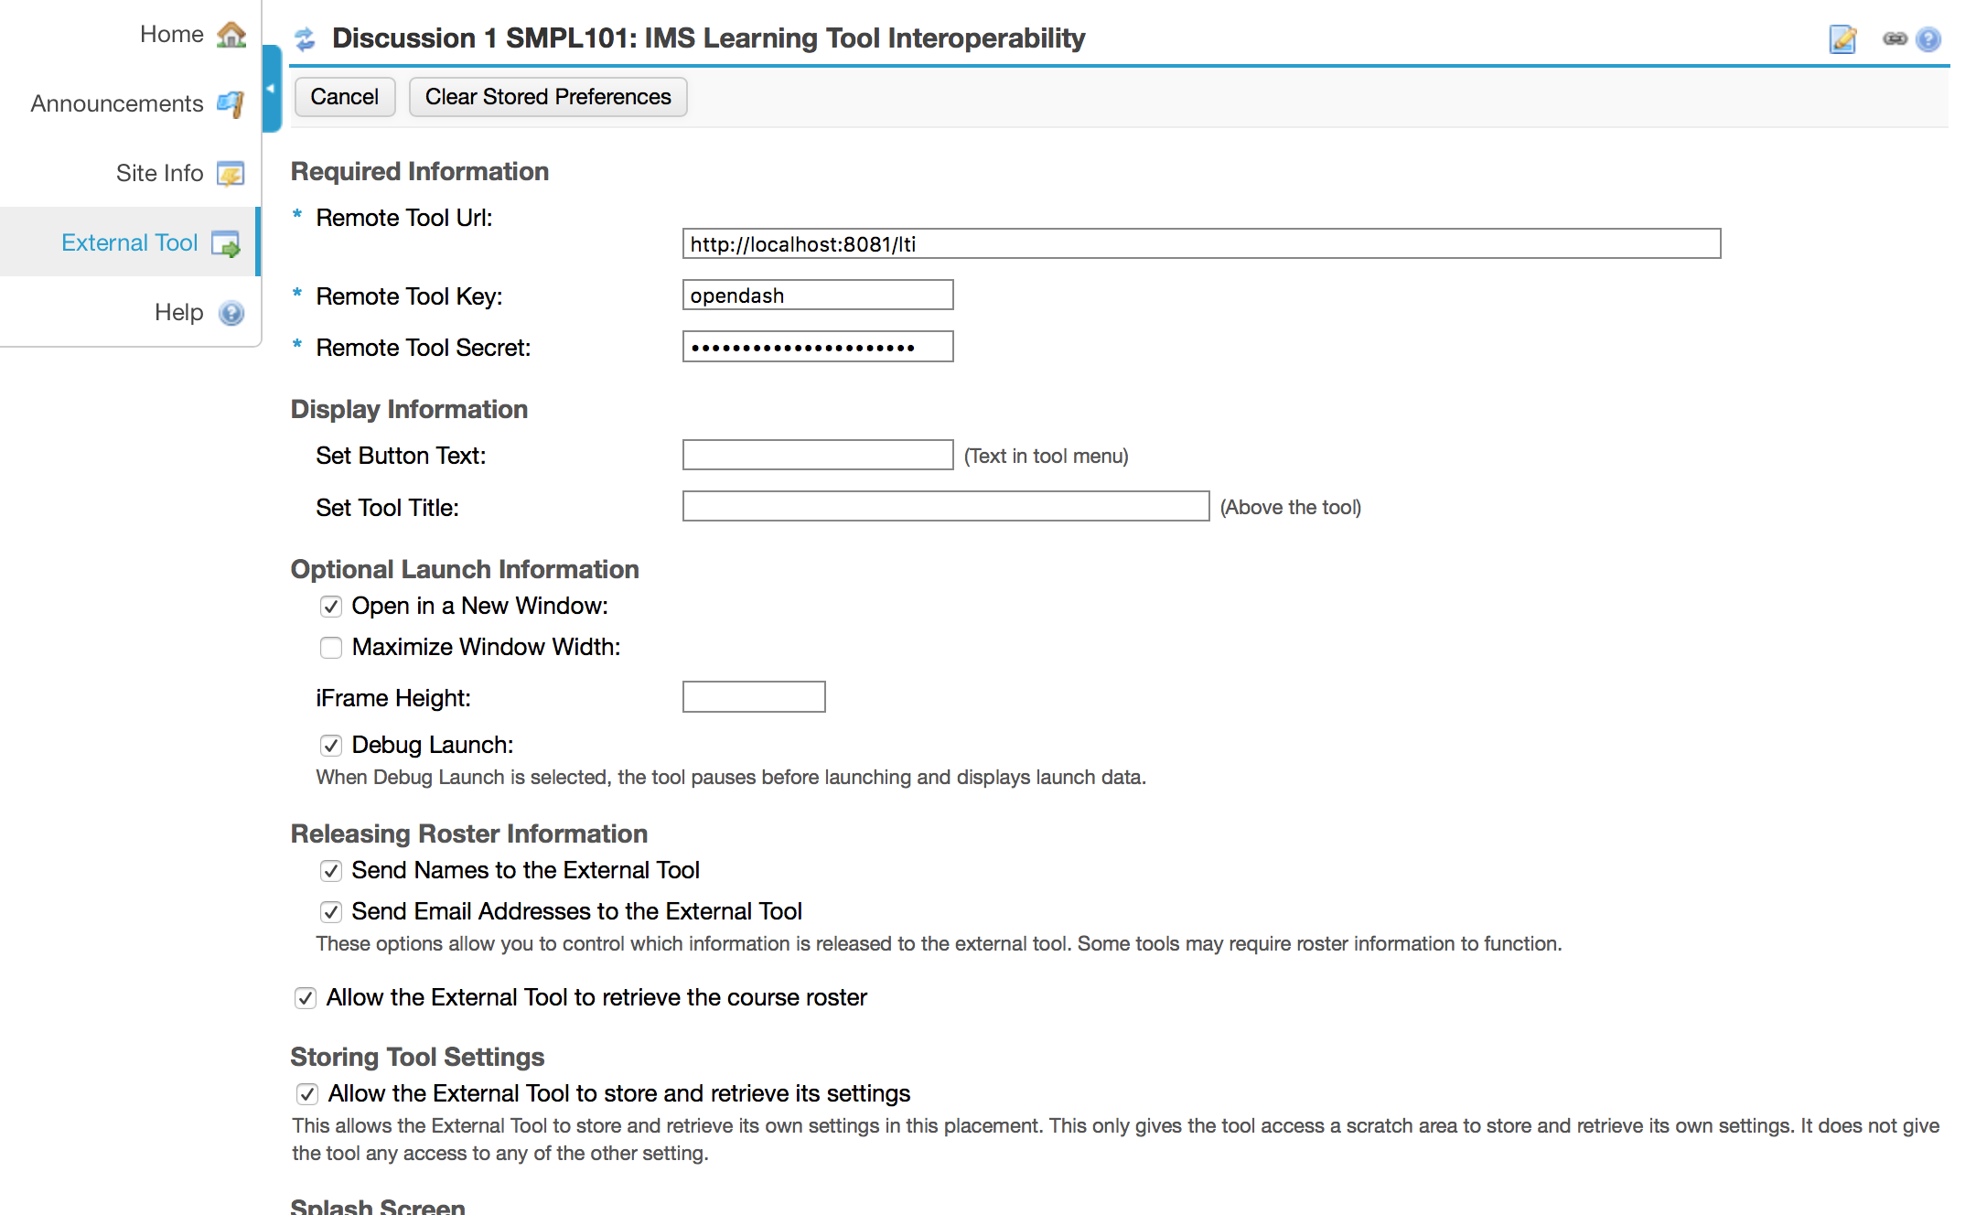

Press the Update Options button and you will now see the debug information page. This shows all the viable passed to the OpenDashboard.

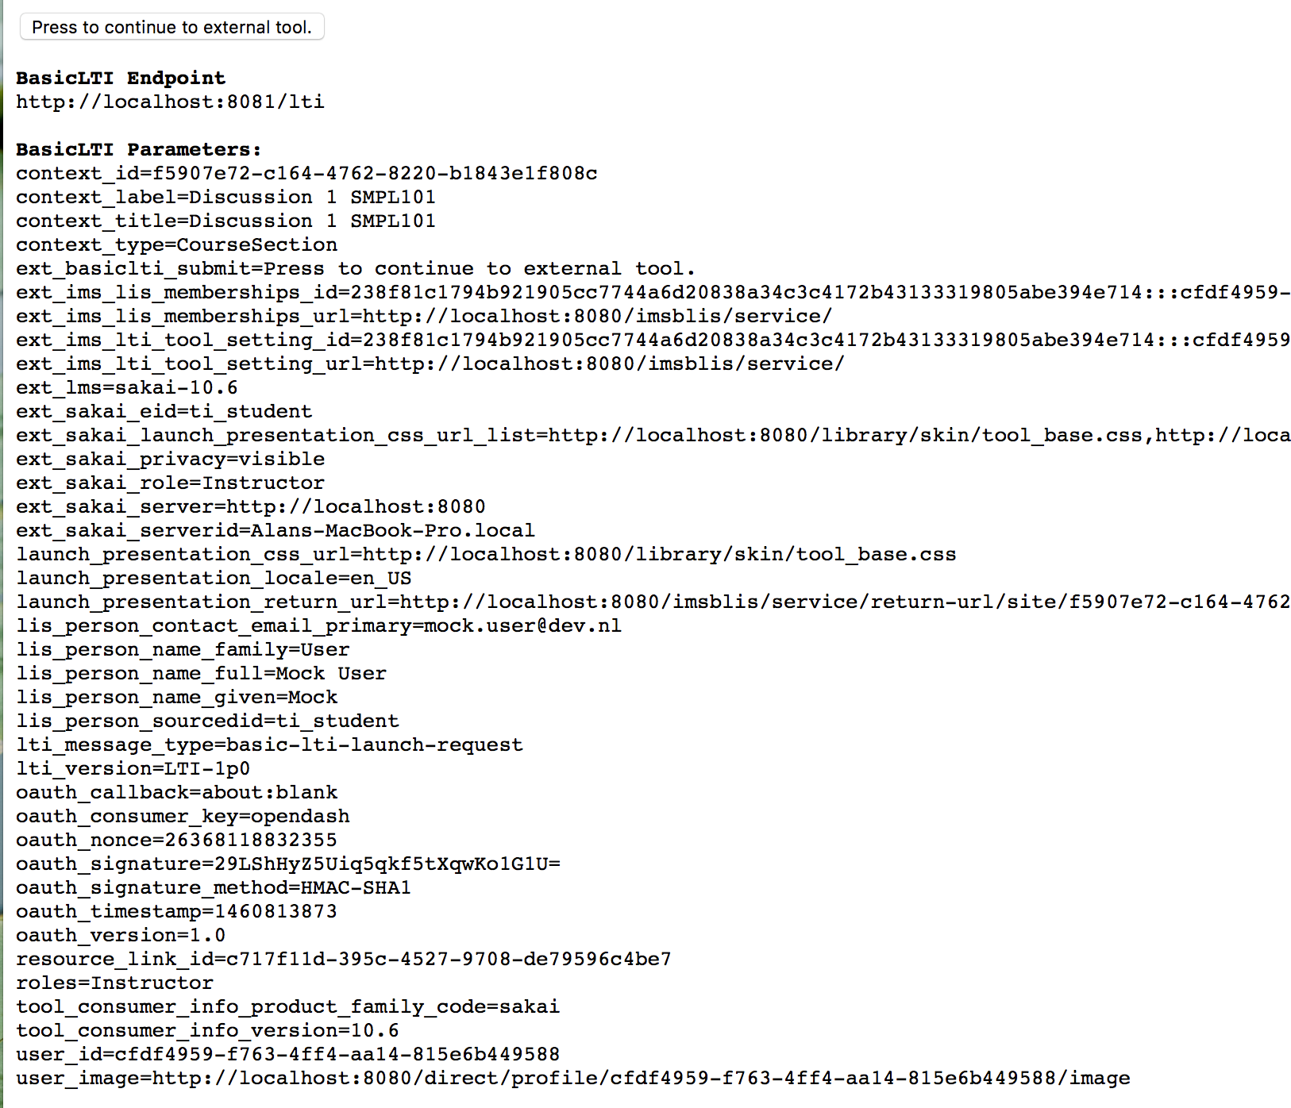

Launch the external tool by clicking on ‘Press to continue to external tool.’

Well done
The tool will now be launched and look like it is running in a Sakai course with the user role Instructor. You have also got the source code where you can update and modify and run the code.
To build your first card you will need to visit: http://apereo-learning-analytics-initiative.github.io/OpenDashboard/
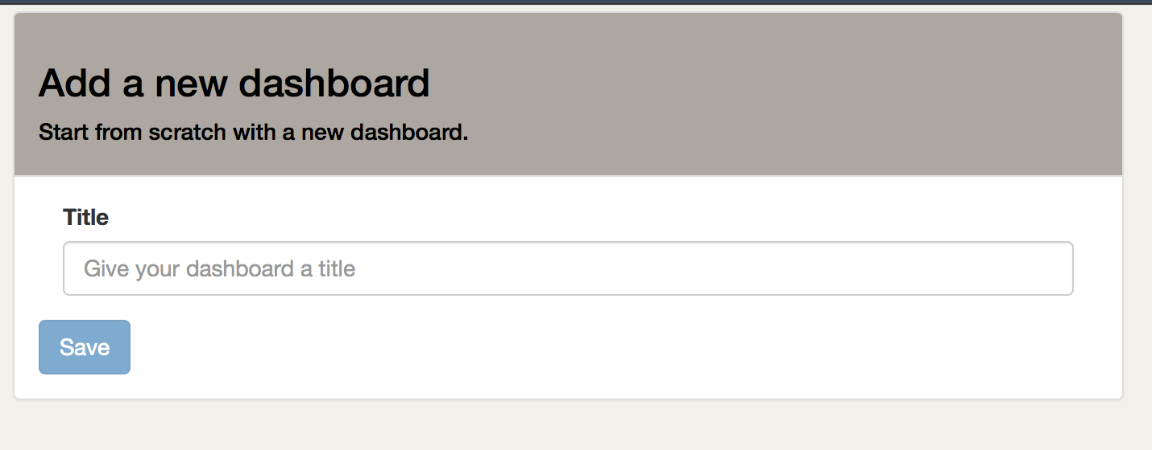

The development cycle is as simple as:

- Modify the directories and files under src/
- Stop the opendashboard
- Start the opendashboard.

Goodluck.

DataSets

JISC recipe details and example dataset
- Information about recipes from JISC: https://github.com/jiscdev/learning-analytics/
- A downloadable dataset in json is here: https://github.com/jiscdev/learning-analytics/blob/master/xapi-test-set.zip

Rough CSV conversion and loading into R

You should have access during the hackathon to a CSV file that was converted from the JISC JSON dataset, This is directly importable into R. E.G.:

file<-"/Users/Alan/Desktop/hackathon/learning-analytics/xapi-test-set/r01.csv"
jisc_data <- read.csv2(file, sep =",", header = TRUE, stringsAsFactors = FALSE)
jisc_data$VERB <- as.factor(jisc_data$VERB)
jisc_data$COURSE <- as.factor(jisc_data$COURSE)
# Remove reduncency as we have only 1 URL
jisc_data$OBJECT<-gsub("http://moodle.data.alpha.jisc.ac.uk/", "", jisc_data$OBJECT )
jisc_data$OBJECT<-as.factor(jisc_data$OBJECT)

# OK, let’s quickly look at the distributions
plot(jisc_data$VERB, main="Verbs",las=1)
plot(jisc_data$COURSE, main="Courses",las=1)
plot(jisc_data$OBJECT, main="Objects",las=2)

# Time for a contingency table
table(jisc_data$OBJECT)

Connecting to the LRS

From CURL running in a bash shell.

ENDPOINT="http://jisc.learninglocker.net/data/xAPI/statements?offset=100"

# Have bash encode the credentials to base64
USER="bb825440cb05aba31f74631864e601e356d2a39d"
PASS="0b3f5f438efade80dee9e6f9dc2d87126ffe7b0d"
AUTH=$(echo -n "$USER:$PASS" | base64)
curl -i -X GET -H "X-Experience-API-Version: 1.0.1" -H "Authorization: Basic $AUTH" $ENDPOINT

100 statements directly From R
library(httr)
library(jsonlite)
url <- "http://jisc.learninglocker.net/data/xAPI/statements?offset=100"
auth <-"Basic YmI4MjU0NDBjYjA1YWJhMzFmNzQ2MzE4NjRlNjAxZTM1NmQyYTM5ZDowYjNmNWY0MzhlZmFkZTgwZGVlOWU2ZjlkYzJkODcxMjZmZmU3YjBk"
ver <-"1.0.1"
req <- GET(url, add_headers("Authorization" = auth, "X-Experience-API-Version" = ver))
json <- content(req, as = "text")
info <- fromJSON(json)
where_next<-info[1]$more
where_next
statements<-info[2]$statements

str(statements)
# Rstudio has nice auto completion
# See: https://github.com/jiscdev/learning-analytics/blob/master/sample_xapi_data.md
# For structure
def_name<-as.factor(statements$object$definition$name$en)
plot(def_name, main="Definition.name",las=2, cex.axis=.5)

Follows structure:

"object":{
"id":"http://moodle.data.alpha.jisc.ac.uk/mod/page/view.php?id=3",
"definition":{
"type":"http://xapi.jisc.ac.uk/define/vle/page",
"name":{
"en":"More Detail Page"
},
"description":{
"en":"<p>More detail</p>"
},

Synthetic Data Generation

One opportunity is to hack around with generating your own synthetic (fake) data. An example test plan to use with Jmeter can be found here. The LRS account details (URL, username, password) will be provided at the event.

git clone https://github.com/Apereo-Learning-Analytics-Initiative/LRSLoadTest.git

To download and install jmeter visit: http://jmeter.apache.org/download_jmeter.cgi

Exercises (in no particular order).
Please keep notes while working on the exercises. Consider working on a shared Google doc and linking back to this Google doc.:

Install Jmeter

Ask for a demonstration

Review the Jmeter examples page: http://jmeter.apache.org/usermanual/index.html

Collect relevant example recipes for querying

Standard recipes

Recipes specific to Learning Locker

Add to Jmeter standard recipes

Add recipes specific to Learning Locker

Perform low level performance test. Which queries are the worst performers

Write recipes that simulate the JISC data set and POST to Learning Locker

Which recipes perform the worst?

Which CSV data is needed

Bonus: Can you write recipes relevant to the opendashboard or those who are writing dashboards. Ask around

Are there any aggregations of recipes that best describe learning moments?

Can we generate these aggregations.

Distributions

Can we generate realistic distributions in an LRS

Can we monitor these distributions, for example directly in R Studio

Brainstorm on further idea’s.

What are your recommendations for further actions.

Example Brute force Perl code for converting s the JISC dataset to a CSV format loadable into R studio

my $uid="";
my $ts="";
my $vb="";
my $course="";

$file="xapi-00006.txt";
$out="r06.csv";

open(TMP,$file)||die;
open(OT,">$out")||die;
print OT "UID,TIMESTAMP,VERB,OBJECT,COURSE\n";
while($line=<TMP>){
if ($line =~ /"actor":{"name":"(\d*)".*"timestamp":"(.*)","v/){
$uid=$1;
$ts=$2;
if ($line=~/display":{"en":"(.*)"}},"object":{"id":"(.*)","d/){
$vb=$1;
$ob=$2;
if ($line=~/course","name":{"en":"(.*)"},/){
$course=$1
}
}
}
print OT "$uid,$ts,$vb,$ob,$course\n";
$uid="";
$ts="";
$vb="";
$ob="";
$course="";
}

Installing your own Learning Locker

No support provided, not advised during the hackathon

http://docs.learninglocker.net/installation/

http://www.jpablo128.com/how-to-install-learning-locker/

