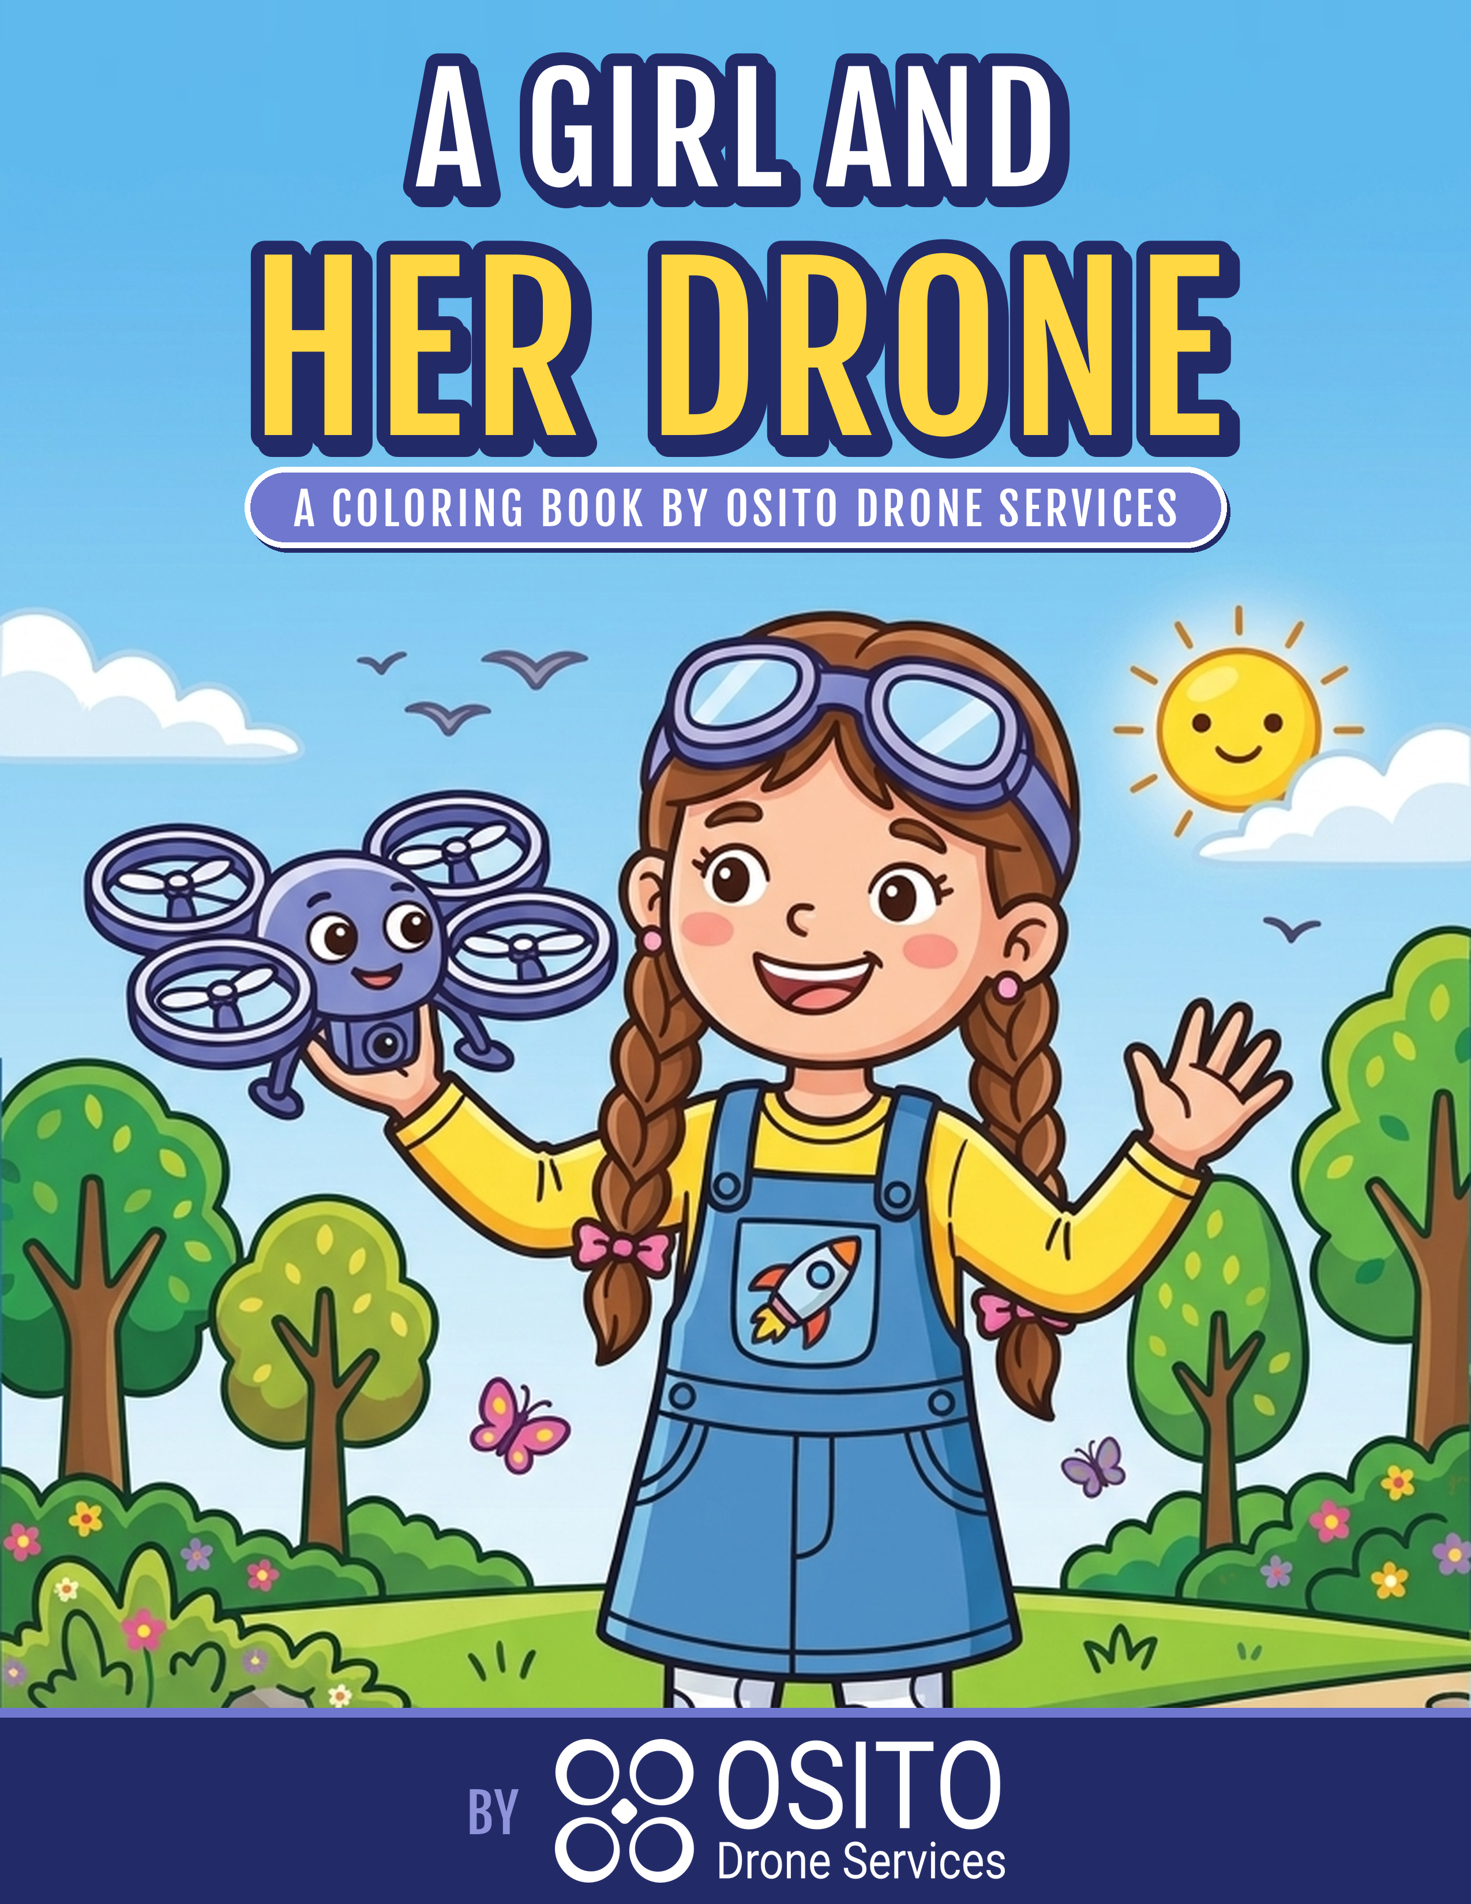


THIS BOOK BELONGS TO
____________________________________________________
YOUNG PILOT'S NAME
____________________________________________________
MY DRONE'S NAME
A Girl and Her Drone - A Coloring Book by Osito Drone Services
10 Full-Page Drone Adventures + 4 Vector STEM Activities • Hands-on Youth Drone STEM at ositodrone.com

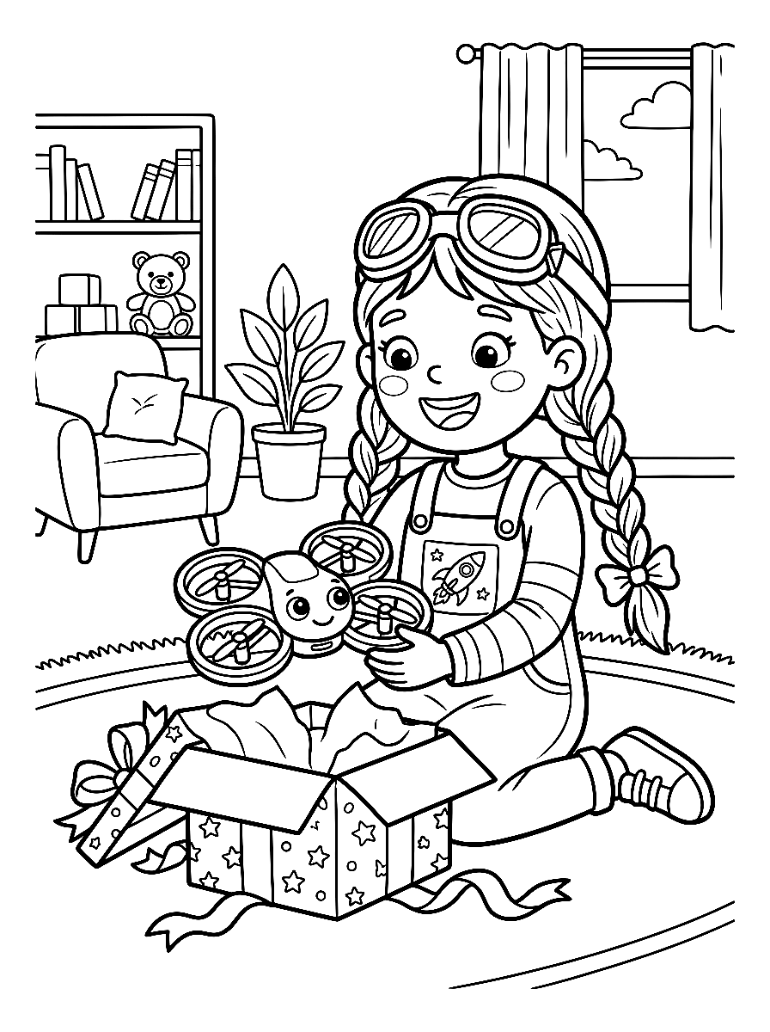

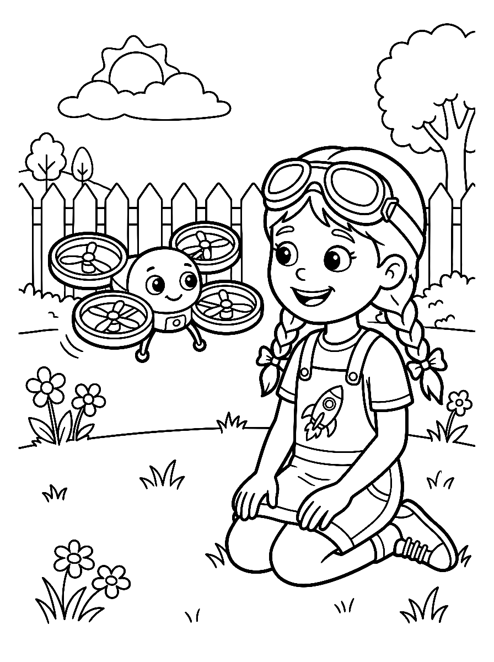

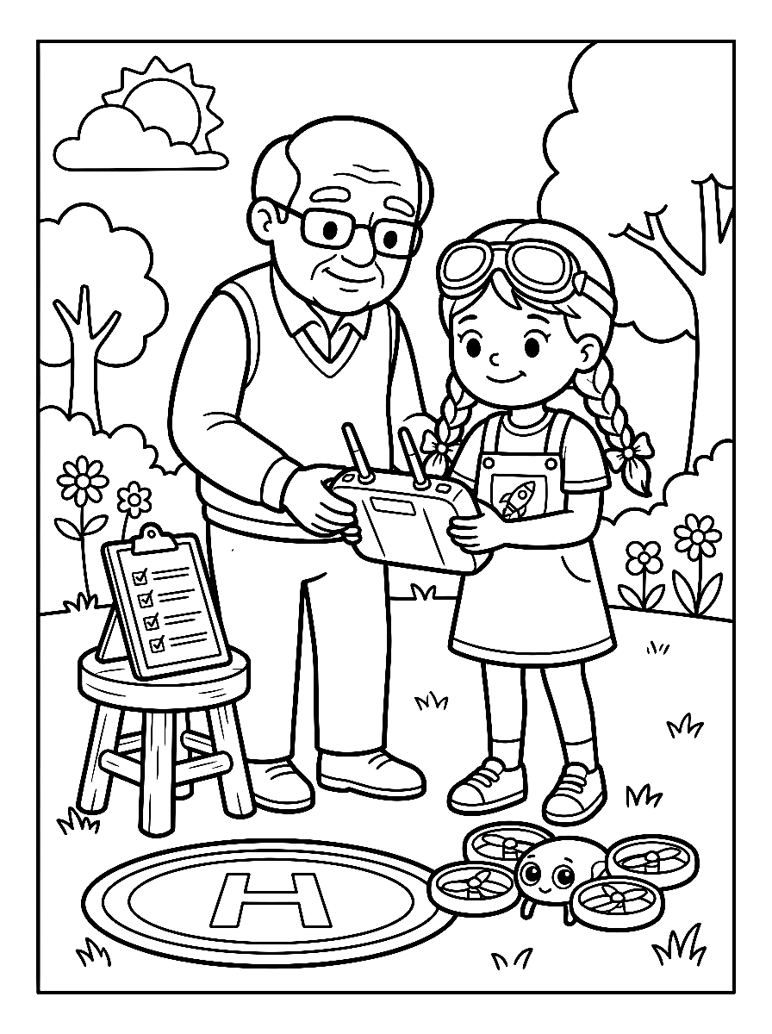

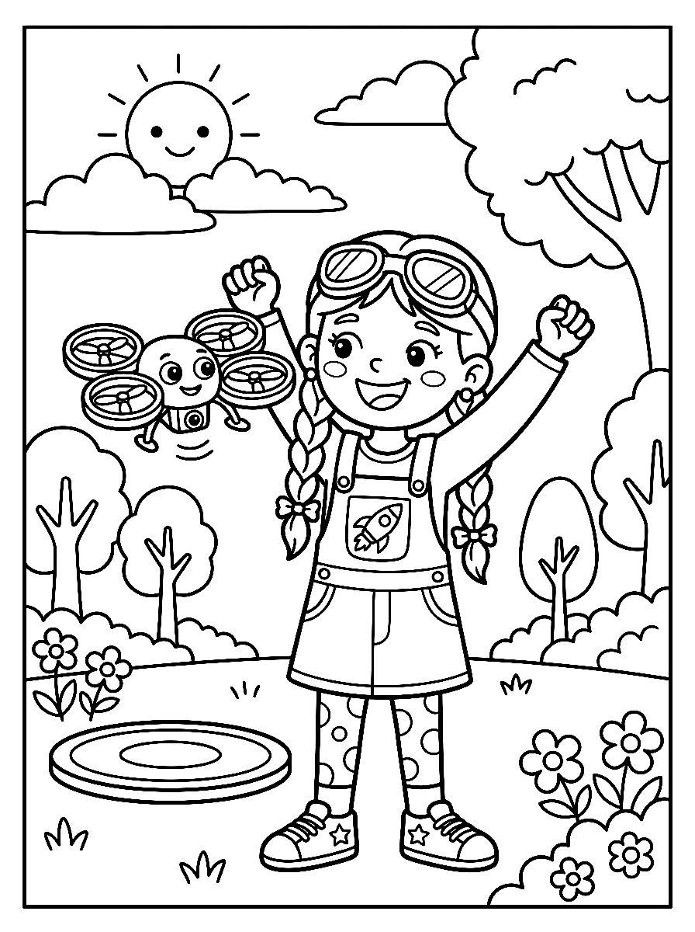

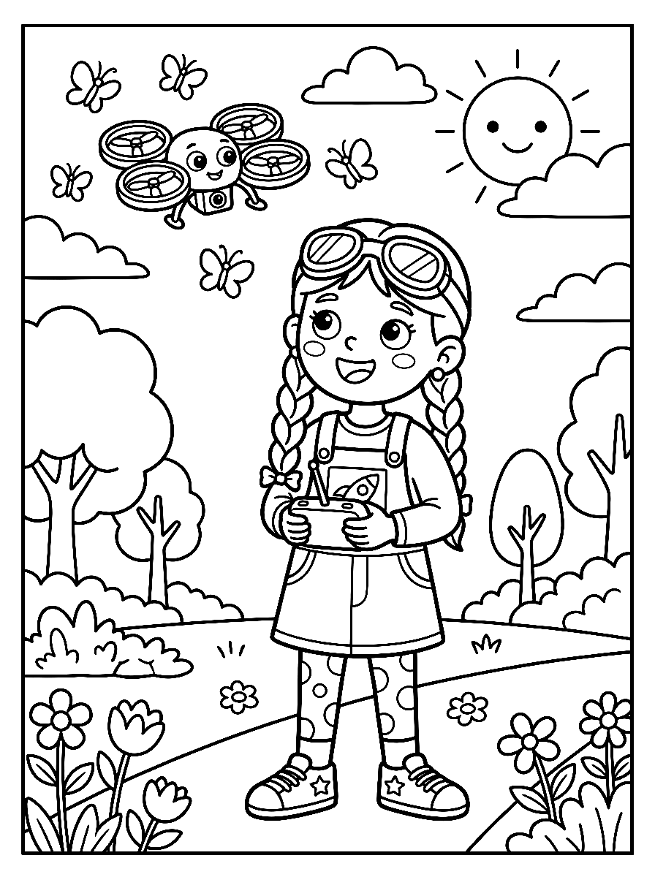

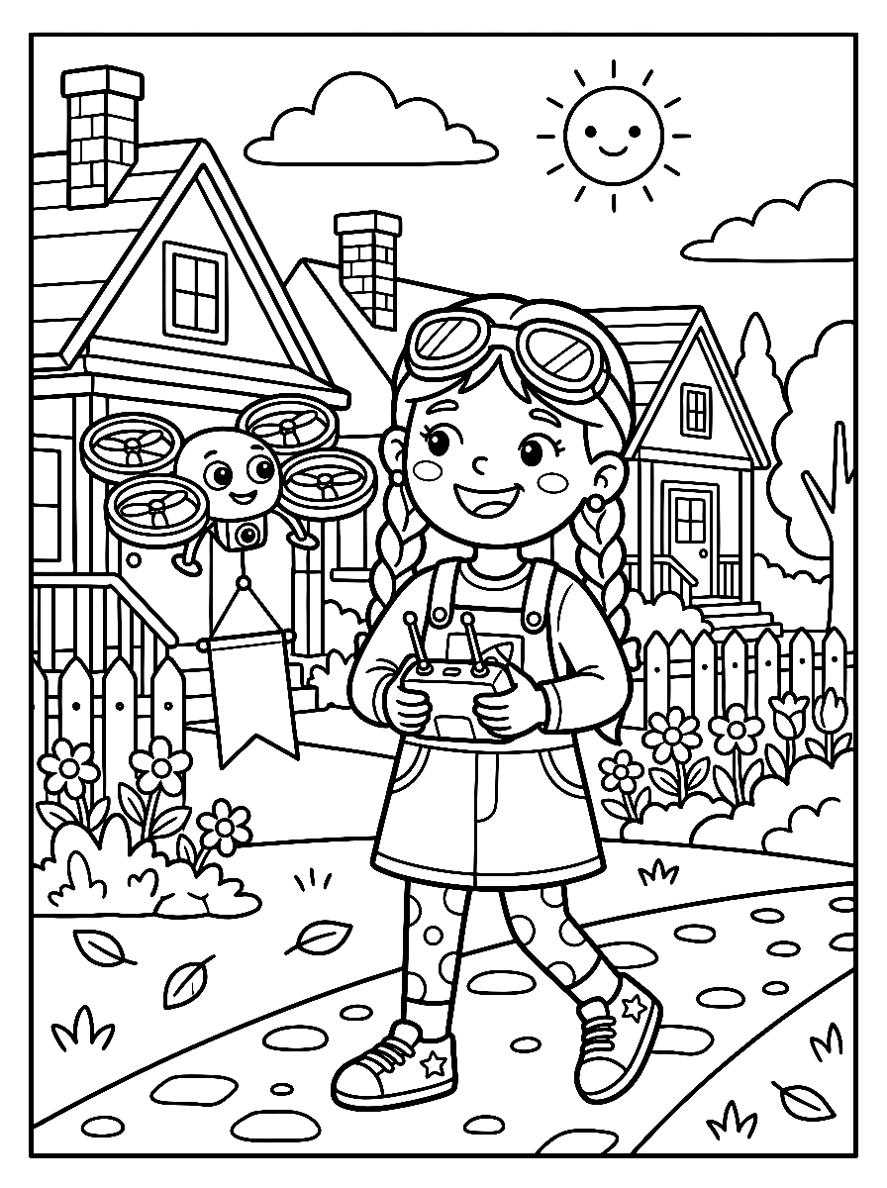

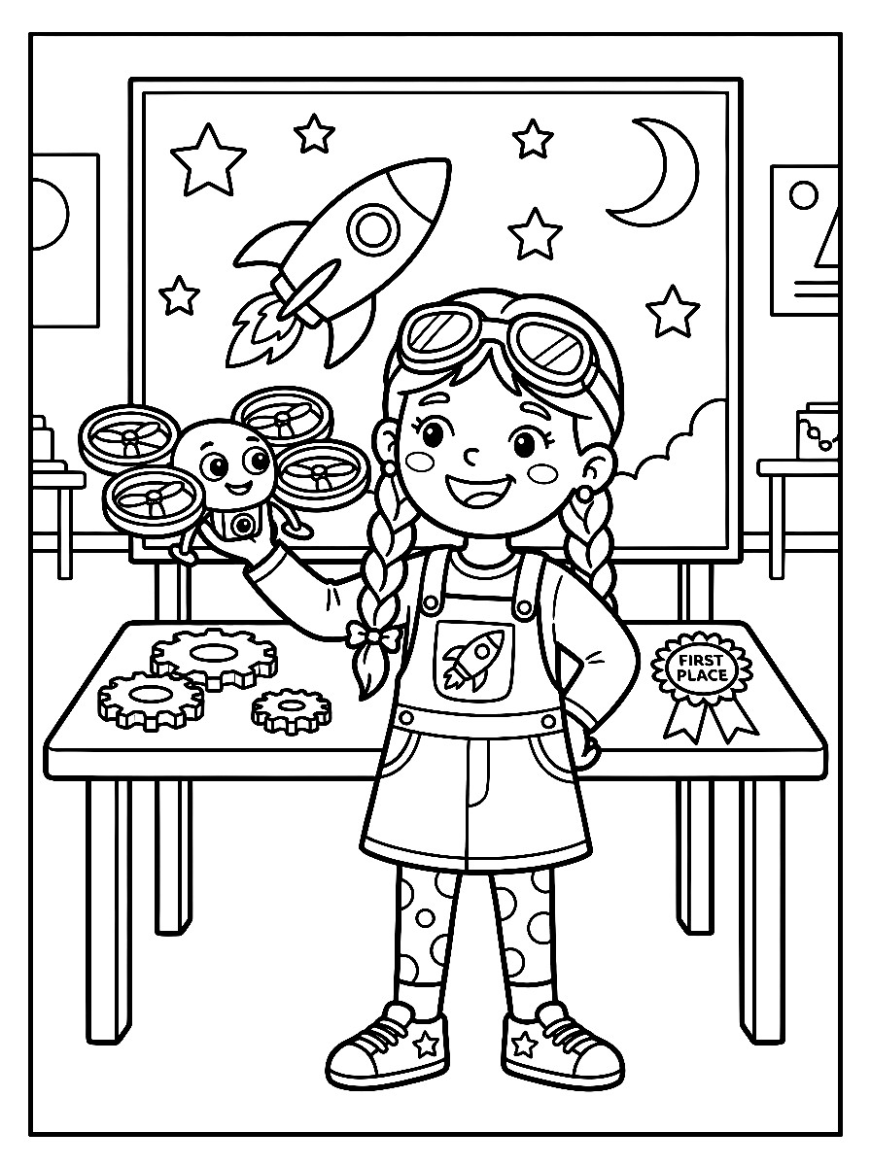

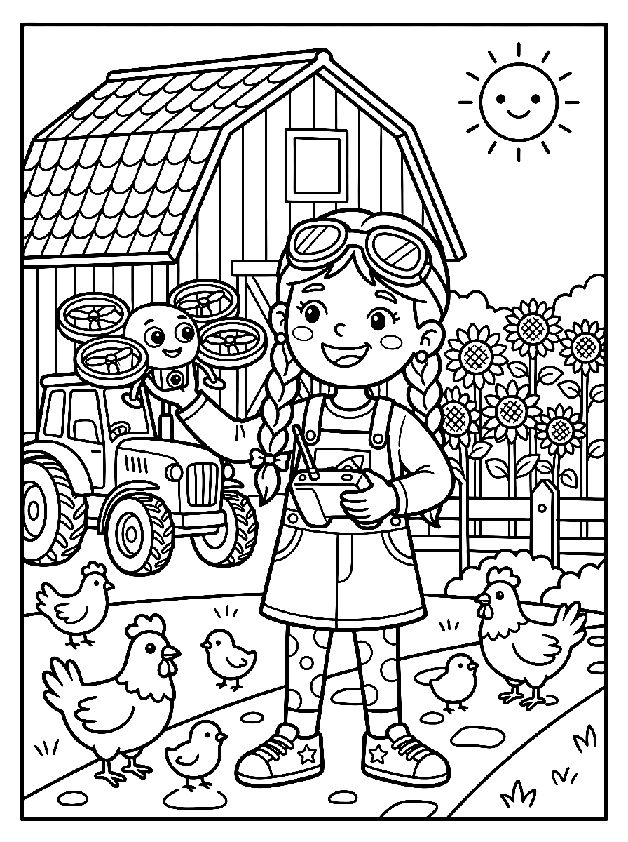

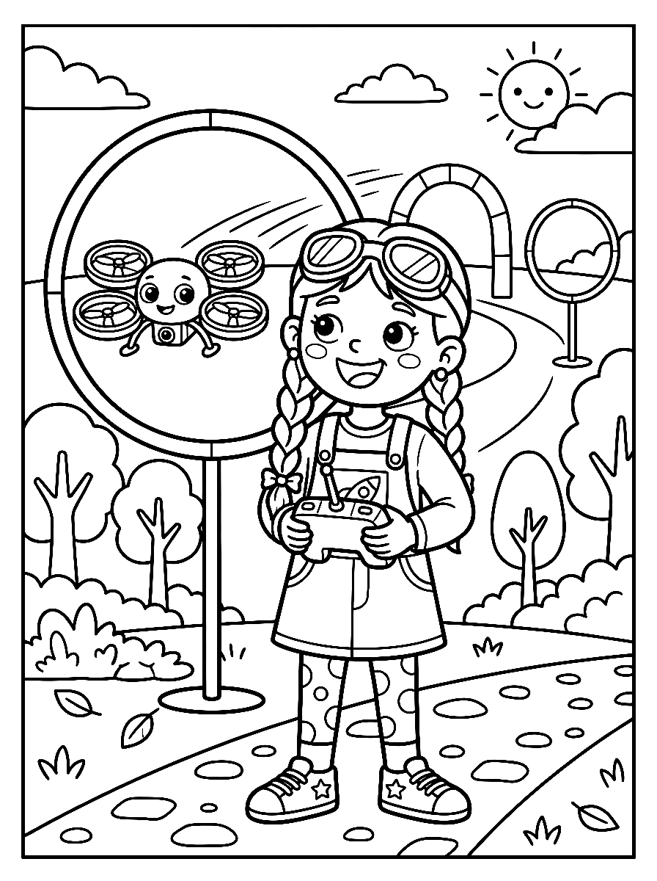

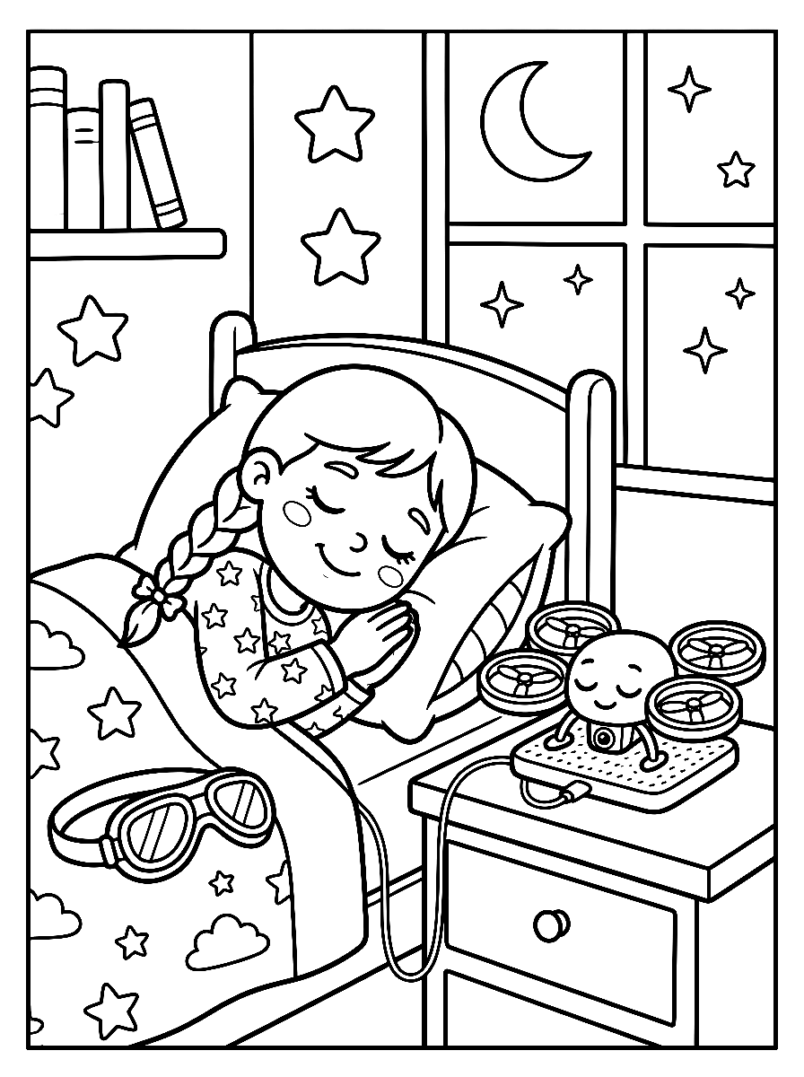

OFFICIAL YOUTH DRONE SAFETY RULES
1. Always Fly With a Grown-Up: Make sure a parent, teacher, or coach is watching every flight.
2. Choose Big, Open Spaces: Fly away from people, pets, cars, trees, power lines, and airports.
3. Keep Eyes on Your Drone: Always keep your quadcopter where you can see it with your own eyes.
4. Pre-Flight Safety Check: Use ducted propeller guards and inspect props and battery before takeoff.
5. Respect People & Privacy: Never fly over crowds or people, and always ask before taking photos.
6. Take the Free FAA TRUST Test: Learn the official recreational rules of the sky with your family!



