
OFFICIAL TEEN AEROSPACE, AUTONOMY & COMMERCIAL SERVICES BOOK • AGES 12–16
WINGMAN TO PRO: THE OSITO DRONE SERVICES TEEN HANDBOOK
Aerospace Physics, 3D-Printed Carbon Micro-Drones, Python Laser Autonomy, Commercial Thermal Inspections & Your FAA Part 107 Pathway (Ages 12–16 Edition)
Osito Drone LLC — STEM Youth Academy & Commercial Aerial Division (San Francisco, CA)
Authors: Miguel Flores (CEO) • Alan Musselman (COO) • Jesus Aceves (CTO) • https://ositodrone.com

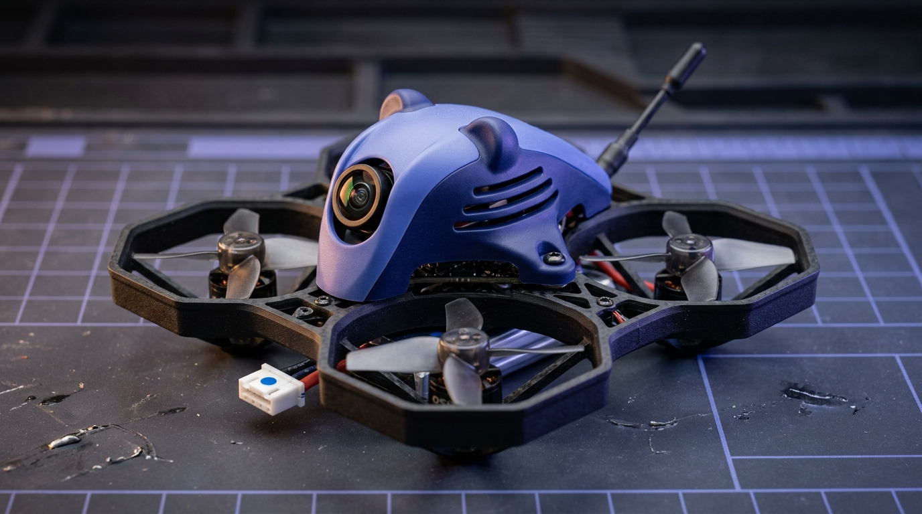
Above: The Flagship Osito MiniCub65 BNF (27.6g AUW) — Engineered & 3D-Printed in San Francisco for Youth STEM & Indoor FPV.
💡 THIS TEEN AEROSPACE HANDBOOK BELONGS TO:
Cadet Name: ____________________________________________ Age / Grade: _______________ Callsign: _____________________
FAA TRUST Certificate #: _________________________________ Target Part 107 Exam Date (Age 14–16): ____________________
THE OSITO TEEN PILOT PLEDGE: 'I pledge to fly with discipline, inspect my airframe and LiHV batteries before every takeoff, respect the FAA National Airspace System and bystander privacy, use my Visual Observer during FPV flight, and apply aerospace science to build safer communities.'

Chapter | Title & Core Aerospace / Commercial Topics | Target Skills (Ages 12–16)
Chapter 01 | Welcome to Osito Drone Services — The Teen Aviation Window | Cadet → Apprentice → Part 107 Pro at 16
Chapter 02 | The Physics of Multirotor Flight — 4 Forces, 6-DOF & Torque | Roll/Pitch/Yaw, CW/CCW Torque, T/W Math
Chapter 03 | Inside the Osito Fleet & 4-Tier Bambu P2S 3D Printing | MiniCub65 (27.6g), CUB-75 (39.5g), THERMO-95
Chapter 04 | Avionics, Flight Controllers, 8kHz PID Loops & Firmware Safety | STM32F411, ICM-42688-P, 16-Bit Rollover Safe
Chapter 05 | Mastering the 4-Station Flight Lab, LiPo Science & Pit Crew Ops | CRM Spotter Protocol, 3.80V Storage, Bat-Safe
Chapter 06 | Coding Autonomous Drones — Python & 8×8 ToF Laser Avoidance | VL53L5CX Laser Matrix, Betaflight 4.5.1 CLI
Chapter 07 | Real-World Commercial Missions at Osito Drone Services | Roof Orthomosaics, Post-Sunset ΔT Thermal, FPV
Chapter 08 | Airspace Law, FAA TRUST (Ages 12–16) & FAA Part 107 (Age 16) | Sub-250g Rule, Class B/C/D/E/G, LAANC, METARs
Chapter 09 | The Osito Teen Career, Apprenticeship & Entrepreneurship Guide | STEM Club Captain, Pit Crew Tech, Paid Coach
Chapter 10 | Worked Math Challenges, P.A.V.E. Checklist, Logbook & 15-Q Exam | Calculations, Flight Log & Cadet Certificate

CHAPTER 01 • OSITO TEEN AEROSPACE & COMMERCIAL HANDBOOK (AGES 12–16)
WELCOME TO OSITO DRONE SERVICES — THE TEEN AVIATION WINDOW (AGES 12–16)
Between ages 12 and 16, your brain's spatial reasoning, hand-eye reflex speed, and engineering curiosity hit peak acceleration. At Osito Drone Services in San Francisco, we don't treat 12-to-16-year-olds like little kids watching a toy demonstration—we train you as real Junior Aerospace Technicians, Python Autonomy Coders, and Future FAA Part 107 Commercial Pilots.
1.1 WHO IS OSITO DRONE SERVICES?
Founded in San Francisco by CEO Miguel Flores, COO Alan Musselman, and CTO Jesus Aceves, Osito Drone LLC operates at the intersection of two fast-growing worlds:
• The Osito STEM Youth Drone Academy: Bringing 4-Station Mobile Flight Labs, 3D-printed carbon-fiber micro-drones, and bilingual English/Spanish aerospace education to middle schools, high schools, recreation centers, and summer camps across the Bay Area.
• Osito Commercial Aerial Services: Executing real-world B2B commercial roof inspections, HVAC thermal radiometry (heat-loss diagnostics), luxury real estate indoor FPV fly-throughs, environmental mapping, and live esports drone racing arenas.
1.2 THE OSITO 12-TO-16 TEEN PROGRESSION LADDER
Why is the 12–16 age bracket the most exciting stage in modern aviation? Because federal aviation law gives you a direct, step-by-step runway from your first indoor hover to a paid commercial license:
• Age 12 (Cadet Wingman): Pass your official FAA TRUST recreational exam (free), master Line-of-Sight (LOS) and First-Person View (FPV) flight on the 27.6g Osito MiniCub65 and 39.5g CUB-75, and learn LiPo battery safety.
• Ages 13–14 (Avionics & Autonomy Builder): Slice 3D-printed carbon-fiber airframes in Bambu Studio, configure Betaflight 4.5.1 PID controllers, and write Python obstacle-avoidance scripts using our 8×8 Time-of-Flight (ToF) laser matrix hats.
• Ages 14–15 (Part 107 Knowledge Scholar & Pit Crew Apprentice): Under FAA regulations (14 CFR § 107.65), you can sit for the official FAA Part 107 Aeronautical Knowledge Exam starting at age 14, and serve as a Station 4 Pit Crew Apprentice or Visual Observer (VO) with Osito coaches.
• Age 16 (FAA Part 107 Certified Commercial Remote Pilot): On the morning of your 16th birthday, you are legally eligible to activate your FAA Part 107 Remote Pilot Certificate—unlocking paid commercial roof inspections, thermal imaging missions, cinematic FPV shoots, and paid Assistant Flight Coach roles!
💡 DID YOU KNOW? THE 'OSITO' CALLSIGN
'Osito' means 'Little Bear' in Spanish—a nod to California's Golden Bear heritage, our bilingual San Francisco Mission District roots, and our flagship micro-drones (the 39.5g CUB-75 and 27.6g MiniCub65) that pack industrial aerospace brains inside palm-sized, ultra-safe ducted airframes.

CHAPTER 02 • OSITO TEEN AEROSPACE & COMMERCIAL HANDBOOK (AGES 12–16)
THE PHYSICS OF MULTIROTOR FLIGHT — 4 FORCES, 6-DOF & TORQUE BALANCE
An airplane needs a runway to move forward and push air over its wings. A quadcopter (multirotor) generates lift by spinning four miniature airfoils (propeller blades) at 15,000 to 35,000 RPM. To fly like an expert—and design your own airframes—you need to understand the exact physics happening every millisecond.
2.1 THE FOUR FORCES OF FLIGHT ON A QUADCOPTER
Every aircraft in the universe is governed by four vector forces:
1. Weight (Gravity, W = m × g): Pulls the drone straight toward the center of the Earth. For an Osito CUB-75 MK-II with battery (All-Up Weight m = 39.5 grams = 0.0395 kg), Weight is 0.0395 kg × 9.81 m/s² = 0.387 Newtons.
2. Thrust (Upward Rotor Force, T): Generated as the four angled propeller blades accelerate a column of air downward (Newton's Third Law: every action has an equal and opposite reaction).
3. Lift & Tilt Vectoring: In a level hover, 100% of Thrust points straight up to balance Weight (T = W). When you push the right stick forward (Pitch), the rear motors spin faster than the front motors, tilting the thrust vector forward by angle θ. Now Vertical Lift is T × cos(θ) and Forward Propulsion is T × sin(θ)!
4. Aerodynamic Drag (D): Air resistance pushing against the frame and prop guards, proportional to the square of velocity (D ∝ v²).
2.2 SIX DEGREES OF FREEDOM (6-DOF) & THE THREE ROTATIONAL AXES
In 3D space, a drone moves along three linear axes (Surge = forward/back, Sway = left/right, Heave = up/down) and rotates around three rotational axes measured by the flight controller's gyroscope:
• ROLL (Rotation around the Longitudinal Front-to-Back X-Axis): Controlled by Right Stick Left/Right. To roll right, the left motors (Motors 2 & 4) speed up while the right motors (Motors 1 & 3) slow down.
• PITCH (Rotation around the Lateral Side-to-Side Y-Axis): Controlled by Right Stick Up/Down. To pitch forward (nose down), the rear motors (Motors 1 & 2) speed up while the front motors (Motors 3 & 4) slow down.
• YAW (Rotation around the Vertical Z-Axis): Controlled by Left Stick Left/Right. How does a quadcopter spin its nose left or right without tilting? Through Conservation of Angular Momentum!
2.3 WHY DIAGONAL PROPELLERS SPIN IN OPPOSITE DIRECTIONS (CW VS. CCW)
If all four motors spun Clockwise (CW), Newton's Third Law dictates that the airframe itself would spin uncontrollably Counter-Clockwise (CCW) like a helicopter that lost its tail rotor! To cancel this reactive torque:
• Two diagonal motors spin Clockwise (CW), and the other two diagonal motors spin Counter-Clockwise (CCW).
• At Osito Drone Services, we configure our fleet in the 'Props-Out' (Reversed) direction: Front-Left (M4) and Rear-Right (M1) spin CW, while Front-Right (M3) and Rear-Left (M2) spin CCW. 'Props-Out' sweeps obstacles and ribbon gates away from the FPV camera lens rather than pulling them into the center of the frame.
• When you command a YAW rotation, the flight controller speeds up the two CW motors while slowing down the two CCW motors by the exact same amount. Total upward thrust stays constant (so you don't climb or drop), while net reactive torque rotates the nose smoothly!
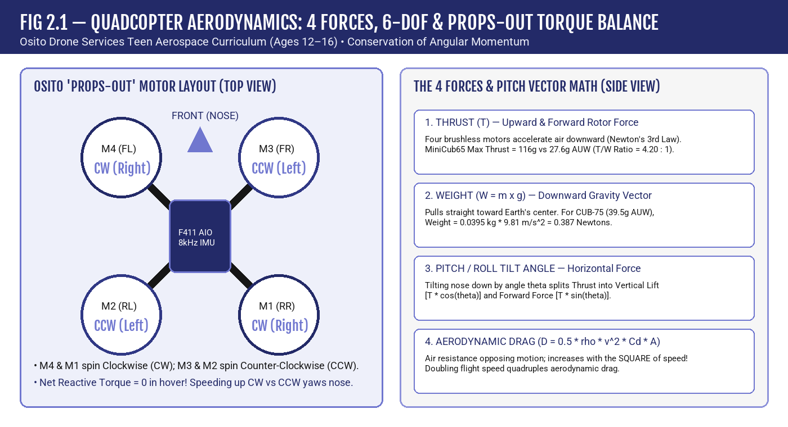
💡 TEEN AEROSPACE FORMULA BOX: THRUST-TO-WEIGHT RATIO (T/W)
Thrust-to-Weight Ratio = Total Max Thrust (g) ÷ All-Up Weight (g).
• A drone needs T/W > 1.0 just to leave the ground, and T/W ≥ 2.0 for crisp control authority.
• Example: The Osito MiniCub65 BNF weighs 27.6g AUW and its four 0702 27,000KV motors produce 116g of peak thrust. Its T/W ratio is 116g ÷ 27.6g = 4.20 : 1—meaning it hovers at just ~24% throttle and has massive reserve power to recover from steep dives!

CHAPTER 03 • OSITO TEEN AEROSPACE & COMMERCIAL HANDBOOK (AGES 12–16)
INSIDE THE OSITO FLEET — CARBON AIRFRAMES & 4-TIER 3D PRINTING
Walk into the Osito Drone Engineering Lab and you won't see fragile store-bought plastic toys. You'll see two Bambu Lab P2S Combo 3D printers with hardened steel nozzles extruding carbon-fiber composites and high-flow elastomers to build our five modular drone platforms.
3.1 MEET THE FIVE CORE OSITO DRONE PLATFORMS
Every drone in the Osito fleet is engineered for a specific training or commercial mission—and every part can be 3D-printed and repaired in-house in under 15 minutes:
1. Osito MiniCub65 BNF (19.8g Dry / 27.6g AUW): Our flagship 65mm 1S brushless micro-drone. Powered by the custom OSITO_CUBBRAIN65_V1 flight controller and 0702 27,000KV motors, it is whisper-quiet, legal to fly indoors anywhere, and tough enough to bounce off gym walls.
2. CUB-75 MK-II (29.0g Dry / 39.5g AUW; 46.0g with SNAP-CODE Hat): Our 75mm ducted STEM workhorse featuring a 4-Pin Magnetic Pogo Snap-Deck on the roof. In two seconds, students can snap on the 6.5g SNAP-CODE Hat (an 8×8 VL53L5CX Time-of-Flight laser ranging matrix) to run Python autonomy code.
3. SHARD-75 / KODIAK-75 (38.0g Open / 45.5g Optical-Flow AUW): Our aerial bumper and physics combat platform featuring downward optical-flow hover lock and a 3-layer composite sandwich horn designed to teach momentum transfer and elastic collisions.
4. THERMO-95 (142.5g Dry / 192.5g AUW): Our sub-250g commercial HVAC and building-envelope inspection trainer, carrying a radiometric thermal camera inside a high-temperature carbon-nylon airframe rated for 140°F attic crawlspaces.
5. OSITO-INT-95 (74.9g Dry / 101.9g AUW): Our high-speed gym 'Cat & Mouse' AI interceptor platform for advanced teens studying computer vision target tracking.
3.2 THE OSITO MASTER 4-TIER 3D PRINTING FILAMENT STANDARD
Why don't we print every drone out of basic classroom PLA? Because standard PLA softens at just 130°F (55°C) inside a sunny car or hot attic, and shatters like glass in a high-speed gate impact! CTO Jesus Aceves standardized our 2× Bambu Lab P2S Combo print farm around four aerospace-grade polymer tiers (using 0.4mm hardened steel nozzles):
• Tier 1 — Bambu PETG-CF (Carbon-Fiber Reinforced PETG, P2S #1 AMS Slot 1): Infused with chopped carbon micro-fibers for high stiffness, zero warping, and light weight. Default for CUB-75 (39.5g) and MiniCub65 (27.6g) frames.
• Tier 2 — Bambu PAHT-CF / PA12-CF (High-Temp Carbon Nylon, P2S #1 AMS Slot 2, dried <12% RH): Withstands 140°F+ attic heat without creeping and absorbs extreme impacts. Default for THERMO-95 (192.5g), SHARD-75/KODIAK-75 (45.5g), and OSITO-INT-95 (101.9g) cores.
• Tier 3 — eSUN PLA+ / Bambu PLA Tough (P2S #1 AMS Slot 3): Used for Aero-Cub gliders, propeller press-fit alignment jigs, N52 magnet polarity wands, and Pelican case dividers.
• Tier 4 — Dual Elastomer Strategy (TPU 95A HF + TPU for AMS 68D): Soft TPU 95A HF is fed exclusively from P2S #2's external dryer port (never put soft TPU 95A inside an AMS or it will buckle!) and sliced at 2 walls + 15% gyroid infill to create shock-absorbing bumper rings. Semi-rigid TPU for AMS (68D) runs in P2S #1 AMS Slot 4 for multi-color canopies and composite horns.
Osito Platform | Wheelbase & Canonical Mass | Flight Controller & Propulsion | 3D-Print Material (Bambu P2S Farm) | Teen Mission Role (Ages 12–16)
Osito MiniCub65 BNF | 65mm | 19.8g Dry / 27.6g AUW | OSITO_CUBBRAIN65_V1 (STM32F411, ICM-42688-P, 12A Bluejay) + 0702 27,000KV | Bambu PETG-CF Frame + TPU 95A HF Canopy/Bumpers | Indoor Precision Acrobatics, FPV Gate Racing & Avionics Bench Lab
CUB-75 MK-II Trainer | 75mm | 29.0g Dry / 39.5g AUW (46.0g w/ ToF Hat) | F411 1S ELRS AIO + 0802 22,000KV JST + 4-Pin Magnetic Pogo Snap-Deck | Bambu PETG-CF Ducted Frame + TPU for AMS (68D) Canopy | Primary STEM Trainer, Python SNAP-CODE 8x8 ToF Laser Autonomy
SHARD-75 / KODIAK-75 | 75mm | 38.0g Open / 45.5g Optical-Flow AUW | F411 ELRS + PMW3901 Optical Flow + 1002 High-Torque Brushless | Bambu PAHT-CF Core + TPU 95A HF Bumper + TPU 68D Horn | Aerial Bumper Physics, Momentum Transfer & Optical-Flow Hold
THERMO-95 Inspector | 95mm | 142.5g Dry / 192.5g AUW (Sub-250g) | F722 HD AIO + Radiometric LWIR Thermal + 2S Ducted Propulsion | Bambu PAHT-CF (High-Temp Carbon Nylon, 140°F Attic HDT) | Commercial HVAC, Attic Heat-Loss (ΔT) & Roof Envelope Training
OSITO-INT-95 Interceptor | 95mm | 74.9g Dry / 101.9g AUW | F745 AIO + Edge AI Optical Target Lock + High-Thrust Tri-Blades | Bambu PAHT-CF Structural Cage + TPU 95A HF Impact Ring | Gym 'Cat & Mouse' Autonomous Tracking & Perimeter Security R&D

Tier & Material SKU | Bambu P2S Farm Assignment | Nozzle / Bed Temp | Engineering Properties | Osito Drone Applications
Tier 1: Bambu PETG-CF (Carbon Fiber PETG) | P2S #1 — AMS Slot 1 (0.4mm Hardened Steel) | 255°C / 70°C | High stiffness-to-weight, zero warping, clean matte carbon finish | CUB-75 (39.5g), MiniCub65 (27.6g), 4-Tablet Sim Pod stands, race gates
Tier 2: Bambu PAHT-CF / PA12-CF (Carbon Nylon) | P2S #1 — AMS Slot 2 (Dried <12% RH) | 290°C / 100°C | 140°F+ Heat Deflection (HDT), extreme tensile & impact strength | THERMO-95 attic frames, SHARD-75/KODIAK-75 (45.5g) cores, OSITO-INT-95
Tier 3: eSUN PLA+ / Bambu PLA Tough | P2S #1 — AMS Slot 3 | 215°C / 55°C | Fast cycle times, rigid dimensional tolerances for classroom tooling | Aero-Cub gliders, prop press jigs, N52 magnet polarity wands, dividers
Tier 4A: Bambu TPU 95A HF (Soft Elastomer) | P2S #2 — External Dryer Port ONLY (Never in AMS!) | 230°C / 45°C | Elastic shock absorption (sliced at 2 walls + 15% gyroid infill) | Impact bumper rings, camera isolation mounts, landing skids
Tier 4B: Bambu TPU for AMS (68D Rigid Elastomer) | P2S #1 — AMS Slot 4 | 235°C / 50°C | AMS-compatible semi-rigid elastomer, zero buckling in PTFE tubes | Multi-color CUB-75 canopies & KODIAK-75 3-layer sandwich horns

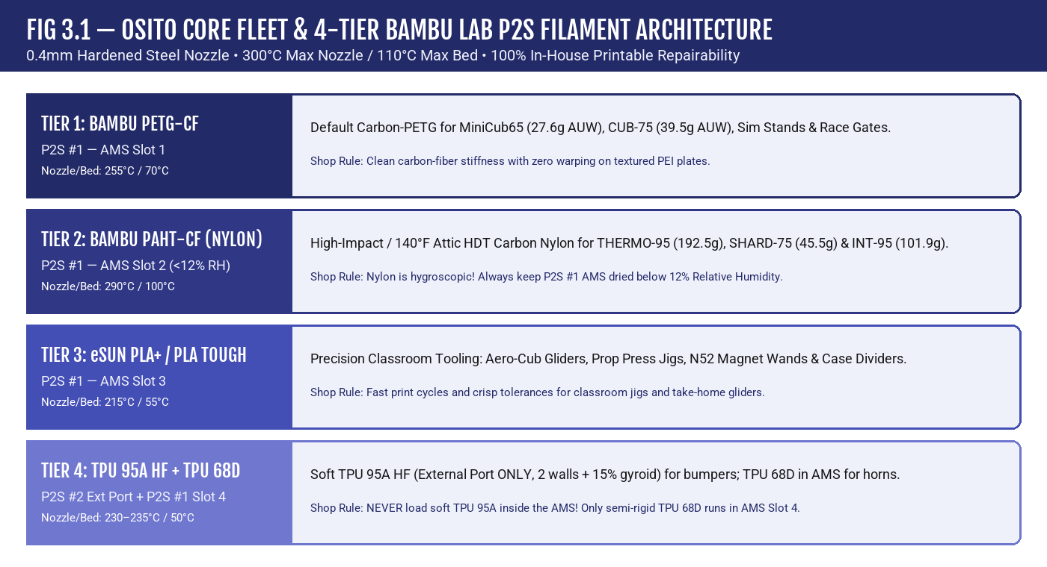
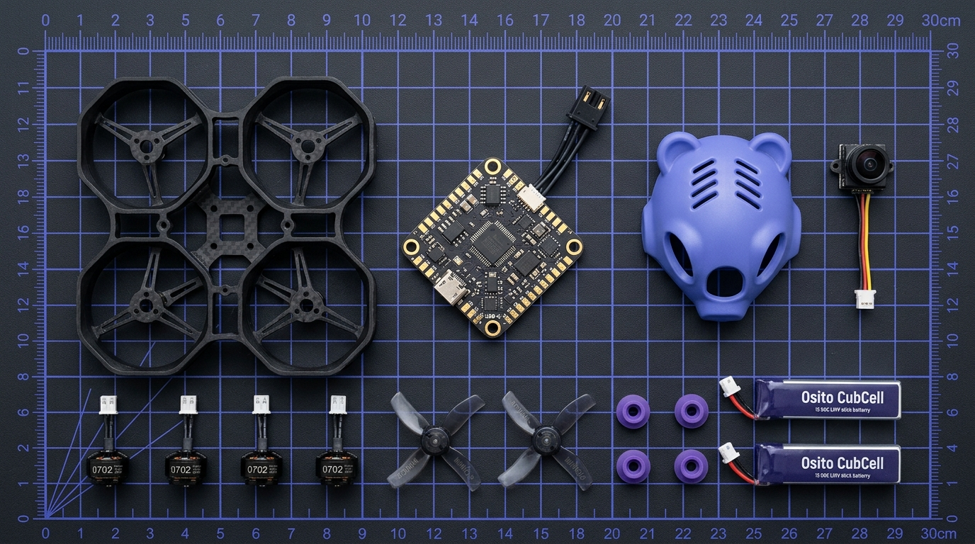
💡 SHOP RULE FOR TEEN CADETS: WHY NYLON MUST BE DRIED BELOW 12% RH
Polyamide (Nylon / PAHT-CF) is 'hygroscopic'—it absorbs water molecules straight out of humid San Francisco air! If you print wet PAHT-CF at 290°C, the trapped water flashes into steam bubbles inside the nozzle, destroying layer adhesion by up to 40%. Always verify the P2S AMS hygrometer reads <12% Relative Humidity before printing Tier 2 parts.

CHAPTER 04 • OSITO TEEN AEROSPACE & COMMERCIAL HANDBOOK (AGES 12–16)
AVIONICS, FLIGHT CONTROLLERS, PID LOOPS & AEROSPACE FIRMWARE SAFETY
At the center of every Osito drone sits a 25.5 × 25.5 mm green-and-gold printed circuit board (PCB) weighing less than two nickels. Yet this tiny All-In-One (AIO) board packs five aerospace subsystems that used to fill an entire rack in a full-scale airliner.
4.1 ANATOMY OF THE OSITO_CUBBRAIN65_V1 AIO FLIGHT CONTROLLER
When you inspect an Osito flight controller under our bench magnifier, you'll identify five key chips:
1. Microcontroller Unit (MCU — STM32F411CEU6): A 32-bit ARM Cortex-M4 processor running at 100 MHz with a hardware Floating-Point Unit (FPU). It executes the Betaflight flight control loop 8,000 times per second.
2. Inertial Measurement Unit (IMU — TDK InvenSense ICM-42688-P): A 6-axis Micro-Electro-Mechanical System (MEMS) containing a 3-axis Gyroscope (measures angular rotation rate in degrees/sec) and a 3-axis Accelerometer (measures linear g-forces and gravity direction so the drone knows which way is 'level' in Angle Mode).
3. 4-in-1 Brushless Electronic Speed Controllers (ESCs — 12A Continuous, Bluejay 48kHz): Four pairs of half-bridge MOSFETs controlled by EFM8BB21 microcontrollers. Because brushed motors wear out after 6–10 hours, Osito uses 3-phase sensorless brushless motors driven via DShot300 digital telemetry and 48kHz PWM for extra flight efficiency.
4. ExpressLRS (ELRS) 2.4GHz Radio Receiver (Semtech SX1281): Receives stick commands from your Hall-gimbal radio at 250 packets per second (4ms latency) using LoRa spread-spectrum modulation that punches through gym Wi-Fi noise.
5. On-Screen Display (OSD — AT7456E) & 5.8GHz Video Transmitter (VTX): Overlays live battery voltage, flight timer, pilot callsign, and artificial horizon directly onto your FPV goggle video feed.
4.2 HOW THE 8KHZ PID CONTROL LOOP KEEPS YOUR DRONE STABLE
Every 125 microseconds (8,000 Hz), the flight controller compares your Desired Stick Rate (Setpoint) against the Actual Gyro Rate (Measurement). The difference is the Error: e(t) = Setpoint − Gyro. The PID controller calculates motor corrections using three terms:
• P — Proportional (Present Error): P_out = Kp × e(t). Pushes back immediately in proportion to how far off-target the drone is. Too little P feels mushy; too much P causes fast, high-pitched oscillations.
• I — Integral (Past Accumulated Error): I_out = Ki × ∫ e(t) dt. Remembers steady forces like a crosswind or an off-center battery and builds up steady motor trim until the drift disappears.
• D — Derivative (Future Rate of Change): D_out = Kd × de(t)/dt. Acts like a shock absorber! As the drone snaps toward its target angle, the D-term brakes the rotation smoothly right before it overshoots (eliminating prop-wash bounce).
4.3 THE THREE GOLDEN RULES OF OSITO FIRMWARE & AVIONICS SAFETY
Across all 68 firmware checks in our workspace safety audit, every Osito script and flight controller enforces three non-negotiable aerospace safety protections:
• Rule 1 — Two-Stage Failsafe Watchdog: If the radio link drops or a companion computer hangs for >100 ms, Stage 1 auto-levels the drone at reduced descend throttle. If link loss exceeds 400–500 ms, Stage 2 disarms the ESCs immediately so a drone can never 'fly away.'
• Rule 2 — Pre-Arm Disarmed Safety Interlock: Flipping the Arm switch will NOT spin the propellers unless the throttle stick is simultaneously held all the way down (<1050 µs) and no boot-time switch fault is active.
• Rule 3 — 16-Bit Millisecond Integer Rollover Handling: Many microcontrollers track time using an unsigned 16-bit integer (uint16_t) counting milliseconds from 0 to 65,535 ms. At 65.536 seconds into a flight, the counter wraps around to 0! Naive code like `if (now_ms > timeout_target)` fails catastrophically at the 65.5-second mark. Proper aerospace code ALWAYS uses unsigned modular subtraction: `(uint16_t)(now_ms - last_ms) >= INTERVAL_MS`.
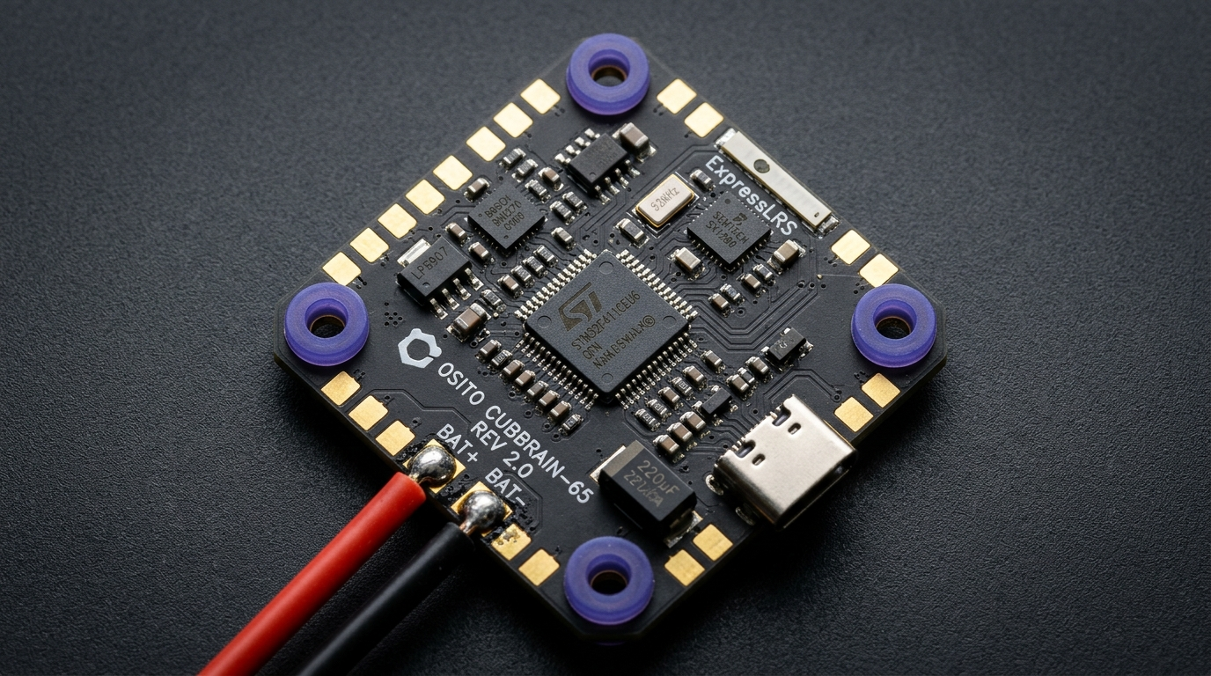
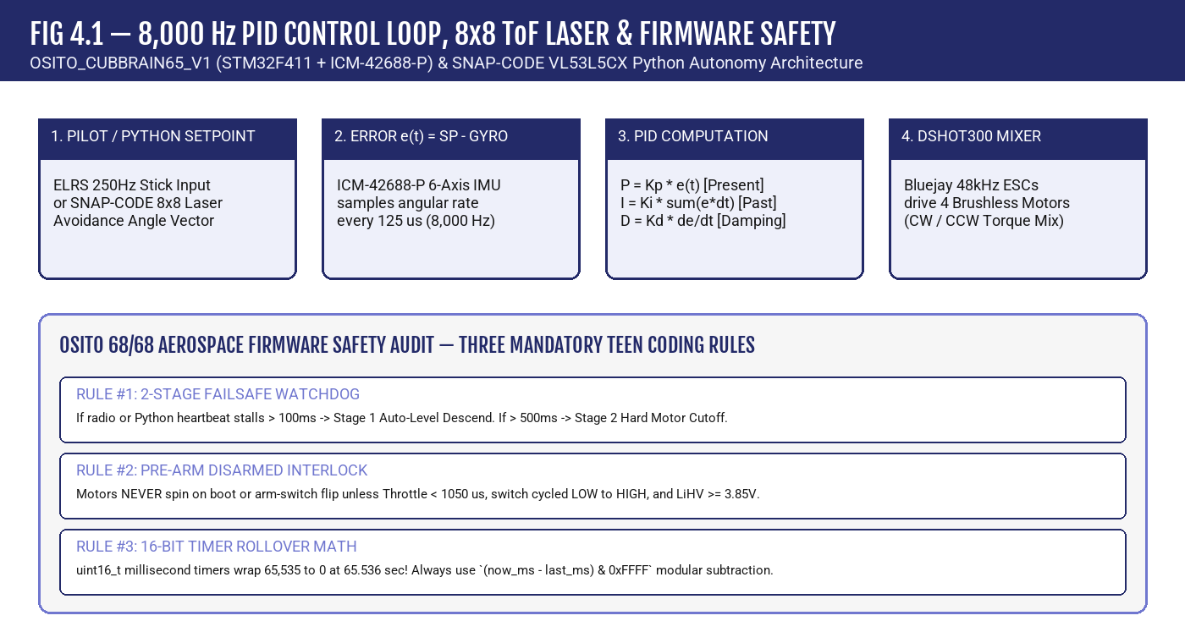
💡 TRY THE ROLLOVER MATH YOURSELF!
Suppose last_ms = 65500 and 80 milliseconds pass, so the 16-bit timer wraps past 65535 to now_ms = 44.
In Python or C: `(44 - 65500) & 0xFFFF = (-65456) & 65535 = 80 ms`!
Unsigned modular subtraction gives the exact 80 ms elapsed time across the wrap-around boundary with zero bugs.

CHAPTER 05 • OSITO TEEN AEROSPACE & COMMERCIAL HANDBOOK (AGES 12–16)
MASTERING THE 4-STATION FLIGHT LAB, LIPO BATTERY SCIENCE & PIT CREW OPS
Great pilots aren't born with magical thumbs—they follow a disciplined training progression and treat high-energy Lithium-Polymer batteries with scientific respect. Here is how Osito's 4-Station Flight Lab turns beginners into pros.
5.1 THE OSITO 4-STATION PROGRESSIVE ROTATION
When Osito Drone Services sets up at a school gymnasium or community center, our team runs four synchronized 15-minute stations so every student gets maximum stick time with zero downtime:
• Station 1 — The 4-Tablet Simulator & Coding Pod: Before risking hardware, you build muscle memory in our CUB-75 / Osito SF Flight Simulator using real USB-C Hall-sensor radios, practicing throttle hover control and Python block/script missions.
• Station 2 — The Pop-Up Netted Hover Cage (Line-of-Sight): Inside a 10×10 ft enclosed mesh tent, you master Stationary Hover at eye level, the 4-Corner Box Drill, and 'Nose-In' orientation (where roll commands appear reversed when the drone faces you!).
• Station 3 — The Neon LED FPV Obstacle Course & Crew Resource Management (CRM): Every FPV pilot flying with goggles is paired with a dedicated Visual Observer (Spotter). Using real airline CRM protocol, the Spotter watches the airspace and calls out battery voltage, gate clearance, and landing cues.
• Station 4 — The Pit Crew & Battery Engineering Bench: Students inspect prop guards, swap tool-free 3-pin JST motors, and log battery storage voltages using ViFly Whoopstor V3 smart chargers inside steel Bat-Safe boxes.
5.2 1S LIHV BATTERY CHEMISTRY, VOLTAGE THRESHOLDS & ENERGY MATH
Our micro-drones use 1-Cell High-Voltage Lithium-Polymer (1S LiHV) batteries (300mAh to 450mAh capacity with BT2.0 high-current connectors). Unlike AA batteries, LiHV cells require strict voltage discipline:
• 4.35 V per cell = 100% Full Charge (LiHV peak voltage).
• 3.80 V per cell = Official Storage Voltage! Always charge or discharge cells to 3.80V on the ViFly Whoopstor V3 at the end of the day. Leaving LiPos at 4.35V for days causes internal gas generation ('puffing') and degrades capacity.
• 3.50 V under load = 'Land Now!' OSD warning floor.
• < 3.30 V = Permanent chemical damage to the lithium-cobalt-oxide cathode layers.
• Energy & C-Rating Formulas:
- Capacity in Amp-Hours (Ah) = mAh ÷ 1,000 (e.g., 300 mAh = 0.30 Ah).
- Stored Energy in Watt-Hours (Wh) = Nominal Voltage (3.8V) × Ah = 3.8V × 0.30Ah = 1.14 Wh.
- Max Safe Continuous Current (Amps) = Capacity (Ah) × C-Rating (e.g., 0.30 Ah × 75C = 22.5 Amps!).
💡 GOLDEN PIT CREW RULE: NEVER UNPLUG BY THE WIRES & ALWAYS USE A BAT-SAFE
Always grip the solid plastic BT2.0 connector housing when unplugging a battery—pulling on the silicone wires can tear the solder joint and cause a dead short! Always charge LiPo/LiHV packs inside a double-walled steel Bat-Safe box with a fiberglass flame-arresting filter, and immediately quarantine any dented or swollen cell.

CHAPTER 06 • OSITO TEEN AEROSPACE & COMMERCIAL HANDBOOK (AGES 12–16)
CODING AUTONOMOUS DRONES — PYTHON, OPTICAL FLOW & LASER MATRIX AVOIDANCE
Manual FPV flying is thrilling, but the future of aerospace belongs to pilots who can also write code. With the CUB-75 MK-II's 4-Pin Magnetic Pogo Snap-Deck, you can snap on our SNAP-CODE Laser Hat and program real autonomous behaviors in Python.
6.1 HOW OPTICAL FLOW AND 8×8 TIME-OF-FLIGHT (TOF) LASERS WORK
Indoors, GPS satellites cannot penetrate gymnasium roofs. So how does an autonomous Osito drone know where it is and avoid walls without GPS?
1. Downward Optical Flow Sensor (PMW3901): Works like a high-speed optical gaming mouse pointed at the floor! It takes 100+ tiny grayscale snapshots per second and tracks how floor textures shift between frames (Δx, Δy) to lock the drone in place with zero horizontal drift.
2. Multi-Zone Time-of-Flight Laser Ranging (STMicroelectronics VL53L5CX): Instead of ultrasonic ping sensors that bounce unpredictably off angled curtains, the VL53L5CX fires invisible, eye-safe 940nm VCSEL laser pulses and measures the exact picoseconds it takes for photons to bounce back across an 8×8 grid (64 independent distance zones at 60 Hz!).
6.2 ANNOTATED PYTHON AUTONOMY SCRIPT (CUB-75 + SNAP-CODE HAT)
Study the Python code listing below. Notice how it combines sensor fusion (reading the 8×8 laser matrix) with the exact aerospace safety rules you learned in Chapter 4 (Disarmed Guard, Pre-Arm Interlock, 2-Stage Watchdog Timeout, and 16-Bit Millisecond Rollover Math):
# ============================================================================
# OSITO DRONE SERVICES — TEEN AUTONOMY LAB (AGES 12-16)
# Platform: CUB-75 MK-II (39.5g AUW / 46.0g w/ SNAP-CODE 8x8 ToF Laser Hat)
# Mission : Autonomous Hover, 8x8 Laser Obstacle Avoidance & Safe Auto-Land
# Safety : Enforces Pre-Arm Interlock, 2-Stage Watchdog & 16-Bit Rollover
# ============================================================================
UINT16_MASK = 0xFFFF # 16-bit MCU timer mask (0..65535 ms)
SOFT_WATCHDOG_MS = 100 # Stage 1 (>100ms): Auto-Level Descend (1150 us)
HARD_WATCHDOG_MS = 500 # Stage 2 (>500ms): Hard Motor Cutoff (1000 us)
MIN_SAFE_DISTANCE_MM = 450 # 450 mm (45 cm) obstacle repulsion threshold
LAND_BATTERY_VOLTS = 3.50 # Auto-land floor for 1S LiHV battery
def elapsed_u16_ms(now_ms: int, last_ms: int) -> int:
"""
AEROSPACE SAFETY RULE #3: Safe 16-bit unsigned integer rollover math.
Even when now_ms wraps from 65535 back to 0, bitwise modular subtraction
(now_ms - last_ms) & 0xFFFF always returns the exact positive elapsed ms!
"""
return (now_ms - last_ms) & UINT16_MASK
class OsitoCub75AutonomousController:
def __init__(self):
self.armed = False
self.throttle_us = 1000
self.last_heartbeat_u16 = 0
def verify_pre_arm_interlock(
self, throttle_us: int, arm_switch_boot_high: bool, battery_v: float, now_u16_ms: int = 0
) -> bool:
"""AEROSPACE SAFETY RULE #2: Disarmed Pre-Arm Safety Interlock."""
self.armed = False
self.throttle_us = 1000
if arm_switch_boot_high:
print("[PRE-ARM BLOCKED] Arm switch was HIGH on boot! Cycle switch to DISARMED first.")
return False
if throttle_us > 1050:
print(f"[PRE-ARM BLOCKED] Throttle ({throttle_us} us) must be below 1050 us!")
return False
if battery_v < 3.85:
print(f"[PRE-ARM BLOCKED] Battery ({battery_v:.2f}V) too low for autonomous launch!")
return False
self.armed = True
self.last_heartbeat_u16 = now_u16_ms & UINT16_MASK
print("[PRE-ARM PASS] All safety interlocks verified. CUB-75 ARMED.")
return True
def compute_avoidance_vector(
self, tof_8x8_grid_mm: list[list[int]], now_u16_ms: int, battery_v: float
) -> dict:
"""
Reads the 8x8 VL53L5CX Time-of-Flight laser matrix (64 distance zones)
and computes pitch/roll avoidance commands in real time.
"""
# 0. Disarmed Interlock Guard: Never spin motors if disarmed!
if not self.armed:
return {"mode": "DISARMED_SAFE_LOCK", "pitch_deg": 0.0, "roll_deg": 0.0, "throttle_us": 1000}
# 1. Two-Stage Rollover-Safe Watchdog Timer (100ms Soft / 500ms Hard)
dt_ms = elapsed_u16_ms(now_u16_ms, self.last_heartbeat_u16)
if dt_ms > HARD_WATCHDOG_MS:
self.armed = False
return {"mode": "FAILSAFE_STAGE2_HARD_DISARM", "pitch_deg": 0.0, "roll_deg": 0.0, "throttle_us": 1000}
if dt_ms > SOFT_WATCHDOG_MS:
return {"mode": "FAILSAFE_STAGE1_AUTO_DESCEND", "pitch_deg": 0.0, "roll_deg": 0.0, "throttle_us": 1150}
# 2. Low-Voltage Battery Auto-Land Floor (<= 3.50V)
if battery_v <= LAND_BATTERY_VOLTS:
self.last_heartbeat_u16 = now_u16_ms & UINT16_MASK
return {"mode": "LOW_BATTERY_AUTO_LAND", "pitch_deg": 0.0, "roll_deg": 0.0, "throttle_us": 1200}
# 3. Inspect Center 4x4 Forward Laser Zones for Obstacles
left_min = min(tof_8x8_grid_mm[r][c] for r in range(2, 6) for c in range(0, 4))
right_min = min(tof_8x8_grid_mm[r][c] for r in range(2, 6) for c in range(4, 8))
front_min = min(left_min, right_min)
pitch_cmd = 3.0 # Default gentle forward cruise (+3 degrees pitch)
roll_cmd = 0.0
if front_min < MIN_SAFE_DISTANCE_MM:
pitch_cmd = -5.0 # Pitch back to brake
roll_cmd = +6.0 if left_min < right_min else -6.0
mode = f"OBSTACLE_AVOID (Front={front_min}mm)"
else:
mode = "CRUISE_CLEAR"
self.last_heartbeat_u16 = now_u16_ms & UINT16_MASK
return {"mode": mode, "pitch_deg": pitch_cmd, "roll_deg": roll_cmd, "throttle_us": 1480}

6.3 FIVE ESSENTIAL BETAFLIGHT 4.5.1 CLI DIAGNOSTICS COMMANDS
When you connect an Osito drone to a laptop via USB-C and open the Betaflight Configurator CLI tab, these five commands let you diagnose any hardware issue in seconds:
• `status` — Displays MCU clock speed, CPU load %, gyro temperature, and active Arming Disable Flags (e.g., `THROTTLE`, `RXLOSS`, `CLI`—telling you why a drone refuses to arm).
• `tasks` — Shows real-time execution frequency (Hz) and microsecond jitter for the Gyro/PID loop (`8000 Hz`).
• `get small_angle` — Shows the maximum tilt angle allowed for arming (set `set small_angle = 180` on ducted whoops so you can use Turtle Mode / Flip-Over-After-Crash).
• `rxrange` — Verifies that your radio stick channels span cleanly from `1000` to `2000 µs` with center at `1500 µs`.
• `diff all` — Exports your customized configuration so you can back it up to a `.txt` file or flash 10 classroom drones identically.
💡 PRO DEBUGGING TIP: READING 'ARMING DISABLE FLAGS'
Remember: while you are inside the Betaflight `CLI` tab or connected to Configurator over USB, Betaflight automatically activates the `CLI` or `MSP` Arming Disable Flag so the props cannot accidentally spin on the bench! Always type `exit`, unplug USB, and place the drone on a flat surface before arming.

CHAPTER 07 • OSITO TEEN AEROSPACE & COMMERCIAL HANDBOOK (AGES 12–16)
REAL-WORLD COMMERCIAL MISSIONS AT OSITO DRONE SERVICES
How do drones actually make money and protect communities? At Osito Drone Services, COO Alan Musselman, CEO Miguel Flores, and CTO Jesus Aceves run five high-demand commercial service lines across Northern California—and teen apprentices aged 14–16 train on these exact workflows.
7.1 COMMERCIAL ROOF, SOLAR & BUILDING ENVELOPE INSPECTIONS
Traditionally, inspecting a 50,000 sq ft warehouse roof required two workers climbing tall ladders, walking across hot membranes, and risking falls. An Osito commercial drone maps the entire roof in 18 minutes:
• We fly an automated Nadir (90° straight-down) and Oblique (45° angled) lawnmower grid with 75% frontlap and 70% sidelap.
• Photogrammetry software stitches 250+ geotagged photos into a centimeter-accurate 2D Orthomosaic Map and 3D Digital Surface Model (DSM), pinpointing cracked tiles, hail impacts, clogged scuppers, and ponding water.
7.2 HVAC, ELECTRICAL & ATTIC THERMAL RADIOMETRY (ΔT HEAT-LOSS ANALYSIS)
Using our PAHT-CF THERMO-95 (192.5g AUW) indoor inspector and enterprise radiometric thermal drones, we see invisible Long-Wave Infrared (LWIR, 8–14 µm wavelength) heat radiation:
• Every pixel in a radiometric thermal image records an exact temperature in °F and °C. We look for Temperature Differentials (ΔT = T_anomaly − T_baseline).
• Why We Fly Roof Moisture Inspections Right After Sunset: During a sunny day, solar rays heat the entire roof. Where water has leaked underneath the roof membrane, that trapped water has high Specific Heat Capacity (it holds heat much longer than dry insulation). About 30–90 minutes after sunset, dry roof sections cool rapidly while wet, leaking sections glow bright warm orange on our thermal camera!
• On commercial solar arrays and electrical panels, a single defective solar cell or loose breaker shows up instantly as a +15°C to +40°C ΔT hotspot before it can spark a fire.
7.3 LUXURY REAL ESTATE & ONE-TAKE INDOOR FPV CINEMA FLY-THROUGHS
Have you ever seen a continuous, single-take video that flies from the street, glides through the front door of a luxury home or stadium, weaves through rooms, and exits out a balcony? Osito flies these missions using sub-250g ducted cinewhoops:
• Ducted prop guards protect walls, chandeliers, and actors.
• Pilots use softened 'Expo' stick curves and constant-velocity coordinated turns, recording raw gyro data so post-production software (Gyroflow) can make the 4K60 footage look like it was shot on a floating magic carpet.
Osito Commercial Service Line | Problem We Solve for Clients | Sensors & Flight Technique | Deliverable to Client | Teen Apprentice Role (Ages 14–16)
1. Commercial Roof & Building Envelope Inspection | Eliminates dangerous ladder climbs on 3-to-6 story warehouses, schools & HOAs | 4K/48MP Nadir (90° down) + 45° Oblique grid patterns at 75% overlap | Annotated Orthomosaic Roof Map + Hail/Crack/Ponding Defect Report | Visual Observer (VO), Ground Control Check & Defect Tagging Assistant
2. HVAC & Solar Thermal Radiometry (ΔT) | Detects hidden roof leaks, missing attic insulation, and failing solar cells | Radiometric LWIR Thermal Camera (8–14 µm) + THERMO-95 indoor duct checks | Calibrated Thermal Delta-T (ΔT) Report showing exact °F/°C hotspots | Post-Sunset Thermal Calibration Log & ΔT Anomaly Spreadsheet Analyst
3. Luxury Real Estate & One-Take FPV Cinema | Creates viral, continuous single-take fly-throughs from street through interiors | Sub-250g Ducted Cinewhoop / MiniCub65 with Constant-Rate Expo turns | Color-graded 4K60 One-Take Reel + Stabilized Gyroflow Master | Room Staging Coordinator, Door-Cue Spotter & Gyroflow Stabilization Tech
4. AgTech, Watershed & Vector Habitat Mapping | Finds standing-water mosquito breeding zones & measures crop vigor | Automated Waypoint Grid + Multispectral NDVI / High-Res RGB | GIS Geotagged Standing-Water Pin Map & Plant Health Index | Flight Path Waypoint Planner & Telemetry Data Logger
5. Gamified FPV Arenas & Corporate/School Events | Brings live esports drone racing and STEM labs to schools & venues | 4-Station Rotation: Sim Pod, Hover Cage, Neon LED FPV Track & Pit Bench | Turnkey Live Leaderboard Tournament + FAA TRUST Youth Certifications | Paid Junior Flight Coach, Sim Pod Mentor & Station 4 Pit Crew Tech

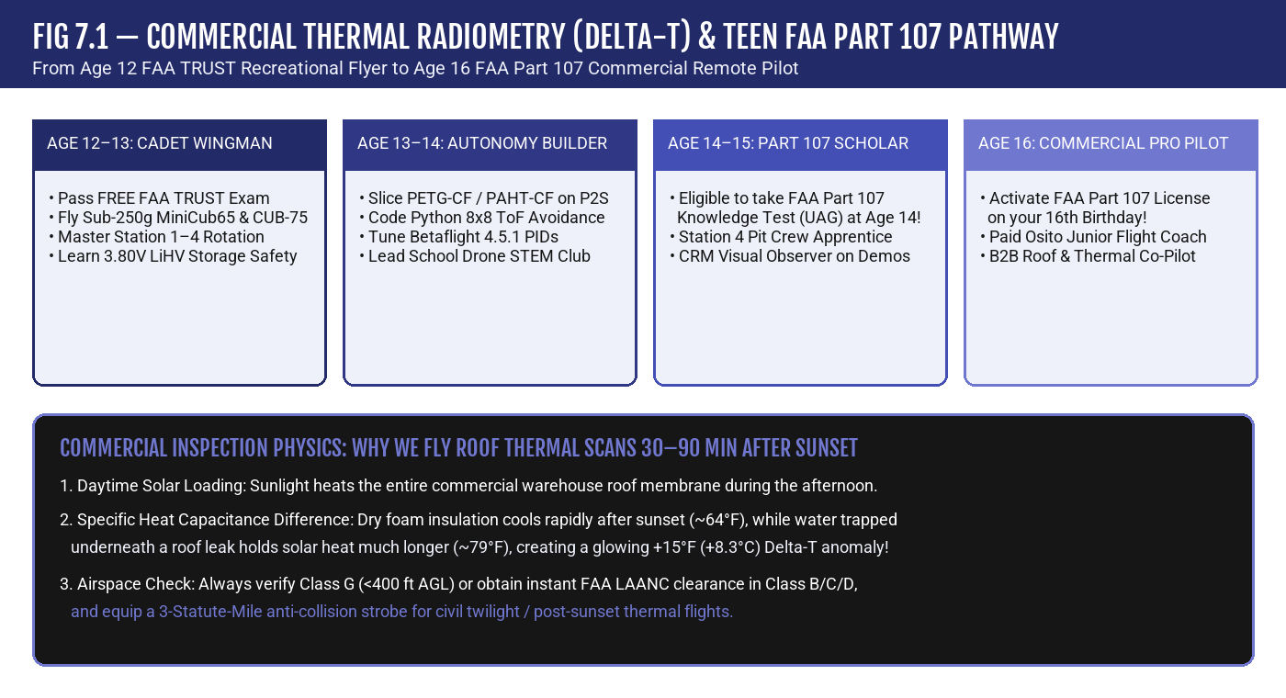
💡 PHYSICS IN ACTION: THERMAL EMISSIVITY (ε)
Not all surfaces radiate infrared heat equally! Matte roof shingles and asphalt have high Emissivity (ε ≈ 0.92–0.95), giving very accurate thermal readings. Shiny unpainted aluminum HVAC ducts have low Emissivity (ε ≈ 0.05–0.10) and reflect the sky like a thermal mirror! Always check surface emissivity before logging a ΔT anomaly.

CHAPTER 08 • OSITO TEEN AEROSPACE & COMMERCIAL HANDBOOK (AGES 12–16)
AIRSPACE LAW, FAA TRUST (AGES 12–16) & YOUR ROAD TO FAA PART 107 (AGE 16)
The moment your drone's propellers lift off the grass outdoors, you are operating an aircraft inside the United States National Airspace System (NAS). Knowing the rules separates an amateur from a respected Osito Cadet—and sets you up to pass your FAA Part 107 exam.
8.1 STEP 1 (TODAY, AGES 12–16): PASS YOUR FREE FAA TRUST EXAM
Under 49 U.S.C. § 44809, EVERY recreational drone pilot in America—regardless of age or drone weight—must pass The Recreational UAS Safety Test (TRUST) before flying outdoors:
• Cost & Age Limit: 100% FREE, online, takes ~20 minutes, and has NO minimum age (12-to-16-year-olds take it at every Osito Academy camp!).
• Can You Fail? No! TRUST is an interactive learn-and-test module; if you miss a question, it explains the rule and lets you answer again immediately, issuing your official lifetime FAA TRUST Completion Certificate.
8.2 THE 250-GRAM (0.55 LB) THRESHOLD, REGISTRATION & STANDARD REMOTE ID
Why did Osito engineer the MiniCub65 at 27.6g, the CUB-75 at 39.5g, the SHARD-75 at 45.5g, the OSITO-INT-95 at 101.9g, and the THERMO-95 at 192.5g? Because 250 grams (0.55 lbs) is the most important weight boundary in FAA law:
• Recreational Flights Under 250g (< 0.55 lbs): Exempt from FAA drone registration and exempt from broadcasting Standard Remote ID!
• Drones Weighing 250g or More (≥ 0.55 lbs), OR Any Drone Flown Commercially Under Part 107 (Regardless of Weight!): Must be registered on FAADroneZone ($5 for 3 years, registration number labeled on the exterior of the hull) and must comply with FAA Standard Remote ID (a digital 'license plate' broadcasting the drone's serial number, GPS position, altitude, and take-off location over Wi-Fi/Bluetooth).
8.3 CORE AIRSPACE RULES & HOW TO PREPARE FOR FAA PART 107 AT AGES 14–16
Whether flying recreationally under TRUST or studying for your commercial Part 107 exam, memorize these core National Airspace System numbers:
• Maximum Altitude: 400 feet Above Ground Level (AGL) in uncontrolled Class G airspace. (Bonus Part 107 Rule: Commercial Part 107 pilots may fly higher than 400 ft AGL ONLY if within a 400-foot radius of a tall structure like a radio tower or building, up to 400 feet above that structure's top!).
• Maximum Groundspeed (Part 107): 87 knots (100 mph).
• Minimum Weather Visibility & Cloud Clearance (Part 107): At least 3 Statute Miles (3 SM) visibility from your control station, and stay at least 500 feet below clouds and 2,000 feet horizontally from clouds.
• Night Operations: Permitted only when your drone is equipped with lighted anti-collision strobes visible for at least 3 Statute Miles (flash rate sufficient to avoid a collision).
• Age 14 Exam / Age 16 Certificate Rule: At age 14 or 15, you can schedule and pass the 60-question FAA Part 107 Aeronautical Knowledge Test (`UAG`, minimum passing score 70% = 42/60) at an FAA testing center, and submit your IACRA application for your commercial Remote Pilot Certificate as soon as you turn 16!
Airspace Class | Real-World Bay Area Example | Altitude & Structure | Drone Authorization Needed? | Teen Pilot Rule of Thumb
Class B (Busy Major Airports) | San Francisco Int'l (SFO) | Surface to 10,000 ft MSL ('Upside-Down Wedding Cake') | YES — FAA LAANC or DroneZone required before takeoff | Never fly near SFO corridors without explicit LAANC grid approval
Class C (Mid-Sized Radar Airports) | Oakland (OAK) & San Jose (SJC) | Surface to 4,000 ft AGL (5 NM inner core + 10 NM outer shelf) | YES — Instant approval via FAA LAANC app up to grid ceiling | Check the FAA B4UFLY / AutoPylot / Aloft grid ceiling (e.g., 100 ft–400 ft)
Class D (Towered Regional Airfields) | Hayward Executive (HWD), Palo Alto (PAO), Concord (CCR) | Surface to ~2,500 ft MSL cylinder around control tower | YES — LAANC required when the control tower is active | Watch for low-flying Cessna training aircraft on approach
Class E (Controlled Transition Airspace) | Starts at 700 ft or 1,200 ft AGL in most areas (or Surface E) | Links Class G surface to high-altitude airways | NO if starting at 700/1200 ft AGL; YES if 'Surface Class E' | Since drones stay ≤400 ft AGL, normal Class E above 700 ft is clear
Class G (Uncontrolled Airspace) | Most neighborhood parks, schoolyards & indoor gyms | Surface up to base of overlying Class E (typically 700/1200 ft AGL) | NO ATC authorization required (must still obey ≤400 ft AGL & TRUST) | Your primary outdoor training zone! Always yield to manned aircraft

💡 HOW TO DECODE AN AVIATION WEATHER REPORT (METAR) LIKE A PART 107 PILOT
Sample METAR: `KSFO 051856Z 28012G18KT 10SM FEW020 18/11 A3002`
• `KSFO` = San Francisco International Airport station.
• `051856Z` = 5th day of the month at 18:56 Zulu (UTC) time.
• `28012G18KT` = Wind blowing from 280° (West) at 12 knots, gusting to 18 knots.
• `10SM` = 10 Statute Miles visibility (exceeds the 3 SM Part 107 minimum!).
• `FEW020` = Few clouds at 2,000 feet AGL (add two zeros to `020`).
• `18/11` = Temperature 18°C, Dewpoint 11°C. `A3002` = Altimeter setting 30.02 inHg.

CHAPTER 09 • OSITO TEEN AEROSPACE & COMMERCIAL HANDBOOK (AGES 12–16)
THE OSITO TEEN CAREER, APPRENTICESHIP & ENTREPRENEURSHIP PLAYBOOK
You don't have to wait until college to turn aerospace engineering and drone piloting into a standout resume or a paid summer job. Here is how 12-to-16-year-old cadets grow inside the Osito Drone Services ecosystem.
9.1 THREE WAYS TEENS BUILD REAL EXPERIENCE WITH OSITO DRONE SERVICES
1. Middle & High School STEM Captain (Ages 12–14): Launch or co-lead an Osito Drone & Robotics Club at your school! Use our Classroom 10-Drone Turnkey STEM Box (`CUB-75` + `SNAP-CODE` ToF Laser Hats) to compete in aerial obstacle courses, science fairs, and Python autonomy challenges.
2. Osito Station 4 Pit Crew & 3D Print Lab Apprentice (Ages 14–15): Join CTO Jesus Aceves and our technical staff during weekend community pop-ups, school demos, and summer camps. You'll manage ViFly Whoopstor V3 battery rotations, perform tool-free JST motor swaps, inspect PETG-CF and PAHT-CF 3D prints, and serve as a certified CRM Visual Observer.
3. Paid Junior Flight Coach & Commercial Part 107 Co-Pilot (Age 16+): Once you hold your FAA TRUST + Part 107 Remote Pilot Certificate at age 16, you qualify for paid summer camp instruction and B2B commercial field apprenticeships—assisting COO Alan Musselman and CEO Miguel Flores on real roof inspections, thermal scans, and real estate FPV shoots.
9.2 BUILDING YOUR TEEN AEROSPACE PORTFOLIO (FOR CTE, INTERNSHIPS & UNIVERSITIES)
High school Career Technical Education (CTE) programs, summer fellowships, and engineering universities love applicants who can prove hands-on technical mastery. Start keeping a folder containing:
• Your Official FAA TRUST Certificate (and your Part 107 Knowledge Test score report at 14–16).
• Your Signed Osito Student Flight Logbook showing logged Simulator, Line-of-Sight, FPV, and Pit Crew hours.
• Photos or STL files of a custom drone canopy, bumper, or sensor mount you sliced in Bambu Studio.
• Your annotated Python autonomy script or Betaflight PID tuning log.
💡 OSITO TEEN ENTREPRENEURSHIP SPOTLIGHT: HIGH-VALUE SKILLS
A single commercial roof inspection or thermal solar scan saves a property manager $1,500 to $5,000 in scaffolding and labor while preventing roof falls. By combining safe piloting, thermal physics, and clear client reporting, you are learning one of the highest-ROI technical trades of the 2020s and 2030s.

CHAPTER 10 • OSITO TEEN AEROSPACE & COMMERCIAL HANDBOOK (AGES 12–16)
ENGINEERING CHALLENGES, PRE-FLIGHT CHECKLISTS, FLIGHT LOG & CERTIFICATION EXAM
Put your aerospace knowledge to the test! Complete the three worked engineering challenges, practice the official Osito P.A.V.E. Pre-Flight Checklist before every takeoff, log your flights, and score at least 12/15 (80%) on the Teen Certification Exam to earn your Osito Teen Aerospace Cadet Wings.
10.1 THREE WORKED TEEN AEROSPACE MATH & ENGINEERING CHALLENGES
CHALLENGE A — Thrust-to-Weight & Payload Budget (`CUB-75 MK-II` + `SNAP-CODE` Hat):
• Problem: An Osito CUB-75 MK-II weighs 29.0g dry and 39.5g All-Up Weight (AUW) with its standard 10.5g 1S LiHV battery. You snap on the 6.5g SNAP-CODE 8×8 ToF Laser Hat. Each of the four 0802 22,000KV motors generates 38.0g of maximum thrust. What is the new All-Up Weight (AUW), Total Thrust, Thrust-to-Weight Ratio (T/W), and approximate Hover Throttle %?
• Step-by-Step Solution:
1. New All-Up Weight (AUW) = 39.5g (standard AUW) + 6.5g (SNAP-CODE ToF hat) = 46.0 grams.
2. Total Max Thrust = 4 motors × 38.0g = 152.0 grams.
3. Thrust-to-Weight Ratio (T/W) = 152.0g ÷ 46.0g = 3.30 : 1 (Well above the 2.0:1 safe agility minimum!).
4. Approximate Hover Thrust % = 1 ÷ 3.30 ≈ 30.3% thrust.

CHALLENGE B — LiHV Battery Watt-Hours & Flight Endurance:
• Problem: Your CUB-75 hovers at an average current draw of 3.6 Amps using a 1S 450mAh (3.8V nominal) LiHV pack. To protect battery health, you use 80% of the pack's capacity before landing at 3.50V. How many Watt-Hours (Wh) does the battery store, and how many minutes of safe flight time do you get?
• Step-by-Step Solution:
1. Capacity in Amp-Hours = 450 mAh ÷ 1000 = 0.45 Ah.
2. Total Stored Energy = 3.8V × 0.45 Ah = 1.71 Wh.
3. Usable Capacity (80% Rule) = 0.45 Ah × 0.80 = 0.36 Ah.
4. Safe Flight Time = (0.36 Ah ÷ 3.6 Amps) × 60 min/hr = 0.10 hr × 60 = 6.0 minutes!

CHALLENGE C — Thermal Roof Inspection Timing & Delta-T (ΔT):
• Problem: During a post-sunset commercial warehouse inspection, the dry roof membrane measures 64°F (17.8°C), while a 12×12 ft section near an HVAC curb reads 79°F (26.1°C) on the THERMO-95 radiometric camera. Calculate ΔT and explain the physical cause.
• Step-by-Step Solution:
1. ΔT = 79°F − 64°F = +15.0°F (+8.3°C).
2. Physical Cause: Water has leaked under the membrane around the HVAC curb. Because water has a much higher specific heat capacity than dry rigid foam insulation, it retains daytime solar heat after sunset and radiates a +15°F warm thermal signature.
10.2 THE OFFICIAL OSITO PRE-FLIGHT P.A.V.E. CHECKLIST
Before every flight—whether inside our 10×10 netted cage or out on a commercial roof—run the FAA P.A.V.E. check:
• [ P ] PILOT (I.M.S.A.F.E.): Am I focused, rested, wearing my lanyard, with my Visual Observer (Spotter) in position?
• [ A ] AIRCRAFT: Are all 4 ducted prop guards intact? Are CW/CCW props tight and free of hair/grass? Is the 1S LiHV battery charged (4.30V–4.35V), un-puffed, and strapped securely through the frame slot?
• [ V ] ENVIRONMENT & AIRSPACE: Is the flying zone clear of bystanders and pets? If outdoors, have we verified Class G / LAANC airspace, wind < 15 knots, and ≥ 3 SM visibility?
• [ E ] EXTERNAL PRESSURES & INTERLOCKS: Is the Throttle stick at 0% (<1050 µs) and Arm switch DISARMED before plugging in the BT2.0 battery? Have we announced 'Clear Prop — Arming!' out loud?
💡 READY FOR YOUR OSITO TEEN CERTIFICATION EXAM?
Complete your Flight Logbook in Section 10.3 and take the 15-Question Osito Teen Aerospace & Part 107 Prep Quiz in Section 10.4! Score 12 out of 15 (80%) or higher to have your Osito Flight Coach sign your Teen Cadet Certificate.

10.3 OFFICIAL OSITO TEEN PILOT FLIGHT & PIT CREW LOGBOOK
Date | Platform (MiniCub65 / CUB-75 / THERMO-95) | Station / Mission Mode | Battery Start/End V | Duration (Min) | Coach / Spotter Initials
____/____/2026 | Osito MiniCub65 BNF (27.6g AUW) | Station 1: Sim + Station 2: Hover Box | 4.35V -> 3.80V | 15 min | ________
____/____/2026 | Osito CUB-75 MK-II (39.5g AUW) | Station 3: FPV LED Course + CRM Spotter | 4.35V -> 3.78V | 15 min | ________
____/____/2026 | CUB-75 + SNAP-CODE Hat (46.0g AUW) | Python 8x8 Laser Obstacle Avoidance | 4.35V -> 3.82V | 20 min | ________
____/____/2026 | SHARD-75 / KODIAK-75 (45.5g AUW) | Optical-Flow Hold & Bumper Momentum Lab | 4.35V -> 3.80V | 15 min | ________
____/____/2026 | THERMO-95 Inspector (192.5g AUW) | Post-Sunset Delta-T Roof/HVAC Simulation | 4.35V -> 3.80V | 15 min | ________
____/____/2026 | Station 4 Pit Crew Bench | Whoopstor V3 3.80V Storage & JST Check | Storage 3.80V | 15 min | ________

10.4 THE 15-QUESTION OSITO TEEN AEROSPACE, TRUST & PART 107 PREP EXAM
1. Why do two diagonal motors on a quadcopter spin Clockwise (CW) while the other two spin Counter-Clockwise (CCW)?
A) To cool down the flight controller battery
B) To cancel out reactive torque (Newton's Third Law / Conservation of Angular Momentum) so the frame doesn't spin uncontrollably
C) Because brushless motors can only spin in one direction
D) To make the drone louder during takeoff
2. An Osito MiniCub65 BNF weighs 27.6g All-Up Weight (AUW) and produces 116g of total maximum thrust. What is its Thrust-to-Weight Ratio?
A) 1.0 : 1
B) 2.1 : 1
C) 4.20 : 1
D) 10.5 : 1
3. Which 3D printing filament from Osito's 4-Tier Bambu P2S standard is used for the THERMO-95 drone so it won't warp inside 140°F attics?
A) Standard classroom PLA
B) Soft TPU 95A HF
C) Tier 2 Bambu PAHT-CF / PA12-CF (High-Temp Carbon Fiber Nylon, dried <12% RH)
D) Wax support filament
4. Why must soft Bambu TPU 95A HF NEVER be loaded inside the enclosed Bambu AMS unit?
A) Soft 95A elastomer buckles and jams inside the motorized AMS PTFE feed rollers; it must feed from P2S #2's external dryer port
B) It changes color in the dark
C) It is magnetic
D) It melts at room temperature
5. In the flight controller's 8,000 Hz PID control loop, which term acts like a 'shock absorber' to brake fast rotations and prevent overshoot?
A) The P-Term (Proportional)
B) The I-Term (Integral)
C) The D-Term (Derivative — rate of change of error)
D) The VTX-Term
6. Why do embedded avionics scripts use `(now_ms - last_ms) & 0xFFFF` when checking a 16-bit millisecond timer?
A) To make the LEDs blink purple
B) Because a 16-bit unsigned integer wraps from 65,535 ms back to 0 at ~65.5 seconds, and modular subtraction prevents rollover lockups
C) To convert milliseconds into miles per hour
D) To disable the gyroscope
7. What is the ideal Storage Voltage per cell for Osito's 1S LiHV batteries on the ViFly Whoopstor V3 charger at the end of a flight day?
A) 0.00 V
B) 2.50 V
C) 3.80 V per cell
D) 4.35 V per cell for weeks
8. How does the CUB-75's SNAP-CODE VL53L5CX Time-of-Flight (ToF) sensor detect obstacles indoors?
A) By bouncing loud sound waves off the floor
B) By timing invisible 940nm laser photon pulses across an 8×8 grid (64 independent distance zones)
C) By connecting to GPS satellites through the roof
D) By measuring air barometric pressure
9. Why does Osito Drone Services perform commercial flat-roof thermal moisture inspections 30–90 minutes AFTER sunset?
A) Because drones fly faster in the dark
B) Water trapped under a leaking roof membrane has high specific heat capacity and stays warm after the dry roof cools down, creating a clear +ΔT thermal signature
C) Because infrared cameras cannot turn on during the day
D) To avoid wind
10. Which FAA test is 100% free, online, has NO minimum age limit, and is legally required for all recreational youth drone pilots?
A) The Airline Transport Pilot (ATP) exam
B) The FAA TRUST (The Recreational UAS Safety Test)
C) The California DMV driving test
D) The NASA astronaut medical exam
11. What is the maximum legal weight (including battery and prop guards) for a recreational drone to be exempt from FAA Registration and Remote ID?
A) Under 250 grams (< 0.55 lbs)
B) Under 55 pounds
C) Under 10 kilograms
D) Under 5 grams
12. If a 39.5g Osito CUB-75 is flown for a PAID commercial roof or real estate job under FAA Part 107, does it require FAA Registration ($5)?
A) No, because it weighs under 250g
B) Yes! Every drone flown commercially under Part 107 must be registered, regardless of weight
C) Only on Tuesdays
D) Only if flown above 1,000 feet
13. What is the standard maximum altitude for drone operations in uncontrolled Class G airspace?
A) 400 feet Above Ground Level (AGL)
B) 1,200 feet AGL
C) 10,000 feet MSL
D) 50 feet AGL
14. At what age can a teen take the FAA Part 107 Aeronautical Knowledge Exam, and at what age can they receive the official Remote Pilot Certificate?
A) Exam at age 18, Certificate at age 21
B) Exam at age 14, Certificate on their 16th birthday!
C) Exam at age 10, Certificate at age 12
D) Exam at age 25
15. In the aviation weather report `KSFO 051856Z 28012KT 10SM FEW020`, what does `10SM` tell the drone pilot?
A) Wind speed is 10 miles per hour
B) Visibility is 10 Statute Miles (well above the 3 SM minimum required for Part 107 flight)
C) There are 10 drones in the sky
D) Temperature is 10°F
💡 OFFICIAL INSTRUCTOR & SELF-STUDY ANSWER KEY (PASSING SCORE: 12 / 15 = 80%)
Q1: B — Spinning two diagonal props CW and two CCW balances angular momentum (net torque = 0) during hover and climb.
Q2: C — 116g max thrust ÷ 27.6g AUW = 4.20 : 1 Thrust-to-Weight ratio.
Q3: C — Bambu PAHT-CF provides high heat deflection temperature (140°F+ attic HDT) and superior carbon-nylon impact strength.
Q4: A — Soft TPU 95A HF feeds from P2S #2's external dryer port; only semi-rigid TPU for AMS (68D) goes inside P2S #1 AMS Slot 4.
Q5: C — The Derivative (D) term opposes rapid rates of change, damping oscillations and preventing overshoot.
Q6: B — Unsigned 16-bit modular subtraction computes exact elapsed time even across the 65,535 -> 0 wrap-around boundary.
Q7: C — 3.80V per cell is the stable chemical storage voltage; storing packs full at 4.35V causes gas puffing and capacity loss.
Q8: B — The VL53L5CX is an 8×8 multizone Time-of-Flight laser ranging matrix measuring photon round-trip time across 64 zones.
Q9: B — Trapped moisture acts as a thermal sink, retaining daytime solar heat longer than dry insulation after sunset.
Q10: B — Under 49 U.S.C. § 44809, all recreational flyers must pass the free online FAA TRUST test.
Q11: A — Drones weighing less than 250g (0.55 lbs) flown purely for recreation do not require registration or Remote ID.
Q12: B — The <250g registration exemption applies ONLY to recreational flights; Part 107 commercial drones must all be registered.
Q13: A — 400 feet AGL is the standard ceiling in Class G airspace (unless within 400 ft of a structure under Part 107).
Q14: B — Teens can sit for the UAG Knowledge Test starting at age 14 and apply for their Part 107 Remote Pilot Certificate at age 16.
Q15: B — 10SM means 10 Statute Miles of surface visibility (Part 107 requires at least 3 SM).

★ 10.5 OFFICIAL GRADUATION CREDENTIAL • OSITO DRONE SERVICES (SAN FRANCISCO, CA) ★
OSITO TEEN AEROSPACE CADET & JUNIOR PILOT WINGS (AGES 12–16)
This certifies that Cadet __________________________________________________ has mastered Multirotor Flight Physics, 4-Tier Carbon 3D-Printed Airframes, 8kHz PID Avionics & 16-Bit Watchdog Safety, 1S LiHV Battery Storage Protocol, Python 8×8 Laser Autonomy, Commercial Thermal Radiometry (ΔT), and FAA TRUST / Part 107 Airspace Law.
Signed: Miguel Flores (CEO) • Alan Musselman (COO) • Jesus Aceves (CTO) | Date: ________________________

