# Sign up for Github

1. Go to <https://github.com/> and sign up for Github
2. Create a repository (only team member does this)

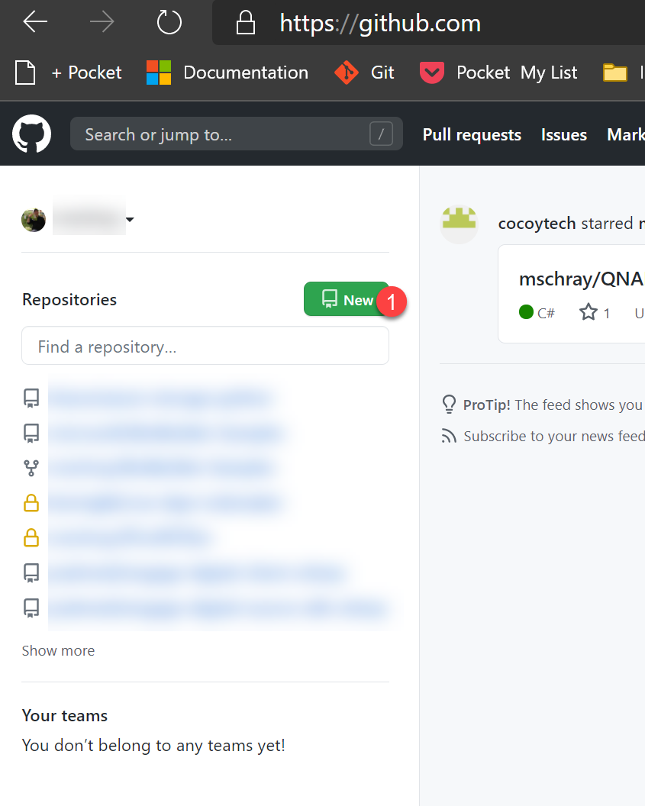

1. Invite other team members to the created the repo (e.g. repository)

