Securing Connected Systems

A Layered Security Framework for WSNs, IoT/CPS, and Virtualized Networks
Engineering-to-Research Monograph Series, Volume 1 of 10
Alan Biju Palayil
Independent Researcher · Application Development Analyst, Financial Services · Doctoral Researcher, University of the Cumberlands
ORCID: 0009-0004-8302-5090
Version 1.0 · June 2026
DOI: 10.5281/zenodo.20733453
License: Text CC BY 4.0 · Companion code MIT
Keywords: wireless sensor networks, Internet of Things, cyber-physical systems, network function virtualization, software-defined networking, lightweight cryptography, secure routing, layered defense, post-quantum cryptography, edge security

Engineering-to-Research Monograph Series · Volume 1 of 10

Executive Summary
Problem. Connected systems now stretch from a battery-powered sensor, through an embedded network stack, into a carrier network whose firewalls and intrusion detectors are themselves software running on shared hardware. Each segment is defended by a different community using a different threat model. Attackers do not respect those boundaries. A compromise that begins at a sensor can become a routing attack and then slip past a misconfigured virtual defense, yet no single community owns that path. The result is a structural blind spot that ordinary, layer-by-layer security does not see.
Findings. Wireless sensor networks, IoT and cyber-physical systems, and virtualized networks are not three security problems. They are three strata of one system, and they share a single root difficulty: providing confidentiality, integrity, and availability under constraints that classical security tools were not built for, namely limited energy, real-time physical safety, multi-tenancy, and large scale. Both the strongest attacks and the strongest defenses operate across strata rather than within one.
Framework. This report contributes a layered framework for connected-system security. It consists of a connected-systems layer model (Figure 3), a unified threat taxonomy that maps attacks consistently across the device, network, and orchestration strata, and a layered defense reference model that assigns proportionate controls to each stratum while requiring cross-stratum coordination (Figure 2). A comparison against established models shows that traditional wireless-sensor, IoT, and virtualization security approaches each cover only part of the stack, whereas the proposed model covers all three strata and their coordination.
Recommendations. Practitioners should match each control to the cost model of its stratum, place public-key operations where energy is available and lightweight symmetric cryptography on constrained nodes, treat the virtualization layer as both the most powerful defensive instrument and the most concentrated single point of failure, and design defenses that span layers because attacks do. The open frontier, developed in later volumes of this series, is the governance and explainability of the automated, increasingly AI-driven defenses that this layer makes possible.

Abstract
Connected systems, including wireless sensor networks (WSNs), Internet-of-Things (IoT) and cyber-physical systems (CPS), and the virtualized network infrastructure that carries their traffic, are usually studied as separate security domains. This separation hides the fact that they form a single layered attack surface. A compromised sensor node, a forged routing advertisement, and a hijacked virtual network function are different expressions of one underlying problem, which is securing computation and communication under severe resource, trust, and scale constraints. This report unifies the three domains. It develops a common threat taxonomy spanning the physical, network, and orchestration layers, reviews the cryptographic and protocol-level defenses available at each layer from classical public-key cryptography through lightweight and post-quantum schemes, and synthesizes the findings into a layered defense reference model for connected systems. The analysis is grounded in three implementation studies that the author conducted: a from-scratch RSA cryptosystem, an NS-3 investigation of TCP behavior under congestion, and an encrypted microcontroller client and server link that culminated in the SensoryPi cyber-physical security system. It is situated against the 2023 to 2026 literature. The report closes with open challenges in post-quantum readiness, AI-assisted detection, and the explainability and governance of automated defenses, which motivate later volumes in this series.

1. Introduction
The number of networked devices has grown faster than our ability to secure them. A modern deployment may run from a battery-powered sensor measuring soil moisture, through a gateway running an embedded TCP/IP stack, across a carrier network whose firewalls and intrusion-detection functions are themselves software running on shared hypervisors. Each segment is studied by a different research community, namely sensor-network security, IoT and CPS security, and network-virtualization security, and each community has produced its own surveys, threat models, and defenses.
Treating these as independent problems is convenient but misleading. The three domains share the same root tension. Security must be provided under constraints that the classical security toolkit was not designed for. In a WSN the constraint is energy and computation at the node. In a CPS it is real-time deadlines and physical actuation. In a virtualized network it is multi-tenancy, dynamic placement, and the loss of the old hardware trust boundary. The attacker, meanwhile, moves freely across these boundaries. A physical-layer compromise of a sensor can seed a network-layer routing attack, which can then be amplified by a misconfigured or hijacked virtual security function.
This report argues that the three domains are best understood as strata of one connected system, and that defenses are most effective when designed across strata rather than within one. The contribution is fourfold. First, a connected-systems layer model that frames the three domains as one architecture (Section 3). Second, a unified threat taxonomy that maps attacks consistently across the physical, network, and orchestration layers (Section 4). Third, a layered defense reference model that consolidates the review into design guidance (Section 8). Fourth, an explicit statement and evaluation of these contributions (Sections 9 and 10). The scope is integrative rather than exhaustive within any single domain. Readers seeking domain-specific depth are pointed to the recent surveys cited throughout, which Section 2 reviews.

2. Related Work
Three bodies of literature inform this report, and a fourth, smaller body motivates it by its absence.
Wireless sensor network security. A large literature addresses secure routing, key management, and trust in WSNs, where resource constraints dominate every design choice. Recent systematic reviews catalogue lightweight cryptographic schemes for resource-constrained devices and their measured trade-offs on real hardware [2], [3], [6]. This work is deep but bounded to the device and routing layers.
IoT and cyber-physical security. A second literature treats the IoT and CPS threat landscape across physical, network, and application layers, including emerging machine-driven attacks, and emphasizes that conventional perimeter models do not fit decentralized, resource-limited deployments [1], [5]. Post-quantum readiness for constrained devices is an active subtopic [4].
Network virtualization security. A third literature examines NFV and SDN security, including hypervisor and orchestrator protection, virtual-appliance ubiquity, third-party functions, and shared resources, and analyzes security threats and mitigations in software-defined and virtualized environments, including 5G slicing [7], [8]. The classic orchestration-challenge framing remains a reference point [9].
The gap. Each literature is rigorous within its layer, and each treats the others as out of scope. Surveys of WSN security rarely model the orchestration layer that increasingly defends them. Surveys of NFV security rarely reach down to the constrained device. No widely adopted framework treats the device, network, and orchestration layers as one attack surface with cross-layer attack chains and coordinated, cross-layer defenses. This report addresses that gap. It does not replace the domain surveys. It connects them.

3. Background and System Model
This report models a connected system as three nested strata, shown in Figure 3.
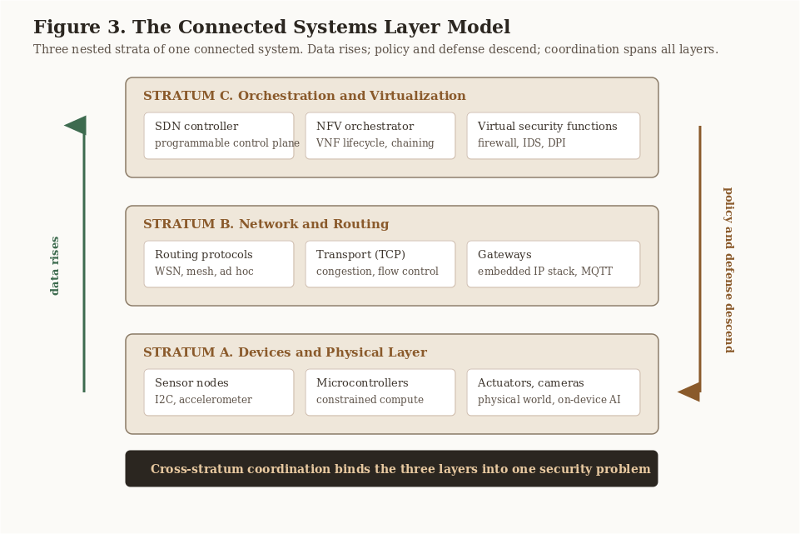
Figure 3. The Connected Systems Layer Model. Three nested strata of one connected system: devices, network, and orchestration. Data rises through the layers, policy and defense descend, and cross-stratum coordination binds the layers into one security problem.
Stratum A, devices and the physical layer. Sensor nodes, actuators, microcontrollers, and gateways. These are resource-constrained in energy, memory, and processing, they have intermittent connectivity, and, importantly, they are physically accessible. An adversary can often touch the hardware. This stratum introduces threats with no analogue in conventional information technology, such as side-channel leakage, node capture, and sensor spoofing that crosses from the cyber world into the physical one.
Stratum B, the network and routing layer. The protocols that move data between devices and toward the core, including WSN routing protocols, the embedded TCP/IP stack, and the transport behaviors such as congestion control, flow control, and reliable delivery that determine whether the network stays usable under stress. Attacks here manipulate the control plane of communication by falsifying routes, exhausting buffers, or partitioning the topology.
Stratum C, the orchestration and virtualization layer. Increasingly, the network functions that defend the lower strata, such as firewalls, intrusion-detection systems, and deep-packet inspection, are themselves virtual network functions (VNFs) instantiated on demand by an orchestrator over shared infrastructure and coordinated by a software-defined networking (SDN) controller. This stratum introduces a new, concentrated attack surface. Compromise the orchestrator or controller and you compromise the defenses of everything below.
The security objectives are the classical triad of confidentiality, integrity, and availability (CIA), extended by authenticity and freshness to resist replay, and, for CPS, by safety, because incorrect computation can cause physical harm. The defining difficulty is that the cost of each objective is paid in the very resources each stratum lacks.

4. A Unified Threat Taxonomy
The first contribution organizes threats by the stratum at which they act and the objective they violate. The value of the unified view is that it exposes cross-stratum chains, that is, sequences in which an attack at one layer enables an attack at another.

4.1 Stratum A, device and physical threats
Node capture and tampering compromise integrity and confidentiality by physically seizing a node to extract keys or implant malicious firmware. Side-channel and fault attacks leak confidential material through timing, power, or electromagnetic signals during cryptographic operation. Sensor and actuator spoofing violate integrity and safety by injecting false measurements or commands, which is the defining CPS threat because it crosses into the physical world. Energy-exhaustion attacks, sometimes called sleep-deprivation attacks, deny availability by forcing constrained nodes to stay awake until their batteries die.

4.2 Stratum B, network and routing threats
Eavesdropping passively intercepts traffic over the open wireless medium. Spoofing, impersonation, and Sybil attacks subvert trust or voting by presenting forged identities. Wormhole and sinkhole attacks tunnel traffic between distant points or attract routes to a malicious node in order to drop or alter packets. Denial of service exhausts the network through flooding, buffer exhaustion, or transport-layer manipulation. Man-in-the-middle and ARP spoofing interpose on a link to read or modify traffic.

4.3 Stratum C, orchestration and virtualization threats
Hypervisor and VNF escape break tenant isolation on shared infrastructure. Orchestrator and SDN-controller compromise is the highest-value target, because control of the controller is control of the network's policy and of the security functions themselves. VNF placement and chaining manipulation forces security functions to be bypassed or mis-sequenced in the service chain. Third-party and supply-chain VNF risk introduces malicious or vulnerable functions through the marketplace model.

4.4 Cross-stratum chains
The unified view matters because attacks combine across strata. Figure 1 shows a representative chain. Node capture at Stratum A yields legitimate keys. The adversary then mounts a Sybil or wormhole routing attack at Stratum B that is indistinguishable from valid traffic, because it uses real keys. If the intrusion-detection VNF is naively scaled or mis-placed by the orchestrator at Stratum C, the malicious flow evades inspection entirely. No single-stratum defense stops this chain. Only coordinated controls do. This is the central motivation for the reference model in Section 8.
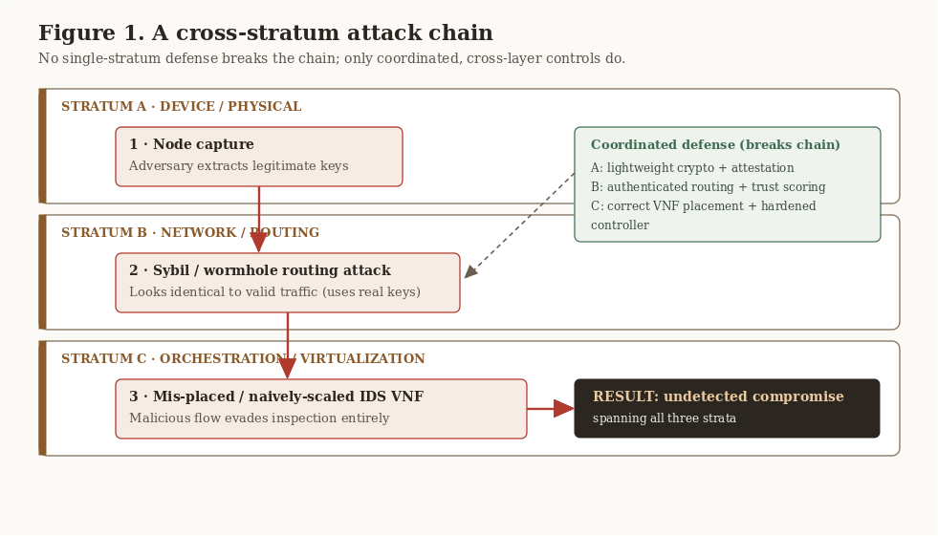
Figure 1. A cross-stratum attack chain. Node capture at Stratum A enables a Sybil or wormhole routing attack at Stratum B that evades a mis-placed intrusion-detection VNF at Stratum C. Coordinated, cross-layer controls break the chain.

5. Cryptographic Foundations and Their Limits
Confidentiality, integrity, and authenticity all rest on cryptography, but the applicability of a primitive depends sharply on the stratum.

5.1 Classical public-key cryptography (RSA), an implementation study
To ground the discussion, the author implemented RSA from first principles. The companion code is the ECE 543 project. The implementation comprises primality generation and verification, public and private key-pair generation, and encryption and decryption, which exposes the full lifecycle rather than calling a black-box library. Two lessons emerged that bear directly on constrained strata. First, key generation is the expensive step. Generating and verifying large primes dominates the cost. On a server this is negligible. On a Stratum-A node it can be prohibitive, which is exactly why public-key operations are pushed to gateways or amortized through session keys. Second, correctness is fragile at the edges. Naive modular exponentiation and weak primality testing are both functional and insecure. Implementing the algorithm rather than importing it makes the gap between working and secure concrete. The takeaway is not that RSA is unsuitable. It is that the cost model of a primitive must be evaluated against the stratum that will run it. A defense that is trivial at Stratum C may be impossible at Stratum A.

5.2 Lightweight cryptography
The constrained-device problem has driven a large body of work on lightweight cryptography, including symmetric ciphers, hash functions, and authenticated-encryption schemes designed for small code size, low energy, and limited memory. The NIST Lightweight Cryptography process standardized and evaluated a substantial family of such algorithms, and recent systematic reviews catalogue their performance and security trade-offs on real IoT hardware [2], [3], [6]. The engineering reality is that symmetric, lightweight, hardware-friendly primitives carry most of the confidentiality and integrity load at Stratum A, with public-key cryptography reserved for key establishment at less-constrained points.

5.3 Post-quantum considerations
Looking forward, the migration to post-quantum cryptography intersects awkwardly with constrained devices. Lattice-based schemes such as CRYSTALS-Kyber offer attractive key sizes and efficiency, yet energy, memory, and hardware limits make adoption on the smallest nodes an open problem, and lightweight post-quantum hybrids are an active research direction [4]. Because connected systems have long deployment lifetimes, post-quantum readiness is a present design concern rather than a future one. A node deployed today may still operate when classical public-key assumptions weaken.

6. Securing the Network and Routing Layer (Stratum B)

6.1 Secure routing in WSNs
Routing is the highest-leverage control point in a WSN. It determines performance, energy consumption, and lifespan, and it is precisely where wormhole, sinkhole, and Sybil attacks operate. The literature surveyed in the author's ECE 543 work converges on a layered set of countermeasures: cryptographic authentication of routing messages, for example the Secure-SPIN family for negotiation-based dissemination, geographic and multipath routing to reduce the value of any single compromised node, and trust and reputation systems that let nodes down-weight neighbors that forward abnormally. No single mechanism suffices. Secure routing is inherently a defense-in-depth problem, because the threats target different invariants, namely identity, topology, and forwarding honesty.

6.2 Transport behavior under stress, an NS-3 study
Availability at Stratum B is not only about malicious flooding. It is also about how transport protocols behave when the network is saturated, because an attacker often aims to induce that saturation. The author investigated TCP congestion control, flow control, and reliable delivery under varying background traffic using the NS-3 discrete-event simulator. The companion code is the ECE 545 project. The study examined how different TCP variants share a bottleneck and recover from loss. Two observations bear on security. First, fairness is a security property. When TCP variants share a link unequally under load, an adversary can weaponize the more aggressive behavior to starve legitimate flows, achieving denial of service without any protocol violation. Second, reliability mechanisms are attack surfaces. Retransmission and congestion-window dynamics that exist for robustness can be manipulated, for example through spoofed acknowledgements, to degrade throughput. Understanding the protocol's normal envelope is a prerequisite for detecting its abuse.

6.3 The embedded stack
On gateways and CPS controllers the same transport behaviors run on far less hardware, and the margin for both performance and security shrinks. This is the bridge to Section 7. Defenses that the embedded device cannot host itself are increasingly offloaded to virtualized functions in the network, which is why Stratum C now matters to Stratum B.

7. Securing the Orchestration and Virtualization Layer (Stratum C)

7.1 NFV and SDN, opportunity and risk
Network Function Virtualization decouples network functions such as firewalls, intrusion-detection and prevention systems, deep-packet inspection, and VPN gateways from dedicated hardware, instantiates them as software on commodity infrastructure, and chains them dynamically. Software-defined networking provides the programmable control plane to steer traffic through those chains. The combination, sometimes called software-defined NFV, is transformative for defending connected systems, because it lets security functions scale and relocate to where threats appear, including close to constrained devices that cannot defend themselves [7], [8]. The author's ECE 545 NFV survey identified the recurring deployment challenges, namely security, performance, and management and orchestration, and the candidate solutions, namely SDN-based steering, hardware acceleration for line-rate functions, and orchestration frameworks for lifecycle management. The classic orchestration-challenge analysis remains the reference framing for why management is as hard as the functions themselves [9].

7.2 The concentrated attack surface
Virtualization relocates risk rather than removing it. Recent analyses enumerate NFV and SDN concerns, including hypervisor and orchestrator protection, the ubiquity of virtual appliances, third-party and marketplace VNFs, and shared virtual machines and storage [7], [8]. The structural danger is concentration. The SDN controller and the NFV orchestrator are single points whose compromise subverts the entire policy fabric and, with it, the security functions protecting Strata A and B. Securing the controller, through authentication, isolation, and integrity attestation, is therefore the foundational control for the whole stratum.

7.3 Security orchestration
The constructive use of this layer is security orchestration, that is, automatically deploying and chaining virtual security functions in response to detected threats. Examples include spinning up an IDS VNF in the path of a suspect flow, or quarantining a compromised CPS segment by reprogramming the data plane. This closes the loop back to Stratum A. The network becomes an active, programmable defender of devices that cannot defend themselves. It also raises the governance and explainability questions taken up in Section 11.

8. A Layered Defense Reference Model
Synthesizing Sections 4 through 7 yields a reference model. For each stratum it states the primary objectives, the dominant threats, and the proportionate controls, as shown in Figure 2 and the table below.
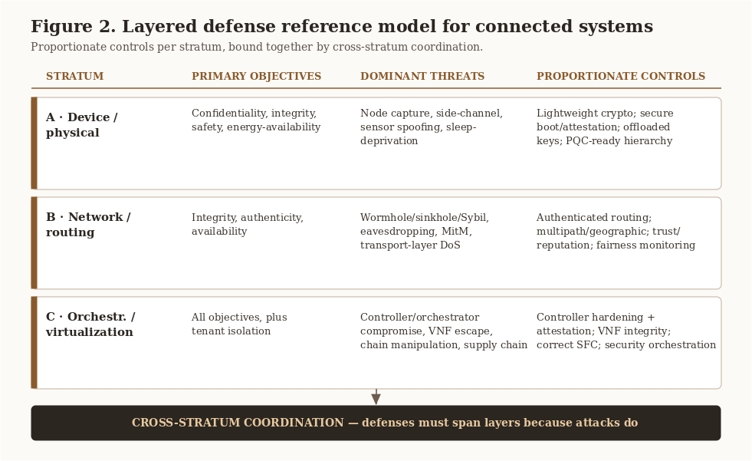
Figure 2. The layered defense reference model. Proportionate objectives, threats, and controls for each stratum, bound together by cross-stratum coordination.
Stratum | Primary objectives | Dominant threats | Proportionate controls
A, device and physical | Confidentiality, integrity, safety, energy-availability | Node capture, side-channel, sensor spoofing, sleep-deprivation | Lightweight symmetric crypto; secure boot and attestation; tamper response; key establishment offloaded to gateways; post-quantum-ready key hierarchy
B, network and routing | Integrity, authenticity, availability | Wormhole, sinkhole, Sybil, eavesdropping, MitM, transport-layer DoS | Authenticated routing of the Secure-SPIN class; multipath and geographic routing; trust and reputation; transport-fairness monitoring
C, orchestration and virtualization | All objectives, plus tenant isolation | Controller and orchestrator compromise, VNF escape, chain manipulation, supply-chain VNFs | Controller hardening and attestation; VNF integrity verification; correct service-function-chaining; security orchestration of virtual IDS and firewall functions

The model rests on one central proposition, stated here so that later sections can refer to it.

Design Principle 1 (Cross-Stratum Coordination). Connected-system defenses must coordinate across the device, network, and orchestration strata, because attacks propagate across those strata. A control that is optimal within one stratum but uncoordinated with the others leaves the cross-stratum chain of Section 4.4 intact.

Three further design principles follow from the model. First, match the control to the cost model of the stratum. Public-key operations belong where energy is available, and constrained nodes receive lightweight symmetric primitives and offloaded key management. Second, defense must be cross-stratum because attacks are. The chain in Section 4.4 is broken only by combining authenticated routing at Stratum B with orchestrated inspection at Stratum C that is itself protected by a hardened controller. Third, the virtualization layer is both shield and single point of failure. Its programmability is the most powerful tool for protecting constrained devices and the most dangerous concentration of risk, so its own integrity is the linchpin of the whole model.

8.1 Illustrative case studies from the author's implementations
The crypto lifecycle study (RSA) demonstrates why key-generation cost dictates where public-key operations can live. The transport-under-stress study (NS-3) demonstrates that fairness and reliability mechanisms are security-relevant, not merely performance concerns. The encrypted microcontroller client and server work, which culminated in SensoryPi, a smart security system performing on-device facial recognition and motion detection over a lightweight MQTT fabric, is a concrete instance of pushing confidentiality to Stratum A while relying on the network for delivery, and it is the natural point at which Stratum-C offload begins.

9. Original Contributions
This report makes four contributions that are stated here so that they are not buried in the narrative.
- A connected-systems layer model. Figure 3 frames wireless sensor networks, IoT and CPS, and virtualized networks as three nested strata of one system, with data rising, policy and defense descending, and coordination spanning all layers. The model gives the three previously separate domains a single architecture.
- A unified, cross-stratum threat taxonomy. Section 4 maps attacks consistently across the device, network, and orchestration strata and, critically, names the cross-stratum chains in which an attack at one layer enables an attack at another. This is the analytic device that the per-domain surveys lack.
- A layered defense reference model with a defense-coordination principle. Section 8 and Figure 2 assign proportionate controls to each stratum and establish Design Principle 1, that defense must coordinate across strata because attacks do. The model is environment-agnostic, holding on-premises, in the cloud, and at the IoT edge, because enforcement is decoupled from infrastructure.
- A security-orchestration mapping. Section 7.3 maps the constructive use of the virtualization layer, namely deploying and chaining virtual security functions in response to threats, onto the protection of the lower strata, turning the network into an active defender of devices that cannot defend themselves.
These contributions are conceptual and integrative. The next section evaluates them against existing models.

10. Framework Evaluation
A framework earns its place by covering what others miss. The table below compares the proposed layered model against the three established families of connected-system security models, scored by whether each addresses the device, network, and orchestration strata and the coordination across them.
Approach | Device (A) | Network (B) | Orchestration (C) | Cross-stratum coordination
Traditional WSN security | Yes | Partial | No | No
IoT and CPS security models | Yes | Yes | No | No
NFV and SDN security models | No | Partial | Yes | No
Proposed layered model | Yes | Yes | Yes | Yes

Two conclusions follow. First, each established family covers only part of the stack. Traditional WSN security is strong at the device layer and weak above it. IoT and CPS models extend to the network layer but stop short of the orchestration layer that increasingly defends them. NFV and SDN models own the orchestration layer but do not reach the constrained device. Second, none of the established families treats cross-stratum coordination as a first-class concern, which is exactly the property that the attack chain of Section 4.4 exploits. The proposed model is not more detailed than the domain surveys within any one layer. Its value is orthogonal. It supplies the connective structure, the coverage of all three strata and their coordination, that the others do not provide. The evaluation is conceptual rather than empirical. Section 11 identifies the empirical work, including a cross-stratum testbed, needed to validate the model quantitatively.

11. Open Challenges and Future Work
Post-quantum readiness on constrained devices. Hybrid lightweight and post-quantum schemes that fit Stratum-A budgets, and migration strategies for long-lived deployments, remain open [4]. Given deployment lifetimes, this is urgent rather than speculative.
AI-assisted detection and its trustworthiness. Machine learning increasingly drives anomaly and intrusion detection across all three strata [1], [5]. Yet learned detectors introduce their own risks, including adversarial evasion, data and concept drift, and, most importantly for systems that take physical action, opacity. A CPS that quarantines a segment or actuates a safety response on the basis of an unexplained model decision is difficult to audit and to trust. This points directly to the edge-AI treatment in Volume 4 of this series.
Explainable and governable automated defense. When security orchestration acts autonomously, two questions become central. Can the decision be explained, which is the explainable-AI question, and who is accountable under which policy, which is the governance question. This is the explicit bridge to later volumes: Volume 6 develops enterprise risk and cybersecurity governance, and the capstone, Volume 10, develops explainable-AI governance. Securing connected systems is, in the limit, inseparable from governing the intelligence used to secure them.
Security for financial and critical infrastructure. The connected systems analyzed here increasingly underpin regulated infrastructure, including financial operations that depend on hybrid cloud and on-premises pipelines. In that setting the availability and integrity guarantees of this framework acquire compliance and continuity stakes, and the resilience and governance controls of Volume 6 and the financial-systems analysis of Volume 8 extend this work into the domain that most differentiates it. This research identity, the intersection of cybersecurity, data science, governance, and financial systems, is the through-line of the series.
Cross-stratum evaluation methodology. The field lacks shared benchmarks that exercise the cross-stratum chains of Section 4.4. Building reproducible testbeds that combine sensor emulation, NS-3-class network simulation, and NFV and SDN orchestration is a concrete, high-value research program and a natural extension of the companion code accompanying this report.

12. Conclusion
Wireless sensor networks, IoT and cyber-physical systems, and virtualized networks are not three security problems but one, viewed at three strata. The unifying difficulty is providing classical security guarantees under non-classical constraints, namely energy, real-time safety, multi-tenancy, and scale. The unifying insight, captured in Design Principle 1, is that both attacks and defenses are most potent when they cross strata. The layered reference model proposed here organizes proportionate controls per stratum while requiring cross-stratum coordination, and it identifies the virtualization layer as simultaneously the most powerful defensive instrument and the most critical single point of failure. The framework evaluation shows that this coverage is exactly what established models lack. The open challenges, namely post-quantum readiness, trustworthy AI-assisted detection, the explainability and governance of automated defense, and the protection of financial and critical infrastructure, define the research agenda that the remaining volumes of this series pursue.

Acknowledgments
The implementation studies underlying this report originated in graduate coursework at the Illinois Institute of Technology: Computer Network Security (ECE 543) and Modern Internet Technologies (ECE 545), taught by Prof. Yu Cheng, and Internet of Things and Cyber-Physical Systems (ECE 442). The author thanks the instructors and project collaborators. All synthesis, analysis, framework development, and writing in this report are the author's own and were written from scratch for publication.

References
[1] E. Dritsas and M. Trigka, "A Survey on Cybersecurity in IoT," Future Internet, vol. 17, no. 1, art. 30, 2025. doi: 10.3390/fi17010030.
[2] S. Ali, "A Systematic Review of Lightweight Cryptographic Schemes for Security and Privacy in IoT," Discover Computing, 2025. doi: 10.1007/s10791-025-09755-3.
[3] "Efficiency and Security Evaluation of Lightweight Cryptographic Algorithms for Resource-Constrained IoT Devices," Sensors (MDPI), 2024. [Online]. Available: https://www.ncbi.nlm.nih.gov/pmc/articles/PMC11207458/
[4] L. H. Mahdi and A. A. Abdullah, "Fortifying Future IoT Security: A Comprehensive Review on Lightweight Post-Quantum Cryptography," Engineering, Technology and Applied Science Research, vol. 15, no. 2, pp. 21812-21821, 2025. doi: 10.48084/etasr.10141.
[5] "A Comprehensive Survey on Cybersecurity Threats and Defense Mechanisms in IoT Networks," arXiv:2601.00556, 2026. [Online]. Available: https://arxiv.org/abs/2601.00556
[6] "Comparative Performance Analysis of Lightweight Cryptographic Algorithms on Resource-Constrained IoT Platforms," Sensors (MDPI), 2025. [Online]. Available: https://www.ncbi.nlm.nih.gov/pmc/articles/PMC12473500/
[7] M. Dominguez-Dorado, J. Calle-Cancho, J. Galeano-Brajones, F. J. Rodriguez-Perez, and D. Cortes-Polo, "Detection and Mitigation of Security Threats Using Virtualized Network Functions in Software-Defined Networks," Applied Sciences, vol. 14, no. 1, art. 374, 2024. doi: 10.3390/app14010374.
[8] A. K. Alnaim, "Securing 5G Virtual Networks: A Critical Analysis of SDN, NFV, and Network Slicing Security," International Journal of Information Security, vol. 23, pp. 3569-3589, 2024. doi: 10.1007/s10207-024-00900-5.
[9] R. Mijumbi, J. Serrat, J. L. Gorricho, S. Latre, M. Charalambides, and D. Lopez, "Management and Orchestration Challenges in Network Functions Virtualization," IEEE Communications Magazine, vol. 54, no. 1, pp. 98-105, 2016. doi: 10.1109/MCOM.2016.7378433.
Primary sources, author coursework, rewritten and synthesized for this report: A. Palayil, "Exploring Security Algorithms and Protocols for Wireless Sensor Networks" (ECE 543, IIT, 2023); "Network Function Virtualization Deployment: A Survey" (ECE 545, IIT, 2023); "In-Depth Investigation of TCP via NS-3 Simulation" (ECE 545, IIT, 2023); "RSA Algorithm Implementation" (ECE 543, IIT, 2023); IoT and CPS encrypted client and server work, SensoryPi (ECE 442, IIT, 2022).

Note on author metadata: references [1], [2], [4], [7], [8], and [9] carry full author lists in IEEE format. Entries [3], [5], and [6] are cited by title and venue pending confirmation of their full author lists, which should be completed before any journal submission. This version (1.0) is prepared for Zenodo deposit as the first publication of the series.

