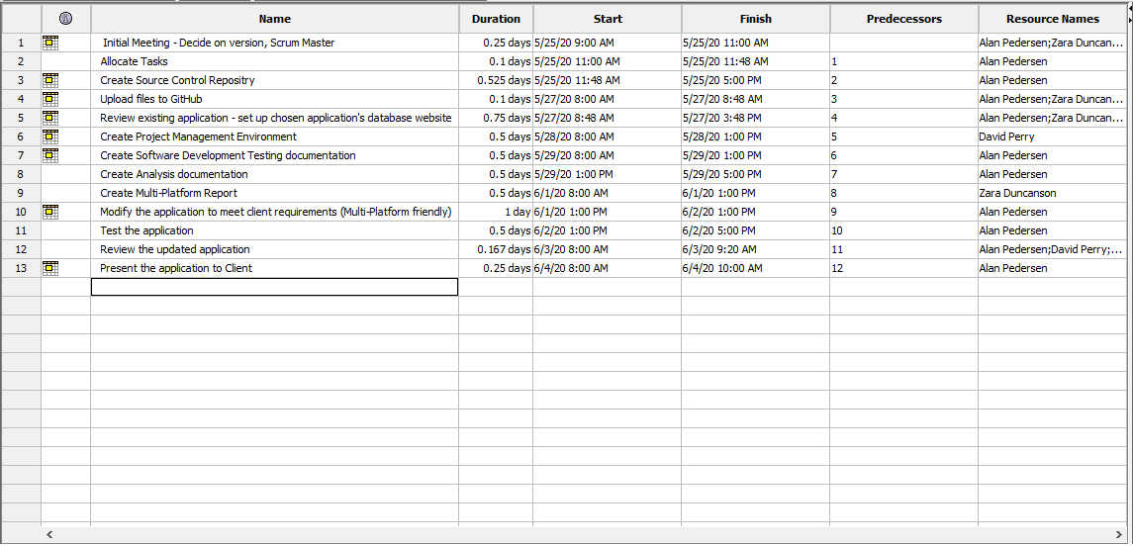

Figure : Sprint One Project Plan

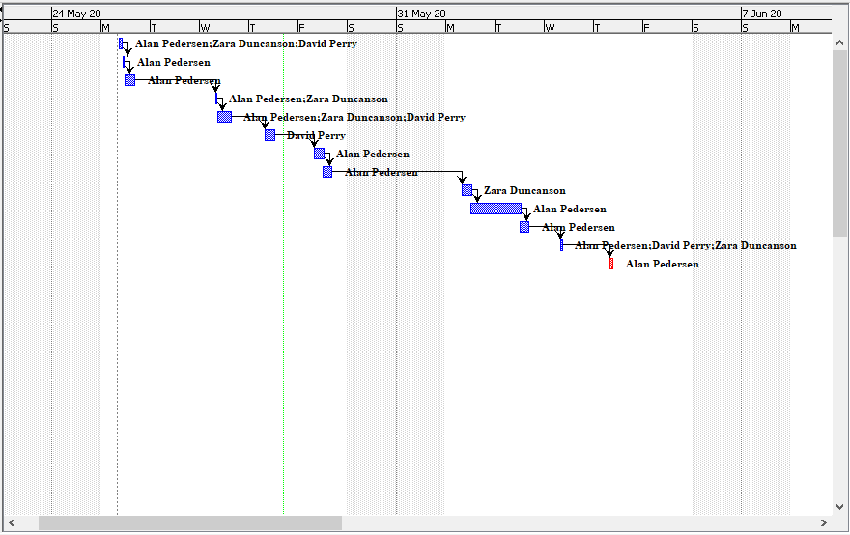

Figure : Sprint One Gantt Chart