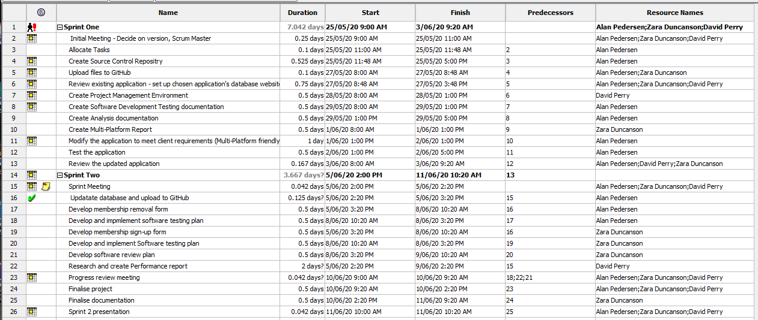

Figure 1: sprint two project task view

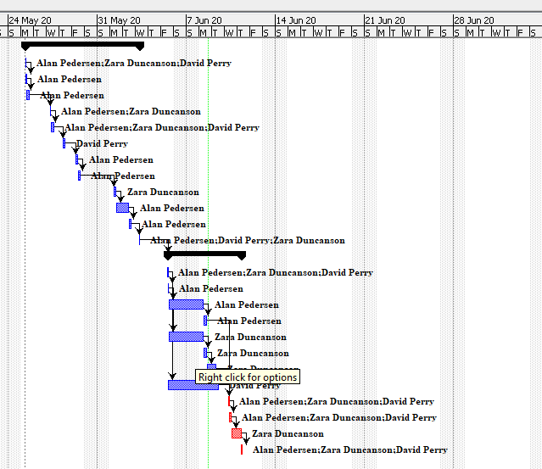

Figure 2: sprint two Gantt chart