## Administration login and user groups

The database has been configured to prompt a user for a login to access. An administration account has been made with the name admin which has all the privileges allowed for the movie database. This includes all options relating to modifying the database.

An additional two users were created which are staff members with restricted access. This is based on the scenario that a staff member can have access to add movies to the database, which can be modified if needed. But they are not allowed to carry out certain tasks such as deleting records.

A user group has been made for acme staff were the two staff users are added. The privileges in the group determine what is displayed if these users are accessing the database. Although other restrictions are already in place for each user, members of the group only have a select number of tabs and options visible.

Figure 1: Admin user has access to all functions related to the movie database

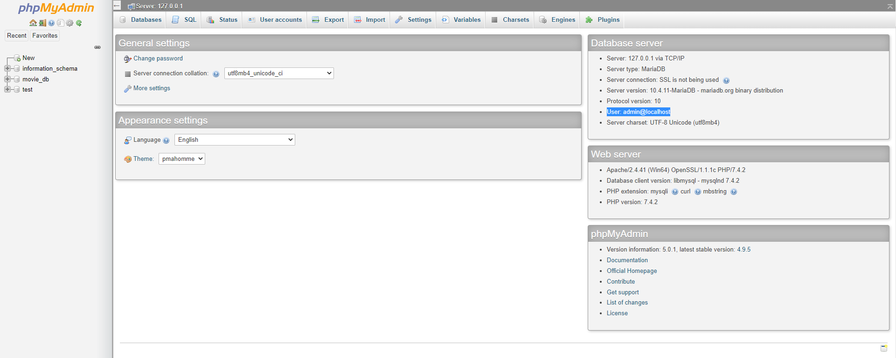

Figure 2: The user group "Acme Staff" contains users, restricts the view of tabs not required by each user

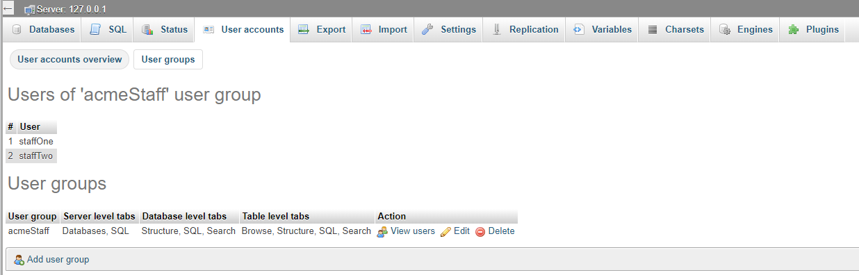

Figure 3: View of the limited tabs available to a staff user

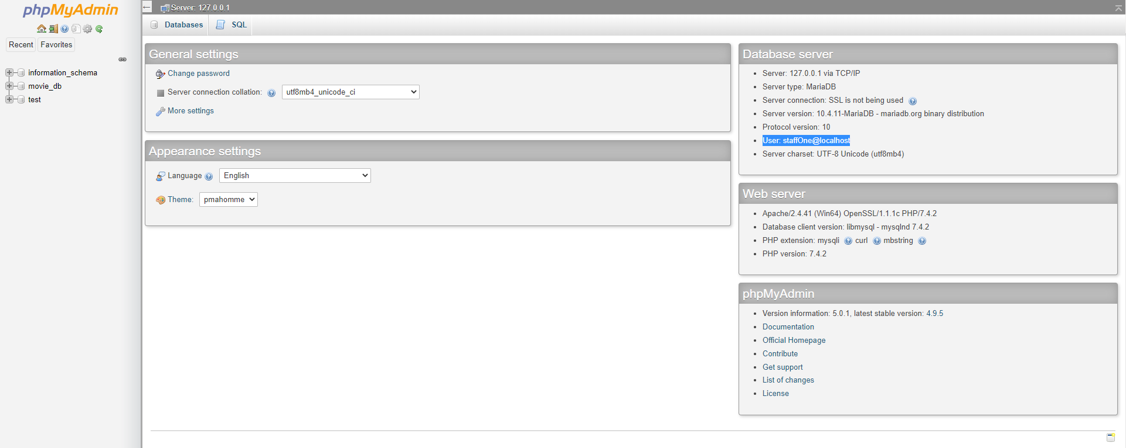

Figure 4: Staff users have limited controls of queries such as deleting data from the tables

