# Optimization Report

A series of tests have been carried out on all the pages to check the speed of the initial load, and the performance of running queries which retrieves data from the database. Google development tools have been used as these are a great tool to use in the development as they offer performance checks on pages loaded with local host.

Overall, the pages all returned excellent results with no recommendation to make any modifications. Some slight modifications can be made to the top 10 page which shows the charts with the CSS but are not necessary. The pages were all tested on a desktop option, mobile option and with a slower internet speed scenario which all returned similar results to the screenshots mentioned in the report. The default tests were carried out on the desktop option.

## SearchMovies.php

The search movies page contains a form to input search data for the title and years of movies. There are also three boxes displaying the available genre, rating, and sort by options to be used with the search. To load the page, scripts will run to retrieve the relevant data from the respective database tables and populate the display.

The performance of this page returns 99 which is an excellent result when it is loaded. A test to search for all the movies was carried out which retrieves and displays all 2298 movies. This was completed in roughly half a second which is a great result. Searching a query with different criteria such as selecting the genre and rating returns a fast result of around 100 milliseconds, though these times will be determined by how many rows are displayed depending on the search.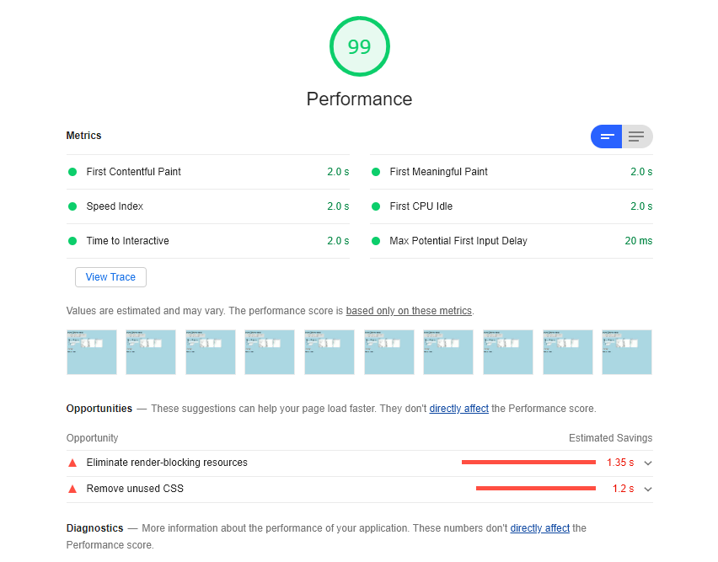

Figure : Loading the Search Movies page

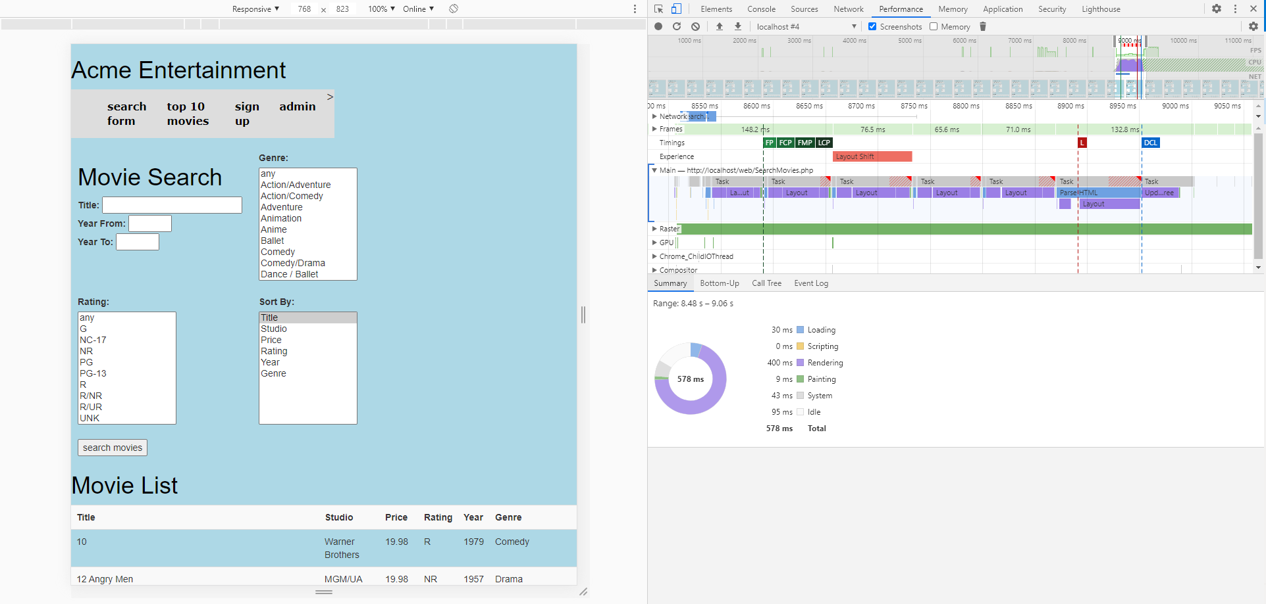

Figure : Loading all movies from database

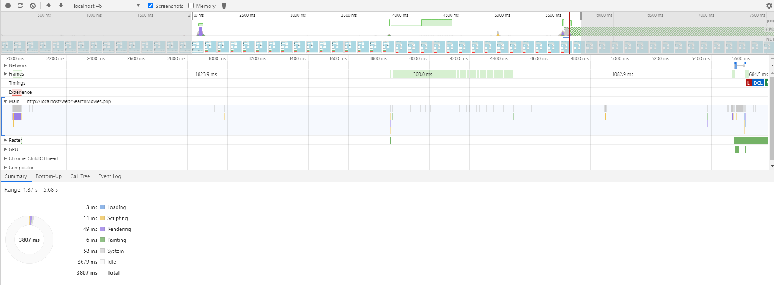

Figure : Searching for a combination of rating and genre

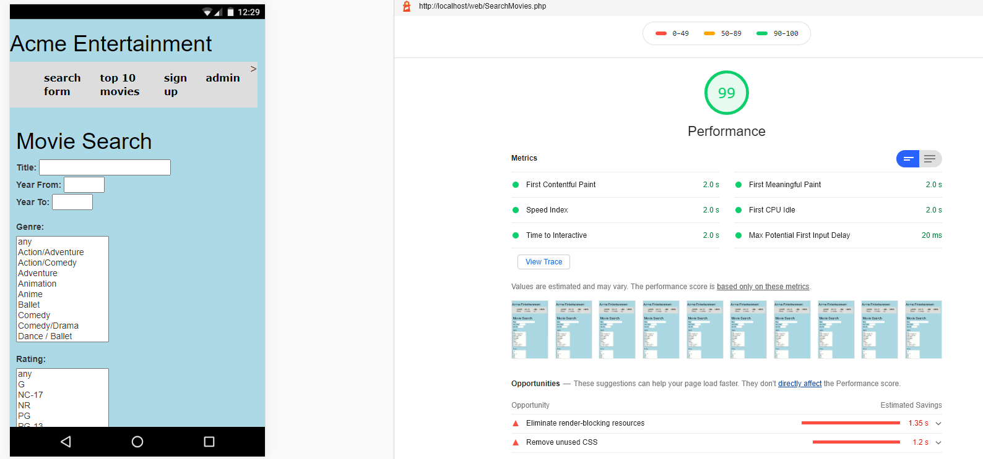

Figure : Loading the Search Movies page in mobile format

## SignUp.php

The sign-up page also returned a performance score of 99. This page has a form for users to sign up and opt out of a newsletter and newsflash. To reach a score of 100 the CSS would need to be modified. A test snapshot of signing up a user was carried out which adds the data to the database. This took under 50 milliseconds, so it is an almost instant result requiring no modification.

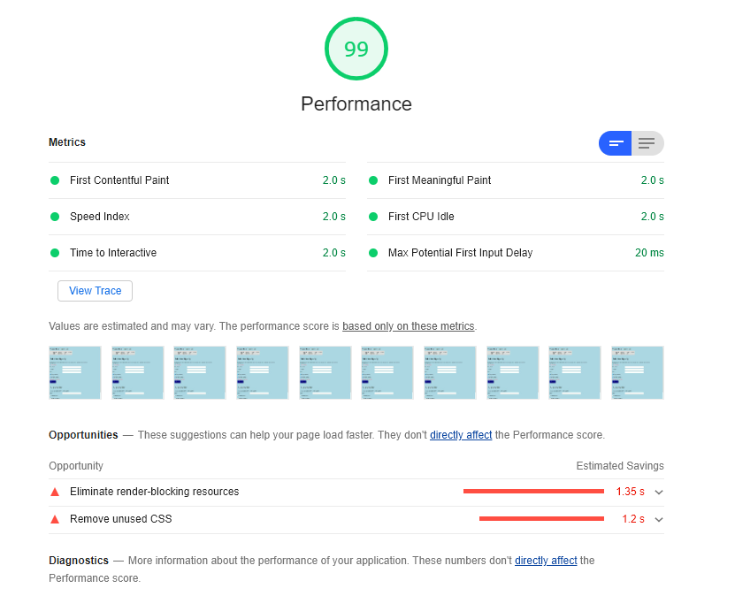

Figure : Loading the Sign-Up page

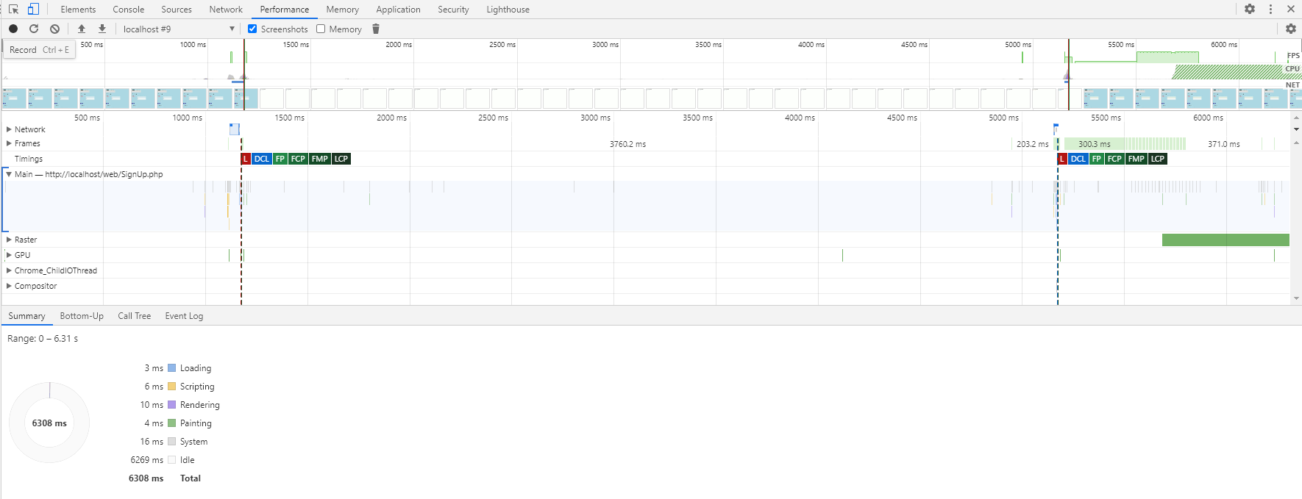

Figure : Using the form to sign up a user

## Top10.php

The top ten page displayed the slowest response of all the pages, but still returns a result of 94. It does need to retrieve data which populates a google chart which need to be drawn. The google charts slow the process slightly so it is expected to perform slightly slower than the other pages. Modifications with the CSS will change the result, but it is an acceptable performance.

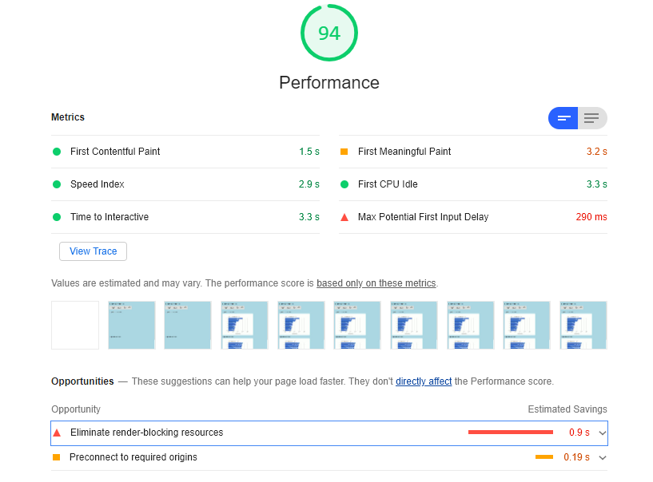

Figure : Loading the Top Ten page

## UnsubscribeUsers.php

The unsubscribe users page has a performance result of 100. It retrieves users’ details from the database and populates a display box. A form is printed which allows the admin to search for a user for the purpose of unsubscribing them from the mail list. The test to record the speed of unsubscribing a user returned a fast speed of under 20 milliseconds. No change to the page is required after the unsubscribe button is pressed which can explain the faster speed. The list does repopulate with the changes made to the database.

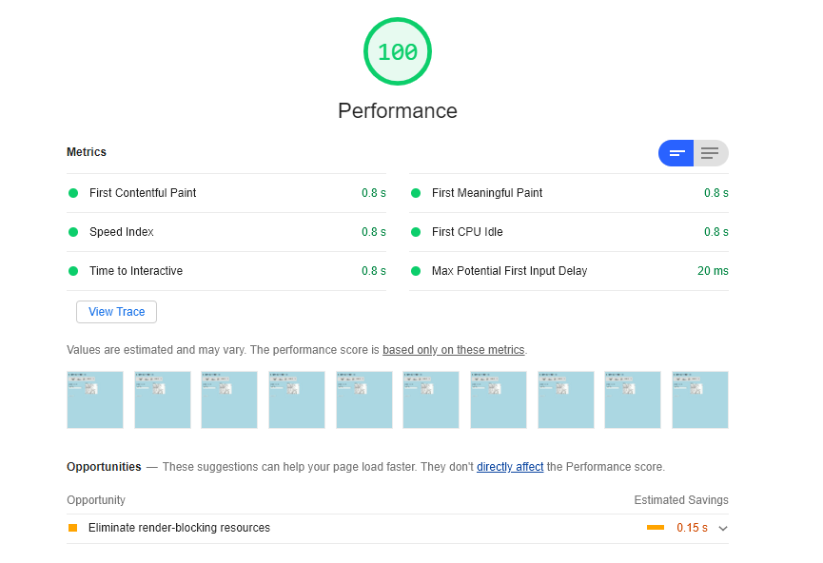

Figure : Loading the Unsubscribe Users page

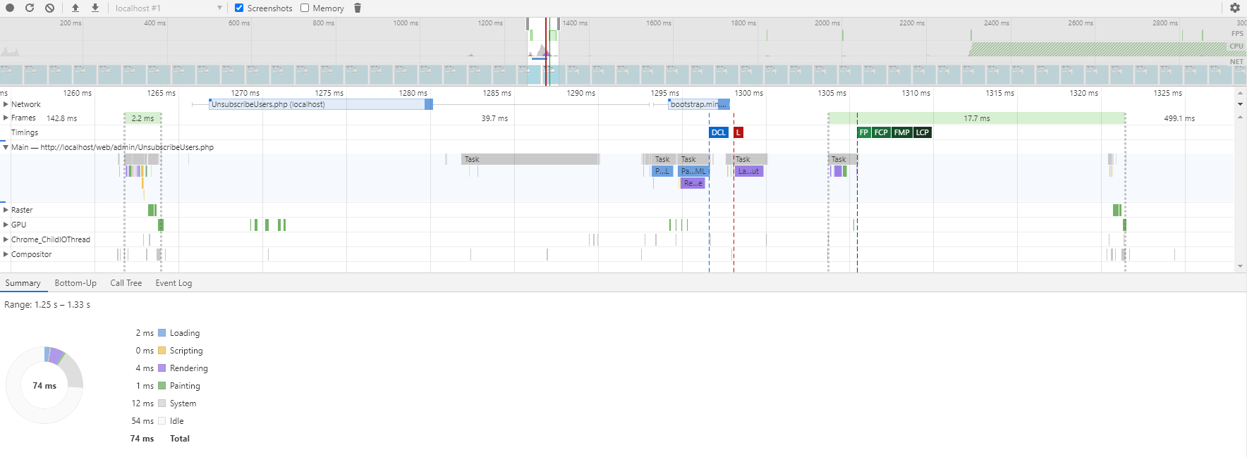

Figure : Unsubscribing a user from mail list