## Test Table

|  |  |  |
| --- | --- | --- |
| Test | Expected Outcome | Observed Outcome |
| Clicking on a movie from the table. | Rating box displays offering the user to click from one to five stars. | As expected,  Ref: Figure 1 |
| Hover the mousse over the stars | Stars change to gold and a pop up stating how many stars will be selected | As expected,  Ref: Figure 2. |
| Submit a rating on a movie | The column in the database of the star selected should increase its count by one. The average should update | As expected,  Ref: Figure 3 & 4. |
| Press the close button on the rating box | The rating box disappears, returning the page to the previous search result | As expected,  Ref: Figure 5. |
| Connect the web application to the database with admin password | The site should function correctly with all features available | As expected,  Ref: Figure 6. |
| The top ten rating chart auto refreshes | After the average ratings are changed on a movie, the data updates in the chart automatically | As expected,  Ref: Figure 7. |
| The top ten chart for searches auto refreshes | After carrying out a search of a movie in the top ten, the chart automatically updates | As expected,  Ref: Figure 8. |

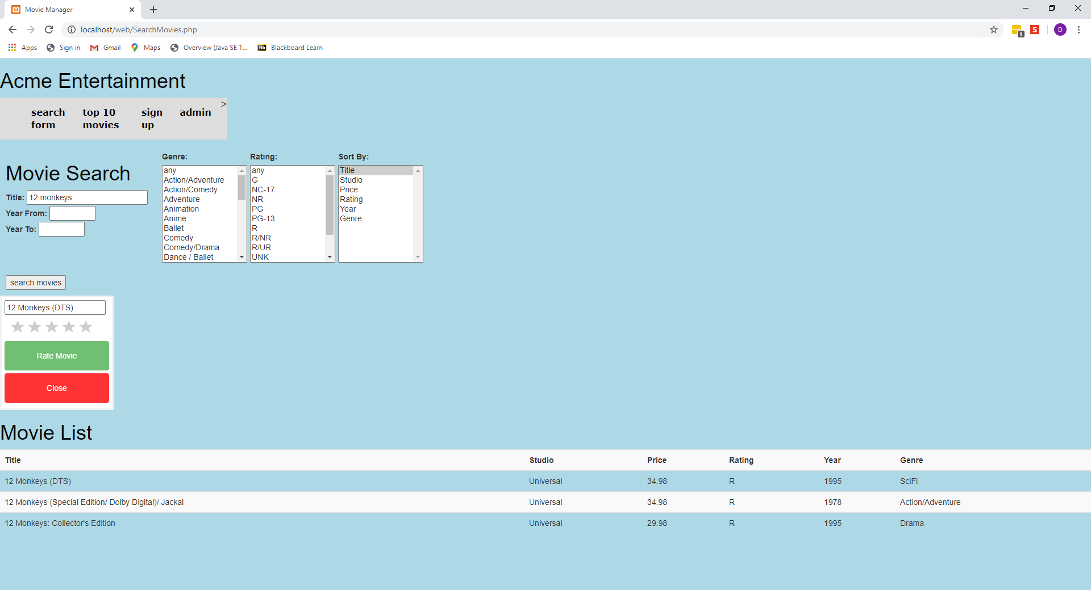

Figure : When clicking on a movie from the table, the rating box appears

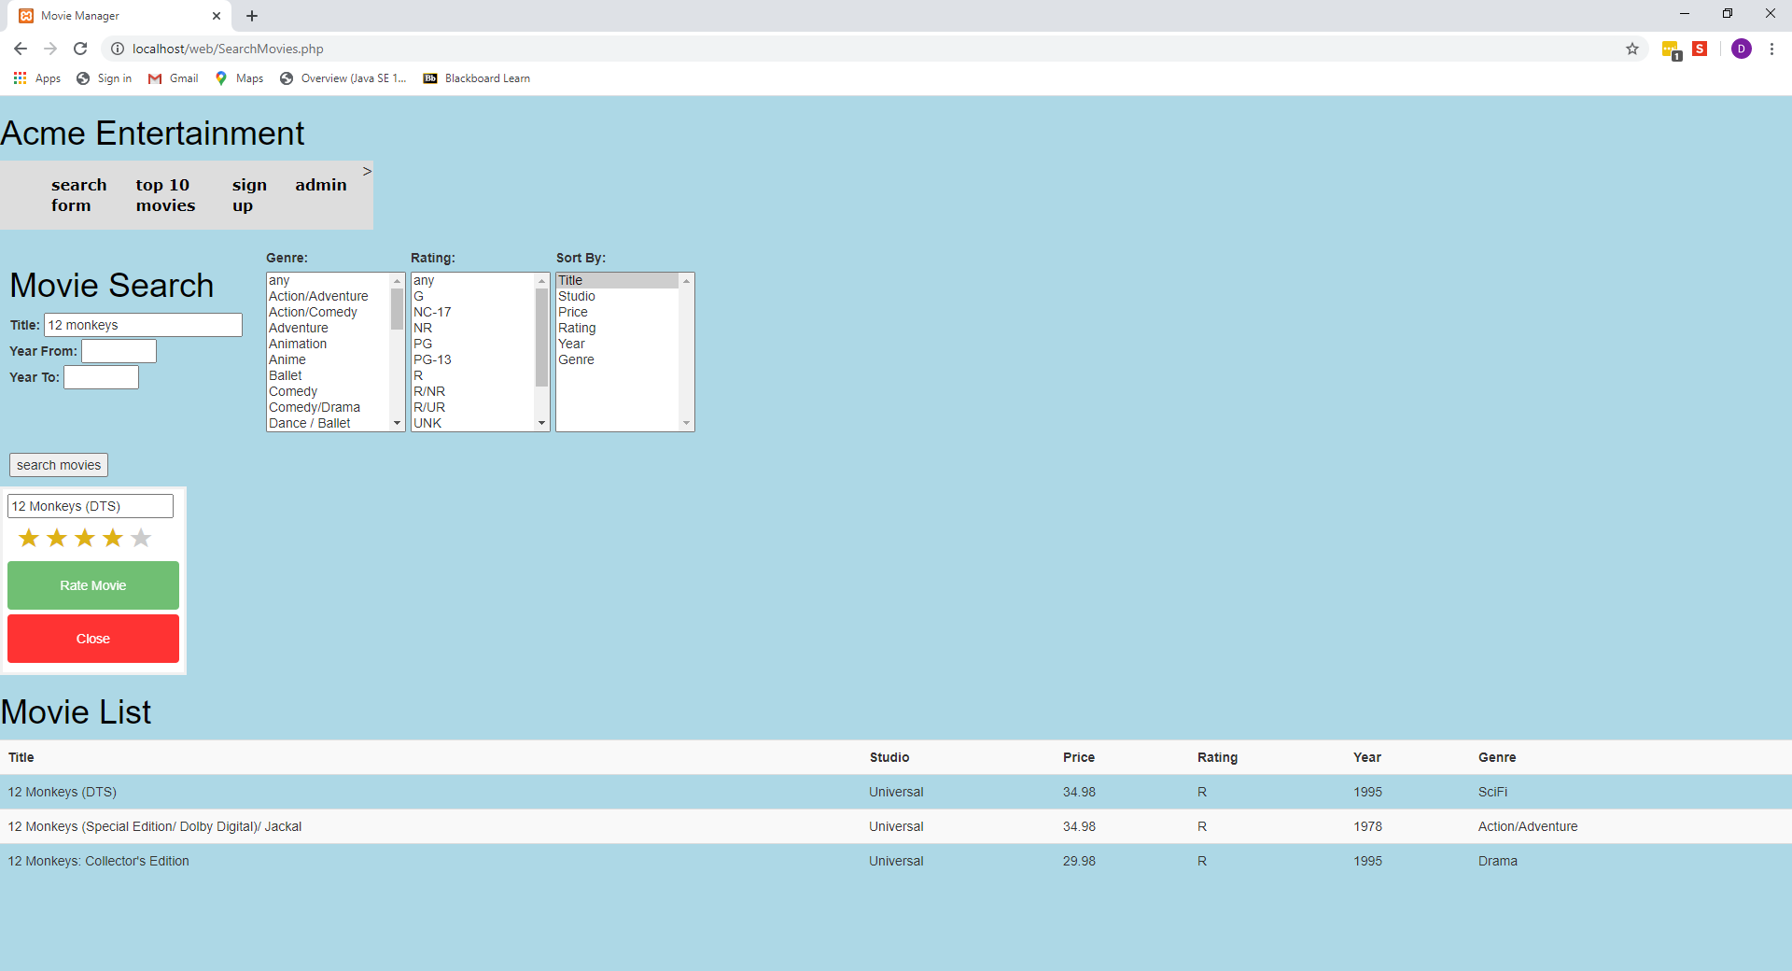

Figure : When hovering over the stars, they illuminate to gold to give the user better experience

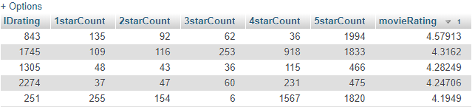

Figure : Snapshot of the top 5 rated movies before a rating is submitted

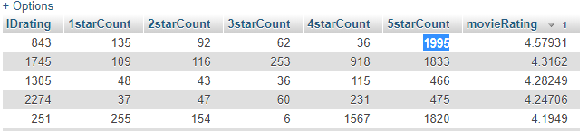

Figure : After a 5-star rating is added to the top movie, the count and average rating increase

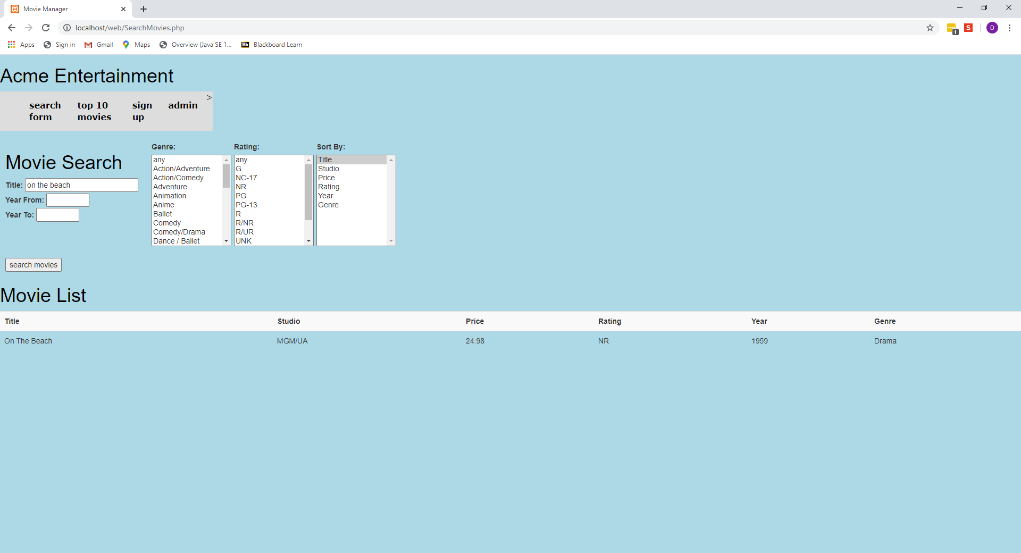

Figure : Page returns to search result after close button pressed in rating box

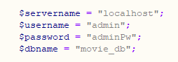

Figure : The admin username and password are hard coded into the connection script

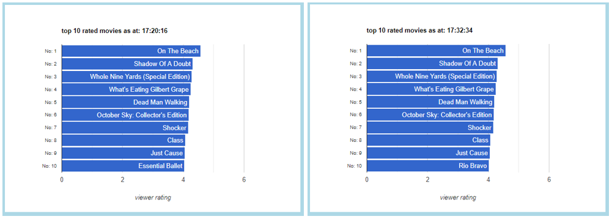

Figure : The chart on the right has updated the 10th movie in the list when the data has changed without the browser being refreshed

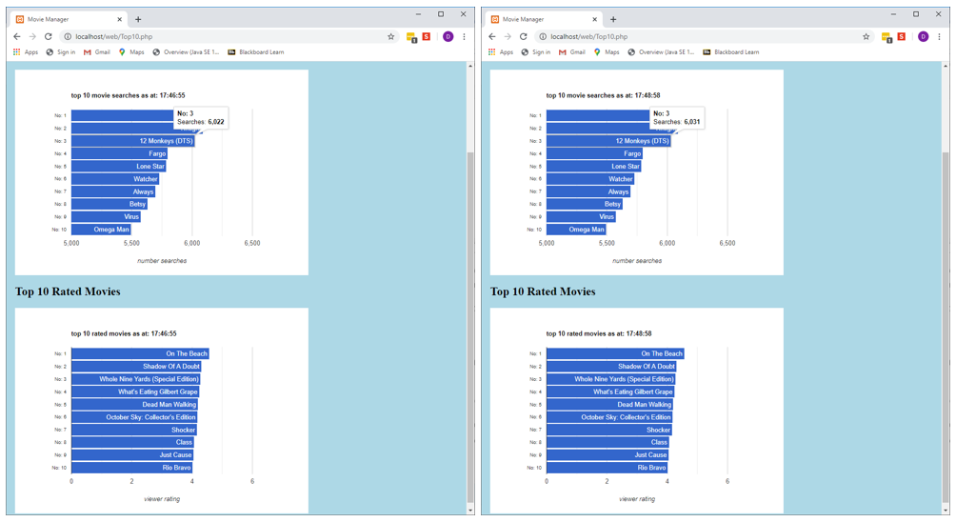

Figure : After running some searches on 12 Monkeys, the chart on the right has updated to display the new data without refreshing the browser