### Unsubscribing a User Design

Acme Entertainment require the development of a suitable user interface for the administrator so they can enter an email address for removal.

The interface will use a form presented in a web page. The form will present a text input element allowing input of a filtering string along with a list of current email addresses matching the filter. The list of email addresses will be limited to 20 values. Where more addresses are matched a message will be displayed. If there are no matching email addresses a message will be displayed.

The form queries the database to extract a list of active email addresses. As characters are entered into the filter text box the list is refreshed using the filter text to select records. Records will be selected if they include the filter text.

Once the administrator has selected one or more email addresses the “unsubscribe” button is enabled.

Clicking the button runs an SQL script flagging the selected records as inactive.

To preserve the integrity of the database the user records will not be deleted, the records in the user table will be flagged as inactive by setting the “active” field to false.

A screen dump of the form is presented below:

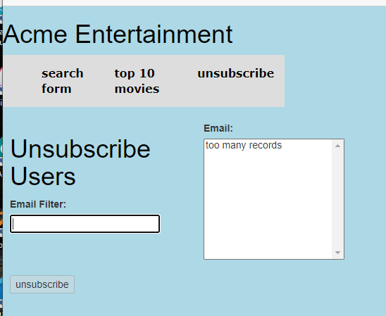

Figure : unsubscribe form design

### Unsubscribing a User Testing

To allow testing of the form 100 random names and email addresses were created and added to the user table.

The following testing table was used to test the operation of the form:

|  |  |  |
| --- | --- | --- |
| Test | Expected Outcome | Observed Outcome |
| Initial display | The form should be displayed  The email list should display “too many records”  The “unsubscribe” button should be disabled. | The form is displayed  Ref: Figure 1 |
| Text entered in filter box | The form should update  When the number of matching email addresses in < 20 the list is displayed. | Filter too many records Ref: Figure 2  Filter applied records displayed Ref: Figure 3 |
| Button activated when a record is selected | The “unsubscribe” button is active when a record is selected | Button active Ref: Figure 4 |
| The selected records are flagged as inactive when the button is clicked | Records flagged in the database  No longer displayed in the form. | Records flagged as inactive and no longer displayed Ref: Figure 5, Figure 6 & Figure 7 |
| The filter string does not match any records | No matching record message displayed | Message displayed Ref: Figure 8 |

Table : unsubscribe form testing table

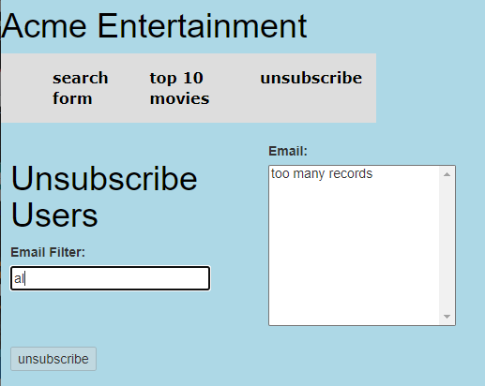

Figure : filter applied too many records

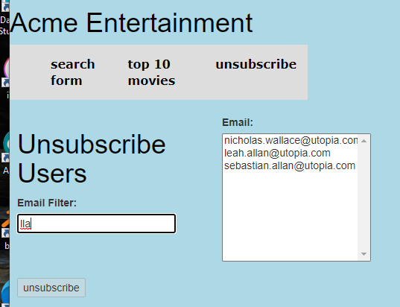

Figure : filter applied records displayed

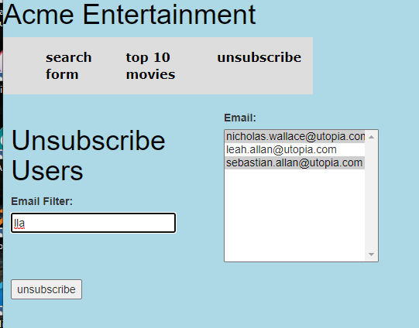

Figure : button active when record selected

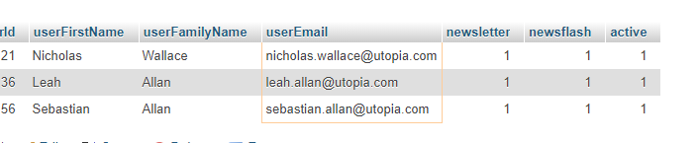

Figure : selected records before flagging

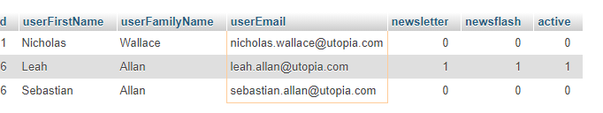

Figure : selected records after flagging

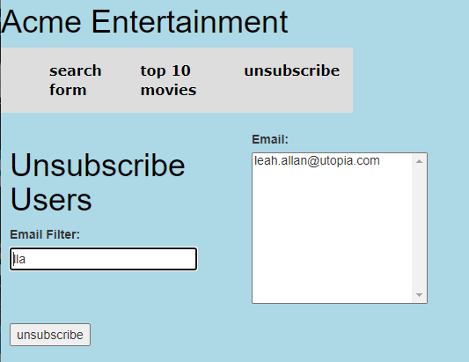

Figure : updated form after flagging

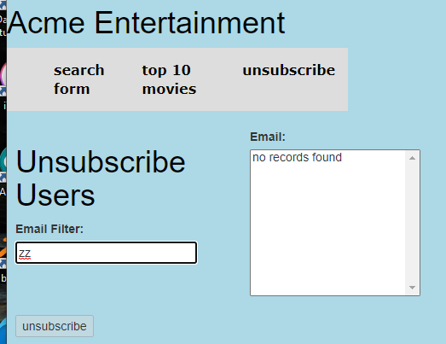

Figure : filter no matching records