### Subscribing a User and Using PHP Mail Design

Acme Entertainment requires a free communications service to sign up users with their email address. Users can either choose to subscribe to; a monthly newsletter, a breaking newsflash notification, or both. Users must also have an option to unsubscribe. This removal process should send an email to the administrator requesting removal of a member’s details from the database.

The interface will use a html form to add new records of members to a database table called ‘tbluserdetails’. There will be text fields for the user’s first name, last name and email, and checkboxes for the two types of communications.

Upon ‘Subscribe’ button press, each of these inputs will be validated to ensure correct formatting and filter out any illegal characters, and that at least one subscription option is chosen. The php script will then query the database to add the record to the table. A message will then be displayed to the user; error if there was a problem with input, and success if everything worked.

Upon ‘Unsubscribe’ button press, a different PHP script will be run, validating the input email and checkboxes of the unsubscribe form, and checking if the input email address matches one currently in the database of users. If it is present, an email to [no-reply@acme.com](mailto:no-reply@acme.com) is drafted using variables and sent including details of which user wants to unsubscribe.

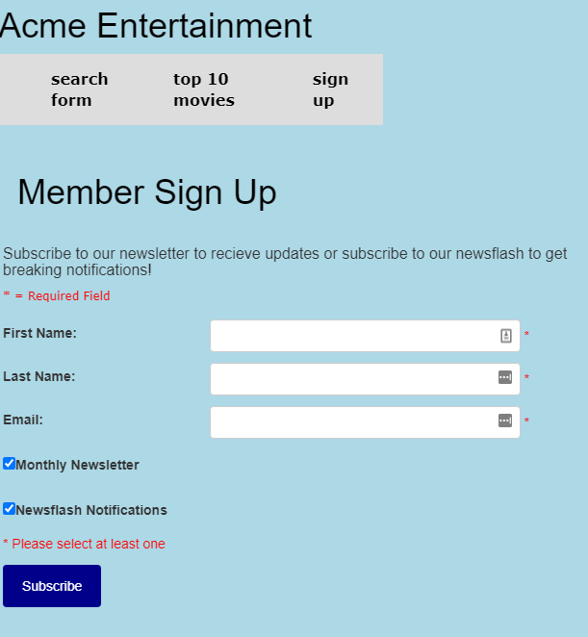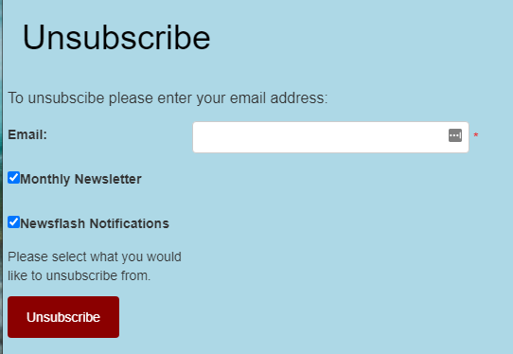The page is also responsive to different device sizes.

Figure : Sign up form interface.

Figure : Unsubscribe form.

### Testing

#### Test Table for Sign Up

|  |  |  |
| --- | --- | --- |
| Test | Expected Outcome | Observed Outcome |
| Initial display | All input fields should be blank  ‘Sign up’ form checkboxes should be checked | As expected.  Ref: Figure 1 |
| ‘Subscribe’ button pressed with no inputs in any fields | Error messages displayed to user with an option to return and try again. | As expected.  Ref: Figure 3. |
| ‘Subscribe’ button pressed with non-alphabetical inputs (e.g. $,%, or numerical) for first name and last name. | Error messages displayed to user with an option to return and try again. | As expected.  Ref: Figure 3. |
| ‘Subscribe’ button pressed with letter inputs for first name and last name but non-email format for email which contains ‘@’. | Error message displayed to user with an option to return and try again. | As expected.  Ref: Figure 4. |
| ‘Subscribe’ button pressed with letter inputs for first name and last name but non-email format for email. | Pop-up displayed on screen informing user of incorrect format. | As expected.  Ref: Figure 5. |
| ‘Subscribe’ button pressed with all inputs in correct format, with no checkboxes checked | Error message displayed to user with an option to return and try again. | As expected.  Ref: Figure 6. |
| ‘Subscribe’ button pressed with all inputs in correct format, with one or more checkboxes checked | User details added to database with relevant subscription options marked as ‘true’  ‘active’ also marked true  Message of success displayed to user | As expected.  Ref: Figure 7 & 8. |

#### Test Table for Unsubscribe

|  |  |  |
| --- | --- | --- |
| Test | Expected Outcome | Observed Outcome |
| Initial display | All input fields should be blank  ‘Unsubscribe’ checkboxes should not be checked | As expected.  Ref: Figure 2. |
| ‘Unsubscribe’ button pressed with no inputs in any fields | Error messages displayed to user with an option to return and try again. | As expected.  Ref: Figure 9. |
| ‘Subscribe’ button pressed with non-email format for email which contains ‘@’. | Error message displayed to user with an option to return and try again. | As expected.  Ref: Figure 4. |
| ‘Unsubscribe’ button pressed with non-email format for email | Pop-up displayed on screen informing user of incorrect format. | As expected.  Ref: Figure 5. |
| ‘Unsubscribe’ button pressed with correct email input format but no checkboxes checked | Error message displayed to user with an option to return and try again. | As expected.  Ref: Figure 9. |
| ‘Subscribe’ button pressed with all inputs in correct format, with one or more checkboxes checked and input email not present in database | Email input is checked to see if present in database.  If not present, an error message is displayed to user. | As expected.  Ref: Figure 10. |
| ‘Subscribe’ button pressed with all inputs in correct format, with one or more checkboxes checked and input email present in database | Sends email to admin requesting un-subscription using php script.  Message displayed to user confirming this is displayed. | As expected.  Ref: Figure 11. |

### Appendix – Screen Captures

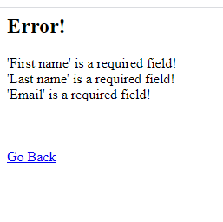 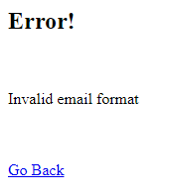

Figure : Error messages with blank inputs on 'Subscribe' Figure : No ‘.’ Following @ symbol in email

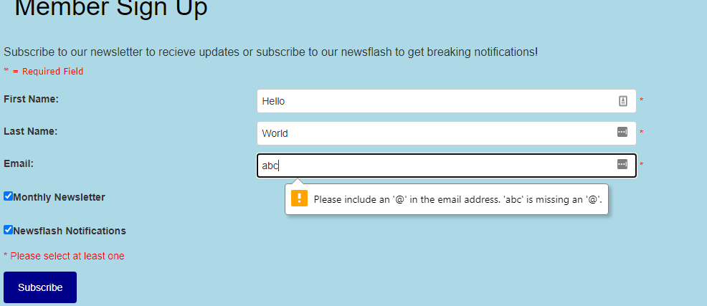

Figure : Email format error.

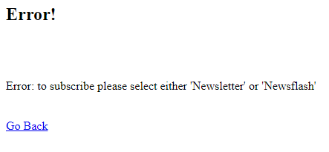

Figure : No subscription option error.

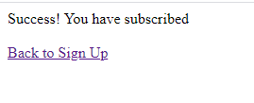

Figure :Success message.

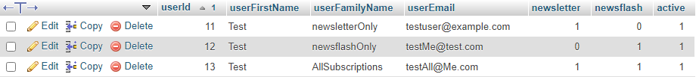

Figure : Successful records with different subscriptions, all ‘active’.

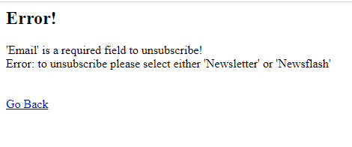

Figure : Unsubscribe error.

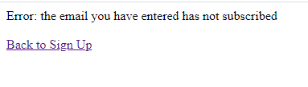

Figure : Email not present error.

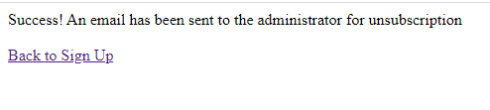

Figure : Success message.